TECHNICAL REPORT ON

STUDENT INDUSTRIAL WORK EXPERIENCE SCHEME (SIWES)

HELD AT

KWARA STATE LIBRARY BOARD, ILORIN (AUGUST, 2024 – NOVEMBER, 2024)

BY

ADEBAYO IBRAHIM OLAREWAJU (ND/23/LIS/FT/0123)

SUBMITTED TO

THE DEPARTMENT OF LIBRARY AND INFORMATION SCIENCE, INSTITUTE OF INFORMATION COMMUNICATION TECHNOLOGY, KWARA STATE POLYTECHNIC, ILORIN

MARCH, 2025

TABLE OF CONTENT
Title Page 1
Table of content 2
Report Over-view 3
CHAPTER ONE: 4
  - Introduction 4
1:2 History and Background of SIWES 5
1:3 Objectives of SIWES
CHAPTER TWO: 6
2:1 Description of the Establishment of Attachment 6
2:2 Location and Brief History of the Establishment 6
2:3 Objective of the Establishment 7
2:4 Organization Structure of the Establishment 8
2:5 Various Department/Unit and their Functions 9
Library Advocacy 11
CHAPTER THREE: 12
3:1 Summary of Actual Work Done with a Clear Statement of the 12
Experience Gained During SIWES 14
CHAPTER FOUR: 16
4:1 Description of Equipment Used and their Functions 16
CHAPTER FIVE: 19
5:1 Summary
5:2 Conclusion
5:3 Problem Encountered
5:4 Recommendation
Reference 20

REPORT OVERVIEW
This report provides the details of the experience I gained in various section/division in Kwara State Library Board. Which include cataloguing, classification, serial, automation, acquisition, reference, humanities, science and technology, and children, which has expose and give me better understanding of what I was taught doing lectures. This report show the detailed information about the establishment which include the history and location and it also give information about the history of SIWES and the objectives.

CHAPTER ONE
INTRODUCTION

History and Background of SIWES

The student work experience scheme (SIWES) is a worldwide program practiced in countries like Japan, Australia, USA, Europe, and in African countries too. It is popularly known as co- operative education and referred to as sandwich in Europe. It is a four (4) months students industrial work experience scheme (SIWES) taken in the second year of the diploma program, which the student go to various establishments related to their course of study.
The program was initially introduced in Nigeria by the industrial training fund ( I.T.F.) which was established under decree 47 of 1972 by the supreme military council, headed by General Yakubu Gowon. The decree was billed to take effect from 31st march 1974 and had as its core objective, the gradual reduction of the percentage of foreign participation in most of Nigeria’s economic activities, accompanied by a systematic cooperation of locally oriented skilled manpower into the vast economic sector.
One of the key functions of the ITF is to work as cooperative body with industry and commerce where students in institutions of higher learning can undertake mid- career work experience attachment in industries which are compatible with student’s area of study. The Students Industrial Work Experience Scheme (SIWES) is a skill Training program designed to expose and prepare students for the industrial work situation which they are likely to meet after graduation. Participation in SIWES has become a necessary pre-condition for the award of diploma and degree certificate in specific disciplines in most institution of higher learning in the country in accordance with education policy of government.

Objectives of SIWES

The following goals are intended to be accomplished by the SIWES programme

    - Give higher education institutions` students a way to gain practical experience and industry skills related to their area of study.
    - Students should be prepared for the industrial work environment they will probably encounter after graduation.
    - Establishing a reciprocal interaction between the theoretical and practical aspects of the field in real-world scenarios

    - Introduce students to working with technology and equipment that may not be available in their institutions

CHAPTER TWO

Description of the Establishment of Attachment
Kwara state library is a public library located in kwara state, Nigeria. The library was established soon after the state was created in 1967 when it was found that the library in kaduna was inadequate. The library was renovated in 2005, establishing the administrative, technical, and acquisition division. Its headquarters are in the state capital Ilorin, with divisional libraries in jebba and offa. It was established with the aim of proving qualitative and adequate reading resources for the people of the state, irrespective of age, educational background, status in the state, religion and gender.

Location and Brief History of the Establishment
Kaduna State Library served the residents of the northern region until kwara state and other states were established in 1967. The year the Kwara State Library was established, the area court building served as its original venue. After, it was relocated until colonel Ahmed Abdullahi, the military ruler, erected the current library. About £300 was provided in addition to the contents from the old library to furnish the new one. On November 21, 1990, Ibrahim Babangida, the military president, officially opened the kwara state library. In 2005, the state`s then-governor, Bukola Saraki, restored the library. The current government of the state promised to spend about #100m to renovate the state library complex and use it as a Launchpad for e-learning and temporary headquarters for the state`s innovation hub.

0bjectives of the Establishment

The following are the objectives of the establishment:

    - To provide every user with access to as much information, establishment, and resources as possible regardless of age, financial situation or any other variables.
    - To contribute to the achievement of the society
    - To enhance the quality of life by providing user access to resources and services that promote the personal growth, cultural enrichment and lifelong learning for every member of the society
    - To offer a free, comfortable and secure pace for the general public to come and learn.
    - To create awareness about important and uses to library.

  - Organisational Structure of the Establishment

ORGANIZATIONAL STRUCTURE OF KWARA STATE LIBRARY

BOARD CHAIRMAN
& MEMBER

DIRECTOR

TECHNICAL
DEPARTMENT
ADMINISTRATIVE
DEPARTMENT

READER SERVICE DEPARTMENT

ACQUISITION SECTION
CATALOGUING SECTION

CIRCULATION SECTION

CHILDREN SECTION

CLASIIFICATION SECTION
AUTOMATION SECTION
HUMANITY SECTION
SCIENCE & TECHNICAL SECTION

E-LIBRARY SECTION
SERIAL & GOVERNMENT PUBLICATIONS

SECRETARY& ACCOUNTANT UNIT
REFERENCE & RESERVE SECTION

BINDERY
SECTION SECURITY &
MAINTENANCE UNIT

SPECIAL PEOPLE SECTION

To achieve its stated objectives, the library is presently organised into 3 division. These are: The Administrative Division, Technical service, and Reader service Division.

Various Division/Units and their Functions

Kwara state library board is a public so its functions are addressed to serve the whole community of kwara state, and purposely to always bridge every information gap between every user in the library.
Kwara state public has three main division which are:

    - Administrative department
    - Reader service department
    - Technical department.

Sections under these departments are:

- Administrative
- Reader service
  - Humanity
  - Science and technology
  - Reference
  - Children
  - Serial
- Technical service
  - Classification
  - Cataloguing
  - Automation
  - Acquisition
  - Bindery

READER SERVICES: Is an important part in the library, they help the library users to find what they are looking for, the reader service is available to assist the user with the location of books on a particular subject to suggest the latest best sellers.
- HUMANITY SECTION: is a section typically contains material related to subjects like philosophy, literature, history, and arts. These materials are often regarded as humanities because they are friendly to the society.

- SCIENCE AND TECHNOLOGY SECTION: This section consists of class 500 and 600 of materials. It typically contains materials like books, journals, and online databases covering topics like physics, chemistry, biology, mathematics, computer science. This section is open to all users and allow them to have access to library materials.
- REFERENCE SECTION: this section consists of materials like encyclopedias, dictionaires, almanacs and so on. These resources provide quick and reliable information on a wide range topic. Library users like researchers, professional are those that visit this section.
- CHILDREN SECTION: this section in the library consist of children materials, toys and game. This is a place where kids can explore the joy of reading, discover new stories and engage in educational and fun activities. Materials in this section are colourful and attractive which make it easy to entice children.
- SERIAL SECTION: Serial is a government publication that is issued out within a regular interval and it is intended to be continue indefinitely. Materials in this section includes, newspaper, journals, magazine, and dictionary.
TECHNICAL SERVICE: Technical service are jobs done in a library to acquire and prepare library materials for use by the patrons. This department deals with ordering materials, receiving materials, arranging materials in the library catalogue.
- CLASSIFICATION SECTION: this is where books and other library material are classified and organised to make it easier for library user to access material. The most commonly used classification scheme in libraries is Dewey Decimal Classification Scheme (DDC). This scheme assigns a unique number to each subject area, allowing books on similar topic to be grouped together.
- CATALOGUING SECTION: this is also one of the important section in the library. The cataloguing section performs the functions of cataloguing activities of all types of material that deals with physical description, indicating their bibliographic details so as to enable users to have access to them.it is the process of preparing entries on a particular subject in a card for easy retrieval and easy accessibility of books on the shelf.
- AUTOMATION SECTION: Automation is the application of ICT tools in the library holdings. It is used to improve the activities that must be done in any properly functioning library. To ensure a smooth running of library operations, all sections in

the library should be automated which include: cataloguing, classification, serial, acquisition, children, reference, science and technology, bindery, and humanities.
- ACQUISITION SECTION: In order to ensure materials in the library are numbered to avoid misplacement or being stolen, accession number are given to all the materials acquired in the library. Library acquire materials through different means such as exchange, donation, inter-library loans, gift, purchase, subscriptions, and registered the new arrivals into accession register book.
- BINDERY SECTION: This section deals binding and rebinding of library materials such as newspapers, books, journals, magazines, and periodicals. They assemble deteriorated newspaper or books that have been stacked and join them together for future reference. Additionally, it fulfils the responsibility of laminating documents for the users.

LIBRARY ADVOCACY ST. JOHN AFRICA JUNIOR SECONDARY SCHOOLS,
MARABA, ILORIN
Library Advocacy is a programme of Kwara State Library to target the young citizen in order to develop their reading habit at a tender age. For this assignment, we were divided into group to visit secondary school of our choice within the state. My group visited John Africa Junior Secondary Schools, Maraba, Ilorin.
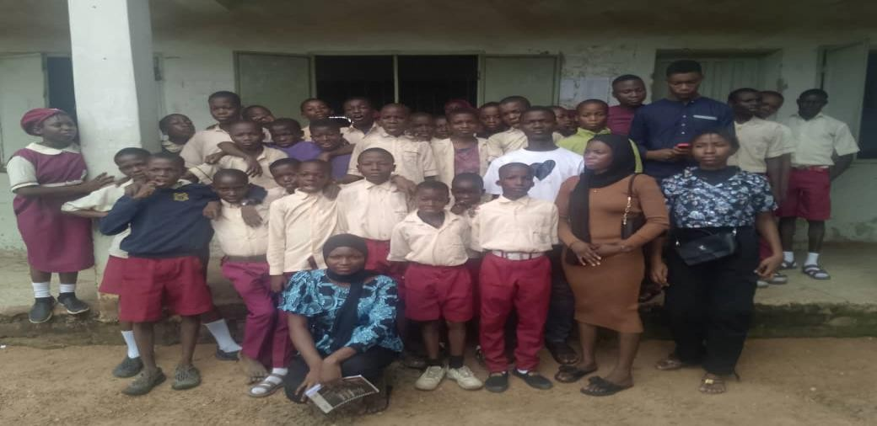
Students of John Africa Junior Secondary Schools, Maraba, Ilorin with Library Advocators

CHAPTER THREE

Work and Experience Gained during SIWES

During my SIWES program at Kwara State library board, I engaged in different kind of activities performed in different section/unit. I was posted to the following sections/units for my attachment for the period of 16 weeks.
        - Humanities
        - Acquisition
        - Classification
        - Children
        - Catalogue
        - Automation
        - Reference
        - Science and technology
        - Serial

HUMANITIES SECTION

I was introduced to the section by MRS GBADEYAN, I was given a brief introduction to the section and I learnt the section is open to all users as it is a reader service section and I learnt that all the main classes are in the section except class 500 to 600. I also learnt about the rules and regulation guiding the section and also the steps the user take before thery can access reading hall. I also take the users statistics in every two hours, and I also answer the user question if there`s any. And i also learn how to add new collection of library materials on the display shelf to enable the user know the new collection available in the section and user cannot use or consult 3 to 4 materials at a time.
ACTUAL WORK DONE

        - Shelf tidying
        - Took users statistics
        - Shelf reading
        - Answering user queries

ACQUISITION SECTION

Acquisition section is one of the technical service in the library. I was introduced to this section by MR SHOLA. I learnt that acquisition section is about selecting. Ordering, purchasing, and obtaining materials to library collection and the method by which book can be acquired in the library which includes gift, donation, loan, legal deposit, purchase, and subscription.
ACTUAL WORK DONE

        - I recorded accession number to the books
        - I stamped the newly acquired materials

CLASSIFICATION SECTION

This is one of the technical service in the library. I was introduced to this section by MR. ADELODUN, he gave brief introduction to the section. I was taught the ten classes of books, I learnt how to assign class number to books and also the subject heading of sears list. Class number assists in locating and organising library material on the shelf.
ACTUAL WORK DONE

        - I assign class number to books

CHILDREN SECTION

I was introduced to this section by MRS. BOLAJI, I learnt that materials in this section are colourful and attractive which is used to entice the children. There are also games and toys that build the children intellectually such as puzzle games, monopoly, and so on.
ACTUAL WORK DONE

        - Shelf tidying
        - Shelf reading

CATALOGUING SECTION

I was introduced to this section by MR. ADEKOLA. I was given brief introduction to the section and I was taught was catalogue, cataloguing and catalogue card is. I learnt that catalogue card is prepared by 12.5 by 7.5cm, I also learnt the abbreviation in cataloguing. I

learnt that catalogue card consist of bibliographic details of a book such as, name of the author, title of the book, year of publication, place of publication, ISBN, page number and so on.
ACTUAL WORK DONE

        - I catalogue books AUTOMATION SECTION
I was introduced to this section by MR. HALIRU.

REFERENCE SECTION

I was introduced to this section by MR. BUKOLA. He gave brief introduction reference, reference material and reference section. I was taught the meaning of reference and types of reference material which includes dictionary, encyclopaedia, and other classes of materials. I also learnt that users in this section are mostly professionals. I did shelf reading and shelf tidying.
ACTUAL WORK DONE

        - Shelf tidying
        - Shelf reading
        - I take users` statistic

SCIENCE AND TECHNOLOGY

I was introduced to this section by MR. ADEWOLE. I learnt that this is a reader service section and it open to all users. It deals with class 500 and 600 only, I learnt that users that comes in has to drop their library card before they can have access to the materials. I also ensure that the users abide to the rules and regulation of the reading hall and I take the user statistic every two hours.
ACTUAL WORK DONE

        - Taking users` statistic
        - Shelf reading
        - Shelf tidying

SERIAL AND GOVERNMENT PUBLICATION

This is the last section I was posted to during my SIWES. I was introduced to this section by MR. HARUNA. I learnt what serial and government publication is and the type of materials available in this section such as newspaper, magazine, journal etc. The actual work done there includes collecting newspapers, record them in the record book, stamped them, and placed them on the table for user`s consultation. After the newspaper has been consulted, the librarian will arranged them according to their date of publication and bind them together then placed it on a shelf.
ACTUAL WORK DONE

        - Collection of newspaper
        - Stamping newspaper

CHAPTER FOUR

Detailed Description of Equipment used and their Functions

The following are the equipment and tools used in all sections I visited including their function and usage description:
    - Stamps
    - Shelf
    - Subject heading of sears list
    - Book guard
    - Computer
    - Toys
    - Television
    - Radio
    - Catalogue cabinet
    - Pencil

STAMPS: Stamp is used in the library to prove the ownership of a library materials and cannot be taken out of the premises without permission.
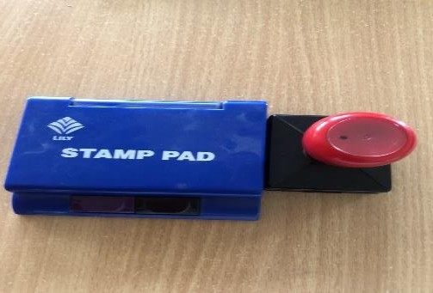

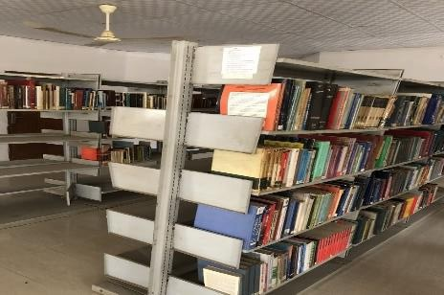
SHELF: This is an area where books are arranged and kept for easy access by users. Shelves are used to organized library material and is used to ensure books are accessible to the end users

.

SUBJECT HEADINGS: This is a tool used in cataloguing and classification section in the library. It is a list of possible subject arranged in an alphabetical order, the main use of the subject headings is to determine the subject of a particular book.
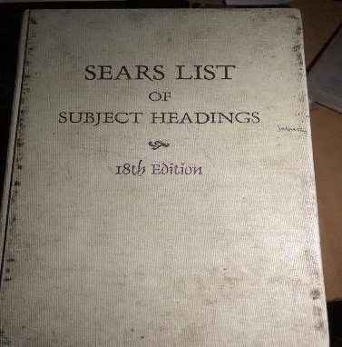

BOOK GUARD: This is an object designed as a book support, they are flat iron that are used to hold the book from being fallen. It support, an upright row of books, it is placed at the end of books on the shelf to prevent it from falling off.
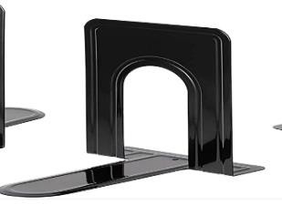
COMPUTER: this is an electronic device that accept data, processed data, and give out an output

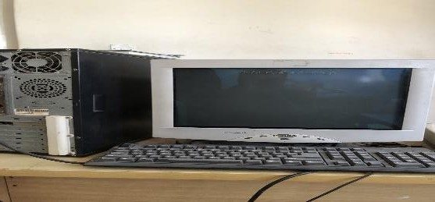
.

TOYS: this is found in children section to entertain and educate the kids.
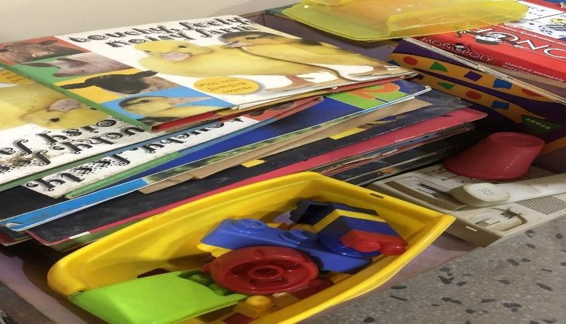

CATALOGUE CABINET: this is made up of wooden structured that is used to keep or organised catalogue card. It also enable user to locate and retrieve information resources and provide access to material that meet their needs.
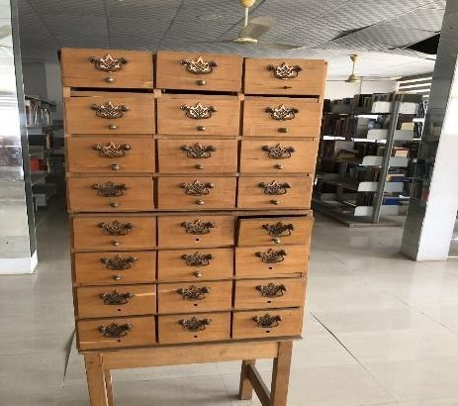

CHAPTER FIVE

Summary of the Attachment activities

The SIWES has provided a training ground where skill relating to how information can be processed, managed, preserved, retrieved and documented. This has gone a long way in equipping with the right knowledge in merging what has been learn in the lecture room to what was actually learnt on the field. The scheme which is a skill program is designed to expose and prepare students of universities and other institutions involved to real life work situation after graduation.

Conclusion

The SIWES is a skill training program designed to exposed and prepare students in institution of higher learning for the industrial work situation they are likely to meet after graduation, the situation described above represent the idea, but sometimes these ideas are achieved: as there are many problems militating against the success or its attainment.

Problem Encountered

Some of the problems encountered during my training include:

- Few professional staff
- Transportation issue
- Lack of internet facilities

Recommendation

The following are the based on the experience of SIWES at Kwara State Library Board

- More professional staff should be employed
- Students during their SIWES should be considered in regards to transport
- Provision of Wi-Fi should be available in the library.

REFERENCE
Industrial Training Fund (2015). Students Industrial Work Experience Scheme in Human Resource Development in Nigeria. Jos: Industrial Training Fund handbook. Retrieve on 30th September, 2019 from www.unirazak.edu.my/pintar/fit/docs/pt-handbook.doc.
Issa, A. and Akangbe, R. (2012). Reading interests as habit of the Federal Polytechnic, Offa students, paper presented at the 2012 AGM/Conference at Kwara State Chapter of N.L.A, held at Federal Polytechic, Offa.
Moses, E.A. (2011). Network of Rural Librarians in Nigeria Dissemination of Information: A necessity for National Development. Presented at the 2011, AGM/Conference of the Kwara State Chapter of N.L.A. Held at the Federal Polytechnic, Offa.
Osinem, E.C. and Nwoji, U.C. (2014). Students Industrial Work Experience in Nigeria: Concepts, principles and practice. Enugu: Cheston Agency Limited.
Okpo, S. and Hassan, D. (2012). Constraints to students’ effectiveness in practical skills acquisition in technical colleges in Kogi State, Nigeria. International Journal of Innovative Scientific and Engineering Technologies Research 6(1):1-9.

