CHAPTER ONE
1.0 INTRODUCTION
1.1 Background to the Study
Height measurement is a fundamental aspect of surveying, providing crucial data forland development, engineering, and construction. The accuracy of elevation determination affects the structural integrity of buildings, road networks, and drainage systems. Surveying instruments such as digital levels and total stations are widely used to determine height, but their performance varies due to environmental, instrumental, and procedural factors (Uren & Price, 2010). Understanding the comparative accuracy and reliability of these methods is essential for selecting the best technique for specific projects.
Digital leveling is considered one of the most precise methods for height determination. It employs an electronic level instrument and a bar-coded staff to measure vertical distances, reducing human errors common in conventional leveling (Wolf & Ghilani, 2012). The technology ensures high precision by minimizing reading errors, making it ideal for precise engineering projects such as dam construction, bridge alignment, and geodetic surveys. However, digital leveling can be time-consuming and less efficient over long distances, which limits its use in large-scale projects (Kavanagh, 2014).
Total stations integrate electronic distance measurement (EDM) and angular measurement capabilities, allowing surveyors to determine both horizontal and vertical positions efficiently. Unlike digital levels, total stations are multifunctional, supporting a range of applications from topographic mapping to construction staking (Schofield & Breach, 2007). However, the accuracy of height measurement using total stations is influenced by factors such as instrument calibration, target reflectivity, and atmospheric conditions, leading to potential errors in elevation determination (Ghilani, 2017).
Several studies have compared digital leveling and total station equipment for height measurement. For instance, Alkan and Karslı (2011) analyzed the precision of both instruments and found that digital leveling provides superior vertical accuracy compared to total stations. Similarly, Ata and Arslan (2015) observed that while total stations offer greater flexibility, their elevation measurements are more susceptible to errors when compared to digital leveling techniques. These findings highlight the need for further comparative evaluations in different environments and project conditions.
In many institutions and construction sites, surveyors rely heavily on total stations due to their efficiency in collecting data over large areas. However, this preference sometimes leads to the compromise of vertical accuracy, especially in projects requiring precise elevation data (Ghosh, 2013). While total stations provide satisfactory results for general land surveying tasks, their limitations in height determination necessitate a more detailed assessment of their reliability when compared to digital leveling.
Environmental factors also play a significant role in determining the effectiveness of height measurement techniques. Atmospheric refraction, temperature variations, and humidity can distort EDM signals in total stations, leading to height discrepancies (Vaníček & Krakiwsky, 2015). Digital leveling, however, is less affected by these factors but can still be influenced by ground settlement and instrument instability. Understanding these environmental influences is critical in determining the best method for achieving precise height measurements in different field conditions.
Despite the widespread use of these instruments, there is limited comparative research on their performance in specific study areas, such as Kwara Polytechnic. Surveyors and engineers working within the region require reliable data to make informed decisions about instrument selection and survey methodology. By evaluating the accuracy and reliability of digital leveling and total stations in the study area, this research will provide valuable insights into their practical applications and limitations.Ultimately, this project will serve as a reference for the institutions and surveying professionals seeking to optimize their height measurement techniques. By understanding the comparative strengths and weaknesses of digital leveling and total stations, stakeholders can enhance project accuracy, reduce construction errors, and improve overall infrastructure planning.

1.2 Statement of Problem
The increasing reliance on modern surveying equipment, such as digital levelling and total station equipment, in educational and developmental projects at Kwara State Polytechnic highlights a critical need to evaluate their accuracy and reliability under local conditions. While these tools promise enhanced precision and efficiency compared to traditional methods, their performance can vary due to factors like operator expertise, equipment calibration, and environmental influences such as temperature and humidity (Schofield & Breach, 2017). Without a clear understanding of how these instruments perform in this specific context, there is a risk of adopting technologies that may not meet the institution’s practical and academic requirements, potentially leading to errors in topographic data critical for campus planning and student training.
In many institutions and construction sites, surveyors often rely on total stations due to their speed and multifunctionality, potentially overlooking the higher precision offered by digital leveling in elevation measurements. This reliance can lead to height discrepancies, affecting structural stability and site planning. Factors such as instrument calibration, atmospheric conditions, and operational limitations contribute to errors in both techniques. Despite advancements in technology, there is limited comparative analysis on the reliability of these instruments in real-world applications, particularly in the study area, Kwara Polytechnic.
This research aims to bridge this gap by evaluating the accuracy and reliability of digital leveling and total station equipment in determining height measurements within a selected part of Kwara Polytechnic. By conducting a comparative analysis, this study seeks to establish the best method for precise elevation determination. Understanding these differences will contribute to improved surveying practices, enhanced data reliability, and better planning for infrastructure development.

1.3 Aim of the Project
The primary aim of this project is to compare the accuracy and reliability of digital leveling and total station equipment in height determination, ensuring precise elevation measurements for surveying and construction applications in Kwara Polytechnic.

1.4 Objectives of the Project
To achieve the above stated aim, the following objectives must be observed.
- Compare the accuracy of digital leveling and total stations in height measurement.
- Assess their reliability under different conditions.
- Recommend the best method for precise height measurement.

1.5 Justification of the Project
Accurate height measurement is essential for various engineering and construction projects, as errors in elevation data can lead to structural failures and costly corrections. Digital leveling and total stations are widely used for this purpose, but their accuracy and reliability differ under various conditions. A comparative study will help surveyors and engineers understand the strengths and limitations of each instrument, ensuring that the most suitable method is chosen for precise height determination.
Despite the increasing use of total stations due to their speed and versatility, studies suggest that digital leveling provides superior accuracy in elevation measurements. However, many surveyors prefer total stations for convenience, potentially compromising precision in projects that require exact height data. This research is necessary to evaluate these differences and provide empirical evidence on the best approach for specific surveying applications.

1.6 Scope of the Project
This study focuses on comparing the accuracy and reliability of digital leveling and total station equipment for height determination within a selected part of Kwara Polytechnic. It will assess the performance of both instruments under different environmental and operational conditions, analyzing factors such as measurement precision, error margins, and ease of use. The study will be limited to field data collection, processing, and evaluation within the study area, providing recommendations for optimal height measurement techniques in surveying and construction applications.

1.7 Personnel
The listed below are the personnel involved in carry out the project;
NAME | MATRIC. NO.
Kazeem Kabirat Damilola | HND/23/SGI/FT/0079 | Writer
Ganiyu Akeem Abiodun | HND/23/SGI/FT/0076 | Member
Abdul Kareem Ramota Olawumi | HND/23/SGI/FT/0078 | Member
Adeoti Qudus Adebayo | HND/23/SGI/FT/0080 | Member
Adeleye Sheriffdeen Olawale | HND/23/SGI/FT/0081 | Member
Abdul Qudus Shukurah Temitope | HND/23/SGI/FT/0083 | Member
Ogunsuyi Babatunde Sunday | HND/23/SGI/FT/0118 | Member
Jimoh Halimah Titilayo | HND/22/SGI/FT/082 | Member

1.8 Study Area
Kwara State Polytechnic, located in Ilorin, Nigeria, serves as a major institution for technical and vocational education. It is situated at approximately latitude 8.4791° N and longitude 4.5418° E, covering a vast area that accommodates academic buildings, administrative offices, student hostels, and recreational facilities. The polytechnic was established to provide quality education in engineering, environmental studies, business, and technology-related fields, contributing significantly to workforce development in Nigeria. Its strategic location within Ilorin makes it an ideal study area for research in surveying and geospatial studies.
The institution's terrain consists of both flat and slightly undulating areas, making it suitable for studying height measurement techniques. With a mix of built-up structures and open spaces, Kwara Polytechnic provides a practical environment for evaluating digital leveling and total station accuracy.

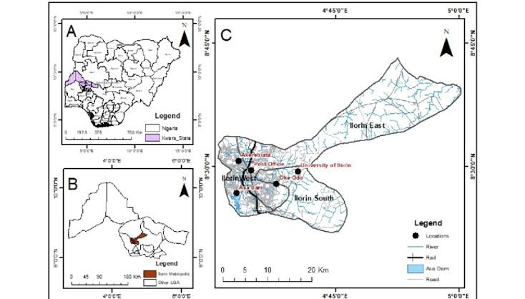
Figure 1.10: Study Area Map

