

TECHNICAL REPORT

ON

STUDENT INDUSTRIAL WORK EXPERIENCE SCHEME (S.I.W.ES 1)

PRESENTED BY

AYINDE FARUQ OLAREWAJU

ND/23/CEC/PT/0136
ON

HIGHWAY CONSTRUCTION

CONDUCTED AT

FEDERAL MINISTRY OF WORKS AND TRANSPORTATION, DEPARTMENT OF CIVIL ENGINEERING, ILORIN KWARA STATE.

SUBMITTED TO THE FACULTY OF ENGINEERING, DEPARTMENT OF CIVIL ENGINEERING, KWARA STATE POLYTECHNIC ILORIN

DEDICATION

I Gratefully dedicate this SIWES report to Almighty God, The most Awesome and Merciful who gave me the uncountable opportunity to participate in the program. I also dedicate it to my Parents.

ACKNOWLEDGEMENT

First and foremost, I give thanks to Almighty God, the creator of the universe for the greatest protection and love given to me as a privilege to start and complete my SIWES programme.

I extend my special thanks to my parents MR and MRS AYINDE for their morally, spiritually, financially and work of encouragement and prayer given to me, who make my SIWES programme successful.

I express my profound gratitude to my department Lecturers and my SIWES supervisor and coordinator for the support towards the success of the time used in SIWES. I also give thanks to my Brothers and Sisters and the entire family of ILE NLA for their advice to me during my SIWES program. May almighty God bless you all (Amen).

I also appreciate the effort of the entire staff of the Federal Ministry of works and Transportation for the tremendous moral assistance throughout the period of my attachment and also my grateful lovely friends for their contribution in one way or another. May almighty God bless them all and provide for their needs.

ABSTRACT

The main body of this report contains details on how my industrial training was spent at the Federal Ministry of works and Transportation, Kwara State Branch.

TABLE OF CONTENT

Title page —------------------------------------------------------------------------------- i

Dedication —----------------------------------------------------------------------------- ii

Acknowledgement ----------------------------------------------------------------------- iii

Abstract —-------------------------------------------------------------------------------- iv

Table of content —---------------------------------------------------------------------- V

CHAPTER ONE

1.0 Introduction —------------------------------------------------------------------------ 1

1.1 Definition of SIWES —------------------------------------------------------------- 2

1.2 Purpose of SIWES —--------------------------------------------------------------- 2

1.3 Objective of SIWES —------------------------------------------------------------ 3

CHAPTER TWO

2.0 Brief history of the organization ------------------------------------------------- 4

2.1 Major activities of the organization --------------------------------------------- 5

2.2 The organization chart ------------------------------------------------------------- 6

2.3 Unit of the organization and their specific function —---------------------- 7

CHAPTER THREE

3.4 Road Pavement --------------------------------------------------------------------- 9

3.5 Type of Road Pavement -----------------------------------------------------------9

CHAPTER FOUR

4.0 Drainage Construction ----------------------------------------------------------- 11

4.1 Type of Drainage Construction ------------------------------------------------ 11

4.2 Process of Construction Reinforced Concrete Drainage -----------------12

4.3 Important of Drainage ------------------------------------------------------------ 12

4.4 Culvert -------------------------------------------------------------------------------- 13

4.5 Types of Culvet --------------------------------------------------------------------- 13

4.6 Equipments used In Culvert Construction ----------------------------------- 15

CHAPTER FIVE

5.0 Conclusion ----------------------------------------------------------------------------20

5.1 Recommendation to the organization on SIWES Programme ----------18

Recommendation to the Institution on SIWES Programme -------------------19

CHAPTER ONE

1.0 INTRODUCTION

The student industrial work experience scheme (SIWES) was introduced by the federal government through the ministry of commerce and industry the nation in corresponding with a body known as Industrial Training Fund (ITF).ITF established SIWES in 1973 to solve the problem of lack of adequate practical skills preparatory for employment in industries by Nigeria graduates of tertiary institutions.

The (SIWES) programme helps the student to practicalize most of the theoretical aspect of their curriculum which they have been taught in their first year in school, likewise it gives solution to some problems of student in terms of practical, this will enable them to always remember and be in their mind forever because is what they practiced with their own hands. This report is based on the experience, which I gained during my three months Industrial Training at the Ministry of Works and Transportation Ilorin.

This program provides employment opportunities for students. It also exposed students to the needed experience in the real time job demands and human relation within and outside the country depends on the area in which they find themselves.

1.1 DEFINITION OF SIWES

The students industrial work experience Scheme (SIWES) is a skill acquisition training programme that forms part of the minimum academic requirement standards in various programs of Nigeria tertiary institutions, it helps students to put what they have learnt theoretically in class into practice in the real problem world. It commences after the second semester exam and is a compulsory course to all ND 1 Proceeding to ND 2, it is a Two (2) unit credit course, so if by any adventure a student fails to participate in the exercise, will attract him/her a failure which makes the person repeat by delaying for an extra year in school.

1.2 PURPOSE OF SIWES

SIWES was purposely introduced in order to make student acquires more knowledge about methods of some professional works and to exposed them to the use of some equipment in the program and also help the student on how to get up and safeguard their own industry and organization in future.

1.3 OBJECTIVE OF SIWES

Specifically, the objectives of the student industrial work Experience are:

- It enabled students to be self dependent not in the theoretical aspect but also in the practical aspect in the field of study.

- The SIWES program prepares students for the work situation they are likely to meet after graduating from school.

- It exposes the students to some equipment which is not available in school.

- It also helps to know the general precaution, rules and regulation of an establishment.

1.4 ROLES OF ITF IN SIWES

The main roles of ITF in SIWES are to:

i. Interact with the SIWES agencies to ensure prompt receipt and processing of placement list.

ii. Co-ordinate, direct and finance the SIWES program in its ramification.

iii. Provide funds for the payments of student's attachment stipend and lecture supervisor allowance.

iv. Supervised student's attachment in different organizations across the country.

v. Ensure that all institutions concerned submit to the ITF office at the end of SIWES programme and end of programme report form.

vi. Ensure the establishment of SIWES in all universities and other institution of higher learning so as to provide for easy and effective co-operation of all SIWES matters

vii. Interact with sister area offices to ensure payment of unpaid students through their respective institution. agriculture, medical, management and other professional programs in Nigerian tertiary institutions.

It is aimed at exposing students to machines and equipment work and ways of safeguarding the work areas and workers in industries and other organizations. The scheme is a tripartite program, involving the students, the universities and industries (Employers of labors). The scheme is organized, funded and directed by ITF for students undergoing studies in Tertiary Institutions.

CHAPTER TWO

2.0 BRIEF HISTORY OF THE ORGANIZATION

Federal Ministry of works and transport was sited along Ahmadu Bello way. it was set up by the state government to control some specific activities in rural and urban centre development in term of routes and other external works in the state. The organization was first known as public work co- operation since creation of kwara state in 1967 until some years back when it was changed to kwara state ministry of works and transport" with its headquarter at Ilorin the state capital.

Kwara state ministry of works and transport was meant for developments of new route, construction of road network and countdown of bridges for public utility project in the state. The organization has done so many construction works and has been the client of majority of construction work done in Kwara state. Eg construction of township roads in Kaima, Erin-ile, Offa, Shonga and rehabilitation of roads along sabo-oke, GRA, Ipata, Sango etc. Construction of post office flyover in Ilorin and so many construction works that could not be mentioned. They are ensuring the easy conveyance of goods services from one area to the other through construction and rehabilitation of roads, highways, bridges, flyovers etc.

2.1 MAJOR ACTIVITIES OF THE ORGANIZATION

Civil engineering department of the ministry of works and transport represent government in any ongoing project i.e. engineering project (ie civil, electrical and mechanical) to ensure that the said project is done to specification. Also, job of the ministry of works and Transport are to monitor the activities on road, development of new routes and maintenance of road and advised the state government on what to done to make such read effective.

The ministry is also responsible for the supervision of the activities of the following underlined parastatals.
- Kwara road maintenance agency (kwarma)

- Kwara state transport co-operation (kwara express)

2.3 THE ORGANIZATION CHART

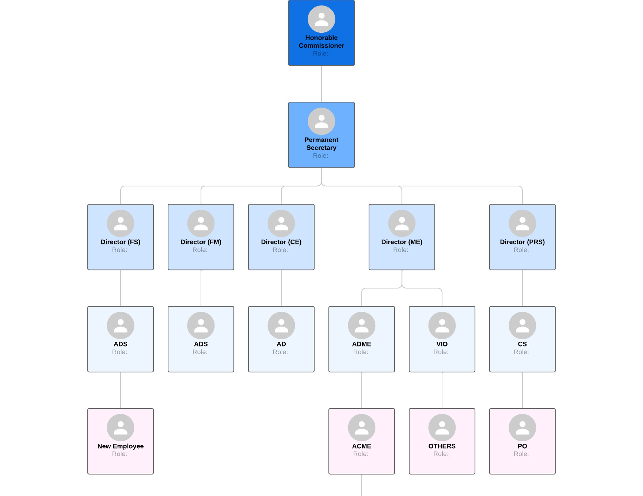
2.3 UNIT OF THE ORGANIZATION AND THEIR SPECIFIC FUNCTION

The organization possessed four sections in civil department.

• Civil engineering design unit

• Civil engineering construction unit

• Civil engineering management of materials

• Civil engineering maintenance unit

CHAPTER THREE

3.0 ROAD PAVEMENT

Road pavement is the portion of the road located directly above the sub grade and beneath any wearing surface. In urban areas it is often bordered by kerbs and channels and in rural areas by road shoulders.

3.1 TYPE OF ROAD PAVEMENT
There are two main types of road pavements. These are

- FLEXIBLE PAVEMENT: This is a road pavement with a structure that defects or flexes, under loading. A flexible pavement structure is typically composed of several layers of materials, each layer receives the road from the above layer, spread them out, then passes on these load to the next layer below.

- RIGID PAVEMENT: This is a pavement structure that deflects very little under loading due to the high modulus of elasticity of its surface course. Because of its relative rigidity, a rigid pavement structure distributes load over a wide area with only one, or at most structural layers.

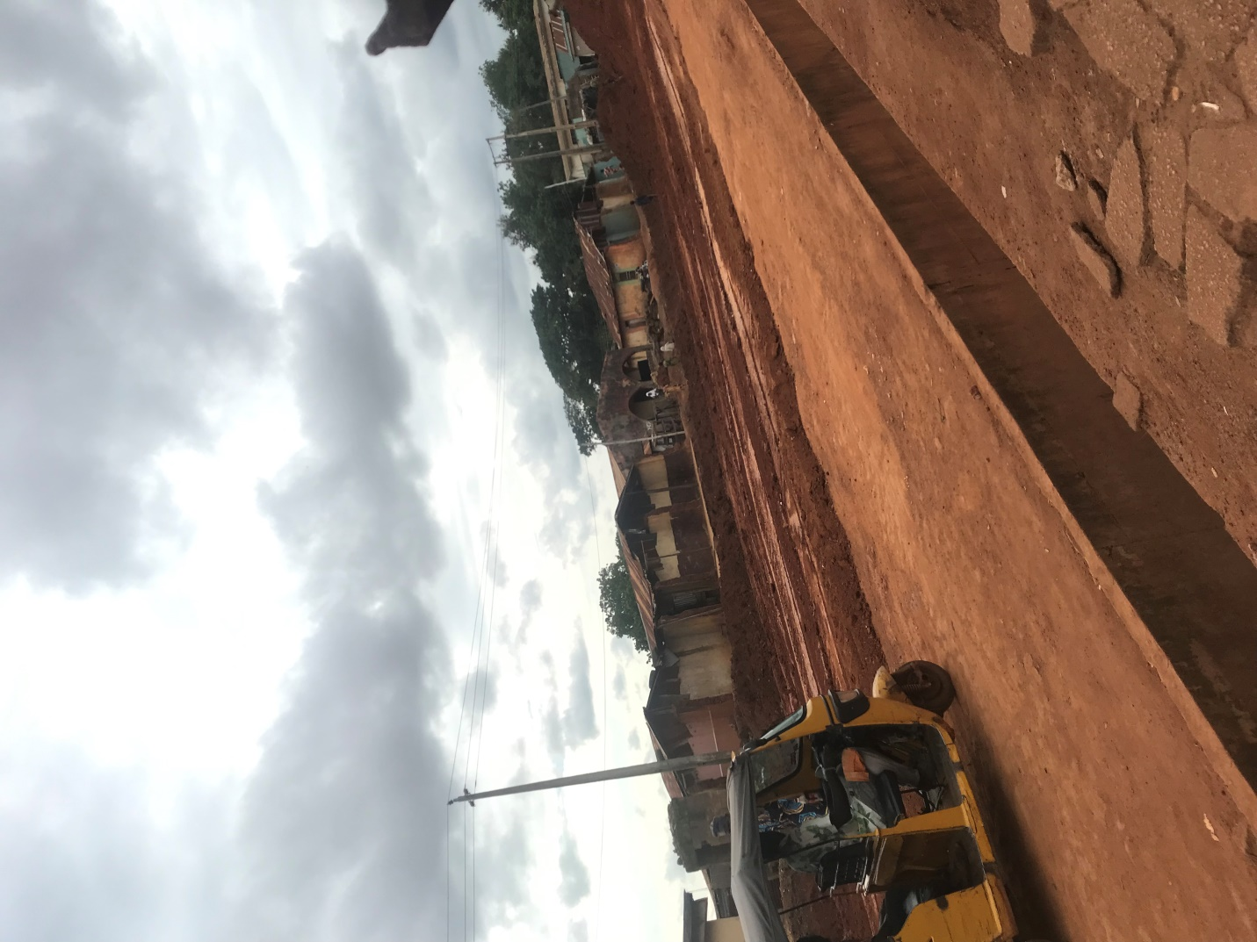
CHAPTER FOUR

4.0 DRAINAGE CONSTRUCTION

Drainage is the natural or artificial removal of surface and sub- surface water from an area. Drainage construction as the name implies is one channel where excess water is discharged to the outlet. Drainage is constructed beside a road so as to carry away excess water from the road to prevent cracks or other failures on the road.

4.1 TYPE OF DRAINAGE CONSTRUCTION

There are different types of drainage construction. These are,

- BLOCK LINE DRAINAGE: this is a drainage that has been constructed using a block as the wall of the drain. This drainage is cost efficient compared to other types of drainage.

- REINFORCED CONCRETE DRAINAGE: this is a drainage that is constructed using reinforced concrete as the wall of the drain. Reinforced concrete is brought in as the wall of the drain.

4.2 PROCESS DRAINAGE OF CONSTRUCTION REINFORCED CONCRETE

- Measurement of width: The measurement of width of the trench and pegging is done with rope to obtain a straight trench of the drainage.

- Blinding: This is done to give a good attachment to both ground and concrete.

- The walking reinforcement casting: These are laid in to prevent under movement of the drainage wall.

- Form work construction: This is the process of fixing planks together to guide the falling walling concrete casting.

- Concrete mixing and casting: This is the mixture of gravel, sand cement and water at a ratio depending on how you want it. Mixing concrete is being transferred to the spacing provided with a wheel barrow and head pan.

- Removal of the form work: After some days the form work will be removed, at this the concrete would have been enough to hold itself off.

4.3 IMPORTANT OF DRAINAGE
> It serves as a channel to discharge excess water during training period.of road.
> It prevents damage to the road.

> It provides direction of flow of water.

> It prevents the wearing away of the soil(i.e. erosion).

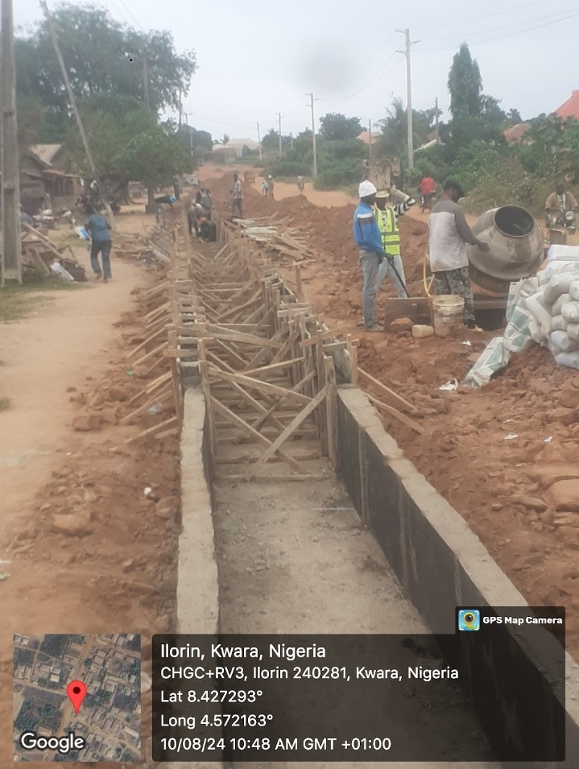

4.4 CULVERT

A culvert is a structure that allows water to flow under a road. Typically embedded so as to be surrounded by soil, a culvert may be made from a pipe, reinforced concrete or other material. Culvert is another form of road drainage which arises when a lying area of a stream or river crosses. The alignments of road arises when a lying area of a stream: or river crosser. The alignment of the road at this point, a culvert or bridge has to be constructed so that the water of the river or stream is made to pass on the other side of the road through them. Such culvert or structure is known as cross drainage work or simply drainage work.

Classification Of Culvert

- Cast Insitu Concrete Culvert

- Precast Concrete Culvert

4.5 TYPES OF CULVERT

- Box culvert

- Ring culvert

- Box culvert

Box culverts are made of a box in which the wall, base and the deck or slab of the culvert are reinforced to allow the flow of water. The box formed work for the reinforcement is in "U" position and concrete deck or slab is cast on it. The inlet and outlet are rectangular in shape. Box culvert is applicable in an area where there is a river or stream for which a pipe or ring culvert is inadequate across the proposed road.

Classification of Box Culvert

- Single cell box culvert
- Double cell box culvert
- Triple cell box culvert

Their uses depend on the volume
of water and which can also withstand high comprehensive load.

- Ring Culvert

Ring culvert is also known as pipe culvert" and is made up of ring/ pipe in which the flow of water will pass through. The sizes are 900mm, 750mm and 600mm. Ring or pipe culvert are named with respect to their shape and can be applicable in the entrance of complex companies and they are called "access culvert" while those on the main road are referred to "cross culvert".

Classification of Ring Culvert

1. Single ring culvert

2. Double ring culvert

4.6 EQUIPMENTS USED IN CU

3. Triple ring culvert
LVERT CONSTRUCTION

Excavator: It is used to dig and make trenches.

Excavator

Concrete mixer machine:
It is used for mixing wet concrete (wet concrete composed of aggregates, sand, cement and water).

`CONCRETE MIXER MACHINE

4.7.3 MATERIALS INSTRUMENT USED IN AND CULVERT CONSTRUCTION

- Cement
- Sharp sand
- Granite/gravel
- Reinforcement bar
- Hammer
- Shovel
- Wood plank
- Head pan/wheelbarrow
- Range

4.7.4 PROCEDURE OF CULVERT

- Levelling,
- Excavation.
- Blinding.
- Reinforcement.
- Casting of the base.
- Form work.
- Casting of the concrete.
- Removal of the form work.
- Back filling.
- Curing

CHAPTER FIVE

5.0 CONCLUSION

The organization to which i was attached gave me more impression about my course of study. The engineers are hard working, they are always in the team which makes the organization. I am also impressed about the way they always plan their work which makes things easier and faster. Also the industrial based supervisor on student industrial work experience scheme programme always give special assistance to the SIWES student for them to achieve their goals.

5.1 RECOMMENDATION TO THE ORGANIZATION ON SIWES PROGRAMME

I will suggest to the organization to always accept the entire student that comes for their SIWES attachment programme.

Also, I will recommend the industrial based supervisor to always have special attention to the SIWES student on their programme. Furthermore, I will recommend the organization to at least be giving the SIWES students their transport fare and their working allowance to motivate working morale.

5.2 RECOMMENDATION TO THE INSTITUTION ON SIWES PROGRAMME

I will suggest that the institution should make sure each student on SIWES programme is attached to an organization which is relevant to their study Course so as to achieve their goal after the programme. More so the institution should find a way of amending the period of SIWES programme so that it will not affect the school academic calendar. The institution should also give proper enlightenment to students for them to know that SIWES is all about and for them to behave and their industrial attachment. The institution supervisor should always visit students at their industrial attachment places for proper checking, balance and punctuality to the organization.

