

A TECHNICAL REPORT
ON
STUDENT INDUSTRIAL WORK EXPERIENCE SCHEME (SIWES)
HELDAT

(COMPUTER SCIENCE)
Beside Alangua Compound Kankatu Area, Ilorin Kwara State.
SUBMITTED BY
ANAFI JAMIU
ND/23/PAD/PT/0364
SUBMITTEDTO:
THE DEPARTMENT OF PUBLIC ADMINISTRATION INSTITUTE OF INFORMATION COMMUNICATION TECHNOLOGY
KWARASTATEPOLYTECHNIC, ILORIN
P.M.B1375, ILORIN, NIGERIA

INPARTIAL FULFILLMENT OF THERE QUIREMENT FOR THE AWARD OF NATIONAL DIPLOMA IN MASS COMMUNICATION
AUGUST - NOVEMBER, 2024.

DEDICATION
This work is dedicated to Almighty God who gives me strength and the inspiration in the course of this work, also my parents Mr. & Mrs. Anafi

ACKNOWLEDGEMENT
All praises goes to Almighty God for His blessing and protection over me for giving me the opportunity in this SIWES program
I wish to acknowledge my Humble HOD (Head of Department) of Mass Communication for his great support and ability for me to gain a lot of thing is related to my studies. I pray Almighty God will crown their effort.
Special appreciation goes to my parent Mr. & Mrs. Anafi for their kindness, caring and loving support they have been showing to me for her help and support both spiritually and financially is highly appreciated. I pray to God that they will reap the fruit of their labour Amen.
My appreciation so goes to my younger and elder ones who have been there for me, May Allah bless them all.
I also appreciate the effort of all staff and members of COMPUTER SCIENCE who assisted a lot in the completion of the program.
Finally, my appreciation goes to my lecturers for their immeasurable support I really appreciate it.

TABLE OF CONTENTS
Title page Dedication Acknowledgement Table of contents
CHAPTER ONE
Mean in go of SIWES
Brief history of SIWES
Objective of SIWES
CHAPTER TWO
History of the Organization
Objective soft he Organization
Various departments in the organization
CHAPTER THREE
Experience Gained during SIWES
Equipment used in Radio Station
CHAPTER FOUR
Achievements & Knowledge Acquired
New Writing and Research at News Room
Knowledge Acquired
CHAPTER FIVE
Challenges
Conclusion
Recommendation

CHAPTER ONE
1.0 INTRODUCTION TO SIWES
SIWES (Student Industrial Working Experience Scheme) was established by ITF in 1973 to solve the problem of lack of adequate practical skills preparatory for employment in industries by Nigerian graduates of tertiary institutions. The Scheme exposes students to industry based skills necessary for a smooth transition from the classroom to the world of work. It affords students of tertiary institutions the opportunity of being familiarized and exposed to the needed experience in handling machinery and equipment which are usually not available in the educational institutions. Participation in Industrial Training is a well-known educational strategy. Classroom studies are integrated with learning through hands-on work experience sin afield related to the student’s academic major and career goals. Successful internships foster an experiential learning process that not only promotes career preparation but provides opportunities for learners to develop skills necessary to become leaders in their chosen professions.
One of the primary goals of the SIWES is to help students integrate leadership development into the experiential learning process. Students are expected to learn and develop basic non-profit leadership skills through a mentoring relationship with innovative non-profit leaders.
By integrating leadership development activities into the Industrial Training experience, we hope to encourage students to actively engage in non-profit management as a professional career objective. However, the effectiveness of the SIWES experience will have varying out comes based up on the individual student, the work assignment, and the supervisor/mentor requirements. It is vital that each internship position description includes specific, written learning objectives to ensure leadership skill development is incorporated.
Participation in SIWES has become a necessary pre-condition for the award of National Diploma in specific disciplines in most institution so higher learning in the country, in accordance with the education policy of government.
Operators - The ITF, the coordinating agencies (NUC, NCCE, NBTE), employers of labour and the institutions.

Funding-The Federal Government of Nigeria
Beneficiaries - Undergraduate students of the following: Agriculture, Engineering, Technology, Environment Computer Science, Science, Education, Medical Science and Pure and Applied Sciences.
Duration - Four months for Polytechnics and Colleges of Education, and Six months for the Universities.

HISTORY OF SIWES
The government’s decree No. 47 of 8th Oct, 1971 as amended in 1990, highlighted the capacity building of human resources in industry, commerce and government through training and retraining of workers in order to effectively provide the much needed high quality goods and services in a dynamic economy as ours (Jemerigbo, 2003). This decree led to the establishment of Industrial Training Fund (ITF) in 1973/1974.
The growing concern among our industrialists that graduates of our institutions of Higher learning, lack adequate practical background studies preparatory for employment in industries, led to the formation of students Industrial Work Experience Scheme (SIWES) by ITF in 1993/1994 (Information and Guideline for SIWES, 2002). ITF has as one of its key functions; to work as cooperative entity with Industry and commerce where students in institutions of higher learning can undertake mid-career work experience attachment in industries which are compatibles with student’s area of study (Okorie 2002, in Asikadi 2003). The Students Industrial Work Experience Scheme (SIWES) is a skill Training programme designed to expose and prepare students of Agriculture, Engineering, Technology, Environment Sobi Fm, Science, Medical Sciences and pure and applied Sciences for industrial work situation which they likely to meet after graduation. Duration of SIWES is four months in Polytechnics at the end of NDI, four months in College of Education at the end of NCE II and six months in the Universities at the end of 300 or 400 or 500 levels depending on the discipline (Information and Guidelines for SIWES, 2002).

AIM AND OBJECTIVES OF SIWES
- SIWES will provide students the opportunity to test their interest in a particular career before permanent commitments are made.

- SIWES students will develop skills in the application of theory to practical work situations.
- SIWES will provide students the opportunity to test their aptitude for a particular career before permanent commitments are made.
- SIWES students will develop skills and techniques directly applicable to their careers.
- SIWES will aid students in adjusting from college to full-time employment.

CHAPTER TWO
HISTORY OF THE ORGANIZATION (SOBI FM)
, Ilorin Kwara State is a rapidly growing media station operating as a sole proprietorship under a Board of Trustees, which serves as its decision-making body.
As a licensed commercial Computer Science, is strategically located at the Beside Alangua Compound Kankatu Area Ilorin Kwara State The station began as an online platform in 2018 and transitioned in to at terrestrial community radio station in October 2019. By 2022, Computer science achieved full licensing as a commercial approved by the National Broadcasting Commission (NBC), cementing its position as a prominent broadcaster.
Nigeria Computer science has become a household name in Ilorin, the capital of Kwara State, which is the most densely populated city in the state. Its central location uniquely positions it as the only station in the heart of the city, embraced by both elites and the general populace as a preferred medium of communication.
The station’s terrestrial broadcasting reach extends across Kwara State and parts of neighboring states, including Oyo, Osun, Ekiti, Ondo, and Niger. Additionally, its online streaming service ensures global accessibility without boundaries.
Nigeria Computer scienceis staffed by at exam of dedicated professionals under the leadership of the General Manager, ensuring efficient operations and quality content delivery.

OBJECTIVES OF THE ORGANISATION
Vision
To be there ferrous point for world –class broadcasting, specifically targeting the youth in Kwara State and Nigeria at large. This will be achieved through the establishment of a premium corporate culture, account Computer scienceability, team spirit, and a relentless pursuit of excellence.

Mission
NIGERIA COMPUTER SCIENCE is committed to promoting excellence, balance, equity, and inclusiveness among all stakeholders. The station aims to add value to youthful listeners, nurture cultural heritage, norms, and traditions, and accelerate the socio- economic growth of Kwara State and Nigeria as a whole.

VARIOUS DEPARTMENT IN THE ORGANISATION

NIGERIA COMPUTER SCIENCE operates under a well-structured organizational framework, ensuring seamless management and operations. The hierarchy is as follows:
    - Boa do f Trustees
    - General Manager
    - Station Manager
    - Programmes Manager
    - Administration Manager
    - Marketing/Finance Manager
    - Studio Operators and Engineers

Departments in Nigeria Television Authority, Ilorin Kwara State TV
- Administrative Department The Administrative Department over sees all staff- related matters, including codes of conduct, moral behavior, rules and regulations,andtheservicescheme.Thisdepartmentmanagespersonnelissues, staff training, new employment, promotions, and disciplinary actions. It also handles record-keeping, insurance, land matters, contracts, and clerical and secretarial duties for other departments.
- News and Programmes Department This department manages all station programs and news segments. It coordinates activities involving various artists, freelancers, and in-house presenters. The Programmes Manager initiates ideas for programs that align with the objectives of informing, educating, persuading, and entertaining the audience.
- Marketing Department The Marketing Department is responsible for generating revenue through advertising, sponsorships, and strategic partnerships. This department ensures the station remains financially sustainable.
- Engineering Department The Engineering Department ensures the station’s technical operations run smoothly. It oversees equipment maintenance, troubleshooting, and upgrades to ensure uninterrupted broadcasting.
- Finance Department The Finance Department manages the station’s financial resources, including budgeting, payroll, and financial reporting, ensuring account Computer Science Ability and efficiency in all monetary transactions.

- News and Curre Computer Science of fairs This unit produces timely and credible news content, keeping the audience informed about local, national, and global events. It adheres to high journalistic standards and integrity.
- Audit Department The Audit Department ensures compliance with financial regulations, conducts period icaudits, and evaluates internal controls to safeguard the station’s assets and resources.

CHAPTER THREE EXPERIENCEDGAINEDDURINGSIWES
A sense of happiness deserted me when Computer Kwara State grantee demy four months students industrial working experience scheme (SIWES) appointment.
It has been aimed desired to work in a highly reputable media house like COMPUTER SCIENC Eeven though, I earned no dime throughout my programme but a lot of fame were bestowed on me. It was indeed an amenity and an honor working for a highly recognized media house like SOBI FM. Infelt ecstatic very time we want on an assignment as verity some lucrative experience we assumed to be gained and achieved. Separated at power as well as the principle of checks and balance is highly encourage right from the upper most post down to the lowest rank. It was indeed, respecting and perspicuous media house where every workers enjoyed their right and
freedom.

EQUIPMENTUSEDINRADIOSTATION
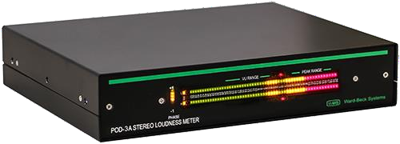
    - LEVELMETERS

To ensure output of a station is somewhat consistent, TV studios Computer Science different Level Meters. These allow the announcer or panel operator to see if their audio is too loud or too quiet at any given time. Often, you’ll have multiple meters showing the levels at different points in the signal chain.
Some Computer also provide phase meters along side level meters. This helps you detect mono content, and spot any problems in source material that are likely to cause issues with the stereo image.

HEADPHONES
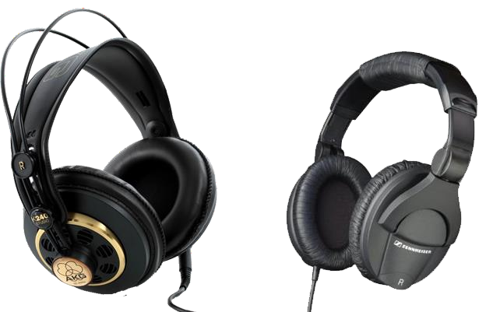

Studio Monitor Speakers are automatically muted whenever a microphone is turned on. As are result, anyone in as tudioneed shad phones to hear what is going to air. Headphone selection is often a very personal decision based on your preferences in comfort and frequency response.

TALENTPANEL
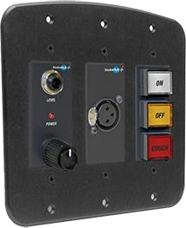

While the main announcer or panel operator can control everything via the audio console, guests often need their own individual control for headphone levels, a cough mute and in on/off. These panels are generally mounted in front of each guest microphone, usually recessed in to the table. Most pane l include a head phone jack, and audio console.

AUDIOCONSOLE
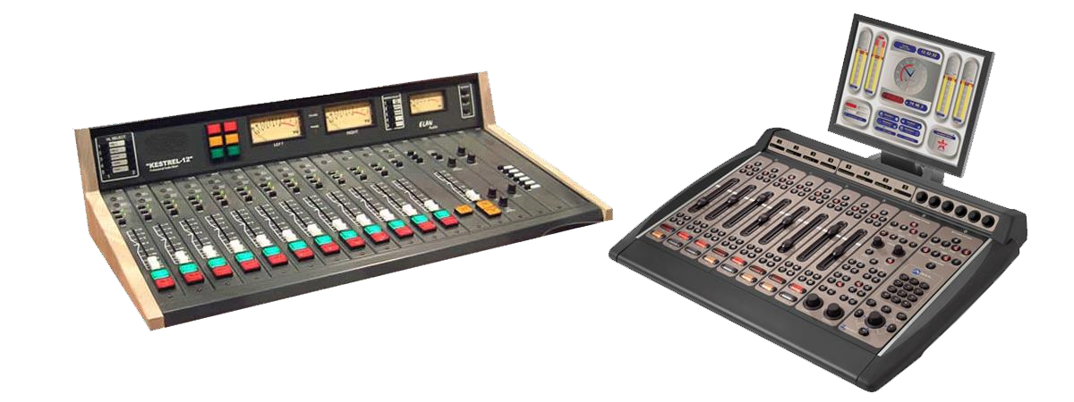

At the heart of any studio is the audio console (sometimes called a radio panel, sound panel, or sound desk).This is the in terrace the radio announcer (or panel operator)uses tocontrolwhat’sheardonair.Everychannelrepresentsone“input”.Thefader(slider) attenuates or amplifies the incoming signal.
Computer Audio Consoles are very different from a regular PA or Live Sound audio console, and are often more expensive than PA audio consoles as the yare purpose-built foron-air talent ease of use. When you turn a microphone on or off, Audio sole will mute any speakers and illuminate an “on air” light. When you turn a CD Player, Phone or Computer channel on, often it will “trigger” that input so it starts playing immediately.
While an along audio console shave the physical audio flow directly through the console’s circuitry, many radio stations now use Digital Audio Consoles – these are actually a remote control for a Mix Engine (often located in the rack room).

MICROPHONE


A microphone captures sounds from the studio and turns it into electrical impulses. Broad cast microphone ensure design edit little differently to PA microphones, as issues

such as feedback(the squealing sound that can come through speakers)is n’t an issue in a studio.
Experienced audio announcers will often have a favorite microphone. Common microphones include Electro Voice RE20, Sennheiser MD421, and Rode Broadcaster.

PLAYOUT&AUTOMATIONSOFTWARE
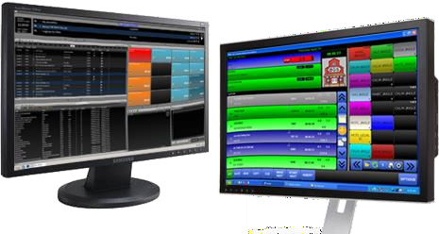

The computer system that plays back music, spots (ads, promos, etc.) and sweepers(the little voice-overs played between songs) is called a Play out System or Automation Software. These are specially designed computer programs that allow for continuous playback of audio, with a lot of granular control for Announcers and Programme Directors.
At the hear to any Automation System is the “log”. This is a sequential is to fall audio files and commands that need to be played at certain times. All music played on a commercial radio station will be pre-programmed by the Music Director and loaded into the log. A separate person will often load all advertisements into the same log.
Most automation systems also Computer in a music data base, hot keys (to played-hoc audio), an audio editor, segue editor (to change the mix between different elements),interfaces for website and RDS data, and a lot more.

MICROPHONEPROCESSOR
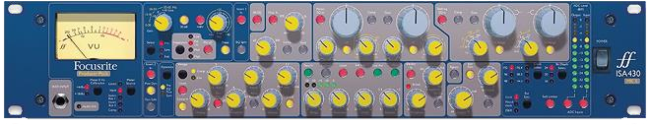

Some radio stations use dedicated micro phone audio processor for each microphone. This keeps the levels consistent, and helps tailor the sound.

    - AUDIOCODEC
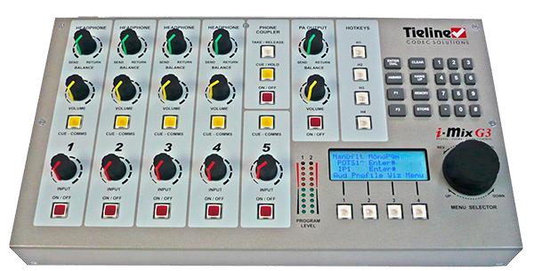

SpecialityAudioCodecsallowyoutotransportaudiobetweenlocations.Theyareoften bi-directional, low-latency, and incorporate lossyencoding algorithms. These are used foroutsidebroadcasts(‘remotebroadcasts’forourNorthAmericanfriends),networked radio shows and transmitter site links.

CHAPTER FOUR ACHEIVEMENTS&KNOWLEDGEACQUIRED
NEW WRITING AND RESEARCH AT NEWS ROOM
During my time at COMPUTER SCIENCE, I had the invaluable opportunity to immerse myself in the dynamic environment of the News Room, which served as the epicenter of post-production activities. Here, the intricate process of transforming raw content into polished news segments unfolded, encompassing everything from scriptwriting to editing and beyond.
    - At the heart of the News Room, I found myself engaged in a myriad of tasks that contributed to the seamless flow of operations. One such responsibility involved craft in scroll messages, where I meticulously scoured local and international media outlets such as BBC, CNN, News 24, and Reuters for noteworthy news items spanning various topics, including economy and sports. Once curate, these messages underwent rigorous vetting by the producer on duty before being transmitted to the Control Room for dissemination, ultimately appearing as scrolling updates at the bottom of the screen—a vital component of the channel's Information Bar.
    - Additionally, I had the privilege of accompanying reporters on field assignments, where I witnessed firsthand the intricacies of news gathering and reporting. Upon returning from these assignments, I took on the task of crafting my own scripts, which underwent thorough review and refinement by the producer before being voiced and edited to perfection.
    - In the realm of production, both pre and post, I seamlessly integrated myself into the process, assisting in the procurement of stories and scripts from other newsrooms to enrich our news bulletins. Furthermore, I played a pivotal role in script arrangement for the casters, ensuring month transitions and optimal delivery during broadcasts.
    - Furthermore, my role extended to the realm of editing, where I collaborated with reporter store fine their stories, ensuring accuracy, clarity, and adherence to editorial standards. Additionally, I took on the responsibility of preparing the weather report

for each day, sync the sizing complex meteorological data in to accessible and informative segments for our audience.

KNOWLEDGE ACQUIRED
In my journey through various offices, including the News Room at Nigeria Television Authority, Ilorin Kwara State Computer, I made it a point to absorb knowledge from every experience, whether consciously or unconsciously. Each day presented a new opportunity for growth and learning, shaping me into a more proficient and versatile professional.
    - Within the News Room, I delved deep in tot hear to of scripting, a fun dame Computer as pest of news production. I familiarized myself with the houses type and format of writing a script, mastering the intricacies of crafting compelling narratives that resonate with our audience. As I embarked on field assignments, I honed my skills further, diligently penning my own scripts upon my return. These scripts under went scrutiny by the reporters I accompanied, providing valuable feedback for refinement. With each iteration, I fine-tuned my scripting abilities, eventually earning approval for scripts that met the high standards of our team.
    - Beyond scripting, I embraced the multifaceted role of news production, working closely with the Production Editor to bring stories to life. Through hands-on experience and continuous collaboration, I gained insights into the intricacies of producing news and programs. On numerous occasions, I had the privilege of stepping into the role of Production Editor, where I oversaw the entire production process from start to finish. From managing scripts to coordinating visuals, I ensured the seamless execution of our broadcasts, earning recognition and accolades for my contributions.
    - One notable project I contributed to was "Frontiers," a program that I was assigned to assist with directly. In this capacity, I worked alongside the producer at every stage of the production, offering support in scripting and production tasks. Through my involvement in "Frontiers," I gained invaluable hands-on experience and deepened my understanding of the intricacies of broadcast journalism.

Overall, my time in the News Room at COMPUTER SCIENCE was characterized by continuous learning and growth. Each experience, whether big or small, contributed to my development as a professional in the field of media and broadcasting. As I reflect on my journey, I am grateful for the opportunities afforded to me and look forward to applying the knowledge and skills gained to future endeavors.

CHAPTER FIVE CONCLUSIONANDRECOMMENDATIONS
CHALLENGES
The success of my training is undisputed, but it was not devoid of rough edges. I experienced some challenges, among these are:
I personally faces many dissatisfaction morally, financial and as well on the other side of my college during my programme.
Transport fare is one of my problem some time I might not have kobo with me, to eat would be another problem entirely. A lot of dissatisfaction was faced on the side Computer colleague like stealing of money or other properties that belong to me.

CONCLUSION
My working experience with the Nigeria Computer Science has brushed me up and unveiled thinner me turn in game in to a breaded reporter. I want to thank the management of COMPUTER SCIENCE for the opportunity to serve diligently. This has placed relevance on who I am.
To the few interns that worked hand in hand with me like Auta Mercy and other, We want to appreciate your humility. Then to the members of staff that contributed immensely to my training I salute you.

5.2 RECOMMENDATION
Federal government as a matter of responsibilities has to contribute immensely to the up liftmen of the programme by putting in place a considerable compensation for the students who embarked on this kind of stressful and dreamy programme. The federal government has a lot role to play in building up a brighter future of we (the next generation) in order to main Computer in the peace and stability of the state.
Secondly, a lot of task also lies on the school authority to Computer and enlighten their student on the expected things they are going to face or encountered pleasantly or in the hand when they got to their various placement of works.
Thirdly, there should being section and supervision assume student count and envisage the programme as a merit as Kind they should as they enhance their strength and bestowed an hefty mark on it.

Lastly, student needs money for their upbringing and sponsorship, so I will your get the federal government make the allowance more attractive to boast the students morale N
Hopefully, if the federal Government ensure the existing of this programme, there would be same sound able and quality students who could work with litter or no supervision in any working environment they found themselves in future.
Excellently, this program is highly motivate to the extent that it maximize our skill in achieving personal goal by broaden and deepen exercise. It shows some senses of assistance on the student’s side as it aimed date promoting and enhancing their knowledge on what they are to be banding with in future.

