

TECHNICAL REPORT ON STUDENT INDUSTRIAL WORK EXPERIENCE SCHEME (SIWES)

UNDERTAKEN AT
ILORIN SOUTH LOCAL GOVERNMENT FUFU

PRESENTED BY
ABDULRAUF IBRAHIM DARE
ND/23/PAD/PT/0003

SUBMITTED TO:
THE DEPARTMENT OF PUBLIC ADMINISTRATION, INSTITUTE OF FINANCE AND MANAGEMENT STUDIES (IFMS) KWARA STATE POLYTECHNIC, ILORIN.

IN PARTIAL FULFILLMENT FOR THE REQUIREMENT OF THE AWARD OF NATIONAL DIPLOMA IN PUBLIC ADMINISTRATION

AUGUST TO NOVEMBER, 2024

DEDICATION
Firstly, I want to dedicate this work to the Almighty Allah who saw me through the period of internship, gracing me with wisdom, strength, knowledge, understanding and unending list of great things.
Also, I dedicated this report to my parents, MR. AND MRS. Abdulrauf for their love, care and support since the time I was born till this moment. I say thanks to my parents.
I am also grateful to my family and friends who has always been there for me in term of need and supports. Thanks to you all.
ACKNOWLEDGEMENT
The favour of Allah that went before me cannot be overlooked Allah saw me through my SIWES I want to thanks him for the wisdom and speed he gave to me to adapt to the work, the protected me, ordered my steps, I gave me good health and speed blessed the work of my hand. I am indeed grateful.
My profound gratitude goes to my lovely parents Mr. and Mrs. abdulrauf for their active role as a parent, throughout my training. I really want to appreciate all my friend for their love and support too. God Bless you all.

TABLE OF CONTENT
Title page
Preface
Dedication
Acknowledgement
Table of content
CHAPTER ONE
  - Introduction/Meaning of SIWES
  - Brief History of SIWES
  - Purpose of SIWES
  - Aims and Objective of SIWE
CHAPTER TWO
2.1 History of the Organization
2.2 Instruments in the Studio
CHAPTER THREE
3.1 An Office

3.2 Workspaces
3.3 Office Equipment
CHAPTER FOUR
4.1 Executive Summary
CHAPTER FIVE
5.1 Challenges Encounter
5.2 Recommendation
5.3 Conclusion

CHAPTER ONE
1.1 INTRODUCTION / MEANING OF SIWES
SIWES was established by Industrial Training Fund (ITF) in 1973 to solve the problem of lack of adequate practical skills preparatory for employment in industrial by Nigerian graduates of tertiary institution.
The scheme exposes student to industry based skills necessary for a smooth transition from the classroom to the world of work. It affords student of tertiary institution the opportunity of being familiarized and exposed to the needed experience in handling machinery and equipment which are usually not available in the educational institution.
Participation in SIWES has become a necessary pre-condition for the award of Diploma and Degree Certificates in specific discipline in most institution of higher learning in the country, in accordance with the education policy of government.
1.2 BRIEF HISTORY OF SIWES
SIWES was founded in 1973 by ITF (Industrial Training Funds) to address the problem of tertiary institution graduates' lack of appropriate skills for employment in Nigerian industries.
SIWES is the Student Industrial Work Experience Scheme students are out annually to professional organization relevant to their course of study with the help of the institution based coordinator. The scheme takes up at the end of the first year during the ND programme for science oriented course, study in polytechnics.
1.3 PURPOSE OF SIWES
In the earlier stage, student are graduating without any technical knowledge or working experience and this makes them to undergo further training after securing an employment. With this reason, student industrial training was established.
During this programme, as designed by the ITF, student are expected to get technical assistance and acquire more experience scheme in their chosen field of study and exposed them to the usage of source machines and safety precaution where relevant before the completion of their programme in their various institutions.
1.4 AIMS AND OBJECTIVE OF SIWES
1. To provide an avenue for student in the Nigerian Institution to acquire industrial skills and experience during their course of study.
2. To prepare students for the work situation they are likely to meet after graduation.
3. To expose the student to work method and techniques in handling equipment and machinery that may not be available in their institution.
CHAPTER TWO
2.1 HISTORY OF THE ORGANIZATION
The Ministry of Water Resources (MWR) has a rich history, evolving over time to manage water resources effectively for various sectors, including agriculture, industry, and domestic use. While the specifics may vary by country, the general history of such ministries follows a common pattern:

Early Water Management (Pre-20th Century)
- Ancient civilizations, such as Mesopotamia, Egypt, India, and China, developed irrigation systems and water storage structures.
- Water management was primarily handled by local communities, kings, or emperors.
- Early water laws and regulations emerged to prevent conflicts over water use.

Formation of Water Departments (19th–20th Century)
- As industrialization increased water demand, many governments created water-related departments.
- In colonial periods, water management was often controlled by colonial administrations.
- Early government efforts focused on irrigation, flood control, and navigation.

Establishment of Independent Water Ministries (Mid-20th Century)
- Many countries established dedicated Ministries of Water Resources after gaining independence.
- The focus expanded to include hydropower development, drinking water supply, and groundwater management.
- Organizations like the United Nations (UN) and World Bank began supporting water infrastructure projects.

Modern Water Resource Management (Late 20th–21st Century)
- Introduction of integrated water resource management (IWRM) to balance economic, social, and environmental needs.
- Climate change and population growth increased the importance of sustainable water use.
- Many ministries adopted digital monitoring systems, water conservation policies, and transboundary water agreements.
2.2 INSTRUMENTS

1. Policy Instruments
- National Water Policy: Framework for water conservation, allocation, and management.
- Integrated Water Resources Management (IWRM): Ensures coordinated development of water, land, and related resources.
- Climate Adaptation Strategies: Addresses water-related challenges caused by climate change.

2. Legal Instruments
- Water Acts & Regulations: Laws governing water use, pollution control, and distribution.
- River Basin Agreements: Laws regulating shared water resources between states or countries.
- Groundwater Management Laws: Regulations on groundwater extraction and recharge.

3. Financial Instruments
- Water Tariffs & Pricing: Charges for water supply services to promote efficient use.
- Subsidies & Grants: Government funding for irrigation, water infrastructure, and conservation projects.
- Public-Private Partnerships (PPP): Collaboration with private companies for water infrastructure development.

4. Technical Instruments
- Water Monitoring Systems: Use of satellites, sensors, and GIS for real-time water data collection.
- Hydraulic Structures: Dams, reservoirs, canals, and pipelines for water storage and distribution.
- Desalination & Water Recycling: Technologies for alternative water sources.

5. Institutional Instruments
- River Basin Authorities: Organizations managing water resources at the basin level.
- Water User Associations (WUAs): Local groups managing community water use.
- International Water Treaties: Agreements between countries for managing shared rivers and lakes.
CHAPTER THREE
3.1 AN OFFICE
An office is a space where the employees of an organization perform administrative work in order to support and realize the various goals of the organization. The word "office" may also denote a position within an organization with specific duties attached to it (see officer or official); the latter is an earlier usage, as "office" originally referred to the location of one's duty. In its adjective form, the term "office" may refer to business-related tasks. In law, a company or organization has offices in any place where it has an official presence, even if that presence consists of a storage silo. For example, instead of a more traditional establishment with a desk and chair, an office is also an architectural and design phenomenon, including small offices, such as a bench in the corner of a small business or a room in someone's home (see small office/home office), entire floors of buildings, and massive buildings dedicated entirely to one company. In modern terms, an office is usually the location where white-collar workers carry out their functions.
MEMO
A memo is a type of message sent to members within a business or organization. A memo, short for memorandum or reminder, is usually a group message sent from one person to several recipients.
In classical antiquity, offices were often part of a palace complex or a large temple.
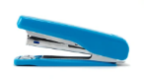
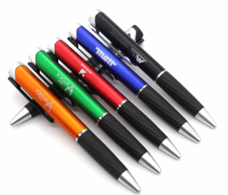
In the High Middle Ages (1000–1300), the medieval chancery acted as a sort of office, serving as the space where records and laws were stored and copied. With the growth of large, complex organizations in the 18th century, the first purpose-built office spaces were constructed. As the Industrial Revolution intensified in the 18th and 19th centuries, the industries of banking, rail, insurance, retail, petroleum, and telegraphy grew dramatically, requiring many clerks. As a result, more office space was assigned to house their activities. The time-and-motion study, pioneered in manufacturing by F. W. Taylor (1856–1915), led to the "Modern Efficiency Desk" of 1915. Its flat top, with drawers below, was designed to allow managers an easy view of their workers.^{[1]} By the middle of the 20th century, it became apparent that an efficient office required additional control over privacy, and gradually the cubicle system evolved.

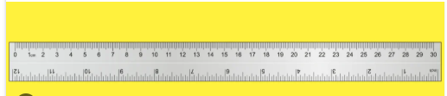
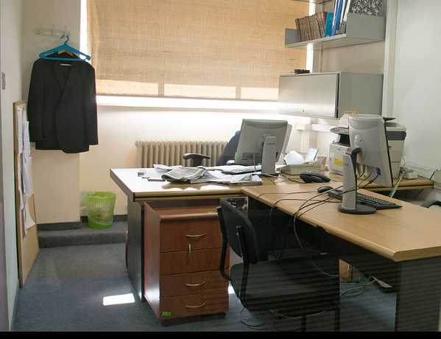

3.2 WORKSPACES
Workspaces in an office are typically used for conventional office activities such as reading, writing, and computer work. There are nine generic types of workspaces,^{[according to whom?]} each supporting different activities.
Private office: an enclosed workspace for one person; suitable for activities that are confidential, demand a lot of concentration, or include many small meetings.
Shared office: a compact, semi-private workspace designed for two or three individuals, facilitating both focused work and small group collaboration.
Team room: an enclosed workspace for four to ten people; suitable for teamwork that may be confidential and demands frequent internal communication.
Study booth: an enclosed workspace for one person; suitable for short-term activities that demand concentration or confidentiality.
Work lounge: a lounge-like workspace for two to six people; suitable for short-term activities that demand collaboration and/or allow impromptu interaction.
Touch down: an open workspace for one person; suitable for short-term activities that require little concentration and low interaction.

Meeting spaces
Meeting spaces in an office typically use interactive processes, be they quick conversations or intensive brainstorming. There are six generic types of meeting spaces,^{[according to whom?]} each supporting different activities.

Small meeting space
Small meeting room: an enclosed meeting space for two to four people; suitable for both formal and informal interaction.
Medium meeting room: an enclosed meeting space for four to ten people; suitable for both formal and informal interaction.
Large meeting room: an enclosed meeting space for ten or more people; suitable for formal interaction.
Small meeting space: an open or semi-open meeting space for two to four persons; suitable for short, informal interaction.
- 
Large meeting space

- 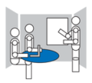
Brainstorm room

- 
Meeting point
Medium meeting space: an open or semi-open meeting space for four to ten persons; suitable for short, informal interaction.
Large meeting space: an open or semi-open meeting space for ten or more people people; suitable for short, informal interaction.
Brainstorm room: an enclosed meeting space for five to twelve people; suitable for brainstorming sessions and workshops.
Meeting point: an open meeting point for two to four people; suitable for ad hoc, informal meetings.

3.3 OFFICE EQUIPMENT
Every business needs to think about the types of equipment their company needs in order for their employees to do their job properly. Office equipment helps in managing office-related work and makes your day to day tasks run smoothly.
Office equipment is usually overlooked, but essential. The right and necessary equipment should be available for every employee so they can work productively and efficiently.
Not only will employees benefit from good quality equipment, but it will also benefit your business image. The right office supplies sends out a positive message to clients and partners.
Basic office supplies include furniture, business printers, collaboration tools, telephone systems, kitchen supplies (such as a coffee machine) and so on. Of course a strong and good internet connection is indispensable. Without a good quality internet connection, your business won’t be able to use certain telephone systems, for example.
There are a lot of suppliers in the UK offering these kinds of office equipment. Depending on the company and their requirements, businesses can choose to buy, rent or lease some of these supplies.
Having the right office equipment will make your office look more professional and it will make the daily working routine run smoothly. Choosing the right office equipment depends on your business requirements and employees needs.
1. Furniture
Buying the right office furniture is important for various reasons. Firstly, it will make your office look pleasant and professional. Your office will be comfortable and accessible for your employees and customers.
Choosing the right office furniture will also play an important role in increasing the morale and productivity of your employees. Employees tend to feel more comfortable to work in a pleasant environment. This way they develop a positive attitude towards the organisation and feel more motivated to work efficiently and be productive.
For instance, using the right colours and lighting are only a few factors that will increase productivity. Always keep in mind to balance what you can spend with what your employees need.
Lastly, office supplies like furniture should reflect the nature of your business. Nice looking office furniture provides a good impression to visitors. This will improve the image of the office and it will make the company look more reliable and professional.
When buying office furniture, it’s essential to consider the space of your office. Always try to arrange these office supplies in a way that will make the office look bigger and accessible.
Choosing the right office furniture might seem challenging since it will determine the comfort of your employees and the way they perform. Therefore there are some factors to consider when making your choice. Buying office furniture is a long-term investment, so it’s not just a matter of design but also a matter of spending every coin wisely.
It’s best to combine design with purpose and function. Also think about whether the furniture you choose is mobile and adaptable to the office area. Safety is another essential factor to consider when choosing the right furniture. Make sure the office furniture are systematically arranged to ensure safety in the office.
Factors to consider when choosing office furniture
Cost: keep your budget in mind
Design: invest in creative designs that send out calmness
Durability: good quality
Uniform: it should go well with your company image
Safety: arrange it systematically
Saving space: arrange it so the office looks bigger
Comfort: think about your employees needs
Portability: it should be easy to move around

2. Internet Connection
Having a high speed internet connection is without a doubt mandatory for every business.
Without a reliable internet connection businesses wouldn’t be able to connect with and share information both internally and externally. Given that a lot of businesses operate online, a good internet connection contributes to daily tasks.
A lot of office equipment are able to connect to the internet. Therefore, IoT is a great system that enables different smart devices to transfer data over a network without any human interaction. These smart devices can for example be smart speakers, photocopiers, coffee machines, smart locks, and more.
Having such smart devices in the office comes with potential security risks. No matter what size your business is, having good office security of IoT is crucial in order to manage smart devices safely.
Other types of office equipment businesses need are routers and on-site backups.

3. Kitchen Supplies
Given that coffee has become a corporate ritual, an office coffee machine has labelled as essential office equipment. Employees should be kept hydrated and satisfied with food and drinks. Providing your staff with free coffee and water helps to keep them motivated and effective. Opting for a water dispenser in your office is therefore a great idea.
There are a lot of coffee machine suppliers in the UK that help offices in choosing a tailored office coffee machine. A coffee vending machine is only one of the options companies can go for. If your company rather prefers a more quality brew, you can choose an espresso or bean to cup coffee machine.
Offering employees free coffee can help them to stay focused and concentrate better. Having an office coffee machine has a positive impact on the company culture and employee morale.
Depending on the size of your business, you can choose between different types of coffee machines. The table below shows the different coffee machines available depending on the size of your business.
It’s hard to keep an office kitchen clean if the right tools aren’t provided. Different cleaning supplies like paper towels and dishwasher soap are needed to keep the kitchen area tidy.
4. Telephone Systems
Effective communication is an essential tool for any business. When considering business equipment, companies should always invest in a good office telephone system. This way employees can keep in touch with customers and colleagues on a personal level.
There are different features, sizes, and options of various telephone systems available. Companies should choose the one that would fit their business the best in terms of objectives and needs. A lot of providers in the UK offer tailored office telephone systems.
Two systems that are a good fit for businesses are PBX and VoIP phone systems. The main difference between these two systems is the way they connect users.
With VoIP systems employees make calls through the internet, as it is a cloud phone system, while PBX systems use a standard telephone line.
Another useful office tool within businesses is a business mobile phone. It’s the perfect way for employees to work remotely and to maintain a healthy work-life balance. In that way they will never miss out on important calls.
Business mobile phones are the best solution for employees that are mobile, meaning those that travel a lot for business purposes or those that are mainly working out of the office. Mainly sales representatives may benefit from a business mobile phone because it enables them to improve sales processes.
The table below shows the different features for PBX phones and VoIP phones.
5. Photocopiers and Printers
Every business should definitely have some basic machines like a business printer, a photocopier, and a scanner. Photocopiers and printers are without a doubt essential office equipment within businesses.
Instead of buying a photocopier, low budget companies can opt for the photocopier rental possibility. The same applies to printers, as a printer rental can be a good cost-effective choice.
A lot of UK providers offer various machines with different features. Again, depending on the requirements of your office, you can choose different types of office machines. When considering a printer, there are some parameters you can keep in mind.
Firstly, it's important to think about the size of your office. Make sure your printer doesn’t take up much of your workspace. Printers could have scanning and faxing options. Another feature to keep in mind is an automatic document feeder. Document feeders are a must if you’re business requires to scan a lot of documents at once.
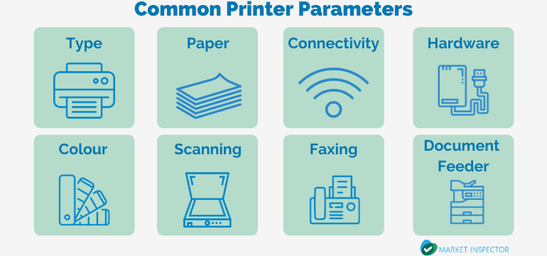
6. Computer Software
Given that information is the backbone of every business, computer software is another necessity that belongs under the category of essential office supplies. Computer software include useful apps, anti-virus software, word processing software, and CRM systems.
According to the business, companies can consider different types of apps. A very important tool to protect devices from hackers is a reliable anti-virus software. There are different anti-virus softwares that offer different features.
A word processing software is an essential tool within offices while it offers automatic corrections of misspellings, improves overall speed, and reduces errors. Besides these benefits, word processing also helps employees to work more efficiently and accurate.
Lastly, CRM systems are a useful tool to incorporate in businesses. Building a good customer relationship is essential in any business. Creating and maintaining this relationship can be done in an online environment or with personal communication through phone calls.
7. Stationery
Office stationery are basic daily essential items that every business should have. Items like pens, paper, notebooks, post-its and other essential office equipment need to be available for employees to work productively and efficiently.
With advanced technology, it can sometimes get too exhausting to look at screens all day. A lot of employees want to escape the screens and grab for some pen and paper to take down some notes. Even though the technology is evolving rapidly, the importance of stationery is still strong and they remain valuable tools.
One of the main reasons employees choose to use stationery is the organisational purpose. It’s easier to keep all information at reach when you have seperate, labelled notebooks or ring-binder folders. Keeping the technological malfunctions in mind, having a hard copy is more reliable than having just an online document.
Using too much paper in offices is not the best eco-friendly way of operating. Trying to find a balance between online documents and hard copies might be a good solution.
A great way of using paper sparingly is a digital notepad. It may be an expensive investment, but it is definitely worth considering given that it is a great way to save the environment.
Depending on the type of business, it might be good to only select the relevant basic office essentials that fit the job. Asking employees what they need to be able to do their job efficiently may also be helpful for choosing the right stationery.
Even with stationery, companies can send out a positive message towards clients. These office supplies can be branded with the company name representing professionalism and uniformity.
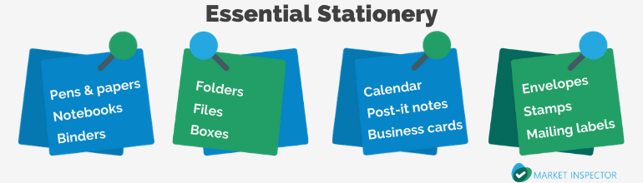
8. Storage Equipment
Office supplies such as storage folders, USB flash disks, and external hard drives help businesses keep everything organised and separate. Even though the technology is evolving and companies are operating online, paper work is always going to be a part of any business.
Storage folders are therefore a useful tool for businesses that want to keep their files organised. Labelled storage boxes might also help to archive documents.
Saving documents to a USB flash disk is another good way of keeping documents organised and safe. When saving documents to a USB disk, you are sure that you have a backup of the original document.
Besides a USB flash disk, an external hard drive would be a handy must-have office tool. This will provide your business with extra storage space on any computer.
9. Collaboration Tools
Collaboration tools like office boards are necessary office equipment. These tools make it easier to keep ideas within a company organised. The essence of collaboration is sharing knowledge and skills to achieve the best result.
Whiteboards are a perfect tool for sketching mind-maps or strategies. It’s also a great way to just write down a few reminders to keep you on track. They fit best in private offices and conference rooms.
Another collaboration tool that is essential in any business environment is a bulletin board. These fit best in a company’s break room. The purpose of this board is mainly to inform employees about the current state of affairs and to update them on the daily duties.
Projectors are also a must in companies. This office equipment does more than just representing a modern, innovative, and high-tech business environment. With a projector, companies can share information faster, communicate better, and collaborate more easily. A projector is also a good office tool to use for training purposes. Trainees can easily view the displayed information and take notes.
Whiteboards and projectors are an eco-friendly way of collaborating. Both options are better than using paper which makes them a green and cost effective solution. Bulletin boards on the other hand are not that eco-friendly but they serve as a great source of inspiration. Through bulletin boards and whiteboards employees can get inspired and motivated.
The table below shows the advantages of three collaboration tools: whiteboards, bulletin boards and projectors.
Advantages of Collaboration Tools
Advantages | Whiteboards | Bulletin boards | Projectors
Reliable: simple and effective
Eco-friendly: no printed hard copies
Engaging
Gives sense of togetherness
Offers quick update on information
Source of inspiration
Increase interaction and communication
Time-saving: no loading time or updates
10. Office Waste and Recycling Tools
Office waste and recycling tools don’t seem to be the first thing businesses consider when thinking about office equipment. Even though it is not self-evident, it is very useful and beneficial for businesses.
A paper shredder also belongs to the office waste tools. Shredders makes it easier for companies to destroy confidential documents, customer reports or other documents.
Recycling in the office and keeping your office clean contributes to your company image. Having enough rubbish bins and recycling bins are a significant part of any organised and clean office. Businesses will not only keep their office area tidy, but they will also contribute to a greener environment.

CHAPTER FOUR
4.1 EXECUTIVE SUMMARY
SIWES is the Student Industrial Work Experience Scheme. Student are out annually to professional organization relevant to their course of study with the help of the institution based. Coordinator and the scheme takes up at the end of the first year during the ND programme for science oriented course study in polytechnics. The scheme was established by the ITF (Industrial Training Fund) to solve the problem of lack of adequate practical skills. During this programme, student are expected to get technical assistance and acquired more experience scheme in their chosen field of study.
A councillor, alternatively councilman, councilwoman, councilperson, or council member, is someone who sits on, votes in, or is a member of, a council. This is typically an elected representative of an electoral district in a municipal or regional government, or other local authority. The title of a councillor varies geographically, with a name generally being preceded by their title (or the shortened version Cllr when written) in formal or council-related situations in many places.

Finland
This is about honorary rank, not elected officials.
In Finland councillor (neuvos) is the highest possible title of honour which can be granted by the President of Finland. There are several ranks of councillors and they have existed since the Russian Rule. Some examples of different councillors in Finland are as follows:
- Councillor of State: the highest class of the titles of honour; granted to successful statesmen
- Mining Councillor/Trade Councillor/Industry Councillor/Economy Councillor: granted to leading industry figures in different fields of the economy
- Councillor of Parliament: granted to successful statesmen
- Office Councillor: granted to leading university figures
- Councillor of Culture/Theatre Councillor/Film Councillor: granted to leading cultural figures
- Chamber Councillor: granted for successful officials in the field of local government

CHAPTER FIVE
5.1 CHALLENGES ENCOUNTER
Honestly speaking, I faced a little bit challenged during my SIWES program;
- The place of my attachment is very far to my house
- Lack of available industry in the location of some student.
- High cost of transport fare from student resident to the location of the attachment.
- Laziness of some student during the attachment.
SOLUTION
- Government should increased their investment on establishing companies for science oriented student.
- Their should be a certain amount to be paid to the student during the attachment.
- Their should be a monthly check on the student during the attachment.
5.2 RECOMMENDATION
I want to say a very big thank you to the government for introducing the SIWES programme which helps in motivating students in their course of study and also to increase the knowledge and understanding of students on their future endeavor.
I will advice the government to ensure the supervisor to supervise all students involved in the program and also encourage them by paying a token amount to the student in order to motivate and release the burden to transport fare being complained by students.
Student should be aware that SIWES is not for money acquisition rather it for knowledge and practical exposure to their course of study.
5.3 CONCLUSION
Student Industrial Work Experience Scheme (SIWES) is a scheme that improved the technical knowledge of student in the Nigerian institution. The scheme expose student to work method and techniques in handling equipment and machinery that may not be available in their institutions. It is a good process that every science oriented course must undergoes.
As for me, the SIWES I undergoes in News and Current Affairs exposed me to the practical aspect of News and Editing. It widening my knowledge and skill on the discipline the scheme equips student properly to fact any future challenges pertaining to the News and interview.
Lastly, big thanks to the Industrial Training Fund (ITF) for the establishment of SIWES which now serves as an opportunity for we students of the Nigerian Institution.

