TECHNICAL REPORT
ON

STUDENTS INDUSTRIAL WORK EXPERIENCE SCHEME (SIWES)
UNDERTAKEN AT

HEAD OF DEPARTMENT OF WORKS, LAND AND HOUSING
EDU LOCAL GOVERNMENT LAFIAGI KWARA STATE.

SUBMITTED BY:
ALIYU ABDULAHI
ND/23/QTS/FT/0002

SUBMITTED TO
THE DEPARTMENT OF QUANTITY SURVEY, INSTITUTE OF ENVIRONMENTAL STUDIES KWARA STATE POLYTECHNIC ILORIN KWARA STATE NIGERIA.

IN PARTIAL FULFILLMENT OF THE REQUIREMENT FOR THE AWARD OF
NATIONAL DIPLOMAL (OND) IN QUANTITY SURVEYING

March, 2025.

DEDICATION
This report is dedicated foremost to God almighty who made it possible for me to be alive and healthy and who made me to participate fully in this training program and made it a successful one, may his name be praised forever, amen Also, it is dedicated to my lovely parent Mr & Mrs Aliyu who has helped me in making my dream to be established and also for their parental support inform of also for their parental support inform of finances , advices and lots more. I pray you would eat the fruit of your labour in Jesus name.

ABSTRACT
During my siwes program, the major area of participation is basically on the patrol unit and taking off of some plan the organization has many department in which I was taken to the patrol department because of any students were in works department so the organization took me to patrol unit to avoid clumsiness.

ACKNOWLEDGEMENT

My deepest appreciation and gratitude goes to god the maker, alpha and omega, the creator of all things for being there for me from the I was born even till now, I say thank you God, Am indicating to my lectures the people of honour in quantity surveying department both teaching and non.

CHAPTER ONE

1.0 INTRODUCTION
This was introduced in Nigeria by the decree No.46 of 1971 for students in institutions of Higher Learning. The Students Industrial Work Experience Scheme (SIWES) was conceived as a tool to expose the students to the practical aspect of their various disciplines which the academic environment is not in a position to offer.
It is aimed at exposing the students to the outside world to experience and appreciate the deference inherent in professional practice and the theory that is imparted to them in their various institutions. The scheme is an important tool in creating a well-rounded education as it not only improves academic knowledge. It equips the students with the necessary skills and technical know-how along with human relationship and the professional ethics in his or her chosen career which in turn generates manpower development in the nation as a whole.

1.1 BACKGROUND
The Students Industrial Work Experience Scheme (SIWES) is a technical programme required in partial fulfillment of the Award of Bachelor of Technology to students in the School of Science, Agricultural, Engineering, Management, and Environmental Technology.
The Federal University of Technology, Akure actively engages her eligible 400level Students on the scheme for a period of 6 months preparatory to the final session in the university. This is the period students are expected to have full Industrial Training Experience.

1.2 SCOPE OF SIWES
SIWES as conducted by the Industrial Training Fund (ITF) and their representative unit in the various institutions is designed to acquaint students in tertiary institutions in Nigeria with the necessary practical/industrial rudiments needed to corroborate the required theoretical knowledge.
The student industrial experience not only exposes students to practical knowledge of the course of study but also perfects their knowledge thereby making them competent professionals.

1.3 AIM AND OBJECTIVES OF SIWES
SIWES brings about a hand-on-the-job training in the industries. It bridges the gap between the level knowledge acquired in tertiary institutions and the practical application of such in the field of work.
The scheme came about through the ITF policy statements No.1 of 1973 with the following objectives:
- To prepare students for the work situations they are to meet after graduation.
- To provide an avenue for students in institution of higher learning to acquire industrial skills and experience in the course of their study.
- To provide students an opportunity to apply his knowledge in real work situation thereby bridging the gap between college work and actual practice.
- To expose students to work methods and techniques in handling equipment and machinery that may not be in educational institutions.
- To make transition from school to the World of work easier and enhance students contact for later job placements.
- To enlist and strengthen employers involvement in the entire educational process for preparing students for employment industry.

CHAPTER TWO

BRIEF HISTORY OF MINISTRY OF WORKS, LAND AND HOUSING EDU LOCAL GOVERNMENT LIFIAGI KWARA STATE

The Ministry is a government parastatal which comprises a team of reputable professionals in the building industry from architects, builders, estate valuers to quantity surveyors.
The Ministry comprises of different departments which are responsible for its success and they include; Administrative and H.R, Architectural and Building Services, Accounts, Quantity Surveying, Physical Planning and Surveying, ICT, Estate, Engineering Services, Legal Services, Public Affairs, Planning and Budget, Internal Audit and Mortgage Unit Departments.
The Ministry also partners with consultants and contractors on different housing projects in order to meet with the ever increasing housing needs of the citizens.
The Ministry is concerned with the provision of affordable housing for the citizenry and it does it so effectively by creating several housing scheme all over the state and is funded through partnership with private industries.

2.1 RANGE OF SERVICES OFFERED

Ministry of Housing provides architectural drawings (working and presentation) to be used in the development of the several housing schemes.

- They also hold design defense from several consultants and contractors who come with different designs to be approved for development.

- The Ministry also offers consultancy services for new innovations in building such as new affordable building material or new building technique.

- The Ministry also undertakes the utilization and landscaping of public spaces around the state.

- The Ministry acts as project managers and supervisors on projects not handled directly by them.

CHAPTER THREE

3.0 WORK EXPERIENCE
During the course of my internship at the Ministry of Housing, I was exposed to a lot of practical realities in the discipline of Architecture. while in the office, and while on site, which I was always accountable to. My internship experience at the Ministry of Housing was highlighted by the various duties:
- Provision of Design Solutions.
- Preparation of Design Sketches.
- Preparation of Working and Presentation Drawings.
- Preparation of Details.
- Attending Site Inspection and Meetings.
My work experience is divided into various parts for easy understanding.
- Technical Experience – This explains the administrative and design & studio aspect
- Field Experience - This explains the aspect of work related to construction work, site meetings and so on.

3.1 TECHNICAL EXPERIENCE
Throughout the course of my learning experience at the Ministry of Housing, I was able to learn the fundamental technicalities needed for an Architect to be relevant in the present day practice. These technicalities are categorized below:

3.1.1 DESIGN-STUDIO EXPERIENCE
The studio is a place where architectural drawings are made. The way the factory is to the manufacturer that is the way a studio is to the architect. During my internship at the Ministry of Housing, the office space was also the studio and each person worked in his/her computer. Working in the office or studio as it were also exposed me to the use of a number of computer aided design (CAD) software which over time has replaced the use of manual drafting that once dominated the profession. As I got more comfortable with the demands of the job my techniques and proficiency in the use of numerous software improved.

3.1.2 DRAFT
Drafting is a means for the drawing aspect to express himself/herself.
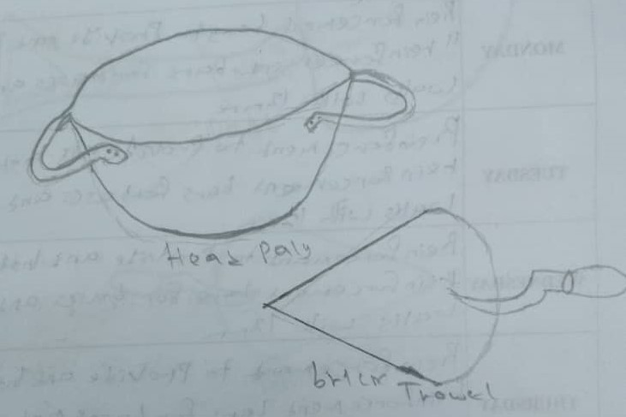

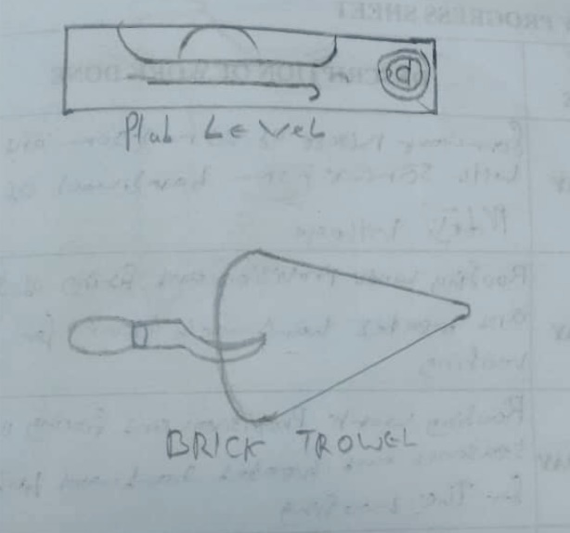

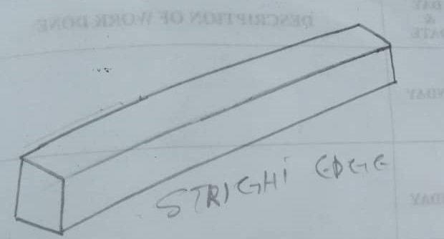

3.1.2.1 USE OF COMPUTERS IN PRACTICE
The use of computers in practices has increased so much in this decade that all the leading firms in Nigeria are fully computerized. A careful observation will reveal that the firms that are not computerized do not normally get large commissions and projects. Furthermore, only the firms that are computerized are in most cases called to bid for new projects through design competitions. The smaller firms not computerized never win or get the upper hand when invited for such competitions. Furthermore, the construction firms that are not yet computerized are now training their staffs in the use of Computer Aided Design..

3.2 ADMINISTRATIVE EXPERIENCE
Part of the aims of the SIWES Programme is to make students have a feel of the labour market so as to understand what it takes to assume responsibility in the employment world. This was largely experienced at my place of industrial attachment as a lot of responsibilities were entrusted into my care.

3.2.1 RECORDS AND FILING
Careful filing is most important as much time can be lost searching for documents when the need arises. Therefore a proper filing of these records or document in a way in which they can easily be retrieved is highly necessary. Documents in the case of large jobs can be sub-divided into several files, e.g. architects, contractors, subcontractors, supplies, reports etc.
My training also permitted me to take records, keep files, and produce progress report of projects directly and indirectly. Such files are presented to my principal or senior colleagues at the close of work for assessment and remarks. My secretariat qualities were called to actions at those times.
My industrial training exposure was all encompassing as no area of administration was left untouched. My training also permitted me to take records, keep files, and produce progress report of projects directly and indirectly. Such files are presented to the boss at the close of work for the week for assessment and remarks. My secretariat qualities were called to actions at those times.

3.3 FIELD EXPERIENCE
Every building erected today is sitting on a site. Sites vary from one place to the other and have various complexities. It is important to note that every site is unique. During my internship period, I have had the privilege to experience firsthand some difficult situations on site and with the tutelage of my supervisor, learnt to overcome them.

3.3.2 CONSTRUCTION WORK
Below is brief but detailed description of some of the construction processes witnessed on site:
- Painting
- Installation of Kitchen Cabinet
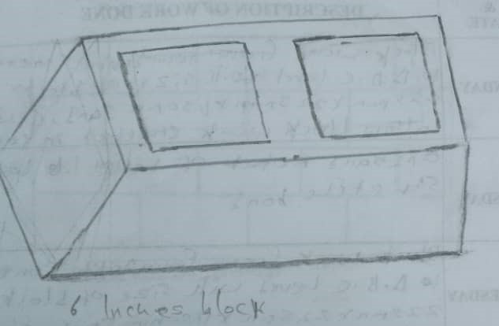
- Tiling

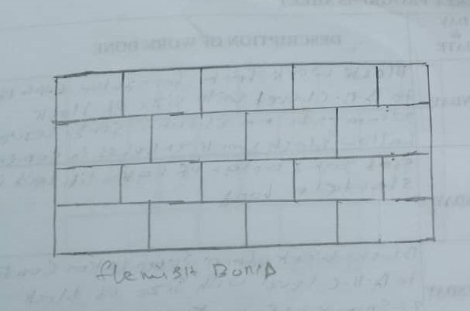

CHAPTER FOUR

CONCLUSION
In conclusion, industrial training is indeed a very good program and can give students the potential to be more qualified in the areas they want today. During the training also, I have experienced how the real environment in the workplace, as well as the good relationships that help each other - help and work together throughout my industrial training.
All the knowledge applied and learned throughout the training will be my best use to move to the future of nature. This training guides many students who are not aware of the additional costs that are being taken and studied while in Polytechnic.

  - RECOMMENDATIONS
The SIWES program is a wonderful one; it enables students gain experience as well as skills required in their fields of study. As one who has benefited from this scheme, I would like to make a few suggestions, to improve the quality of experience gained by students: The professional body (NIA) should provide some form of incentive for firms and organizations who take on students for Industrial Training attachment, as this would encourage firms to accept more students for their SIWES programme.

