

STUDENT INDUSTRIAL WORK EXPERIENCE SCHEME [SIWES] INDUSTRIAL TRAINING REPORT

HELD AT
BASH NIGERIAN ELECTRICITY MANAGEMENT SERVICE AGENCY

WRITTEN BY

ISSA SODE JAPHETH

MATRIC NO; ND/23/EEE/PT/0131

PRESENTED TO

THE DEPARTMENT OF ELECTRICAL ELECTRONICS ENGINEERING, INSTITUTE OF TECHNOLOGY [IOT] KWARA STATE POLYTECHNIC, ILORIN P.M.B 1375 KWARA, NIGERIA

IN PARTIAL FULFILLMENT TO THE AWARD OF THE NATIONAL DIPLOMAL [ND] IN ELECTRICAL AND ELECTRONICS ENGINEERING

MARCH 2024

DEDICATION
This report is dedicated to Almighty Allah the creator and the finisher of our faith, the one who strengthen and spare my life to complete my SIWES programme. May his name be glorified forever? And to my lovely parent in person of Mr and Mrs Issa for their spiritual moral and financial support towards the completion of the programme.

ACKNOWLEDGEMENT
My gratitude and sincere appreciation goes to Almighty Allah for his guidance and protection over my family, also for the strength and wisdom granted to me throughout my SIWES programme.
I wish to express my profound gratitude to my SIWES supervisor and other lecturers in the Electrical and Electronics Department.
I also give thanks to the Adam crew, starting from the owner of the company, Engineer Adam and my other colleagues.
I also appreciate the effort of my parent of Mr and Mrs Issa over me. I pray God will keep blessing them.

CHAPTER ONE
INTRODUCTION

1.0 BRIEF HISTORY OF STUDENTS WORK EXPERIENCE SCHEME (SIWES)
SIWES is the accepted skill training programme which forms part of the approved minimum academic standards in the various degree programmes for all the Nigerian universities. It is an effort to bridge the gap existing between theory and practical of engineering and technology, science, agriculture, media management and other professional education programme in the Nigerian tertiary institutions.
The Students Industrial Work Experience Scheme (SIWES) was initiated in 1973 by the Industrial Training Fund (ITF). This was in response to the mandate given to the ITF through decree 47 of 1971, charging it with the responsibility of promoting and encouraging the acquisition of skills in the industry and commerce with the view to generating a pool of trained indigenous manpower sufficient to meet the need of the nation’s economy. The Industrial Fund (ITF) introduced the scheme for employers to be involved in the entire educational process of preparing student for employment in our various industries with the vision "To be the foremost skills training and development organization in Nigeria and one of the best in the world" and mission "To set and regulate training standards and offer direct training interventions in industrial and commercial skills training and development, using a corps of highly competent professional staff, modern techniques and technology" The scheme is a tripartite programme involving the students, the universities and industries (employers of labor). It is funded by the Federal government of Nigeria and jointly coordinated by the industrial training fund (ITF) and the National Universities Commission (NUC)
1.1 AIMS AND OBJECTIVES OF SIWES:
The aim of SIWES is to put students through the labour market for them to apply and incorporate their classroom knowledge into the working practice of engineering and technology and other fields.
The objectives of SIWES programme include:
- The opportunity of being familiarized and exposed to the mode of work, handling of
- To impact practical method of performing professional functions to undergraduate of the tertiary institutions
- Provision of an enabling environment where student can develop personal attributes such as critical thinking, creativity, leadership, time management, presentation skills and interpersonal skill and other.
- It make student appreciate the roles of their professions which enable them be a creators of change and contribute to grow of the economy and national development.
- It make student to be aware of the work related problems and enable them to see how they can solve the difficulties them all them selves
1.2BENEFITS AND CHALLENGES OF SIWES

A. BENEFITS OF THE SCHEME (SIWES)
- It’s gives opportunity for student to be in direct contract with junior, immediate and senior professional staff in the industry.
- There are several benefits derived from SIWES, some of which are:
- Its gives student opportunity of getting employment if such student if such student prove himself worthy of getting employed, and for the industries to evaluate the prospective employers.
- Successful SIWES operation provides the government the opportunity of reducing the importation of expatriate Engineers and professional personnel.

B. CHALLENGES OF THE SCHEME
- Inadequate funding for the maintenance of the scheme by the Federal Government of Nigeria.
- Inadequate and ineffective supervision of students on attachment by staff of institutions and ITF either due to lack of mobility or delays in payment of supervision allowance to both the staff and students.
- Growing number of Higher Institutions increases the number of eligible courses and hence students while the relevant industries are either shutting down or lack the capacity to accept such numbers.
- Acceptance of students to institution only based on vacancy.

CHAPTER TWO

2.0 HISTORICAL BACKGROUND OF THE ORGANIZATION
Bash Nigerian electricity management service agency located at Ilorin kwara state no: 20 oke andi
2.1 UNIT OF THE ORGANIZATION AND THEIR SPECIFICATION
i. Electrical installation
ii. Pumping machine installation
iii. Solar installation
2.2 TOOLS USED IN ELECTRICAL INSTALLATION AND THERE USES
FIXING TAPE: It is used to pull standard or solid wire through mutual PVC conduit
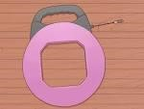
TAPE MEASURE: it is used to measure height for switches and outlets.

HAMMER: it is used to secure boxes equipped with nail on brackets studs in a home.
Its also used to clip down wires in surface wiring.

VOLTMETER: it is used to check voltages and verify that circuits are indeed “live”
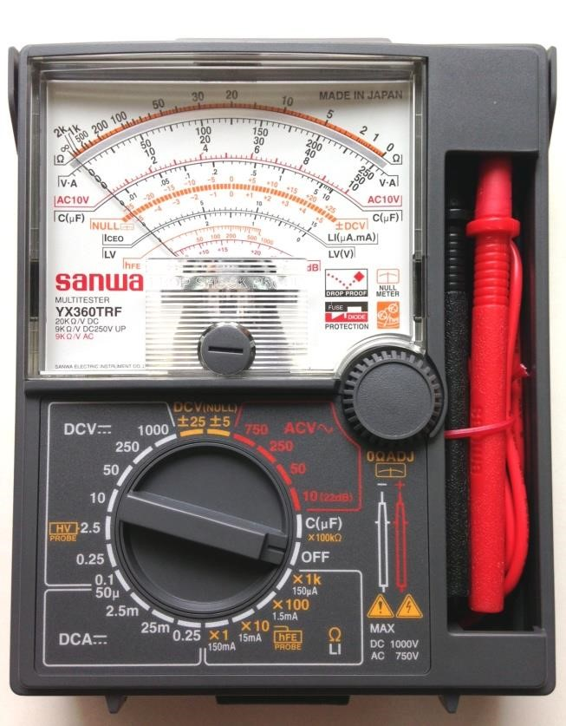
GLOVES: it is used to guide against electrical and mechanical damages to the body.

ALLEN KEYS SETS: it is used to lighted Allen headed screws in electrical works.
BLADE/KNIFE: it is used to cut the installation off the insulated wire.
STAR SCREWDRIVER OR (PHILLIPS SCREWDRIVER): it has a blade for installing star head screw. The tips look like a plus sign.
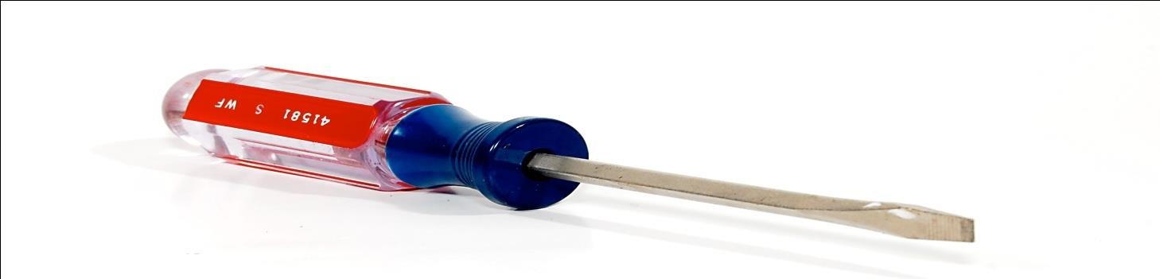
TESTER: it is a tool used to detect the flow of current in the system or in a cable and it comprises of three components inside which are the bulb, insulators and lead.
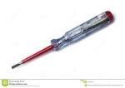
SOLDERING IRON: it is used for soldering of a panel with the use of the soldering bit.
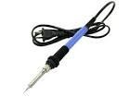

PLIER: it is used for cutting, disconnecting or for remover of installation material like rubber from the conductor, it can also be used to hold material firmly in order to couple the material together. There are various types of pliers which are the Long Nose Pliers and Cutting Pliers.
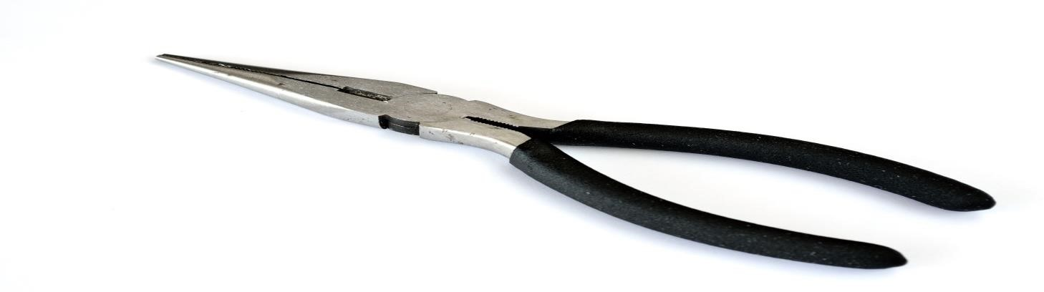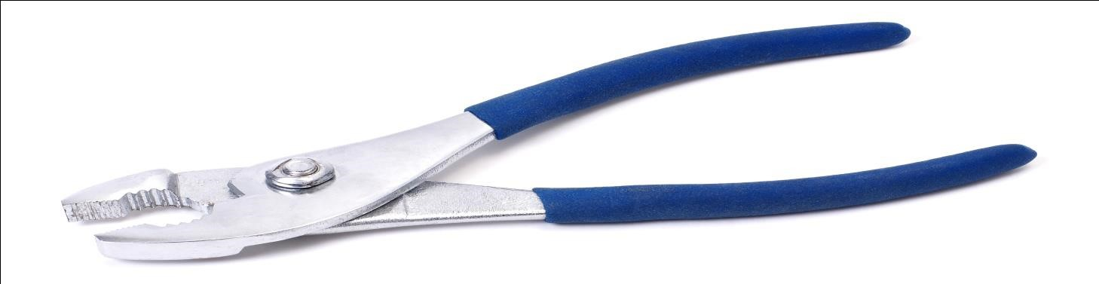

CHAPTER THREE
3.1 Experience Gained
3.2 Installation of pumping machine
Installing a pumping machine involves a few key steps to ensure it operates efficiently and safely. Below is a simplified and general step-by-step guide to help you with the installation process of a pumping machine, such as a submersible pump, surface pump, or jet pump:

1. Preparation and Site Assessment
- Purpose of Pump: Determine what the pump will be used for (e.g., domestic water supply, irrigation, industrial use, etc.).
- Pump Type: Choose the right type of pump:
  - Submersible Pump: For deep boreholes or wells.
  - Jet Pump: For shallow wells.
  - Surface Pump: For open water sources like rivers, lakes, or reservoirs.
- Water Source: Ensure the water source is reliable and accessible (e.g., borehole, river, tank).
- Electrical Power: Ensure there is sufficient and stable electrical power to run the pump (could be from mains electricity or a generator).

2. Gather Materials and Tools
- Pump (submersible, surface, or jet pump)
- Pipes and Fittings: For inlet and outlet connections.
- Power Supply: Electrical cables, switches, and possibly a control panel.
- Tools: Wrenches, pliers, drill (if needed), pipe cutters, and safety gear (gloves, goggles).

3. Prepare the Installation Site
- Borehole or Well: For submersible pumps, ensure the borehole is drilled to an adequate depth and is clean.
- Flat, Stable Surface: For surface pumps, ensure the pump is positioned on a level and sturdy platform.
- Electrical Setup: Check that you have access to a reliable power supply (mains or generator). You may need a dedicated circuit breaker for safety.

4. Install the Pump

For Submersible Pump:
- Lower the Pump into the Borehole:
  - Carefully lower the pump into the borehole or well using a rope or pulley system.
  - Ensure that the pump is positioned properly at the bottom of the well or borehole.
- Connect the Discharge Pipe:
  - Attach the discharge pipe to the pump's outlet. Ensure all connections are secure and tightly fitted to prevent leaks.
  - Connect the other end of the discharge pipe to the water distribution system (storage tank, irrigation lines, etc.).

- Electrical Wiring:
  - Connect the pump to the power supply, ensuring that the wiring is waterproof and safe for underground use.
  - Use waterproof connectors and ensure proper insulation of wires.
  - If applicable, connect the pump to an automatic pressure switch or control panel.

For Surface Pump:
- Position the Pump:
  - Place the pump on a stable, flat surface, such as a concrete base or a metal frame to avoid vibrations.
- Connect the Inlet Pipe:
  - Attach the intake pipe to the pump's inlet and ensure it is securely connected to the water source (river, tank, etc.).
  - Install a filter or strainer to prevent debris from entering the pump.
- Install the Outlet Pipe:
  - Attach the outlet pipe to the pump’s discharge point, directing the water where it is needed (e.g., a tank or irrigation system).
- Connect the Electrical Wiring:
  - Connect the pump to the power source using suitable cables. Make sure the wiring meets safety standards.
  - Install a circuit breaker to protect the pump from electrical faults.
  - Use waterproof electrical connectors if the pump will be exposed to the elements.

5. Test the Pump
- Check for Leaks: Turn on the system and inspect all the connections (pipes and electrical) for leaks.
- Start the Pump: Turn on the pump and check if water flows smoothly through the system.
- Monitor Operation: Observe the pump for any abnormal sounds or issues during operation, like unusual vibrations or overheating.
- Verify Pressure: If applicable, check that the water pressure meets the required flow rate.

6. Final Adjustments
- Pressure Switch Settings (if using an automatic pump): Set the pressure switch to the desired pressure level for automatic start/stop.
- Electrical Settings: Double-check electrical connections, ensure safety measures are in place, and verify that the power supply is adequate.

7. Routine Maintenance and Monitoring
- Regular Checks: Inspect the pump regularly for any signs of wear and tear, and clean any filters or strainers that may be clogged with debris.
- Lubrication: If your pump has moving parts, lubricate them as recommended by the manufacturer.
- Electrical Maintenance: Ensure that the electrical system is checked regularly to prevent faults or short circuits.
- System Monitoring: Keep an eye on the system’s performance, checking for drops in pressure or efficiency.

8. Safety and Compliance
- Follow Safety Guidelines: Always adhere to electrical safety guidelines and ensure that the installation meets local standards.
- Comply with Local Water Regulations: Ensure the installation complies with local water usage regulations, especially for agricultural or large-scale operations.
3.3 HOW TO CONNECT CHANGE OVER SUPPLY

Install the Changeover Switch
The changeover switch should be installed between the main power supply (grid) and the generator, with the load (appliances or electrical system) connected to the output side of the changeover.

Step-by-Step Installation:
- Mount the Changeover Switch:
  - Install the changeover switch at an accessible location on the wall or panel near your main power entry point and generator.
  - Ensure it's mounted securely and is easily accessible for switching.
- Connect the Mains (Grid) Power to the Changeover Switch:
  - Neutral and Live Wires: The live (L) and neutral (N) wires from the main grid power should be connected to the input terminals of the changeover switch. These are typically marked as “L” and “N” on the switch.
  - Earth (Ground): The earth wire (if applicable) should be connected to the earth terminal of the changeover switch.
- Connect the Generator to the Changeover Switch:
  - Live, Neutral, and Earth: The live (L), neutral (N), and earth wires from the generator should be connected to the corresponding terminals on the switch marked for the generator (usually marked as “G” or "Generator").
  - Ensure that you connect the generator neutral wire correctly and securely to avoid any electrical faults.
- Connect the Output (Load):
  - The load output from the changeover switch will be connected to the circuit(s) that will be powered by either the mains or the generator.
  - Connect the live (L), neutral (N), and earth wires from the output terminals to the load distribution board or directly to the electrical system (like a panel board).
3.4 HOW TO REPAIR FAN
Repairing an electric fan can be a relatively straightforward task, but it's essential to follow safety precautions and be aware of potential hazards related to electricity. Here's a general guide to help you with the process:
- Safety First: Before starting any repair work, unplug the fan from the power source to avoid electric shock. If the fan has been running recently, allow it to cool down before handling.
- Diagnose the Problem: Identify what's wrong with the fan. Common issues may include a malfunctioning motor, damaged blades, faulty wiring, or a broken switch.
- Cleaning and Maintenance: Often, the fan's performance can be improved with simple cleaning and maintenance. Dust and debris may accumulate over time and obstruct airflow. Gently clean the blades, grills, and vents with a soft brush or compressed air.
- Checking the Motor: If the fan is not working at all, the motor may be the culprit. Check for any loose connections or burnt-out wires. If you have the technical expertise and equipment, you can use a multimeter to test the continuity of the motor windings.
- Replacing Parts: If you've identified the faulty component, you may need to replace it. Common replacement parts include motors, switches, and power cords. You can find replacement parts online or at hardware stores.
- Fixing the Blades: If the blades are damaged or bent, you can try gently bending them back into shape. However, if they are severely damaged, it's best to replace them to maintain proper balance and airflow.
- Repairing Wiring Issues: Inspect the wiring for any exposed or frayed sections. If you find any damaged wires, carefully cut out the damaged portion and replace it with a suitable wire of the same gauge, using wire connectors and insulating tape.
- Lubricating Moving Parts: If your fan makes unusual noises, it may need some lubrication. Check the manufacturer's guidelines for recommended lubricants and apply them to the necessary parts, such as bearings and moving joints.
- Reassembling the Fan: After completing the repairs, reassemble the fan carefully, ensuring that all components are properly secured. Double-check that you haven't missed any steps before plugging it back in.
- Test the Fan: Once the fan is reassembled and plugged in, test it to ensure that it's functioning correctly and safely. Observe the fan's operation for a few minutes to make sure there are no unusual noises or vibrations.
3.5 How to Install Street Lights
Street lighting is crucial for contemporary urban transportation. It provides illumination for drivers, pedestrians, and cyclists at night. If you are responsible for installing streetlights in your community, it is essential to do so safely and efficiently. This guide offers detailed instructions on street light installation in your community in a safe and efficient manner.

Step 1: Determine the need Before Street Light Installation
Before installing any streetlights, first, determine the need for streetlights. Look at the area where streetlights will be installed and assess the current lighting levels.
- For areas with streetlights:
You will need to evaluate the effectiveness of the streetlights. From there, determine if additional streetlights are required.
- For areas without street lights:
Consider the level of pedestrian and vehicular traffic at night. You will also need to assess the area’s crime rate and any potential safety hazards. Installing street lights will prevent as many of these safety hazards as possible.

Step 2: Obtain the Necessary
PermitsIn the previous step you identified the need for street lights. Next, it will be necessary to acquire the appropriate permits before any installation. Depending on your location, you may need to obtain a permit from your local government or utility company. These permits will usually list the technical requirements for the streetlights. These requirements include the type of lamps and bulbs that can be used, etc.

Step 3: Choose the right equipment
Next, you need to choose the right equipment for your street lights. This will include the lamps, bulbs, and poles that will be used. Choosing superior quality equipment is highly recommended. For example, Luxific makes street lights that can withstand harsh weather conditions.
When choosing bulbs, you want to consider color temperature and brightness levels. The generally recommended color temperature for streetlights is 3000K-4000K. Such streetlights provide warm, natural light that is easy on the eyes. As for brightness, you want to choose a level appropriate for the area where the streetlight will be installed. For example, a busy intersection may need brighter lighting than a residential street.

Step 4: Lay out the location of the lights
Before street light installation, you will need to lay out where the street lights will be installed. It usually involves measuring the distance between each light. You will then need to mark where the light poles will be installed.
It is essential to ensure the lights are adequately spaced from each other. If the lights are too far apart, dark areas may exist between them. On the other hand, if the lights are spaced too close together, the area may be overly illuminated. Both of these situations may pose a safety hazard to drivers.

Step 5: Install the light poles and fixtures
After marking the location, you may proceed with the installation of the light pole and luminaire. First, dig a hole with the pole. Then use concrete to fix it. Finally, install the light fixture on the pole. Ensuring the pole is installed at the correct height and angle is essential. The height of the pole will be determined by the width of the roadway and the desired level of illumination.In general, poles should be installed at 15-25 feet. The angle of the light pole will depend on the roadway’s width and the curve’s angle.

Step 6: Connect the wiring
After the light pole and fixture are installed, you will need to connect the wiring. It usually involves running a wire conduit from the light pole to the power source. The wires are then connected to the luminaire.
Ensuring proper grounding of the wiring and securing all connections is crucial. It will help prevent electrical shorts and other safety hazards.

Step 7: Test the lights
As soon as the street light installation is complete, you must test the lights to ensure they are working properly. You must turn on each light and check for flicker or other problems. You also should ensure that the area’s lighting level is appropriate for the installed fixture.

Step 8: Maintain Street lights
Finally, you should maintain your streetlights. This step ensures that streetlights continue to function properly over time. Clean the fixtures and replace bulbs as needed. You must also perform regular inspections to identify potential safety hazards.

CHAPTER FOUR
4.1 INSTALLATION OF 2000KVA TRANSFORMER

Step 1. Area Considerations
Make sure there is enough fresh air and that there are no sources of ignition or corrosion nearby.
Confirm the transformer's nameplate specifications (kVA, frequency, line voltage, and load voltage) are appropriate for the application.

Step 2. Mount the Transformer
Put the transformer in place carefully.
Then, you should disable the mains power supply by using lockout/tagout procedures. Next is to remove the panel covering the wires.

Step 3. Adjust the Correct Tap Setting
After isolating each secondary tap, make any required adjustments to the primary taps.
Before installing or removing any tap, you must remove the protective coating.
It is necessary to clean the tap and coat it with an electrical compound before you can bolt the wire.

Step 4. Route Wires on The Holes
You can use the existing holes or drill to feed cables into the enclosure.
Wireless ventilated devices must enter the device below the terminals and the coil.
Step 5. Ground the Transformer
Connecting the transformer is straightforward, provided you use the principal wiring diagram found on the label.
Next, ensure that you ground the enclosure adequately under the National Electrical Code and other applicable standards.

Step 6. Energize The Transformer
Check to see if the secondary voltage is sufficient for the load as the power comes on.
Then, inspect if you have shut off the main power using lockout/tagout procedures.

Step 7. Connect to Terminals
Ensure that you connect the load to the secondary terminals. Then replace the power supply's cover.

Step 8. Perform A Final Inspection
Once the transformer arrives at its final site, you must assemble and test it before powering it.
Before turning on the electricity, ensure that you inform everyone working on the transformer.
Remember that inside the transformer enclosure, all connection points are fatal voltage.
4.2 INSTALLATION OF COOKER SOCKET
To install a cooker socket, follow these steps: ensure you are a qualified electrician or consult one before attempting this task; always disconnect power to the circuit before working;
1. Preparation:
- Locate the position:
Decide where you want to install the cooker socket, typically near your cooker and at a suitable height on the wall.
- Check for existing wiring:
Check if there is already a dedicated power cable for the cooker socket at the chosen location. If not, you will need to run new wiring from the fuse box.
- Gather materials:
You will need a cooker socket with appropriate amperage rating, suitable cable, cable clips, a drill, a screwdriver, a wire stripper, and a suitable sized hole saw for the socket box.
2. Electrical work:
- Isolate the power:
Turn off the electricity at the fuse box to the circuit where you plan to install the cooker socket.
- Strip wires:
Strip the ends of the power cable to expose the live, neutral, and earth wires.
- Connect wires to socket:
  - Connect the live wire from the power cable to the marked "L" terminal on the socket.
  - Connect the neutral wire to the "N" terminal.
  - Connect the earth wire to the "E" terminal.
3. Installation:
- Drill holes: Use a drill bit to create the necessary holes for the socket box at the marked position on the wall.
- Fix the socket box: Secure the socket box to the wall using screws or suitable fixing methods.
- Feed cables: Thread the prepared power cable through the hole in the socket box and into the socket.
- Attach the socket: Align the cooker socket with the box and fasten it securely using screws.
4. Final checks:
- Tighten connections:
Double-check that all wire connections within the socket are properly tightened.
- Test the circuit:
Turn the power back on at the fuse box and test the cooker socket with a suitable appliance.
- Check for safety:
Ensure the socket is securely mounted, no exposed wires are visible, and the appliance functions correctly.
Important considerations:
- Consult a professional:
If you are unsure about any aspect of the installation, always consult a qualified electrician.
- Correct amperage rating:
Choose a cooker socket with the appropriate amperage rating for your appliance.
- Dedicated circuit:
Ideally, use a dedicated circuit for the cooker socket to avoid overloading other outlets.
- Earthing:
Ensure the earth wire is properly connected for safety.

CHAPTER FIVE

5.0 CONCLUSION
The student industrial work experience scheme (SIWES) had contributed to my exposure and training in the field of electrical and electronic engineering.
The programme had also enabled me to put into practice the knowledge gained in the classroom with the actual industrial experience and to develop a critical and realistic approach to problems and their solutions in the electric field.

5.1 RECOMMENDATION
The Student Industrial Work Experience Scheme (SIWES) is very interesting and planned. This programme gives me more practical experience of what we have been taught in class because it deals with practical aspect of the field in which I specialized. Moreover, am using this medium to advice government to establish more company and pass the student to this company on their own.
Finally, industrial experience should be given priority by the government.

