
A TECHNICAL REPORT
OF

STUDENT INDUSTRIAL WORK EXPERIENCE SCHEME (SIWES)
HELD AT

DIAMOND 88.7 FM, PLOT 2, NEW YIDI ROAD, IREWOLEDE,
ILORIN, KWARA STATE

BY
KOMOLAFE PELUMI GRACE
ND/23/MAC/PT/0793

SUBMITTED TO THE DEPARTMENT OF MASS COMMUNICATION
INSTITUTE OF INFORMATION COMMUNICATION TECHNOLOGY
KWARA STATE POLYTECHNIC, ILORIN KWARA STATE
IN PARTIAL FUFILMENT OF THE REQUIREMENTS FOR THE AWARD OF NATIONAL DIPLOMA IN MASS COMMUNICATION

AUGUST-NOVEMBER, 2024

DEDICATION
This report is dedicated to my beloved parents, Mr. and Mrs. Komolafe, whose unwavering love, guidance, and teachings have shaped me into the person I am today. Dad and Mom, your wisdom, support, and encouragement have been a constant source of strength throughout my journey. I am forever grateful for the valuable lessons you have imparted on me, teaching me not only about life but also about resilience, determination, and kindness. Your boundless love and sacrifices have been a beacon of light, guiding me through both challenges and triumphs. I dedicate this report to you both as a token of my deepest gratitude and appreciation for everything you have done for me.
ACKNOWLEDGEMENT
I thank God Almighty for his mercy and grace that kept me all through my Industrial Training period.
I am greatly indebted to my parents, Mr. and Mrs. Komolafe for their financial and moral support during the course of the programme and also ensuring that my industrial training was worthwhile and fulfilling one.
I also want to thank everyone that contributed to the success of my industrial training, my industrial supervisor, Engr. Usman I. Salihu my colleagues and co-workers.
TABLE OF CONTENTS
Cover Page
Dedication
Acknowledgement
Table of contents
Chapter One
Aims and objectives of SIWES
Origin of SIWES
Brief History of the Company
Introduction
Chapter Two
What is news?
Elements of news story
Types of news story
Organization chart
News written and interview
Chapter Three
Problem faced during SIWES
Types of Headlines
Front page of a newspaper
Arrangement and paragraph of news story
Terminology used in journalism
Chapter Four
Quality of a good news story
Important of headline in news story
Grammatical rules in writing headlines
Chapter Five
Conclusion
Summary
CHAPTER ONE
AIMS AND OBJECTIVES OF SIWES
- To provide an avenue for students in Institutions of higher learning to acquire industrial skills and experiences in their course of study.
- To provide students with an opportunity to apply their knowledge in real work and actual practice.
- To make the transition from school to the world of work easier and to enhance students contacts for later job placement.
- Prepare students for industrial work situation they are likely to meet after graduation.
- Expose students to work methods and techniques in handling equipment and machinery that may not be available in their institution.
ORIGIN OF SIWES
The Students Industrial Work Experience Scheme (SIWES) was initiated in 1973 by the Industrial training Fund (ITF). It is a tripartite programme involving the students, the Universities and industries. It is founded by the Federal Government of Nigeria and jointly coordinated by the ITF and the National Universities Commission (NUC).
It is a skill training programme designed to expose and prepare students of Tertiary Institution for the Industrial Work situation they are likely to meet after graduation. The scheme also exposing themselves to the needed experience in handling equipment and machinery.
BRIEF HISTORY OF DIAMOND FM 88.7
Diamond FM (88.7 MHz) is a radio station in Ilorin, Kwara State, Nigeria. The station began operating on 22 December 2020.
In 2021, the launch of a sister television channel, Diamond TV, was announced.
Diamond FM is an urban radio station in Ilorin, Kwara State, Nigeria. Our radio waves cover North Central and South Western Nigerian.
We offer exclusive news stories, music and programmes that focus on entertainment, topical issues, community development and corporate social responsibility.
We engage our audience in conversations that add value to their lives and contribute to nation-building. Our vision is to continue earning the trust of our audience through quality reportage, standard content production, entertaining and informative programmes and the right business attitude that encourages growth and community development.
We are relentless in our resolve to maintain professional and ethical standards.
INTRODUCTION
Training is a key factor in enhancing the efficiency and expertise of the workforce. The Students Industrial Work Experience Scheme (SIWES) programme prepares students for labour markets.
It has become an innovative phenomenon in human resources development and training in Nigeria. The media profession, like other professions is dynamic. This dynamism is in response to Information and Communication Technology (ICT).
CHALLENGES OF SIWES TO STUDENT
Problem I encountered during the programme was the problem of transportation. It is difficult for student that lives in far place to get to the organization every working days.

CHAPTER TWO
WHAT IS NEWS?
News is the account of event been gathering and written to the reading pleasure or listen pleasure of the target audience.

ELEMENT OF NEWS STORY
Proximity: We can define it as someone that is closer to you or nearer to you, for example, if a air flight crashes and there are three Nigerians involves in the crash found dead and two hundred Americans dead in the crash, the people closer to you are the Nigerians. If you are ask to report the incident in your Newspaper company. The headline will be THE FEDEDRAL GOVERNMENT OF NIGERIA APPROVE THE SUM OF 70 BILLION GRANT FOR SMEs.

Prominence: This is the act of been important among other, e.g. if the president of Federal Republic of Nigeria visited the Rector Kwara State Polytechnic while commissioning the academic conference centre of the Institution. The most important at the academic conference centre is the president because he is the number 1 citizen of the country.

Timeliness or immediacy: something that is happening now. News is what is new. An afternoon raid on a rock cocaine house may warrant a live ENG report during the 6p.m News. However, tomorrow, unless there are major new developments, the same story will probably not be important enough to mention.

Oddity: Whatever that is strange or unusual.
TYPES OF NEWS STORY
- Feature Story: This story is all about research, for radio or television you interview someone the source of the news story.
- Interpretative or indebt report: It is a story whereby you explain everything in detail account with a background story.
- Promotional Story: It is a story that is meant for promoting a particular person, organization or body.
- Factual Story: It is based on what happen directly telling us what happen or occur in an event.

NEWS WRITING AND INTERVIEW
“EFCC OPERATIVES PRODUCE BINANCE EXECUTIVE IN COURT”
An official of Binance Holdings Limited, Tigran Gambaryan, was in court over allegation of tax evasion.
He and fleeing Nadeem Anjarwalla are expected to be arraigned at the Federal High Court in Abuja.
PUNCH/KOMOLAFE

INTERVIEW
Interview: This is an act of getting news from the source and disseminating it to the audience.
SERIES OF INTERVIEW
One on one interview
Complex interview
Event interview
THINGS YOU HAVE IN MIND BEFORE CONDUCTING AN INTERVIEW
- Background information
- Bold enough to face any interviewee
- You must know what you want to ask about
- You must be very neat
- Serving the interviewee, a notice
- You must allow the interviewee to explain in details
- You must have a recorder (midget)
CHAPTER THREE
TYPES OF HEADLINES
- Rider Headline: This can be bold and tiny, it has sub-headline under it.
- Kicker Headline: It kick start the news directly and is not allowed in newspaper, rather use comma.
- Pan left or right Headline: They are arranged in either left side or right side of the Newspaper.
- Banner Headline: A large Newspaper headline, especially one across the top of the front page.
FRONT PAGE OF A NEWSPAPER
- Most head or name plate
- Name of the Newspaper
- Date
- Amount
- Online address
- Number
- Email
The date, amount, online addresses, numbers, e-mail on the front page of newspaper are called folio.
ARRANGEMENT AND PARAGRAPH OF A NEWS STORY
- The headline
- The byline
- The lead
- The body
- The conclusion
The first paragraph is called the head, the second paragraph must entails the whole 5ws and H, the third paragraph must entails the full story of the lead and the last part of the news is the conclusion.
TERMINOLOGY USED IN JOURNALISM
Alleged
Noted
Stressed
Said
Protest
Played
Blasted
Expressed
Displeasure
Inaugurate
Commission
Debunked

CHAPTER FOUR
QUALITIES OF A GOOD NEWS STORY
Accuracy: It must be very accurate, free from error
Balance: Every part that is involved may say something
Truthful or objective: It must be factual; the story must be truthful exactly what happen
Recent or timeliness
Straight to the point
IMPORTANCE OF HEADLINE IN A NEWS STORY
It must be attracting the reader
It makes readers to decide whether to move further
It makes a Newspaper better sale
GRAMMATICAL RULES IN WRITING HEADLINES
- You must make use of present simple tense. For example, STATE GOVERNMENT CONFOUNDS BURSARY AWARD TO STUDENT
- Always do away with auxiliary verb, for example, if a new policy has been decided by the new parliament.
- Always use infinitive for future event, for example WILL in the headline change to- TO, and in the body it will change to would.
- Leave out article in any news headlines, for example GUN MEN KIDNAPS MAN ASK FOR RANSOME
- Always replace conjunction with punctuation marks, e.g. APC OFFICE INVASION: DSS SHUNS COURT ORDER
CHAPTER FIVE
SUMMARY
The Student Industrial Work Experience Scheme (SIWES) has served as a valuable platform for honing skills related to information processing, management, preservation, and documentation. Through this program, I have gained practical experience that complements theoretical knowledge acquired in the classroom. The hands-on training received during SIWES has been instrumental in bridging the gap between academic learning and real-world application, allowing me to merge theoretical concepts with practical scenarios encountered in the field. As a result, SIWES has significantly contributed to my ability to effectively apply knowledge gained in the lecture room to practical situations, thereby enhancing my overall skill set and readiness for professional endeavors.
CONCLUSION
The evaluation conducted thus far reveals a significant disparity between the intended objectives and the practical execution of the Students Industrial Work Experience Scheme (SIWES). It is concerning to observe that the lack of proper coordination and supervision has emerged as a key factor hindering the full realization of SIWES objectives. This discrepancy underscores the urgent need for collective action from all stakeholders to ensure that students are adequately equipped with the skills and knowledge required for workplace efficiency. The Federal Government, in collaboration with the Industrial Training Fund and other relevant agencies overseeing the SIWES program, must take proactive steps to address the existing shortcomings within the system. By doing so, they can ensure that the loopholes in the system are effectively addressed, thus enhancing the overall effectiveness of the SIWES program and equipping students with the necessary tools for success in their respective fields.
LIST OF STUDIO EQUIPMENTS
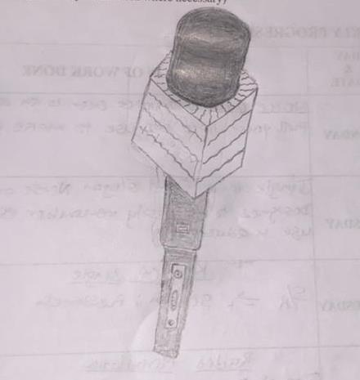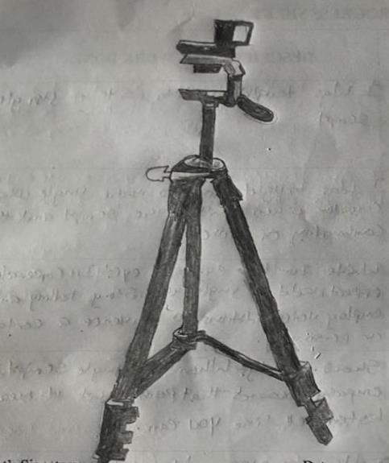
MIC TRIPOD
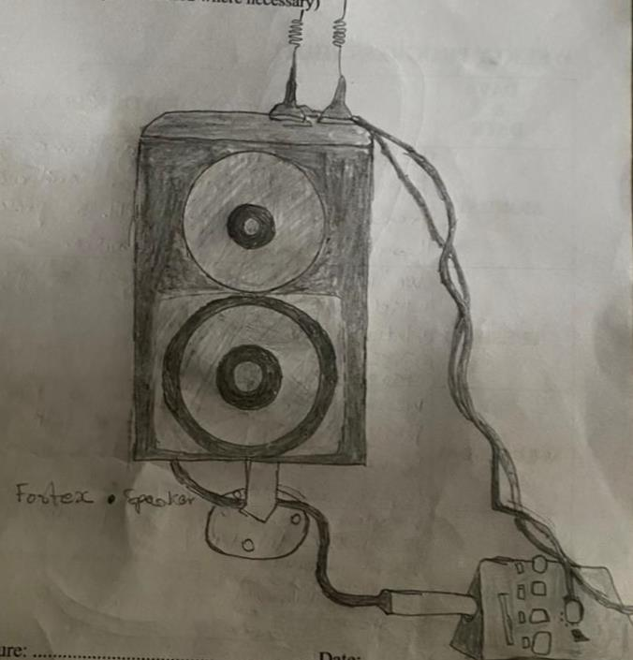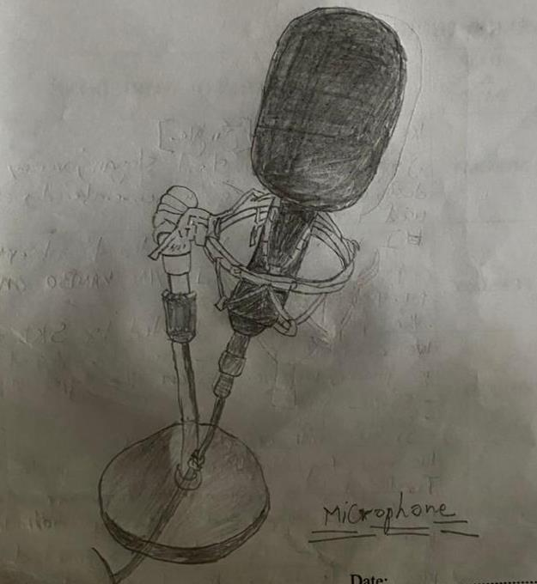
SPEAKER STUDIO MIC
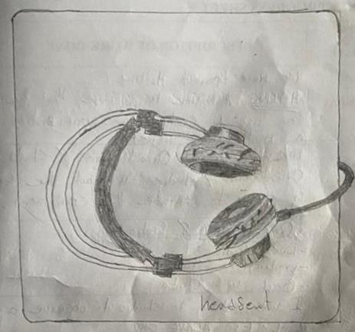
HEAD SET

