A TECHNICAL REPORT
ON STUDENT INDUSTRIAL WORK EXPERIENCE SCHEME
(SIWES)

UNDERTAKEN AT

KWARA STATE RADIO BROADCASTING CORPORATION
(99.1 MIDLAND FM RADIO KWARA)

BY
YUSUF WASILAT ALAKE
ND/22/MAC/PT/1253

SUBMITTED TO THE DEPARTMENT OF MASS COMMUNICATION, INSTITUTE OF INFORMATION AND COMMUNICATION
TECHNOLOGY, KWARA STATE POLYTECHNIC, ILORIN KWARA STATE

IN PARTIAL FULFILMENT OF AWARD OF ORDINARY NATIONAL
DIPLOMA IN THE DEPARTMENT OF MASS COMMUNICATION 14/08/2023 - 28/11/2023

CERTIFICATION
This report certify that I, YUSUF WASILAT ALAKE of matriculation number ND/22/MAC/PT/1253 declares that I undergo a three months Student Industrial Work Experience Scheme (SIWES) Training at 99.1 Midland FM Radio Kwara, Ilorin, KwaraState Nigeria. And that this report was written by me and to the best of my practical knowledge in the course of the program.

DEDICATION
I dedicate this Student Industrial Work Experience Scheme (SIWES) training report to Almighty Allah for his protection and who endowed me with knowledge, wisdom and understanding throughout my industrial training. Also dedicate this piece of work to my parent.

ACKNOWLEDGEMENT
All thanks to my beloved parent, my departmental HOD, lecturers and staff of Mass Communication, Radio Kwara’s Staff, my colleagues, Supervisors and colleagues for their financial and moral support.

TABLE OF CONTENTS
COVER PAGE i
CERTIFICATION ii
DEDICATION iii
ACKNOWLEDGEMENT iv
TABLE OF CONTENTS v
CHAPTER ONE: INTRODUCTION
1.1 Background 1
1.2 Objectives 2
CHAPTER TWO: DESCRIPTION OF THE ESTABLISHMENT OF ATTACHMENT
2.1 History of Kwara State Broadcasting Corporation (Radio Kwara) 4
2.2 Objectives of Radio Kwara 4
2.3 Organization Structure (organogram) 5
2.3 Overview of various departments and functions 6
CHAPTER THREE: WORK DONE/SERVICE RENDERED
3.0 Outline of work done 6
3.2 Description of work Done 6
CHAPTER FOUR: CONTINUATION OF DESCRIPTION OF WORK DONE 12
CHAPTER FIVE: SUMMARY, CONCLUSION & RECOMMENDATION
5.1 Summary of attachment activities 14
5.2 Problems encountered during the program 14
5.3 Suggestions for the improvement of the scheme 15

CHAPTER ONE

INTRODUCTION

1.1 BACKGROUND
According to Ochiagba (1995), Practical knowledge relates to doing. Practical knowledge is learning without which mastery of an area of knowledge may be too difficult to achieve. Practical knowledge involves developing skills through the use of tools or equipment to perform tasks that are related to a field of study.
No society can achieve meaningful progress without encouraging its youths to acquire necessary practical skills. Such skills enable them to harness available resources to meet the needs of society. It was against this background that SIWES, otherwise referred to as Industrial Training (IT) was introduced in Nigerian tertiary institutions.
SIWES is a skill development program designed to prepare students of universities, polytechnics/monotechnics and colleges of education for transition from the college environment to work (Akerejola, 2008).
Eze (1998) points out that government has recognized the importance of SIWES through the establishment of the Industrial Training Fund (ITF). The ITF was established in 1971 and was charged with human resources development and training. Following the establishment of ITF, SIWES commenced in 1974 with the aim of making education more relevant and to bridge the yawning gap between the theory and practice of engineering, technology and science-related disciplines in tertiary institutions in Nigeria. Participation in SIWES has become a necessary pre-condition for the award of Diploma and Degree Certificates in specific disciplines in most institutions of higher learning in the country, in accordance with the education policy of government. The operator is ITF, the coordinating agencies include (NUC, NCCE, NBTE), employers of labour and the Institution, funding is from the Federal Government of Nigeria, beneficiaries are undergraduate students of the following: (Agriculture, Engineering, Technology, Environmental, Sciences, Education, Medical Science and Pure and Applied Sciences), duration is four months for polytechnics and colleges of Education and six months for universities.

1.2 OBJECTIVES OF SIWES
An examination of the extent of attainment of the objectives of SIWES is germane and pertinent in appraising the effectiveness of the scheme. Generally-speaking, there is consensus amongst stakeholders that SIWES has broadly met its objectives. The interim report of the research conducted by the ITF into SIWES and presented during the 11th Biennial SIWES conference indicates that the scheme has contributed over the years in enhancing the quality of technical skills that are available in the economy.
However, not all participants in SIWES have the same opportunity with respect to quality placement nor derive the same benefits from participation in the scheme. It is necessary, therefore, to reposition SIWES to fully subscribe to and to implement the internationally accepted tenets of Cooperative Education which promotes work-integrated learning. For example, the objective of SIWES to enlist and strengthen employers’ involvement in the entire educational process can be enhanced through incorporating feedbacks from employers on the technical skills that are required by industry in the design of set curricula in tertiary institutions.
The specific objectives of SIWES were summarized by the Federal Government in its
Gazette of April, 1978 as follows:

- To provide an avenue for students in institutions of higher learning to acquire industrial skills and experiences in their course of study.
- To provide students with an opportunity to apply their knowledge in real work and actual practice.
- To make the transition from school to the world of work easier and to enhance students contacts for later job placement.
- To expose students to work methods and techniques in handling equipment and machineries in their institutions.
- Enlist and strengthen employers’ involvement in the entire education process and prepare students for employment in Industry and Commerce.
- With all the experiences and knowledge acquired, it is hoped that the students will be able to choose appropriate work upon graduation.

CHAPTER TWO

2.1 HISTORY OF 99.1FM RADIO KWARA
Kwara Radio, also known as "Radio Kwara," is a state-owned radio station in Nigeria. It is located in Ilorin, the capital city of Kwara State, which is situated in the western part of the country. The station was established on April 1, 1974, during the military administration of Colonel Ibrahim Taiwo, the then military governor of Kwara State.
Kwara Radio was established to provide broadcasting services to the people of Kwara State, offering a platform for news dissemination, entertainment, educational programming, and cultural promotion. Over the years, the station has grown to become a significant voice in the state, playing a crucial role in informing, entertaining, and educating its audience.
Located strategically in Ilorin, Kwara Radio serves as a vital communication medium for the diverse population of the state, broadcasting in various languages and dialects to cater to the linguistic diversity of the region. The station has likely undergone technological advancements and renovations to keep pace with the evolving broadcasting landscape and the changing needs of its audience.
2.2 OBJECTIVES OF RADIO
Radio Kwara, like many other radio stations, typically aims to fulfill several objectives, which may include:
- Informing: Providing accurate and up-to-date information to listeners about local, national, and international news, events, and developments.
- Educating: Offering educational programs that cover a range of topics such as health, agriculture, entrepreneurship, civic education, and more. These programs aim to enlighten and empower listeners.
- Entertaining: Broadcasting entertainment content such as music, dramas, comedy shows, and interviews with celebrities or local personalities to keep listeners engaged and entertained.
- Promoting Culture and Tradition: Showcasing the cultural heritage, traditions, and values of the local community through programs that celebrate local music, folklore, history, and customs.
- Community Engagement: Serving as a platform for community engagement by airing discussions, debates, and phone-ins on issues that affect the community, allowing listeners to voice their opinions and concerns.
- Promoting Development: Supporting community development initiatives by raising awareness about social issues, promoting public health campaigns, and advocating for positive change within the community.
- Advertising and Promotion: Providing a platform for businesses, organizations, and government agencies to advertise their products, services, and initiatives, thus contributing to economic growth and development in the region.
- Building Unity and Cohesion: Fostering a sense of unity, cohesion, and belonging among listeners by promoting tolerance, understanding, and respect for diversity.

2.3 ORGANIZATIONAL CHART (ORGANOGRAM)
Like all other frequency modulated station Radio Kwara is headed by general manager who direct and regulates the activities of the seven department that make up the station each department which includes news department programs department marketing all as its head.

2.3 OVERVIEW OF VARIOUSLY DEPARTMENTS 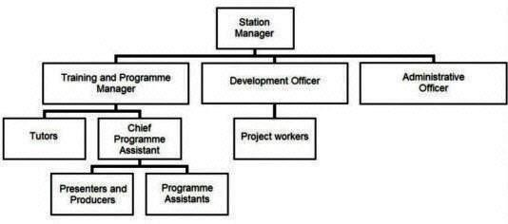

O
R
G
A
N
O
G
R
A
M

O
F

R
A
D
I
O

K
W
A
R
A

- General Manager/Director: Responsible for the overall management and operation of the radio station. This individual oversees all departments and ensures that the station meets its objectives and goals.
- Programs Department
  - Programs Manager: In charge of planning, developing, and scheduling radio programs. This department includes producers, presenters, and content creators.
  - News Desk: Responsible for gathering, reporting, and broadcasting news and current affairs programs.
  - Music Department: Handles the selection and scheduling of music content for various programs.
- Technical Department
  - Technical Manager: Oversees all technical aspects of the radio station, including broadcast equipment, maintenance, and transmission.
  - Engineers: Maintain and repair broadcasting equipment, ensure the quality of audio output, and manage transmission facilities.
- Sales and Marketing Department:
  - Sales Manager: Leads the sales team in selling advertising slots and sponsorships.
  - Marketing Manager: Develops marketing strategies to promote the radio station and attract advertisers and listeners.
- Administration and Finance Department:
  - Admin Manager: Manages administrative tasks such as human resources, payroll, and office management.
  - Finance Manager: Handles financial matters, including budgeting, accounting, and financial reporting.
- Creative Services Department:
Creative Director: Oversees the creation of promotional materials, advertisements, and branding initiatives for the radio station.
- Community Relations/Outreach Department:
  - Community Relations Manager: Coordinates community engagement activities, outreach programs, and partnerships with local organizations.
- Digital Media Department:
  - Digital Media Manager: Manages the station's online presence, including social media, website content, and digital marketing efforts.

CHAPTER THREE

3.0 WORK DONE IN BROADCASTING AND NEWS AND CURRENT

AFFAIRS DEPARTMENT
VOX POP: this means sampling people's opinions on a particular issue I also participated in this aspect issues. I was assigned to with few of my colleagues to interview sellers in the market during the wake of the market subsidy which was instructed to take effect in Nigeria. We were able to summon courage and interview people in other to gain information and know their say on the current issue on ground.
INTERVIEW: is a conversation in person between a journalist and someone whose opinion he or she wishes to record for publication
I was introduced to the station recording studio, it is a studio in the organization a room set of equipment important to carry out communication process through a radio wave. It is well prepared room where broadcast takes place.
Equipment there are as follows: Microphones, amplifier, telephone, CD player headset and console. I was able to record a program which lasted for an hour in the recording studio.
SOURCE FOR NEWS: I was taught on how to gather news from a credible sources and also made mention of some of the credible news sources which includes: BBC, Tribune, AIT, The nation newspaper e.t.c
EDITING: I was also taught how to edit news making use of the inverted pyramid style and I was also asked to edit some of the news in such a way that it will sound captivating and interesting in the ears of the listeners thereby making it credible. I was also asked to create a program which is presentable on air without breaking the rules of NBC
I was asked to create a jingle which I also recorded in the recording studio which was broadcast on air and that added to my knowledge in this field of study.
I also acquired more knowledge from other departments in the station like the programme where I joined others to do news transition from English to Yoruba and I was also opportune to know how things are being done in the recording studio wherein I was thought how recording was being done.
I was also taught some theory aspects in the news department which includes studio monitor speakers that is used to provide information on what um is going on on air and it is also used to monitor abnormalities and sound quality can also be detected it provides and helps those in the news departments to further know how to improve um their voice speech as well as monitoring other news stories that are being reported in order radio stations so as to gain more knowledge in order to be strongly competitive in the market without losing audience interests.

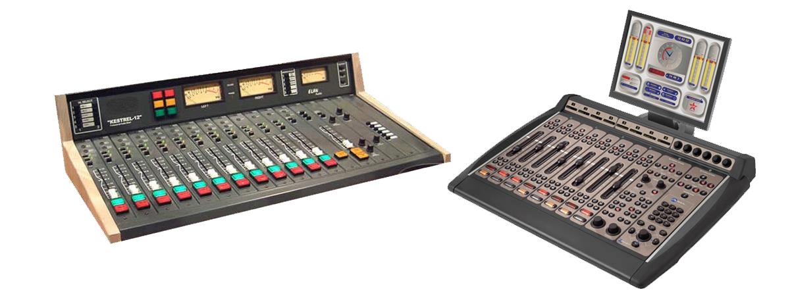SOME EQUIPMENTS INTRODUCED TO STUDENT AND BEEN USED IN
RADIO STATION
S

A
UDIO
CONSOLE

The
heart of any studio is the audio console (sometimes called a rad
io
panel,
sound
panel, or sound desk). This is the interface the radio announcer (or panel operator) uses to control what’s heard on air. Every channel represents one “input”. The fader (slider) attenuates or amplifies the incoming signal.
Radio Audio Consoles are very different from a regular PA or Live Sound audio console, and are often more expensive than PA audio consoles as they are purpose-built for on-air talent ease of use. When you turn a microphone on or off, a radio console will mute any speakers and illuminate an “on air” light. When you turn a CD Player, Phone or Computer channel on, often it will “trigger” that input so it starts playing immediately.
While analog audio consoles have the physical audio flow directly through the console’s circuitry, many radio stations now use Digital Audio Consoles – these are actually a remote control for a Mix Engine (often located in the rack room).
MICROPHONE
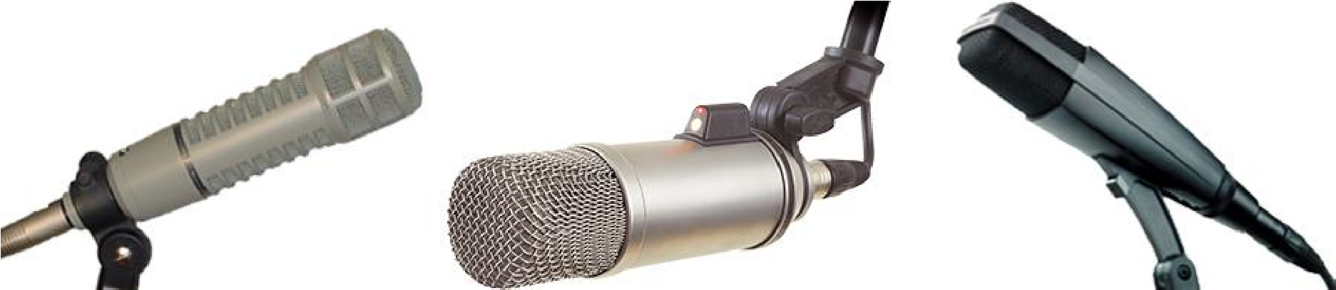

A microphone captures sounds from the studio and turn it into electrical impulses. Broadcast microphones are designed a little differently to PA microphones, as issues such as feedback (the squealing sound that can come through speakers) isn’t an issue in a studio.
Experienced audio announcers will often have a favourite microphone. Common microphones include ElectroVoie RE20, Sennheiser MD421, and Rode Broadcaster.
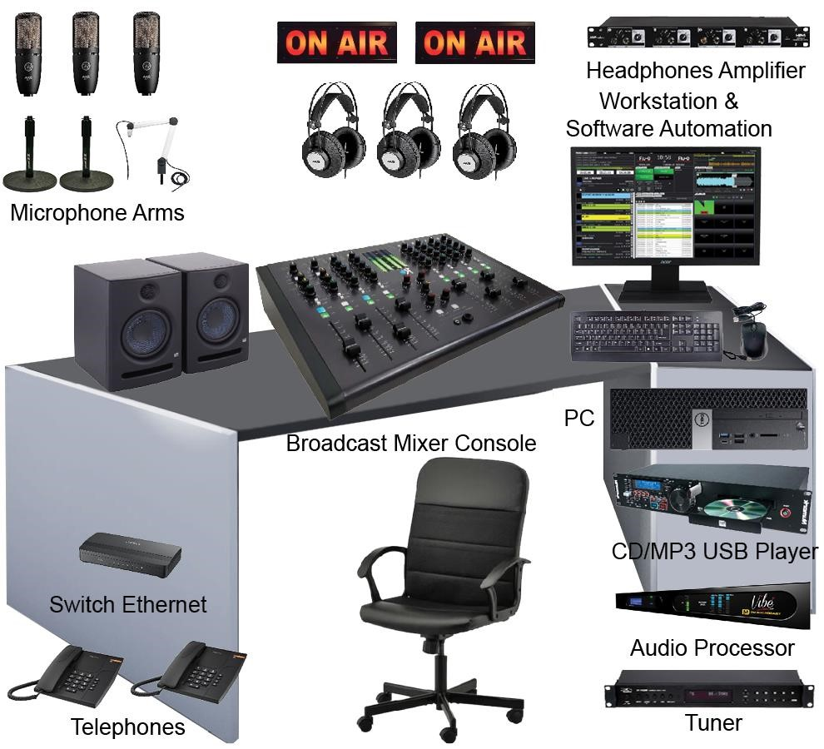
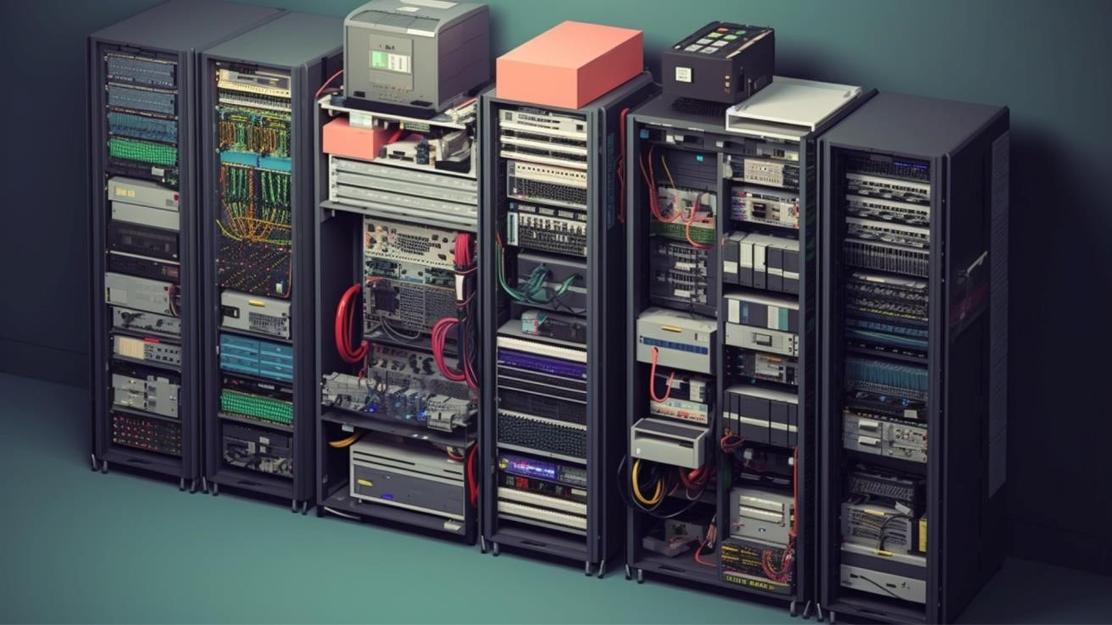
TRANSMISSION ROOM

CHAPTER FOUR

CONTINUATION OF EXPERIENCE GAINED
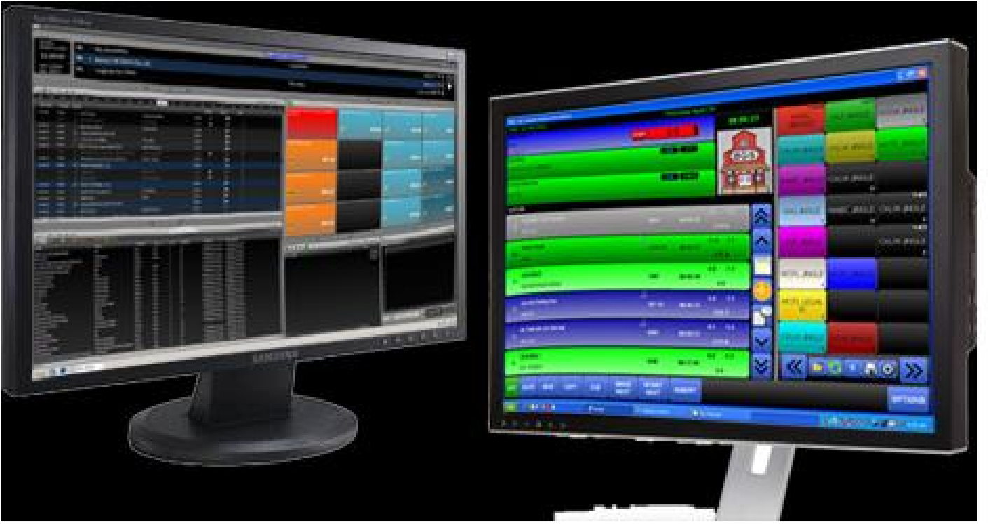
The computer system that plays back music, spots (ads, promos, etc.) and sweepers (the little voiceovers played between songs) is called a Playout System or Automation Software. These are specially designed computer programs that allow for continuous playback of audio, with a lot of granular control for Announcers and Programme Directors.
At the heart of any Automation System is the “log”. This is a sequential list of all audio files and commands that need to be played at certain times. All music played on a commercial radio station will be pre-programmed by the Music Director and loaded into the log. A separate person will often load all advertisements into the same log.
Most automation systems also contain a music database, hot keys (to play ad-hoc audio), an audio editor, segue editor (to change the mix between different elements), interfaces for website and RDS data, and a lot more.
LEVEL METERS
To ensure output of a station is somewhat consistent, radio studios contain different Level Meters. These allow the announcer or panel operator to see if their audio is too loud or too quiet at any given time.
Often, you’ll have multiple meters showing the levels at different points in the signal chain.
Some radio stations also provide phase meters along side level meters. This helps you detect mono content, and spot any problems in source material that are likely to cause issues with the stereo image.
STUDIO MONITOR SPEAKERS

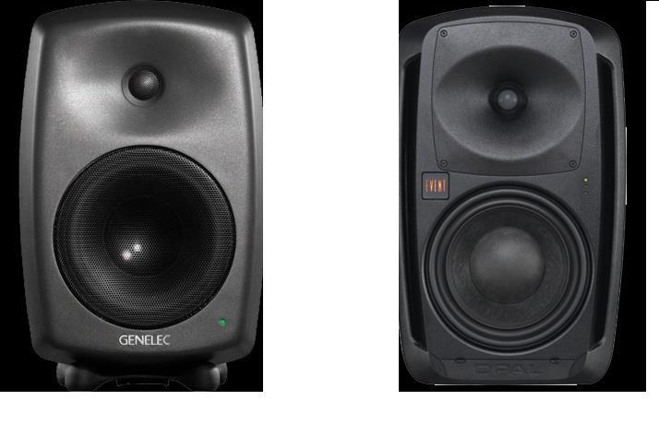

Studio Monitor Speakers provide an easy way to hear what’s going to air without headphones. Often, these are very high quality speakers so any abnormalities in sound quality can be detected.

CHAPTER FIVE

SUMMARY, CONCLUSION AND RECOMMENDATION

5.1SUMMARY OF ATTACHEMENT ACTIVITIES
With regards to the 12 weeks industrial training undergone, I can strongly attest to the fact that the Student Industrial Work Experiences Scheme are highly important program for all Mass Communications students, this training has exposed me to skills that a Mass Communicator needs to utilize and apply in their feed, break the gap between theory and practical aspects and has also given me a sense of provisional work ethics as journalists to be. The training has made me a better reporter and a better writer as I now adopt what as length as the students industrial work experience scheme in what I do. I am proud of my feet now then I was before knowing full word that without us the nation will be in darkness of what is going on. We are the bedrock of information in the world whatever we put out is the most accurate and precise.
My experience at Radio Kwara has brushed me up and unveiled the inner me into a breaded reporter. My experience was indeed worthwhile through with the help of other intern and staffs I worked with.

5.2 PROBLEMS ENCOUNTERED DURING THE TRAINING
The success of my training is undisputed, but it was not devoid of rough edges. Some of the challenges include:
- Radio Kwara is government owned media comes with its own strict rules. Interns are not also allowed to go on air which is a major disadvantage on our part. In news department which I am the intern students are only allow following the presenter to the live studio and are not allowed casting news
- Some of my colleagues there in the establishment are not ready to learn and so whenever the supervisor senses an atmosphere of unseriousness the entire students under his supervision will be dealt with and this was a great burden upon me.
- The issue of expensive transportation, due high cost of transportation, much money was spent.

5.3 SUGGESTION FOR THE IMPROVEMENT OF THE SCHEME
- Interns should be allowed to go on air after they have been trained and properly tested
- Regular maintenance of equipment should be carried out to avoid machine breakdown and
failure
- Students undertaking internship should understand the importance of the training and not joke about it. They should use this opportunity to be hardworking and enterprising.
- Stipends should be added to help interns on daily expenses.

