REPORT ON

STUDENT INDUSTRIAL WORK EXPERIENCE SCHME
(SIWES)
AM MEDIA TV LAGOS STATE NIGERIA
BY
BUHARI AMINAT ARIKE
ND/23/MAC/PT/0059
IN PARTIAL FULFIMENT OF THE REQUIREMENT FOR THE
AWARD OF NATIONAL BOARD FOR TECHNICAL EDCATION (NBTE)

SUBMITTED TO
DEPARTIMENT OF MASS COMMUNCATION KWARA STATE POLYTECHNIC, ILORIN.

AUGUST TO DECEMBER 2024.

TABLE OF CONTENT.
Certification____________________________________i
Dedication_____________________________________ii
Acknowledgement_______________________________iii
Abstract_______________________________________iv

CHAPTER____________________________________1
1.0 Introduction to siwes
1.1 Background of siwes
1.2 Objective of siwes
1.3 Place of attachment
1.4 Location and brief history of attachment
1.5 Organization structure
CHAPTER______________________________________2
2.0 The studio
2.1 The television studio
2.2 Studio terminologies
2.3 Items in the television studio
2.4 Production light
2.5Types of light in production
CHAPTER____________________________________________3
3.0 The microphone
3.1 Types of microphone
3.2 The console
3.3 The video camera
CHAPTER______________________________________________4
4.0 Summary
4.1 Recommendation and
4.2 Conclusion
4.3 Problem encountered
4.4 Possible solution

CERTIFICATION
This is to certify that I participated in the four months industrial work experience scheme (SIWES) at Am Media Lagos State. between August to December 2025.

---------------------- -------------------
Student name Date

---------------------- -------------------
Supervisor Date

---------------------- ------------------
Siwes Coordinator Date

DEDICATION
To my entire family, who’s struggled to give me a solid educational background. This eventually paved way for my polytechnic education (ND).

ACKNOWLEDGEMENT
I thank GOD almighty and I give all the glory, honour and adoration for His mercy over my life during the course of my study and when undergoing my Industrial Training.
My appreciation also goes to my Industrial Based lecturer; MR. MUSA MURITALA BADA whose accessibility, untiring effort, patients, guidance and suggestions fabulously contributed to the completion of this report, may GOD continue to guide and protect her and her family.

ABSTRACT
This report gives a good account of training and experience which I was exposed during the student industrial work experience scheme (SIWES) at Am Media Tv Lagos Stste. This report comprises of seven chapters. Chapter one is about student industrial work experience scheme (SIWES) and about place of attachment. The chapter two is about studio, television studio, items in the studio and studio terminologies.

CHAPTER ONE
1.0 INTRODUCTION TO SIWE
The student industrial work experience scheme (SIWES) can be defined as a technical skill and acquisition of knowledge from the organization, industrial sector. It also serves as a motive that compliments the learning which student have acquired in the classroom or theoretically.

The student industrial work experience scheme is in practical fulfillment of TCS 210 of becoming a competent student in the field. It is a major work which is to expose student to the practical aspect of what they are been thought in class. During the course of study, I was posted to the programs department of the establishment.
1.1 BACKGROUND OF SIWES
The student industrial work experience scheme (SIWES) was established by ITF in 1973 to solve the problem of lack of adequate practical skill preparatory for employment in various industries by Nigerian graduates of tertiary institution.
The purpose of the scheme is to expose student to different kinds of industrial based skills necessary for a smooth transition from classroom to the world of labor. It afford the student of tertiary institution the opportunity of being engaged, familiarized and expose to the needed experience in handling various kinds of equipment and machine which are usually not available in the educational environment or institution.
However, participation in siwes has becomes a necessary pre-condition for the award of diploma in most institution of higher learning in the country, in accordance with the education policy of the government.

1.2 OBJECTIVES OF SIWES
The objectives of the student industrial work experience scheme (SIWES) as a follow:

- It improves student’s knowledge about the industrial sector or organization.
- It enable the student to practicalised different test form what they have learnt theoretical in the classroom.
- It relates the student to the labor market and how it’s being operated.
- It also enlighten student to various division of industries or organization of work in which their course of study can be practicalised.
- It enable student to know more the technological innovation in course of study, and some equipment which are or involved.
- It enable student to know the practical aspect of chosen field of study.
1.3 Description of the establishment of attachment.
The Nigeria Television Authority, Ilorin was established in 1977. Its maiden transmission of programmed was from Lagos via satellite.
Between 1977 and date, the station has undergone tremendous changes which today have made it the toast of viewers and clients within and outside the state.
At present, the station has staff strength of ninety-one, headed by the General Manager T.R Gyang and it transmits 24 hours on weekdays.
1.4 LOCATION AND BRIEF HISTORY OF AM MEDIA TV LAGOS
Although the idea of establishing a television station in kwara state was conceived as far back as 1971, some early teething problem did not make for its takeoff. Following a meeting in 1971 by a number of journalists who are indigenes of the state with military Governor Lieutenant-colonel Lasisi Bamigboye, the idea of establishing a newspaper and television station was conceived both of which was considered necessary for the state.
The then government gave its blessing to the immediate establishment of a newspaper, while accepting the idea of a television station in principle. The newspaper, known as “Nigeria Herald” started two years (1975) while feasibility studies for the television also started the same year. The change of Government in 1975 threatened the establishment of the station in Ilorin, but in view of the large sum of money already into the project, there could be no going back.

Board of director
Commercial managers
Announcers
Reporters
Maintenance supervisor
Transmitter manager
Sales manager
Accounting technical
Sales representative
Accountancy
General Manager
Director of Programme
Engineering
Commercial
Controller programmes production.
Editors
Engineers
Manager News and current affairs
Account
Producers
Manager programmes
Controller News and current affairs
Administration department

1.5 Objectives of Establishment.

The objective Am Media Tv seeks to achieve is synonymous with the corporation objective of Television Broadcasting in the country. Television as a medium seeks to enrich the life the Nigerians by influencing her social, cultural, economic political and technological views. Other includes:
- To educate, inform and entertain.
- To contribute to the development of national unity and strive for continuing expression of the Nigerian identity.
- To enhance:
A united, strong and virile nation.
A land of bright and full opportunities for all citizens.
The station, in pursuit of its goals in its locality and reads its news in local language of Batonum, Nupe and Yoruba.
In its effort at promoting harmony through its various programmes, the station changed its application from ‘The station of Harmony’ to ‘Promoting Harmony through Broadcasting’. Given this new vision programmes transmitted.
It is remarkable that management and staff Am Media Tv Lagos State are united in their bid to ensure and sustain excellent service delivery.

CHAPTER TWO

2.0 THE STUDIO
The word studio is derived from the Italian word; studio, from Latin: stadium, from studere: meaning to study or zeal.
A studio is an artists or workers workroom, or the catchall term for an artist and his or her employees who work within the studio. This can be for the purpose of Architecture, painting, pottery (Ceramics), sculpture, scrap booking, photography, graphic design, film making, animation, radio or television production broadcasting or the making of music.
2.1 THE TELEVISION STUDIO
A television studio is an installation in which a video production takes place, either for the recording of live television to video tape, or for the acquisition of raw foot age for post-production. The design of a studio is similar to, and derived from, movie studios, with a few amendment of the special requirement of television production. A professional television studio generally has several rooms. Which are kept separate for noise and for particular reasons. These rooms are connected via inter com, and personnel will be divided among these workplace.
2.3 STUDIO TERMINOLOGIES.
- Tracking: this is a studio term use to control the camera man to move the entire camera along with the tripod to another position. Tracking is for moving in relation to the thing filming or recording.
- Zoom in and out: this is a studio term use to control the camera man to show the object that is being filming and recording from close or further away with the use of a zooming lens.
- Pan left and right: this is a studio term use to control the camera man to turn the camera without moving the entire camera with the tripod to get a good picture or emotional picture.
- Tip up and down: this is a studio term use to control the camera man to bring up or down the camera without moving the whole camera.
- Cue: this is a studio term that the camera man use to command the presenter to start action, the camera man give a signal to the presenter to start.
- Cut: a cut is a term use in a production to stop filming or recording, each stopping in a filming or recording is called a cut.
2.4 ITEMS THAT CAN BE FIND IN A TELEVISION STUDIO
The studio floor is the actual stage on which the actions that will be recording take place. A studio floor has the following characteristics and installations:
- SETS CONTRUCTION: I s the process by which a set designer works in collaboration with the director of a production to create the set of a theatrical film, or television production. The set designer produces a scale model, scale drawing, paint elevation and research props, textures, and so on. Model and paint elevation are frequently hand produced through in recent years, many designers and most commercial theatres have begin production scale drawing with the aid of computer drafting programs such as AUTO CARD or VECTOR works.

2.5 PRODUTION LIGHT
Studio lightening it enables the camera to see and take clear picture and to provide the viewer with important virtual information about an event such as space area, time of the day and even mood of an event.
2.6 TYPES OF PRODUCTION LIGHT
- Base lightening: this is general studio lightening which is soft and not hard, it is directed to any particular place and therefore does not create much shadow. However the lightening is enough for a television camera to transmit acceptable picture.
- Modern lightening: this lightening usually directed toward a specific sense or performance. It contain three base light namely; key light, fill light, back light.
  - The key lights are directional, very strong and illuminate the subject, but one disadvantage is that it creates shadow.
  - Fill light reduce the hardness of the shadow.
  - The backs light on the other hand outline the subject and separate him/her from the background.
- Red harded lightening: this is usually use to change the color of a particular background with the help of using gel of any color and the color will infect in the object, for a particular purpose.

CHAPTER THREE
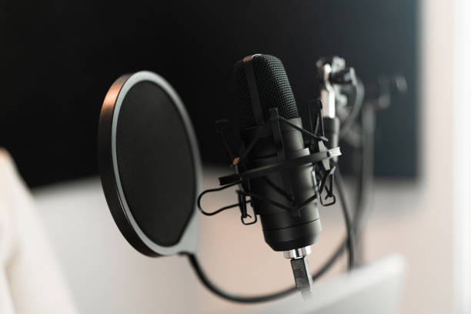
3.0 MICROPHONE

The microphone is also important equipment needed by broadcaster in the discharge of their daily duties. Microphones are several type but they perform one function that of magnifying the voice of the artist as fear as program production is concerned. Microphone converts sound energy into electrical energy.
3.1 TYPES OF MICROPHONE
- Uni-directional microphone: this type of microphone can be used in one direction. It can only handle about two person ant not more than that and the person must position in one direction.
- Omni-directional microphone: this type of microphone usually has a long cable and be extended over a considerable space within a given area. It can be easily use for outside broadcasting.
- Bi-directional microphone: this kind of microphone can be directed at the voice from different direction at the same time. This type is most suitable for interview and group discussion program.
- Nick microphone: this is a small electronic cup-on the microphone which is extensively use for speech pick up, it can be use to libel, shirt or tie and may be hidden beneath the clothing.
- Hanging microphone: this type of microphone, it is suspended over the action area and is effective for area sound pick such as choir or orchestra.
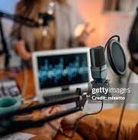
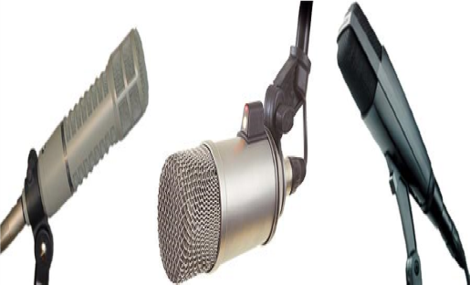

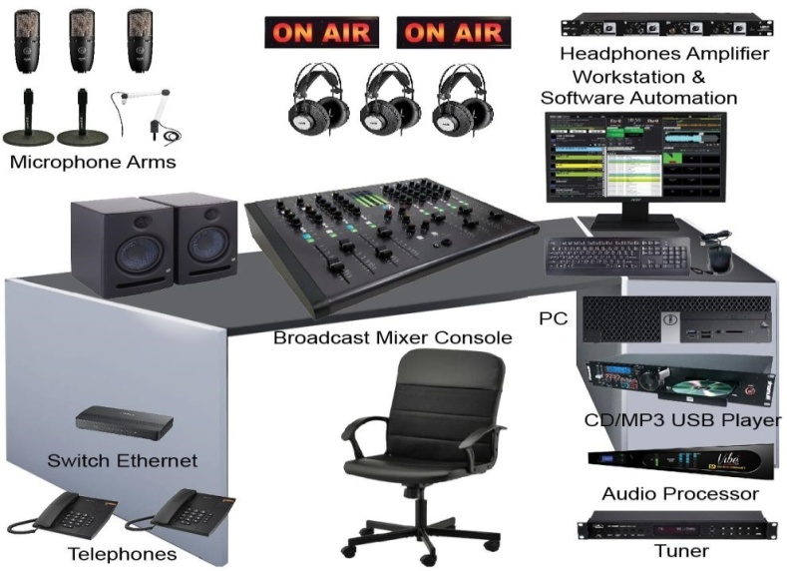

3.2 THE CONSOLE
The console is the link between the microphone and the recording channel, it is equipped with faders, equalizer, various button and switches, they are use to regulate and modulate signal

3.3 THE VIDEO CAMERA
A video camera (often called a television camera even through the use has spread beyond television) is a high-end device for creating electronic moving images that record the originally developed for use in television station, they are now commonly use for corporate and education videos, music videos and direct-to-video movies. There are two types of professional video camera:
- Television studio camera: which link the recording capability of a camcorder, and are often fixed on studio pedestal, or tripod to get a good caption for the viewers.
- High end portable recording camera (essentially, high end tapeless camcorders) use for electronic news gathering (ENG) and electronic field production (EFP) portable professional camera are generally much large then the consumers and are designed to be carried on the shoulder.

CHAPTER FOUR
SUMMARY, RECOMMENDATION AND CONCLUTION.
4.0 SUMMARY
Having passed through my four months of industrial traiting at the socially responsible station, Am Media Tv Lagos State, one should see thay thousands of people are transformed with this medium.
The work of broadcast station is to inform, educate and also entertainit audience. As a student that had undergo the traiting mainly on programmes which had a lot of experiences and knowledge concerning production of programs.
4.1 RECOMMENDATION
The training is a great previlledge for student to know more about this course and also know practically the handling of the practical aspect of this course.
4.3 CONCLUTION
I therefore conclude that broadcas station help in transforming many lives.
More so, I wish to state here that the training has been a memorable one.
4.4 SUMMARY OF ATTACHMENT ACTIVITIES
The summary of work carried out, Am Media Tv Lagos State I was deploy to has different units which include; camera handling, film making, editing, teams of production, etc.
4.5 PROBLEM ENCOUNTERED DURING THE PROGRAMME.
The problem uncounted during the programme was financial problem.
4.6 SOLUTION TO PROMLEM ENCOUNTERED DURING THE PROGRAMME.
The government should provide financial to all students that did the programme.

