REPORT OF
STUDENT INDUSTRIAL WORK EXPERIENCE SCHEME (SIWES)

@
EASY BROTHER NIGERIA ENTERPRISE
NO 8, SANNI OKIN STREET AGAKA, ILORIN, KWARA STATE

5TH August – 30TH November 2024

BY
ISIAQ UMAR OPEYEMI
MATRIC NO:-ND/23/EEE/PT/0152

TO BE SUBMITTED TO:
DEPARTMENT OF ELECTRICAL ELECTRONICS ENGINEERING
KWARA STATE POLYTECHNIC, ILORIN

November, 2024.

DEDICATION
This Siwes Work is dedicated to Almighty Allah who kept me going through these year

ACKNOWLEDGEMENT
Without mincing any words, I am exceedingly happy and grateful to the Almighty God the source of my inspiration and strength, for giving me the opportunity to undergo or ability, endurance to complete this exercise (SIWES). I am particularly appreciative of this privilege.
My acknowledgement goes to Eng. Isiaq Adejumoh Jimoh my supervisor at Easy Brother Nigeria Enterprises No 8, Sanni Okin Street Agaka Ilorin. Kwara State. (I.T) for supporting me in the written up of my logbook throughout of my programme (SIWES). I am very grateful with your full support and I pray that Allah will continue to be with you throughout the endeavour of your life.
My special gratitude goes to my beloved and caring parents in person of Mr. and Mrs. Isiaq who gave me their support throughout my academic performance. I am praying to Almighty Allah to continue his blessing upon you all and assist you all in all your endeavour.
Lastly, my thanks also goes to the Director of SIWES and all staff in SIWES department likewise in our greatest and dynamic department (Electrical Electronics Engineering) Kwara State polytechnic, Ilorin. May Almighty Allah guide you and direct you all throughout your life.

ABSTRACT
The Student Industrial Work Experience Scheme (SIWES) is a course which helps the vocational and technical students to become self employed in the aspect of their life.
The SIWES now serve as a big advantage to every students who participated in the programme and also know how to make use of his time within the period.
This programme (SIWES) have positive influence in the growth and development of students, because it will teach students the uses and important of computer system in all over the world.

TABLE OF CONTENTS
TITLE PAGE i
DEDICATION ii
ACKNOWLWDGEMENT III
ABSTRACT IV
TABLE OF CONTENTS V
INTRODUCTION 1
REVIEW OF RELATED LITERATURE 2
CHAPTER ONE 1
CHAPTER TWO 5
CHAPTER THREE 13
CHAPTER FOUR 16
CONCLUSION 16
RECOMMENDATION 16
REFERENCES 18

CHAPTER ONE
INTRODUCTION
The Student Industrial Work Experience Scheme (SIWES) is a programme or course which was established and founded by Industrial Training Fund (ITF).
The aims and objectives of establishing this programme is to help the students in technical and vocational education becoming self reliant.

DEFINITION OF SIWES
SIWES stands for Students Industrial Work Experience Scheme. It is the accepted skills training program, which forms part of the approved minimum Academic standards in the various degree program for all Nigerian tertiary Universities (N.U 1996). SIWES goes a long way in putting to test the level of knowledge a student has acquired during the industrial training program. It is an effort to bridge the gap existing between theory and other practice of architecture, engineering and technology, sciences, agriculture and other professional educational programs in the Nigerian tertiary institutions. It is aimed at exposing students to machines and equipment and professional work methods in industries and other organizations.
The scheme is a tripartite program, involving the students, the universities and the industries (employers of labor). It affords students the opportunity to familiarize and expose themselves to the knowledge and experience needed in handling equipment that is not readily available in their various institutions. Before the establishment of this scheme, employers believed that the theoretical education in tertiary institutions were not adequate enough to meet most of the needs of employers of labor.
HISTORY OF SIWES
Students Industrial Work Experience Scheme (SIWES) was established in 1971 by decree 47 with the aim of promoting and encouraging the acquisition of skills in the private and public industries. Its relevance in education system cannot be over emphasized as it develops the student to become skilled and experience professionalism in their various disciplines. It enables students to appreciate the basic concept involved in their field of study. It is also an effort to bridge the gap existing between theory and practical, in the sense that it exposes students to real industrial work experience. SIWES, which involves the University authorities and the industrial sector, runs for 24weeks for students in the fourth academic year in universities. The scheme was organized by the Federal Government and jointly coordinated by the Industrial Training Fund (ITF) and the Nigeria Universities Commission (NUC).The importance of the training scheme is justified as it is a research field, which enables students to be totally in-depth in finding the working culture, practice and tools in their various areas of specialization.
AIMS AND OBJECTIVES OF THE SCHEME
- To provide an avenue for students in the Nigerian Universities to acquire industrial skills and experience in their various field of study.
- To prepare students for the work situation they are likely to meet after graduation.
- To expose students to work methods and techniques in handling equipment and machinery that may not be readily available in the universities.
- To make transition from the university to the world of work and thus enhance student’s contacts for future job placements.
- To provide students with the opportunity to apply the theoretical knowledge they had gain in school to real-life work situation, thereby bridging the gap between university work and actual practice.
- To enlist and strengthen employers involvement in the entire education process of preparing university undergraduate for employment in the industry.
- To provide students with an opportunity to apply their theoretical knowledge in real work situation, thereby bridging the gap between University work and actual practice.
- To serve as opportunity for self- actualization for students thus making positive and commendable contribution within the scope of his/her knowledge.

RELEVANCE AND JUSTIFICATION OF SIWES
One of the significant features of advanced industrial societies is the degree to which they have achieved progress in the field of science and technology. This had enabled the citizens to enjoy a good standard of living, which exceeds that of the developing Countries. Thus, formal education comprising of field or industrial work is vital for the production of graduates with.
The Student Industrial Work Experience Scheme (SIWES) is a programme or course which was established and founded by Industrial Training Fund (ITF).
The aims and objectives of establishing this programme is to help the students in technical and vocational education becoming self reliant.

CHAPTER TWO
INTRODUCTION
Electronic Engineering is a branch of engineering that focuses on the design, development, and testing of electronic circuits, devices, and systems. It deals with the behavior and movement of electrons in semiconductors, resistors, capacitors, inductors, and other electronic components. This field plays a crucial role in modern technology—everything from smartphones, computers, and televisions to medical equipment, satellites, and renewable energy systems relies on electronic engineering.

Key Areas in Electronic Engineering
- Analog Electronics: Involves circuits that deal with continuously variable signals.
- Digital Electronics: Focuses on systems that use binary (0s and 1s) to represent information.
- Microelectronics: Design of very small electronic components like microchips.
- Signal Processing: Analyzing and manipulating signals to improve transmission and storage.
- Embedded Systems: Small computers built into other devices (like washing machines or cars).
- Control Systems: Automated systems that manage processes without human intervention.

Important
Electronic engineering is behind much of the innovation we see today. It powers communication, automation, healthcare, defense, entertainment, and more. As technology evolves, electronic engineers continue to push boundaries, making devices smarter, smaller, and more efficient.

Electrical Control Panel standing fan

All engines are equipped with a cooling system to counter the heat given off during combustion. Some motor vehicle (including motorcycle) and boat engines are air-cooled. In these systems, the outer surface of the cylinder is divided into a series of cooling fins with a large metallic surface area to diffuse the heat from the cylinder. Other engines are water-cooled, and their cylinders are enclosed in a jacket filled with water. In motor vehicles, a pump causes the liquid to circulate inside the jacket. Cooling occurs as the water flows through the tubes of a radiator. For greater efficiency, the engine temperature must be kept at around 96°C * depending on the vehicle). As the engine water temperature varies according to engine use (vehicle idling, under load, air conditioning running, etc.), an optimum temperature can be maintained by managing an electric fan unit. *Maintained at a constant value (between 96°C and 108°C on the model).
Fan operation
The fan creates an air flow to enhance powertrain cooling. When the fan motor is actuated, the impeller is driven and creates the air flow that cools the various heat exchangers present:
- Cooling radiator (primarily)
- Air conditioning condenser⎫
- Intake air heat exchanger⎫
- Power steering oil heat exchanger
- Gear oil heat exchanger⎫
3 • Use the best control fan type
DC fans are widely regarded as the most efficient type of fans. They consume significantly less power than AC fans. In fact, DC fans consume up to 70 percent less energy to produce the same output as traditional AC fan types.
The best fan type for control systems is the PWM (Pulse Width Modulation) fan. Unlike standard fans that operate at fixed speeds or vary speed by changing voltage, PWM fans allow precise speed control by adjusting the duty cycle of the electrical signal sent to the fan. This makes them ideal for systems where cooling needs to be dynamically adjusted based on real-time temperature or system load, such as in computers, industrial machines, and smart home appliances.
One of the key benefits of PWM fans is their efficiency. Since the fan only runs as fast as necessary, it consumes less power and reduces wear on the motor. This also helps in reducing noise, which is important in applications like personal electronics or quiet work environments. Additionally, PWM fans often include a tachometer wire that provides feedback on the fan's actual speed, allowing the control system to monitor and adjust performance accurately.
In comparison to other fan types like DC voltage-controlled or AC fans, PWM fans offer superior responsiveness and stability. DC fans, while simple, offer limited speed control and are less efficient, while AC fans are bulky and not ideal for fine-tuned applications. For modern electronic systems that require reliable, adjustable, and quiet cooling, PWM fans provide the best balance of performance, control, and longevity.
Always start with simple control components (Relays, Timers, etc.) When simple doesn’t get the job done, use something with more functionality like a programmable Smart Relay or a Programmable Logic Controller (PLC). These provide significantly more functionality, but they also require a computer and programming software and someone who knows how to program the desired functionality.
Some control panel designers start with a Programmable Logic Controller (PLC). Sometimes a PLC is the way to go, but you should always use the simplest control type appropriate to the application.
BODY OF THE REPORT
There are so many advantage and experience that I as a student of Electrical Engineering have gained during the program (SIWES).
The experiences are stated below:
ELECTRICAL CONTROL PANEL ELECTRICAL COMPONENTS
Eight types of electrical components exist within an electrical panel enclosure which define and organize the several different functions carried out by the panel. These components include:
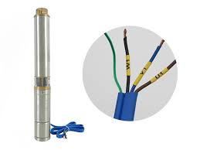
- Submassive pumping Machine. This is like the disconnect of the main Pump Submersibles were the first type pumps used by man to move fluids from one place to another underwater. The three types of pump submersibles are Axial flow, Radial flow and Mixed Flow.
- Electronic Kettle. This component quickly heat water using electricity. Unlike traditional stovetop kettles, it operates by converting electrical energy into heat through a metal heating element located at the base. When plugged in and switched on, the element rapidly heats up and transfers that heat to the water, usually boiling it within a few minutes.
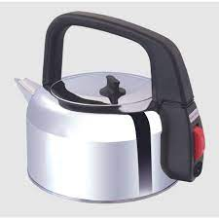

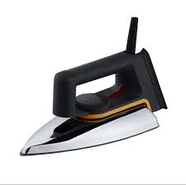
- Electronic Iron. Depending on the incoming voltage, Most electronic appliances, such as kettles, irons, TVs, and refrigerators, depend on mains voltage to operate. The mains voltage is the standard electrical power supplied by utility companies through wall outlets. In most countries, it ranges between 220V–240V (like in Europe, Asia, and Africa) or 110V–120V (like in North America). Devices are designed to work efficiently within these voltage ranges to power their internal circuits and components.

- Electronic Heater. Common applications include space heating, cooking, water heating and industrial processes. An electric heater is an electrical device that converts an electric current into heat..
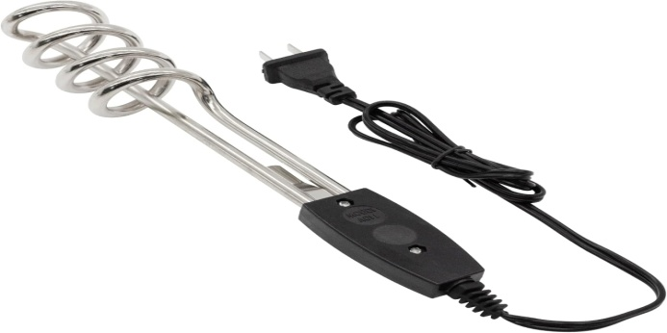

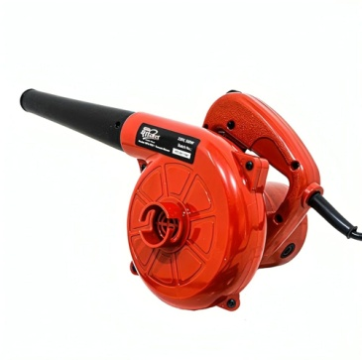
- Blower Machine. Blower is equipment or a device which increases the velocity of air or gas when it is passed through equipped impellers. They are mainly used for flow of air/gas required for exhausting, aspirating, cooling, ventilating, conveying etc.

CHAPTER THRE
POWER FACTOR
In electrical engineering, the power factor of an important concept in electrical engineering that refers to how efficiently electrical power is being used. In simple terms, it is the ratio between real power (used to do actual work like rotating a fan blade) and apparent power (the total power supplied to the fan). A fan with a high power factor uses most of the supplied electricity for useful work, while a fan with a low power factor wastes more energy, often due to phase differences between voltage and current.
Fans, especially induction motor-based fans (like ceiling fans or industrial ventilators), can sometimes have a low to moderate power factor, especially under light loads. This is because the motor inside the fan has inductive properties, which cause the current to lag behind the voltage. This lag creates a situation where not all the supplied power is doing useful work, leading to reduced efficiency and unnecessary strain on the electrical system.
To improve power factor in fans, especially in large commercial or industrial settings, power factor correction methods are used. One common method is to install capacitors in parallel with the fan motor. These capacitors supply the reactive power locally and help reduce the load on the power source, improving the overall power factor. Some modern fans also come with energy-efficient motors (like BLDC motors) that naturally have better power factors.
A good power factor (close to 1) is essential for efficient energy use, especially when multiple fans are operating simultaneously. Poor power factor doesn't just waste energy—it can also lead to higher electricity bills, overheating of cables, and reduced lifespan of equipment. That’s why understanding and managing the power factor in fan systems is important, particularly in energy-conscious environments like smart buildings and factories.
Power-factor correction (PFC) is the process of improving the power factor of an electrical system to make it more efficient. Power factor is the ratio of real power (used to do useful work) to apparent power (the total power supplied by the source). When the power factor is low, more current is required to deliver the same amount of useful power, which leads to energy waste, voltage drops, and increased load on electrical equipment.
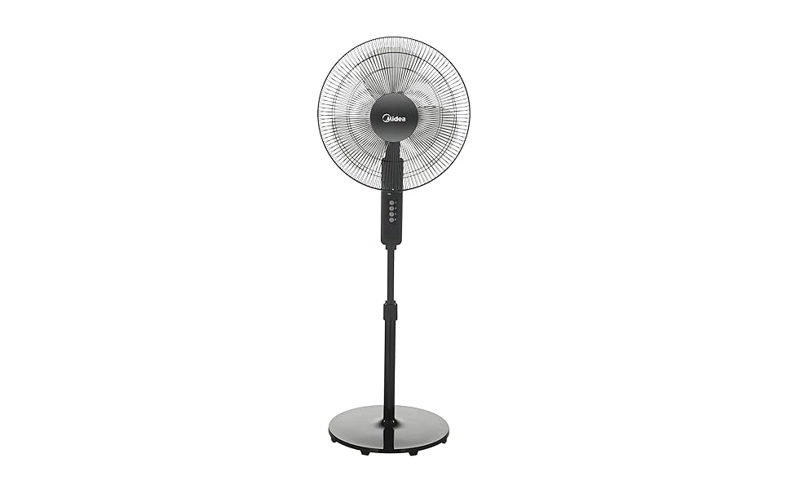
Low power factor typically occurs in systems with inductive loads, such as electric motors, fans, pumps, and fluorescent lighting. These devices cause the current to lag behind the voltage, creating reactive power that does no useful work. Although reactive power is necessary for the operation of inductive devices, it increases the total current in the system, reducing overall efficiency. Power-factor correction is usually done by adding capacitors or synchronous condensers to the electrical system. Capacitors generate leading reactive power, which offsets the lagging reactive power caused by inductive loads. When properly sized and installed, capacitors help bring the power factor closer to unity (1.0), meaning almost all the power is being used effectively. Improving the power factor has several benefits: it reduces energy losses, improves voltage stability, frees up capacity in electrical systems, and can lower electricity bills—especially in commercial and industrial settings where utilities may charge penalties for low power factor. In modern systems, automatic power factor correction panels (APFCs) are often used to adjust the correction dynamically based on load changes.

CHAPTER FOUR
CONCLUSION AND RECOMMENDATIONS
CONCLUSION
The Student Industrial Work Experience Scheme (SIWES) is an exercise which helps me to know that Electrical work is plating a vital role in the growth and development of individual, societies and nation at large.
The people that are electrical engineering they have opportunity to establishing companies, organization and business centre in order to increase the growth of the society and nation at large and also serve as a means of making a living.
RECOMMENDATIONS
During the Student Industrial Work Experience Scheme I gained a lot of knowledge which take me from unknown to known. For this motive, I recommend the following:
- The parent should makes as much as possible to give their children perfect and good education especially computer education.
- The school should make sure that the students are attending the SIWES programme.
- The government should assist the student by providing the materials needed for SIWES exercise.
- The students should also help themselves by making sure that they are present from the beginning to the end of the programme in order to achieve their aims and goals.

REFRENCES
Abdullahi, A., & Mallam, M. (2021). Piezoelectric Energy Harvesting: A Systematic Review of Reviews. arXiv preprint arXiv:2101.09312.
Adegbite, S. & Musa, K. (2024). Mechanical Engineering in Automotive Innovation: A Review of Electric Vehicles and Future Trends. International Journal of Scientific Research in Applied Sciences, 6(2), 12–27.
Afolabi, O. A., & Sanusi, L. (2021). A Novel Modified Hexagonal Fractal Antenna with Band Notches for WLAN Rejection. Journal of Electrical and Electronics Engineering Research, 13(4), 117–125.
Ahamed, R., & Kumar, R. (2024). Electrical Engineering in Renewable Energy Systems: A Review of Design and Integration Challenges. Emerging Science and Technology Journal, 4(1), 36–47.
Akinola, O. A., & Yusuf, A. A. (2023). Optimal Power Flow Solution Using HFSS Algorithm. Journal of Electrical and Electronics Engineering Research, 15(2), 57–67.
Bansal, R., & Choudhary, A. (2021). Wire Antennas for Textile Applications. Journal of Electrical and Electronics Engineering Research, 13(2), 64–71.
Bassey, C. A., & Nwankwo, M. U. (2024). A Novel Design of a Low-Cost SCADA System for Monitoring Standalone Photovoltaic Systems. Journal of Electrical and Electronic Engineering, 3(1), 70–85.
Chen, Y., & Wang, X. (2017). Design of a Double Clad Optical Fiber with Particular Consideration of Leakage Losses. Journal of Electrical and Electronics Engineering Research, 9(2), 55–62.
Kim, S., & Park, H. (2017). Two-Way Comparison Between Stitched Transmission Lines with Copper Wires and Conductive Threads, and with Conductive Threads Only. Journal of Electrical and Electronics Engineering Research, 9(1), 21–30
Lee, T., & Cho, J. (2019). Impact of Electromagnetic Interference of Soft Magnetic Sensor on IoT Current Detector: Design and Development. Journal of Electrical and Electronics Engineering Research, 11(3), 89–97.
Naik, S., & Swain, R. (2018). State-of-the-Art Economic Load Dispatch of Power Systems Using Particle Swarm Optimization. arXiv preprint arXiv:1812.11610.
Okonkwo, I., & Abdulrahman, A. (2024). Evaluation of a HVDC Interconnection to Improve the Voltage Stability of the Nigerian Transmission Network. Journal of Electrical and Electronic Engineering, 3(1), 1–15.
Ramezani, S., & Gandomkar, M. (2024). A Systematic Review on Expert Systems for Improving Energy Efficiency in the Manufacturing Industry. arXiv preprint arXiv:2407.04377.
Singh, D., & Kumar, R. (2024). Optimal Tuning of PID Controllers for LFC in Renewable Energy Source Integrated Power Systems Using an Improved PSO. Journal of Electrical and Electronic Engineering, 3(1), 33–47.
Yadav, R., Patel, P., & Khan, Z. (2023). Advancements in Arc Fault Detection for Electrical Distribution Systems: A Comprehensive Review from Artificial Intelligence Perspective. arXiv preprint arXiv:2311.16804.

