

TECHNICAL REPORT ON
STUDENTS INDUSTRIAL WORKS EXPERIENCE SCHEMES (SIWES)

HELD AT
EASY TECH MULTIBIZ BAKERY
EASY TECH MULTI BIZ, Plot 25 Bakery Street, Lagos, Nigeria

PRESENTED BY:

ABDUL RAHEEM HALIMA TITILOPE
ND/23/BAM/PT/0297
SUBMITTED TO:

THE DEPARTMENT OF BUSINESS ADMINISTRATION, INSTITUTE OF FINANCE AND MANAGEMENT STUDIES, KWARA STATE POLYTECHNIC, ILORIN.
IN PARTIAL FULFILMENT OF THE REQUIREMENT FOR THE
AWARD OF NATIONAL DIPLOMA (ND) IN BUSINESS ADMINISTRATION.

SEPTEMBER - NOVERMBER 2024

DEDICATION
I am delight to dedicate this report to Almighty God who gave me the grace and opportunity to complete this programme.

ACKNOWLEDGEMENT
I thank God Almighty for his mercy and grace that kept me all through my SIWES period.
I am greatly indebted to my parents, Mr. & Mrs. ABDUL RAHEEM for their morally, spiritually and financially, word of encouragement and prayer given to me, who make my SIWES programme successful and also my relatives and siblings.
I also want to thank my friend and everyone that contributed to the success of my SIWES program my Industrial supervisors, my colleagues and co-workers for the tremendous moral assistance throughout the period of my attachment.

REPORT OVERVIEW
The report comprises the background of SIWES, the description of the organization, its aims and objectives, the experiences gained as an industrial training student and the summary, conclusions and recommendations.
It has a total of 5 chapters with sub-chapters. It also has the preliminary pages, such as the title page, report overview and table of contents and recommendations on the improvement of scheme.

TABLE OF CONTENT
Title Page
Dedication
Acknowledgement
Report Overview
Table of Contents
CHAPTER ONE
1.1 Background of SIWES
1.2 Objectives of SIWES
1.3 Purpose of Training in a Bakery
CHAPTER TWO
2.1 History and background of organization
2.2 History and Overview
2.3 Organizational Structure
2.4 Mission Statement
CHAPTER THREE
3.1 WORK EXPERIENCE AND TRAINING ACTIVITIES
3.2 Weekly Activities
3.3 Skills Acquired
CHAPTER FOUR
4.1 Problems Encountered
4.2 Solutions and Coping Strategies

CHAPTER FIVE
5.1 Summary of Experience
5.2 Conclusion
5.1 Recommendation

CHAPTER ONE: INTRODUCTION

1.1Background of SIWES
The Student Industrial Work Experience Scheme (SIWES) is a program designed to expose students to the real working environment and bridge the gap between theory and practical. It is organized by the Industrial Training Fund (ITF) and is a compulsory part of many tertiary institutions’ academic curriculum.

1.2Objectives of SIWES
• To provide students with an opportunity to apply theoretical knowledge in a real industrial setting.
• To expose students to work methods and techniques in the industry.
• To develop the students’ ability to work as part of a team.
• To gain relevant skills for future employment.

1.3 Purpose of Training in a Bakery
The purpose of my industrial training in a bakery was to gain hands-on experience in baking processes, understand hygiene and safety standards in food production, and learn how bakery operations are managed in a commercial environment.

CHAPTER TWO: DESCRIPTION OF THE ORGANIZATION

2.1EASY TECH MULTI BIZ BAKERY
EASY TECH MULTI BIZ, Plot 25 Bakery Street, Lagos, Nigeria.

2.2History and Overview
EASY TECH MULTI BIZ BAKERY was established in 2010. It is a medium-scale bakery that produces various baked goods including bread, cakes, meat pies, sausage rolls, and cookies. The bakery is known for its quality products and affordable prices.

2.3Organizational Structure
• Manager
• Production Supervisor
• Bakers and Assistant Bakers
• Sales and Customer Service Team
• Cleaners and Support Staff

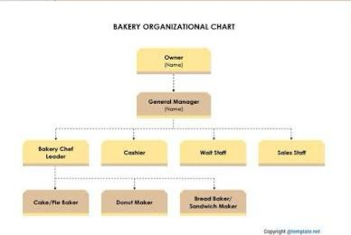
2.4 Mission Statement
To deliver high-quality, fresh, and tasty baked goods that meet customer satisfaction through excellence in baking and customer service.

CHAPTER THREE: WORK EXPERIENCE AND TRAINING ACTIVITIES

3.1 Introduction
During my training, I was assigned to the production unit, where I participated in various baking and operational activities.

3.2Weekly Activities
• Week 1: Orientation and safety procedures, introduction to bakery equipment.
• Week 2: Learning about ingredients used in baking; measuring and mixing procedures.
• Week 3: Bread production process – mixing, kneading, proofing, baking, and packaging.
• Week 4: Cake preparation – creaming, baking, icing, and decoration.
• Week 5: Making pastries like meat pies, doughnuts, and sausage rolls.
• Week 6: Inventory management and packaging techniques.
• Week 7: Cleaning and sanitation routines.
• Week 8: Customer service, sales, and basic cashier operations.

3.3 Skills Acquired
• Operating bakery equipment (oven, mixer, slicer)
• Baking and decorating cakes
• Preparing dough for bread and pastries
• Maintaining hygiene standards
• Packaging and labelling baked goods
• Teamwork and time management

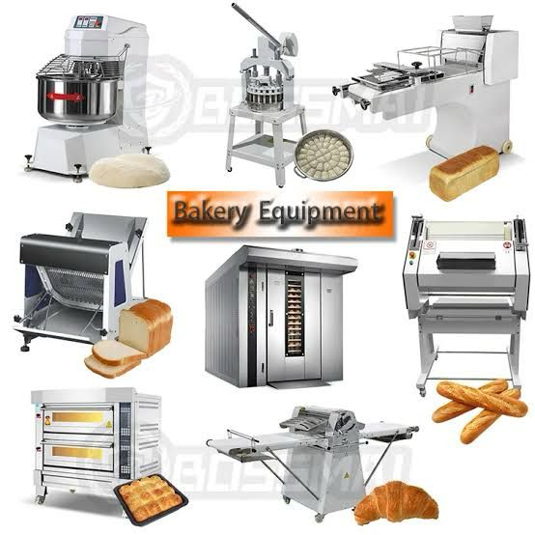

CHAPTER FOUR: PROBLEMS ENCOUNTERED AND SOLUTIONS

4.1 Problems Encountered
• Heat and physical stress from long hours of standing.
• Difficulty in handling heavy baking equipment initially.
• Understanding commercial measurements and recipe scaling.
• Time management challenges during rush hours.
• Limited access to modern baking technology.

4.2 Solutions and Coping Strategies
• Adapted to the working conditions through gradual physical adjustment.
• Received support from senior staff to operate equipment safely.
• Practiced scaling recipes repeatedly to understand measurements.
• Learned multitasking and prioritizing during peak production hours.
• Asked questions and researched modern methods to improve my knowledge.

CHAPTER FIVE: SUMMARY, CONCLUSION AND RECOMMENDATIONS

5.1 Summary of Experience
My SIWES experience at Sweet Crust Bakery was enlightening and beneficial. I gained practical knowledge in baking, learned to work under pressure, and understood the dynamics of a commercial bakery.

5.2 Conclusion
The training has helped bridge the gap between theory and practice. It improved my technical skills and workplace behavior, preparing me better for future employment.

5.3 Recommendations
• The bakery should provide more modern equipment to ease workload.
• Students should be encouraged to take the training seriously.
• Schools should follow up with students during their SIWES to monitor progress.
• SIWES duration should be extended for more comprehensive exposure.

Let me know if you’d like a Word or PDF version, or help customizing this for your school or personal experience!

