
A TECHNICAL REPORT ON STUDENT INDUSTRIAL WORK EXPERIENCE SCHEME (SIWES)
HELD AT
STAK CONSTRUCTION LTD
LAGOS, STATE

BY
ALADE ABDULSAMAD AKOREDE
ND/23/CEC/PT/0106
SUBMITTED TO
DEPARTMENT OF CIVIL ENGINEERING,
INSTITUTE OF TECHNOLOGY (I.O.T) KWARA STATE POLYTECHNIC,
ILORIN.

IN PARTIAL FULFILLMENT OF REQUIREMENT FOR
THE AWARD OF NATIONAL DIPLOMA
(ND) IN CIVIL ENGINEERING
AUG – DEC, 2024

Table of contents
Title page i
Preface ii
Dedication iii
Acknowledgement iv
Chapter one
  - Introduction/meaning of siwes
  - Aims and objectives of siwes
1.3. History of siwes
Chapter two
2.0 Brief History of the Organization
chapter three
3.1 Site Clearance
3.2 Setting Out
3.2.1 Important considerations in setting out

3.2.2. Tools and equipment used in setting out a building.
Chapter four
4.1 Foundation

4.2 Types of foundation and their uses

4.3 Laying blocks and bricks
4.4 Roof
4.4.1 Types of roof

4.5 Plaster
Chapter Five
5.1 Conclusion
5.2 Recommendation

CHAPTER ONE
  - INTRODUCTION/MEANING OF SIWES
The student industrial working experience scheme (SIWES) is the accepted skill training programme which forms part of approved minimum academic standards in the various degree programme of the Nigeria tertiary institutions.
This scheme help students in their various field to know or have knowledge and picture of what they have been studying in school which enable the student to practicalized the theoretical aspects of his or her professional this scheme contribute in the large way to prepare the students for any future engagement exposing him to atmosphere of versatility and adaption.
  - AIMS AND OBJECTIVES OF SIWES
- Students industrial work experience scheme (SIWES) provide avenue for student to acquire industrial skill and experience in their approve course of study.
- It prepare student for their industrial work situation which are likely to meet after graduation.
OBJECTIVE OF SIWES
- To provides avenue for students in institutions of higher learning to acquire industrial skills and experience in their course of study.
- It prepares students for post graduation working situation.
- To exposes students to work methods and techniques in handling equipments and machinery that may not be available in educational institution.
- To provides opportunity for students to apply their knowledge in real work situation thereby bridging the gap between theory and practice.
- To ease the transition from school to the world of work and enhance students contact for later job.
- To Ernest placement and strengths employees involvement in the education process of preparing student for employment in industries.
1.3. HISTORY OF SIWES
Student industrial world experience scheme SIWES was established by ITF in 1973 to solve the problem of lack of adequate practical skills preparatory for employment in industrial by Nigerian graduates of tertiary institutions. The scheme exposes students to industrial based skills necessary for a smooth transition from the classroom to the world of work it affords students of tertiary institutions the opportunity of being familiarized and exposed to the needed experience in handling machinery and equipment which are usually nor available in the educational institutions.
Participation in SIWES has become a necessary pre-condition for the award of Diploma and Degree Certificate in specific discipline in most institutions of higher hearing in the country, in accordance with the education policy of government.
Operators:- The ITF, the coordinating agencies (NUE,NCCE, NBTE) employers of labour and the institutions.
Funding:- The federal Government of Nigeria
Duration:- Four months for Polytechnic and College of Education and six month for the University.
CHAPTER TWO
2.0 BRIEF HISTORY OF THE ORGANISATION
SERVICES
- Architecture
- Construction
- Consultant
- Landscaping
- Cost analysis
- Engineering
- Town planning and developer
2.1 BACKGROUND
Architectural & landscaping: we consider architecture a function art. We therefore have an artistic approach to architectural problem. Our designs have been used in the past to complement the efforts of nature.
We then proceed to carry out the following of a potential project. We then proceed to carry out following.
- Outline scheme drawing, sketch design
- Final design whether interior, landscaping or structural design & working drawing
- Construction details & preparing of tends document and project site supervision and management preparation of record drawings planning
- The environment we live portrate the image of the user. We therefore believe in orderly development. The level of orderly development and sophistication is measure from the extends of plan development whether it is situated we therefore, try to anticipate the psychological reaction of the building ultimate users and plan.
Our organization has facilities and resource for executing small and large scale physical planning. We plan and design for situations in which financial is not a primary concern neither those it place a limit for our imagination.

CHART
Director
Engineering D
Engineers
Asst ENGR
Estimation Dept
Quantity survey
Architectural

Secretary

Receptionist

CHAPTER THREE
3.1 SITE CLEARANCE
Site clearance for foundation construction requires excavation and setting out. As well as health and safety measures to ensure that the site is ready for construction and no one is injured. To construct an excellent project, the site needs to be prepared for construction. Hence, the condition of the project site, including its surface and subsurface condition. This must be assessed and investigated thoroughly.
Site clearance involves adhering to health and safety legislation. Moreover, only trained construction workers and laborers can effectively and safely remove all unwanted rubble from the site. Most importantly, the construction site must be cleared of all vegetation, tree stumps, brush wood, and tree roots etc. This ensures efficiency while constructing the project.
To ensure that the construction site is cleared efficiently, consider the following tips.

Put up Safety Signs at your Site Clearance
First and foremost, before working on a construction site, signs must be displayed to ensure that people understand that it is a hazardous zone. Entry is restricted to authorised personnel only. Because it is a construction zone, many activities will be taking place. From demolition to the loading/unloading of goods and materials. Therefore people must be aware that entering a construction site is very dangerous if they are not sure of the correct pathways.
Construction workers must wear safety hats and jackets when entering the construction zone. This will not only ensure their safety but will also inform passersby that a certain type of activity is happening in the area, so they must not enter.

Hire Proper Contractors
To clear the area and prepare it for construction, you will need to hire a professional or a site clearance contractor who has the relevant equipment to do the job effectively.
Professionals are mandatory for this job because a range of dangerous activity is involved in site clearance and only professional contractors know how to proceed with safety and caution. Ensuring that nearby areas and neighbourhoods are not affected by the work and making sure that all waste and debris is disposed of properly takes a lot of effort and time. Therefore, it is advisable to hire a professional contractor for the job.

The Correct Machinery for the Job
Site clearance requires the use of the specific machinery and equipment. Proper tools and equipment are essential not only for safety purposes but also to increase efficiency. Without the correct machinery and tools, time and money can be wasted. A task that should take two hours would probably take a whole day if the correct equipment and tools are not used.
You can search online to determine the best machinery for the task, or you can seek advice from your local contractor about which machinery and tools are most appropriate. However, you are advised not to operate the machinery or tools if you are not confident that you can use them correctly.

Monitor Dust, Vibration, and Noise
Environmental welfare is also vital during site clearance. Dust, vibration, and noise are common bi-products of clearing or demolishing a site. It is important to ensure that these aspects are managed and monitored to minimise disturbance to neighbouring parties.
When demolished structures are cleared, it causes a lot of dust that spreads in the air. This can cause several health complications, especially to those who have respiratory problems such as asthma. To improve this, the surface or ground can be dampened with water so that dust particles are absorbed by the moisture.

Manage Traffic Movement
Segregation of vehicles and pedestrians must be implemented. Although safety signs are helpful, a worker must be appointed solely to perform this safety measure. This will ensure that ongoing road traffic is not affected by the activities taking place on the construction site.
It is also helpful to manage the machinery and other heavy vehicles that come and go constantly to and from the site. This reduces the risk of causing accidents. If the clearance site is much larger, more workers should be appointed for traffic duty. This will keep the flow of traffic uninterrupted.

Disposal of Waste
Waste disposal is the most critical aspect of site clearance. If not taken care of, it can pose several environmental hazards that are not only harmful to humans but also to animals, birds, and plants. Therefore, it is important to organise professional disposal and transportation of unwanted materials and rubble from the clearance site.
Clearing a landscaping or construction site requires different waste disposal management. The waste can comprise of anything from demolished building waste to natural waste, such as uprooted trees and vegetation.
3.2 SETTING OUT
Setting out is the process of developing the physical positions of corners and walls of a building, and it’s done by transferring dimensions from the layout plan (also called as setting out plan, demarcation plan) to the ground. The setting out clearly defines the outline of the excavations and the centre line of the walls, so that the construction can be carried out according to the plan, the main aim of setting out is to establish the position of the trench and wall of the house as well as the position of corners and rooms when renovating an already existing one, especially an extension. The process of Setting out is done by a contractor, and overseen by the lead project consultant engineer, architect or any other qualified member of the project team.
Techniques used to achieve these aims of setting out are based on three general principles.
  - Horizontal control points must be established within or near the design area.
  - Vertical control (bench marks) must be within or near the design area.
  - Accurate positioning techniques must be adopted to establish design points from horizontal and vertical control.
3.2.1 IMPORTANT CONSIDERATIONS IN SETTING OUT
    - Recording and filling information, booking e.t.c for easy accuracy.
    - Care of instruments; check instruments before work commences and at regular intervals.
    - Maintaining accuracy, design points must be set from the control network and from other points to avoid cumulative errors.
    - Regular site inspections, to detect missing pegs i.e. a peg may be disturbed or replaced without the surveyor being informed, control should be permanently and clearly marked and protected.
    - Error detection- Apply independent checks, errors should be detected must be corrected at an early stages.
    - Communication on site- Lack of it cause errors, the surveyors need to understand what needs to be done before doing it.

3.2.2. TOOLS AND EQUIPMENT USED IN SETTING OUT A BUILDING.
- Theodolites.: For large complex buildings, theodolites, survey equipment’s, are used to mark out building external wall extents.
- Measuring tape: For small scale types of construction, use of long type builder’s square , steel measuring tape are sufficient to demarcate the building external wall extents and internal wall partitioning.
  - For shorter distances, the steel tape is most appropriate, eg distances between two rooms, thickness of wall while setting out etc.
  - For larger distances, eg perimeter wall measurement, hexagonal check, the flexible type is most appropriate.
- Spirit Level: Spirit level is used to ensure that the nylon strings used in setting out are horizontal.
- Nylon String: Nylon strings are used to demarcate the wall thickness and building extent.
- Lime Powder: White lime powder is used to mark the foundation walling and column footing positions for further excavation till rock or stable ground. White lime used to measure out the extents of the building footprint in readiness for excavation.
- Timber, 75mm by 50mm or any appropriate size.
- Nylon threads (Manila rope).
- Ordinary nails inch and 2 inch.
- Round poles to act as pegs or steel for hard ground.
- Panga/Machete.
- Clear hose pipe for determining horizontal levels.
- Sledge hammer

CHAPTER FOUR
4.1 FOUNDATION
Foundations are classified as shallow and deep foundations. Types of foundations under shallow and deep foundations for building construction and their uses are discussed.
It is advisable to know the suitability of each type of foundation before their selection in any construction project.

4.2 TYPES OF FOUNDATION AND THEIR USES
Following are different types of foundations used in construction:
- Shallow foundation
Individual footing or isolated footing
Combined footing
Strip foundation
Raft or mat foundation
- Deep Foundation
Pile foundation
Drilled Shafts or caissons

Types of Shallow Foundations

1. Individual Footing or Isolated Footing
Individual footing or an isolated footing is the most common type of foundation used for building construction. This foundation is constructed for a single column and also called a pad foundation.
The shape of individual footing is square or rectangle and is used when loads from the structure is carried by the columns. Size is calculated based on the load on the column and the safe bearing capacity of soil.
Rectangular isolated footing is selected when the foundation experiences moments due to the eccentricity of loads or due to horizontal forces.
For example, Consider a column with a vertical load of 200 kN and a safe bearing capacity of 100 kN/m² then the area of the footing required will be 200/100 = 2m². So, for a square footing, the length and width of the footing will be 1.414 m x 1.414 m.

2. Combined Footing
Combined footing is constructed when two or more columns are close enough and their isolated footings overlap each other. It is a combination of isolated footings, but their structural design differs.
The shape of this footing is a rectangle and is used when loads from the structure is carried by the columns.

3. Spread footings or Strip footings and Wall footings
Spread footings are those whose base is wider than a typical load-bearing wall foundations. The wider base of this footing type spreads the weight from the building structure over more area and provides better stability.
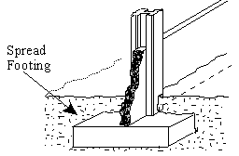
Spread footings
Spread footings and wall footings are used for individual columns, walls and bridge piers where the bearing soil layer is within 3m (10 feet) from the ground surface. Soil bearing capacity must be sufficient to support the weight of the structure over the base area of the structure.
These should not be used on soils where there is any possibility of a ground flow of water above bearing layer of soil which may result in scour or liquefaction.

4. Raft or Mat Foundations
Raft or mat foundations are the types of foundation which are spread across the entire area of the building to support heavy structural loads from columns and walls.
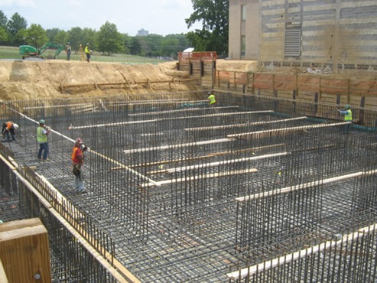
Raft or Mat Foundation
The use of mat foundation is for columns and walls foundations where the loads from the structure on columns and walls are very high. This is used to prevent differential settlement of individual footings, thus designed as a single mat (or combined footing) of all the load-bearing elements of the structure.
It is suitable for expansive soils whose bearing capacity is less for the suitability of spread footings and wall footings. Raft foundation is economical when one-half area of the structure is covered with individual footings and wall footings are provided.
These foundations should not be used where the groundwater table is above the bearing surface of the soil. The use of foundation in such conditions may lead to scour and liquefaction.

Types of Deep Foundation

5. Pile Foundations
Pile foundation is a type of deep foundation which is used to transfer heavy loads from the structure to a hard rock strata much deep below the ground level.
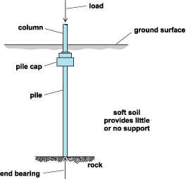
Pile Foundation
Pile foundations are used to transfer heavy loads of structures through columns to hard soil strata which is much below ground level where shallow foundations such as spread footings and mat footings cannot be used. This is also used to prevent uplift of the structure due to lateral loads such as earthquake and wind forces.
Pile foundations are generally used for soils where soil conditions near the ground surface is not suitable for heavy loads. The depth of hard rock strata may be 5m to 50m (15 feet to 150 feet) deep from the ground surface.
Pile foundation resists the loads from the structure by skin friction and by end bearing. The use of pile foundations also prevents differential settlement of foundations.

6. Drilled Shafts or Caisson Foundation
Drilled shafts, also called as caissons, is a type of deep foundation and has an action similar to pile foundations discussed above, but are high capacity cast-in-situ foundations. It resists loads from structure through shaft resistance, toe resistance and/or combination of both of these. The construction of drilled shafts or caissons are done using an auger.
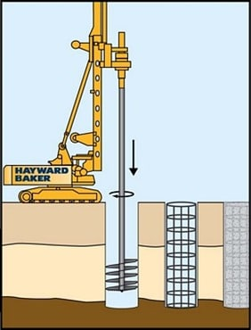
Drilled Shafts or Caisson Foundation (Source: Hayward Baker)
Drilled shafts can transfer column loads larger than pile foundations. It is used where the depth of hard strata below ground level is located within 10m to 100m (25 feet to 300 feet).
Drilled shafts or caisson foundation is not suitable when deep deposits of soft clays and loose, water-bearing granular soils exist. It is also not suitable for soils where caving formations are difficult to stabilize, soils made up of boulders, artesian aquifer exists.

4.3 LAYING BLOCKS AND BRICKS
The basic laying procedure for block and brick walls is the same for all types of block and brick and is identical to the procedure for block foundation walls.
• The top surface of the foundation, or of the previous course, should be covered with a bed of mortar. Apply the mortar only on the edges of hollow bricks. Cover the entire surface of solid blocks.
• Butter each new block or brick on its ends either before or after it is placed. Again, butter only the edges of hollow blocks; butter the entire head of solid blocks.
• Use string to guide the placement of each new block or brick in a straight line. Position the blocks or bricks up to but not touching the string. Press and tape each one firmly into place so that the mortar joint is 11.25cm thick. Do not pound the block in place.
• After every 2-3 blocks or bricks check the course for level and plumb. Remove and re-mortar any blocks that are out of line.
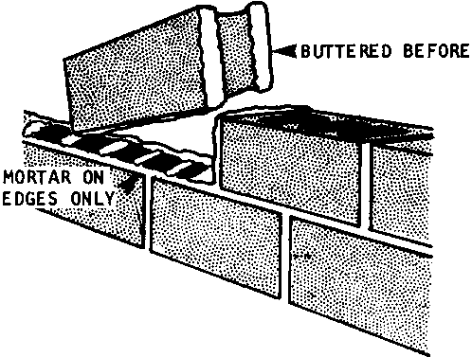
Buttered before

BOND ARRANGEMENTS FOR BLOCK AND BRICK WALLS
There are important differences between the bonds that should be used with blocks and the bonds for adobe bricks.
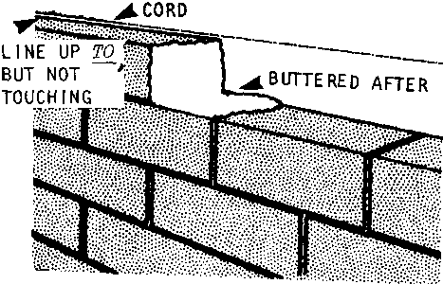
Line up to but not touching
Bonds for BLOCKS With Cement Content
The main bond for blocks with cement content is the staggered arrangement used in block foundation walls. This simple bond is easily continued through corners by alternating the direction of each corner block ( see page 148 for details).
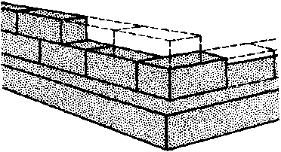
Bonds for blocks with cement content
When working with blocks, the intersection of exterior and interior walls is treated much like a corner.
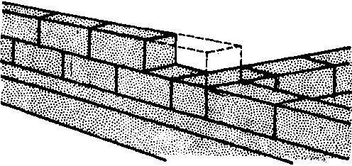
Walls is treated much like a corner

When framing windows and doors, the blocks next to the opening must be half-size in every other course: hence the great advantage of using a half-size mold.
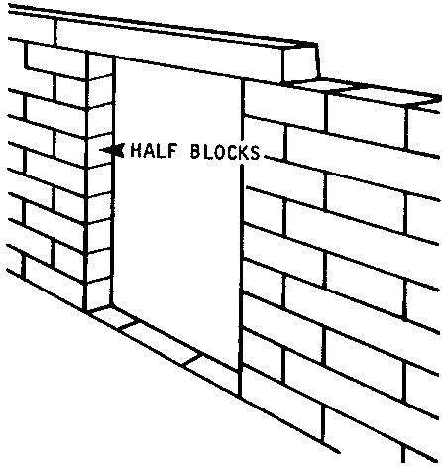
Half blocks
4.4 ROOF
Roof, covering of the top of a building, serving to protect against rain, snow, sunlight, wind and extremes of temperature. Roofs have been constructed in a wide variety of forms – flat, pitched, vaulted, domed, or in combinations – as directed by technical, economic, or aesthetic consideration.
4.4.1 TYPES OF ROOF
Gable roof: Gable roof designs are of the more simple styles when it comes to roofs. The gable roof style looks like an inverted/upside down V. Gable roofs are not ideal for area with high wind because they easily can catch the wind much like a sail would.
Flat roof: flat roofs are common especially with commercial buildings. Flat roofs are definitely the most simple roof to build because they have little to no pitch. The most common types of roofing systems used with flat roofs are rubber roofing system.
Hip roof: hip roofs are a common residential style roof. This type of roof is more difficult to construct when compared to flat roofs and gable roofs because they have a more complicated truss and rafter structure. A hip roof style roof has four sloping sides with zero vertical roof lines/walls. Hip roof can be both square and rectangular.

Gambrel Roof:
The best way to describe a gambrel roof is by saying barn roof. The gambrel style roof is most commonly used on barns. However, it is also used in residential construction. This type of roof has the benefit of providing a good amount of space in the attic. In fact, it provides so much extra space that it is often turned into bedrooms or other living areas.

Dutch Hip Roof:
The dutch hip roof is basically a hip roof with a small gable at either end. The gables can be used as ventilation.

Shed Roof:
A shed roof is basically a flat roof but has more pitch. It is frequently used for additions on homes or other roof styles.

Mansard Roof:
The mansard roof is a french design and is more difficult to construct than the hip or gable roof.

Butterfly Roof:
The butterfly roof is not a roof style that is widely used. The style provides plenty of light and ventilation but is not the effective when it comes to water drainage.

Winged Gable Roof:
The winged gable roof varies slightly from the tradition gable roof. It varies by extended outwards from the peak of the roof.
A-Frame Roof:
This type of roof is very popular for churches, cottages, homes, and other structures. The roof acts as both the roof and the walls for a structure.

Folded Plate Roof:
The folded plate roof has limited use in single family homes. It looks like a series of small gable roofs placed side by side of each other.

4.5 Plaster
Plaster may be defined as Lean Mortar used mostly for covering masonry surfaces.
They are lean mixes of Binding Materials ( Lime or Cement ) with fillers material such as Sand or Crushed stones.
And the process of covering surfaces with Plaster is called Plastering.
They are specially prepared for two reasons.
- For Protection.
- For Decoration.
In protective covering, the Plaster saves the Bricks or Stones from Direct Destructive Attacks of Atmosphere such as Wind, Rain and Harmful Industrial Gases.
As a decorative finish, Plasters are used to give many appealing shades and finish designs to the construction.

Cement Plasters.
These are the homogeneous lean mixture of Portland Cement and sand with water. They have been found suitable for all type of plastering work such as Protective and Decorative Finishes.
The most common proportion for Cement Plasters is ( 1:3 ).
- For external surfaces ( 1:3 ).
- For internal surfaces ( 1:4 ).
However, the ratio of sand can be increased to as much as 8 like ( 1:8 ) depending upon the nature of construction.
Cement Plasters are generally applied only in a single coat. It is important that the surface of plasters should be kept wet at least for 3 days after its application.

Gypsum Plaster.
These are that type of plasters in which gypsum is used as a Binding Material instead of Cement or Lime.
The Gypsum Plaster are commonly used for making Architectural fancies and Decorative Designs on wall and roofs. Their most important Properties are:
- They have great resistance to fire.
- They provide comparatively better insulation against heat and sound.
- They set and harden quickly.
- They undergo very little expansion and contraction.

Types of Gypsum Plaster.
Following types are commonly used.

(1.) Ready Mix:
This Consists of Plaster of Paris and Aggregates (Sand) in a dry-mix form in a Pre-determined proportions.
This type of Plasters possesses three times better insulation properties than the ordinary cement or lime plasters.

(2.) Gypsum Neat Plaster:
It is prepared by mixing commercial grade of Plaster of Paris with the desired quantity of sand in the dry state.
The dry mixture is then reduced to a homogeneous paste with simultaneous addition of water and shuffling with the help of Trowels.

(3.) Keen’s Cement Plasters:
It is a high density gypsum plaster that is capable of taking fine polish on its finished surface.
Gypsum gauge plasters are made by mixing suitable proportions of Gypsum Plaster with lime putty ( hydrated lime ).
They are considered especially useful for providing a hard surface at the base within a short time.

(4.) Stucco Plasters:
It is commonly used for decorative purposes. It is applied on the external surface of construction and gives a Marble like finish to the structure.
Cement or Lime is commonly used as a Binding material in this type.

CHAPTER FIVE
5.1 CONCLUSION
In conclusion, as a student of Building technology, I have been able to obtain the most relevant and effective practical industrial training and experience in a duration of four months(4 months) having been exposed to practical on-site situations and activities. Furthermore, an awareness of the general workplace has been developed in me and I have acquired important behavior and interpersonal skills with the opportunity giving me to get a feel of the work environment and exposure as a student to the architects responsibilities and ethics .Finally, I would like to state that the SIWES programme is a very relevant and necessary programme for all students that must be taken advantage of by every student for each student’s professional development prior to graduation.
SIWES plays a significant role in human resource development in Nigeria SIWES program has enable the student develop new skill. Student should be aware of what d present society held for
accordingly . This can only be facilitated by educator and practitioners with adequate provision IICT infrastructure.
The federal government of Nigeria should therefore not relent on their effort in reinforcing the body that control and monitor the program as it adding more knowledge to student especially those that were not taught in the class or lecture room
5.2 RECOMMENDATION
Base on the industrial training I have undergone the experience, skill, and challenges I encountered and the SIWES attitude towards this training scheme, I come up with the following recommendation:
- That the necessity of the industrial training should be made known to the
student involved so as to discourage those who usually avoid it.
- There must be a good interactive between the industrial base supervisors
and the SIWES officials in other to ensure that the student at their duty post are well taken care of.
- Any student who deliberately refuse to involve him/herself in SIWES program is severely punished so that others will learn.
- Ensure that the industrial base supervisors do not maltreat students and use them as their house help.
Finally the provision for paying and giving student grants in their places of industrial training should be allowed in SIWES programme

