
TECHNICAL REPORT ON THE STUDENTS’ INDUSTRIAL WORK EXPERIENCE SCHEME (SIWES)

HELD AT
OLAREWAJU ENGINEERING CONSTRUCTION WORK
SHOP 20, SABOJO STREET, OPPOSITE QUEEN ELIZABETH SCHOOL, SAW MILL ROAD ILORIN
BY

ABDULKAREEM ABDULKAREEM ADEGOKE

ND/23/MEC/PT/0038

SUBMITTED TO:
THE DEPARTMENT OF MECHANICAL ENGINEERING
KWARA STATE POLYTECHNIC, INSTITUTE OF TECHNOLOGY (IOT)
P.M.B. 1375 ILORIN, KWARA STATE.
IN PARTIAL FULFILMENT FOR THE AWARD OF NATIONAL DIPLOMA (ND) IN MECHANICAL ENGINEERING,

3rd AUGUST TO 3rd NOVEMBER 2024

DEDICATION
I dedicate this report to God Almighty for His Unlimited Grace, Consistent Love, Immeasurable Faithfulness, and for sparing my life throughout the period of my SIWES programme.
Secondly, I dedicate it to my parents Mr. & Mrs. Abdulkareem for their undiminished support and unquantifiable assistance throughout the whole exercise and beyond.

ACKNOWLEDGEMENTS
First and foremost, my deepest acknowledgement goes to God Almighty for His overwhelming love upon my life throughout the Scheme.
I appreciate my parents Mr. and Mrs Abdulkareem and friends for their constant help and support.
I also appreciate all staff members of Olarewaju Engineering Construction Work, especially my supervisor who gave out of his tight schedules to attend to me.

TABLE OF CONTENTS
Title……………………………………………………………………………………….i
Dedication…………………………………………………………………………………ii
Acknowledgement……………………………………………………………………….iii
Table of Contents………………………………………………………………………..iv

CHAPTER ONE

1.0 INTRODUCTION TO SIWES
1.1 AIM AND OBJECTIVE OF SIWES
1.2 HISTORICAL BACKGROUND OF THE ORGANIZATION ATTACHMENT
1.3 ORGANIZATION CHAT OF THE ORGANIZATION
1.4 MAJOR ACTIVITIES OF THE ORGANIZATION
1.5 WORKSHOP SAFETY

CHAPTER TWO

2.0 BASIC WORKSHOP HAND TOOLS AND EQUIPMENT WITH THEIR FUNCTION
2.1 SECTION OF THE ORGANIZATION AND THEIR SPECIFIC FUNCTION

CHAPTER THREE
3.0 STUDENT SPECIFIC INVOLVEMENT AT VARIOUS SECTIONS
3.1 PRODUCTION SECTION
3.2 FABRICATION SECTION

CHAPTER FOUR
4.0 EXPERIENCE GAINED
4.1 INTERPERSONAL RELATIONSHIPS WITH THE ORGANIZATION
4.2 SUGGESTION FOR IMPROVEMENT OF THE PROGRAM

CHAPTER FIVE
5.0 CONCLUSION
5.1 RECOMMENDATION

CHAPTER ONE

1.0 INTRODUCTION TO SIWES
In 1974, the federal government of Nigeria introduced the National policy on industrial training called the student industrial work experience scheme (SIWES).
This program is under the umbrella of the ministry of education through the Industrial Training Fund (ITF), was design to help student acquire the necessary practical education experience in their fields of study and other related professions.
The program was established basically to impact elaborate practical understanding to student with respect to their various discipline. It is also intended that the student through a process of relation to academic knowledge and practical industrial application would understand the underlying principle and become better focused and acquire the practical application toward excellence in his/her discipline.
The student are expected to develop occupational competence that would facilitate their fitting into the world of work after graduation.

1.1 AIM AND OBJECTIVE OF SIWES
The student industrial work experience scheme (SIWES) has it major aims and objective of establishment. The following are the aim and objective of the program.
- To provide student an opportunity to apply their theorical knowledge in really work situation, thereby bridging the gap between theory and practical.
- To expose student to working method and techniques in handing equipment and machineries that is not available in their various institutions.
- To make the transition from the institution to the world of work easier and thus enhance student contact for later job placement
- To prepare student in skill development by participating in field works, particularly in writing report in their fields of works.
- The construction of oven with not plate
- The construction of yam pounding machine
- Production of strap bolt and nut

1.2 ORGANIZATION CHART
Managing Director

Supervisor

SIWES

Workers
Student

1.3 WORKSHOP SAFETY
Safety is the preventive measure timely taken to guide against any form of hazard injury or accident in our daily activities in the workshop. Workshop safety is particularly focusing on ways of preventing danger particularly accident, injury a times death to personnel or other things around the operator while doing work. The following are the basic work shop safeties that must be comply with these include:
- Always clean the machine and check the condition of the machine before working on it
- Do not use the hand to stop the working machine
- Do not play with any machine
- Know where the emergency stop buttons are positioned in the workshop in case of accident.
- Always use the right tools for the right job
- Always return the tool to its original place after use
- Always off the machine while you are not working on it
- Always put on your safety boot, safety glove and other safety equipment.
- Always listen carefully to the supervisor and follow the instructions.

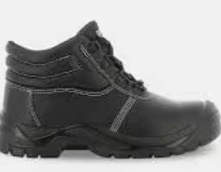

Safety Boot

Safety Hand Glove



Safety Goggle

CHAPTER TWO

2.0 BASIC WORKSHOP HAND TOOLS AND EQUIPMENT WITH THEIR FUNCTION
The following are the basic workshop hand tools and equipment used in mechanical workshop:
- Tape rule: We use it to measure our material to accurate size
- Vennier Calipher: We use it to measuring hole in and outer pat of the material
- Spanner: - spanner are use in tithing a bolt and nut they are of different type’s e.g flat, ring and socket e.t.c.
- Hammer: -Hammer is mainly use in hitting, driving, and pulling some part of the machine or work piece. They are of different types which include: cross pane hammer, ball pane hammer, straight pane hammer and double face sledgehammer.
- Electrode: We use it to weld steel or to join to material together in a different shape
- Grounding disk : is a disk which place on a machine for smoothing surface of the material
- Hand file:-file are used for smoothing the surface of the work piece. They are different type of hand file:- Rough file, smooth file etc.
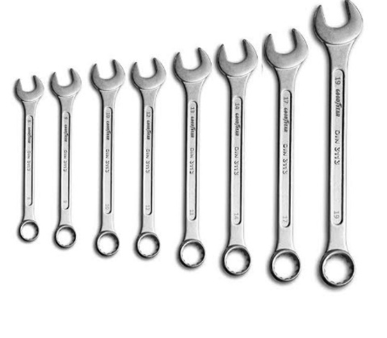
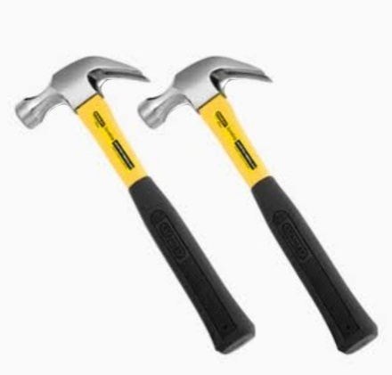
- Hack saw: -it is use for cutting metal.
Hammer
Spanner

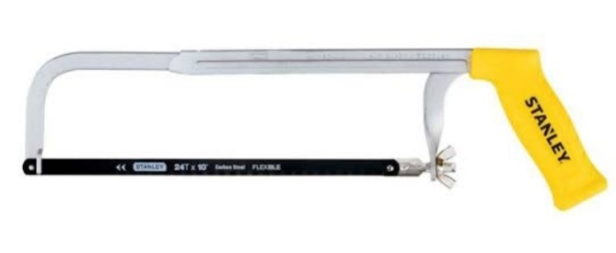
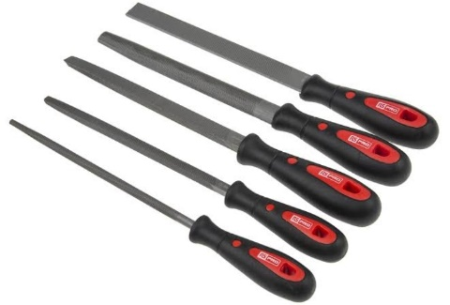
2.1 SECTION OF THE ORGANIZATION AND THEIR SPECIFIC FUNCTION
Hand File
The section of the organization include:-
- Fabrication section
- Production section
- Automotive section

a. FABRICATION SECTION
Hack saw
This section deals with cutting, bending and assembling of metal to form a given structure. Different methods are used in doing this include - grooving, welding, casting and machine e. t. c.
Various machine such as:-
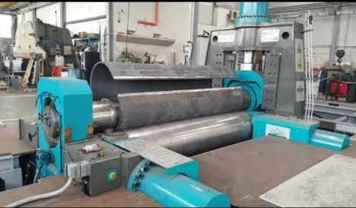

ROLLING MACHINE
ROLLING MACHINE:- It is use for rolling a metal in to a circler part e.g production of a metal drum.

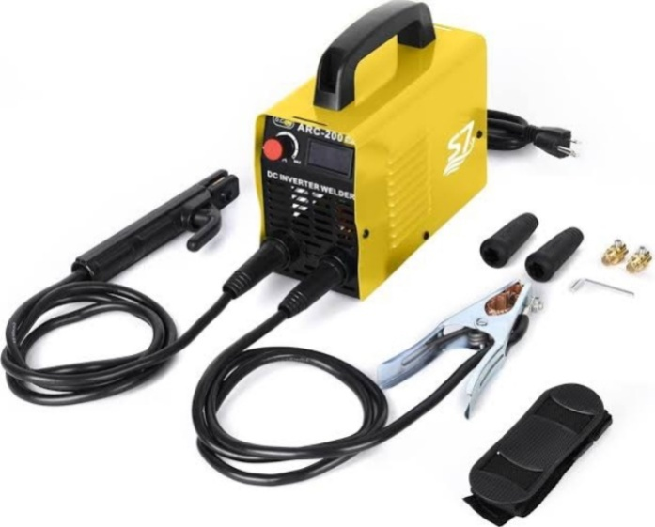

ARC WELDING MACHINE
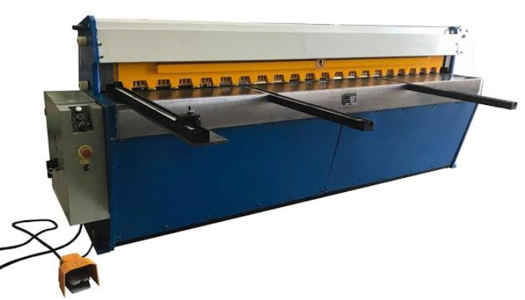
ARC WELDING MACHINE:-For joining two or more metals together with the help of electrode.

GUILLOTINE MACHINE

GUILLOTINE MACHINE:-It is use to cut sheet metal into straight edged pieces.

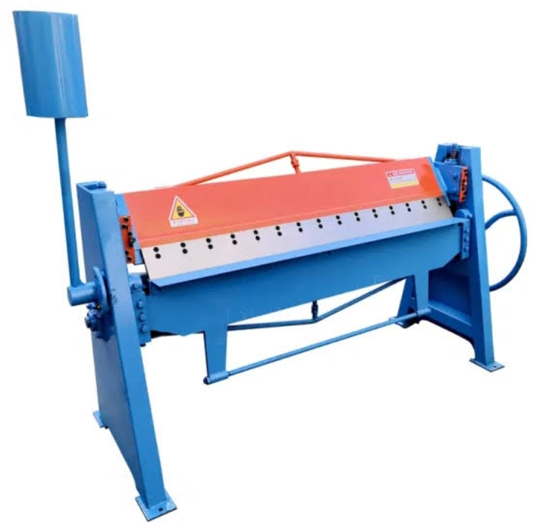

BENDING MACHINE

b. PRODUCTION SECTION
The production section makes use of machine tools such as:-

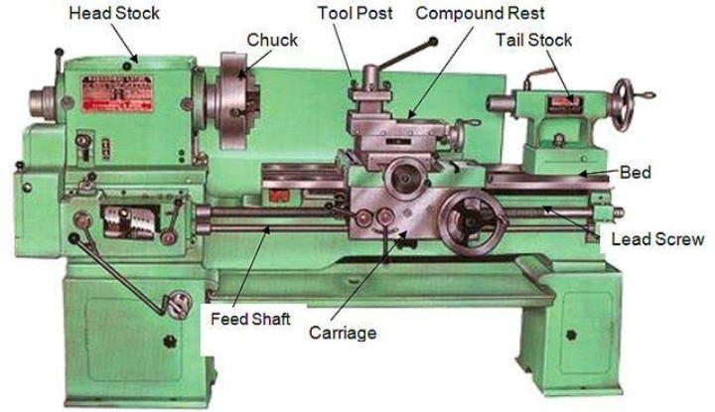

LATHE MACHINE
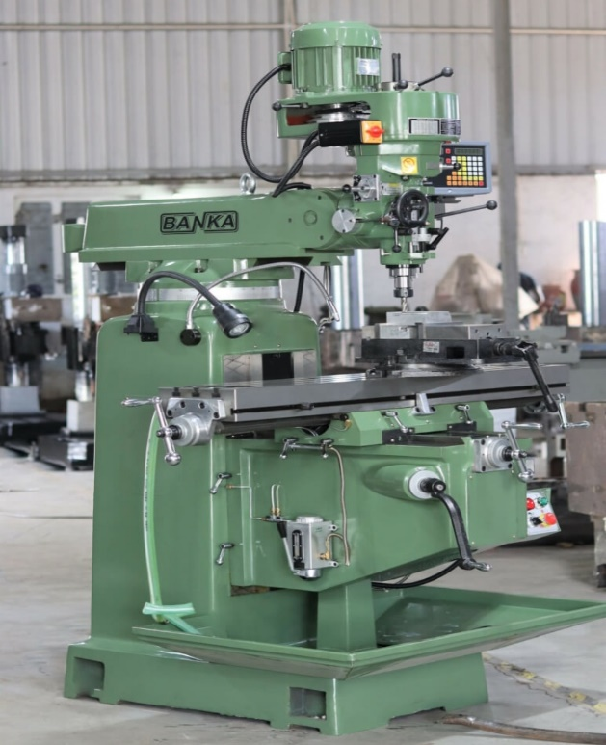

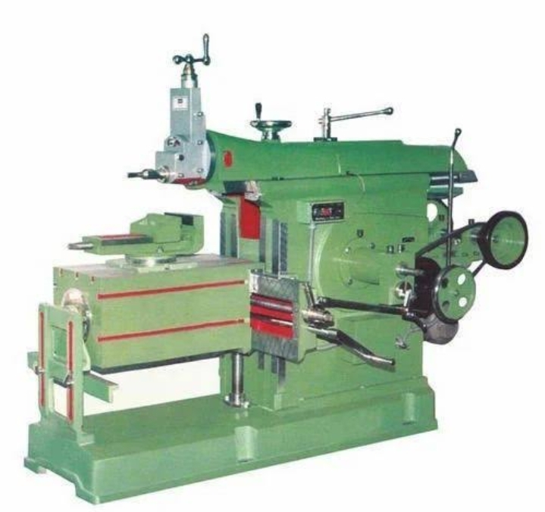
MILLING MACHINE

SHAPING MACHINE
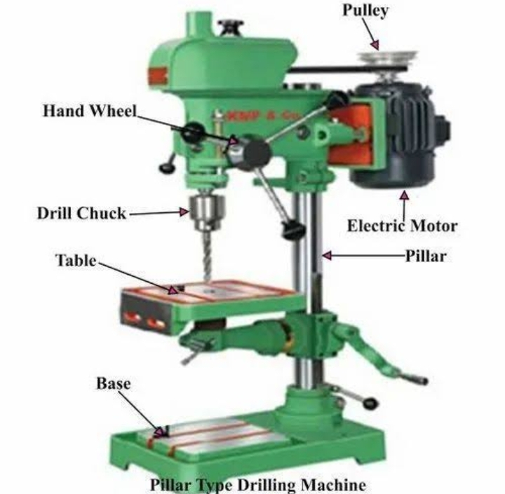

DRILLING MACHINE
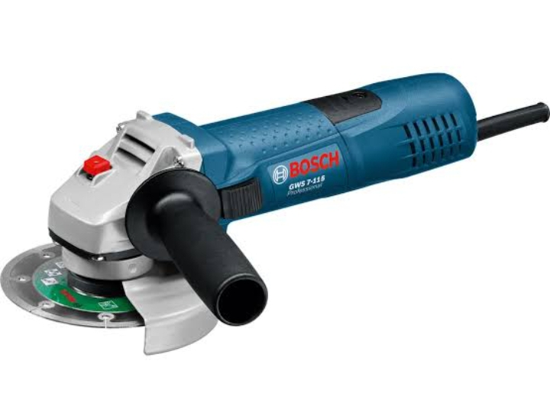

GRINDING MACHINE
Drilling machine, grinding machine and shaping machine e. t. c. In producing part of an object with desire a good surface finish.
The machine tool in production section can perform various matching operation due to their r versatility, operation like.- Drilling, Boring, Teaming, Counter sinking, Counter boring, Turning operation, Knurling and facing e. t. c.

C. AUTOMOTIVE SECTION
This is the section where preparing, servicing and maintenance of automotive such as:- Motor vehicles, Motorcycle, tricycle and car engine is been done.
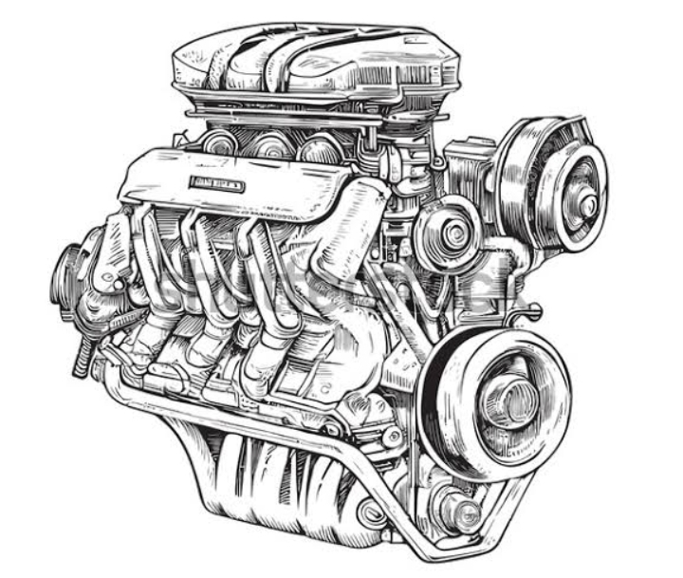

CHAPTER THREE
3.0 STUDENT SPECIFIC INVOLVEMENT AT VARIOUS SECTIONS
I was involved in two section which is production section and fabrication section

3.1 PRODUCTION SECTION
The production section also know as machine workshop, it is a section that makes use of machines tool in performing any metal removing processes.
Machining is any various processes in which piece of raw materials is cut into desired final shape and size by controlled material removal process. The machining is done by the use of machine tools. Machine tools are machine for shaping, ctting, boring, grinding and shearing or other form of deformation. Example of machine tools include the lathe machine, milling machine, shaping machine, drilling machine and grinding machine.

LATHE MACHINE
The lathe machine is known as the father of all machine tool due to it versatility i.e ability to perform different operations e.g Turning, morning, Knurling, drilling and facing operation e.t.c.

DRILLING MACHINE

Drilling is the process of originating the hole on the works piece
Drilling machine is the machine tool used in accomplishing the task of originating hole, dreaming, boring, counter boring and other drilling operation.
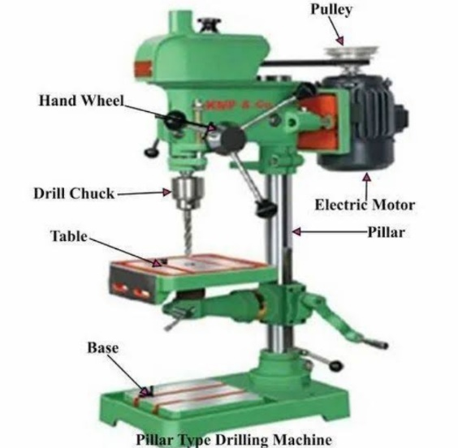

MILLING MACHINE
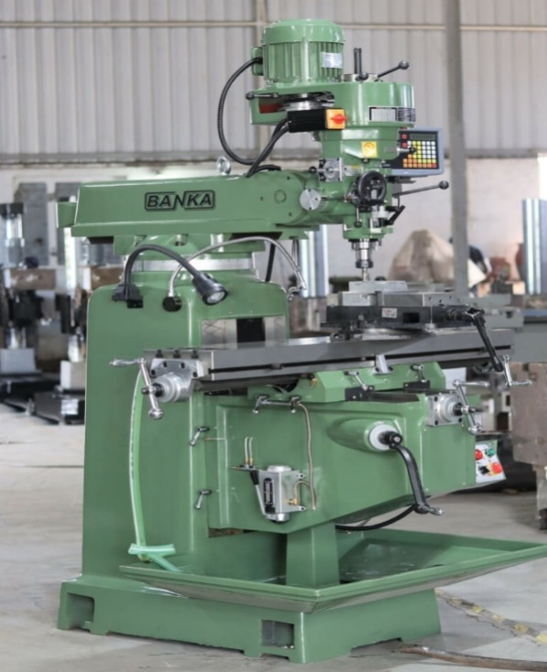
These are machine in which multi-tooth tools (cutter) are employed to perform metal removing operation, sometimes single tooth are used e.g fly cutter.

3.2 FABRICATION SECTION
This section deals with joining of metals together by different method such as welding, grooving and forging.
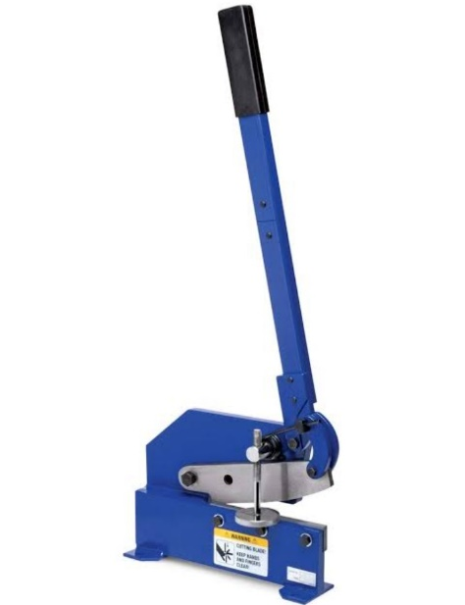
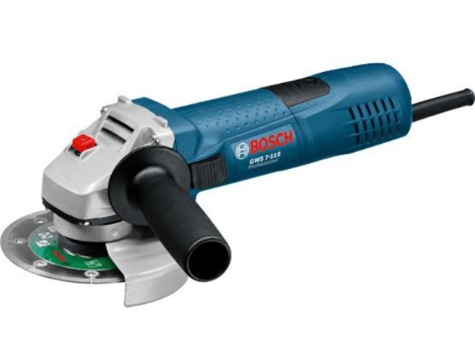
There are various machine in the fabrication section this include:- Arc welding machine, guillotine machine, bench shears, bending machine and rolling machine.

.

GRINDING MACHINE

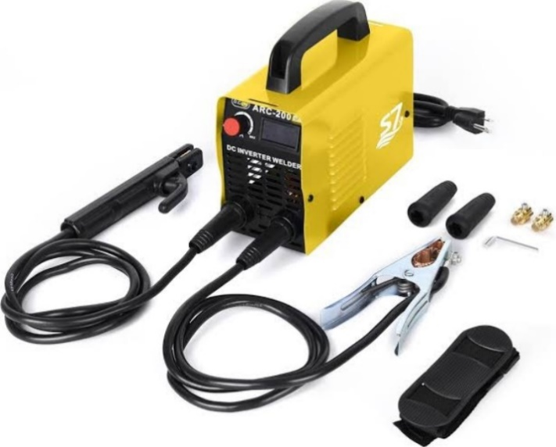
BENCH SHEAR

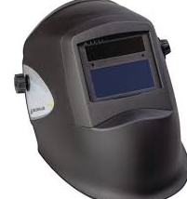

ARC WELDING MACHINE

Protective Shade

CHAPTER FOUR

4.0 EXPERIENCE GAINED
During the four months program, I gained a lot especially in the fabrication section where by we cut plate in to sizes weld a coal pot And burglary window. All this gives me the knowledge of constructing and designing a project.
Also in production section, I learnt how operate various types of machine in the production workshop e.g lathe machine, shaping machine, grinding machine, milling machine and Drilling machine.

4.1 INTERPERSONAL RELATIONSHIPS WITH THE ORGANIZATION
My four month SIWES program has equipped me the knowledge of mechanical engineering design in term of fabrication and production of a particular Project
During the course of staying with the coordinator in the various section has turn a new movement in my course of study like the production section in person of Engr. Dayo and Engr. Soliu in fabrication respectively.
4.2 SUGGESTION FOR IMPROVEMENT OF THE PROGRAM
The Industrial training Fund should have up and hold a committee on inspecting the student in their various organization that they are attached to as this will improve the level of seriousness of the student to the program. Also the federal government in collaboration with the Industrial training Fund (ITF) to increase the student allowance for the program as this will encourage them in active participation.

CHAPTER FIVE

5.0 CONCLUSION
I found it interesting and I fully participated in it which in turn yields a successful result indeed it prepares me for future challenge in my chosen field. This SIWES program has turn out to be more interesting education due to the nature of the program itself.

5.1 RECOMMENDATION
The experience I gained during my SIWES program cannot be over emphasized I was practically oriented I humbly recommend that the SIWES program should be made compulsory for student of engineering, fields in order to gain more experience in their course of study.

