
A TECHNICAL REPORT ON STUDENT INDUSTRIAL WORK
EXPERIENCE SCHEME

(SIWES)

HELD AT

MINISTRY OF WORKS AND ROAD TRANSPORT
ILORIN, KWARA STATE

BY

NAME: SALAUDEEN HABEEB AYINDA
MATRIC NO: ND/23/CEC/pT/0286

SUBMITTED TO

DEPARTMENT OF CIVIL ENGINEERING,

INSTITUTE OF TECHNOLOGY (I.O.T)

KWARA STATEPOLYTECHNIC, ILORIN.

IN PARTIAL FULFILLMENT OF REQUIREMENT FOR THE
AWARD OF NATIONAL DIPLOMA (ND) IN ENGINEERING

APRIL 2025
DEDICATION
This report is dedicate to Almighty Allah for his protection, Faithfulness, loving kindness and goodness that endures forever.
Also to my beloved parent’s Mr. and Mrs. Salaudeen , for their moral, financial and prayer support toward achieving my goals. May Almighty Allah continue to bless and uplift you . Amen

ACKNOWLEDGMENT
I return all the glory to my creator for the Opportunity I have received, I thank him for the Divine wisdom, knowledge, understanding, protection, golden privilege and grace he has given to me to have a better placement for this SIWES and successfully completed the programme.
Furthermore, my profound gratitude goes to my beloved parents, Mr. and Mrs. Salaudeen for their financial support, coupled with words of encouragement; I am greatly indebted to them.
Also, my heart of gratitude goes to the entire management of ministry of works and transport (civil Engr Dept) for absorbing me into their company as a SIWES student.
Finally, my appreciations goes to all lecturers of civil engineering department kwara state poly Ilorin thank you all .

CHAPTER ONE
INTRODUCTION.

1.1 Background
The student industrial work experience scheme (S.I.W.E.S.) is a skill development programme initiated by industrial training fund (I.T.F.) in the year 1973 to solve the problem of lack of adequate practical skills preparative for employment in industries by Nigerian graduates of tertiary institutions.
The student industrial work experience scheme (S.I.W.E.S.) was also founded in order to expose students to industry based skills necessary for an easy transition from the classroom to the world of work, which enables students to be exposed to work methods and techniques in handling equipment and machinery that may not be available in their institutions
The scheme started with 784 students from 11 institutions with 104 suitable courses at inception in 1974.The number of students that participated in SIWES from universities, polytechnics and college of education at the end of the year 2007 was 194,890. In the year 2008, the number of the students that participated in the scheme increased to 210,390 students with over
112 suitable courses from 219 institutions.
1.2 Objectives of S.I.W.E.S.
- To provide an avenue for students in the Nigerian universities to acquire experience and industrial skills during their course of study.
- To prepare students for the work situations they are likely to meet after graduation.
- To expose the students to work methods and techniques in handling equipment and machinery that may be available in their institutions.
- To provide students with an opportunity to apply their theoretical knowledge in real work situation thereby bridging the gap between theory and practice.
- To allow the transition phase from school to the world of working environment easier and facilitate students contact for later job placements.

CHAPTER TWO

1.0 HISTORICAL BACKGROUN OF THE ORGANIZATION
Kwara state ministry of works and transport Ilorin was set up by state government to control some specific activities in rural and urban center development in term of route and other external works in the state. The organization was first known as public work co-operation since creation of Kwara State in 1967 until some year when it was changed to (KWARA STATE MINISTRY OF WORKS AND TRANSPORT ILORIN) with its headquarter at Ilorin the state capital.
The organization is meant for development of route, construction of road network and countdown of bridges for public utility project in the state.

1.1 MAJOR ACTIVITIES OF THE ORGANIZATION
Civil engineering department of ministry of works and transport represent government it any ongoing organization project (i.e electrical and mechanical) to ensure that the project is done to specification.
Also job of the ministry of works and transport are to monitor the activates on road, development of new routes and maintenance of road and advise the state government on what is be done to make such road effective.

1.2 THE ORGANIZATION CHART
The chart below had shown the organization of the Kwara state ministry of works and transportation in which civil engineering department had been exemplified and detail section attached to the ministry for student industrial work experience scheme (SIWES) programme.

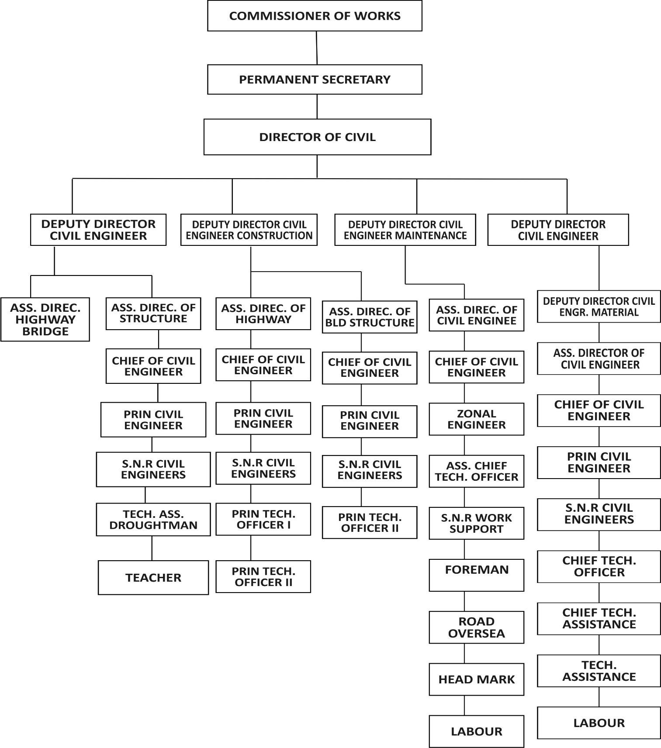

2.3 UNIT OF THE ORGANIZATION AND THEIR SPECIFICATION
The organization possessed four sections
- Civil engineering design unit
- Civil engineering construction unit
- Civil engineering management unit
- Civil engineering maintenance unit.

Civil engineering design unit
This unit had been meant for road, bridges construction and majority on structure.
The unit consisted of many engineers and the drought man tracked and checker is inclusive in the design unit. They produced the drawing for needed execution the project in the ministry.

Civil engineering construction unit
This unit are meant to construct any project awarded to the organization both government and individual project.

Civil engineering management unit
This are the part that are responsible in the management of any governments roads that are to be patched or amend for propel used.

Civil engineering maintenance unit
This section is meant to foresee the maintenance and construction or road the project in the ministry. The maintenance unit at ministry of works and transport is called Kwara State road and maintenance agency (KWARMA). The organization in this section took the proper care to road equipment, patching potholes along the road network, scarification of widening potholes for the suitable of the projects.

CHAPTER THREE

3.1 ROAD CONSTRUCTION
A road is define as a line of communication (travelled way) using stabilized base open to public traffic, primarily for the of road motor vehicles running on their own wheels.
A road can also be defined as a route, or way on land between two places that has been paved otherwise improved to allow travel by some conveyance including motor vehicles, bicycle, and other means of transportation on land.

PART OF A ROAD
- Shoulder: - these are extreme edge of carriage way which is the beside the drainage construction and is a place where vehicle can park and also serves as pedestrian walkway.
- Carriage way: - this is the way where vehicles move or travel.
- Median: - it serves as divider which separates the carriage way into two equal parts and provides movement of vehicles in opposite directions.

ROAD PAVEMENT
The road pavement is the portion of the road located directly above the sub-grade, and beneath any wearing surface. There are two types of road pavement;
- Flexible pavement
- Rigid pavement
FLEXIBLE PAVEMENT: - Flexible pavement are those which are surfaced with bituminous (or asphalt) materials. Flexible pavement structures are typically composed of several layers of material. Each layer receives the road from the above layer, spreads them out, and then passes on these loads to the next layer below. These layers of flexible pavement comprises of:-
- Wearing surface:-This is the uppermost layer, it provide smooth riding surface, resist wear and abrasion due to moving vehicles. It also provide water proof surface and protect the base and sub-grade from surface water.
- Base:- it distribute stresses due to wheel load on wearing surface and transmits mineral stresses on sub-grade in order to prevent excessive deformation of foundation, must be capable of resisting effect of capillary water and or frost action.
- Sub-base:- use in cases of weak sub-grade or as a construction table. It is use to build up the pavement strength economically above that provided by the sub-grade soil.
- Sub-grade:- Serves as foundation of the road, support all load applied on pavement structure usually natural earth surface, compacted soil from cut section or upper layer of embankment. RIGID PAVEMENT: - it is usually known as concrete road constructed to behave as a slab or cantilever. It might be reinforced or mass pavement. They have sufficient rigidity and have high modulus of elasticity. It is normally laid directly on the sub-grades.

3.2 DRAINAGE CONSTRUCTION
Drainage construction is the artificial removal of surface and subsurface water from an area, it is under goes the process of excavating the surface for free and easy passage of excess water. Drainage construction as the name implies is one channels when excess water discharge to the outlet.
Drainage construction in civil engineering is mainly used to channel water and mostly constructed at the highway. Drainage is very important and contributes a vital role to the construction of the road. Drainage found at each sides of the road. It is to take away any water that may be stay on the bituminous road, so road cambering is introduce to send the unwanted water to each edges of the road which help in maintaining the life span and durability of the road.
TYPES OF DRAINAGE
i.V-shape or Earth drain ii.Rainforced concrete drain iii.Block drainage iv.Precast drainage
Materials for reinforce drainage
Sand, Cement, Steel, Gravel, Granite, Water, and Form work.

PROCESS OF REINFORCE CONCRETE DRAINAGE
Measurement of wedth: - the measurement of width of trench and pegging is done with rope to the obtain a straight trench of the drainage/
Base reinforce casting: - This is done immediately after excavation is done before the laying of the base concrete to provide more strength to the base.
1.Bliding: - These one done to give a good attachment to bolt ground and concrete
2.The walling reinforcement casting: - These are lay in to prevent under movement of the drainage wall.
3.Form work construction: - This is the process of fixing plank together to guide the falling of the walling concrete casting.
4.Concrete mixing and casting: - This is the mixture of gravel sand, cement and water at a ratio depend on how you want, the mixing concrete is being transfer to the specing provide with and wheel borrow and head pan.
5.Removal of the form work: - after some days the form work will be removed, at this concrete would have been strong enough to hold its off.

IMPORTANT OF DRAINAGE
1.It serve as channel to discharge excess water during raining period.
2.It prevent wearing of the soil (e,g erosion).
3.It prevent damage of the road construction.
4.It provide direction for water following.
5.It protect the life span of the road.
6.It prevent uneven flowing of water.

3.3 CONSTRUCTION OF THE CULVERT
Culvert is a drainage facility that allows water to flow under the road without causing traffic disruption. It can also be defined as an open channel that convey water form of erosion from carriageway, lake, stream into the drain. It appears in many shapes and sizes such as round, box e.t.c, culvert can be made up of steel, precast concrete and polymer (plastic).
Type of culvert I. Ring culvert ii.Box culvert iii. Ring culvert: -it is the type of culvert that made up of rings with mass concrete but without reinforcement. Ring culvert are of different sizes such as 0.3m, 0.4m, 0.5m, 0.6m, 0.75m, 0.8m,
0.9m, 1.2m.
iv.Box culvert: -This is made up of reinforcement and concrete materials so as to convey heavy runoff water unther the road. It is normally constructed in an area where there is a mountains, streems, rivers e.t.c. it provide more room for wild life passage than ring culvert.

Element of culvert
1.Wing wall: - it provide improved inlet and outlet hydraulics for culvert, it prevent the culvert from storm water outfalls and protect a gist erosion.
2.Apron: - apron is used at the outlet of a culvert to protect erosion.
3.Head wall: - head wall is a retaining wall which is designed to support structure of the culvert

3.2 SLAB DESIGN
A slab is a part of a reinforced concrete structure which more often than not is subjected to bending (tensile of compression) but in rare cases, (such as, in bridge deck) subjected to shear. In most cases, slabs are horizontal members but they can be used as vertical members, such as, walls to infill panels, side walls to drains etc.

There are various types of slab
- Solid slab: - Solid slabs are the most common especially in residential areas and offices and are generally employed when the span of the slab does not exceed 6.0m. Depending on the structural configuration, solid slabs may present itself as a cantilever slab.
- Flat slab: - Flat slabs span between columns with no beams at all. Flat slabs are used where large spans and heavy live loads are required or were they would be aesthetically pleasing.
- Waffle slabs: - Waffle slabs are used where large spans and heavy live loads are required or were they would be aesthetically pleasing. Waffle slabs are of two types: those with beams from column to column on all sides and the mushroom type which has no beams but with capital around the columns (column heads).
- Ribbed slabs: - Ribbed slabs are used where large spans and heavy live loads are required or were they would be aesthetically pleasing. They can be whole concrete ribbed floor of ribbed floor with hollow floor with hollow pots in-fill.

CHAPTER FOUR

RELEVANCE OF EXPERIENCE GAINED TO FIELD OF STUDY
The experience I gained which is related to Civil Engineering is as follows:
- Identification of plants/equipment and their uses.
- Working grades / mixing ratio.
- Aggregate types.
- Safety tips on site.
- Reconnaissance survey of a proposed route/road.

4.1 IDENTIFICATION OF PLANTS AND THEIR USES
- Excavator: It is a heavy construction equipment consisting of a boom, stick, bucket, and cab on a rotating platform known as the house. It is used for: digging of trenches, material
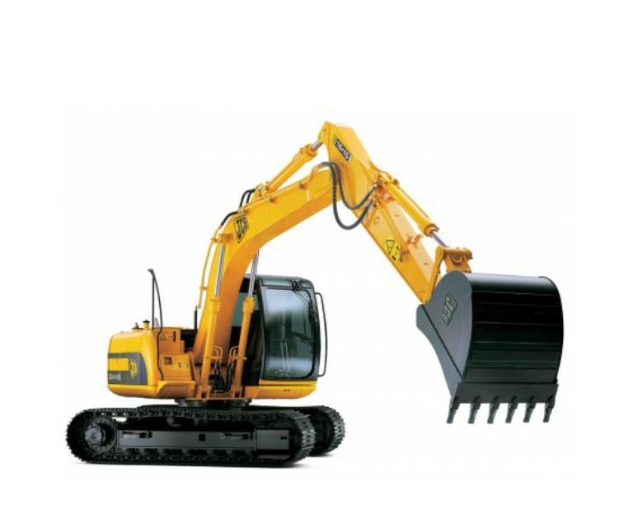

- handling, demolition, river dredging, etc.
- Crane: It is a type of machine that is generally equipped with a hoist, wire ropes or chains, and sheaves, that can be used to both lift and lower materials. It is mainly used to lift heavy things, and transport them to other places.

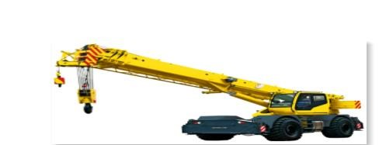
- Pay Loader: it is a heavy machine used in construction to move aside or load materials such as demolition debris, gravel, sand, dirt, etc.
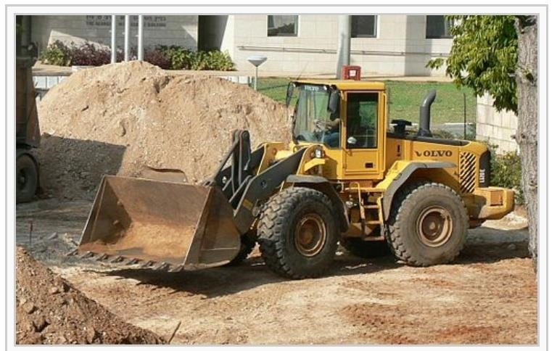
- Mobile Concrete Mixer: It is use for mixing and conveying concrete mixture to place of use.
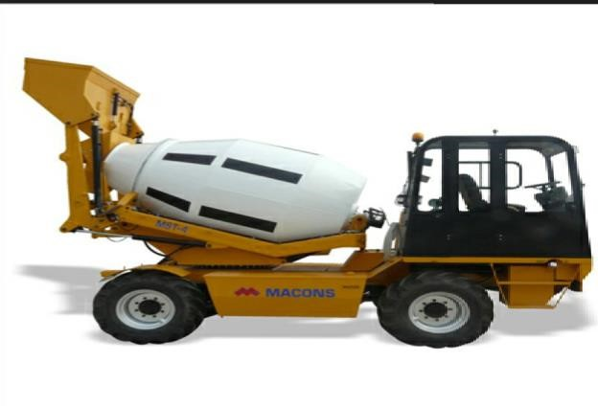
- Truck: It is use for various hauling operation.
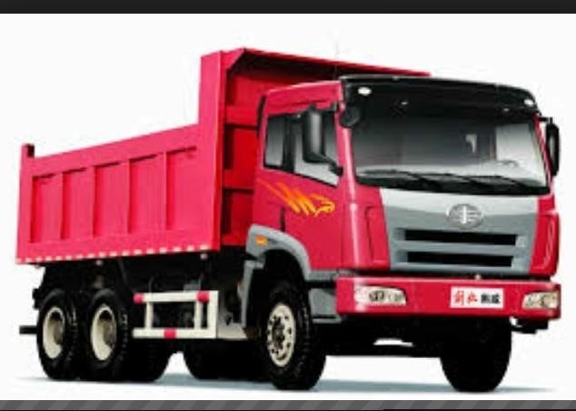
- Grader: It is use for cutting the slope of an embankment for smoothing grade level, and for spreading loose materials.
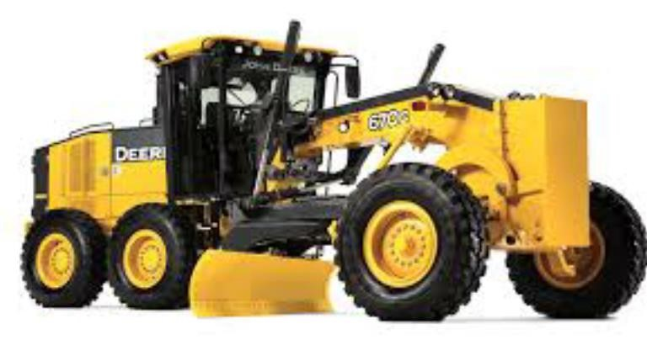
- Bulldozer: It is use for the demolishing of existing structures and also use for clearing a virgin land in preparing for construction.
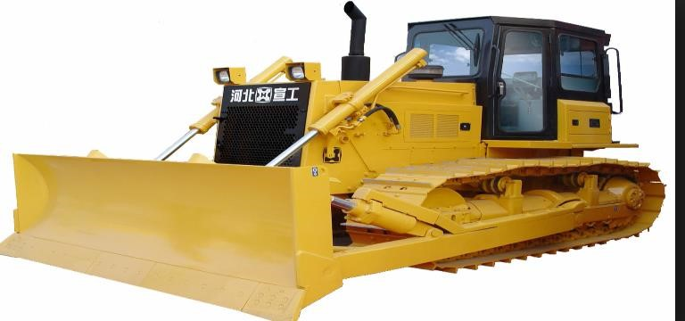
- Low Bed: It is used to transport machines from one place to another.
- Hand Concrete Mixer: It is used for mixing concrete at a stationary position.
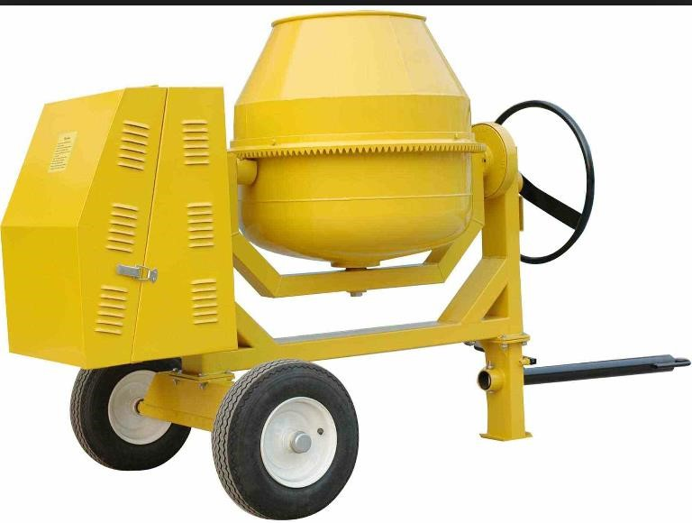
- Rammer: It is a hand compacting machine for soil compaction. xii. Vibrating Roller: It is use to compact soil and also roll on asphalt during lying.
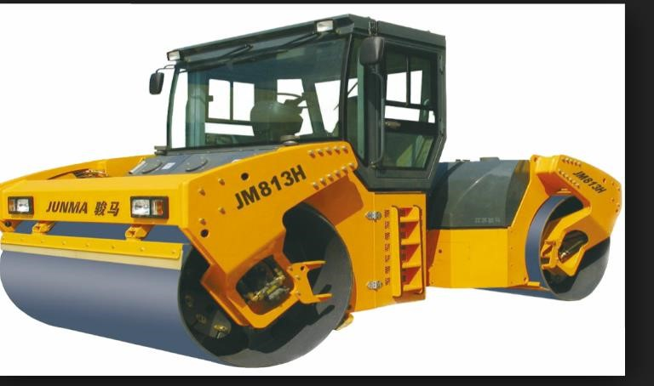
- Paver: It is used for laying or spreading asphalt concrete mixture in a uniform layer of desired
thickness and shapes.
- Tar Boiler: This is used for heating/ boiling tar for road construction.
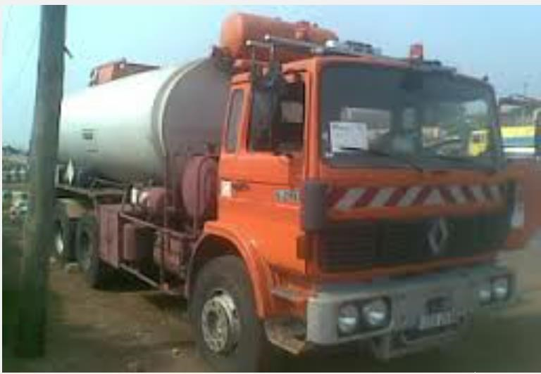
- Hand Roller: This is used for compacting soil and rolling on asphalt.
- Dumper: This is use for transporting materials in construction site.

4.3 AGGREGATE
Aggregate can be grouped into two depending on their sizes,
- Fine Aggregate :- Quarry dust, Sharp sand
- Coarse Aggregate: - Gravel, Granite laterite

CHAPTER FIVE

SUMMARY, CONCLUSIONS AND RECOMMENDATION

5.1 Summary of attachment activities
The industrial training gave me the chance to know what S.I.W.E.S. itself means or entails, also I had the opportunity to know what civil engineering discipline constitutes. During my industrial training work, I had the privilege to be a part of the team that carried out the reconnaissance survey of the proposed route (road) construction which would serve as a link/connection between the university of Ilorin permanent site campus and the university of Ilorin teaching hospital. I had the chance of experiencing how it feels to navigate in a large expanse of virgin land and finding our ways through the use of GPS (Global Positioning System)

5.2 Problems encountered during the programme
The program was indeed a memorable one, it was almost a problem-free one, the few times problems do occur is usually as a result of the difficulty faced in trying to make the labourers follow standard procedures and instructions given to them, and also the problem of trying to make them obey safety regulations which they are supposed to observe while on site as a member of the engineering team.

5.3 Suggestions for improvement of the scheme
I would like to recommend that there be more (strict) supervisions by the supervisors, as this makes both the student and the firm to be more committed to achieving the aim for which the scheme (S.I.W.E.S.) was established.

5.4 Suggestions for improvement of the Institution
I would like to recommend that the department should encourage the deep target of other section in the department like design and material as that of road construction unit. And the department should give room for the young engineers who had gained experience with them and have been tested and justified to be given employment opportunity in his /her field of study.

