KWARA STATE POLYTECHNIC, ILORIN
STUDENT INDUSTRIAL WORK EXPERIENCE
SCHEME (SIWES)

A TECHNICAL REPORT ON SIWES

DONE AT

ARCHI-VIEW FINDER PROPERTIES CONSULTANT
10, ORO ROAD ILORIN KWARA STATE

By

OLORUNMOJO DARASIMI EMMANUEL
ND/23/ARC/FT/0011

SUBMITTED TO:

DEPARTMENT OF ARCHITECTURAL TECHNOLOGY
INSTITUTE OF ENVIRONMENTAL SCIENCE
KWARA STATE POLYTECHNIC, ILORIN, KWARA STATE.

ON PARTIAL FULFILMENT OF THE REQUIREMENTS FOR THE AWARD OF NATIONAL DIPLOMA IN ARCHITECTURAL TECHNOLOGY

AUGUST – NOVEMBER 2024
CERFTIFICATION
I hereby certify that this report of Student Industrial Work Experience Scheme (SIWES) was prepared and compiled by OLORUNMOJO DARASIMI EMMANUEL (Matric Number: ND/23/ARC/FT/0011) from the department of ARCHITECTURAL TECHNOLOGY INSTITUTE OF ENVIRONNMENTAL SCIENCE, KWARA STATE POLYTECHNIC, ILORIN, KWARA STATE for the successful completion of my four (4) months Industrial Training undertaken at ARCHI-VIEW FINDER PROPERTIES CONSULTANT, 10, ORO ROAD ILORIN KWARA STATE.

DECLARATION
I hereby declare/ascertain that this compressive report was compiled by me (OLORUNMOJO DARASIMI EMMANUEL) and entails precisely what I have done during my SIWES Industrial Training at ARCHI-VIEW FINDER PROPERTIES CONSULTANT KWARA STATE. I withal declare that this report or its content has not been submitted to this or any other institution of learning for the purport of consummating the requisites for the award of any degree or diploma. All citations and sources of information’s and research are pellucidly acknowledged by betokens of references

OLORUNMOJO DARASIMI EMMANUEL…………………………………………………….

DEDICATION
I would relish dedicating this report to The Almighty God, who has been my ultimate source of bliss, vigor, sapience, good health and sustenance for visually perceiving me through and for the prosperous completion of my SIWES programme in one piece. Would additionally want to dedicate this report to my parents Mr. and Mrs. OLORUNMOJO, my Brother and sibling, who provided for me and the family who accommodate me during my SIWES programme. It is withal dedicated to the ARCHI-VIEW FINDER PROPERTIES CONSULTANT, ORO ROAD, ILORIN, KWARA STATE for all the care, attention and understanding throughout the duration of my SIWES in their reputable department.

ACKNOWLEDGEMENT
I acknowledge the Lord God Almighty through the Lord Jesus Christ, the Author and Finisher of our faith. To Him alone be the glory and honor. I am what I am today by His grace, His name be praised forever and ever.
My sincere appreciation also goes to my parent MR & MRS OLORUNMOJO who play the role of a father and a mother and I also thank my siblings and all my colleagues at ARCHI-VIEW FINDER PROPERTIES CONSULTANT, 10, ORO ROAD, KWARA STATE for the support and cooperation during my Student Industrial Work Experience Scheme (SIWES) exercise.
I also want to appreciate my boss RUFUS .O. LAWAL, the officer in charge of the SIWES Student in the ARCHI-VIEW FINDER PROPERTIES CONSULTANT ORO ROAD KWARA STATE who approved my application letter to do my SIWES exercise with them. My gratitude also go to the whole workers in the ARCHI-VIEW FINDER PROPERETIES CONSULTANT ORO ROAD KWARA STATE I pray may the Lord bless you all abundantly. (Amen).

ABSTRACT
This report presents a comprehensive account of the Student Industrial Work Experience Scheme (SIWES) undertaken at ARCHI-VIEW FINDER PROPERTIES CONSULTANT, over a period of four months. The industrial training provided hands-on exposure to real-world architectural practices, bridging the gap between theoretical knowledge and practical application. During the course of the training, various tasks were carried out including site visits, architectural drafting, 3D modeling, and participation in design development processes.
Key software tools such as AutoCAD, Revit, SketchUp, and Adobe Photoshop were utilized in developing architectural drawings and visualizations. The experience also included learning proper studio workflow, understanding building codes, and gaining insights into sustainable design practices. Special emphasis was placed on teamwork, time management, and adherence to safety protocols within a studio environment.
Overall, the industrial attachment significantly enhanced both technical and interpersonal skills, laying a solid foundation for future professional development in the field of architecture.

TABLE OF CONTENTS
TITLE PAGE i
CERTIFICATION ii
DECLARATION iii
DEDICATION iv
ACKNOWLEDGEMENT v
ABSTRACT vi
TABLE OF CONTENT vii-viii
CHAPTER ONE
- INTRODUCTION 1
  - Background of Study 1
  - Brief history of SIWES 1-2
  - Aims and objectives of SIWES 2
- DESCRIPTION OF INDUSTRY
  - Industry Overview
  - Organizational Structure.
- LITERATURE REVIEW
  - Architectural Studio
  - Safety Precaution in Architectural studio
  - Architectural equipment and their Uses
  - Basic Aspects of Architecture
4.0 COMPONENTS OF BUILDING WITH THEIR STANDARD DIMENSIONS
5.0 OBSERVATION, RECOMMENDATION AND CONCLUSION
CHAPTER ONE
INTRODUCTION
  - BACKGROUND OF STUDY
Student Industrial Work Experience Scheme (SIWES) is one of the Industrial Training Fund (ITF) programmes which were introduced in 1974 due to the in ability of Students in Nigeria University and Polytechnic to meet the practical aspect of their training. That is, the needs to enable student match their theoretical school knowledge with the practical aspect of their training in Industry/Investment.
The program was designed for Students of Tertiary Institution with aims of exposing Students that have acquired theoretical knowledge in the class to the practical exposure and experience. The scheme is a tripartite programmes involving the Students, Tertiary Institutions and the Industry (Employers of Labor). It is funded by the Federal Government of Nigeria and jointly coordinated by the Industrial Training Fund (ITF) And the National University Commission (NUC).

  - BRIEF HISTORY OF SIWES
In recognition of the shortcomings and witnesses in the formation of Graduate, particularly with respect to acquisition of relevant production skills (RPSs), the Industrial Training Fund (which was itself established in 1971 by decree 47) initiated the Student Industrial Work Experience Scheme (SIWES) in 1973. The scheme was designed to exposed student to industrial environment and enable them develop occupational competencies so that they can readily contribute their quota to National Economic and Technological Development after Graduation. Participation in SIWES as becomes a necessary condition for the award of Degrees and Diplomas.
The main thrust of ITF programmes and services is to stimulate human performance, improve productivity and reduce value added production in commerce and Industry.

  - AIMS AND OBJECTIVES OF SIWES
- To help Students prepare for the cooperate world and enhance their curriculum vitae.
- To bridge the gap between theoretical and practical knowledge, thereby given Students the opportunities to apply their knowledge accurately.
- To improve interpersonal relationship skills of the students.
- To provide avenue for students in Nigeria Universities to acquire industrial skill and experience in their course of study.
- To develop skill on practical knowledge.

CHAPTER TWO
2.0 DESCRIPTION OF INDUSTRY

2.1 Industry Overview

The architectural and property consultancy industry plays a vital role in the development and planning of the built environment. It encompasses a wide range of services, including architectural design, construction management, property development, land use planning, and real estate consultancy. These services are essential for translating client visions into functional, aesthetic, and structurally sound buildings and infrastructure.
In Nigeria, the industry is experiencing continuous growth due to increasing urbanization, population growth, and the rising demand for residential, commercial, and public buildings. Firms such as ARCHI-VIEW FINDER PROPERTIES CONSULTANT, located in Kwara State, are key players contributing to this development by offering tailored architectural solutions and property advisory services. The integration of modern technology, such as CAD software and 3D modeling tools, has also enhanced design quality and efficiency in service delivery.
Furthermore, the industry is influenced by factors such as government regulations, environmental sustainability concerns, client demands, and economic trends. As such, professionals in this field must stay updated with current standards, building codes, and innovations to maintain relevance and deliver high-quality outcomes.
Overall, the architecture and property consultancy industry is dynamic, interdisciplinary, and essential for fostering sustainable development in both urban and rural settings.
2.2 Organizational Structure
The organizational structure of ARCHI-VIEW FINDER Properties Consultant is likely a hierarchical structure, which defines clear lines of authority, roles, and responsibilities. This helps ensure smooth workflow, accountability, and effective project delivery. Below is a breakdown of the key positions and their functions within the organization:

1. Principal Architect / Managing Director
- The highest-ranking officer in the firm.
- Responsible for overseeing all operations, making executive decisions, and ensuring that the firm’s vision and goals are achieved.
- Often the founder or lead designer with deep industry experience.

2. Architect / Design Lead
- Handles the creation of architectural concepts and design proposals.
- Works closely with clients to understand their needs and translates them into functional and aesthetic designs.
- Oversees junior architects and ensures design consistency.

3. Project Manager / Site Supervisor
- Responsible for coordinating on-site construction activities.
- Ensures that projects are executed according to design, budget, timeline, and safety standards.
- Acts as the link between the design team and contractors.

4. Property Consultant / Estate Officer
- Provides real estate advisory services, such as property valuation, land acquisition, and property management.
- Assists clients in making informed investment decisions.
- Ensures all property transactions comply with legal and regulatory frameworks.

5. Draftsmen / CAD Technicians
- Supports architects by producing detailed 2D and 3D drawings using CAD software.
- Prepares working drawings, sections, and elevations needed for approvals and construction.

6. Administrative Staff / Front Desk Officer
- Manages the day-to-day administrative tasks of the office.
- Handles client inquiries, schedules meetings, and maintains office records.
- Provides support services to all departments.

7. Interns / Trainees (e.g., SIWES Students)
- Assist with drawing, modeling, site visits, and basic administrative tasks.
- Learn practical skills under the supervision of senior staff.
- Gain exposure to real-world design and construction practices.
This structure promotes a clear chain of command and helps team members specialize in their roles, making collaboration more efficient. Depending on the size of the firm, some roles may be merged or expanded.
.

CHAPTER THREE
3.0 LITERATURE REVIEW
3.1 ARCHITECTURAL STUDIO
An architectural studio is:
- A design environment where architects or students work on projects.
- Commonly found in universities, where students use studio time for hands-on learning and critiques.
- A place where collaboration, creativity, and iterative design happen.
3.2 SAFETY PRECAUTION IN ARCHITECTURAL STUDIO
Safety in an architectural studio is super important, especially since it often involves working with sharp tools, physical models, heavy materials, and digital equipment. Here’s a list of key safety precautions in an architectural studio setting — whether academic or professional.
3.2.1 GENERAL SAFETY PRECAUTIONS
- Keep the workspace tidy
  - Clear clutter to avoid tripping or knocking over fragile models.
  - Store tools and materials properly.
- Proper ventilation
  - Especially when using spray adhesives, paints, or other chemicals.
  - Always use spray booths if available.
- Use tools responsibly
  - Handle cutters, blades, and other sharp tools with care.
  - Always cut on proper surfaces (e.g., cutting mats) and away from your body.
- Wear appropriate gear
  - Safety goggles when cutting or sanding.
  - Gloves for handling rough or hazardous materials.
  - Dust masks when dealing with foam, sawdust, or fumes.
- Mind electrical safety
  - Don’t overload sockets.
  - Keep liquids away from laptops, printers, and cutting machines.
3.2.2 Fire Safety
- Know where the fire extinguishers and exits are.
- Avoid using flammable materials near heat or open flames.
- Never leave hot tools (like glue guns or heat knives) unattended.

3.2.3 Model-Making and Workshop Safety
- 3Use machines (e.g., laser cutters, 3D printers) only after training.
- Follow lab or workshop rules strictly.
- Report broken tools or machines immediately.

3.2.4 Personal Health and Safety
- Take breaks — long hours can lead to fatigue, increasing the risk of mistakes or injury.
- Practice good posture when drawing or using computers.
- Use adjustable chairs and worktables to avoid back or neck strain.

3.2.5 Studio Etiquette (which doubles as safety!)
- Don’t distract someone while they’re using sharp tools.
- Warn others before spraying or using loud equipment.
- Label your materials, especially chemicals or adhesives.

3.3 ARCHITECTURAL EQUIPMENT AND THEIR USES
Architectural design involves both manual and digital tools that assist in producing precise and presentable drawings. Below are some essential equipment used in architectural studios:

1. Drawing Board
- Use: A flat, sturdy surface used for creating architectural drawings manually.
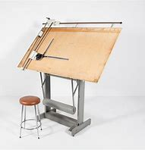
- How to Use: Place drawing paper on the board and secure it with clips or tape. Use T-squares and set squares to draw straight lines and angles accurately.

2. T-Square
- Use: Used to draw horizontal lines and align other drawing instruments.
- How to Use: Rest the head of the T-square against the edge of the drawing board and slide it up or down to draw straight horizontal lines.
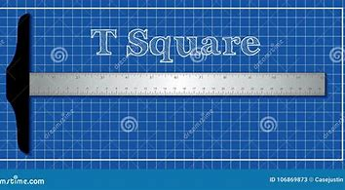

3. Set Squares (Triangles)
- Use: For drawing vertical lines and specific angles like 30°, 45°, 60°, and 90°.
- How to Use: Place it against the T-square or ruler to draw perfect angles and perpendicular lines.
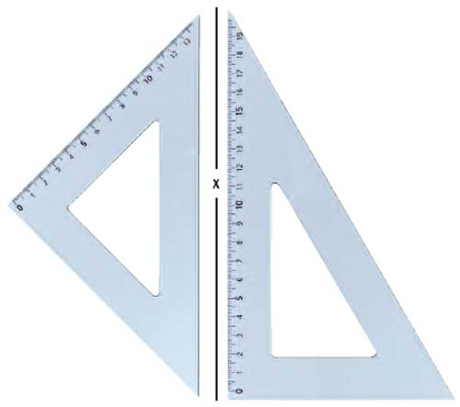

4. Compass
- Use: To draw arcs and circles.
- How to Use: Place the needle at the circle’s center and rotate the pencil arm around the point.
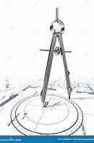

5. Scale Ruler
- Use: For measuring and drawing to scale.
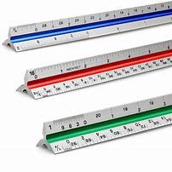
- How to Use: Select the appropriate scale (e.g., 1:100), align the ruler with the drawing, and use the scaled markings to measure accurately.

6. Tracing Paper / Drafting Film
- Use: For creating overlays, revisions, or clean final drawings.
- How to Use: Place over a base drawing and trace using fine liners or pencils.
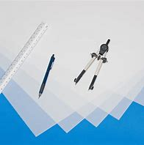

7. Technical Pens / Fine Liners
- Use: For inking architectural drawings with precision.
- How to Use: Choose a pen size (e.g., 0.1mm, 0.5mm) according to line weight. Ink over pencil sketches, using rulers and French curves for precision.


8. Cutting Mat & Cutter
- Use: For model-making and cutting paper or board cleanly.

- How to Use: Place material on the mat, use a steel ruler as a guide, and run the cutter along the edge.

9. Computer-Aided Design (CAD) Software
- Examples: AutoCAD, Revit, SketchUp, ArchiCAD
- Use: For digital drafting, 3D modeling, and rendering.
- How to Use: Use drawing tools (lines, arcs, dimensions) to create floor plans and models. Utilize layers and tools for organization and presentation.
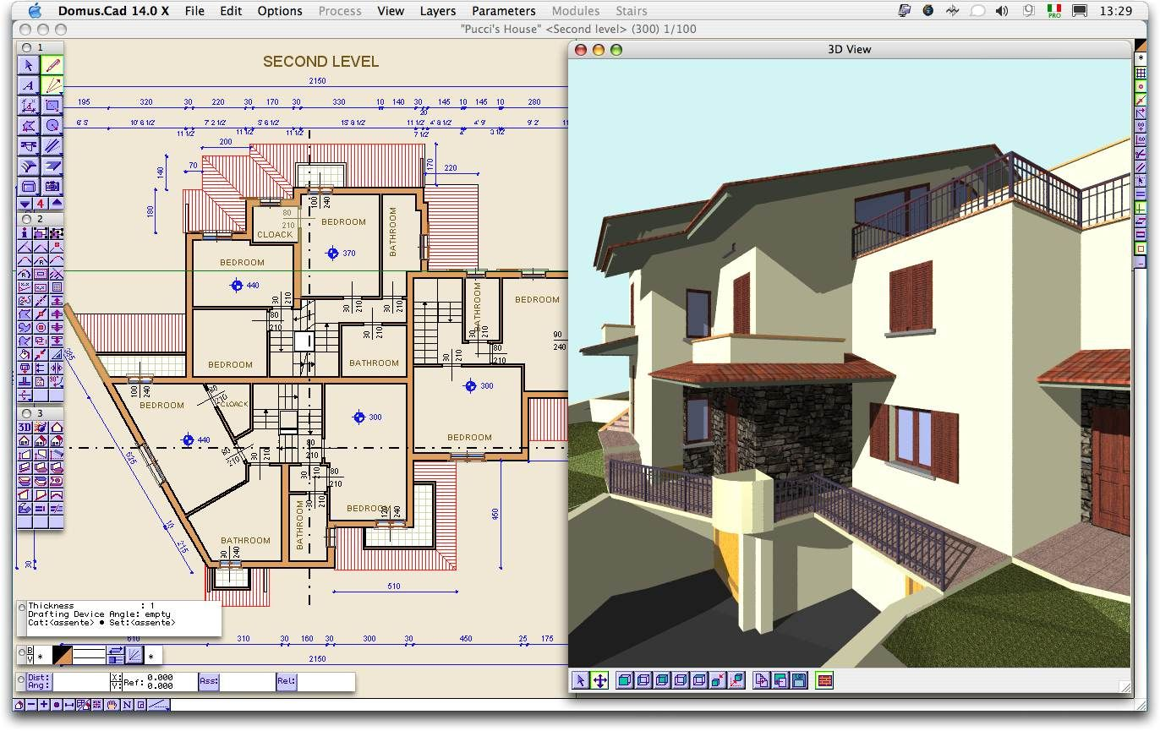

10. Laptop / Desktop Computer
- Use: To run design software and handle digital architectural workflows.
- How to Use: Ensure high RAM and graphics specs. Install architectural software and connect peripherals like mouse and external drive.


3.4 BASIC ASPECTS OF ARCHITECTURE
There can be various aspects of architecture. So, following is all about architecture and its 10 various aspects:

1. Functionality Aspect:
Functionality is first and foremost aspect of architecture. This aspect of building is main because it depends upon type of building such as Educational, Healthcare & Commercial etc. The building is designed as per requirement of users. It is important for an designer to understand whether Form follows function or Function follows form? But its always the functionality of the building comes first. So accordingly its “Form follows function”.

2. Durability and Stability Aspect:
Next is about the durability and stability of building. If building is aesthetically appealing but not stable enough then it’s a disaster. The building is designed for at least 100 years. So, building is durable and stable only if structural designing of building is strong. It is a scientific process. The architect’s also capable of designing a structurally strong building. But if scale of project is large then project team can also hire a Civil Engineer.

3. Quality Aspect:
Quality is important for building’s construction and management. But building is stable and durable if quality of construction material is good. “A” grade material need be used for construction. It includes Cement, bricks, mortar, timber and stone etc. The construction technique is also equally important. Skilled workers and laborers also plays important role for construction of any building.
So, if quality of construction material and technique is not good then building will not last for long time. It can also face structural issues. May also collapse in the future.

4. Aesthetics Aspect:
Aesthetics is related to appearance of the building. All about how the building looks. It is as important as its functionality. Building is aesthetically appealing if the facade is designed creatively. The various horizontal & vertical architecture design elements should be used.
The aesthetic is not only limited to the exterior. It also create an impact for interior of the buildings. The interiors can turn aesthetically appealing by proper interior designing of space. This contributes to architecture and its various other aspects.
5. Universal Design Aspect:
Universal designing of any building is mandatory nowadays. Buildings is designed such that it can be used by people of any age group. Also important to consider physically challenged people.
Now question arises, how to make a building which is universal friendly? For old & physically challenged people elements like ramp, lift. Proper signage needs to be provided at every building level. Universal designing is mandatory and building bye laws are stated by National Building Code.
6. Comfort Aspect:
Comfort is necessary aspect of building designing. But if there is no comfort inside living space get really difficult sometimes. So, it can be achieved by better designing & understanding of space. Different buildings have different functions. Similarly comfort level of every building type is also different. Comfort inside the building depends upon various factors such as: Temperature, Light, indoor air quality, decor or furniture. As an architect it is really important to achieve comfort for users of the building or space.

7. Budgeting Aspect:
The budgeting of building refers to total amount of money to be spent in specific amount of time. It covers all from construction and finishing of project. Budgeting is very important aspect that’s why it should be planned accordingly.
Estimation and costing of building is basically done for calculations of the quantities. The total material used and its cost is listed for whole project.

8. Accessibility Aspect:
Accessibility aspect associated with approach. Circulation outside or inside the building. This term is associated with the universal design. The building need to be designed such that it is easily accessible to each and everyone.
Proper building connectivity through road and pathways is necessary. For inside proper planning of staircase, lift and corridors is required. The smooth circulation is required without any hindrance. This is important architectural aspect.

9. Adaptability Aspect:
Adaptability is related to acceptance of built environment by the users. Users are most prime factor in architecture. They need to be adjust the spatial and functional configuration of building. Adaptability comes with comfort. Also necessary for the users to feel comfortable inside that space. It is mandatory because people spend their most of day time in that particular space.
If it’s home or any private place, it need to have a feel of belonging to it. Otherwise you will not find peace in that space.

10. Sustainable or Environment friendly Aspect:
Last but not the least, building designed to be sustainable and environment friendly. It should not harm the environment or its surroundings. The green buildings are future of modern architecture. Building can be designed smartly and always create a positive impact on our environment. This will be beneficial for the coming future generations.
Given above are all the aspects of architecture. While designing it will be helpful to keep these all aspects in mind. But aspects can vary from designer to designer. So, this is all about architecture and its 10 various aspects. Also architecture is the profession with ample scope for the future generations.

CHAPTER FOUR

4.0 COMPONENTS OF BUILDING WITH THEIR STANDARD DIMENSIONS
Here are the most common building components

1. Foundation
A Foundation is the lowest part of the building structure resting on soil below ground level. All loads of building are transferred to the foundation through beam and column arrangement.
Its main function is to distribute the load evenly and safely to the ground.
Foundation
In framed structures, Footings are generally used as foundations to support the structural load of the building.
The following are various types of foundations and footings used in construction:
- Shallow foundation
  - Individual footing or isolated footing
  - Combined footing
  - Strip foundation
  - Raft or mat foundation
- Deep Foundation
  - Pile foundation
  - Drilled Shafts or caissons
Standard Dimensions
Foundation size and depth totally depend on the structural and site ground condition. So, there are no standard dimension recommendations for it.
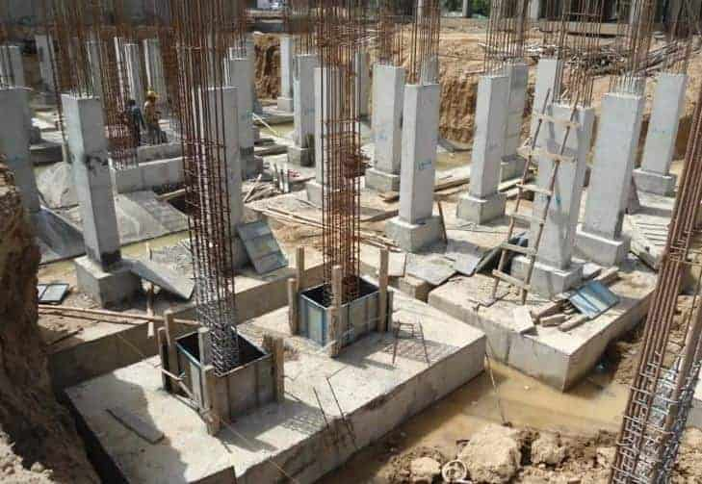
But, For small structures like row houses depth of the foundation should be at least 1.5 m from ground level.

2. Plinth Level
The Plinth level or Plinth is the offset created between ground level and the superstructure of the ding. It is made by constructing a brick wall from ground level to the ring level of the building. Its main function is to prevent the entry of moisture from the ground surface to the building superstructure.

Standard Dimensions
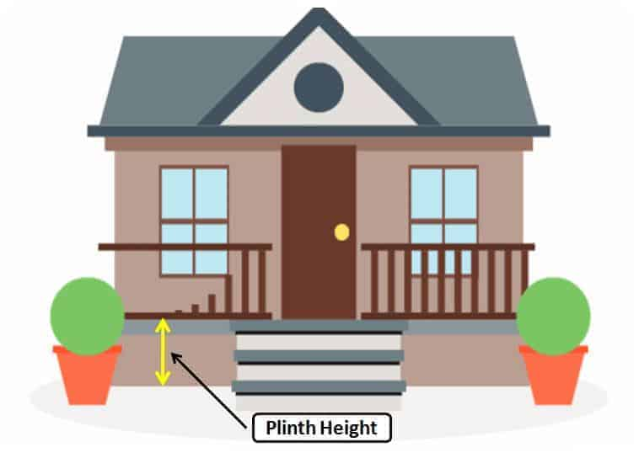
The plinth height of any building must be at least 45 cm or 3 feet from the ground level.

3. Earth Filling
An Earth Filling or Soil Filling is done between the plinth wall. It is essential to fill the open space left between the ground level to the plinth level.
Earth filling must be very well compacted so that the flooring gets a sufficiently hard surface base.
Standard Dimensions:
Earth must be filled to the top of the plinth level. Different materials can utilize as earth fills like soil, coarse aggregate, waste materials, Brick Bat, etc
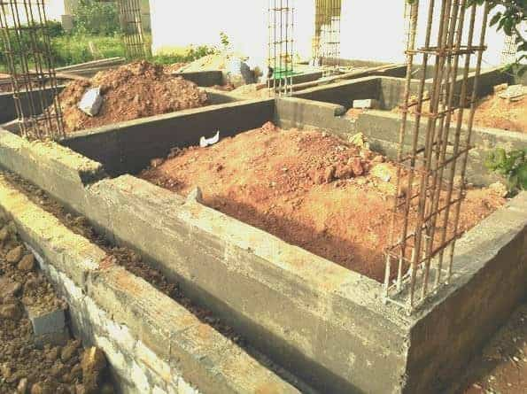

4. DPC (Damp Proof Course)
DPC is a layer of waterproofing material such as asphalt or waterproof cement at the plinth level.
The superstructure walls are constructed above the DPC layer so that no dampness rises from the ground surface into the walls.
Damp Proof Course
In short, DPC prevents the rise of water to superstructures.
If dampness rises in the wall of the superstore it reduces the strength of the walls and creates unhealthy living conditions.
Also, it created many defects in paint and plaster and ultimately increases maintenance costs.
In the case of Plinth, beams are provided above ground level DPC is not required. Because the plinth Beam itself performs as a DPC layer to restrict the entry of dampness.
Standard Dimensions
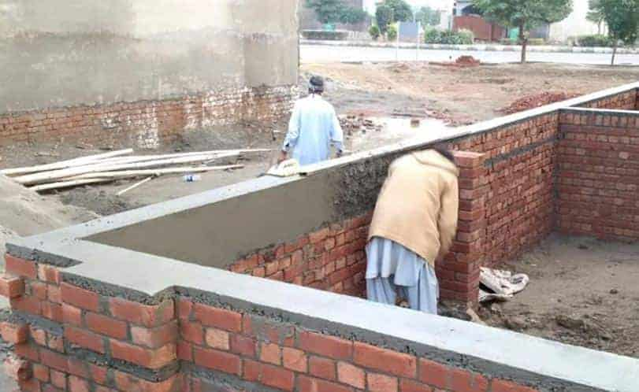
Generally, DPC is laid on brick masonry construction up to the plinth level. So the width of DPC is the same as the width of the Brick wall and thickness may vary from 2.5cm to 5cm.

5. Flooring
Flooring is an important component of the home. It is one that provided an attractive and pleasant look to the house. Flooring is made by laying tile on it.
There are different types of flooring designs and materials available,
- Timber Flooring
- Laminate Flooring
- Vinyl Flooring
- Porcelain or Ceramic Tile Flooring
- Natural Stone Flooring – Marble, Granite, etc.

Standard Dimensions
Flooring is provided above the earth filled with a base made of cement concrete (1:2:4). The flooring material should have sufficient thickness and strength.

6. Walls
Walls are the vertical component of any structure. It can be constructed using stones, bricks, concrete blocks, etc. Different types of bonds are used for constructing walls.
Bricks walls are essential to enclose the inside area and protect against wind, sunshine, rain, etc. Doors and Windows are provided in the walls for ventilation and access to the building.
Standard Dimensions
Walls may be made of single brick walls or double brick walls. The single brick wall has a thickness of 100 mm and the Double brick wall has a thickness of 230mm.

7. RCC Column

Columns are vertical members constructed to support any structural frame. Load Coming from the Slab, Beam transferred to column and column transfer load to the footing safely. Building structures may have two types of columns.
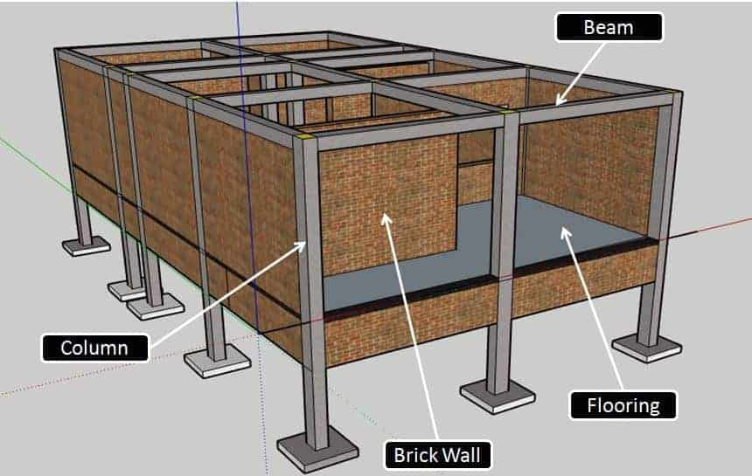
Architectural columns and structural columns. Architectural columns primly used to increase the aesthetic appearance of a building while a structural column takes the load coming from the slab above and transfers it safely to the foundation.

RCC Column
Standard Dimensions
Columns may have various sizes as per the structural load requirements. But, for minimum dimension for any structural column is restricted to 9” x 9” or 225mmx225mm.

8. Sill Level
It is the base point of any window in the house or it is a level where windows are placed. The Sill level is very important to ensure evenness in all window levels.
A sill is a height which is ensuring that the proper amount of light enters the house. It also provides easy habitat to look outside through the window without any discomfort. It provides a solid base for window installment.

Standard Dimensions:
The Sill Level of Any House should be around 3 ft or 900 mm.
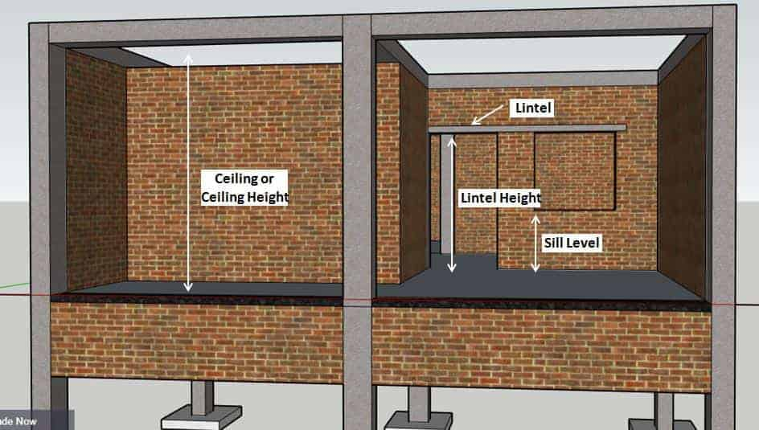

9. Lintel
Lintels are constructed from reinforced cement concrete. It is provided above the wall openings like doors, windows, etc. The Lintel actually takes the load coming on window and door openings.
In Sort, the lintel safeguards the door and window from excess load coming from above. In residential buildings, lintel can be constructed from concrete or brick masonry.
Standard Dimension
Generally, the lintel width is as same as the width of the wall, and the thickness is between 4” to 6”

10. Ceiling
The ceiling is not a separate part but is the bottom face of any slab. The ceiling is the most important part of any room because it can be decorated to increase the aesthetic appearance. POP (Plaster of Paris) is a material used for making false ceilings.
It is a location where we can hang decorative items, fans, etc to increase the architectural view of the room.
Standard Dimension
The ceiling height is kept from 9’ 6” to 10’ 6”. (it can be more or less as per requirement)

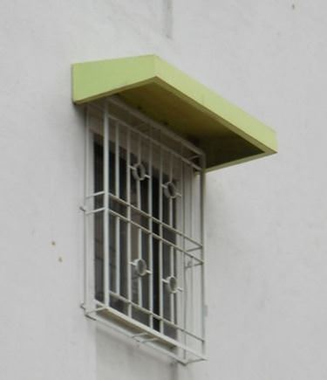
11. Chhajjas

Chhajjas is also called a Weather shed. This is a structure that is constructed above the window and projected outside from the window face.
The main function of the weather shed is to restrict the direct entry of rainwater and sunlight. Chhajjas are constructed from reinforced cement concrete.
Standard Dimensions
Length of Chhajjas = Width of Window + 0.15m Bearing on both Side
Width of Chhajjas = 0.45 m to 0.60 m.

CHAPTER FIVE
OBSERVATIONS AND RECOMMENDATIONS

5.1 OBSERVATION
During the SIWES program at Archi-View Finder Properties Consultant, I observed the following:
- The firm operates primarily in architectural design, property consultancy, and real estate development.
- There is a high level of professionalism and collaboration among the staff, with clear delegation of duties.
- The use of architectural software such as AutoCAD, Revit, and SketchUp is prevalent in daily operations.
- Clients’ needs are prioritized, with frequent consultations and feedback incorporated into designs.
- Projects typically follow a structured process: client briefing, site analysis, conceptual design, development, and presentation.
- Sustainability and functionality are key considerations in every architectural plan produced.

5.2 RECOMMENDATION
Based on my experience, I would like to recommend the following:
- For the Company: More structured training for interns would enhance the learning process and reduce the time spent figuring out routine tasks.
- For Future Interns: Interns should come prepared with basic knowledge of architecture software and project presentation to integrate smoothly into the workflow.
- For Institutions: Universities should organize pre-SIWES orientation or crash courses on industry tools to make students more valuable during industrial placements.

5.3 CONCLUSION
My SIWES training at Archi-View Finder Properties Consultant was highly beneficial and enlightening. It bridged the gap between theoretical knowledge and practical application, exposed me to real-life design challenges, and improved my communication, teamwork, and problem-solving skills. This experience has significantly boosted my confidence and clarified my career interests in architecture and property development.

5.4 REFERENCES
- Archi-View Finder Properties Consultant. (2025). Internal project documentation and site plans.
- Ching, F. D. K. (2014). Architecture: Form, Space, and Order. Wiley.
- AutoDesk. (n.d.). AutoCAD User Guide.
- Nigeria Institute of Architects (NIA). (2023). Architectural Practice Manual.

5.5 APPENDIX
- Appendix A: Sample floor plans designed during internship
- Appendix B: Site visit photographs
- Appendix C: Revit and SketchUp model screenshots
- Appendix D: Weekly logbook entries
- Appendix E: SIWES acceptance and completion letters

