

A TECHINICAL REPORT ON THE STUDENT INDUSTRIAL WORK EXPERIENCE SCHEME (SIWES)

UNDERTAKEN AT
MEDY ELECTRICAL SALES AND SERVICES LIMITED
OPPOSITE ASK PURE WATER COMPANY, AJARA VETHO, BADAGRY, LAGOS STATE

PREPARED BY
BANKOLE TOBILOBA MICHAEL
ND/23/EEE/PT/0206

SUBMITTED TO
THE DEPARTMENT OF ELECTRICAL/ELECTRONIC ENGEERING,
INSTITUTE OF TECHNOLOGY,
KWARA STATE POLYTECHNIC, ILORIN

IN PARTIAL FULFILLMENT OF THE REQUIREMENT FOR THE AWARD OF NATIONAL DIPLOMA IN ELECTRICAL/ELECTRONIC ENGEERING

AUGUST– DECEMBER, 2024

DEDICATION
The report is dedicated to Almighty God and my beloved parents Mr. and Mrs. Bankole for their support and unconditional love.

ACKNOWLEDGEMENT
I would like to place on record my deep sense of gratitude to God for His love, mercy, favour and protection during this Student Industrial Work Experience Scheme (SIWES).
I appreciate the efforts of my parent Mr. & Mrs. Bankole, my Siblings and my friends who where a source of support for me all through the SIWES period.
I express my profound gratitude to my Department Lecturers, my SIWES Supervisor Engr. Okoye Basit, SIWES Coordinator Engr. Alabi Medemipon Ibukun and my Head of Department (H.O.D) Engr. Abdullateef Dindi for the support towards the success of my SIWES. Also, I give thanks to my brothers, sisters, and the entire family of Bankole Family for their advice to me during my SIWES program. May GOD bless you all (AMEN).
I also appreciate the effort of the entire staff of the Medy Electrical Sales and Services Limited, Opposite ASK Pure Water Company, Ajara Vetho, Badagry, Lagos State for the tremendous moral assistance throughout the period of my attachment; and my lovely friends for their contribution in one way or the other. May Almighty God bless them all and provide for their needs.
TABLE OF CONTENTS
Title Page i
Dedication ii
Acknowledgment iii
Table of Contents iv
CHAPTER ONE
1.0 Introduction 1
1.1 Aims of Siwes 1
1.2 Importance of Siwes 2
1.3 Mission of Siwes 2
CHAPTER TWO
2.0 Orientation about the Company 3
2.1 Tools and Material Handling 3
2.1.1 Four Categories of Material Handling Equipment 3
2.1.2 Storage and Handling Equipment 4
2.2 Industrial Trucks and Machines 5
2.3 Bulk Material Handling Equipment 6
2.4 Engineered Systems 8
2.5 Material Handling Equipment 9
2.5.1 Function and Space 9
2.5.2 Type of Materials 9
CHAPTER THREE
3.0 Electrical Wiring and Installation 10
3.1 Modern Wiring Materials 11
3.2 Copper Sheathed Mineral Insulated Cables at a Panel Board 12
3.3 Copper Conductors 14
3.4 Aluminum Conductors 14
CHAPTER FOUR
4.0 Industrial and Commercial Electrical Systems 16
4.1 Commercial Electrical Work 16
4.1.1 Industrial Electrical Work 16
4.1.2 Electrical Load and Capacity 16
4.1.3 Complexity and Control 16
4.1.4 Safety Regulations 16
4.2 Fault Detection and Troubleshooting 18
4.2.1 Fault Detection 18
4.2.2 Fault Finding and Troubleshooting 18
4.2.3 Methods of Fault Detection 18
4.2.4 Steps to Electrical Fault Finding 18
4.2.5 Steps of Troubleshooting 19
4.3 Advanced Installation and Maintenance 19
4.3.1 Installation and Maintenance Electrician 19
4.3.2 Maintenance Installation and Repair 19
4.4 Project Participation and Teamwork 19
4.4.1 Project Participation 19
4.4.2 Participation Important in Teamwork 19
4.4.3 Project Team 20
4.4.4 Types of Participation 20
CHAPTER FIVE
5.0 Conclusion 21
5.1 Recommendation 21

CHAPTER ONE
1.0 INTRODUCTION
The Students Industrial Work Experience Scheme (SIWES) was established in 1973 by the Industrial Training Fund (ITF) in Nigeria. It was introduced to bridge the gap between theoretical knowledge acquired in educational institutions and practical experience in industries. Initially, SIWES focused on science and technology-related courses but later expanded to include other fields. Over the years, it has played a vital role in preparing students for the workforce by exposing them to real-life work environments.
The Student Industrial Work Experience Scheme (SIWES) provided hands-on training in electrical installation, wiring, and maintenance in both industrial and commercial settings. Throughout the training, I was exposed to practical applications of electrical engineering concepts, safety procedures, and teamwork in a professional environment.
The Students Industrial Work Experience Scheme (SIWES) provided hands-on training in electrical installation, fault detection, maintenance, and repair of various electrical systems. This report summarizes the weekly tasks performed, including wiring, connection of electrical components, troubleshooting, and learning about key electrical concepts.
1.1 AIMS OF SIWES
The main objectives of SIWES are:
1. Bridging the Gap: To link classroom learning with practical industrial experience.
2. Skill Development: To provide students with hands-on experience relevant to their field.
3. Enhancing Employability: To improve students' job readiness and adaptability.
4. Technology Transfer: To expose students to the latest industry trends and technologies.
5. Encouraging Entrepreneurship: To inspire self-employment by providing real-world exposure.
6. Reducing Skill Mismatch: To ensure students gain industry-relevant skills.

1.2 IMPORTANCE OF SIWES
1. Provides students with practical knowledge and technical skills.
2. Helps industries get skilled manpower for future employment.
3. Enhances collaboration between academic institutions and industries.
4. Exposes students workplace ethics, teamwork, and professionalism.
5. Encourages innovation by giving students a real-world perspective.
6. Improves students' confidence in handling real work challenges.
1.3 MISSION OF SIWES
The mission of SIWES is to produce a workforce that is competent, skilled, and ready for industrial and professional challenges by integrating practical training with academic learning. It aims to ensure that Nigerian graduates are technically sound and prepared to contribute effectively to national development.
Weekly Activities Summary
CHAPTER TWO
2.0 ORIENTATION ABOUT THE COMPANY
Introduced to the workplace environment, company policies, and safety regulations. Observed experienced engineers and technicians to understand workplace operations. Assisted in basic electrical installations and learned about different types of electrical components.
2.1 TOOLS AND MATERIAL HANDLING
Material handling equipment is any machine or tool that is used to transport, process, store, or package materials. For example, forklifts, conveyors, shelves, and even autonomous mobile.
Using material handling equipment improves efficiency and can help automate processes that would otherwise require a lot of manual labor, saving you time and money. Common uses for material handling equipment include processing agricultural products like grain, organizing and storing inventory in a warehouse, and loading and unloading dirt or hardscape.
In this post, we go over the four material handling categories and the equipment within each category, so you can choose the right tools for your workflow.
2.1.1 Four Categories of Material Handling Equipment
The four main categories of material handling equipment are storage and handling equipment, industrial trucks, bulk material handling equipment, and engineered systems.
This chart breaks down the common uses and tools for each category:

 | Storage and Handling Equipment | Industrial Trucks and Machines | Bulk Material Handling Equipment | Engineered Systems
Used for | Storage and inventory, organization, and preparation | Transporting materials to a designated area | Storing, transporting, or processing materials in bulk | Packaging, shelving, or storing materials
Type of tools | Shelves, storage racks, and mezzanines | Forklifts, order pickers, and pallet jacks | Conveyors, hoppers, and reclaimers | Palletizers, automated guided vehicles, and warehouse robots
2.1.2 Storage and Handling Equipment
Storage and handling equipment is the most basic of the four categories. As the name implies, it is used to store products that are being held as inventory or materials that are awaiting the next part of the production process. This equipment helps you maximize your space, particularly your vertical and floor space.
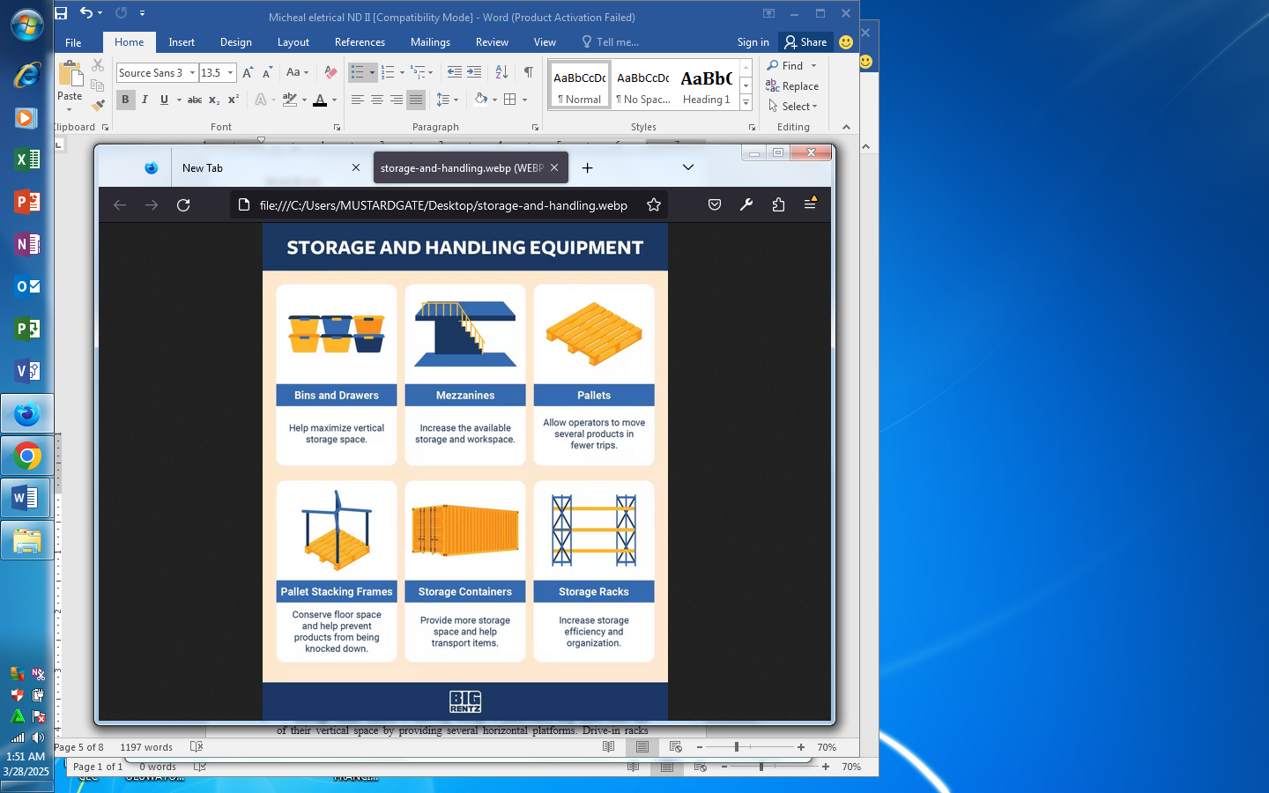

Common types of storage equipment include:
Bins and Drawers: These hold small to medium-sized items. Bins have open tops, allowing employees or automated systems to quickly grab inventory. Drawers allow for high-density storage and may maximize space better than shelves.
Mezzanines: Mezzanines are semi-permanent structures that add another floor between the floor and the ceiling. This increases a warehouse’s usable space, providing additional workspace or a larger storage area.
Pallets: Pallets store packaged loads, making it easier to move and transport them with industrial trucks or pallet jacks.
Pallet Stacking Frames: These attach to pallets, allowing you to stack palletized loads on top of each other. They require minimal storage space when they’re not being used.
Storage containers: Storage containers, also called shipping containers, can come in a variety of sizes, but are generally designed to store large objects or large amounts of materials.
Storage Racks: Similar to shelving, storage or pallet racks help teams make use of their vertical space by providing several horizontal platforms. Drive-in racks allow forklifts to drive in and load pallets, increasing storage space, but minimizing accessibility.
2.2 INDUSTRIAL TRUCKS AND MACHINES
These machines are used to load and transport materials. They can be manual, like hand trucks, or motorized, like forklifts. Industrial trucks primarily use fork attachments, which are compatible with palletized loads.
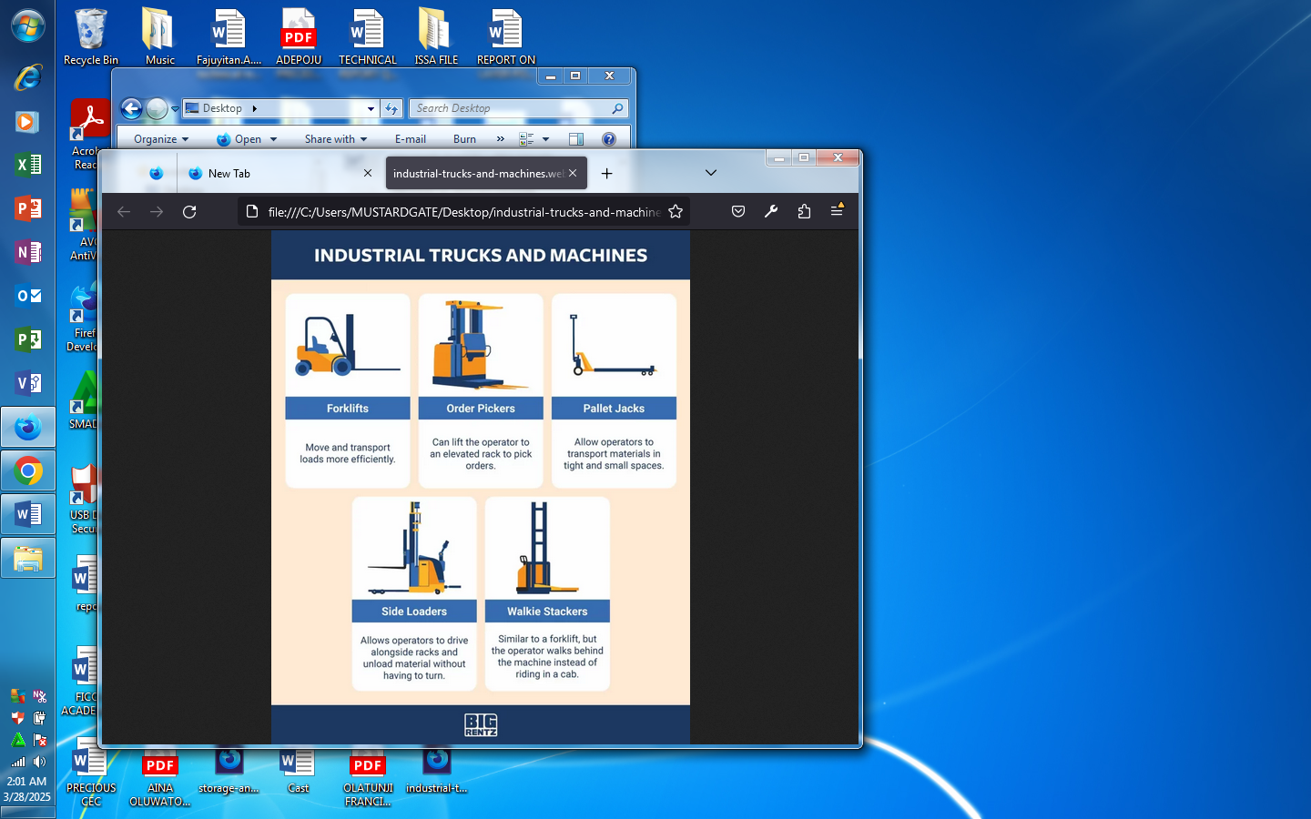

The most common types of industrial trucks for material handling are:
Forklifts: Most standard warehouse forklifts can handle loads up to 5,000 pounds and lift 10 to 15 feet. Large-capacity models can carry much heavier loads.
Order Pickers: Order pickers raise warehouse employees, allowing them to pick orders off of elevated shelves. Their load capacity is typically around 3,000 pounds and they can raise up to 32 feet.
Pallet Jacks: Also known as pallet trucks, these machines come in manual and electric versions. They typically only transport one to two pallets at a time and their load capacity maxes out around 5,500 pounds for standard models, though you can also find high-capacity options.
Side Loaders: These are a type of forklift with forks at the side instead of the front. This allows the machine to navigate in narrow aisles, like between warehouse shelving, and load products without turning the cab.
Walkie Stackers: Walkie stackers don’t have a cab – the operator stands behind the machine while operating it. Similar to pallet jacks, walkie stackers have a limited load capacity, ranging from 2,000 to 4,000 pounds. They can typically lift 5 to 10 feet.
2.3 BULK MATERIAL HANDLING EQUIPMENT
Bulk material handling equipment helps to move, load, and process large quantities of items. This includes small items like grain or rocks, and larger items like consumer packaged goods.
You may find this equipment in indoor and outdoor environments. For example, silos may store bulk food items on a farm and conveyors transport packages in a warehouse.
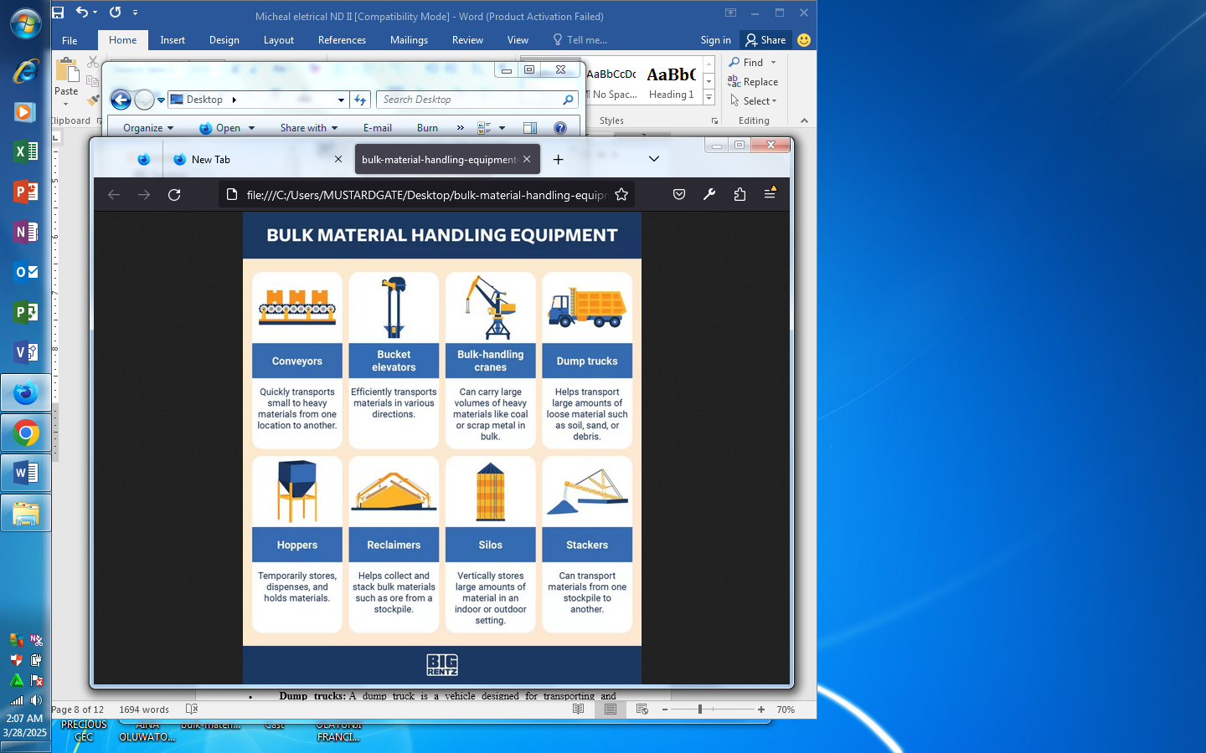

Common types of bulk material handling equipment include:
Conveyors: A conveyor system helps move and process materials en masse. Similar to an old-school assembly line, it uses a system of belts and pulleys to keep things moving from point A to point B.
Bucket Elevators: A bucket elevator, also called a grain leg or grain elevator, hauls flowable bulk materials vertically. It’s typically used in an agricultural setting, moving loose materials like grain or fertilizer.
Bulk-Handling Cranes: Building on the design of a basic crane, a bulk-handling crane includes a two-piece hinged grab to lift and balance bulk cargo like coal or mineral ore.
Dump Trucks: A dump truck is a vehicle designed for transporting and unloading large quantities of materials. It’s often used in construction to offload or haul away debris or loose materials.
Hoppers: Often used in agriculture, hoppers are containers that transport bulk products like grain and corn, unloading them through compartments at the bottom.
Stackers and reclaimers: A reclaimer is typically used in conjunction with a stacker. The stacker piles bulk material like ore or coal. The reclaimer loads it, guiding it to a conveyor to be transported.
Silos: Silos are tall, cylindrical containers that provide high-volume storage for items like coal, woodchips, or feed.
2.4 ENGINEERED SYSTEMS
Engineered systems are completely automated. As the name implies, they use multiple systems to minimize the need for manual labor. This type of material handling equipment is commonly found in manufacturing and warehousing.
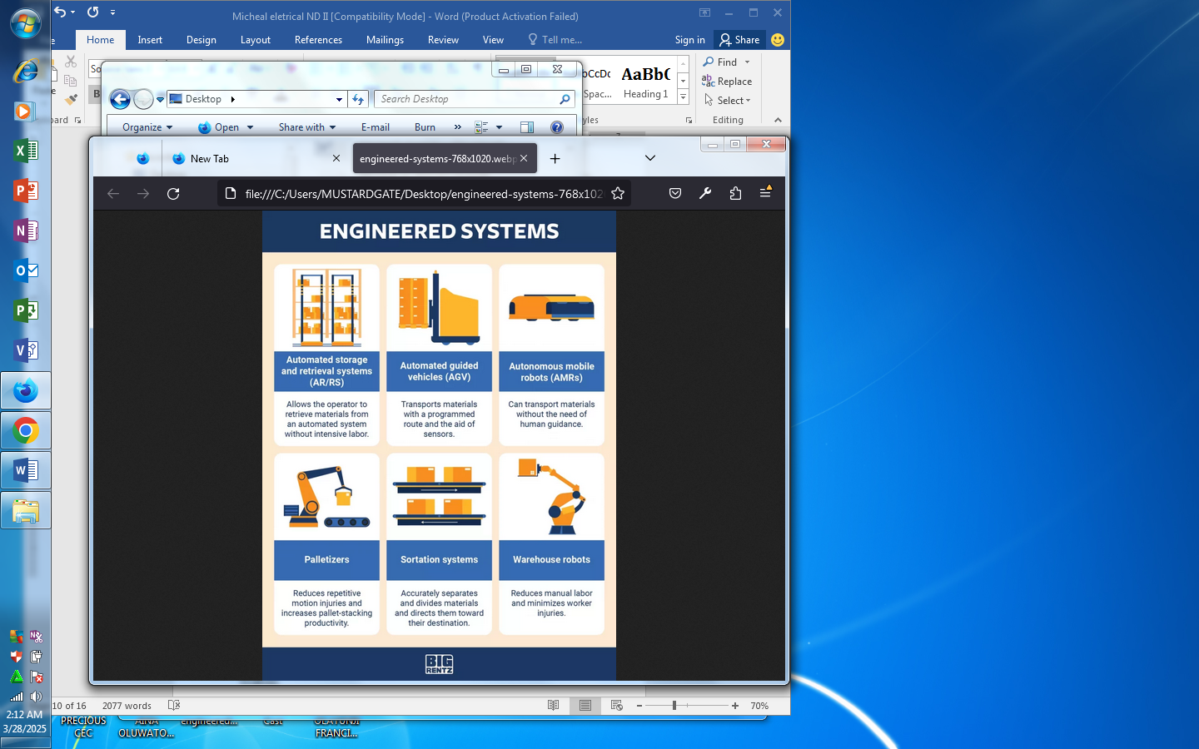

These are some of the most common engineered systems:
Automated storage and retrieval systems (AR/RS): AR/RS is a type of robotic delivery system that can place and retrieve materials from set storage locations.
Automated guided vehicles (AGV): Sometimes called self-guided vehicles, AGVs are designed to drive and operate themselves, following marked lines, wires in the floor, or other programmed controls for navigation.
Autonomous mobile robots (AMRs): AMRs are more advanced than AVGs. They can map and adapt to their surroundings using sensors.
Palletizers: Palletizers replace the need for humans to load pallets. They stack items on a pallet and release the pallet onto a conveyor for further processing.
Sortation systems: Sortation systems can automatically detect objects and route them to the desired location.
Warehouse robots: Warehouse robots are AI designed for use in warehouse applications to automate simple, repetitive tasks, like picking products off of a shelf.
2.5 MATERIAL HANDLING EQUIPMENT
As you can see, there are many different types of material handling equipment to assist with manufacturing, warehousing, agricultural, or construction needs. Choosing the right piece of equipment depends on a variety of factors.
2.5.1 Function and Space
The purpose of material handling equipment is to improve efficiency. Consider how you can productively use all your space. For example, you may want to add a mezzanine to a warehouse to increase your square footage.
2.5.2 Type of Materials
The size and shape of your material will dictate the type of material handling equipment you need. Granular items may need to be packaged, while boxed items can easily be palletized.
If you’re working in an outdoor environment, you may require a crane to move large, heavy materials or a reclaimer to sift through stockpiles.

CHAPTER THREE
3.0 ELECTRICAL WIRING AND INSTALLATION
Electrical wiring is an electrical installation of cabling and associated devices such as switches, distribution boards, sockets, and light fittings in a structure. Wiring is subject to safety standards for design and installation. Allowable wire and cable types and sizes are specified according to the circuit operating voltage and electric current capability, with further restrictions on the environmental conditions, such as ambient temperature range, moisture levels, and exposure to sunlight and chemicals.
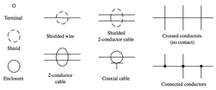Associated circuit protection, control, and distribution devices within a building's wiring system are subject to voltage, current, and functional specifications. Wiring safety codes vary by locality, country, or region. The International Electrotechnical Commission (IEC) is attempting to harmonise wiring standards among member countries, but significant variations in design and installation requirements still exist.

Materials for wiring interior electrical systems in buildings vary depending on:
Intended use and amount of power demand on the circuit:
- Type of occupancy and size of the building
- National and local regulations
- Environment in which the wiring must operate.
Wiring systems in a single family home or duplex, for example, are simple, with relatively low power requirements, infrequent changes to the building structure and layout, usually with dry, moderate temperature and non-corrosive environmental conditions. In a light commercial environment, more frequent wiring changes can be expected, large apparatus may be installed and special conditions of heat or moisture may apply. Heavy industries have more demanding wiring requirements, such as very large currents and higher voltages, frequent changes of equipment layout, corrosive, or wet or explosive atmospheres. In facilities that handle flammable gases or liquids, special rules may govern the installation and wiring of electrical equipment in hazardous areas.
Wires and cables are rated by the circuit voltage, temperature rating and environmental conditions (moisture, sunlight, oil, chemicals) in which they can be used. A wire or cable has a voltage (to neutral) rating and a maximum conductor surface temperature rating. The amount of current a cable or wire can safely carry depends on the installation conditions. The international standard wire sizes are given in the IEC 60228 standard of the International Electrotechnical Commission. In North America, the American Wire Gauge standard for wire sizes is used.
3.1 MODERN WIRING MATERIALS
Modern non-metallic sheathed cables, such as (US and Canadian) Types NMB and NMC, consist of two to four wires covered with thermoplastic insulation, plus a wire for Protective Earthing/Grounding (bonding), surrounded by a flexible plastic jacket. In North America and the UK this conductor is usually bare wire but in the UK it is required that this bare Protective Earth (PE) conductor be sheathed in Green/Yellow insulating tubing where the Cable Sheathing has been removed. Most other jurisdictions now require the Protective Earth conductor to be insulated to the same standard as the current carrying conductors with Green/Yellow insulation.
With some cables the individual conductors are wrapped in paper before the plastic jacket is applied. Special versions of non-metallic sheathed cables, such as US Type UF, are designed for direct underground burial (often with separate mechanical protection) or exterior use where exposure to ultraviolet radiation (UV) is a possibility. These cables differ in having a moisture-resistant construction, lacking paper or other absorbent fillers, and being formulated for UV resistance. Rubber-like synthetic polymer insulation is used in industrial cables and power cables installed underground because of its superior moisture resistance.
Insulated cables are rated by their allowable operating voltage and their maximum operating temperature at the conductor surface. A cable may carry multiple usage ratings for applications, for example, one rating for dry installations and another when exposed to moisture or oil.
Generally, single conductor building wire in small sizes is solid wire, since the wiring is not required to be very flexible. Building wire conductors larger than 10 AWG (or about 5 mm²) are stranded for flexibility during installation, but are not sufficiently pliable to use as appliance cord. Cables for industrial, commercial and apartment buildings may contain many insulated conductors in an overall jacket, with helical tape steel or aluminium armour, or steel wire armour, and perhaps as well an overall PVC or lead jacket for protection from moisture and physical damage. Cables intended for very flexible service or in marine applications may be protected by woven bronze wires. Power or communications cables (e.g., computer networking) that are routed in or through air-handling spaces (plenums) of office buildings are required under the model building code to be either encased in metal conduit, or rated for low flame and smoke production.
3.2 COPPER SHEATHED MINERAL INSULATED CABLES AT A PANEL BOARD
For some industrial uses in steel mills and similar hot environments, no organic material gives satisfactory service. Cables insulated with compressed mica flakes are sometimes used. Another form of high-temperature cable is mineral-insulated cable, with individual conductors placed within a copper tube and the space filled with magnesium oxide powder. The whole assembly is drawn down to smaller sizes, thereby compressing the powder. Such cables have a certified fire resistance rating and are more costly than non–fire-rated cable. They have little flexibility and behave more like rigid conduit rather than flexible cables.
The environment of the installed wires determines how much current a cable is permitted to carry. Because multiple conductors bundled in a cable cannot dissipate heat as easily as single insulated conductors, those circuits are always rated at a lower ampacity. Tables in electrical safety codes give the maximum allowable current based on size of conductor, voltage potential, insulation type and thickness, and the temperature rating of the cable itself. The allowable current will also be different for wet or dry locations, for hot (attic) or cool (underground) locations. In a run of cable through several areas, the part with the lowest rating becomes the rating of the overall run.
To prevent loosening of the connections of individual conductors of a cable, cables must be supported near their entrance to devices and at regular intervals along their runs. In tall buildings, special designs are required to support the conductors of vertical runs of cable. Generally, only one cable per fitting is permitted, unless the fitting is rated or listed for multiple cables. Special cable constructions and termination techniques are required for cables installed in ships. Such assemblies are subjected to environmental and mechanical extremes. Therefore, in addition to electrical and fire safety concerns, such cables may also be required to be pressure-resistant where they penetrate a vessel's bulkheads. They must also resist corrosion caused by salt water or salt spray, which is accomplished through the use of thicker, specially constructed jackets, and by tinning the individual wire stands.
US single-phase residential power distribution transformer, showing the two insulated line conductors and the bare neutral conductor (derived from the earthed center-tap of the transformer). The distribution supporting cantenaries are also shown.
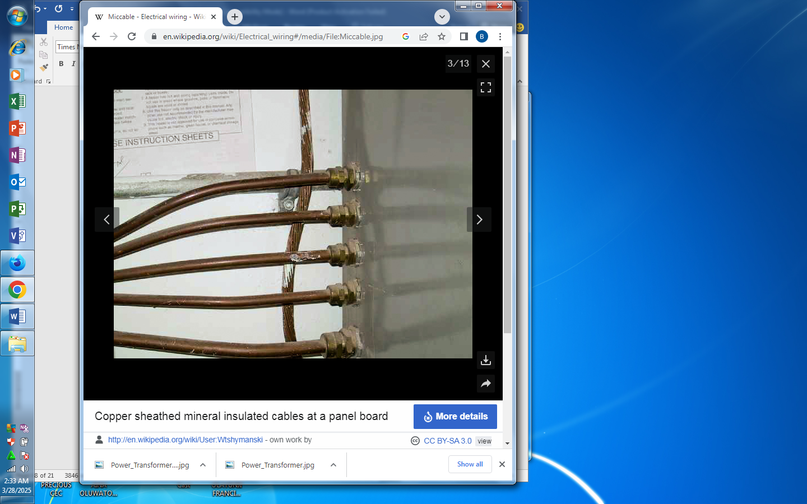In North American practice, for residential and light commercial buildings fed with a single-phase split 120/240 service, an overhead cable from a transformer on a power pole is run to the service entrance point. The cable is a three conductor twisted "triplex" cable with a bare neutral and two insulated conductors, with no overall cable jacket.^{[1]} The neutral conductor is often a supporting "messenger" steel wire, which is used to support the insulated line conductors.

3.3 COPPER CONDUCTORS
Electrical devices often use copper conductors because of their properties, including their high electrical conductivity, tensile strength, ductility, creep resistance, corrosion resistance, thermal conductivity, coefficient of thermal expansion, solderability, resistance to electrical overloads, compatibility with electrical insulators, and ease of installation. Copper is used in many types of electrical wiring.
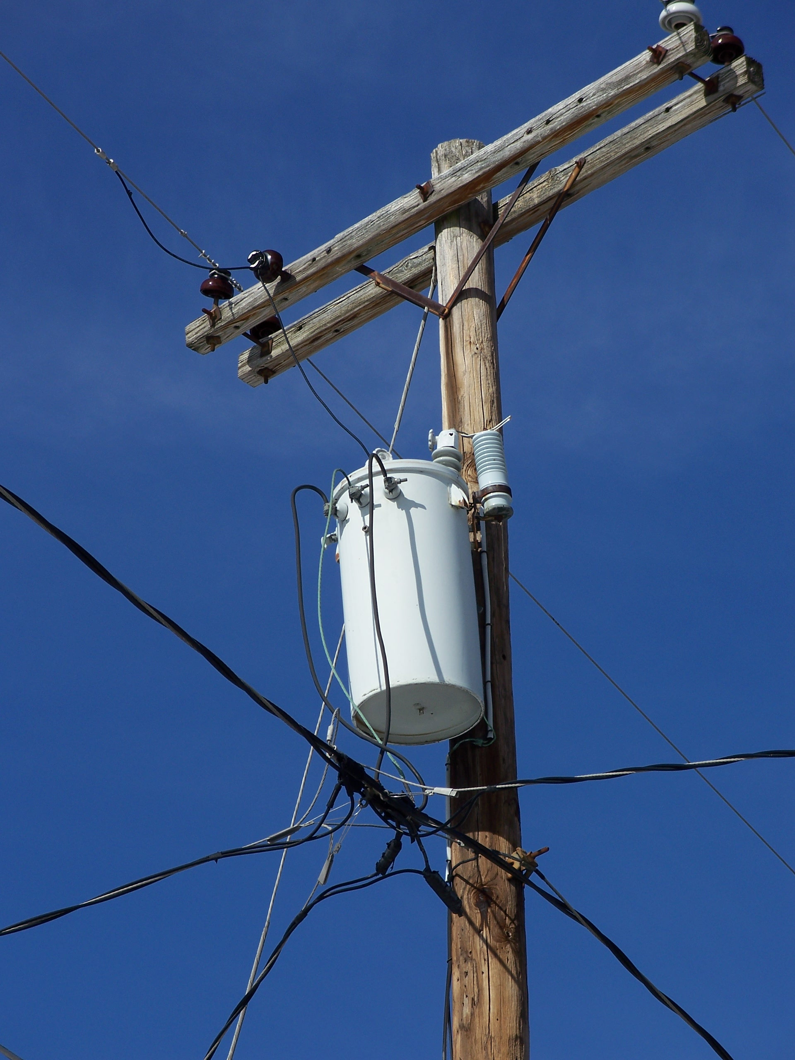

3.4 ALUMINIUM CONDUCTORS
Terminal blocks for joining aluminium and copper conductors. The terminal blocks may be mounted on a DIN rail. Aluminium wire was common in North American residential wiring from the late 1960s to mid-1970s due to the rising cost of copper. Because of its greater resistivity, aluminium wiring requires larger conductors than copper. For instance, instead of 14 AWG (American wire gauge) copper wire, aluminium wiring would need to be 12 AWG on a typical 15 ampere lighting circuit, though local building codes vary.
Solid aluminium conductors were originally made in the 1960s from a utility-grade aluminium alloy that had undesirable properties for a building wire, and were used with wiring devices intended for copper conductors.^{[4][5]} These practices were found to cause defective connections and fire hazards. In the early 1970s new aluminium wire made from one of several special alloys was introduced, and all devices – breakers, switches, receptacles, splice connectors, wire nuts, etc. — were specially designed for the purpose. These newer aluminium wires and special designs address problems with junctions between dissimilar metals, oxidation on metal surfaces, and mechanical effects that occur as different metals expand at different rates with increases in temperature.
Unlike copper, aluminium has a tendency to creep or cold-flow under pressure, so older plain steel screw clamped connections could become loose over time. Newer electrical devices designed for aluminium conductors have features intended to compensate for this effect. Unlike copper, aluminium forms an insulating oxide layer on the surface. This is sometimes addressed by coating aluminium conductors with an antioxidant paste (containing zinc dust in a low-residue polybutene base^{[6]}) at joints, or by applying a mechanical termination designed to break through the oxide layer during installation.
Some terminations on wiring devices designed only for copper wire would overheat under heavy current load and cause fires when used with aluminium conductors. Revised standards for wire materials and wiring devices (such as the CO/ALR "copper-aluminium-revised" designation) were developed to reduce these problems. While larger sizes are still used to feed power to electrical panels and large devices, aluminium wiring for residential use has acquired a poor reputation and has fallen out of favour.
Aluminium conductors are still heavily used for bulk power transmission, power distribution, and large feeder circuits with heavy current loads, due to the various advantages they offer over copper wiring. Aluminium conductors both cost and weigh less than copper conductors, so a much larger cross sectional area can be used for the same weight and price. This can compensate for the higher resistance and lower mechanical strength of aluminium, meaning the larger cross sectional area is needed to achieve comparable current capacity and other features. Aluminium conductors must be installed with compatible connectors and special care must be taken to ensure the contact surface does not oxidise.

CHAPTER FOUR
4.0 INDUSTRIAL AND COMMERCIAL ELECTRICAL SYSTEMS
4.1 COMMERCIAL ELECTRICAL WORK
Commercial electrical work typically involves smaller-scale projects, such as offices, retail stores, restaurants, and other businesses.
The primary focus is on providing electrical services for the smooth operation of the premises, including lighting, HVAC systems, computers, and security systems. Commercial buildings are often designed with aesthetics in mind, so electrical installations must be neat and concealed to maintain a polished appearance.
4.1.1 Industrial Electrical Work
Industrial electrical work, on the other hand, is associated with large-scale operations like factories, manufacturing plants, refineries, and power generation facilities. The primary purpose is to facilitate the functioning of heavy machinery, production processes, and power distribution on a massive scale.
In industrial settings, functionality and safety take precedence over aesthetics, and electrical components are often exposed for easy access and maintenance.
4.1.2 Electrical Load and Capacity
Another significant difference lies in the electrical load and capacity requirements for commercial and industrial installations.
4.1.3 Complexity and Control
The complexity and control requirements in commercial and industrial electrical work also differ substantially.
4.1.4 Safety Regulations
Both commercial and industrial electrical work adhere to stringent safety regulations, but the specific standards and requirements can vary significantly.
In summary, while commercial and industrial electrical work share some common principles and components, they are distinct fields with unique challenges and requirements. Commercial electrical work centres around smaller-scale projects with a focus on moderate electrical loads, while industrial electrical work deals with large-scale operations, heavy machinery, and complex control systems. Both fields prioritise safety, but the regulations and protocols can differ significantly. Understanding these differences is crucial for our electricians working in these sectors to ensure the safe and efficient operation of electrical systems in commercial and industrial settings.
At HF, we are NICEIC and Select Approved Electrical Contractors providing Manned electrical 24-hour Call-out Service nationwide for domestic, commercial and industrial electrical work and are the first choice for some of the country’s leading businesses when it comes to electrical services.
From Electrical Installations to Planned Maintenance Contracts, quality service and peace of mind are the principles on which the Fulton family founded the company as electrical contractors all those years ago, and it’s just as important today.
We can provide our electrical contract services across the UK. With branches in Glasgow, Edinburgh, Manchester, Belfast and Aberdeen, we can work in:
- Hospitality & Tourism Sectors
- Commercial & Office Sectors
- Food & Drink Sector
- Healthcare Sector
- Industrial Sector
- Retail Sector
- Education Sector
- Leisure & Sports Sectors
- Green Energy
With an approach which combines traditional values and innovative thinking, we know that for our customers, a faulty light switch requires the same level of service and professionalism as a multi-million-pound electrical installation project.
To find out more about the work we do in electrical services, please contact us today.


Service Icons

- Electrical
- Green Energy
- Mechanical
- Plumbing/Heating & AC
- Fire & Security
- Telecommunications
- Automated Controls
4.2 FAULT DETECTION AND TROUBLESHOOTING
Fault detection is the process of identifying abnormalities or deviations from expected behavior in a system or device. It helps identify issues or malfunctions, allowing for timely maintenance or corrective actions to prevent further problems.
4.2.1 Fault Detection
Fault detection is the process of discovering the presence of a fault in any equipment before it manifests itself in the form of a breakdown. It is the most important stage of FDD as all of the downstream processes depend on its accuracy.
4.2.2 Fault Finding and Troubleshooting
It is the process of analyzing the behavior or operation of a faulty circuit to determine what is wrong with the circuit. It then involves identifying the defective component(s) and repairing the circuit. Depending on the type of equipment, troubleshooting can be a very challenging task.
4.2.3 Methods of Fault Detection
Fault detection and diagnosis methods are mainly divided into three categories as quantitative, qualitative, and data- driven. Quantitative models need an accurate process model based on system governing equations such as momentum, energy, and mass conservation equations, chemical kinetics, and thermodynamic equations.
4.2.4 Steps to Electrical Fault Finding
- Turn All Circuit Breakers Off.
- Turn the Main Safety Switch On.
- Turn Each Circuit Breaker Back On.
- Identify the Faulty Circuit.
- Turn All Switches Off Again.
- Turn the Electricity Back On.

4.2.5 Steps of Troubleshooting?
- Identify the Problem. This step is often the easiest.
- Establish a Theory of Probable Cause.
- Test the Theory to Determine the Cause.
- Establish a Plan of Action and Implement the Solution.
- Verify Full System Functionality and Implement Preventive Measures.
- Document Findings.
- Keep It Simple.
4.3 ADVANCED INSTALLATION AND MAINTENANCE
4.3.1 Installation and Maintenance Electrician?
The broad purpose of the occupation is to install, maintain and repair electrical systems in industrial, commercial and residential environments including communal areas. The scope of an Electrician's work encompasses using engineering knowledge and understanding to apply technical and practical skills
4.3.2 Maintenance Installation and Repair
People with careers in Maintenance, Installation and Repair perform preventive maintenance procedures on machines tools and equipment These are performed routinely and on a regular basis. They also troubleshoot and repair electrical, electronic and mechanical systems.
4.4 PROJECT PARTICIPATION AND TEAMWORK
4.4.1 Project Participation
Project Management for Development. Rodolfo Siles, PMP. Participation in project management is a process that allows sharing some of the control on the project with key stakeholders, especially beneficiaries.
4.4.2 Participation Important in Teamwork
Participation is the key to team results. In practical reality, it takes a team to complete a project, solve a problem and brainstorm strategic decisions. Whether you lead an individual team or an entire department, your ability to motivate that team to success is critical.

4.4.3 Project Team
A project team is a group of people that work together to complete a project. Usually, project teams are cross-functional—meaning they're made up of individuals from different groups or departments within the organization, working toward a common goa
4.4.4 Types of Participation
1. Passive participation. Passive participation is when community members are only informed or consulted about a project or intervention that is planned and implemented by external agents, such as NGOs, government agencies, or donors.
2. Active participation.
3. Transformative participation.
4. Here's what else to consider.

CHAPTER FIVE
5.0 CONCLUSION
The SIWES program was an invaluable experience that improved my practical knowledge in electrical engineering. I gained hands-on skills in wiring, installation, troubleshooting, and safety procedures. The exposure to real-world projects helped enhance my confidence, problem-solving abilities, and technical expertise in electrical systems. This experience has prepared me for a future career in the electrical engineering industry.
5.1 RECOMMENDATION
I would propose that the institute management create a mutual relationship with a number of industries to accept more students for I.T. placements with accommodation, transportation and monetary support. I also would propose more frequent impromptu visit of the school supervisors so as to ensure that students are able to fully comprehend the theoretical work done in school. Hence, I implore the institute to create strong ties with neighboring industries.

