

TECHNICAL REPORT ON STUDENTS INDUSTRIAL WORK EXPERIENCE SCHEME (SIWES)
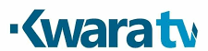
HELD AT

KWARA STATE TELEVISION AUTHORITY (KWTV)
Television house P.M.B 1520, ApataYakuba Ilorin, Kwara State, Nigeria.
BY
OSENI OLAIDE AJOKE
ND/23/MAC/PT/0891

SUBMITTED TO:
THE DEPARTMENT OF MASS COMMUNICATION, KWARA STATE POLYTECHNIC
INSTITUTE OF INFORMATION AND COMMUNICATION TECHNOLOGY (IICT)
P.M.B. 1375 ILORIN, KWARA STATE.

IN PARTIAL FULFILMENT FOR THE AWARD OF NATIONAL DIPLOMA (ND) IN
MASS COMMUNICATION,
KWARA STATE.

AUGUST TO NOVEMBER, 2024

DEDICATION
I dedicate this to God for seeing me through; also to my lovely parent Mr and Mrs OSENI for their support both morally and financially, May God reward you abundantly with long life and good health.

ACKNOWLEDGEMENT
Special appreciation goes to my parent Mr and Mrs OSENI for their love and care. I applaud them for making me fall in love with education.
My gratitude is incomplete without acknowledging my maternal family for their support and contribution to my onward progress in life.
I also commend my supervisor, Mr Bada for his intellectual contribution and support during my SIWES
A big thanks to my colleagues from different intuitions that formed the group members during my training.

TABLE OF CONTENTS
TITLE PAGE…………………………………………………………………………..i
Dedication……………….………………………………………………………………ii
Acknowledgement………………………………………………………………………iii
Table of Contents……………………………………………………………………iv-v
CHAPTER ONE
- Introduction………………………………………………………………………….1
  - Background of the SIWES………………………………………………………..…1-2
  - Aims and Objectives of SIWES……………………………………………………..2
  - Location and Brief history of KW TV………………………………………………3-4
  - Objectives of KW TV……………………………………………………………….4
  - Organization of Kwara TV……………..……………………………………...……5
  - KWTV organization Chart…………………………………………………………..6
CHAPTER TWO
2.0 Items in the Studio with their functions…………………………………………..7-8
2.1 Departments in KWTV and their functions.…………………..…………………9-10
CHAPTER THREE
- Student specific involvement at various section………………………………11-12
CHAPTER FOUR
- Experience Gained………………………………………………………………..13
4.1 Interpersonal Relationship with the organization……………………………........14
4.2 Suggestion for improvement of the program……………………………………14
CHAPTER FIVE
- Conclusion………………………………………………………………………..15
5.1 Recommendation………………………………………………………………..15

CHAPTER ONE
1.0 INTRODUCTION
1.1 BACKGROUND OF SIWES
The abbreviation “SIWES” stands for student industrial work experience scheme. It was initiated by Industrial Training Fund (ITF) in 1973 so as to complement the theoretical knowledge acquired in higher institutions with practical experience.
The Scheme exposes students to industry based skills necessary for a smooth transition from the classroom to the world of work. It affords students of tertiary institutions the opportunity of being familiarized and exposed to the needed experience in handling machinery and equipment which are usually not available in the educational institutions.
Participation in Industrial Training is a well-known educational strategy. Classroom studies are integrated with learning through hands-on work experiences in a field related to the student’s academic major and career goals. Successful internships foster an experiential learning process that not only promotes career preparation but provides opportunities for learners to develop skills necessary to become leaders in their chosen professions.
One of the primary goals of the SIWES is to help students integrate leadership development into the experiential learning process. Students are expected to learn and develop basic non-profit leadership skills through a mentoring relationship with innovative non-profit leaders. By integrating leadership development activities into the Industrial Training experience, they hope to encourage students to actively engage in non-profit management as a professional career objective.
Participation in SIWES has become a necessary pre-condition for the award of Diploma and Degree certificates in specific disciplines in most institutions of higher learning in the country, in accordance with the education policy of government. Another goal of the SIWES is to promote industrialization in Nigeria, an avenue between the world of teaching, learning, industry and work with reference to the field of study.
  - AIMS AND OBJECTIVES OF SIWES
- Provision of avenue for students in the Nigerian universities to gain industrial skills and experience in their course of study.
- To expose students to work methods and techniques in handling equipment and machinery that may not be available in the universities.
- To make the transitions from the university to the world of world of work easier and thus enhance students’ contacts for later job placement.
- To provide students with the opportunity to apply their theoretical knowledge in real work situation, thereby bridging the gap between university work and actual practice.
- To enlist and strengthen employers involvement in the entire educational process of preparing university graduates for employment.
- To provide students the opportunity to test their interest in a particular career before permanent commitments are made.
- To provide students the opportunity to develop attitudes conducive to effective interpersonal relationships.
- To increase students’ sense of responsibility.
- To prepare students for work situation they are likely to meet after graduation.
1.3 LOCATION AND BRIEF HISTORY OF KWTV
Kwara state television authority [KWTV] is a state established station situated at television house PMB 1520, along Kwara state polytechnic ApataYakuba Ilorin, Kwara State, Nigeria.
KWTV is an indigenous television station in Ilorin, Kwara State, and North Central Nigeria operating on frequency 25 UHF. It operates a license type of terrestrial television. The station broadcast educative, informative and entertaining programmes almost round the clock.
Successive government in kwara state has stated their desire to set up a television station in the state since the early 70s. However the first attempt to actualize the dream was aborted in 1977 with the promulgation of the Nigeria television decree no 24 of 1977 which brought all the state television station under a single federal authority.
A technical committee was however set up in 1991 by the then military administration to study and justify the desire for the establishment of kwara state television when a federal government television was already on ground which is the Nigerian Television Authority [NTA].
The committee’s recommendations had to wait till 1992 when the third civilian governor of the state Alhaji Mohammed Sha'aba Lafiagi set up an implementation committee and later awarded the contract for the station in July 1992.After installation, KWTV began test transmission with films on April 26 1994 while it commenced news and other programs in April 1995
. It then began full transmission on Wednesday march 12, 1997 under the able leadership of Mallam Ishaq Moddibo Kawu who was the pioneer general manager. The establishment was promulgated into a decree in 1999.
After the tenure of Mall.Moddibo, the former state governor Mohammed Lawal merged both radio and television broadcasting corporation together and appointed AlhajiMeiro Mustapha as the director general of the two stations.
Alhaji Salami Ayinla Ayilara was appointed as the chairman for three month after the tenure of mall. Moddibo. Lasisi Bello who was a former director programme was then appointed as the general manager after salami Ayinla.
Lasisi Bello took over the mantle of leadership and was there till the year 2005 when mall. Tajudeen kareem was appointed to lead corporation. His tenure was short lived as he was removed by Governor Bukola Saraki's administration.
Engr. Kolawole Tomori [MNSE] was appointed as the assistant general manager after the exit of Mall. Tajudeen kareem of which after two years another general manager was appointed in person of MallamNurudeen Imam Abdulrahim who is now the assistant general manager and became the general manager of kwara state television authority,
Ilorin with effect from 3th June, 2008. With the exits MallamNurudeen Imam Abdulrahim on 16th June 2010, Barrister Mahmud Abdulraheem was subsequently appointed as the new general manager and the appointment was with immediate effect. Barrister Mahmud Abdulraheem resigned his appointment with the station on 31st October, 2011.
On 27th February 2012, AlhajiAbdulLateefAdebowaleAdedeji was appointed as the assistant General Manager for the station. On 1st November, 2012 AlhajiAbdulfataiAdewaleAdebowale was appointed as the General Manager for Kwara State Television Authority and his appointment was with immediate effect and he remain so up till date. The signals of the station are received in most part of the state as well as Kogi, Niger, Ekiti, Oyo, Ondo and Osun State.
The television station is designed as the station choice for the indigenous people of kwara state both young and old including the people outside the state. The station is trying to go now from analogue to digital. Programmes on the station are designed to encourage local content and launch indigenous starts into international and national limelight leveraging the use of ICT.
  - OBJECTIVES OF KWTV
- To be the channel transforming the world through broadcasting by upholding our heritage using global best practice.
- To raise and sustain a television station that promotes stakeholders mutual relation and agreement through professionalism and innovative quality programming.
- To put information and classic entertainment music at listener’s fingertips
- To enable audience to be aware/involve in certain issue.
- To make a tour to the station’s site in the cyberspace presents a programming promise that is focused on a package of culture that is rich in local content, news, education and youth entertainment.
- To ensure that its main core values are practiced to provide quality service and to enable satisfaction from its audience. The core values of kwara state television authority is explained below;
K knowledge of the job
W wealth of experience
A awareness
R respect for individuals
A ability
T total commitment
E excellence
L lively entertainment
E enriching societal values
V viewers satisfaction
I innovation
S service
I insight
O objectivity
N newness
1.5 ORGANIZATIONAL STRUCTURE OF KWARA TV
An organizational structure is the typically hierarchical arrangement of lines of authority, communications, rights and duties of an organization. It determines how the roles, power and responsibilities are assigned, controlled, and coordinated, and how information flows between the different levels of management.
It provides for explicit and implicit institutional rules and policies designed to provide a structure where various work roles and responsibilities are delegated, controlled and coordinated. Organizational structure also determines how information flows from level to level within the company. In a centralized structure, decisions flow from the top down. In a decentralized structure, the decisions are made at various different levels.
In most organizations, the organizational structure is often referred to as organogram. The head of KWTV is the General Manager. The explanation below is how KWTV structure is being arranged.

- GENERAL MANAGER
A general manager or GM is the chief executive officer of a television station. This person manages the budget for the station, set human resources policies, hires and fires staff and also oversees all programming and sales initiatives. This or these individuals create a strategic plan for organization and set benchmarks for achieving goals. They often have a high profile in the community and form strategic partnership with local organization to raise the visibility of the station within the market.
- SALES MANAGER
Most television stations rely on advertising to generate revenue. The station sales manager works with the ad sales staff on lead generation, sales techniques and client relations to sell station's available commercial time. The best sales opportunities are searched for. This individual works closely with the general manager to determine thestation's revenue needs and the best methods to meet those needs.
- PRODUCTION MANAGER
The production manager supervises each live local newscast and assigns news stories to anchor. The tasks of the production manager includes, setting the order of stories for each newscast and selecting when and where any live remote reports occur. The production manager works in the operations booth, alongside the director and technical staff to ensure that the lights, camera angle and sound cues all work together to present a professional and informative program.
1.6 KWTV ORGANIZATION CHART
GENERAL MANAGER

Chief engineer
Operations
Transmitter manager
News director
Business manager
Talents
Building maintenance
Maintenance supervisor
Engineers
Technicians
Traffic manager

Reporters
Accounting
CHAPTER TWO
CHAPTER TWO
2.0 ITEMS IN THE STUDIO WITH THEIR FUNCTIONS
The television studio is a treasure trove of equipment, tools, and props that collectively contribute to the seamless execution of broadcast productions. From state-of-the-art cameras to intricate set designs, each item plays a vital role in bringing stories to life on screen. Let's delve into the diverse array of items found within the studio:
Cameras: Cameras are the eyes of the production, capturing visuals that transport audiences into the heart of the action. From traditional studio cameras mounted on pedestals to handheld and robotic cameras, each serves a unique purpose in capturing dynamic shots and angles.
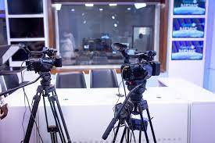

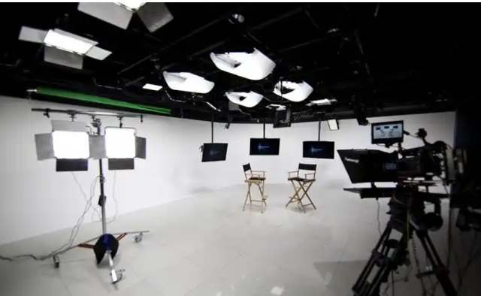
Lighting Equipment: Lighting equipment is essential for setting the mood, atmosphere, and tone of a production. This includes various types of lights such as key lights, fill lights, and backlights, as well as accessories like diffusers, gels, and barn doors to control and manipulate light intensity and direction.

Audio Equipment:
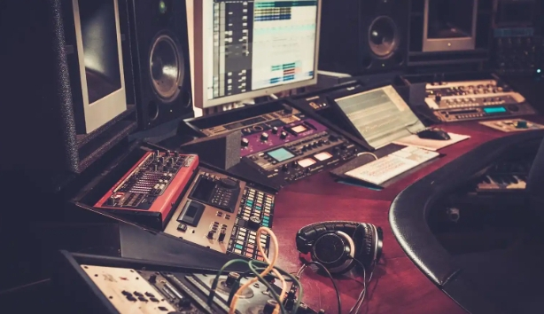
Audio equipment ensures crystal-clear sound quality, immersing viewers in the auditory world of the production. Microphones, mixers, amplifiers, and monitors are among the essential components used to capture, process, and monitor audio signals during recording and broadcasting.

Set Design Elements:
Set design elements encompass a wide range of props, furniture, and scenic elements that transform a soundstage into a vibrant and immersive environment. From furniture and decor to backdrops and set pieces, each element is carefully selected and arranged to enhance the visual storytelling experience.
Teleprompters:
Teleprompters are invaluable tools for presenters and actors, providing them with a script or cue cards displayed on a screen in front of the camera lens. This allows performers to deliver lines and dialogue confidently while maintaining eye contact with the audience.

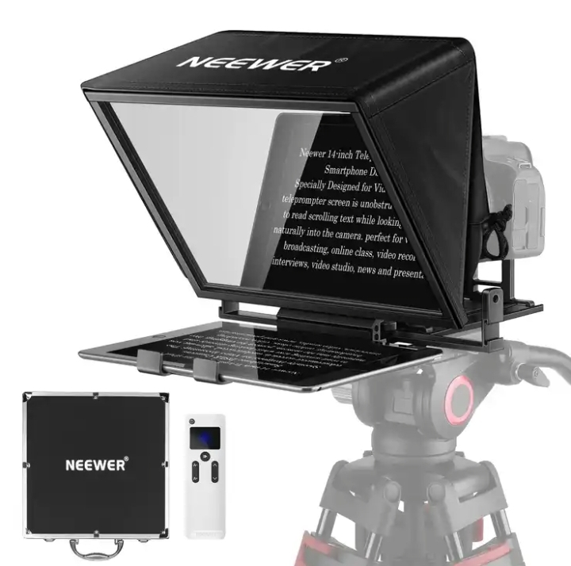

Graphics and Visual Effects:
Graphics and visual effects add depth, context, and visual interest to broadcast productions. This includes on-screen graphics, animations, virtual sets, and augmented reality elements that enhance storytelling and engage viewers in new and exciting ways.
ATEM
An ATEM is a device that switches between SDI (Serial Digital Interface), HD (High Definition) or Ultra HD video standards so that one can form exciting live production with a wide range of video sources such as cameras, disk recorders and slide shows or animation from computers.
Fig: ATEM 2M/E Broadcasting Board
Powerful features such as chroma key, creative transitions, audio mixer, multi-view and more, can be gotten The more advanced models include features such as up to 20 SDI inputs, Super Source multi-layer engine, full motion DVE (Digital Video Effect), larger media pool with full motion clips and up to an incredible 6 auxiliary outputs.
Control Room Equipment:
The control room is the nerve center of the studio, housing equipment such as video switchers, audio mixers, and computer systems that facilitate real-time monitoring, editing, and broadcasting of live and recorded content.
2.1 DEPARTMENTS IN KWTV AND THEIR FUNCTIONS
KWTV has the following departments:
- Administrative and human resource department: This department handles the day to day business of a television station .They see to staff recruitment, training, promotions, etc. This department is also responsible for smooth management of the processes in KW TV. Also they consult with other department heads regarding cash flow and expenditures. In KWTV the branch manager oversees the activities of other departments and ensures proper working condition for staffs, hiring employees and ensures a safe workplace in all departments.
- News and current affairs department: This department is the local face of any television station. They are responsible for the compilation of news and keeping up to date with trending information, news, events and so on. In this department; there are various beat reporters who are assigned to different locations in Ilorin. Therefore, this department sees to the generation and presentation of news items and current affairs material as well as editing, writing/typing and printing the news in the station’s house-style. The department carries out research everyday as events/occurrences unfold to have their facts and figures as well as having accurate report for their listener. News anchors, reporters, meteorologists and sports anchors usually become recognizable personalities in their communities.
- Programmes /programming/production department: This department is sub-divided into two: programmes and production sections. The programmes department is in charge of programming while the production unit is made up of producers who produce programmes and presenters that do the presentations. In this department, there are the English and Yoruba newscasters as well as the sports broadcaster. The production department consists of the manager and assistant staff, e.g production staff, operations staff and on-air personalities. The production department in KWTV makes certain that all program contents and commercials are timely produced and lined up for timely broadcast.
- Engineering department: This department handles the technical aspects of broadcasting and on air time. It ensures broadcast signals are transmitted to the audience as well as see to the proper functioning of the studio equipment. Therefore, the department is in charge of all the technological and electronic machines/equipment in the radio station be it the transmitter, monitor, mixer and so on. Some of the engineers in this department record, work on and edit recorded materials in the recording studio before it is being broadcast. Under a chief engineer otherwise known as director of broadcasting operations, there are host of managers like engineers and studio crew members including show directors, cameramen, audio board operators, photographers, videographers, tape room editors and engineering technicians.
- Sales and marketing department: This department generate revenue. They are responsible for generating direct revenue for the broadcast station by selling air time to advertisers. Also they includes staffs like the voice talent, art directors etc
- Finance/account department: this department is in charge of handling all revenues and expenses in the TV station. The primary function is to ensure that dues from advertisers are collected in a timely manner and similarly all payments like utilities, salary and others are done on time.

CHAPTER THREE
3.0 STUDENT SPECIFIC INVOLVEMENT AT VARIOUS SECTIONS
On the 14TH August, 2023, I started my three month SIWES program at kwara state television authority, television house apatayakuba Ilorin, Kwara State Nigeria.
I was assigned by the head of administration HOA, in the person of Mrs B. A Adebayo to work and gain skills at the news and current affairs department where I spent 12 weeks. The news and current affairs department was headed by director of news and current affairs DNCA, MrAbayomi and assisted by Mrs. Abubarka aka iyaalaje.
On getting to the department I was welcome by the assistant DNCA. She introduced me to the other staff members. I was then put in care of a casual staff that also cast news and write news stories in person of Miss TolulopeIpinyomi. Later in the day, I was introduced to the industry based supervisor in person of MrKunleGbadeyan. He is in charge of overseeing the affairs of SIWES students.
Editorial meeting usually take hold every Monday by 9am, where all matters/problems faced in the previous week are discussed. Also suggestion on news stories are brought up and each person is assigned to each beat to take upon.
I was put to test on how to write a TV broadcast news from a press release. I had the opportunity to watch a newscaster casting news live at the studio. Also on the first day I was put to trial on news reading by MrAbayomi. I also wrote the news line up for the day and I learnt about the seven 'origbomeje' in osun state.
I had the opportunity of learning and acquiring journalistic skills of sourcing for news, new gathering and editing fast. I got to know different news sources amongst which are
news now Nigeria, daily post, radio Nigeria, news 24, premier, Ajazira, naira land forum, news agency of Nigeria NAN, world news, BBC, Sahara reporters, CNN, on pulse ng, the net, ace showbiz; sport news on complete sport, super sport, goal.com and so on which I became familiar with within a short span of time.
At the news and current affairs department, we operated on shift because there were many SIWES students. My working days were Mondays to Saturday by 9-5pm. I work with the sub-editor or any journalist in the department who is available on the compilation of the mid-day news as well as the Yoruba news. We worked on the compilation news update which is read by 5pm and the evening news to be read at 7pm and 10pm.
In the news and current affairs department, there is always internet connection to surf the internet for the sourcing of news as well as getting the news stories sent by the beat reporters via the e-mail.
In this department, I was able to source for news (like foreign, business, sports, entertainment etc) on various sites as well as putting it in the in-house style of the TV station. I observed that their news stories do not exceed four to five paragraphs so I worked in accordance with the house style. From a news story of 15 paragraphs I was able to identify salient part of the news as well as discarding that which is of least importance We were told to always join the news casters in the live studio anytime we were around to observe them and during the period of observing the news casters, we were able to see the practical aspects of theoretical background we had in school on the ethics of journalism.
The head of department made arrangement on how we will go out with beat reporters on covering events/news. I was once assigned to MR faith but the day we were meant to go out to cover our beat, the driver that was meant to take us to the venue of the event was unavailable so he had to go alone so as not to be behind time but when hecame back, he invited me to the recording studio to work on the rushes he had which we edited together with the engineer on duty. Also, post mortem production is essential at the end of every news production.
In order to have a byline in the TV station, the head of the department asked us to write an essay on a topic of interest and I wrote on “cultism”. Also brevity is what broadcast deals with due to time management. Also there are two type of news, they are soft and hard news. Three copies of the bulletin produced are printed. One for the general manager, one for the director and the other for the caster.
.

CHAPTER FOUR
4.0 EXPERIENCE GAINED
During my four months program, I gained a lot especially in the news and current affairs department where I had the opportunity of learning and acquiring journalistic skills of sourcing for news, new gathering and editing fast.
Here are some of the gained during my stay at kwara state television station:
PRACTICAL SKILLS
- Content Creation: Learning how to create engaging content, including writing, filming, and editing.
- Studio Operations: Understanding the technical aspects of studio operations, including lighting, sound, and camera work.
- Live Broadcasting: Gaining experience with live broadcasting, including anchoring, reporting, and producing.
- . Video Editing: Developing skills in video editing software and techniques.
- . Audio Production: Learning about audio production, including sound design, mixing, and mastering.
INDUSTRY INSIGHTS
- . Industry Trends: Staying up-to-date with the latest industry trends and technologies.
- . Networking Opportunities: Building relationships with professionals in the field, including producers, directors, and anchors.
- . Production Processes: Understanding the production process, including pre-production, production, and post-production.
- . Content Distribution: Learning about content distribution, including broadcasting, streaming, and online platforms.
- . Regulatory Framework: Understanding the regulatory framework governing the television industry.
PERSONAL DEVELOPMENT
- . Communication Skills: Developing strong communication skills, including verbal and written communication.
- . Teamwork: Learning to work effectively in a team environment, including collaborating with producers, directors, and other crew members.
- . Time Management: Developing time management skills, including meeting deadlines and managing workflows.
- . Problem-Solving: Developing problem-solving skills, including thinking critically and creatively.
- . Adaptability: Learning to adapt to changing circumstances, including unexpected events and tight deadlines.
CAREER OPPORTUNITIES
- . Job Placement: Potential job placement opportunities within the television station or industry.
- . Career Advancement: Gaining experience and skills that can lead to career advancement opportunities.
- . Industry Connections: Building connections and relationships within the industry that can lead to future opportunities.
- . Portfolio Development: Developing a portfolio of work, including videos, scripts, and other projects.
- . Entrepreneurial Opportunities: Gaining the skills and knowledge necessary to start a production company or pursue other entrepreneurial ventures.
4.1 INTERPERSONAL RELATIONSHIPS WITH THE ORGANIZATION
My four (4) months SIWES program at KW TV Ilorin was very fantastic, because the staffs of the Station are very friendly, disciplined and they are always there for us at all time to lecture us what Advertisement is all about.
This make all SIWES student to be very close and gain more experience from the great Staff of KWTV Ilorin

CHAPTER FIVE
5.0 CONCLUSION
This industrial training has afforded me the basic practical and theoretical knowledge that I may not have gotten from the lecture room. It also gave me the opportunity to have a feel of what it would be like after graduation when I start working.
At the conclusion of my internship at KWTV, I can effectively source for news in their print form and edit in the proper TV format.
What made learning faster for me apart from the theoretical background I had in school. I was also shown recognition and was loved by everyone due to my hard work. Other benefits included opportunity to observe is access to the recording studios. I never for once was useless at the TV station during my SIWES because there is access to the internet which facilitated my work, research, had opportunity of accessing social network, sites, blogs and so on.
Finally the internship has bridged the gap between academic theory and practical and has built a good degree of confidence especially in my abilities to perform. It has also given me a first-hand experience of the entire broadcast media especially TV. I can confidently say that the experience gotten from this training was a worthwhile experience.

5. RECOMMENDATION
In case of next time, I.T supervisors should try their best in visiting I.T students to know how they are faring and observe them rather than not going at all or just visit once.
Also, SIWES supervisors should see to ensuring students go out on their fields by making it mandatory for every organizations

