

a TECHNICAL report on student industrial work experience scheme
(SIWES)
held at
FEDERAL MINISTRY OF SOLID MINERALS DEVELOPMENT
FEDERAL SECRETARIAT COMPLEX, FATE, ILORIN, KWARA STATE

written by
SULYMAN OLAMILEKAN ABUBAKRI
nd/23/mpe/ft/0006
submitted to
department of minerals and petroleum resources engineering, institute of technology (iot), Kwara state polytechnic, p.m.b 1375, ilorin, kwara state, nigeria

In partial fulfillment for the award of national diploma (ND) in minerals and petroleum resources engineering

AUGUST – December, 2024
DEDICATION
This report is dedicated to the Almighty Allah for the gift of life He has given me and also for good health and the useful people He blessed me with during the course of this program.
Also, to my parent MR. & MRS. SULYMAN for their support in ensuring that I succeed.

Acknowledgements
my deepest appreciation and gratitude goes to Allah for his gift of life to me and strength of journey through my student industrial work experience scheme (SIWES) training program and the director of the firm (Federal Ministry of Solid Minerals Development). Engr. Peter the lecture coordinator of the firm (Federal Ministry of Solid Mineral Development) for giving me this very rare privilege and opportunity to learn and be trained under them.
Furthermore, my sincere appreciation also goes to my parent Mr. & Mrs. Sulyman and the entire workers of the firm for developing in me an awareness of the general workplace, behavior and interpersonal skills development and giving me the opportunity to get a feel of the work environment which has exposed to me.
My thanks and appreciation also goes to my institution and my Department and also my SIWES supervisor.
May God bless you all.

abstract
This report is a summary of experienced gained during my student industrial work experience scheme (SIWES) training program at FEDERAL MINISTRY OF SOLID MINERALS DEVELOPMENT.
It is carefully arranged in chapters, written according to the aspect of mining activities professional practical experienced.

TABLE OF CONTENTS
Tittles Page i
Dedication ii
Acknowledgement iii
Abstract ii
Table of Contents v
CHAPTER ONE
1.0 Introduction of Siwes 1
1.1 Aims of Siwes 1
1.2 Objective of Siwes 1
CHAPTER TWO
2.0 About Federal Ministry of Solid Minerals Development 2
2.1 Introduction to Site Work 2
2.2 Safety Factors 2
2.3 Site Safety Precautions 3
2.4 Function of Each Unit of the Organization 3-4
CHAPTER THREE
3.0 Mine Terminologies 5
3.1 Minerals Identification 5-9
CHAPTER FOUR
4.0 Overburden Removal 10
4.1 Material required in Removing Overburden 10-12
4.2 Drilling 12-13
4.2.1 Types of Drilling 13
4.2.2 Drilling Machine 13
4.2.3 Working Principle of Jackhammer and Compressor 14
4.2.4 Problems Encounter when Drilling 15
4.2.5 Diagram of Jackhammer and Compressor Machine 15-16
4.3 Explosive 16
4.3.1 Classification of Explosive 16
4.4 Blasting 17
4.4.1 Types of Blasting 17
4.4.2 Blasting Accessories 17-18
4.4.3 Blasting Procedure 19
4.4.4 Term used in Blasting Operation 19
4.4.5 Causes of Mis-fire 19
4.4.6 How to handle mis-fire 19
4.4.7 Precaution taken while blasting 19
CHAPTER FIVE
5.0 Conclusions 20
5.1 Recommendation 20

Chapter one
1.0 Introduction of siwes
Student industrial work experience scheme is a program designed by the institution to expose students to the practical aspect of his/her course of study. It was introducing in 1973 by the Nigeria University Commission (NUC) and sponsored by the Industrial Training Fund (ITF). Moreover, it involves the attachment of a student to an organization in line with his/her respective course of study that can provide the training and experience required in the industry, as this experience cannot be obtain in the lecture room but the theoretical knowledge thought in lecture room shall be applied by the student in real industrial situations.
In addition, a great deal of knowledge and tremendous skill related to my course of studied was imbibed on me during the few month of rigorous training I went through at Federal Ministry of Solid Minerals Development. An enormous amount of physical and intellectual strength is required to survive on site at the engineering firm.
1.1 AIMS OF SIWES
- Siwes enable the student to be familiar with modern technology.
- It also trains the student in order to be self-discipline and problems solving.
- It also makes a student to be a good ambassador of this country as some tend to travel abroad.

1.2 Objectives of siwes
- To gives access to student to understand the working operation which cannot be comprehended through lecturing.
- to aid industrial satisfaction with diploma result
- To give opportunity to student to transform his/her theoretical knowledge to practical application

Chapter two
2.0 About Federal MInistry of solid mineral Developmpent
The Federal Ministry of Solid Minerals Development (FMSMD) is a Nigerian government agency responsible for overseeing the exploration, exploitation, and development of the country’s solid minerals sector. It plays a key role in regulating mining activities, formulating policies, and promoting investment in solid mineral resources.
Key Functions of the Ministry
1. Policy Formulation: Develops policies for the sustainable management of Nigeria’s solid mineral resources.
2. Regulation and Oversight: Regulates mining operations and ensures compliance with environmental and safety standards.
3. Mineral Resource Development: Encourages exploration and exploitation of solid minerals such as limestone, gold, tin, coal, and lead.
4. Investment Promotion: Attracts local and foreign investors to the mining sector through incentives and partnerships.
5. Geological Surveys & Data Management: Conducts geological surveys to provide data on Nigeria’s mineral potential.
6. Community Development & Environmental Protection: Ensures responsible mining that benefits host communities and protects the environment.
Agencies Under the Ministry:
- Nigerian Geological Survey Agency (NGSA)
- Mining Cadastre Office (MCO)
- Nigerian Institute of Mining and Geosciences (NIMG)
- Solid Minerals Development Fund (SMDF)
The Ministry is key to Nigeria’s efforts to diversify its economy away from oil dependency by harnessing the potential of its rich mineral resources.
  - Introduction to site work
i started my industrial training on August 2024 to December, 2024. I was introduced by my supervisor to the site, the manager, workers and site engineers who further exposed me to proper site work. Site work involved the entire process in mining activities and on site; the following factors must be considered and applied for effectiveness
2.2 Safety factors
Safety is an important consideration in the site, but I was made to understand that on site, extra safety is of crucial important and should be everyone’s primary concern. Safety is based on knowledge, skills and an attribute of care and concern. Thus, safety factors include all the measure carried out to protect both the workers and all the peoples present on the site at every given time from fatalities and injuries and as well as minimize all possible hazard.
2.3 SITE SAFETY PRECAUTION
Safety precaution guideline for workers and people present in the sites are:
- Proper clothing is as essential to safety; loose clothing is dangerous to worker around power tools and equipment.
- Foot wear must be wear
- Always aware and alert of the surrounding
Through my stay in the firm, I was exposed to various mining activities covered by the firm. My training experienced covered the following activities:
- Mine terminologies
- Mineral identification
- Overburden removal
- Drilling
- Explosive
- Blasting
2.4 function of each unit of the organization
Quarry Managers: Are responsible for ensuring that quarries pit and open cast site operate carefully. They also oversee all operations both on site and in the office, manage staff, coordinate production and monitor all site system.
Managing Director: Is the most senior role in any company with ultimate responsibility for the company’s performance. Primarily, the manager directors are responsible for implementing company policy and change to it. Also, managing director represent the company in public at event or with the press.
Production Manager: They organize the business, finance and development issues in film and television production. Production manager involves in planning and organizing production schedule and also in assessing project and resources requirement. More so, he estimates, negotiate and agreeing budgets and time scale with clients and manager.
Mining Engineer: Involved at all stages of the project, before a new site is develop, they asses it viability and assist with planning. Also, they ensure the safe and efficient development of mines and other surface and underground operation.
Marketing Manager: A marketing manager is someone who manages the marketing of a business or project. Moreover, a marketing manager manages all marketing for the company and activities within the marketing department.
Quarry Supervisor: A quarry supervisors are people who are in charge of quarry operations. They also ensure the timeliest and cost effective production of aggregate. Moreover, they are also in charge of planning leading, organizing and controlling the quarry resources to meet the needs of both the company project and external clients.
Marketer: A marketers are people whose duties include the identification of the goods and services desired by a set of consumer as well as marketing of those goods and services on behalf of a company.
Blaster: A blaster is a person who blast or cause the disintegration of the rock. Also, He ensures all activities under his supervision and condition in a safe manner. He also designs and load holes to prevent fly rocks or other dangerous effects e.g air blast, ground vibration e.t.c.
Quarry Worker: Quarry worker perform any or combination of the following task in rock quarry.
1. They break stone into pieces using sledge hammer.
2. They also load broken rock from quarry using shovel, stone fork and hand into the trucks.

Chapter three
3.0 Mine terminologies
- Quarry: is a place where marble is exploited.
- Quarrying: is a process of exploiting marble.
- Outcrop: is the part of minerals or rocks that is exposed to the earth surface.
- Overburden: is the material or waste rock that covered the valuable ore body.
- Gangue: they are the worthless mineral in the deposit.
- Prospecting: is the process of searching for mineral deposit.
- Mine: a mine is an excavation made in the earth to extract minerals
- Exploitation: is the actual stage of mining and it involving the taking of mineral from their ore body.
- Exploration: is the process of quantifying both the quantity and quality of mineral deposit.
- Tailing: are the unwanted mineral in an ore body.
- Concentrate: it is the useful mineral in an ore that are obtain by beneficiation.

3.1 Minerals identification
Minerals are naturally occurring substance that has definite chemical composition and atomic structure. It can be classifying into three main classes. Which are?
- Metallic mineral
- Industrial mineral
- Gemstone

a. Metallic Minerals/Ore: These are the minerals that are used to extract metals e.g iron ore, cassiterite, columbite and gold.
b. Industrial Minerals: They are the naturally physical resources which are homogenous in structure and chemically composed, which man can extract from the earth to carry on his industrial activities e.g marble, limestone.
c. Gemstone: They are the minerals which are among the most fascinating object, beautiful and rare to be successfully used as gem. Such as aquamarine, emerald, tommaline (pink, blue, green), torpaz, zircon.
Notwithstanding, the identification of minerals based on its physical properties, for substance to be a minerals, it must be
    - Naturally Occurring: it must be created in nature.
    - In organic: it is not made by an organism
    - Solid: it is not a liquid or gas at standard temperature and pressure
    - Definite Chemical Composition: All occurrence of minerals have a chemical composition identical within a specific limited range
    - Ordered Crystal Structure: Means that the atoms in a mineral are arranged in a systematic and repeating pattern.
Materials required in identifying minerals are:
- Hand lens
- Acid (HCL, H₂SO₄, HNO₃ etc)
- Scratch plate
- Rock hammer
Hand Lens: it is used as a hand lens microscope.
Acid: it is a chemical that will fizz in contact of a certain minerals due to mineral chemical composition. It is used to know the reaction of minerals with acid.
Scratch Plate: it is a dense plate that is used to observe mineral in powder form.
Rock Hammer: it is used for breaking dense mineral

Diagrams of the required material for identify minerals

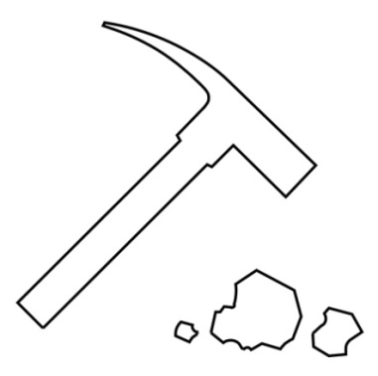
Acid

Rocks hammer

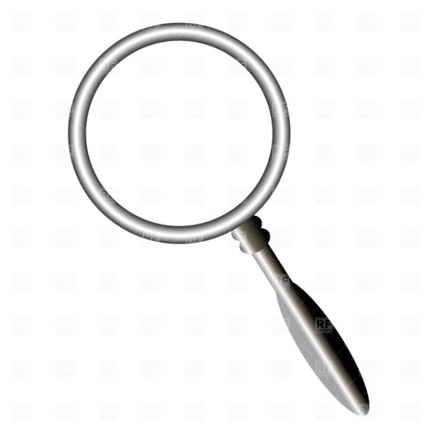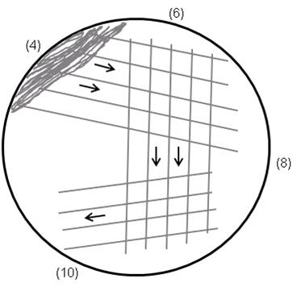
Hand lens streak plate
Notwithstanding, Minerals can be identifying by its appearance and other properties. Some minerals have properties that can be used to help identify them. These properties are
- Colour
- Streak
- Hardness
- Cleavage
- Luster
- Fracture

1. Colour: It is the easiest property to observe. but in most case, minerals cannot be identifying by only its colour, because different minerals have the same colour. E.g Talc and marble.
2. Streak: it is the colour of a mineral in its powder form. It can be done by scrape the mineral across an unglazed porcelain plate (streak plate). The plate is harder than many mineral and the steak is more reliable property than the colour of the mineral sample because the colour of a particular mineral may vary but its streak does not vary.
3. Cleavage: it is the tendency of a mineral to break along certain plane to make smooth surface
4. Fracture: it describes how a mineral break when it is not broken along a cleavage plane. It also describes a break when the resulting surface is not smooth and flat.
5. Lustre: it is the way light reflects off of the surface of the mineral. It can be describing by first divide the mineral in metallic and nonmetallic luster. Mineral that are opaque and shiny has metallic luster. E.g pyrite.
6. Hardness: it is the ability of a mineral to resist being scratch. The hardness of a mineral can be observed by scratching its surface with a mineral of a known hardness.
Here are the four main situations that might observe when comparing the hardness of two specimens.
Let specimen A be marble and specimen B be granite. The result therefore goes thus:
- If specimen A can scratch specimen B, then specimen A is harder than specimen B. (i.e marble is harder than granite).
- If specimen A does not scratch specimen B, then specimen B is harder than specimen A. (i.e granite is harder than marble).
- If the two specimens are equal in hardness, they will be relatively in effective at scratching each other. Small scratched might be produce or difficult to determined
- If specimen A can be scratched by specimen B but cannot be scratched by specimen C, then the hardness of specimen A is between the hardness of specimen B and C.
- Moreover, moh’s scale can also be used to test the hardness of minerals.
Moh’s scale hardness of minerals

Minerals | Number of Hardness
Talc | 1
Gypsum | 2
Calcite | 3
Fluorite | 4
Apatite | 5
Feldspar | 6
Quartz | 7
Topaz | 8
Corundum | 9
Diamond | 10

some minerals and their property

S/N | MINERALs | COLOUR | TEXTURE | HARDNESS | STREAK | LUTRE | REACTION WITH CHEMICAL | USES
1 | Marble (dolomite)  Camg(co₃)₂ | white | Coarse | 2.8 – 2.9 | White | Non metallic | Effervescent occur | Used as building material. Also, as flux in steel making
2 | Granite | Multiple colour | Coarse grain. | 7 | Green | Non metallic | Not reacted | Used in road construction.
3 | Talc mg₃si₄o₁₀(oh₂) | Brown lightly gray | Fine grains | 2.6 - 2.8 | White | soapy | Not reacted | As filter for paint, plaster, used in plaster. Etc
4 | Galena  Pbs | Black | Fine grains | 7.4 – 7.6 | Black | Metallic | Not reacted | Used as corrosion resistant, pipe and lining. Etc
5 | Feldspar  KAlSi₃O₈ | Pink | Fine grain | 4 – 5 | white | Non metallic | Not reacted | Used in the manufacture of porcelain, pottery and glass. Etc
8 | Quartz  Si0₂ | Brownish white | Coarse | 7 | White | Non metallic | Not reacted | Used in steel industry,

Chapter four
4.0 overburden removal
In mining, overburdens are the unconsolidated material that lies above an area that is economical valuable or ore body. It is distinct from tailings.
It is removed during surface mining and it is not contaminated with any toxic chemicals. More so, it may be used to restore an exhausted mining site before mining began.
Therefore, Overburden removal is the process of removing the natural rock and soil that sit above and around the ore body. It is not subjected to any chemical process at the mine but need to be removed to allow access to the ore.

4.1 Material required in removing overburden.
- Head pan e. Hoe i. Bucket wheel excavator.
- Shovel f. Scrapper
- Cutlass g. Wheel barrow
- Rake h. Bulldozer

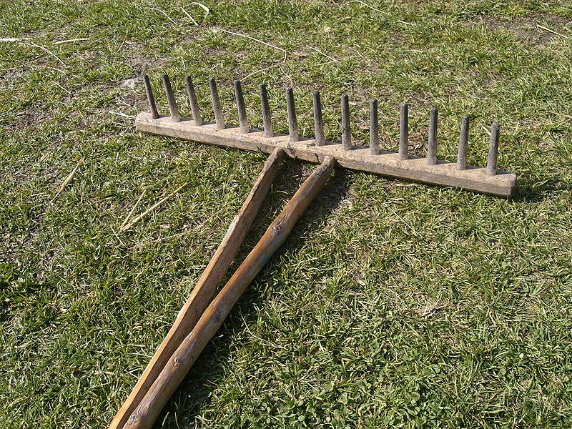
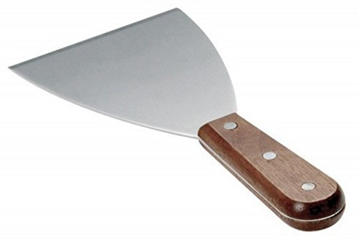

SCRAPPER RAKE
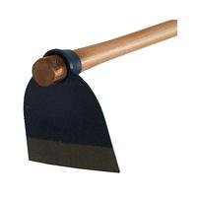
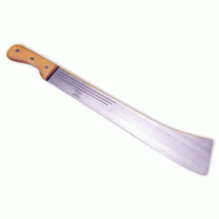

HOE CUTLASS

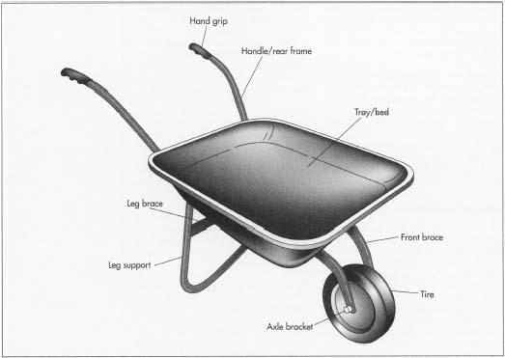
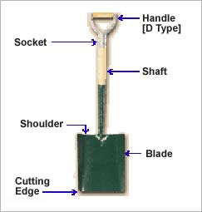
wheelbarrow
SHOVEL

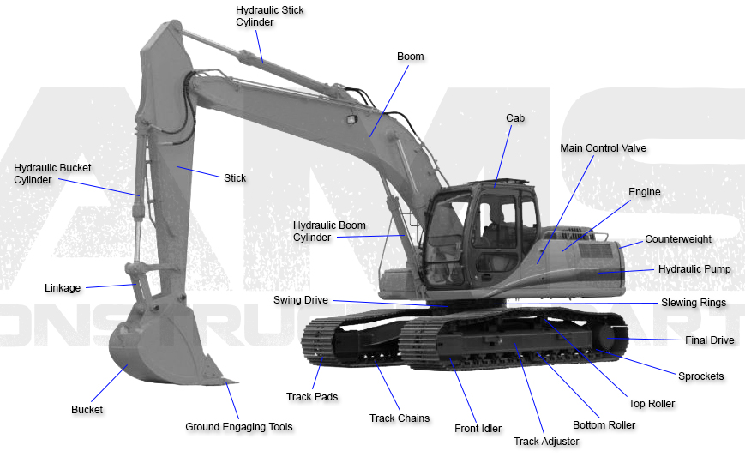

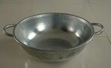

HEAD PAN

Bucket wheel excavator

4.2 DRILLING
Drilling is the process of making an opening or hole on a rock. The diameter of drilling rod or pipe used is proportional to the diameter of opening or hole made on rock. The length of the hole range from 3, 4 – 8ft depending on the size of the ore body. The drilled hole diameter varies from 30mm — 40mm. More so, drilling of holes is an operation which forms a considerable part of the preparatory work necessary for the entry and developing of an ore body. The holes drilled are then loaded with explosives and explosive charged is fired to break off part of the ore or the rock from the solid lump.

4.2.1 Types of Drilling
There are two major type of drilling operations usually carried out in a site. Thus, these are:
- Primary Drilling and
- secondary drilling
- Primary drilling: It is an operation that is carried out on the parent rock (insitu). It employs the use of heavy duty machine such as wagon drilling machine. In primary drilling holes diameters are of 30mm-40mm.
- Secondary drilling: It is an operation carried out on the boulders which are produced after primary blasting operation. It occurred as a result of insufficient fragmentation during primary blasting operation and basically involved the use of jack hammer to drill small diameter of hole.

4.2.2 Drilling machine
These are the devices used in drilling operations. Thus, drilling machines are:
- Wagon drilling machine
- Jack hammer drilling machine
- Ridges drilling machine
Different between the above listed machines are:
Wagon drilling machine (larger) | Ridges drilling machine (medium) | jack hammer drilling machine (smaller)
It has the highest inches of diameter of drilling bit. | It has the higher inches of diameter of drilling bit. | It has the high inches of diameter of drilling bit
Larger diameter of drilling hole | medium diameter of drilling hole | small diameter of drilling hole
it can contain 8-12 explosive when charging | it can contain 4-6 explosive when charging | it can contain 2-4 explosive when charging
Notwithstanding, there are variety of the method used in drilling operation, but the major method adopt at oreke is rotary drilling method whereby the hole is bored in a rotatable manner by which the drilling machine rotate.
The major drilling machine used by oreke miners are jackhammer and compressor drilling machine.

4.2.3 Working principle of jackhammer and compressor to drill hole
- The compressor helps to drive the rod or pipe of jackhammer by producing the power that is pneumatic in nature. It has two part, which are engine part and air part
- The compressor produced pneumatic energy which result from conversion of energy that take place in the compressor engine where mechanical energy is converted to air energy to power the jackhammer.
- The air produce by the compressor is discharge through the discharging nozzle of the compressor into long pipe of the jackhammer, which then propelled the rod and blow out the dust
- The air discharge into the jackhammer causes the drilling operation.
- The drilled hole ranges from 3, 4 – 8ft, depending on the size of the ore body.
- The drilled diameter varies from about 30 - 40mm

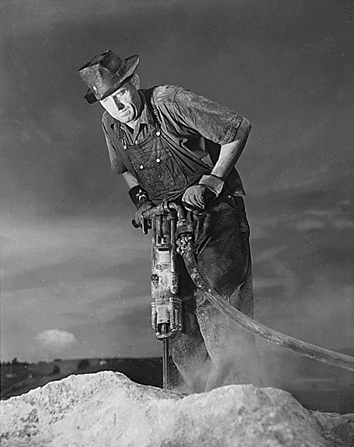
Drilling Operation in Process

4.2.4 Problems encounter when drilling
Drilling problems are the difficulties encounter while drilling. The most prevalent drilling problems encounter in the site is pipe sticking
Pipe sticking: during drilling operation, a pipe is considered to be stuck if it cannot be freed and pulled out of the hole without damaging the pipe

4.2.5 Diagram of jackhammer and compressor drilling machine

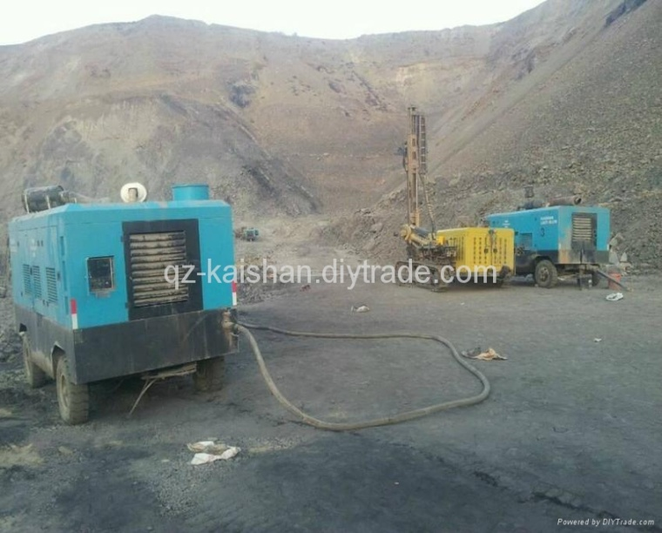
Air Compressor
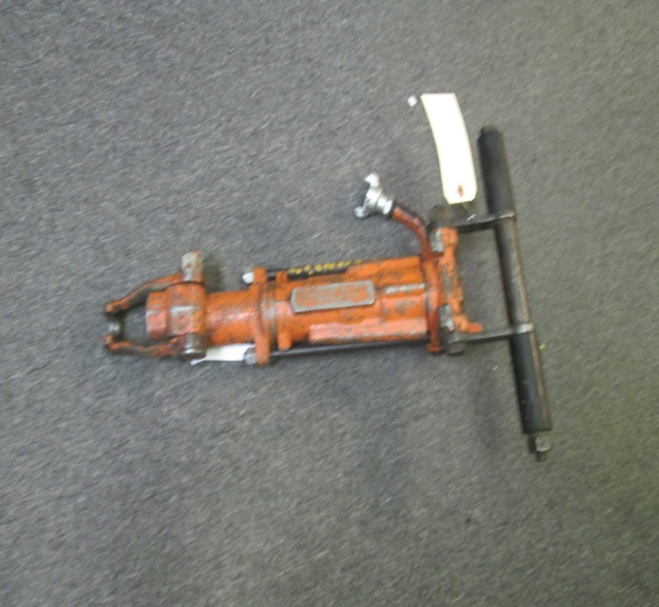
Jackhammer
4.3 Explosive
Explosive is a reactive substance that contains a great amount of potential energy that can produce an explosion. It usually accompanied by the production of light, heat, sound and pressure. These gases expand rapidly with sufficient forces overcoming the confining force of the rock body around the drilled holes.
The potential energy stored in an explosive are:
- Chemical energy e.g Nitroglycerin
- Pressurized gas e.g Aerosol
- Nuclear energy e.g Uranium 235

4.3.1 CLASSIFICATION OF EXPLOSIVE
Explosives are categorized by their sensitivity and velocity at which they expand. Thus, the classification of explosives is:
- High explosive
- Low explosive
- High explosive: High explosives are those with higher density e.g dynamite, gelatin.
- Low explosive: Are those with lower density. E.g mixture of Ammonium Nitrate and Fuel Oil (ANFO).

Different between high and low explosive

High explosive | Low explosive
It occur at speed greater than the speed of sound (detonate) | It occur at speed less than the speed of sound (deflagrate).

4.4 blasting
Blasting is the process of disintegrate a rock. It involved the process of fracturing material by the use of a calculated amount of explosive so that a predetermined volume of material is broken.
4.4.1 Types of Blasting
- Electric Blasting
- Non Electric Blasting

- Electric Blasting: is a method that involved the use of electric detonator and cartridges of explosives. The cartridges are loaded into each hole and make sure the two ends of one side of the wire-lead length from the detonator come out from the holes to allow connection between the two adjacent holes, stemming is then done to isolate and retain each charge in position. The Connection could be done in series or parallel making the two alternate wires to be connected to the lead wires that go to the main sources of power (car battery, generator e.t.c)
- Non-electric Blasting: is a method that employs the use of detonating cord, explosives and safety fuses. The same prompt used for electric blasting is also used in non electric blasting except that sufficient length of detonating cord is extended into each hole to replace an electric detonator per hole.
4.4.2 Blasting accessories
Blasting accessories are the devices used in carried out blasting operation. These are:
- High explosive(dynamite/gelatin)
- Detonating cord/cortex (blue or any colour)
- Ammonium nitrate + fuel oil (ANFO)
- Stemming rod
- Safety fused
- Mud/ gravel
- Safety/ blasting cap.
Diagram of blasting accessories
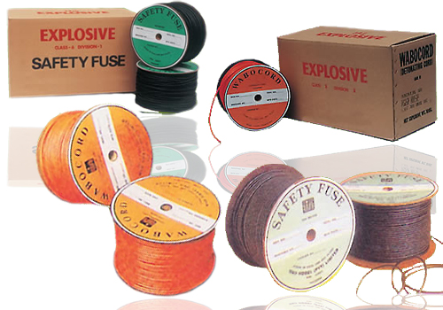

4.4.3 Blasting procedure
- Flushing: the process of blowing the drilled hole (water lodge).
- Cortex( detonating cord) is then put inside the hole that long than drilled hole with 10cm for connection
- Addition of explosive (gelatin) which is water resistor.
- Using of stick to pull it down.
- Addition of Ammonium nitrate + fuel oil (ANFO)
- Using of mud to stem the filled hole with explosive
- Stemming rod/ stick to stem to confined the filled hole and avoids sparking of explosive.
- Connection of cortex to each other.
- Safety fused to be used to lighting the explosive at least 10cm, which will blast at the rate of 1minute to avoid loosing of life.
- Safety cap is the one we used to hold safety fused to hold it down to where to face.

4.4.4 Term used in blasting operation.
- Mis-Fire: Is referred to unexpected result occurred during blasting operation.
4.4.5 Causes of mis-fire
The most common causes of mis-fire in blasting operation are:
- Poor wire connections (corrosion).
- Detonators not connected to the circuit
- Inadequate firing line
- Inadequate power supply
- Improper priming
- Using non-water resistance explosives in wet holes
- Improper loading practice

4.4.6 how to handle mis-fire
The best way of handling mis-fire is to reshoot provided there are sufficient burden around the hole to prevent rocks hazards. In handling mis fire, one must be very careful as work requires removing the stemming. Stemming could be removed with a stream of water through a plastic pipe or holes.
Wet Hole: is referred to the hole that contained water (h₂0). It should not be loaded with unprotected ANFO because water readily dissolves Ammonium Nitrate and leading to desensitization of the ANFO. It can easily be separated by floating in water or muds in the hole and priming of every other bag can help overcome this problem.
4.4.7 Precaution taken while blasting

- Avoid using of Ammonium nitrate + fuel oil (ANFO) where there is water lodge because it can dissolve in water.

Chapter five
5.0 conclusion
My period of industrial attachment was a period of learning and great exposure to the practice of the theoretical aspect of what I learnt in lecture room. It also brought me in contact with some high class of people which I may not have met if I did not undergo this training.
5.1 Recommendation
Based on student industrial work experience scheme (SIWES) program,
- I recommend that the program is very good and trainees should be allowed monthly package in their place of work as they do other regular employee work.
- Also, orientation should be giving to student before going to their place of work.

