
A TECHNICAL REPORT
ON
STUDENT’S INDUSTRIAL WORK EXPERIENCE SCHEME (SIWES)
CONDUCTED AT:
AFOFASHA GLOBAL NIGERIA LIMITED
7, BENIN CITY ROAD, ADEWOLE ESTATE, ILORIN, KWARA STATE
COMPILED BY:
FANOU JOSHUA ALEX
ND/23/BLD/PT/0022
SUBMITTED TO:
DEPARTMENT OF BUILDING TECHNOLOGY,
INSTITUTE OF ENVIRONMENTAL SCIENCE (I.E.S),
KWARA STATE POLYTECHNIC, ILORIN.

IN PARTIAL FULFILLMENT OF THE REQUIREMENT FOR THE AWARD OF NATIONAL DIPLOMA IN BUILDING TECHNOLGY.
AUGUST – DECEMBER 2024
DEDICATION
This Students’ Industrial Work Experience Scheme (SIWES) report is dedicated to Almighty God, the beneficent and the most merciful, the source of all knowledge, wisdom and understanding for His guidance and protection on me.
I also dedicate this report to my parents; MR & MRS. FANOU for their moral, Spiritual and financial supports.

ACKNOWLEDGEMENT
I give all glory and high regard to Uncreated Creator, The Doer of What He wills for the preservation of my soul and for the great things He has done in my life from childhood till this moment.
I’m grateful to my parents; Mr. and Mrs. Fanou for their love, care, encouragement and financial supports. I pray that Almighty God grant them long life and divine health to reap the fruits of their labor.
Special thanks to the HOD of Building Technology for his quality leadership and the Staff of the department at large.
At this juncture, I deeply appreciate AFOFASHA GLOBAL NIGERIA LIMITED SIWES Supervisor for the ultimate guidance, teaching, motivation provided towards the successful completion of the SIWES. The appreciation is also extended to entire Staff of the organization for their immense contribution.

REPORT OVERVIEW
This is a report of Industrial attachment (SIWES) programme carried out at AFOFASHA GLOBAL NIGERIA LIMITED situated at 7, Benin City Road, Adewole Estate, Ilorin, Kwara State within the period of Four months. The report comprises the background of SIWES, the description of the organization, its aims and objectives, the experiences gained as an industrial training student and the summary, conclusions and recommendations. It has a total of 5 chapters with sub-chapters. It also has the preliminary pages, such as the title page, report overview and table of contents, Summary of the experiences gathered during the training, Problems faced and recommendations on the improvement of scheme.

TABLE OF CONTENTS
Title Page
Dedication
Acknowledgment
Report Overview
CHAPTER ONE
1.1 Introduction
1.2 General Backgrounds of SIWES
1.3 Objectives of SIWES
CHAPTER TWO
2.1 Location and brief history of the establishment
2.2 Objectives of establishment
2.3 Organizational structure of the establishment
CHAPTER THREE
3.1 Activities conducted during the attachment
CHAPTER FOUR
4.1 Continuation of the activities carried out
CHAPTER FIVE
5.1 Summary
5.2 Problems encountered during the program
5.3 Suggestions for the improvement of the scheme
5.4 Conclusion

1.0 CHAPTER ONE
1.1 SIWES INTRODUCTION
The Students’ Industrial Work Experience Scheme (SIWES) is an accepted skill training program which forms part of the approved minimum academic standard in various programs for all Institutions in Nigeria. It is an effort to bridge the gap in between theory and practical of Engineering and Technology, Science, Agriculture, Management and other professional educational program in the Nigeria Institutions.
1.2 GENERAL BACKGROUND OF SIWES
SIWES was established by Industrial Training Fund (I.T.F) in 1973 to solve the problem of lack of adequate practical skills. SIWES is funded by Federal Government of Nigeria and operated by I.T.F, the coordinating Agencies; Nigeria Universities Commission (N.U.C), National Council for Colleges of Education (N.C.C.E), National Board for Technical Education (N.B.T.E).
The beneficiaries of SIWES include; Undergraduate students of Agric Technology, Engineering, Environmental Sciences, Education, Medical Sciences, Pure and Applied Science.
1.3 OBJECTIVES OF SIWES
- Provide an avenue for students in institutions of higher learning to acquire industrial skills and experience in their course of study
- Prepare students for the industrial work situation they are to meet after graduation.
- Expose students to work methods and techniques in handling equipment and machinery that may not be available in their institutions.
2.0 CHAPTER TWO
2.1 BACKGROUND OF THE ORGANIZATION
AFOFASHA GLOBAL NIGERIA LIMITED is a building construction and other related business services company. The organization specialize mainly on Aluminum roofs, sales and fitting, general building contracts, general merchandise, project supervision and other building services.
The building construction company is located at 7, Benin City Road, Adewole Estate, Ilorin, Kwara State.
AFOFASHA GLOBAL NIGERIA LIMITED continues to chase her vision by continual training and empowering Youth and Kids with building & construction skills, maintenance solutions, and becoming the best Building professional dreams employer.
2.2 VISION AND MISSION OF THE ORGANIZATION
Vision
- To become one of the leading construction firm
- To continually provide excellent value and innovative construction services to meet the expectation of our clients and beyond.
- To be a first thought construction and building firm in the minds of our esteemed clients through provision of exceptional and professional services while prioritizing the use of modern and sophisticated technologies.

Mission
- To provide the highest level of service in the construction industry while offering superior craftsmanship to every contract we handle.
- To innovate, develop, renovate and adopt state-of-the-art technology in methods and materials to enhance productivity.
- To raise a safety culture targeted at continually reducing the frequency severity rate towards achieving zero accident.
- To mitigate all the environmental impacts arising from our industrial activities and comply with the applicable environmental norms.

2.3 ORGANISATIONAL STRUCTURE
CHAIRMAN/ CEO
MANAGER

UNIT SUPERVISOR

GENERAL STAFF OFFICERS

3.0 CHAPTER THREE
3.1 ACTIVITIES CARRIED OUT DURING THE PROGRAMME
The Student’s Industrial Work Experience Scheme (SIWES) gave an avenue to engage in various practical aspects of Building Technology and one of the activities carried out during the training was the involvement in Block & Block Production.
- BLOCK AND BLOCK PRODUCTION
A concrete block is primarily used as a building material in the construction of walls. It is sometimes called a Concrete Masonry Unit (CMU). A concrete block is one of several precast concrete products used in construction. Most concrete blocks have one or more hollow cavities, and their sides may be cast smooth or with a design.
STRUCTURE OF A BLOCK
- Block Height – It's the sequence number of the block in the chain of blocks.
- Block Size – It's a 4-bytes or 32-bit field that contains the size of the block.
- Block Reward – This field contains the amount rewarded to the miner for adding a block of transactions.
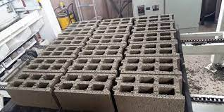

PRODUCTION
For the production of concrete blocks, cement, sand, stone dust, and crumb are used, with a diameter of 3 to 5 mm. These are the most common materials for the production of all types of concrete blocks and bricks. By mixing individual ingredients in different proportions, we can obtain different types of blocks and bricks, including hollow blocks.
Equipment for the production of building blocks or concrete blocks has a high level of automation, the machine is controlled from a single centralized control center PLC. The line works very reliably and stably, has a compact structure, convenient maintenance, high productivity, and low power consumption.

THE GENERAL PROCESS OF PRODUCING CONCRETE BLOCKS IS AS FOLLOWS:
- The mixer is loaded with cement, sand, stone crumb with a special loader
- This mixture falls on a conveyor belt
- And then directly to the machine for the production of blocks. It forms and moves blocks
- After that, the ready-made wet products go to the elevator
- And finished products are transported to the warehouse
- EXCAVATION AND EARTHWORK
Excavation is the process of moving earth, rock, or other materials with tools, equipment, or explosives. It includes earthwork, trenching, wall shafts, tunneling, and underground. Excavation has a number of important applications including exploration, environmental restoration, mining, and construction.

TYPES OF EXCAVATION

Mechanical Excavation
- Vacuum excavation
Earthwork includes operations connected with roadway excavation, repair of slope failures, blasting, structure excavation, backfill, ditch excavation, compaction, embankment construction, grading, borrow excavation, placement of subgrade enhancement geosynthetic (SEG), placement of shoulder backing.
Excavating equipments
- Backhoe loader
- Dredge
- Excavator
- Wheeled
- Trencher
- Chain

4.0 CHAPTER FOUR
4.1 FURTHER ACTIVITIES CARRIED OUT DURING THE TRAINING
The training also provided adequate practical knowledge on Foundation construction and it was really an enjoyable experience.
- Foundation: this is the structure found below the earth surface of the ground in which it rest the combined dead and imposed load in a way that will not allow part of a building i.e. collapsing of the building.
The function of any foundation is to safely sustain and transmit to the ground on which it rests the combined dead, imposed and wind loads in such a manner as not to cause any settlement or other movement which would impair the stability or cause damage to any part of the building.
Various type of foundation depends on the nature of soil on which the foundation would be constructed, the nature of the soil is the major factor that influences the choice of foundation to be constructed or used, and other factors are:
- The amount of settlement produced by loading
- The total load of the building.

- WALL CONSTRUCTION
Wall construction can be done with a variety of materials including wood, concrete, brick, stone and metal. The type of wall construction depends on factor such as the intended use of the wall, the building codes and the budget.
Wall construction is the critical part of building design, as it provides support and stability for the structure, while also providing an aesthetic finish.

TYPES OF WALL
There are several types of wall used in construction. Here are a few common types;
- BEARING WALLS: These are walls that support the weight of the structure such as load-bearing walls.
- CURTAIN WALLS: These walls are non-structural and are typically used in modern buildings as a façade.
- FIRE WALLS: These walls are designed to resist fire and contain it within the building.
- RETAINING WALLS: These walls are used to retain soil and support slopes.
- PARTITION WALLS: These walls are non-load bearing and are used to separate spaces within a structure.
TYPES OF PARTITION WALL
STUD WALLS
These are the most common type of partition walls made from vertical wooden studs covered with dry wall.
MANSORY WALLS
These are walls made from bricks, concrete blocks or stone.
METAL STUD WALLS
These are walls similar to stud, but use metal stud instead of wood.
GLASS PARTITION WALLS
These walls are made from glass panels that provide a visual separation spaces while still allowing light to pass through.

- ROOF

The roof forms the topmost component of a building structure. It covers the top face of the building. Roofs can be either flat or sloped based on the location and weather conditions of the area.
BUILDING ROOF TYPES
Building roof types is another interesting thing that was satisfactorily mentioned during the period of the training and this was extended to visitation of various sites to see practically.
The slope of roof has both a practical and aesthetic function. Water from rain or snow, for example, tends to shed, or run off, quicker on a steep slope roof. The roof’s slope is expressed in a ratio based on the roof’s proportions.
Roofing contractors may use the term 6 in 12 or use a contracted version such as 6:12 or 6/12. What this means is that the roof rises 6 inches vertically for every 12 inches (or 1 foot) horizontally. This can easily be translated for any number. A roof with a 4 in 12 slope will rise four inches vertically and 12 inches horizontally.
GABLE ROOF
The gable is an extremely popular roof style, and it works well on a variety of home designs. You can fancy it up with front gables over your entryways or go with a crossed gable design that consists of two ridges set at right angles.
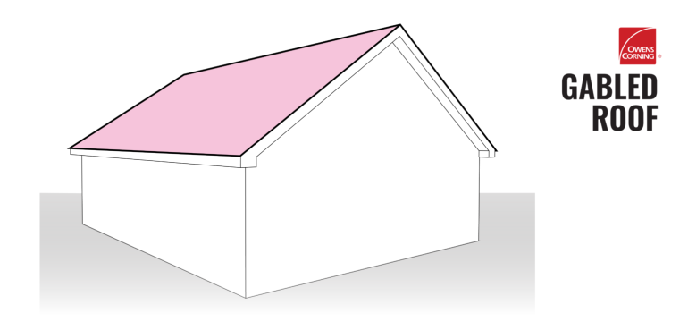
GABLED ROOF

DUTCH GABLE ROOF
The Dutch gable roof is another combination style roof that uses design elements of both gable and hip roofs. A miniature gable roof, or “gablet”, is perched atop a traditional hip roof. The gable portion provides homeowners with increased attic space and can even be fitted with windows for added sunlight.
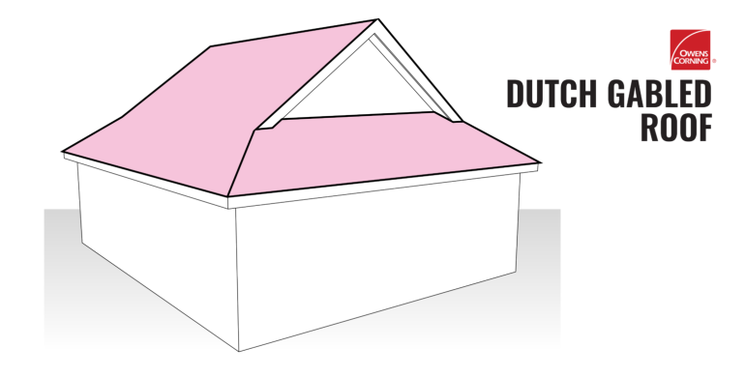
DUTCH GABLE ROOF

HIP ROOF
A traditional hip roof consists of four equal-length slopes that meet to form a simple ridge. There are variations, though, such as a half-hip that features two shorter sides with eaves. If you have a hip roof, then you may have already realized that most of the roof is visible when looking at your house. The type and color of roofing shingles you get installed on a hip roof will make up a big piece of your home’s overall exterior look because it is so highly visible.
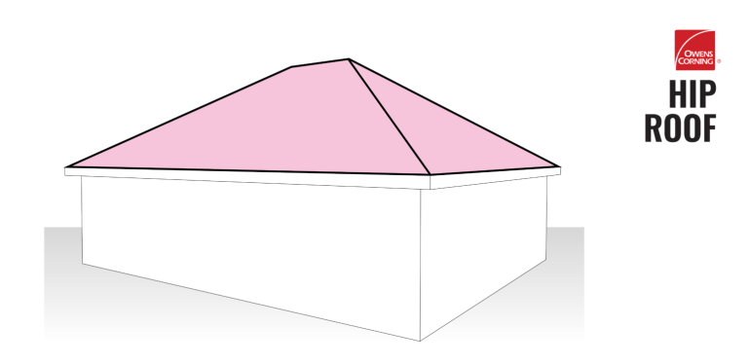
HIP ROOF

5.0 CHAPTER FIVE
5.1 SUMMARY
Summarily, the Students’ Industrial Work Experience Scheme (SIWES) undertaken at AFOFASHA GLOBAL NIGERIA LIMITED provided the necessary exposure to real work situation as well as the acquisition of industrial skills that are relevant to Building field. It also enhanced self-development by improving problem-solving and creative abilities by tasking both the mental and physical faculties which provided for the acquisition of new knowledge, skills, and experience.
This SIWES was very educative as knowledge in the practical aspect of Building and general Construction were learnt and understood, and the operations in the various units necessary were also gained.
5.2 PROBLEMS ENCOUNTERED DURING THE PROGRAM
- Obtaining of industry placement is quite difficult due to congestion and bureaucracy in most organizations, and the lack of formidable existing industry partnerships between the polytechnic and key industry players.
- Lack of remuneration as an incentive for students which may be lead to nonchalant attitude towards the SIWES program.
- Problem of accommodation for SIWES students.

5.3 SUGESTIONS FOR IMPROVEMENT OF THE SCHEME
- The polytechnic should establish formidable industry partnerships to foster quick absorption of students into the workforce during internships and after graduation.
- They should encourage more automated and more standard technologies in the organization and frequent renewal of knowledge and technical know-how to advance the services rendered in the organization.
- Federal government should implement policies to both private and public industries to pay undergraduates on industrial attachment so as to help boost their interest for the SIWES.
5.4 CONCLUSION
The Industrial training at Afofasha Global Nigeria Limited has proven to be a transformative experience, providing a comprehensive immersion into the practical knowledge of Building and Construction. The exposure to real-world challenges, coupled with the application of various equipment has been invaluable in bridging the gap between theoretical knowledge and practical implementation.
The institute commitment to providing a conducive learning environment, coupled with the mentorship and guidance received from experienced professionals, has played a pivotal role in shaping the skills and competencies of the trainees. The collaborative and interdisciplinary nature of the projects undertaken has not only enriched my understanding of my field but has also fostered teamwork and communication skills that are crucial in professional settings.

