KWARA STATE POLYTECHNIC

INSTITUTE OF APPLIED SCIENCE

DEPARTMENT OF AGRICULTURAL TECHNOLOGY

COMPREHENSIVE TECHNICAL REPORT ON STUDENT INDUSTRIAL WORK EXPERIENCE SCHEME(SIWES) AT ADEBOMI FARM LIMITED, IJETU, OSHOGBO, OSUN STATE.

BY

JAMIU ZAINAB AJOKE

ND/23/AG/FT/0056

ND II

SUBMITTED APRIL 2025

I hereby certify that I, JAMIU Zainab Ajoke with matriculation number ND/23/AG/FT/0056 has successfully completed her four months Industrial Training Experience Scheme at Adebomi Farm Nig LTD, Oshogbo, Osun State.

Department Siwes Coordinator Date

DEDICATION

I dedicate the completion of this Student Industrial Work Experience Scheme (SIWES) to God almighty, also to my parents MR AND MRS JAMIU who helped me pursue my dream career and all the lecturers who have helped me achieve this feat, I promise to revolutionize Agriculture.

ACKNOWLEDGEMENT

I wish to thank all the people who trained and guided me to this completion of this industrial training. I’ll never forget my parents on how they guided me and help me to this level even all through difficulties. They told me to pursue my dreams, also thought me about self reliance, respect for another and the wonderful feeling of trust, for this I’ll forever be grateful, I also want to thank the people I worked for and with at Adebomi Farm LTD respectively. They really made my adaptation and fitting into farm work easy for me from the time I arrived there, survival was in doubt everyday but with sheer determination, teamwork and a desire to learn, I completed in goodwill I will also like to acknowledged the various Industrial Training students for the ideas we shared together and finally all lecturerd attached to the department of agricultural technology specially and in general all lecturers in the institute of applied science for impacting knowledge into me GOD BLESS YOU ALL.

TABLE OF CONTENTS

COVER PAGE 1

CERTIFICATION 2

DEDICATION 3

ACKNOWLEDGEMENT 4

TABLE OF CONTENTS 5,6,7

CHAPTER ONE 8

I.0 HISTORY OF SIWES 8

1.1 OBJECTIVES OF INDUSTRIAL TRAINING SCHEME 8

1.2 OBJECTIVES OF SIWES REPORT 9

1.3 HISTORY OF ADEBOMI FARM LTD 9

1.4 GEOGRAPHICAL LOCATION 10

1.5 INFRASTRUCTURAL FACILITIES ON THE FARM 11

1.6 SECTIONS ON THE SITES 11

CHAPTER TWO 12

2.0 DEPARTMENTS IN ADEBOMI FARM LIMITED 12

2.1 HATCHERY DEPARTMENT 12

2.1.1 OPERATIONS OF HATCHERY 12

2.1.1.1 COLLECTION OF EGGS FROM BREEDERS’ FARM 13

2.1.1.2 EGGS STORAGE 13

2.1.1.3 SORTING AND TRAYING OF EGGS 13

2.1.1.4 FUNMIGATION 16

2.1.1.5 INCUBATION 16

2.1.1.6 CANDLING AND TRANSFER 17

2.1.1.7 CHICKS HANDLING, SORTING AND BOXING 18

2.1.1.8 CHICKS VACCINATION 18

2.1.1.9 CLEANING AND DISINFECTION AFTER HATCHING 18

2.1.2 ROUTINE MANAGEMENT PRACTICES IN HATCHERY 19

2.2.1.1 BROODING UNIT 19

2.2.1.2 REARING/GROWING UNIT 21

2.2.1.3 LAYING UNIT 22

2.2.1.4 HEALTH MANAGEMENT PRACTICES 23

2.3 FEEDMILL DEPARTMENTS 29

2.3.1 EQUIPMENT IN THE FEEDMILL DEPARTMENTS 29

2.3.2 MANAGEMENT PRACTICES AT THE FEEDMILL 31

CHAPTER THREE 33

3.0 CONCLUSIONS AND RECOMMENDATIONS 33

3.1 CONCLUSIONS 33

3.2 RECOMMENDATIONS 33

CHAPTER ONE
- HISTORY OF SIWES
SIWES was introduced in 1973 by the Federal Government of Nigeria. It is an effort to bridge the gap existing between theory and practical in the sciences, Engineering, Agriculture and other professional educational programmes in Nigerian tertiary institutions. Students in their penultimate year are attached to reputable establishments as part of Government efforts towards providing adequate skills and training for students of higher institutions of learning. The Federal government provides funds through the ITF in an attempt to sustain the industrial training programme (spanning from 3-18 months). The scheme is a programme involving institution-based supervisors, the students and industry-based supervisors. The industrial period is for the whole of the second semester of the fourth year of the Undergraduate programme.
1.1 Objectives of Industrial Training Scheme
Objectives of the student industrial work experience scheme are:
- To promote and encourage the acquisition of skill in industries.
- It affords students the opportunity of being familiarized and exposed to the needed experience in handling machineries and equipment which are usually not available in the educational institutions.
- To expose student to new industrial development and innovations.
- To appreciate the importance of good communication skills and to develop the skills.
- To enable educational institutions to produce highly qualified graduates with sound theoretical and practical knowledge in their respective disciplines.

1.2 Objectives of SIWES report
1. To provide students additional opportunities on how to write field reports.
2. To match classroom theories with the practical experience acquired during the industrial attachment programme.
3. Make known all the practical experiences and knowledge gained during the period of training
4. Present a detailed technical report on the work done and the activities of the establishment and to keep the report for future as a good reference material.
5. And finally, offer useful recommendations for further improvement of the programme.
1.3 History of ADEBOMI FARM LIMITED
My SIWES site ADEBOMI FARM LIMITED, started in the year 2005 before it was purchased by the current managing director, Engr. Adebomi Olusola eziekel with about 1,000 layers.
Presently, the farm had increased tremendously and there are many sections in the farm. Operations like, poultry, hatchery, feedmill, fishery, sales/marketing of Agricultural products and health care/services.
1.4 Geographical Location
ADEBOMI FARMS LIMITED has her headquarter situated at opp Hidden Mama Ministry Headquarters, along Aiyegbami Area, Ijetu, Oshogbo, Osun State.

MANAGING DIRECTOR

FARM MANAGER
ADMINISTRATIVE/ACCOUNT MANAGER
HEAD DOCTOR

VETERINARY DOCTORS
UNITS SUPERVISORS
AUDITOR

UNITS ATTENDANTS
VETERINARY ASSISTANTS

CASHIERS
SECURITY MEN
SALES CLERKS
DRIVERS

Figure 1.1 Organizational chart of ADEBOMI FARM Limited.

1.5 Infrastructural Facilities on the Farm
There were several infrastructural facilities at ADEBOMI FARM LIMITED. These are; Farm building, administrative block, Poultry pens, Hatchery building, Feed mill house, Stores, Generating plants, Truck, Pumping machines, Tankers e.t.c.
1.6 Sections on the site
The following are the different sections on the farm
- HATCHERY
- POULTRY
- FEED MILL
- VETERINARY

CHAPTER TWO
- DEPARTMENTS IN ADEBOMI FARM LIMITED
There are various departments in ADEBOMI FARM LIMITED and they are listed below.
- HATCHERY
- FEEDMILL
- ADMINISTRATIVE
- VETERINARY

2.1 Hatchery Department
A Hatchery is a special building where fertile or hatchable eggs can be hatched into day old chicks.
2.1.1 Operations at Hatchery
- Collection of eggs from breeders’ farm.
- Eggs storage
- Selection and traying of Eggs
- Fumigation
- Incubation
- Eggs candling and transfer
- Chicks sorting, handling and boxing
- Chicks vaccination
- Cleaning and disinfection after hatching

2.1.1.1 Collection of eggs from Breeders’ Farm
At ADEBOMI FARM LIMITED, The hatchable eggs were gotten from the breeders’ farm, from customers in other farms and sometimes imported hatchable eggs.
Eggs were transported in clean, disinfected and covered vehicle because hatchable eggs should not be exposed to direct sunlight, wind and dust during transportation.
Eggs were set carefully in clean egg trays and stacked together in egg case.

2.1.1.2 Eggs Storage
Eggs brought from the breeders’ farm were stored in egg storage room till the setting day. Because the number of eggs needed may not be attained at times. At ADEBOMI FARM LIMITED, eggs were usually set and hatched twice weekly (Monday and Wednesday) and Eggs were stored for maximum of five days at temperature of 18ºC.

2.1.1.3 Sorting and Traying of Eggs
Traying means setting of the eggs on incubator trays while handling involves sorting and setting of the eggs. When eggs were set on incubator trays, they were sorted to pick out suitable eggs for hatching and bad eggs were separated, because bad eggs will not hatch or may hatch to disabled chicks.

Factors considered when setting eggs
- Crack eggs and dirty eggs were avoided
- Extra large or extra small eggs were avoided (weight of a hatchable eggs is between 45-65g)
- The pointed ends of the eggs were faced vertically downward.

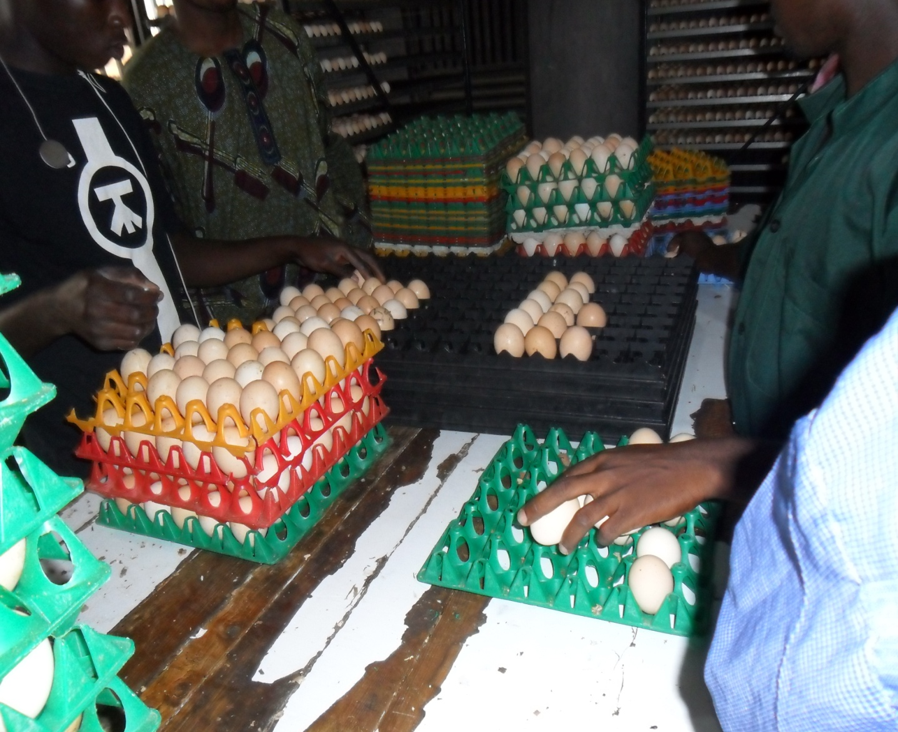
Figure 2.1 Setting of Eggs on Incubator Trays

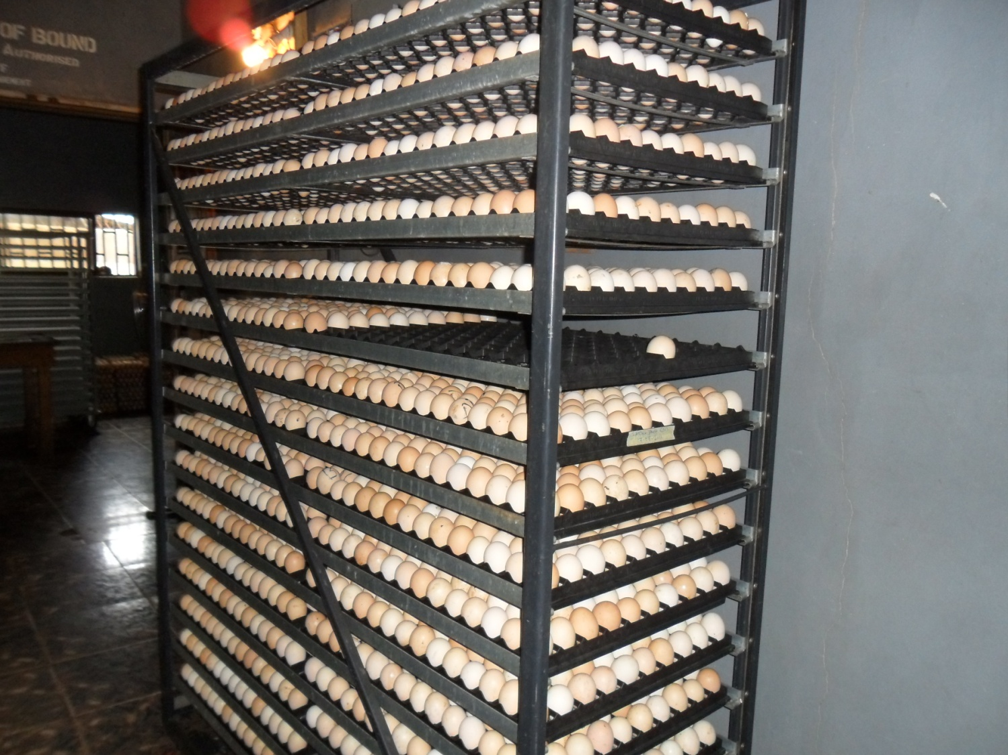
Figure 2.2 Eggs in an Incubator Trolley

2.1.1.4 Fumigation
Fumigation is the process through which pathogenic organisms on the eggs could be destroyed. The method of fumigation process that was used at ADEBOMI FARM LTD was formalin solution and Potassium permanganate (KMnO₄).

Procedure for Fumigation at ADEBOMI FARM Ltd
- Hatchable eggs were clean with dry spongy (not iron spongy)
- Fumigation was done in the box after each collection
- 10g of potassium permanganate (KMnO₄) in 20ml of formalin solution for box of 4x8x4 feet cabinet for half an hour.
(This was not done in my presence but was given to me by the Hatchery manager Mr. Tunde ).

2.1.1.5 Incubation
This is the artificial management practices of a fertile eggs to ensure that day old chicks are produced, these involves good temperature, better humidity, normal ventilation, good turning of eggs and quality of the hatching eggs. The machine used for these is called INCUBATOR.
There were two (2) types of INCUBATOR at ADEBOMI FARM LTD; these are Belgium type (Peterson) and USA type (Chick master).

Incubator Description

BELGIUM TYPE (PETERSON)
- The incubator is from Belgium
- It is a large Size incubator of 57,600 chicken egg setting capacity. It has a setter of 12 trolleys, 32 trays and 150 eggs in a tray.
- The egg chamber is a section type
- It is force draught with automatic egg turning device and hot air heat transfer
U.S.A TYPE (CHICKS MASTER)
- The incubator is from U.S.A
- It is mammon incubator of 101,400 chicken egg setting capacity. It has 2 setters of 50,700 eggs per each and 307 trays of 165 eggs in a tray.
- The egg chamber is a section type
- It is force draught with automatic egg turning device and hot air heat transfer

2.1.1.6 Candling and Transfer
This is the process by which a clear cut distinction is made between fertile and unfertile eggs i.e. it helps to determine the fertility of the incubated hatchable eggs. Candling was done at 18th day of incubation at ADEBOMI FARM LTD.

Processes of Candling
Eggs were subjected to direct beams of light. The fertile eggs will be opaque but the unfertile eggs will give colour like yellow e.t.c.

Egg transfer
The fertile eggs after candling were transferred into the hatcher at 18th day for the completion of the incubation for 72 hours (3 days).

2.1.1.7 Chicks Handling, Sorting and Boxing
Handling: After hatching, Chicks were handled with care to prevent injury and death of the chicks because improper handling will cause stress on the chicks.
Sorting: Chicks were removed from the midst of broken egg shells within the hatching trays, after which they were sorted to remove the undesirable ones and to grade the good ones. The undesirable ones were usually the runts, deformed chicks, very weak chicks, chicks with unhealed navel and dead chicks.
Boxing: After sorting, chicks were parked carefully into chick boxes. The chick boxes used at ADEBOMI FARM LTD, were paper type which is partitioned into two compartments, each compartment usually accommodates 25 chicks, all together making 50 chicks in a box.

2.1.1.8 Chicks Vaccination
After boxing, vaccinations of chicks were done and this was carried out by the veterinary doctors. The chicks were usually been vaccinated against Mareks and Newcastle diseases at day old. Mareks diseases vaccines were usually administered subcutaneously with the use of automatic syringe. The Newcastle disease vaccine (NDV La Sota) was usually administered intra-ocularly or intra-nasally with droppers.

2.1.1.9 Cleaning and Disinfection after Hatching
The hatcher, hatching trays and egg trolleys were usually been washed properly with detergent and disinfectant after each hatch. The equipment were allowed to dry and they were been fumigated.
    - Routine Management Practices in Hatchery
- Sweeping of the floor of hatchery, making sure the environment is kept clean.
- Putting of disinfectant in the tyre dip and foot dip.
- Collection of eggs from breeders’ farm
- Storage and fumigation of eggs
- Setting and traying of eggs
- Checking and regulation of the readings on the incubator control panel, readings like; temperature, humidity and egg turning counter.
- Checking of the effectiveness of the incubator gadgets, which are, heating system, cooling system, incubator fan, humidity bowl, ventilator, red light and alarm.
- Check and remove blown up, cracked or fallen eggs on the floor of the incubator.
- Candling and transfer of eggs at 18th day of incubation
- Washing and disinfecting of incubator equipment like; egg trays, egg trolleys, hatching trays after each hatch.
- Fumigate the hatcher and hatching room after each hatch.
- Packing, boxing and Vaccination of chicks.
- Servicing of incubator.

2.2.1.1 Brooding Unit
This unit comprised of house and equipment for brooding, the chicks were raised from day old to 8 weeks of age (growing stage). In the brooding house, heat and other necessary care are given to the chicks coming from the hatchery. The floor of the brooder house was well concreted to allow easy cleaning and disinfecting. At the entrance was a foot dip for disinfecting soles of shoes to prevent disease transmission.

Preparation for brooding of chicks
These were various preparation made for brooding of chicks at ADEBOMI FARM LTD.
- Washing, cleaning and disinfecting of brooder house a week before the arrival of chicks
- Demarcation of the brooder house with wooden planks (brooder guard) for the needed chicks
- Fixing of nylon to the brooder house to prevent wind from entering the pen
- Checking and testing of all the brooding facilities
- Cleaning and disinfecting of tray feeders, drinker, coal pot and all the brooding equipment
- Setting up of brooding facilities. (spreading of shavings (litters), heating the coal pots e.t.c)

At the arrival of chicks
At the arrival of chicks at ADEBOMI FARM LTD, the following practices were carried out.
- Chicks were carefully and properly counted out of the chick boxes into the brooder house.
- Disabled and dead chicks were removed from the chicks.
- Chicks’ boxes were removed and disposed off properly by burning.
- Vitamins, glucose and antibiotics were given to reduce stress on the chicks
- Feed and water were already in the feeders and drinkers before the arrival of chicks

Daily routine practices
- Checking and observation of the behaviours of chicks
- Washing of feeders and drinkers
- Provision of fresh and adequate feed (chicks mash) and clean water with necessary medication
- Checking and regulating of brooding temperature to see that the temperature is not too hot none too cold for the chicks.
- Removal of dead chicks and isolation of sick chicks
- Daily record keeping of feed intake, mortality, medication and vaccination

Occasional routine practices
- Removal of the wooden planks used as brooder guard
- Changing of feeders and drinkers to bigger one.
- Changing of litters with new one
- Reduction and removal of coal pot as their age increases
- Lifting and removal of nylon used to cover the brooding house
- Provision of necessary medication and vaccination
- Collection of fresh feed (chicks mash) from the feed mill section
- proper cleaning of the surrounding of brooding house

2.2.1.2 Rearing/Growing Unit
This is a separate house always prepared ready for rearing, the brooded chicks were transferred to this house after 8 weeks of age and they were reared from 8-16 weeks of age before they were transferred to laying pen. The male growers are called cockerel and the female growers are called pullet. They were fed with growers mash and the necessary care, medication and vaccination were given to them.

Management practices
- Washing of feeders and drinkers, Provision of fresh feed (growers mash) and clean water
- Removal of dead birds and isolation of sick one
- Provision of necessary medication and vaccination
- Turning and changing of litters
- Daily record keeping of feed intake, mortality, medication and vaccination
- Debeaking of birds at 9 weeks of age and deworming at once in 3 months

2.2.1.3 Laying Unit
The points of lay chickens from growers section were transferred after 16 weeks of age to the house where battery cages were prepared ready to house the layers. The types of battery cage system are; automatic feeder and drinker 3 steps battery cage housing and manual feeder and drinker 3 steps battery cage housing. Birds here were fed with pre-lay mash from 16 weeks of age until they started laying eggs before their feed was changed to layer mash. The type of breeds reared were Hacco black and Isa brown and the total number of layers during my stay at the unit were about 6,000.

Management practices
- Cleaning of feeder, washing of drinker and Provision of fresh feed and clean water
- Removal of dead birds and isolation of the sick birds from the cages
- Cleaning of the passages and the surrounding
- Collection of eggs three time daily (9:30 am, 12:30 pm and 5:30 pm)
- Daily record keeping of feed intake, egg collected, mortality, medication and vaccination

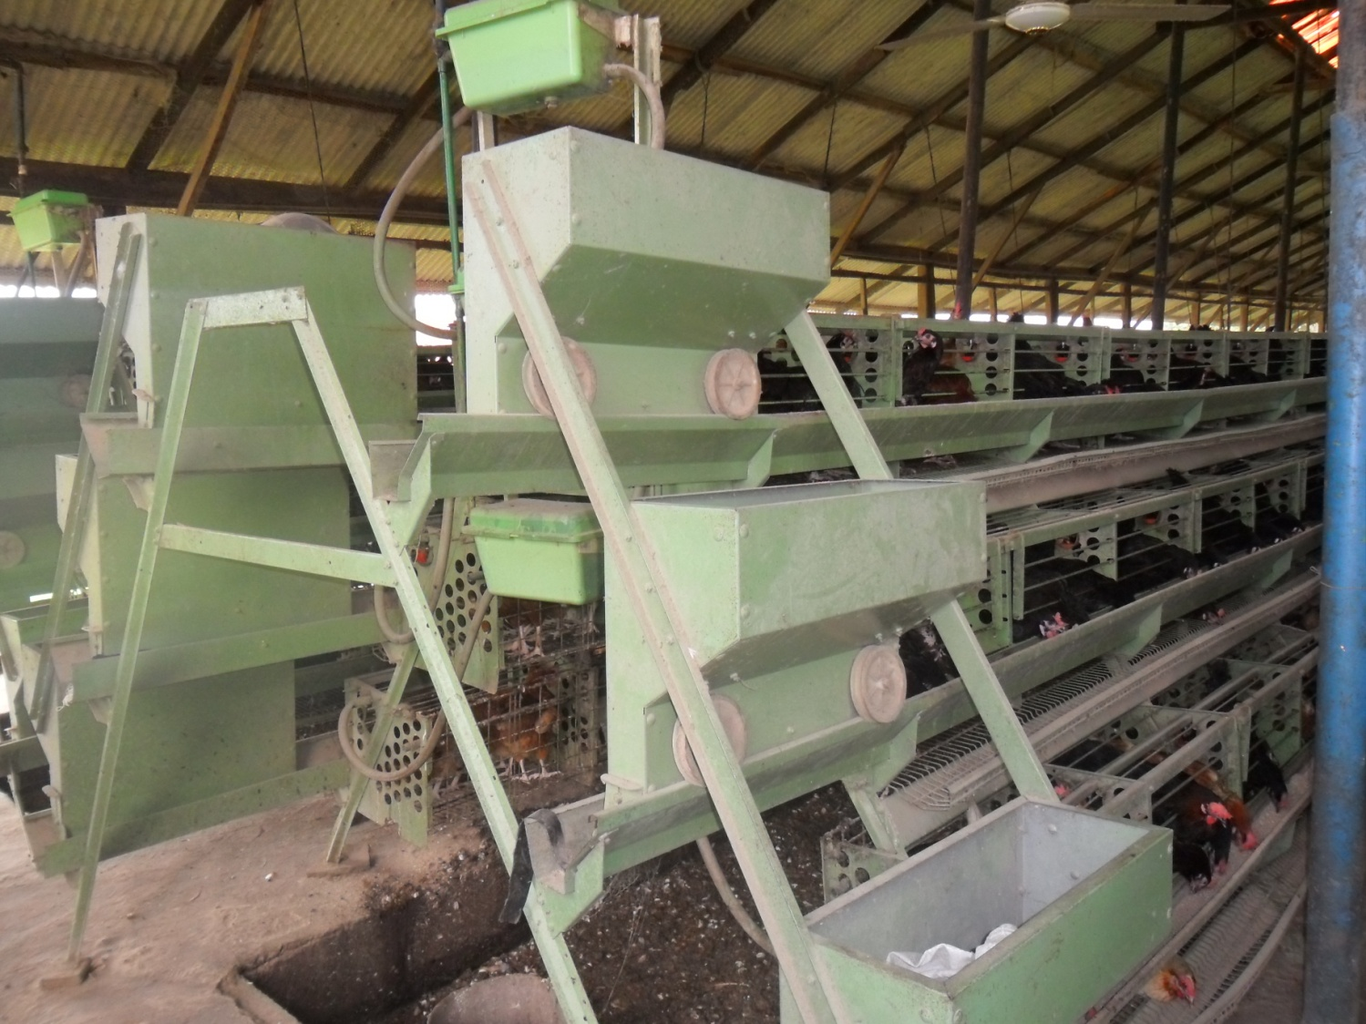
Figure 2.3 Laying Unit (3 Step battery cage with automatic feeder and drinker)

2.2.1.4 Health Management Practices
The health management practices at ADEBOMI FARM LTD were medication and vaccination.
Medication is the administration of drugs to sick Chickens.
Vaccination is to inoculate animals or birds with vaccine to produce immunity to a disease.

TABLE 2.1 Vaccines and drugs administered from day old to point of lay for commercial layers at ADEBOMI FARM LTD

Age (days) Vaccines/drugs Route
1 Mareks vaccine + NDV La Sota Subcutaneous and ocular/nasal
2 Gumboro Intraocular
2-4 Vitamins, Glucose + Antibiotics Oral
5 Immucox Oral
14 IBDV (Gumboro) Oral
24 NDV La Sota Oral
6 weeks NDV Komarov Intramuscular
8 weeks Fowl pox Wing web jab
9 weeks Dewormer Oral
12-13 weeks IBV Oral
16 weeks NDV Komarov + EDS Subcutaneous
Keys:
NDV = Newcastle disease vaccine
IBDV = Infectious Bursal disease vaccine
EDS = Egg drop syndrome

2.2.1.5 Breeders unit
At ADEBOMI FARM LTD, all the breeders (parent stock) were reared in cages and not in deep litter as common to many farms where they can have free mating, the breeders cock were reared in a separate cage and the breeders layer also in a separate cage in different pen. This was what led to artificial insemination.
Artificial Insemination: This is the process whereby semen (sperm) is been collected from breeder cock and deposited inside the genital opening of the female breeder by the means of instruments. This was practiced on poultry breeder that has reached 16-20 weeks of age but better result was achieved when the first egg is noticed before the insemination started.

Instruments of Artificial Insemination
- A Syringe of 1ml capacity
- A Glass rod of 6cm long
- Semen collecting tube
- Rubber tube, cotton wool and scissors

Processes of Artificial Insemination
The syringe was connected with the glass rod by the help of a rubber tube and the cotton wool was used to cover the base of the semen collecting tube to keep the semen cool till after insemination. The semen collected was used between 30-45 minutes of collection.

Cautions in Artificial Insemination at ADEBOMI FARM LTD
- A.I was done between the hours of 3-5 pm.
- It was done in the morning to avoid wasting of semen because hen will lay between 8-11 am and the semen inserted might come out with the egg.
- Collected semen was used between 30-45 minutes of collection.
- A.I was repeated every 72 hours.
- Feed were removed from the cock 2 hours before A.I to avoid coming out of faeces during the process of collecting semen.
- All A.I materials/instruments were sterilized before and after use.

Advantages of Artificial Insemination
- It increase mating ratio in the flock, usually for deep litter it is one cock per 6-10 hens, but with A.I, ratio was increased four fold. It depends on the strain and breeds of birds.
- It helps to use an injured cock: valuable male birds that have been injured in the leg were used for A.I.
- It helps in elimination of preferential mating
- It helps to be sure that the hen is mated and also for successful cross breeding.

TABLE 2.2 Vaccines and drugs administered from day old to point of lay for breeder layers at ADEBOMI FARM LTD

Age (days) Vaccines/drugs Route
1 Mareks vaccine + NDV La Sota Subcutaneously and occularly
2 IBDV (Gumboro) Intraocular
2-4 Vitamins, Glucose + Antibiotics Oral
5 Levacox Oral
7 NDV La Sota Oral
17 Gumboro Oral
21 NDV La Sota Oral
27 Gumboro Oral
28 IBV (H 120) Oral
49 ND + IB live vaccine Oral
52 ND oil emulsion Subcutaneous
60 I.A.E Oral
7 weeks Fowl pox Wing web jab
9 weeks Dewormer Oral
12-13 weeks IBV Oral
14 weeks Infectious Coryza vaccine Subcutaneous
16 weeks NDV Komarov + EDS Subcutaneous
Keys:
NDV = Newcastle disease vaccine
IBDV = Infectious Bursal disease vaccine
EDS = Egg drop syndrome
A.E = Infectious Avian Encephalomyelitis

2.3 FEEDMILL DEPARTMENT
This section was responsible for feeds formulation and production for chickens. During my stay in feedmill, feed were been formulated for poultry chickens (chick mash, growers mash, broilers mash (starter and finisher), layer mash). The feed ingredients used were; maize, groundnut cake (G.N.C), wheat bran, wheat offal, soya meal, bone meal, biscuit dust, toxynil, lysine, methionine, salt, vitamins premix, mineral premix e.t.c.
There are different units in feedmill section at ADEBOMI FARM LTD
Storing unit: where all the feed ingredients were stored, here, we have several stores which are;
- Macro ingredient store
- Micro ingredient store
Milling, mixing and bagging unit: this was where all the ingredients were milled, mixed and bagged into 50 kg or 25 kg.

During my stay at the feedmill, Feed formulations were always based on the following:
- Nutrient level of each ingredient
- Nutrient requirement of the chickens
- Total quality of feed ingredients
- Essential feed ingredients sources. e.g. energy sources, protein sources, vitamin sources or mineral sources.

2.3.1 Equipment in the feed mill department
Crusher/hammer mill: used for crushing different feed ingredients like maize, GNC, bone meal, e.t.c
Mixer (contain auger for mixing): this was used for mixing the feed ingredients together.
Weighing balance (scale): this was used to weigh the feed ingredients.
Digital scale: this was used to weigh the lighter feed ingredients like lysine, methionene, premix e..t.c.
Sewing and sealing machine: this was used to seal the bags of feed ingredients after mixing and weighing them into the required quantity 50 kg or 20 kg.
Needles and thread: used to sow the bags of feed manually. Other equipments are Scaling pans, knives e.t.c.

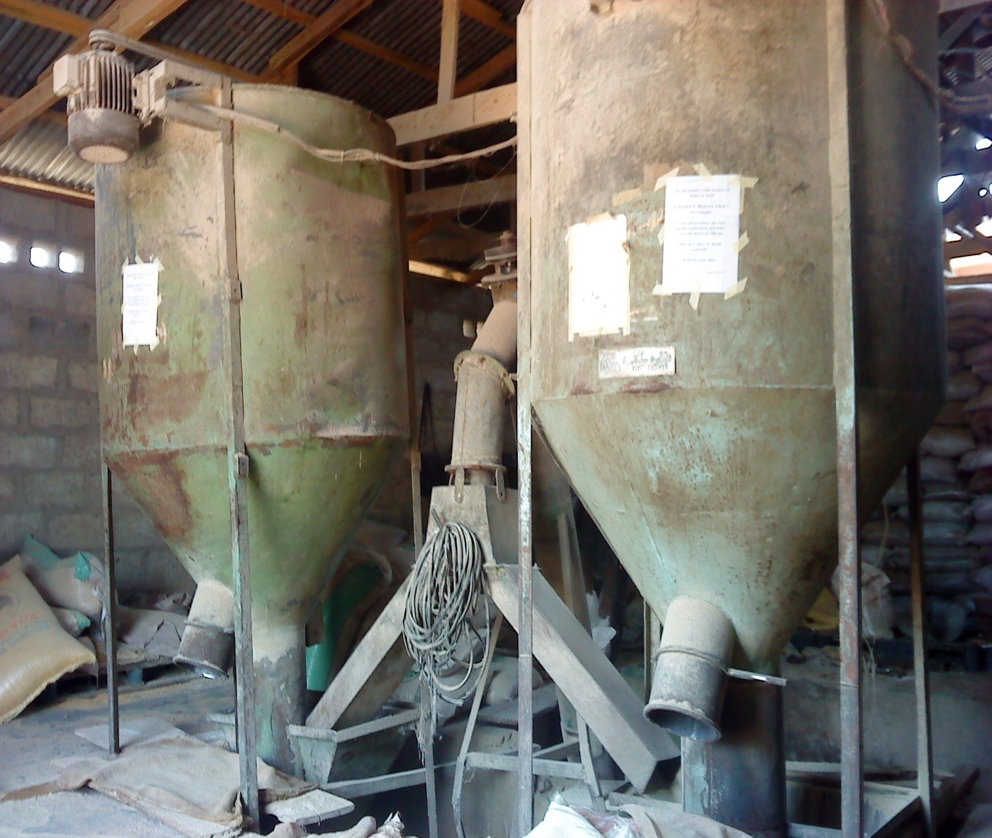

Figure 2.4: A Pair of Mixer with Feed Conveyor from the underground Crusher

2.3.2 Management practices at feedmill
- Sweeping of the floor
- Inspection of the machines and equipment
- Checking of feed ingredients to see those that are spoiled and those that are not available.
- Weighing and scaling of feed ingredients
- Crushing, milling and mixing of feed ingredients
- Offloading, weighing, Bagging and sowing of mixed feed in 50 kg or 25kg
- Changing of worn out parts in the crusher and mixer
- Repairing of machines and equipment

CHAPTER THREE
- CONCLUSION AND RECOMMENDATIONS

3.1 CONCLUSION
The industrial training has really been a channel of exposition of the challenges ahead to me as an animal producer and has broadened my knowledge and widened my practical scope. The programme was such a challenging, interesting, educative and informative one to me. It is therefore a laudable scheme.
The period of my Industrial Training at the ADEBOMI FARM LIMITED, at opp Hidden Mama Ministry Headquarters, along Aiyegbami Area, Ijetu, Oshogbo, Osun State, Nigeria was a success because it affords me the opportunity to acquire more practical and technical experiences on Agricultural practices like: hatchery management, vaccination and drug administration, feedmill. Above all, the experiences gathered has been tremendous
3.2 RECOMMENDATIONS
Recommendations to Adebomi Farm Limited
- The welfare of the workers in terms transport and incentives to them should be improved to enhance maximum productivity.
- The road from the farm to the main road is bad, the management should repair the road for better transportation.
- There should be clear distinction and specialization of duties among staffs.

Recommendations to the Industrial Training Unit
- The Industrial Training unit of Kwara State Polytechnic should intensify effort in visiting students at their respective training sites as this will give them encouragement and regard from their site’s supervisors and also help students solve their problems of getting along.
- The programme should be continued.
Recommendations to the Polytechnic/students
- Students should try and put in their best to acquire the knowledge needed while in school and during the training. It could be much more costly to get the knowledge after leaving school.
- Also they should embrace the scheme and see it as capacity building scheme.

