
A TECHNICAL REPORT
ON
STUDENTS’ INDUSTRIAL WORKING EXPERIENCE SCHEME (SIWES)
CONDUCTED AT:
AFOFASHA GLOBAL NIGERIA LIMITED
7, BENIN CITY ROAD, ADEWOLE ESTATE, ILORIN, KWARA STATE

COMPILED BY:
ADEYEMI ADEJUWON NURUDEEN
ND/23/BLD/PT/0013

SUBMITTED TO:
DEPARTMENT OF BUILDING TECHNOLOGY,
INSTITUTE OF ENVIRONMENTAL SCIENCE (I.E.S),
KWARA STATE POLYTECHNIC, ILORIN.

IN PARTIAL FULFILLMENT OF THE REQUIREMENT FOR THE AWARD OF NATIONAL DIPLOMA IN BUILDING TECHNOLGY.
AUGUST – DECEMBER 2024

DEDICATION
This Students’ Industrial Work Experience Scheme (SIWES) report is dedicated to Almighty God, the beneficent and the most merciful, the source of all knowledge, wisdom and understanding for His guidance and protection on me.
Finally, this report is also dedicated to my family; MR. & MRS ADEYEMI, my brothers and everyone whom by any chance support me throughout my SIWES program for their unfailing love and support.

ACKNOWLEDGEMENT
I thank the lord Almighty for His divine protection and provision throughout my training programme.
My profound gratitude goes to my Parents, siblings, friends and family. I also extend the appreciation to AFOFASHA GLOBAL NIGERIA LIMITED staff for their guidance, mentorship and support to ensure that the programme is a success.

REPORT OVERVIEW
This report is basically an account of the knowledge and experience gained during the Students' Industrial Work Experience Scheme (S.I.W.E.S) program, held at AFOFASHA GLOBAL NIGERIA LIMITED at 7, Benin City Road, Adewole Estate, Ilorin, Kwara State which lasted for a period of 4 months. Students' Industrial Work Experience Scheme (S.I.W.E.S) is a program designed for students in the higher institutions of learning to acquire practical experience in their various fields of study. During the four months industrial attachment, I was privileged to work in the above organization. In the course of this report, it shall focus on the basic activities carried out which are of relevance to my field.

TABLE OF CONTENTS
TITLE PAGE
DEDICATION
ACKNOWLEDGEMENT
REPORT OVERVIEW
CHAPTER ONE
1.1 Introduction
1.2 General Background of SIWES
1.3 Objectives of SIWES
CHAPTER TWO
2.1 Location and brief history of the establishment
2.2 Various departments/Unit and their Functions
2.3 Organizational structure of the establishment
CHAPTER THREE
Activities carried out during the training
CHAPTER FOUR
Continuation of activities carried out during the Industrial Attachment
CHAPTER FIVE
5.1 Summary
5.2 Challenges Faced
5.3 Recommendations for improvement
5.4 Conclusion

1.0 CHAPTER ONE
1.1 SIWES INTRODUCTION
The Students’ Industrial Work Experience Scheme (SIWES) is an accepted skill training program which forms part of the approved minimum academic standard in various programs for all Institutions in Nigeria.It is an effort to bridge the gap in between theory and practical of Engineering and Technology, Science, Agriculture, Management and other professional educational program in the Nigeria Institutions.
1.2 GENERAL BACKGROUND OF SIWES
SIWES was established by Industrial Training Fund (I.T.F) in 1973 to solve the problem of lack of adequate practical skills. SIWES is funded by Federal Government of Nigeria and operated by I.T.F, the coordinating Agencies; Nigeria Universities Commission (N.U.C), National Council for Colleges of Education (N.C.C.E), National Board for Technical Education (N.B.T.E).
The beneficiaries of SIWES include; Undergraduate students of Agric Technology, Engineering, Environmental Sciences, Education, Medical Sciences, Pure and Applied Science.
1.3 OBJECTIVES OF SIWES
- Provide an avenue for students in institutions of higher learning to acquire industrial skills and experience in their course of study.
- Prepare students for the industrial work situation they are to meet after graduation.
- Expose students to work methods and techniques in handling equipment and machinery that may not be available in their institutions.
CHAPTER TWO
2.1 BACKGROUND OF THE ORGANIZATION
AFOFASHA GLOBAL NIGERIA LIMITED is a building construction and other related business services company. The organization specialize mainly on Aluminum roofs, sales and fitting, general building contracts, general merchandise, project supervision and other building services.
The building construction company is located at 7, Benin City Road, Adewole Estate, Ilorin, Kwara State.
AFOFASHA GLOBAL NIGERIA LIMITED continues to chase her vision by continual training and empowering Youth and Kids with building & construction skills, maintenance solutions, and becoming the best Building professional dreams employer.
2.2 VISION AND MISSION OF THE ORGANIZATION
Vision
- To become one of the leading construction firm
- To continually provide excellent value and innovative construction services to meet the expectation of our clients and beyond.
- To be a first thought construction and building firm in the minds of our esteemed clients through provision of exceptional and professional services while prioritizing the use of modern and sophisticated technologies.

Mission
- To provide the highest level of service in the construction industry while offering superior craftsmanship to every contract we handle.
- To innovate, develop, renovate and adopt state-of-the-art technology in methods and materials to enhance productivity.
- To raise a safety culture targeted at continually reducing the frequency severity rate towards achieving zero accident.
- To mitigate all the environmental impacts arising from our industrial activities and comply with the applicable environmental norms.

2.3 ORGANISATIONAL STRUCTURE
CHAIRMAN/ CEO
MANAGER

UNIT SUPERVISOR

GENERAL STAFF OFFICERS

CHAPTER THREE
3.0 ACTIVITIES CARRIED OUT
3.1 BUILDING MATERIALS
The Students’ Industrial Work Experience Scheme (SIWES) really provided adequate practical knowledge of Classroom teachings and exposed me greatly to the world outside the Polytechnic.
It was an enjoyable experience at the place of Industrial attachment to have been acquainted with various building materials.
Building material is any material used for construction purpose such as materials for house building. Wood, cement, aggregates, bricks, concrete, clay are the most common type of building material used in construction. The choices of these are based on their cost effectiveness for building projects.

CONCRETE
Concrete is a composite building material made from the combination of aggregate (composite) and a binder such as cement. The most common form of concrete is Portland cement concrete, which consists of mineral aggregate (generally gravel and sand), portland cement and water. Concrete is a composite material made from a mixture of water, aggregates (granite, sand, or gravel), and cement.
At various site constructions I was opportune to visit, we use concretes extensively in the construction of buildings, bridges and other various structures.
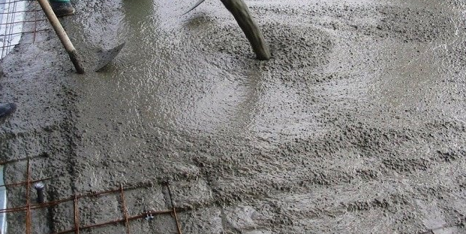
A TYPICAL IMAGE OF CONCRETE

BRICK AND BLOCK
A brick is a block made of kiln-fired material, usually clay or shale, but also may be of lower quality mud, etc. Clay bricks are formed in a moulding (the soft mud method), or in commercial manufacture more frequently by extruding clay through a die and then wire-cutting them to the proper size (the stiff mud process).
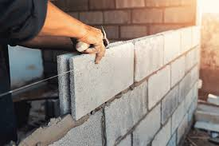
BRICK/ BLOCK

SAND
Artificial sand, Coarse sand, and River sand are some of the diverse forms of sand we use as building materials in Nigeria. Here are various uses of sand in the construction industry:
- As a binding substance in concrete
- We use it for plastering
- Also used as an abrasive to clean structural elements in the process of sandblasting

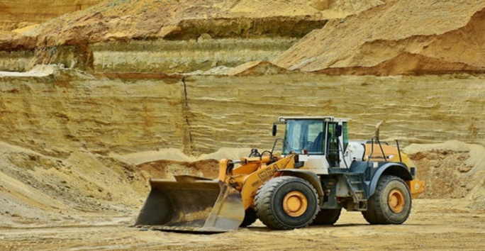

CEMENT
Cement is a fine, powdery-kind substance that adheres to other building materials to hold them together. On our construction sites, cement is mixed with water, and used to hold sand and gravel into a solid substance referred to as concrete.
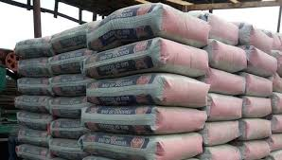 CEMENT
3.2 BLOCK AND BLOCK PRODUCTION
The Industrial training also created an avenue to get familiar to how block is being produced which is an essential material for construction.
A concrete block is primarily used as a building material in the construction of walls. It is sometimes called a Concrete Masonry Unit (CMU). A concrete block is one of several precast concrete products used in construction. Most concrete blocks have one or more hollow cavities, and their sides may be cast smooth or with a design. In use, concrete blocks are stacked one at a time and held together with fresh concrete mortar to form the desired length and height of the wall.
STRUCTURE OF A BLOCK
- Block Height – It's the sequence number of the block in the chain of blocks.
- Block Size – It's a 4-bytes or 32-bit field that contains the size of the block.
- Block Reward – This field contains the amount rewarded to the miner for adding a block of transactions.
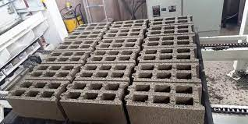
PRODUCTION
For the production of concrete blocks, cement, sand, stone dust, and crumb are used, with a diameter of 3 to 5 mm. These are the most common materials for the production of all types of concrete blocks and bricks. By mixing individual ingredients in different proportions, we can obtain different types of blocks and bricks, including hollow blocks.
Equipment for the production of building blocks or concrete blocks has a high level of automation, the machine is controlled from a single centralized control center PLC. The line works very reliably and stably, has a compact structure, convenient maintenance, high productivity, and low power consumption.

THE GENERAL PROCESS OF PRODUCING CONCRETE BLOCKS IS AS FOLLOWS:
- The mixer is loaded with cement, sand, stone crumb with a special loader
- This mixture falls on a conveyor belt
- And then directly to the machine for the production of blocks. It forms and moves blocks
- After that, the ready-made wet products go to the elevator
- And finished products are transported to the warehouse
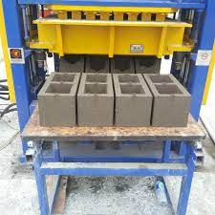

CHAPTER FOUR
4.0 FURTHER ACTIVITIES DONE
- WALL CONSTRUCTION
This is also important activities I actively participated in during the period of SIWES at AFOFASHA GLOBAL NIGERIA and it was really an interesting experience.
Wall construction can be done with a variety of materials including wood, concrete, brick, stone and metal. The type of wall construction depends on factor such as the intended use of the wall, the building codes and the budget.
Wall construction is the critical part of building design, as it provides support and stability for the structure, while also providing an aesthetic finish.
TYPES OF WALL
There are several types of wall used in construction. Here are a few common types;
- BEARING WALLS: These are walls that support the weight of the structure such as load-bearing walls.
- CURTAIN WALLS: These walls are non-structural and are typically used in modern buildings as a façade.
- FIRE WALLS: These walls are designed to resist fire and contain it within the building.
- RETAINING WALLS: These walls are used to retain soil and support slopes.
- PARTITION WALLS: These walls are non-load bearing and are used to separate spaces within a structure.
TYPES OF PARTITION WALL
- STUD WALLS
These are the most common type of partition walls made from vertical wooden studs covered with dry wall.
- MANSORY WALLS
These are walls made from bricks, concrete blocks or stone.
- METAL STUD WALLS
These are walls similar to stud, but use metal stud instead of wood.
- GLASS PARTITION WALLS
These walls are made from glass panels that provide a visual separation spaces while still allowing light to pass through.
- ROOF

The roof forms the topmost component of a building structure. It covers the top face of the building. Roofs can be either flat or sloped based on the location and weather conditions of the area.
- BUILDING ROOF TYPES
Building roof types is another interesting thing that was thoroughly mentioned during the period of the training and this was extended to visitation of various sites to see practically.
The slope of roof has both a practical and aesthetic function. Water from rain or snow, for example, tends to shed, or run off, quicker on a steep slope roof. The roof’s slope is expressed in a ratio based on the roof’s proportions.
Roofing contractors may use the term 6 in 12 or use a contracted version such as 6:12 or 6/12. What this means is that the roof rises 6 inches vertically for every 12 inches (or 1 foot) horizontally. This can easily be translated for any number. A roof with a 4 in 12 slope will rise four inches vertically and 12 inches horizontally.
GABLE ROOF
The gable is an extremely popular roof style, and it works well on a variety of home designs. You can fancy it up with front gables over your entryways or go with a crossed gable design that consists of two ridges set at right angles.
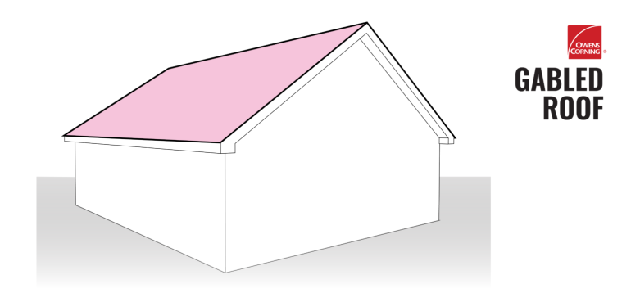
A TYPICAL ILLUSTRATION OF GABLED ROOF

DUTCH GABLE ROOF
The Dutch gable roof is another combination style roof that uses design elements of both gable and hip roofs. A miniature gable roof, or “gablet”, is perched atop a traditional hip roof. The gable portion provides homeowners with increased attic space and can even be fitted with windows for added sunlight.
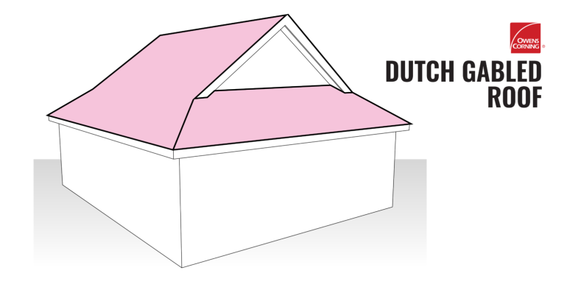

HIP ROOF
A traditional hip roof consists of four equal-length slopes that meet to form a simple ridge. There are variations, though, such as a half-hip that features two shorter sides with eaves. If you have a hip roof, then you may have already realized that most of the roof is visible when looking at your house. The type and color of roofing shingles you get installed on a hip roof will make up a big piece of your home’s overall exterior look because it is so highly visible.
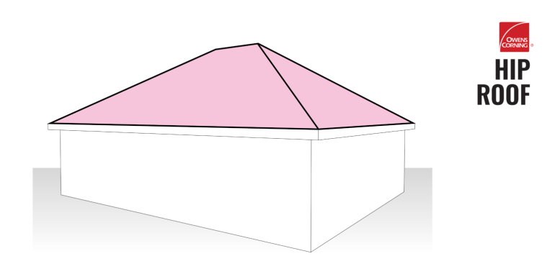
- CEILING
Ceiling: a structure made of insulator like asbestos, wood, found before the roof of a building, its function is to regulate the warmth within a building and also to control sound, they are generally two major classification of ceiling
- The suspended ceiling
- The non – suspended ceiling

- FINISHES
Finishes are requirement in building for its beautification, these include plastering, rendering, tiling, painting, wiring and decorating the building with furniture’s and electronic gadget.
* General decoration, i.e. paint and wallpaper condition damaged, faded
* Woodwork/joinery condition, defects, damage, paintwork
* Plaster ceiling (plasterboard or lath and plaster?)Condition and stability
* Plaster walls render and plaster or plasterboard, damage and quality of finish
* Staining plumbing leaks (ceiling), moisture penetration (wall openings), and rising damp
* Fittings and ironmongery adequacy and function, weather exclusion and security.

- Plastering
Plastering is the internal application of coats of plaster to the wall of a building. The process involves the application of three coats of plaster.

- Rendering this is the external application of coats of plaster to the wall of a building.

5.0 CHAPTER FIVE
5.1 SUMMARY
The report stated the objective of SIWES which is to provide an avenue for students in institution of higher learning to acquire industrial skills and experience in their approved course of study and also prepare students for the industrial works situation which they are likely to meet after graduation.
The report also stated the description of the establishment of attachment and the work carried out during the attachment period.
More so, it also stated the problems encountered during the programme and also gave suggestion for improvement of the scheme.

5.2 CHALLENGES FACED
1. Cost of Transportation: The cost of movement To and Fro everyday was a big challenged that I faced in the course of undergoing my SIWES training.
2. Time Constraint: Meeting work deadlines and completing tasks within a stipulated timeframe posed a significant challenge. The fast-paced nature of industrial settings often demands quick turnarounds, leaving limited time for in-depth analysis and thorough exploration.
3. Task Ambiguity: Some projects lacked clear guidelines or had ambiguous objectives. This ambiguity made it challenging to devise a structured approach and necessitated creative problem-solving skills.

5.3 RECOMMENDATION
As a result of difficulties experience during the Four months SIWES program, I will like to recommend the following changes;
- The Industrial Training Fund should make monthly allowance available for students, so as to put end to financial difficulties that may arise as a result of transportation problems.
- The Institution must confirm that each student partake in the Industrial Training program, by making sure that they pay every student a visit before the end of the program.
- The Institution and Industrial Training Fund should help the student to get the place of attachment, so that the program will commence as planned.
- Students on SIWES program should be posted or deployed to the Organizations, Department or Firms that are relevant to their Course of study, so that the sole aim of SIWES can be achieved.

5.4 CONCLUSION
This program has brought improvement to my field of study. The experience gained through this program is majorly based on building construction; this program has inspired me to have technical knowledge and practical aspect of what I have learnt in school.
I hereby forward my appreciation to the rector and director of the institute, HOD of my department, lecturers in my department including my colleague in training, friends and every member of my family for their support both moral and financial. I pray that God bless you and reward every of endeavor abundantly.

