A REPORT ON
STUDENTS INDUSTRIAL WORK EXPERIENCE SCHEME
(SIWES)

UNDERTAKEN AT
XTREMECHANICS ACADEMY
GANMO, ILORIN
KWARA STATE

FROM
AUGUST, 2024 – NOVEMBER, 2024

BY

JAMES IYIOLA GLORY
ND/23/MCT/FT/0002

SUBMITTED TO
THE DEPARTMENT OF MECHATRONICS ENGINEERING,
INSTITUTE OF TECHNOLOGY, KWARA STATE POLYTECHNIC, ILORIN.
IN PARTIAL FULFILMENT OF THE REQUIREMENT FOR THE
AWARD OF NATIONAL DIPLOMA (ND) IN MASS COMMUNICATION.

AUGUST, 2022

TABLE OF CONTENT

CHAPTER ONE: Introduction
1.1 Background to the Study 1
1.2 Objectives of SIWES 2

CHAPTER TWO: Description of Establishment of Attachment
2.1 Location and Brief History of Establishment 3
2.2 Background and Origin
CHAPTER THREE: ACTUAL WORK DONE WITH EXPERIENCE GAINED 4

CHAPTER FOUR: Actual Work Done with Experience Gained (Cont’d) 6

CHAPTER FIVE: Summary and Conclusion
5.1 Summary of Attachment Activities 7
5.2 Problems Encountered 7
5.3 Suggestions for Improvement of the Scheme 7
5.4 Conclusion 8
APPENDICES 9-12

CHAPTER ONE

INTRODUCTION
The Students’ Industrial Work Experience Scheme (SIWES) is a scheme established by the Industrial Training Fund (ITF) in 1973 to help students of tertiary institution in Nigeria acquire technical skills and practical exposure in an industrial environment based on various course of study.
Prior to the Establishment of SIWES, science and technology education in Nigeria was marred with the problem of lack of adequate practical and industrial skills and working experience that will prepare students of tertiary institution in Nigeria for employment opportunities in industries. It was in this view that the scheme was established and students in tertiary institution of Nigeria studying sciences and technology related courses were mandated to participate in the program to enable them have technical knowledge and working experience before graduating from their prospective institution and makes it a smooth transition from the lecture room to the world of work.
1.1 BACKGROUND TO THE STUDY
SIWES was established by industrial training fund to solve the problem of lack of adequate practical skills in preparation for employment in industries by Nigerian graduates of tertiary institutions.
The Students’ Industrial Work Experience Scheme (SIWES) was designed, established and implemented by the Industrial Training Fund (ITF) in 1974 to ensure acquisition of field practical knowledge and skills by students before graduation, mainly coordinated by the National University Commission (NUC). The NUC recognizing the importance of job specifications in the scheme did set the necessary machinery in motion soon after the resolution was taken in 1998. However, from 1989-1993, the drawing up of the minimum academic standards documents (a major statutory of commission) owe resultant accreditation exercise and the movement of the commission secretariat to Abuja did not leave sufficient time to actualize this goal.
It was not until January 1996 at a 3 days national workshop in Jos that specification was drawn for the entire program that had industrial attachment component in the minimum academic standard documents. Participants were drawn from senior academic from universities across the country, SIWES coordinators and officers in all nine panels, each headed by a senior academic officer were constituted for the entire forty-six program. Prior to drawing job specification, however, a one-day meeting was held at which a five-day meeting was presented and the procedure content and format for presentation of the specification documents were decided.
SIWES commenced in 1974 in the aim of making education more relevant to bridge the gap between the theory and the practice of agriculture, engineering, technology and science related discipline in tertiary institutions in Nigeria.
For students in polytechnics and mono-technics and college of education, the duration of SIWES is for 4 months while university undergraduates go for a 6 months duration. Each institution is expected to have a SIWES coordinator who is in charge of all activities that pertains to students industrial training in the institution.
The production of SIWES job specification is without doubt a milestone in the development of academic activities in the national university system. The benefit derivable by the employer, universities and the students alike are immense and will go a long way to move the country forward technologically.
Operators: The ITF, the coordinating agencies (NUC, NCCE, NBTE), the employers of labor and institution.
Funding: The Federal Government of Nigeria
Beneficiaries: Undergraduate students of the following; Agriculture, Engineering, Technology, Environmental, Sciences, Education, Medical sciences and Pure and applied sciences.
1.2 OBJECTIVES OF SIWES
- It provides students the opportunity to test their interest in a particular career before permanent commitments are made.
- It provides an avenue for students in tertiary institutions to acquire industrial skills and work experience in their course of study.
- Makes the transition from school to the world of work easier and enhances students contacts for later job placement.
- It helps students to develop skills and techniques directly applicable to their careers.
- It provides students the opportunity to understand informal organizational interrelationships.
- It helps students develop skills in the application of theory to practical work situations.
- It increases a student’s sense of responsibilities
- It prepares students to enter into full time employment in their area of specialization upon graduation.

CHAPTER TWO

DESCRIPTION OF ESTABLISHMENT OF ATTACHMENT
  - LOCATION AND BRIEF HISTORY OF ESTABLISHMENT
Xtremechanics Academy is an engineering training center focused on automotive and mechanical engineering, product design, and 3D printing. The academy provides hands-on learning opportunities for students and professionals looking to improve their skills in modern engineering tools and techniques. XtreMechanics Academy, established in 2016, is a vocational and technical training institution located in Ganmo, Ilorin, Kwara State, Nigeria. The academy specializes in hands-on training in fields such as automotive technology, 3D printing, composite materials, and telecommunications. A notable achievement of the academy is the development of Nigeria's first locally made race car, unveiled in 2021. This project, led by Engineer Gbola Bolarin, aimed to demonstrate the capabilities of Nigerian engineers and inspire confidence in local manufacturing industries. XtreMechanics Academy offers flexible training schedules, including day, evening, and weekend classes, to accommodate a diverse range of students. The institution is committed to providing quality education and practical experience to equip students for success in various technical fields.

CHAPTER THREE

ACTUAL WORKDONE WITH EXPERIENCE GAINED

This report provides an overview of my four-month Student Industrial Work Experience Scheme (S.I.W.E.S) at XTREMECHANICS ACADEMY. The training involved learning how to use SOLIDWORKS, operating a 3D printer, Construction of an F1 Vehicle, understanding Engine components, and modeling a ginger drink bottle.

Training Activities
During my four-month SIWES, I engaged in the following activities:
3.1 Learning SolidWorks
- Understood the fundamentals of computer-aided design (CAD).
- Created 3D models of mechanical parts and assemblies.
3.2 Operating a 3D Printer
- Learned how to prepare 3D models for Printing.
- Understood different materials and techniques used in 3D Printing
3.3 Construction of an F1 vehicle
- Participated in the design and assembly of an F1 prototype.
- Learned about aerodynamics and materials selection for vehicle construction.
3.4 Understanding Engine Components
- Explored different engine parts and their functions.
- Learned about mechanical and electrical components in modern engines.
3.5 Modelling a Ginger Drink Bottle
- Designed a ginger drink bottle using SolidWorks
- Focused on products aesthetics and manufacturability.
3.6 Vehicle Diagnosis and Troubleshooting
- Use of OBD-II scanners for diagnosing vehicle faults.
- Interpretation of diagnostic trouble codes (DTCs).
- Understanding real-time data and sensor readings.

3.7 Engine Maintenance and Repairs
- Performing routine engine oil changes and servicing.
- Timing belt/chain inspection and replacement.
- Cylinder head removal and gasket replacement.

3.8 Suspension and Brake System
- Inspection and replacement of worn-out suspension parts (shock absorbers, control arms, etc.).
- Brake pad, rotor, and caliper servicing and replacement.
- Bleeding of brake systems.

3.9 Electrical and Electronic Systems
- Battery testing and replacement.
- Starter and alternator diagnosis.
- Wiring system checks and repair.

CHAPTER FOUR

ACTUAL WORKDONE WITH EXPERIENCE GAINED (Cont’d)

4.0 Transmission Systems
- Transmission fluid replacement (ATF).
- Diagnosing issues in automatic gearboxes.
- Basic manual transmission servicing.

4.1 Customer Interaction and Service Management
- Writing job cards and service reports.
- Interfacing with customers to explain faults and repairs.
- Scheduling maintenance visits.

4.2 TOOLS AND EQUIPMENT USED
- OBD-II and advanced diagnostic scanners (e.g., Launch X431, Autel MaxiSys)
- Torque wrenches and socket sets
- Hydraulic lifts and jacks
- Multimeter and test lights
- Compression tester and fuel pressure gauge

CHAPTER FIVE
SUMMARY AND CONCLUSION
SUMMARY OF ATTACHMENT ACTIVITIES
The SIWES training at Xtremechanics Academy has been an enriching and practical experience that complemented my academic learning. It provided me with valuable hands-on skills, deepened my understanding of automobile systems, and prepared me for a future career in automotive engineering. The summary goes thus:
- Gained hands-on experience in CAD modelling and 3D printing
- Learned teamwork and problem-solving in engineering projects.
- Developed a better understanding of automotive engineering and mechanical components.
- Improved my technical skills in product design and manufacturing process.

PROBLEMS ENCOUNTERED
The major challenge I faced during my SIWES training was:
- Unavailability of personal computer (Laptop) for practice. This limited my ability to work on SolidWorks outside training hours, slowing down my learning process.
- Proficiency in reading and interpreting diagnostic codes.
- Confidence in performing routine maintenance and advanced mechanical repairs.
- Teamwork and effective communication in a workshop environment.
- Improved technical report writing and documentation skills.
5.3 SUGGESTIONS FOR IMPROVEMENT OF THE SCHEME
- Visiting of students during the program should be ensured by the ITF
- Students should be paid their allowance on time to ensure motivation
- Selection of placement should not be left to students. Polytechnics should make a means of allocating students to related companies
- Seminars should be organized for establishments to acquaint them with their roles towards students on training
- Government should participate fully in the provision of equipment in the placement centers
5.4 CONCLUSION
The period has contributed immensely to my academic experience. Students Industrial Working Experience Scheme (SIWES) is an important program for all students. It helps in tackling the issue of unemployment amongst youth as it teaches us way to be independent. The exercise made me understood part of what is expected as a journalist in the practice. It helped groom my relationship skills especially in areas where team work are required and communicating with the staffs and students alike. It has exposed me to work ethics and routines.
The problems, if not tackled, will make it lose its usefulness and vitality notwithstanding the benefits of it.
Finally, I do hope the program will be improved so as to enhance manpower development and student’s skill in their respective field of study.

8. APPENDICES
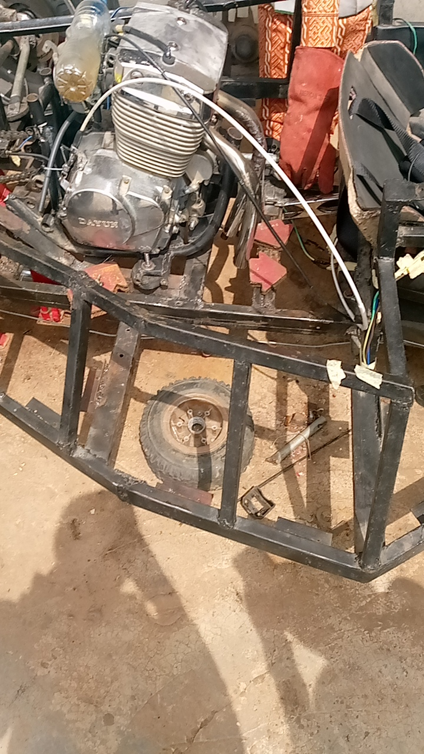
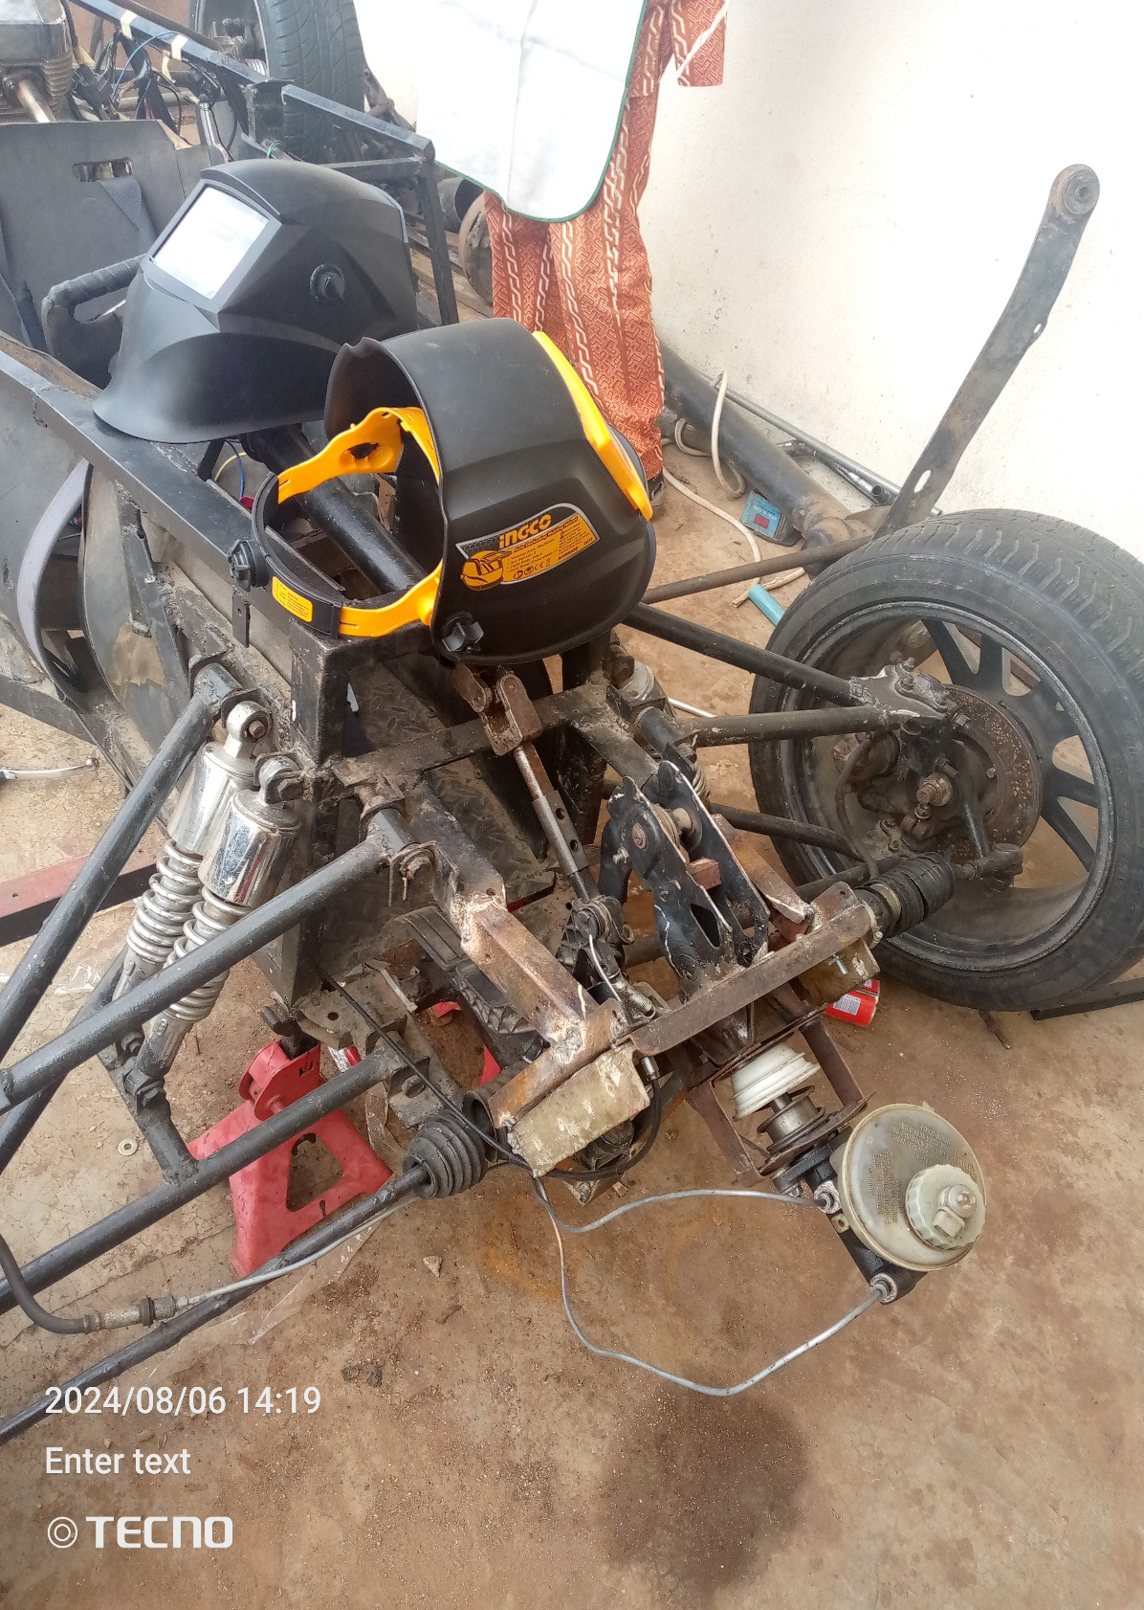

CONSTRUCTION OF AN F1 VEHICLE

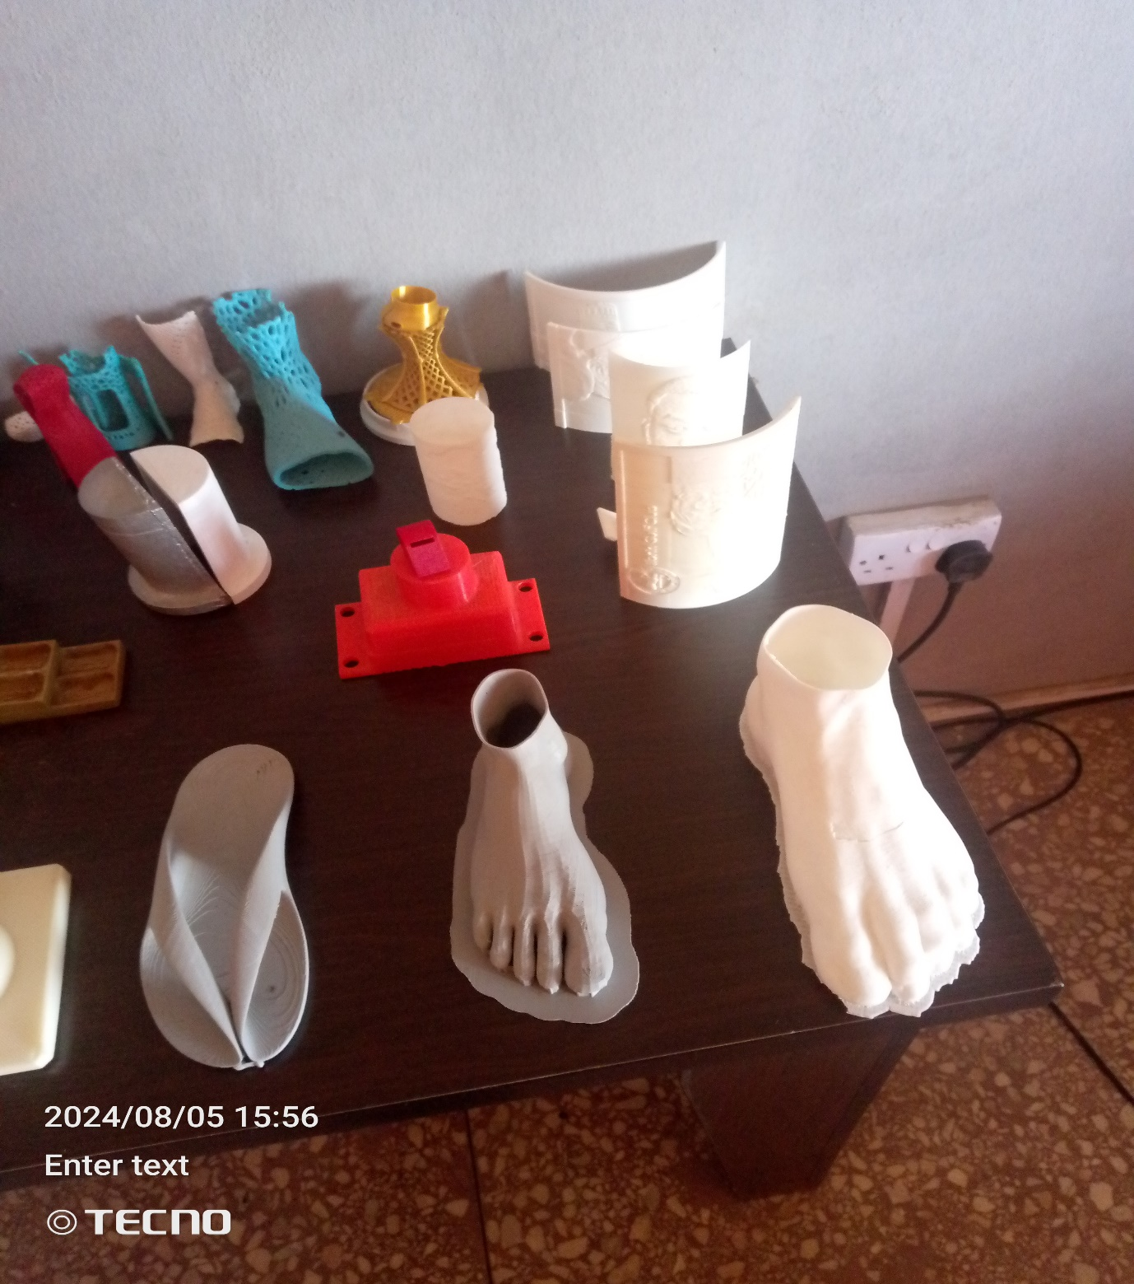

PRODUCTS BUILT BY 3D PRINTER
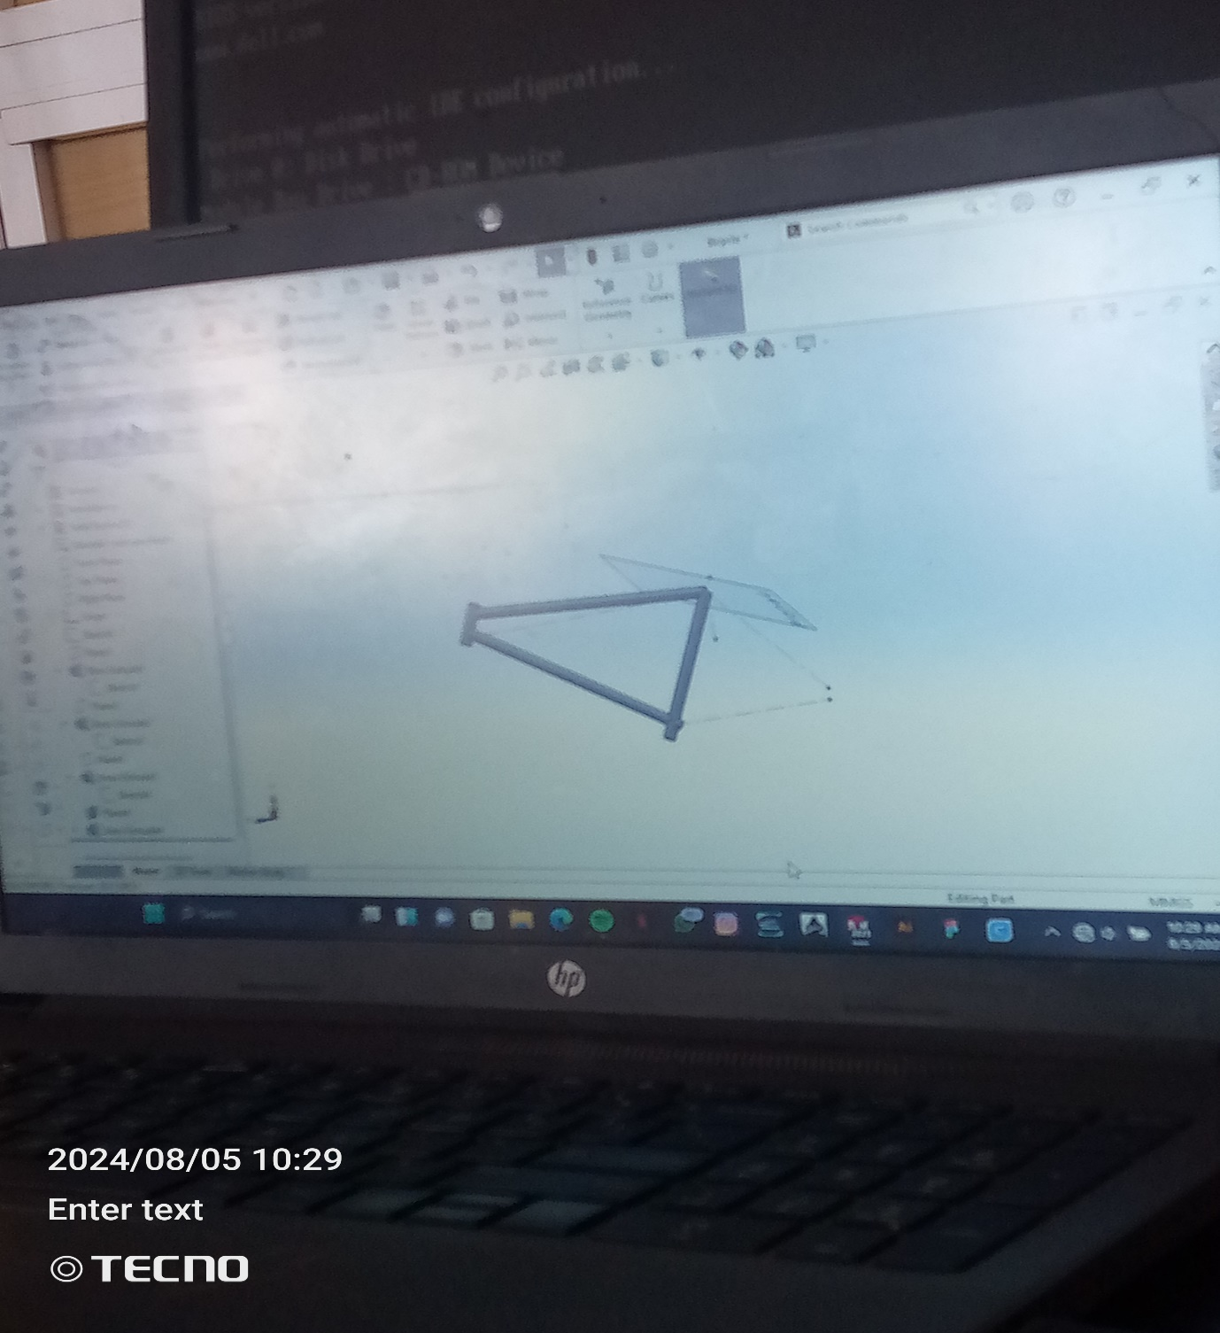

WORKING WITH SOLIDWORKS

