

PREFACE
The industrial training experience is organized to introduce student to the practical aspect of their chosen course of study in their profession.
This programme is of immense importance to engineer student because it will give them a foresight of what will be encounter in their various investment in future, it is the moral aspect, creativity, level of attitude to work, relationship with other student, industrial work experience take care of all these.

DEDICATION
This report is dedicated foremost to God Almighty for his favor, mercy and grace upon my life especially during my 4 month SIWES programme at Ede South local government secretariat.
I would also like to dedicate this report to my Parent (MR. & MRS. ATOYEBI) and My siblings for their love and support and everyone else that contributed towards making my SIWES training fun and successful one.

ACKNOWLEDGMENT
I will like to give my profound appreciation and gratitude goes to Almighty God for his special love mercy over me, also the strength, power and prosperity given to me throughout the period of this training.
I will also extent my greeting to my industrial based supervisor and host of all staff in Building department and for the help of training given to me during the course of my training God bless you all (Amen).
I pray for almighty God to give you long life in order for me to be beneficent to you in future. (Amen)

TABLE OF CONTENTS

Title Page
Preface
Dedication
Acknowledgement
Table of Contents

CHAPTER ONE
1.0 Introduction
1.1 Definition of SIWES
1.2 History of SIWES
1.3 Aims and Objectives of SIWES

CHAPTER TWO
2.0 Company Profile
2.1 Works Department
CHAPTER THREE
3.0 Report on One Particular Unit of Building

CHAPTER FOUR
4.0 Images Showing Practical Work and Steps on Site
4.1 Impression about the organization
4.2 Personal relationship with the organization

CHAPTER FIVE
5.0 Conclusion
5.1 Recommendation

CHAPTER ONE 1.0 INTRODUCTION
This report is a conscious attempt in partial fulfillment of the requirement for the award of the National diploma. The aim is to know good material to be used for any construction project and the normal scale for any Building Technology drawing.
It will tell us more about project execution and the material to be used, this will automatically make us to know whether to rely totally or partially on any executing project years ago, constructed building are easily and quickly goes out of existence (loose it standard) many structures collapse due to the fact that poor/bad materials used workmanship, earth movement of settlement of foundation.
The problems were said to have been caused by things, but the major cause of this problems is due to bad materials used and workmanship.
It has been discovered that this problems facing most of construction on project can be solve if our Engineers/constrictors can used quality not quantity of materials and supervised the workmanship very effective. It affords student of tertiary institutions the opportunity of being familiarized and exposed to the needed experience in handling machinery and equipment which are not available in the educational sector.
The industrial Training Fund (ITF) was set up under act No 47 of 1971 (as amended up to date) to promote and encourage the acquisition of the skills in industrial of the commerce with a view to generate a pool of indigenous trained manpower sufficient to meet of the economy.
Participation of SIWES has become a mandatory precondition for the award of diploma and degree certificates in specific disciplines in most Institutions with the education policy of government operator. The ITF, the coordinating agencies (NUC, NCCE,NBTE). Employers of labour and the institutions
- Funding: The Federal Government of Nigeria.
- Beneficiaries: Under graduate students of the following Agriculture, Engineering,
Technology, and Environment Scheme. Education, Medical Science and pure and applied
Science

1.1 DEFINITION OF SIWES
Students Industrial Work Experience Scheme (SIWES) can be defined as the practical experience of student in order to have quality control and satisfactory performance, when in the field. ‘SIWES’ can be interest in a particular subject which is connected with the people and activities involves in producing a particular. Thing (industrial) by involving in a hard physical work rather than office work (work) in order to gain knowledge and skill through the job undergo for a period of time (Experience) under a system of organizing things (scheme).

1.2 HISTORY OF SIWES
Student industrial work experience established by industrial Training Fund (ITF) in 1993 to solve the problem the lack of adequate practical skills preparatory for employment on Nigeria industries.
The scheme exposes student to industrial based skill necessary for a smooth transition from classroom to the word of work.
Duration: Four months for polytechnic colleges of education and six month engineering students of the University.

1.3 OBJECTIVE OF SIWES
- To improve the technology development of the country.
- To help students to put into practice what they have learnt theoretically in school.
- The scheme exposes students to industrial based skill necessary for a smooth transition from the classroom to the world of work.
- To exposes the students and broaden their knowledge on the practical aspect of the course they are pursing in their various schools
- To promote and encourage the acquisition of skills in industries and commerce with a view to generate a poor of indigenous trained manpower, sufficient to meet the needs of the economy.
- To help to solve the problem of lack of adequate practical skill preparatory for employment in industries by Nigeria graduates of tertiary institutions.

CHAPTER TWO

2.0 COMPANY PROFILE (EDE SOUTH LOCAL GOVERNMENT SECRETARIAT)
The Ede South local government secretariat, Osun State was established by Timi Agbale. The decision to establish the Ede South was announced during the launching of the four years development plan in agreement with the policy of the Federal Military Government on training and man power supply as contained in the second National Development Plan .

2.1 WORKS DEPARTMENT
The Works Department at Ede South local government secretariat Osun, plays a crucial role in overseeing the planning, design, construction, and maintenance of the institution's physical infrastructure. This department is responsible for managing various projects related to buildings, roads, utilities, and other facilities on the campus.
The Works Department at Ede South local government secretariat, typically consists of a team of engineers, architects, surveyors, technicians, and other professionals who work together to ensure that the institution's infrastructure meets the needs of students, staff, and visitors. They are responsible for maintaining a safe, functional, and aesthetically pleasing environment for the campus community.
Some of the key responsibilities of the Works Department at Ede South local government secretariat may include:
- Planning and designing new construction projects on campus.
- Overseeing the maintenance and repair of existing buildings and facilities.
- Managing infrastructure upgrades and renovations.
- Ensuring compliance with building codes and regulations.
- Collaborating with other departments and stakeholders on campus development projects.
The Works Department at Ede South local government secretariat plays a vital role in supporting the overall mission of the institution by providing and maintaining quality infrastructure that enhances the teaching, learning, and research environment for students and staff.

CHAPTER THREE

3.0 REPORT ON ONE PARTICULAR UNIT OF BUILDING
The building construction of a four (4) bungalow are to be analyzed, the first thing to be done has it’s been written in the earliest page are
- Visitation to site
- Site clearance
- Site works before building construction
- Things engineers/builders concern about construction of building
- Objectives of setting out
- Concrete in foundation
- Foundation
- The block walls
Site Clearance: This as to be done immediately after the land is well suitable for the engineers concerned for them to establish their works site clearance as to do with the cutting down of green vegetation of the land and deforestation the trees after deforestation of the trees are been done.
Then removal of tree shrubs will be done and can be employed to uproot or remove those trees shrubs from the land in which the house will be established.
Site work’s before building construction is been done. It is expected of the engineers or builders involving in the construction work of a building to ensure that he/she take a general view of the whole land to check the topography of the land (shape) either the land is sloppy or shallow before any construction work could be done on such a land.
And during that time it will help the engineer concern to know when start preparing their bill of quantity for such a work on site.
Things engineers / builders involves are to take care of in building construction works
- A block plan showing contours and beation of the job in relation to the surrounding topography.
- A set drawing with scale detail as necessary showing the architectural drawing for specify construction of a building
- A bill of quantities should be provided so as to know the total capital needed for such contract to be established.
- Contract information should be included so as to know the cost and the completion date.

SETTING OUT
It is the process of developing the physical positions of corners and walls of a building, and it’s done by transferring dimensions from the layout plan (also called as setting out plan, demarcation plan) to the ground. The setting out clearly defines the outline of the excavations and the centre line of the walls, so that the construction can be carried out according to the plan.. The process of Setting out is done by a contractor, and overseen by the lead project consultant engineer, architect or any other qualified member of the project team.

Method of Setting Out
The method of setting out for the particular project of four bungalow building is been done by machine. It’s this particular machine that help to set out the land. (Total station).
After this has been done the architectural plan for the building is been used in order to mark out the scale for each apartment in the four bedroom flat. Pegging of each apartment in the building according to the architectural plan. Then the profile board is been made.

Foundation: Is the basement power of a building which as direct contact with the soil and on which soil and other structure are to be excavated. the ability of a building to remain firm for several years on the ground upon which it is built depend on its foundation, this is the structure found below the earth surface of the ground in which it rest the combined dead and imposed load in a way that will not allow part of a building i.e. collapsing of the building
The function of any foundation is to safely sustain and transmit it to the ground on which it rests the combined dead, imposed and wind loads in such a manner as not to cause any settlement or other movement which would impair the stability or cause damage to any part of the building..
Various type of foundation depends on the nature of soil on which the foundation would be constructed, the nature of the soil is the major factor that influences the choice of foundation to be constructed or used, and other factors are:

- The amount of settlement produced by loading
- The total load of the building.

Hardcore filling: this involves the filling of the foundation with materials like broken bricks demolition waste broken rock, compacted laterite soil to satisfy and level the upper most surface of a building area before the ground and concrete. This involves the method of layer of about 50 – 75mm thick or weak concrete under all – reinforced
Concrete foundation: the foundation of the building is to provide a good level surface from which the reinforcement can be positioned
Termite treatment: termite present a danger to building by eat the cellulose in the timber used for building, to avoid this danger, the termite nest must be dug out and the content must be destroyed , anti-termite treatment like toxic chemicals aims to eradicated termite and the consequence hazard they pose to the building and its component

The Block Wall
This very block wall can be refers to as the bricks’ that protect the building from external and atmospheric factors like rain, sunlight, noise pollution etc. it also provide shelter for occupant.
Wall is being refer to as the blocks diving the room into different apartment. One major function of wall in building is that it gives the building a definite shape and without wall, the rooms of a building would be void.
After the Damp Proof membrane has been done, the block wall is being laid to attain at the height of Nine courses to the lintel stage and this is done by reinforcing the concrete with steel bars, so as to increase the bearing capacity and withstand either super imposed and natural loads coming on it,
Wall can be divided into external wall and internal wall, after successfully erecting a lintel, it is preceded by laying of two coaches of block to the external wall and laying of three coaches of block to the internal walls, it is usually done depending on the type of roof to be used.

STAIRS CASE
A stair is a series of steps arranged in such a manner as to connect different floors of a building. Stairs are designed to provide as easy and quick access to different floors. A staircase is an enclosure which contains the complete stairway.
Generally, stairs are of following types
- Straight stairs
- Quarter turn stairs
- Half turn stairs
- Three quarter turn stairs
- Circular stairs
- Spiral stairs
- Curved stairs
- Geometric stairs
- Bifurcated stairs and
- Combination above types

ROOFING
A roof is part of a building envelope. It is the covering on the uppermost part of a building or shelter which provides protection from animals and weather, notably rain or snow, but also heat, wind and sunlight. The word also denotes the framing or structure which supports that covering.
The characteristics of a roof are dependent upon the purpose of the building that it covers, the available roofing materials and the local traditions of construction and wider concepts of architectural design and practice and may also be governed by local or national legislation. In most countries a roof protects primarily against rain. A verandah may be roofed with material that protects against sunlight but admits the other elements. The roof of a garden conservatory protects plants from cold, wind, and rain, but admits light.

TYPES OF ROOF
Hip Roof
Flat Roof
Butterfly Roof

Pyramid Roof

CHAPTER FOUR

4.0 Images Showing Practical Work and Steps on Site

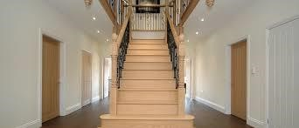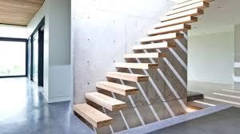
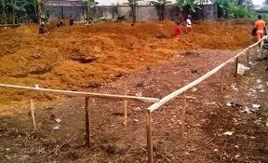

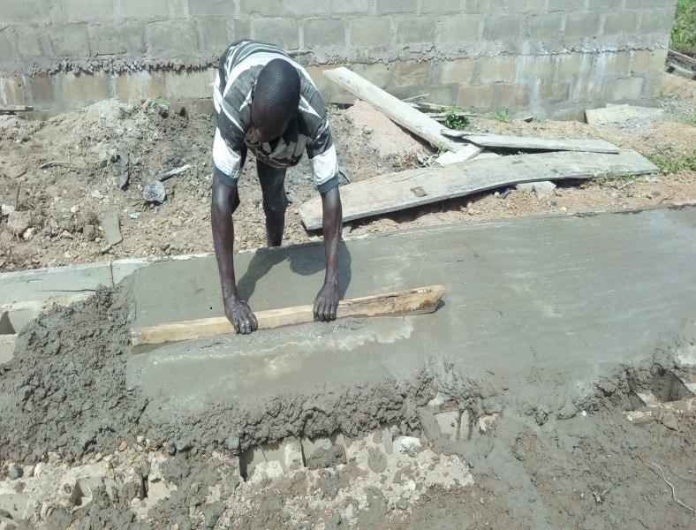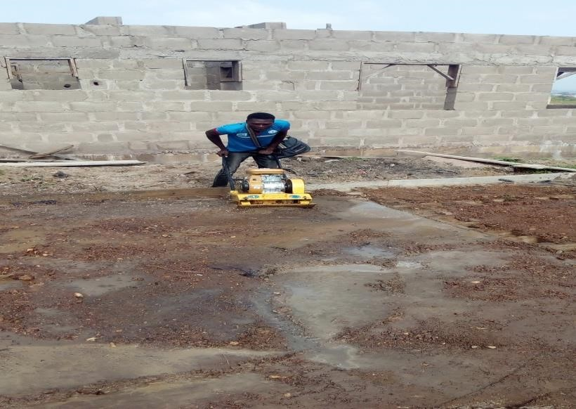

Image 6: showing compaction of soil by Image 7: showing DPC manual compacting machine
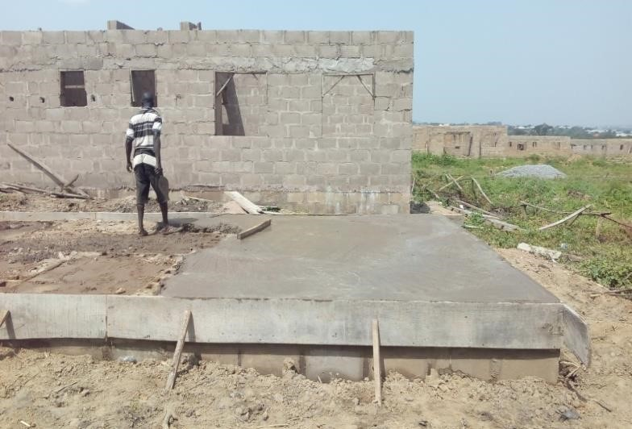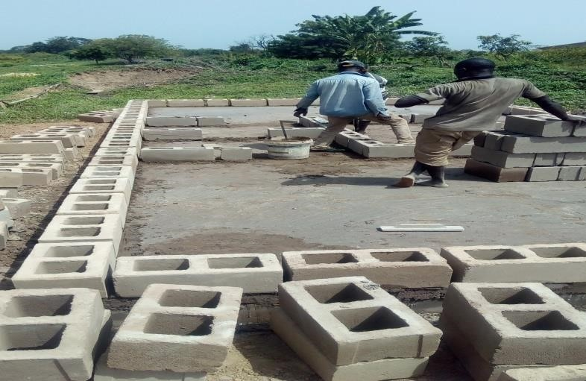
Image 8: showing DPC Image 9: showing block forming after DPC

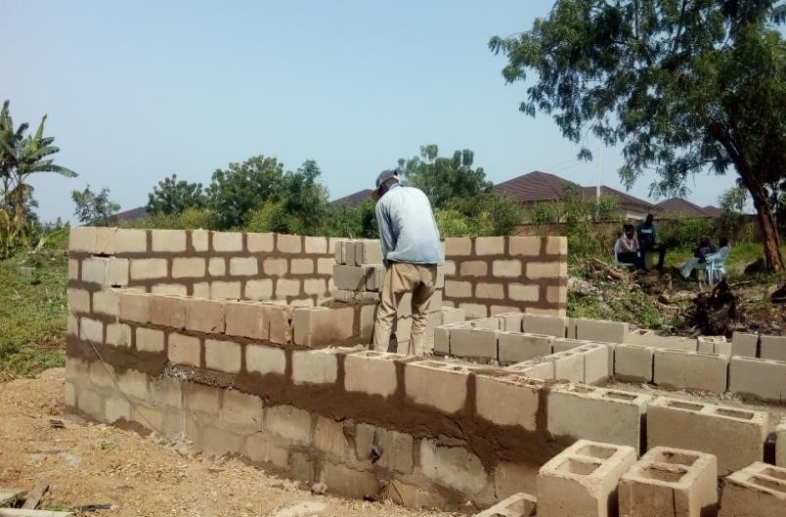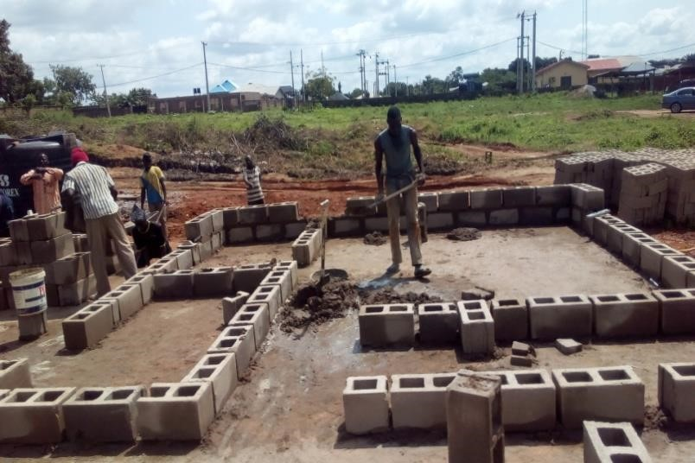
Image 10: showing block forming after DPC Image 9: showing block work in
superstructure

4.1 Impression about the organization
Impression about the industrial training base on four months programs (siwes) was the acceptance of my siwes letter in their organization and also for provision of a construction site to enlighten and show all siwes student the practical work style of a professional builder on a construction site.

4.2 Personal relationship with the organization
The personal relationship with the company in highly correlating, because company accepts the training of the siwes students as their personal assignment, by showing us different technique in building construction.
The welfare and care giving to us in company was highly impressive because the company attached each and every one of the siwes student to different supervisor in which we are free to ask question about every unclear aspect during field work on site

CHAPTER FIVE 5.0 CONCLUSION
This program has brought improvement to my field of study. The experience gained through this program is majorly based on substructure and superstructure works on a four bedroom- bungalow, this program has inspired me to have technical knowledge and practical aspect of what I have learnt in school.
I hereby forward my appreciation to the Rector and Director of the Institute, HOD of my Department, and Professional Lectures in my department including my colleague in training, friends and every member of my family for their support both moral and financial.
My prayer to you all is for God in his infinity mercy bless you and reward every of your endeavor abundantly.

5.1 RECOMMENDATION
As a result of difficulties experience during the Four months SIWES program, I will like to recommend the following changes;
- The Industrial Training Fund should make monthly allowance available for students, so as to put end to financial difficulties that may arise as a result of transportation problems.
- The Institution must confirm that each student partake in the Industrial Training program, by making sure that they pay every student a visit before the end of the program.
- The Institution and Industrial Training Fund should help the student to get the place of attachment, so that the program will commence as planned.
- Students on SIWES program should be posted or deployed to the Organizations, Department or Firms that are relevant to their Course of study, so that the sole aim of SIWES can be achieved.

