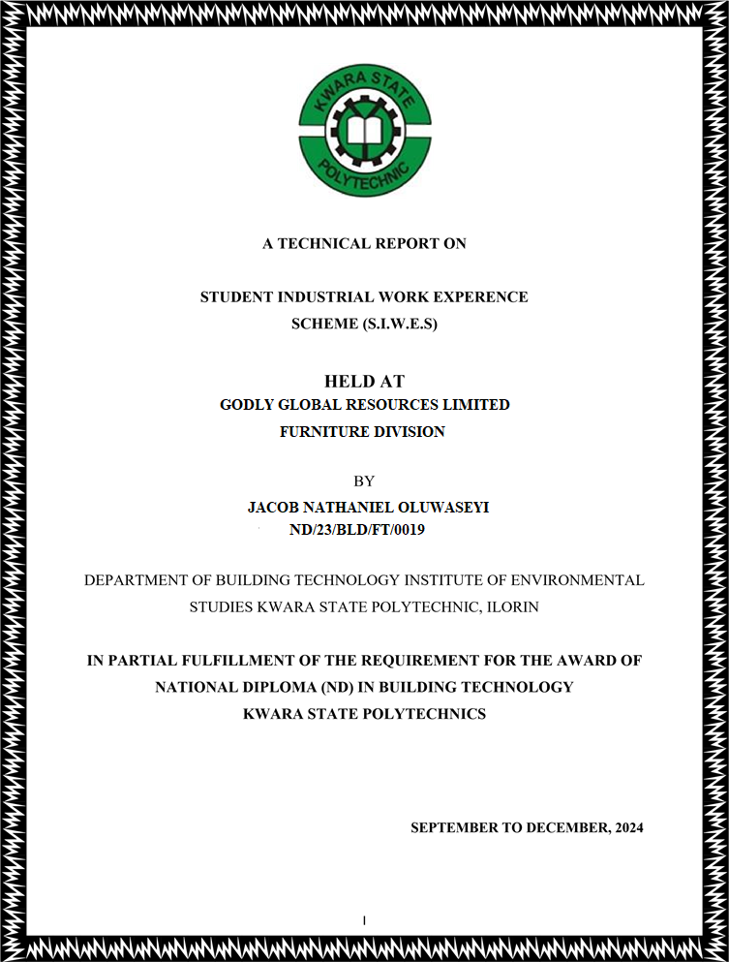

PREFACE
The industrial training experience is organized to introduce student to the practical aspect of their chosen course of study in their profession.
This programme is of immense importance to engineer student because it will give them a foresight of what will be encounter in their various investment in future, it is the moral aspect, creativity, level of attitude to work, relationship with other student, industrial work experience take care of all these.

DEDICATION
This report is dedicated foremost to God Almighty for his favor, mercy and grace upon my life especially during my 4 month siwes programme at Nutoye Nigeria Enterprises
I would also like to dedicate this report to my Parent (Mr. & Mrs. JACOB) and My siblings for their love and support and everyone else that contributed towards making my siwes training fun and successful one.

ACKNOWLEDGMENT
I will like to give my profound appreciation and gratitude goes to Almighty God for his special love mercy over me, also the strength, power and prosperity given to me throughout the period of this training.
I will also extent my greeting to my industrial based supervisor and host of all staff in Building department and for the help of training given to me during the course of my training God bless you all (Amen).
I pray for almighty God to give you long life in order for me to be beneficent to you in future. (Amen)

TABLE OF CONTENTS

Title Page
Preface
Dedication
Acknowledgement
Table of Contents

CHAPTER ONE
1.0 Introduction
1.1 Definition of SIWES
1.2 History of SIWES
1.3 Aims and Objectives of SIWES

CHAPTER TWO
2.0 Company Profile
2.1 Works Department
CHAPTER THREE
3.0 Report on One Particular Unit of Building

CHAPTER FOUR
4.0 Images Showing Practical Work and Steps on Site
4.1 Impression about the organization
4.2 Personal relationship with the organization

CHAPTER FIVE
5.0 Conclusion
5.1 Recommendation

CHAPTER ONE

1.0 INTRODUCTION
This report is a conscious attempt in partial fulfillment of the requirement for the award of the National diploma. The aim is to know good material to be used for any construction project and the normal scale for any Building Technology drawing.
It will tell us more about project execution and the material to be used, this will automatically make us to know whether to rely totally or partially on any executing project years ago, constructed building are easily and quickly goes out of existence (loose it standard) many structures collapse due to the fact that poor/bad materials used workmanship, earth movement of settlement of foundation.
The problems were said to have been caused by things, but the major cause of this problems is due to bad materials used and workmanship.
It has been discovered that this problems facing most of construction on project can be solve if our Engineers/constrictors can have used quality not quantity of materials and supervised the workmanship very effective. It affords student of tertiary institutions the opportunity of being familiarized and exposed to the needed experience in handling machinery and equipment which are not available in the educational sector.
The industrial Training Fund (ITF) was set up under act No 47 of 1971 (as amended up to date) to promote and encourage the acquisition of the skills in industrial of the commerce with a view to generate a pool of indigenous trained manpower sufficient to meet of the economy.
Participation of SIWES has become a mandatory precondition for the award of diploma and degree certificates in specific disciplines in most Institutions with the education policy of government operator. The ITF, the coordinating agencies (NUC, NCCE, NBTE). Employers of labour and the institutions
- Funding: The Federal Government of Nigeria.
- Beneficiaries: Under graduate students of the following Agriculture, Engineering,
Technology, and Environment Scheme. Education, Medical Science and pure and applied
Science

1.1 DEFINITION OF SIWES
Students Industrial Work Experience Scheme (SIWES) can be defined as the practical experience of student in order to have quality control and satisfactory performance, when in the field. ‘SIWES’ can be interest in a particular subject which is connected with the people and activities involves in producing a particular. Thing (industrial) by involving in a hard physical work rather than office work (work) in order to gain knowledge and skill through the job undergo for a period of time (Experience) under a system of organizing things (scheme).

1.2 HISTORY OF SIWES
Student industrial work experience established by industrial Training Fund (ITF) in 1993 to solve the problem the lack of adequate practical skills preparatory for employment on Nigeria industries.
The scheme exposes student to industrial based skill necessary for a smooth transition from classroom to the word of work.
Duration: Four months for polytechnic colleges of education and six-month engineering students of the University.

1.3 OBJECTIVE OF SIWES
- To improve the technology development of the country.
- To help students to put into practice what they have learnt theoretically in school.
- The scheme exposes students to industrial based skill necessary for a smooth transition from the classroom to the world of work.
- To exposes the students and broaden their knowledge on the practical aspect of the course they are pursing in their various schools
- To promote and encourage the acquisition of skills in industries and commerce with a view to generate a poor of indigenous trained manpower, sufficient to meet the needs of the economy.
- To help to solve the problem of lack of adequate practical skill preparatory for employment in industries by Nigeria graduates of tertiary institutions.

CHAPTER TWO

2.0 GODLY GLOBAL RESOURCES LIMITED
Godly Global Resources Limited was incorporated in Asa Dam Ilorin, Nigeria. It was registered on 05 Sep, 1996 and it's current status is unknown. Company's registered office address is suite 56, B Aiyetoro, Off Asa Dam Road Ilorin, Kwara State

2.1 WORKS DEPARTMENT
The Works Department at Godly Global Resources limited plays a crucial role in overseeing wood work, and furniture work, interior in a build. This department is responsible for managing various related to Furnishing and wood work of a building
The work department at G.G.R Limited consist of surveying department, the delivery department, architect department, the drilling department, the cutting department, painting department, these department is responsible for managing various wood works and furniture work in building construction. They are responsible for maintain a safe, durable and nice interior.
A brief explanation on each department
- The Surveying department: This are the department that visit the buildings, check around, survey the whole building. Where and where will be suitable for the furniture works.
- The Architect department: They design a suitable interior that matches the building and will suit the client taste.
- The Cutting department: They are in charge of high cutting tool such as circular machine, gig saw, 7D machine, they cut every plant to various sizes needed for the project.
- The Drilling department: They basically deals on driving hole on wood e.g for door mortising, table mortising etc.
- The Finishes department: These department manages the well and good finishes of the project.
- The Painting department: These department deals with everything painting at GG.R.
Some of the key responsibilities of the work department at G.G.R may include:
- Planning and designing new furniture works in a building.
- Overseeing the maintenance and repair of existing furniture works.
- Ensuring compliance with building codes and regulation.
- Collaborating with other department and stakeholder in building project.
- The works department at G.G.R play avital role in supporting the overall mission of the building by providing and maintaining quality needed in such building.

CHAPTER THREE

3.0 REPORT ON ONE PARTICULAR UNIT OF BUILDING
Wooden doors are commonly made using a variety of wood types, including hardwoods like Iroko, Mahogany, Teak, and Mansonia, as well as synthetic materials like MDF. Solid wood doors, particularly those made from hardwood, are favored for their durability and longevity.
Wooden doors are incredibly strong, and developments in their design and construction over their hundreds of years of manufacture mean they can outlast some of their counterparts
They are a traditional choice, known for their natural insulation, durability, and ease of working with.
Benefits of Wooden Doors:
- Natural Insulation: Wood is a good insulator, helping to reduce noise and improve energy efficiency.
- Aesthetic Appeal: Wooden doors can be designed in various styles and finishes, adding to the overall beauty of a home.
- Durability: Solid wood is a strong and durable material, making wooden doors resistant to breakage.
- Versatility: Wooden doors can be customized and adapted to different architectural styles.
- Maintenance: Wooden doors require regular maintenance, such as painting or staining, to protect them from the elements and ensure their longevity.
Types of Wooden Doors:
- Solid Wood Doors: Made from a single piece of wood, known for their strength and durability.
- Composite Doors: Combine wood with other materials like MDF or veneer, offering a balance of strength and cost.
- Sliding Doors: Provide access to larger openings and can be customized to fit specific needs.
Engineered Wood:
- HDF: High Density Fibreboard is a popular choice for door cores due to its consistent structure, smooth surface, and resistance to warping
Other Materials are nails, filler, paint, glue such as top bond, which is highly recommended etc

Tools use are
- Hand Circular machine
- Table saw
- Hand saw
- Drilling machine
- Grinding machine
- Compressor
- Iron square
- Measuring tape
- Rafter machine
- Hammer
- E.t.c

CHAPTER FOUR

4.0 Images Showing Practical Work and Steps on Site

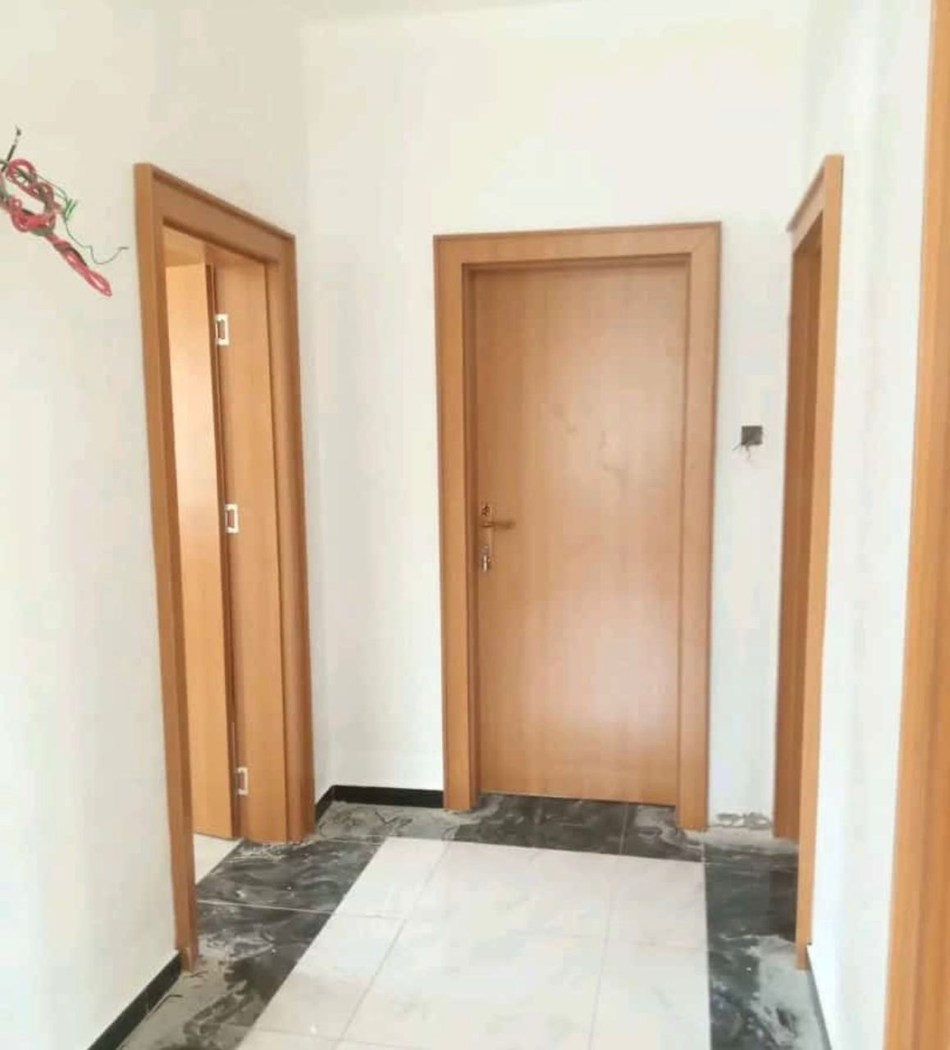

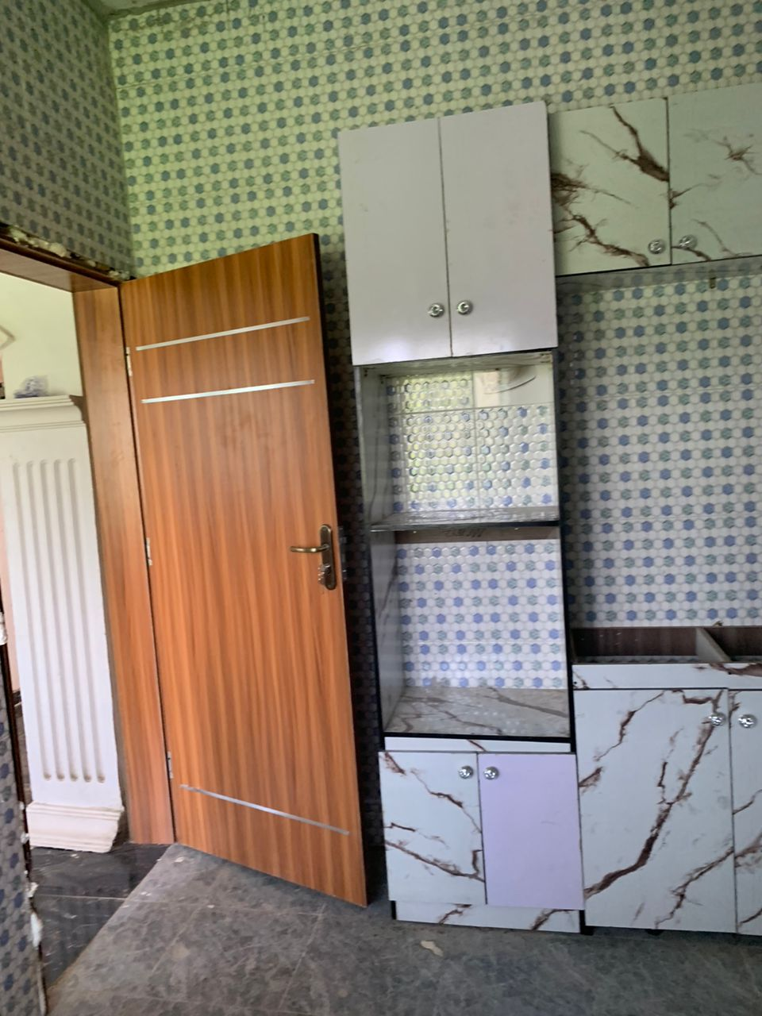
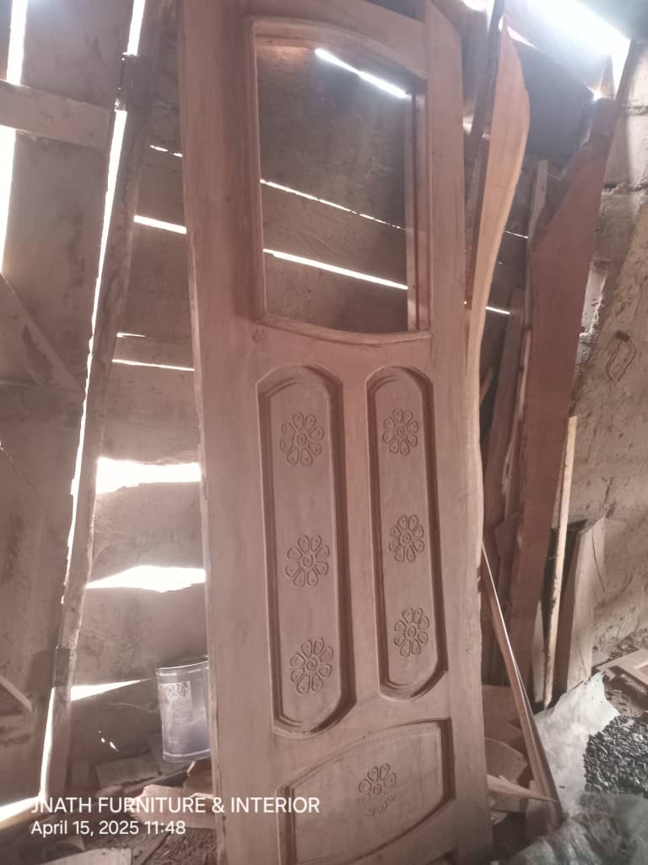

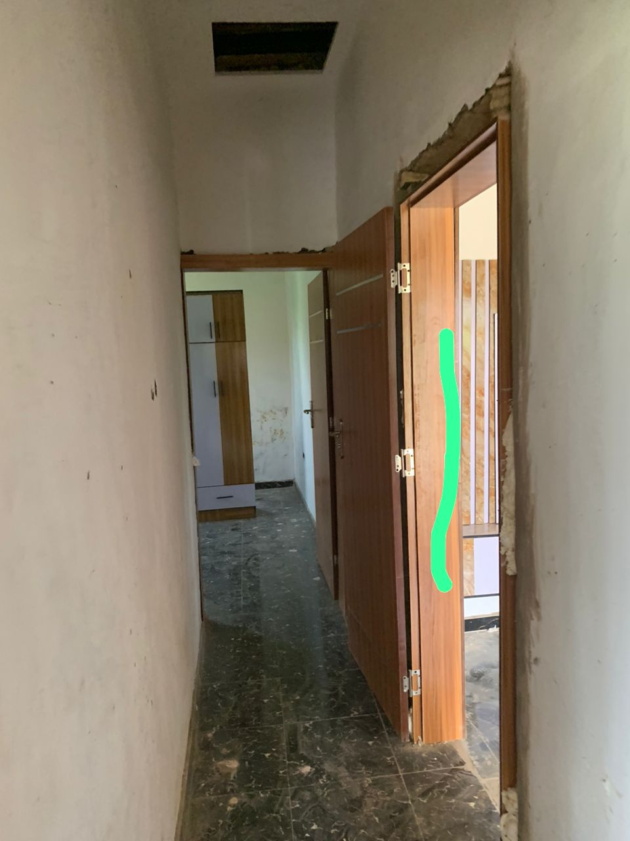
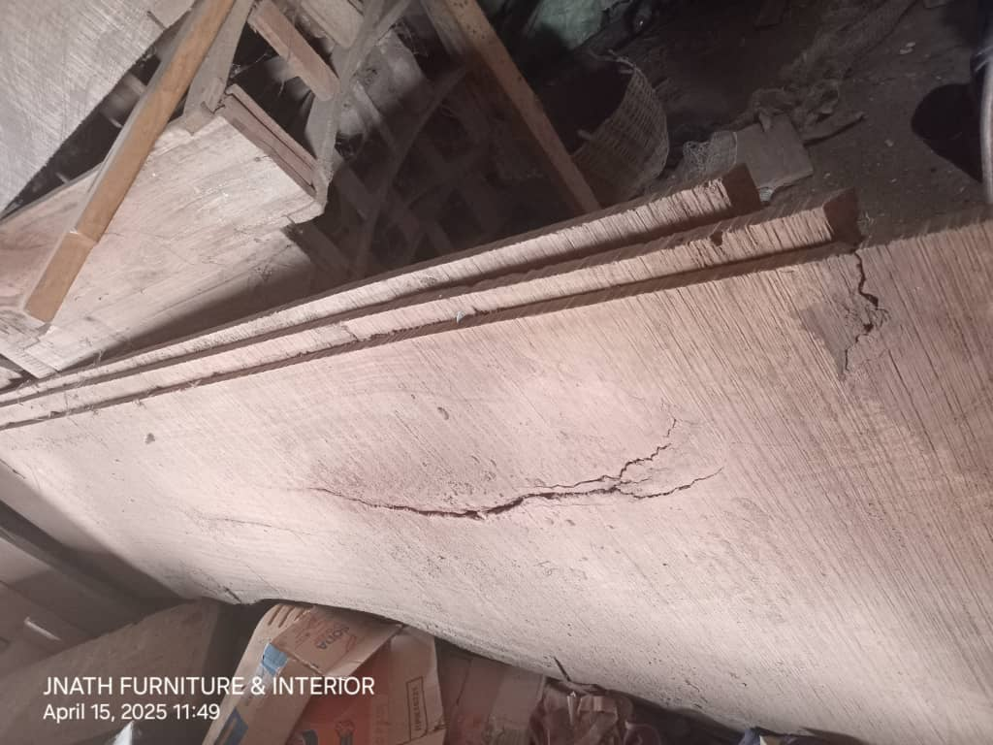

4.1 Impression about the organization
Impression about the industrial training base on four months’ programs (SIWES) was the acceptance of my SIWES letter in their organization and also for provision of a construction site to enlighten and show all SIWES student the practical work style of a professional builder on a construction site.

4.2 Personal relationship with the organization
The personal relationship with the company in highly correlating, because company accepts the training of the SIWES students as their personal assignment, by showing us different technique in building construction.
The welfare and care giving to us in company was highly impressive because the company attached each and every one of the SIWES student to different supervisor in which we are free to ask question about every unclear aspect during field work on site

CHAPTER FIVE

5.0 CONCLUSION
This program has brought improvement to my field of study. The experience gained through this program is majorly based on substructure and superstructure works on a four bedroom- bungalow, this program has inspired me to have technical knowledge and practical aspect of what I have learnt in school.
I hereby forward my appreciation to the Rector and Director of the Institute, HOD of my Department, and Professional Lectures in my department including my colleague in training, friends and every member of my family for their support both moral and financial.
My prayer to you all is for God in his infinity mercy bless you and reward every of your endeavor abundantly.

5.1 RECOMMENDATION
As a result of difficulties experience during the Four months SIWES program, I will like to recommend the following changes;
- The Industrial Training Fund should make monthly allowance available for students, so as to put end to financial difficulties that may arise as a result of transportation problems.
- The Institution must confirm that each student partakes in the Industrial Training program, by making sure that they pay every student a visit before the end of the program.
- The Institution and Industrial Training Fund should help the student to get the place of attachment, so that the program will commence as planned.
- Students on SIWES program should be posted or deployed to the Organizations, Department or Firms that are relevant to their Course of study, so that the sole aim of SIWES can be achieved.

