

A TECHNICAL REPORT ON
STUDENT INDUSTRIAL WORK EXPERIENCE SCHEME (S.I.W.E.S)

UNDERTAKEN AT:

SOLID MINERAL INDEX COMPANY, KWARA STATE
OKE-OSE DANGIWA ILORIN, KWARA STATE

BY:

ABIODUN EMMANUEL SEYI
(ND/23/MPE/FT/0074)

SUBMITTED TO

DEPARTMENT OF MINERALS AND PETROLEUM ENGINEERING
KWARA STATE POLYTECHNIC, ILORIN

SUBMITTED IN PARTIAL FULFILLMENT OF THE AWARD OF NATIONAL DIPLOMA (ND) IN MINERALS AND PETROLEUM RESOURCES ENGINEERING

FROM:
AUGUST TO NOVEMBER,2024

DEDICATION

I truly certify that this report was written entirely by me. The training and experience described in this report represent my participation in the four-month Student Industrial Work Experience Scheme (SIWES) at Solid Mineral Index. All of the information in this report is accurate and was written by me.

ACKNOWLEDGEMENT

I give thanks to the source that creat life for providing me with the strength, opportunity, and grace to complete my industrial training.
I am sincerely grateful to my parents for their love and support.
My appreciation also goes to Engr. A.B Abdulrahman, my industrial based supervisor, who has been very understanding and supportive throughout my training, at Solid Mineral Index Limited Company.
Finally, I appreciate all my lecturer of the Department of Minerals and Petroleum Engineering for their continuous effort in promoting SIWES.

TABLE OF CONTENTS
- DEDICATION
- ACKNOWLEDGEMENT
- ABSTRACT
- TABLE OF CONTENT
CHAPTER ONE
1.0 INTRODUCTION TO TRAINING PROGRAM
1.1 OVERVIEW
1.2 ORGANIZATION AND OPERATIONS OF SIWES
1.3 AIMS AND OBJECTIVES OF SIWES
1.4 IMPORTANCE OF SIWES PROGRAM
1.5 CHALLENGES FACED BY SIWES
1.1 BRIEF HISTORY OF THE COMPANY
1.1.1 PRODUCTS OF COMPANY
1.2 QUALITY POLICY STATEMENT
1.1.2 COMPANY’S ORGANOGRAM

CHAPTER TWO
2.0 THE TRAINING PROGRAM
2.1 DESCRIPTION OF WORK EXPERIENCE
2.1.1 LIMESTONE
2.1.2 LATERITE
2.1.3 COAL
2.2 GYPSUM
2.2.1 IRON DUST
2.2.2 ACCOUNT OF WORK DONE IN THE MINING DEPARTMENT
2.2.3 RESEARCH & DESIGN UNIT
2.2.4 REVIEW OF WORKDONE BY TEAM
2.2.5 COMPILATION OF RESEARCH MEMOS
2.2.6 REVIEW OF VARIOUS STANDARD PUBLICATIONS
2.2.3 QUARRY UNIT
2.2.4 SAFETY IN THE MINES
2.2.5 LIMESTONE PROCESS
2.2.6 SMI CHEMICAL LABORATORY
2.2.7 EQUIPMENT AND TOOLS IN SOLID MINERAL INDEX LABORATORY
2.2.9 EXPERIMENTS ON HOW TO GET TC & LOI
2.0.3 STEPS ON HOW TO DETERMINE THE PERCENTAGE TOTAL CARBONATE PRESENT IN CEMENT
2.1.3 STEPS ON HOW TO DETERMINE THE LOSSON IGNITION
2.1.4 SMI PHYSICAL LABORATORY

CHAPTER THREE
3.0 OBSERVATIONS
3.1 TECHNICAL SKILLS AND PROFESSIONAL KNOWLEDGE GAINED
3.2 RELEVANCE OF EXPERIENCE GAINED TO CLASSROOM KNOWLEDGE
3.3 PROBLEMS ENCOUNTERED DURING THE PROGRAM

CHAPTER FOUR
4.1 CONCLUSION
4.2 RECOMMENDATION
REFERENCES

CHAPTER ONE
1.0 INTRODUCTION TO TRAINING PROGRAM

1.1 OVERVIEW

The difference in economic growth and inter-country income inequality is best explained on the grounds of technological differences. It is undoubtedly evident that the position of any country in the hierarchy of the work force must be adequately equipped with the appropriate technical skills to be able to create goods and render services that meet economic needs. Deficiencies in the level of competence and skill set of the work force can lead to flaw sin the operations of industrial organizations and other economic sectors.
A report of the National Needs Assessment Survey conducted by the National Universities Commission (NUC) in 2004, titled “Labour Market Expectations of Nigerian Graduates” reported hat-“employers believe graduates bring sufficient theoretical knowledge to the job but that they lack hands-on practical skills that would make them productive”. It was in the face of such criticisms in the past by employers that graduates of Nigeria’s tertiary institutions lacked appropriate and adequate technical skills preparatory to employment in industry, that the Students’ Industrial Work-Experience Scheme (SIWES) was initiated in 1973 by the Industrial Training Fund (ITF) in accordance with its mandate through Decree 47of1971,chargingitwiththeresponsibilityofpromotingandencouragingtheacquisition of skills in Industry and Commerce with the view of generating a pool of indigenous manpower sufficient to meet the needs of the economy.
The scheme gives a unique opportunity to be introduced to the industrial environment and obtain technical knowledge while studying. It has become acrucial prerequisite for the award of diploma and degree certificates in Science, Engineering, and Technology (SET).
To make them employable upon graduation. SIWES was solely funded by ITF during its early stage not until it was difficult to continue due to economic stress then; the responsibility was shared between ITF and the Federal Government. The Federal Government took over the funding of the scheme and ITF managed the funds received from a managerial position in order to sustain the scheme. The effective management of SIWES has been a result of the cooperation and well-played roles of the Federal Government, ITF, the supervising agencies, employers of labor, and various institutions.
1.1 ORGANIZATION AND OPERATIONS OF SIWES
Operator: | The ITF, the coordinating agencies (NUC, NCCE, NBTE), employers of labor and the institutions.
Funding: | The Federal Government of Nigeria
Beneficiaries: | Undergraduate students of the following: Agriculture, Engineering, Technology, Environmental, Science, Education, Medical Science, and Pure and Applied Sciences.
Duration: | Polytechnics and Colleges of Education-Four months Universities- Six months


INDUSTRIALTRAINING
FUND
(SIWESDivision)
TERTIARYINSTITUTIONS
(Universities,Polytechnics)
STUDENTTRAINEES
(Science,Engineering&Technology)
ITFAREAOFFICES(SIWESUnit)
EMPLOYERS
(Industry/Government)
SUPERVISINGAGENCIES(NUC, NBTE, NCCE)
ORGANISEDPRIVATESECTOR
(NECA,NACCIMA,MAN)
CHIEFEXECUTIVES’
FORUM
FEDERALGOVERNMENT
(FederalMinistryofIndustryTrade & Investment)

Figure1.2: Relationship among SIWES stakeholders.

AIMS AND OBJECTIVES OF SIWES
- Provide avenues for students to acquire Industrial Skills for experience during their course of study.
- Reduce dependency on foreign
- Expose students to work methods and techniques in handling equipment and machinery that may be inaccessible within the tertiary institutions.
- Prepare students for industrial work situations they are likely to face upon graduation.
- Provide students with the opportunities to apply their educational knowledge in area work situation, there by bridging the gaps between theoretical knowledge of graduates of tertiary institutions and the skill sets the employer requires in the industry.
- To make the transition from school to the world of work easier through enhancing students’ contacts with potential employers while on training.
- To minimize the bewilderment experienced by students, particularly those from a non-technological background pursuing courses in science, engineering, and technology with regard to equipment, processes, tools, etc. available in the industry.
- To broaden their knowledge on how to relate with people in the organization.
- Enabling students to appreciate the connection between their courses of study and other related disciplines in the production of goods and services.

- Making SET students appreciate the role of their professions as the creators of change and wealth and indispensable contributors to growing the economy and national development.

IMPORTANCE OF SIWES PROGRAM
The importances of Industrial training in which students can benefit from are as follows:
- It enables students to acquire technical skills and experience for professional development in their studies.
- SIWESisanefforttobridgetheexistinggapbetweentheoryandpracticeandexpose students to necessary skills for a smooth transition from the classroom to the world of work.
- Provision of an enabling environment where students can develop and enhance personal attributes such as critical thinking, creativity, and interpersonal skills amongst others

CHALLENGES FACED BY SIWES
SIWES plays a significant role in human resource development in Nigeria. However, some challenges are being faced by the body which includes:
- Insufficient placement opportunities for students in work organizations
- Inadequate funding of the scheme
- Poor supervision of students on SIWES
- Delay or Non-payment of students’ allowances

BRIEF HISTORY OF THE COMPANY

Solid Mineral Index Limited Company (SMILC) is Nigeria’s leading green building products company. SMILC is a professionally managed organization with technically qualified personnel and trained staff. Solid Mineral Index Limited Company (SMILC) fiber cement operations involve the use of a sophisticated Hatschek process in the factory situated at Oningbedu, Ogun state, Nigeria. The company has contributed economically and technologically towards the growth of the industry in Nigeria. The company is focused on manufacturing high-quality environment- friendly building products and providing excellent service to its customers.
This diversification has given the company a competitive edge in terms of cost advantage and consistency in cement-based products which are manufactured in-house.
At SMILC, everything weds achieved with the support of our customers, our employees, our products, our shareholders, and of course, our environment in mind. We, at Solid Mineral Index Limited Company, are committed to ... Building green solutions.

1.6.1 PRODUCTS OF THE COMPANY
      - Cement
      - Fiber Cement sheets
      - Specialty building products

1.6.2 QUALITY POLICY STATEMENT
Solid Mineral Index Company Limited (SMICL) is committed:
- To provide high-quality & cost-effective Cement and fiber cement sheets.
- To meet our customer’s requirements through measurable objectives set at Corporate and Department levels.
- To review the objectives when necessary to ensure their continued suitability.
- To ensure the effective implementation of NIS ISO 9001:2015 as well as all other regulatory and statutory requirements.
- To constantly strive for continual improvement, higher organization effectiveness, and customer satisfaction.

COMPANY’S ORGANOGRAM
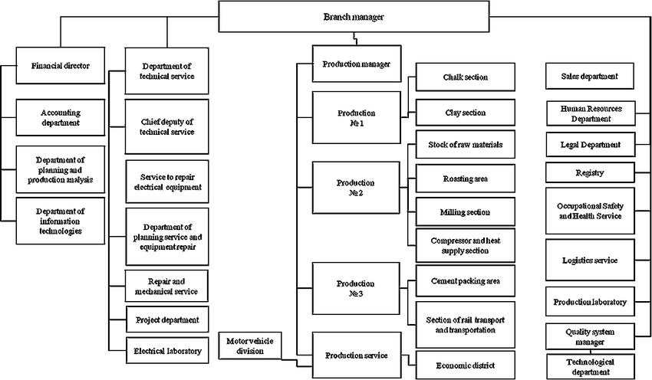
Fig1.6.3a: SMI Organogram
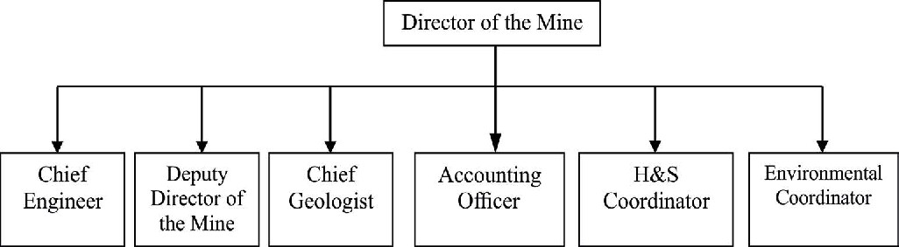
Fig1.6.3b: Organizational flowchart of SMI mines

CHAPTER TWO
  - THE TRAINING PROGRAM

DESCRIPTION OF WORK EXPERIENCE
My Industrial Training program commenced on the 5th of August, 2024 and ended on the 29th of November, 2024 at Solid Mineral Index Company Limited (SMICL).
The resumption time was 8:30am and the closing time was 5:00pm. I made sure acordial relationship was entrenched with the employees of SMICL both in the department I worked in and in other departments. I also familiarized myself with the protocol of the company.
My experience in SMICL is mainly based on mineral process (Solid Process) which involves the mining of solid from the quarry which is then to be processed with other materials such as; laterite, coal, gypsum & iron dust in the kiln into cement.

SOLID MINERAL
Solid is a sedimentary rock composed mainly of calcium carbonate, usually in the form of calcite or aragonite. It may contain considerable amounts of magnesium carbonate (dolomite) as well as; minor constituents. Limestone has two origins:
- Bio-genic precipitation from seawater, the primary agents being lime- secreting organisms and foraminifera
- Mechanical transport and deposition of pre existing limestones, forming clastic deposits.
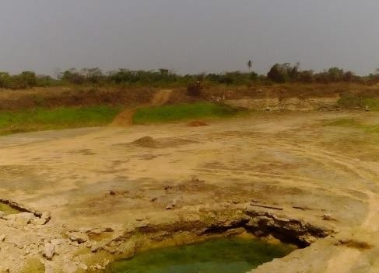

Fig2.1.1Limestone quarry

LATERITE
Laterite is a soil layer that is rich in iron oxide and derived from a wide variety of rocks weathering under strongly oxidizing and leaching conditions. It forms in tropical and subtropical regions where the climate is humid. Lateritic soils may contain clay minerals; but they tend to be silica-poor, for silica is leached out by waters passing through the soil. Typical laterite is porous and claylike. It contains the iron oxide minerals goethite, HFeO2; lipid ocrocite, FeO(OH); and hematite, Fe2O3. It also contains titaniumoxides and hydrated oxides of aluminum, the most common and abundant of which is gibbsite, Al2O3·3H2O. The aluminum-rich representative of laterite is bauxite
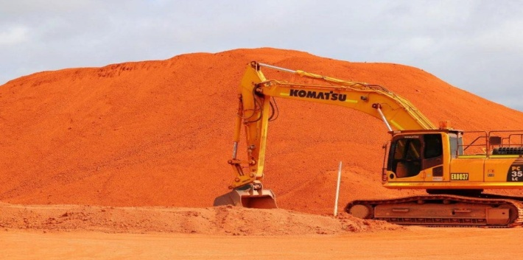
Fig2.1.2Lateriteyard

COAL
Bituminous coal, or black coal, is a type of coal containing a tar-like substance
Called bitumen or a sphalt. Its coloration can be black or sometimes dark brown; often there are well-defined bands of bright and dull material within the seams. It is typically hard but friable.

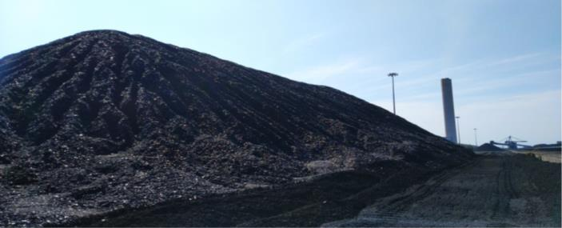

Fig2.1.3 Coalyard

GYPSUM
Gypsum: is as of tsulfate mineral composed of calcium sulfate dihydrate, with the chemical formula CaSO4·2H2O. It is widely mined and is used as a fertilizer and as the main constituent in many forms of plaster, blackboard/sidewalk chalk, and drywall.
Gypsum plays an important role in cement production, it controls the setting time of cement, that is, it slows down the hydration process in cement on ceit is mixed with water. The effects of gypsum on cement are as follows:
1. Gypsum prevents the flash setting of cement during manufacturing.
2. It retards the setting time of cement.
3. It allows a longer working time for mixing, transporting, and placing of the cement.
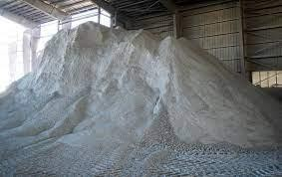
Fig2.1.4Gypsumyard

2.1.5 IRON DUST

It contains mainly iron oxide (Fe2O3) and its usage should be 1 to 2% in cement.

It was found that the optimal quantity of Fe2O3 is0,01% by weight of cement in the presence of

polymer powder PAV-22, because it increases the hardened cement stone flexural strength, and slightly

decrease the compressive strength.

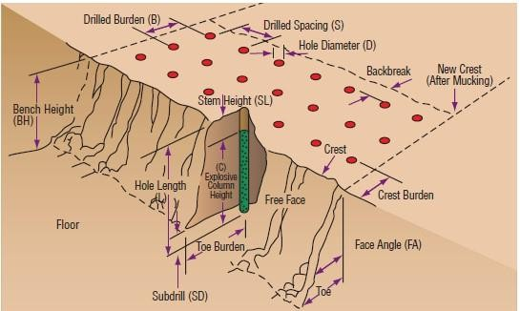
Figure2.2.1.1: Blasting Design and formulas

Compilation of Research Memos
I imbibed the culture of recording reflective notes during data collection and analysis; this helped keep myself and Team a embedded in the empirical reality and contribute to the reliability of the project. I complied research for every conceptual idea derived from differentincidentsfrombothTeamAandTeamBbasedontheprinciplesinstilledinmeby the Mines Manager and his reiteration of the fact that “memo is an important element of data analysis”

2.2.1.3 Review of various Standards Publication
As part of my responsibilities as an engineering intern, I reviewed relevant International Standards (ISO) such as; A new ISO subcommittee on mining reclamation management (ISO/TC 82/SC 7) has recently been created to develop International Standards that can helpminimizethepotentiallong-termdamagefromminingactivities,thusenhancingthe quality of life of residents living in a mining area, ISO 14001, etc. Indian Standards (IS) andvariousPublicationonlimestoneprocessesandmining.Onthereviewofthevarious publications and reports, I outlined the various mining methods and calculations of explosives to be charged during mining.

2.2.2 Quarry Unit

I, together with other trainees were assigned to the quarry/mining unit to experience first- hand the mining process and techniques that we have been taught within the walls of the classroom. It allowed us practical hands-on experience with some of the machines and equipment used on the site while under the vigilance of our supervisor. The quarry unit is mainly responsible for the extraction of limestone ores by blasting and using mechanical excavation from the quarry which is basically a Limestone process.

Safety in the Mines
Starting from the first day of resumption, the company’s HSE department took their time in reeling us in on the safety rules, risks and precautions to be taken whenever we were on site. The orientation included visits to every department in the company including the Mine Site, where they handed us over to a senior technician and the blaster who disseminated information about each equipment and machine, their safety guidelines, and the risk of not adhering to the rules which could lead to fatal injuries. I learnt the meaning of all safety signs on sites and also made sure I always had my Personal Protective Equipment (PPE) whenever I am in the quarry.
Some of the safety rules I learnt are;
        - Workers have a duty to always use correctly their personal protective equipment (PPE) provided by the company. Examples include; hearing protection, respiratory protection, hard hats/helmet, steel toe-capped boots.
        - The use of high-visibility clothing greatly improves the visibility of workers in the quarry and reduces their exposure to the risk of an accident.
        - Workers should always use the designated pedestrian routes.
        - Maintainequipment–Performregularequipmentmaintenancecheckstoensurethat hand tools and automated machines are functioning properly and updated as necessary to avoid errors and a higher probability of injury. Also, do not leave any machine/equipment on and unattended to.
        - Ring the alarm and go to the safe zone whenever there is an emergency.
        - Mobilephonesandradioshouldnotbeusedbyanyanyoneoperatingtheplantor during blasting.
        - Workers should never engage in improper behaviour.
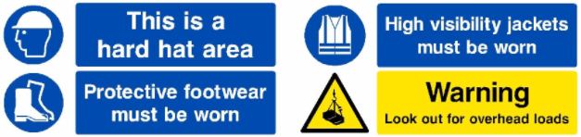

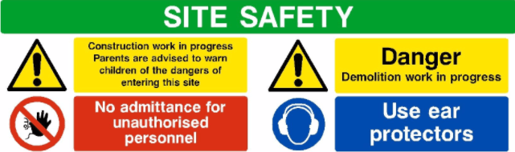

Figure2.2.2.1: Some safety signs and their meanings
2.2.1.4 LIMESTONE PROCESS
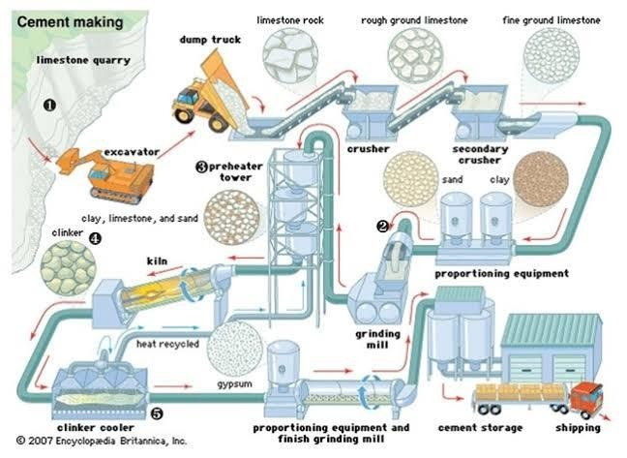
Being under the tutelage of the mining engineering, I learnt the process involved in mining limestone from the quarry, how to interpret and read blast design. I was taught the importance of calculating the explosive to be charged before blasting which plays abigrole in avoiding damages to the earth surfaces which might lead to earth tears and other hazards. Limestone Process, In the field of metallurgy, it is the art of treating crude ore sand mineral products (Limestone) in order to separate the valuable minerals from the waste rock or gangue. It is the first process that most ores undergo after mining.
Figure2.2.2.2: Limestone Process flowchart, Cement Production.
The limestone Process is divided into two major part namely;
- Limestone Mining process
- Cement Production

LIMESTONE MINING PROCESS
There are 5processes involved in the mining of limestone from the quarry, which are:
  - Overburden
  - Drilling
  - Blasting
  - Haulage/ Excavating
  - Crushing
OVERBURDEN: In mining, overburden (also called waste or spoil) is the material that lies above an area that lends itself to economical exploitation, such as rock, soil, and ecosystem that lies above the ore (limestone) body. Overburden is removed during surface mining, but is typically not contaminated with toxic components. It may also be used to restore an exhausted mining site.
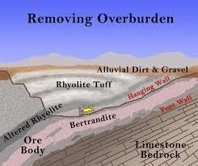
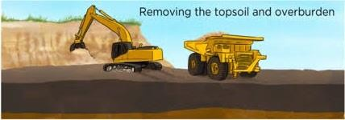
Figure2.2a: Overburden process

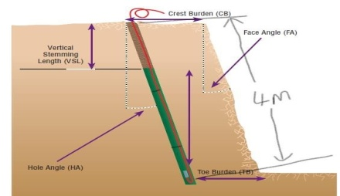
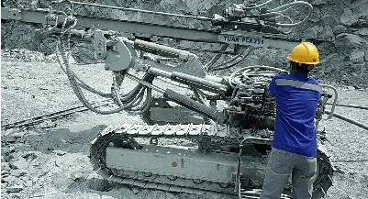
DRILLING: By its nature, mineral exploration involves drilling to discover what is below the surface. In regards to limestone mining, Surface drilling is needed to carry out blasting and the explosive has to be inserted in the hole, and in surface drilling, we carry out this drilling either vertical or slightly inclined.

Figure2.2b: inclined drilling Figure2.2 .cooperating the air hydraulic crawler for drilling

We have various drilling patterns which have been developed and aid particles fragmentationwhenblasting.Thesepatternsrefertothepatternoftheinitialscutwhichare then blasted into from the surrounding holes. The various drilling patterns are;
- Rectangle drilling pattern
- Square drilling pattern
- Triangle drilling pattern

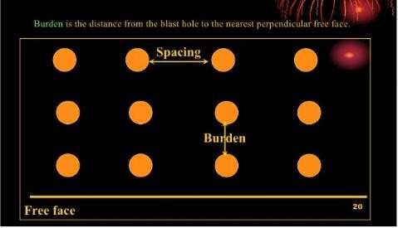

Figure2.2d: Square drilling pattern
BLASTING: Drilling and blasting are the most frequently used rock excavation techniques. Blasting breaks rocks and quarries for aggregate production operation oral so to excavate. Blasting is accomplished by discharging an explosive that is either placed in an unconfined or confined space such as the drill hole. Commercial high explosives widely used for blast hole charge are dynamite and ANFO (Ammonium Nitrate fuel oil).
Dynamite is used extensively for initiating or charging the blast hole, this nitroglycerin based product is the most sensitive of all the generic classes of explosives in use. Individual cartridges vary in size from approximately 90mm in diameter and weigh 25kg, a detonator or a prima cord may be used to fire. In surface blasting, millisecond delay and electronic detonators are frequently used. Millisecond delay blasting can be used both in single drill row or multiple row shots, when each charge breaks the part of rock mass from the burden before the next charge denotes, ground vibration, air blast, and fly rock are minimized and fragmentation is increased.

TYPE OF BLASTING TECHNIQUES
There are three main types of blasting techniques which are;
1. PRIMA BLASTING
2. ELECTRIC BLASTING
3. NONNEL (Non electric initiation system) BLASTING
HAULAGE: This involves the transportation of limestone from the quarry with the use of various transporting machines such as; dump hopper, tractor, or excavator. The limestone are been transported to the crusher (Jawcrusher) and then stored at the limestone stock yard for further uses.

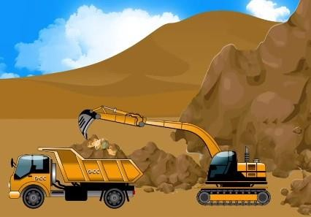
Figure2.2e: transport of the limestone with the excavator
CRUSHING: Crushing is the largest process operation in mineral processing. The goal of this process is to produce or mineral fractions to be used as raw materials for industrial production. A crusher is used for the crushing process, which is a machine designed to reduce the size of the ore materials fed into it. The crushing process is divided into two stages which are; primary and secondary crushing.
Primary crushing is the first stage of material reduction and can sometimes be the only stageneededtogeneratethedesiredproductforthejob.Dependingonthesetup,primary crushing will take the larger material that has been blasted, excavated, or reclaimed and process it through an impactor, jaw, or gyratory crusher to generate a specific range of product sizes needed for production.
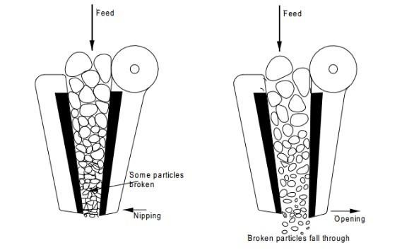
Secondary crushing is the second stage of material processing following its initial reduction. At this stage, them aterial will flow through perhaps second impactor or even a cone crusher, which is effective in breaking down the materials.
Figure2.2f: Crushing process

CEMENT PRODUCTION

The process for cement productionisdividedinto4stages and they are;
  - Raw Mill
  - Kiln
  - Cement Mill
  - Parking
These stages are further explained using the images below:
    - The crushed limestone from the Jaw crusher is stacked through the Chev-con method in a continuous circular blending pile. The stacked limestone is reclaimed by a reclaimer and transported to raw mill hoppers.

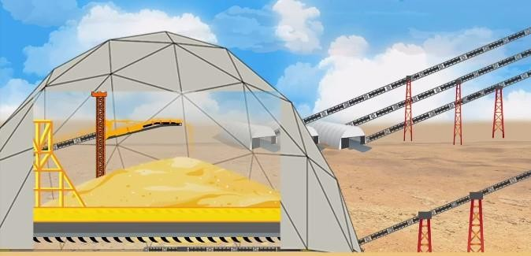

Figure2.2g: Stacked limestone stored
    - Pre-blended raw materials (limestone, coal, iron dust, laterite) conveyed to the raw mill’s hoppers through a belt conveyor. The weigh feeder counter belt proportions the raw materials according to the cement being produced. The mixture is then taken to tube raw mills which are used for grinding the materials using the milling balls. The final blend known as Raw meal is moved to the Homo Silos for homogenization and then stored in the storage silos

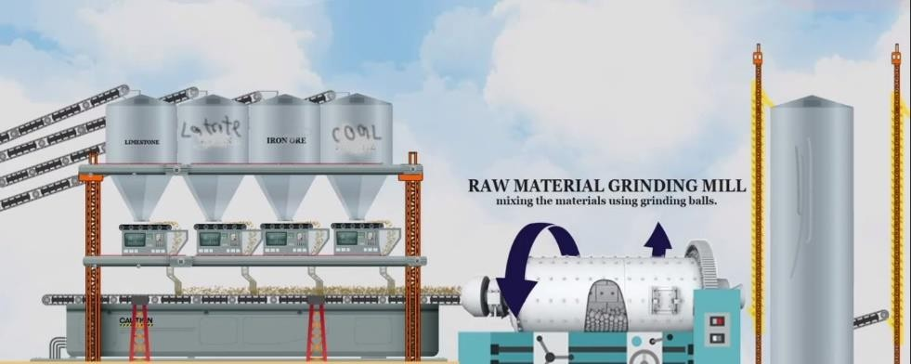

Figure2.2h: rawmil process in cement production

- The heat exchange tower or preheater tower consists of 5 cyclones and interconnecting riser ducts. The heat transfer between the raw materials and hot gases current from the kiln takes place. Raw meal from the preheater is then moved to the rotary kiln. The kiln is a cylindrical vessel inclined slightly horizontally, which is rotated slowly about its longitude axis. Clinker cooler cools the hot granules of clinker by quenching air into it bringing the temperature down to less than or below 100ºc, several chemical reactions take place in a thermal condition created by burning fuel, i.e natural gas to get the Output product Clinker, the main ingredient to produce cement. Clinker cooler cools below 150ºc.

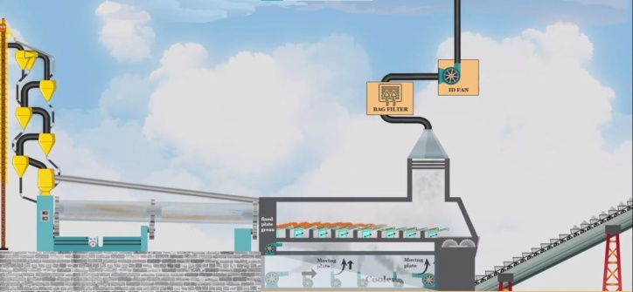

Figure2.2i: Reactions at the kiln

From the clinker silo clinker is transferred to the clinker hopper at the cement mill. The weigh feeders in the cement mill regulate the flow of cement, gypsum, and additive proportionately. Gypsum is added to the clinker and then fed to the finish grinding mills.

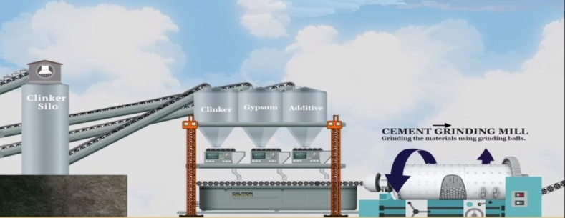

Figure2.2j: Process at the cement mill
    - Finished product cement from the cement mill is stored in the cement silo based on the type of cement produced (which is Ordinary Portland Cement OPC). The cement is then packed and loaded to be delivered to the customers.
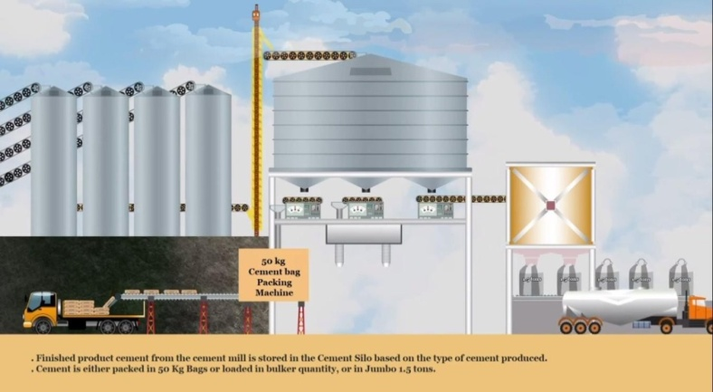

Figure2.2k: Packing process

CHAPTER THREE

OBSERVATIONS
I saw the disparity between the school atmosphere and the labor market as a student and made the following observations:
    - I also noticed that safety was a top priority and that it could easily be seen as the major purpose of the entire company's workforce, not just the technicians. Safety equipment and instructions were always installed or made available in key locations across the organization, such as the mines, workshop, service desks, administrative offices, and receptions.
    - Another important quality was neatness. Technicians were always exhorted to be as neat as possible in their dressing and in carrying out their tasks, despite the fact that the work is often perceived as a dirty one. This was aided by providing rewards to technicians who could follow the guidelines to the letter.

TECHNICAL SKILLS AND PROFESSIONAL KNOWLEDGE GAINED
- Ability to carry out a research to picin my discipline.
- Ability to gain first-hand experience in mining.
- Ability to gain transferable skills which are communication (verbal and listening skills), critical thinking (problem-solving, analytical thinking, and teamwork which are all important skills needed in the workspace.
- Ability to operate the air hydraulic drilling machine.
- Ability to carry out and design correctly the type of drilling pattern needed to be drilled before blasting to ensure fragmentation.
- I learnt that every industrial practice and process is carried out in the agreement to a predefinedstandardasthisguaranteesrepeatabilityandreproducibility, consequently validating the outcome of the process and/or test results.
- My exposure to the auditing process of the organization allowed me to understand the relevance and importance of documentation of processes and results as it serves as a means of validation.
- The opportunity to apply the theoretical knowledge thought within the walls of the classroom was of utmost relevance. I was exposed to the practice background on mineral processing, destructive testing of materials, materials election, and other
engineer materials mainly applicable in mineral processing industries. This opened a window of opportunities into the highly diversified field of metallurgy and materials engineering and left me with a range of options to pursue as a career.

RELEVANCE OF EXPERIENCE GAINED TO CLASSROOM KNOWLEDGE
The relevance of the experience gained can be linked to the following courses;
MME532–MINERALPROCESSINGTECHNOLOGY–(lime stone process) MME 417 – MATERIALS LABORATORY II – (chemical lab/physical lab) MME 326 – MATERIALS PROCESSING I – (physical lab)
MME324–PROPERTIES OF MATERIALS–(limestone process/ chemical lab) MME 322 – MATERIALS LABORATORY I – (chemical lab/physical lab)
MME331–PYRO-METALLURGICAL PROCESSES–(cement production-kiln) MME313– MATERIALS IN ENGINEERING DEVELOPMENT –(physical lab)

PROBLEMS ENCOUNTERED DURING THE PROGRAM
Six months of industrial training at Solid Mineral Index Company Limited (SMICL) couldn't have gone any better despite the many challenges I faced during my programme as an industrial trainee. These challenges, if looked into and acted upon with possible solutions, would greatly improve this program. Some of these very glaring challenges are:
- Inability to secure a placement: This proved to be one of the greatest challenges I faced as companies I visited to submit my placement form were either not accepting IT trainees or I had to know someone on the inside in other to facilitate acceptance or those who accepts for letters to be submitted never sent a reply across later on. This is one of the major causes for students not starting their industrial training at the speculated time.
- Remuneration: This was an equally daunting challenge as the company where I worked, SMI didn’t have any form of remuneration for their IT trainees. The financial burden wastelling heavily on my pocket as transportation fare and feeding were my sole responsibilities.
- Restriction to certain areas of the company: Some areas were restricted, where I was a trainee was unable to enter and learn. This restriction was also a daunting problem I encountered during my training.
- Difficulty in operating machines: During the early month of my industrial training, it proved quite difficult to operate some machines like the air hydraulic crawler drilling machine. However, I became more acquainted with it through regularity at work and constant practice.

CHAPTER FOUR

CONCLUSION
The idea behind the Student Industrial Work Experience Scheme should be commended because it has afforded students like me the opportunity to apply our theoretical knowledge into real-life practical applications, equipping us with the technical know-how and required skills to tackle the challenges in our respective fields as well as the opportunity to interact with experienced veterans in our various fields and learning from their experiences.
My six months industrial attachment as a materials engineering internet Solid Mineral Index Company Limited was an enormous achievement and a great time of acquisition of knowledge and skills. Through my training, I was able to appreciate my course of study considerably more, because I had the opportunity to blend the theoretical knowledge acquired from school with the practical hands-on experience gained here to perform important tasks that contributed in a way to my productivity in the company. My training here has given me a more extensive view of the significance and relevance of Metallurgical and Materials Engineers in the immediate society and the world in general, as now anticipate impacting it positively after graduation. In addition, I have been able to improve my communication and presentation skills and subsequently built a good relationship with my colleagues and supervisor at work. I have also been able to appreciate the connection between my course of study and other disciplines in producing a successful result.

RECOMMENDATION
The following recommendations were made regarding the SIWES scheme:
    - The portion of the ITF act which covers the employment of students by firms needs to be better implemented and strictly adhered to by companies. Ideally, companies shouldn't reject students requesting to do their SIWES with them, more so if the student's course of study is related to that firm, irrespective of whether the student's school and the company are in the same state or not. The implementation of this act
should also include a form of punishment or fine for defaulting companies after proper inspection. Avenues should also be created through which students who are not treated right by the companies in which they work can air their views for appropriate discipline. When companies within the vicinity of a student employ him, it will also solve the problem of students having to go to long distances either when searching for IT placements or to work at far distances without pay, as it is known that some companies do not pay their IT students.
    - The designated stipend for students participating in the SIWES program should be made available at the beginning of every month as this will lessen the financial burden on the students. If possible, students
    - I implore all necessary authorities within the institution, industry, and relevant government agencies to vehemently pursue academic-industry partnership on various research agendas this would spur innovation for technological development of the society.
    - Finally, securing industrial attachment proved quite difficult for some students therefore, it would be of great advantage if the school could recommend students to preferred places of industrial attachment relevant to their course of study.

REFERENCES

Mafe, O.A.T, (2015). Students’ Industrial Work-Experience Scheme (SIWES)– Guideto Successful Participation in SIWES. Akoka-Yaba, Lagos. Unilag Press and Bookshop Ltd.
LimestoneProcessRetrievedfromhttps://en.wikipedia.org/wiki/Limestone-process

https://www.911metallurgist.com/mineral-processing-services/#

https://en.wikipedia.org/wiki/Cement-prodctions

https://www.thermofisher.com/blog/mining/the-cement-manufacturing-process/#:~:text=Cement%20manufacturing%20is%20a%20complex,C%20in%20a%20cement%20kiln.

