

A TECHNICAL REPORT ON
STUDENT INDUSTRIAL WORK EXPERIENCE SCHEME (SIWES)
HELD AT
DINNERS HOTEL
9, ADEJOYE OBADORE, IGANDO, LAGOS STATE, NIGERIA.

BY
RAHEEM SOFIAT OYINKANSOLA
ND/23/BAM/PT/0520
SUBMITTED TO

DEPARTMENT OF BUSINESS ADMINISTRATION AND MANAGEMENT,

INSTITUTE OF FINANCE AND MANAGEMENT STUDIES,

KWARA STATE POLYTECHNIC ILORIN KWARA STATE.

IN PARTIAL FULFILMENT OF THE REQUIREMENT FOR THE AWARD OF NATIONAL DIPLOMA (ND) IN BUSINESS ADMINISTRATION AND MANAGEMENT

AUGUST – NOVEMBER, 2024
CERTIFICATION
This is to certify that the report was based on SIWES experience gained by RAHEEM SOFIAT OYINKANSOLA with matric. number ND/23/BAM/PT/0520 of Department of Business Administration and Management, Institute of Finance and Management Studies, Kwara State Polytechnic, Ilorin, Held at DINNERS HOTEL, 9, ABEJOYE OBADORE, IGANDO, LAGOS STATE, NIGERIA as Part of the requirement of the course.

DEDICATION
This Technical report is dedicated to Almighty ALLAH, the Author of all Knowledge and it is equally dedicated my Parent (MR. AND MRS. RAHEEM) and all my family members for their Spiritual, Moral and Financial Support throughout the period of this programme, wishing them long life and a healthy life (Amen).

ACKNOWLEDGEMENT
I acknowledge the Highest GOD for His power and mighty work of love in my life helping me through the years of my studies.
My sincere gratitude and appreciation to my Parent (MR. AND MRS. RAHEEM) and all my other family for their moral and financial assistance at all times.
To all my lecturer goes this gratitude creating time to impact knowledge and making understand the importance of studying.
Finally, to my SIWES coordinator who has find time to help me out during the course of the programme.

PREFACE

The writing of this report was motivated by the experience gained during my SIWES attachment NEW-WAY SUPER MARKET, OPPOSITE WORU MARKET, AGUNBELEWO, OSOGBO, OSUN STATE, NIGERIA. This report is meant to be a guideline to every student.

The purpose of writing this report is to relate the various area which I participated during the Industrial Training Attachment in my place of work. It is indeed very encouraging that all students to get acquainted with what is been done in class, so as to be familiar with what is been done in the practical field.

Finally, This Industrial Training Attachment is required for every student because it tends to backup and build the students physically, morally and educationally for the task after graduation.

TABLE OF CONTENT
Cover page
Certification
Dedication
Acknowledgement
Preface
Table of content
CHAPTER ONE
1.1 Introduction
1.2 Definition of SIWES
1.3 General Objectives of SIWES
CHAPTER TWO
2.1 Historical Background of ORGANIZATION
2.2 Organogram of ORGANIZATION
CHAPTER THREE
  - Technical Training Experience
CHAPTER FOUR
4.1 Relevance of experience gained to student field of study
4.2 Interpersonal Relationship with the Organization
CHAPTER FIVE
  - Conclusion and Recommendation
5.2 Personal impression about the organization
5.3 Suggestion and recommendation to the organization and the polytechnic concerning the SIWES programme

CHAPTER ONE
1.1 INTRODUCTION
Student industrial work experience scheme (SIWES) is set for the development by the federal government for student to facilitate them with basic practical knowledge to deviate from predominant dependence on foreign experience and be self-reliable and creative through the training rendered by the organization in question
1.2 DEFINATION OF SIWES
SIWES can be defined as an organized body basically to equip student with basic knowledge through industrial training
1.3 AIMS AND OBJECTIVES OF SIWES
The aims and objectives of industrial training are as follows:
- It enables student to know their possible area of employment whengraduated from school.
- To access students’ interest and their ability in the course they havechosen.
- To expose students to modern equipment while they do not access to.
- To make student know the meaning and application of their cause of study.
- To give maximum experience to the student.
- To connect students professionally.

CHAPTER TWO
BACKGROUND INFORMATION
2.1 HISTORICAL BACKGROUND OF THE ORGANIZATION
Dinners Hotel is located at Afolabi Bus Stop, Along Igando - Lasu road, Badia Ijora, Lagos. While I couldn't find a detailed historical background of Dinners Hotel, here's what I know about the hotel:
- About: Dinners Hotel is a budget-friendly hotel providing comfortable accommodations for travelers and visitors. They offer complementary meal services and hospitality solutions at affordable costs.
- Contact: You can reach them at 0903 611 8405 or +234 814 880 8800, +234 700 880 8800.
- Amenities: Although specific amenities aren't listed, similar hotels in the area offer services like laundry, banquet halls rental, and local and continental dishes.
MISSION AND VISSION
- Mission Statement: "To provide exceptional hospitality and create memorable experiences for our guests, while building a strong reputation for quality and service."
- Vision Statement: "To be the leading hotel brand in our market, known for our innovative approach to hospitality and our commitment to excellence.
2.2 ORGANOGRAM OF TEMIADARA POULTRY VENTURES.
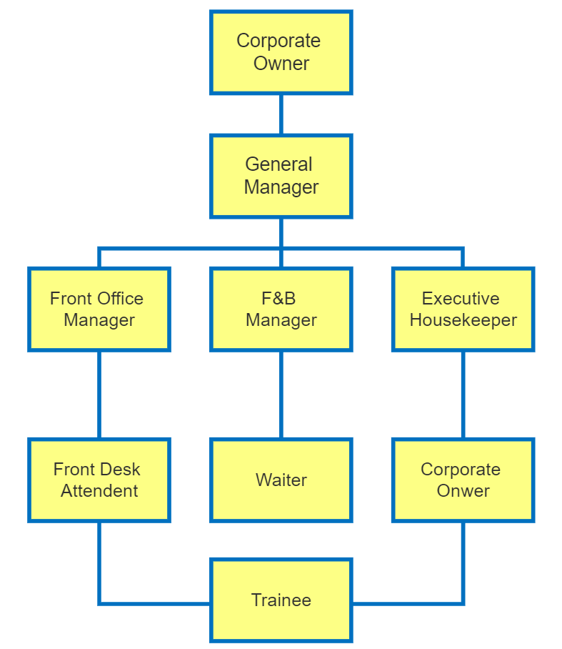
CHAPTER THREE
TECHNICAL TRAINING EXPERIENCE
3.1 INTRODUCTION TO INVENTORY RECORDS
INTRODUCTION TO STORE
Store refers to the physical arrangement of a retail store's interior, including the placement of fixtures, shelving, and merchandise. A well-designed store layout aims to create an attractive and functional shopping environment that enhances the customer experience, improves navigation, and ultimately drives sales.
Objectives of Store Layout
1. Create an Attractive Shopping Environment: A visually appealing store layout that showcases products effectively.
2. Improve Customer Navigation: A logical and easy-to-follow layout that helps customers find what they're looking for.
3. Increase Sales: Strategic placement of products and promotions to encourage impulse buying and increase average transaction value.
4. Enhance Customer Experience: A comfortable and engaging shopping environment that encourages customers to linger and return.
Types of Store Layouts
1. Grid Layout: A traditional layout featuring parallel aisles and shelves, often used in supermarkets and big-box stores.
2. Racetrack Layout: A circular or oval layout that guides customers through the store, often used in department stores and specialty retailers.
3. Free-Flow Layout: A flexible layout that allows customers to move freely throughout the store, often used in boutiques and specialty stores.
4. Mixed Layout: A combination of different layout types, often used in larger stores or those with multiple departments.
Key Considerations in Store Layout
1. Customer Flow: The path customers take through the store, influencing product placement and promotion.
2. Product Placement: Strategic placement of products to maximize visibility, accessibility, and sales.
3. Fixtures and Shelving: The type and placement of fixtures and shelving, affecting product display and customer navigation.
4. Signage and Visual Merchandising: The use of signs, displays, and other visual elements to communicate with customers and enhance the shopping experience.
5. Lighting and Ambiance: The lighting and ambiance of the store, influencing customer mood and behavior.
Benefits of Effective Store Layout
1. Increased Sales: A well-designed store layout can increase sales by encouraging customers to explore the store and make impulse purchases.
2. Improved Customer Satisfaction: A logical and easy-to-follow layout can reduce customer frustration and improve overall satisfaction.
3. Enhanced Brand Image: A visually appealing store layout can reinforce the brand's image and values.
4. Reduced Operating Costs: An efficient store layout can reduce labor costs, improve inventory management, and minimize waste.
DEFINITION OF INVENTORY RECORDS
Inventory records refer to the systematic documentation and tracking of inventory items, including their quantity, location, value, and other relevant details.
Inventory records are a crucial aspect of inventory management, enabling businesses to track and manage their stock levels, monitor inventory movement, and make informed decisions about inventory replenishment and optimization.
Importance of Inventory Records
1. Accurate Inventory Tracking: Inventory records provide a real-time snapshot of inventory levels, enabling businesses to track inventory movement and identify trends.
2. Improved Inventory Management: Inventory records facilitate informed decision-making about inventory replenishment, optimization, and disposal.
3. Enhanced Supply Chain Efficiency: Inventory records help businesses to optimize their supply chain operations, reducing lead times and improving delivery performance.
4. Better Customer Service: Inventory records enable businesses to provide accurate product availability information, improving customer satisfaction and loyalty.
5. Reduced Inventory Costs: Inventory records help businesses to identify areas of inefficiency and waste, reducing inventory holding costs and improving profitability.
Types of Inventory Records
1. Physical Inventory Records: Manual or automated records of physical inventory counts.
2. Perpetual Inventory Records: Continuous records of inventory transactions, including receipts, issues, and adjustments.
3. Cycle Count Records: Records of regular inventory counts, used to verify inventory accuracy and identify discrepancies.
Key Components of Inventory Records
1. Item Description: Detailed description of the inventory item, including its characteristics and attributes.
2. Quantity: The physical quantity of the inventory item on hand.
3. Unit Cost: The cost of a single unit of the inventory item.
4. Total Value: The total value of the inventory item, calculated by multiplying the quantity by the unit cost.
5. Location: The physical location of the inventory item, including the warehouse, bin, or shelf.
Best Practices for Maintaining Inventory Records
1. Regular Updates: Regularly update inventory records to reflect changes in inventory levels and transactions.
2. Accurate Data Entry: Ensure accurate data entry to prevent errors and discrepancies.
3. Standardized Processes: Establish standardized processes for inventory recording and reporting.
4. Inventory Audits: Conduct regular inventory audits to verify accuracy and identify areas for improvement.
5. Training and Support: Provide training and support to staff responsible for maintaining inventory records.

CHAPTER FOUR
4.1 RELEVANCE EXPERIENCE GAINED TO STUDENT FIELD OF STUDY
After the SIWES program I gained how to operate as a Business Administration student in a DINNERS HOTEL.
Furthermore, I was introduced to other section of the organization, where I was taught how to engage to different works, such as:
a. Learning about inventory records, its importance and recheck shelves with products.
b. Helping customers transactions at the checkout counter for proceed payment.
c. Learning in stock taking and check for new arrival of products.
d. Counting out the items
f. I do engage into daily routine for all Sections which as follows:
a. Cleaning the shelves and product
b. Checking the register book for the proper auditing
4.2 INTERPERSONAL RELATIONSHIP WITH THE ORGANIZATION
During my stay at the DINNERS HOTEL, I enjoy every bit of it until the last hour of my departure as a SIWES student.
Starting with the Director, Board-members to all the coordinators, and my supervisor showed love and care to me like parent to his daughter.
My cordial relationship with the instructor in my section helps me a lot in the sense that, he never relent in answering my question both theoretical and practical.

CHAPTER FIVE
SUMMARY, CONCLUSION AND RECOMMENDATIONS
5.1 CONCLUSION
Even though there was a little hardship especially when the work of the organization is pilled up on me and payment was very meager for transportation.
The SIWES program at the organization give me a wonderful and everlasting experience. The program is readily helped to bridge the gap between theoretical aspect and practical work in the industrial training.
5.2 RECOMMENDATION TO THE ORGANIZATION
Since the SIWES cannot be overemphasized in all aspects in the recent times, I therefore think it is standard enough for any student of Business Administration and Management to be giving opportunity after school in this organization to serve and possible employed if he/she deem it.
5.3 SUGGESTION FOR IMPROVEMENT OF THE SCHEME
Base on the experience and knowledge acquired at the course of the SIWES training, I hereby give the following recommendation base on my observations;
• Proper orientation should be given to the students by the Polytechnic before they go on SIWES.
• The placement letter should be given to students early enough so as to avoid attachment in irrelevant organization.
• Institution should ensure that students are attached at relevant establishment for effective training, experience and exposure.
• Government, ITF and the Institution should ensure that students do not pay any amount of money before accepted in any organization. This organization should be sensitized on the objective of SIWES training and the need why they should not collect money before accepting students.

