

A TECHNICAL REPORT ON THE STUDENT INDUSTRIAL WORK EXPERIENCE SCHEME (SIWES)

HELD AT

KWARA STATE MINISTRY OF WORKS AND TRANSPORTATION
AHMADU BELLO WAY ILORIN KWARA STATE

WRITTEN BY

MICHAEL ISAAC
ND/23/CEC/PT/0263

SUBMITTED TO
THE DEPARTMENT OF CIVIL ENGINEERING
INSTITUTE OF TECHNOLOGY
KWARA STATEPOLYTECHNIC P.M.B 1375 ILORIN NIGERIA

IN PARTIAL FULFILMENT OF THE REQUIREMENT FOR THE AWARD OF NATIONAL DIPLOMA (ND) IN CIVIL ENGINEERING DEPARTMENT KWARA STATE,POLYTECHNIC ILORIN,NIGERIA.

AUGUST-DECEMBER, 2024

DEDICATION
I gratefully dedicate this SIWES report to Almighty God, the most awesome and merciful who gave me the uncountable opportunity to participate in the program. And also dedicated to my parent Mr and Mrs. Michael Isaac.

ACKNOWLEDGEMENT
First and foremost, I give thanks to Almighty God, the creator of the universe for greatest protection and love been given to me as a privilege to start and complete my SIWES programme.
I also appreciate the effort of the entire staff of Ministry of works and Transportation for the tremendous moral assistance throughout the period of my attachment and also my grateful to my lovely friends for their contribution in one way of other. May almighty God bless them all and provide for their needs.

TABLE OF CONTENT
Title page i
Dedication ii
Acknowledgement iii
Table of content v

CHAPTER ONE
1.0 Introduction 1
1.1 Definition of SIWES 2
1.2 Purpose of SIWES 2
1.3 Objective of SIWES 2

CHAPTER TWO
2.0 Brief history of the organization 4
2.1 Major activities of the organization 5
2.2 The organization chart 6
2.3 Unit of the organization and their specific function 7

CHAPTER THREE
3.0 Work-done 8
3.1 Bridge 8
3.2 Types of Bridge 8
3.3 Road Pavement 10
3.4 Type of Road Pavement 10
3.5 Drainage Construction 11
3.6 Type of Drainage Construction 11
3.7 Process of Construction Reinforced Concrete Drainage 12
3.8 Important of Drainage 12
3.9 Culvert 13
3.10 Types of Culvert 13
3.11 Materials and Instrument used in culvert construction 18

CHAPTER FOUR
4.0 Experience gain 20

CHAPER FIVE
5.0 Conclusion 21
5.2 Recommendation to the Institution on SIWESProgramme 21

CHAPTER ONE
1.0 INTRODUCTION
The student industrial work experience scheme (SIWES) was by the federal government through the ministry of commerce and industry the nation in corresponding with a body known as Industrial Training Fund (ITF).ITF established SIWES in 1973 to solve the problem of lack of adequate practical skills preparatory for employment in industries by Nigeria graduates of tertiary institutions.
The (SIWES) programme helps the student to practicalize most of the theoretical aspect of their curriculum which they have been taught in their first year in school, likewise it gives solution to some problems of student in terms of practical, this will enable them to always remember and be in their mind forever because is what they practiced with their own hands. This report its base on the experience, which I gained during my four months Industrial Training at Ministry of Works and Transportation Ilorin.
This program provides employment opportunity for student. It also exposed student to the needed experience in the real time job demands and human relation within and outside the country depends on the area in which they find themselves.
1.1 DEFINITION OF SIWES
The students industrial work experience Scheme (SIWES) is a skill acquisition training programme that forms part of the minimum academic requirement standards in various programs of Nigeria tertiary institution, it helps students to put what they have learnt theoretically in class into practice in the real problem world. It commences after the second semester exam and is a compulsory course to all ND1 going to ND2 students, it is a four (4) unit credit course, so which if by any adventure a student fail to participate in the exercise, will attract him/her a failure which makes the person repeat by delaying for extra year in school.
1.2 PURPOSE OF SIWES
SIWES was purposely introduced in order to make student acquires more knowledge about methods of some professional works and to exposed them to the use of some equipment in the program and also help the student on how to get up and safeguard their own industry and organization in future.
1.3 OBJECTIVE OF SIWES
Specifically, the objectives of the student industrial work Experience are:
- It enabled students to be self-dependant not in theoretical aspect but also on practical aspect in the field of study.
- SIWES program prepare students for the work situation they are likely to meet after graduating from school.
- It exposes the students to some equipment which are not available in school.
- It also helps to know the general precaution, rules and regulation of an establishment.

CHAPTER TWO
2.0 BRIEF HISTORY OF THE ORGANIZATION
Kwara state ministry of works and transport sited along Ahmadu Bello way, it was set up by the state government to control some specific activities in rural and urban centre development in term of routes and other external works in the state. The organization was first known as public work co-operation since creation of kwara state in 1967 until some years back when it was changed to kwara state ministry of works and transport’’ with its headquarter at Ilorin the state capital.
Kwara state ministry of works and transport was meant for developments of new route, construction of road network and countdown of bridges for public utility project in the state. The organization has done so many construction works and has been the client of majority of construction work done in Kwara state. Eg construction of township roads in Kaima, Erin-ile, Offa, Shonga and rehabilitation of roads along Sabo-Oke, GRA, Ipata, Sango etc. Construction of post office flyover in Ilorin and so many construction works that could not be mentioned. They are ensuring the easy conveyance of goods services from one area to the other through construction and rehabilitation of roads, highways, bridges, flyovers etc.
2.1 MAJOR ACTIVITIES OF THE ORGANIZATION
Civil engineering department of the ministry of works and transport represent government in any ongoing project i.e. engineering project (i.e civil, electrical and mechanical) to ensure that the said project is done to specification. Also, job of the ministry of works and Transport are to monitor the activities on road, development of new routes and maintenance of road and advised the state government on what to done to make such road effective.
The ministry is also responsible for the supervision of the activities of the following underlined parastatals.
- Kwara road maintenance agency (kwarma)
- Kwara state transport co-operation (kwara express)
2.2 THE ORGANIZATION CHART
HON. COMMISION
PERMANENT SECRETARY
DIRECTOR (FS)
DIRECTOR(ME)
DIRECTOR (CE)
DIRECTOR (FM)
DIRECTOR (PRS)
ADS
CF
AD FIRE
OTHERS
OTHERS
ADS
CEO
OTHERS
AD
CCE
VIO
ADME
OTHERS
ACME
OTHERS
PO
CS

2.3 UNIT OF THE ORGANIZATION AND THEIR SPECIFIC FUNCTION
The organization possessed four sections in civil department.
- Civil engineering design unit
- Civil engineering construction unit
- Civil engineering management of materials
- Civil engineering maintenance unit
CHAPTER THREE
3.0 WORKDONE
3.1 ROAD PAVEMENT
Road construction/Road pavement is the portion of the road located directly above the sub grade and beneath any wearing surface. In urban areas it is often bordered by kerbs and channel and in rural areas by road shoulders.
3.1.1 TYPE OF ROAD PAVEMENT
There are two main types of road pavements. These are
- FLEXIBLE PAVEMENT: A flexible pavement yields “elastically” to traffic loading. It is constructed with a bituminous-treated surface or a relatively thin surface of hot-mix asphalt (HMA) over one or more unbound base courses resting on a subgrade. A flexible pavement structure is typically composed of several layers of materials, each layer receives the road from the above layer, spread them out, then passes on these load to the next layer below.
- RIGID PAVEMENT: Rigid pavement is the technical term for any road surface made of concrete. Concrete roads are called rigid. These terms refer to the amount of deformation created in the road surface itself when in use and over time.
3.1.2 DRAINAGE CONSTRUTION
Drainage is the natural or artificial removal of surface of surface and sub-surface water from an area. Drainage construction as the name implies is one channel that excess water is discharge to the outlet. Drainage is constructed beside a road so as to carry away excess water from road to prevent from crack or other failure on road.
3.1.3 TYPE OF DRAINAGE CONSTRUCTION
There are different types of drainage construction. These are,
- BLOCK LINE DRAINAGE: this is a drainage that is been constructed using block as the wall of the drain. This drainage is cost efficient compare to other type of drainage.
- REINFORCED CONCRETE DRAINAGE: this is a drainage that is constructed using reinforced concrete as the wall of the drain. Reinforced concrete is brought as the wall of the drain.
3.1.4 PROCESS OF CONSTRUCTION REINFORCED CONCRETE DRAINAGE
- Measurement of width: The measurement of width of the trench and pegging is done with rope to obtain a straight trench of the drainage.
- Blinding: This is done to give a good attachment to both ground and concrete.
- The walling reinforcement casting: These are lay in to prevent under movement of the drainage wall.
- Form work construction: This is the process of fixing plank together to guide the falling walling concrete casting.
- Concrete mixing and casting: This is the mixture of gravel, sand cement and water at a ratio depending on how you want it. Mixing concrete is being transfer to the spacing provides with and of wheel barrow and head pan.
- Removal of the form work: After some days the form work will be removed, at this the concrete would have been enough to hold itself off.
3.1.5 IMPORTANT OF DRAINGE
- It serves as channel to discharge excess water during raining period.
- It prevents the damage of road.
- It provides direction of flow of water.
- It prevents the wearing away of the soil(i.e erosion).
3.1.6 EQUIPMENT USED IN CONSTRUCTION OF DRAINAGE
- Machines used are: concrete mixer, tipper truck, excavator, dumper, water tanker and project car.
- Material used are: cement, granite, sharp sand, water, reinforcement bars, wood plank and nail
- Instrumental used are: shovel, wheel barrow, head pan, measuring tape, hammer and hand trowel.
Equipment and their use
These are the equipment used in setting out works
- Steel tape and linear tape.
- Site square.
- Builder square.
- Cowley level.
- Trammel.
- Level.
- Theodolite.
- Plumb line instrument.
Steel tape: is used for linear measurement of distance and taking of offsets in some case while linear tape is used for taking offsets only.


Builder Square: it is used for setting out angle 90. It Is made out of timber and in ratio of 3:4:5
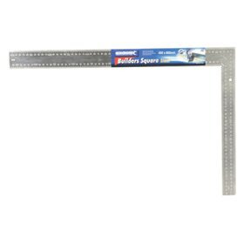
Cowley level: to obtain point on the ground.
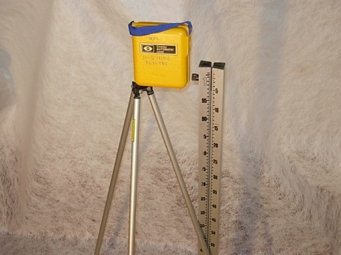
Theodolite: for alignment, to define straight line to establish levels on the ground e.t.c.
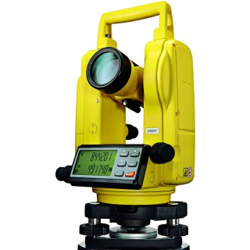

3.2 CULVERT
A culvert is a structure that allows water to flow under a road. Typically embedded so as to be surrounded by soil, a culvert may be made from a pipe, reinforced concrete or other material. Culvert is another form of road drainage which is arises when a lying area of a stream or river crosses. The alignments of road at arises when a lying area of a stream or river crosser. The alignment of road at this point, a culvert or bridge has to be constructed so that the water of river or stream is made pass on the other snider side of the road through them. Such culvert or structure is known as cross drainage work or simply drainage work.
3.2.1 TYPES OF CULVERT
Culvert can be classified into two, namely:
- Box culvert
- Ring culvert
Box culvert
Box culvert are made inform of a box in which the wall, base and the deck or slab of the culvert are reinforced to allow the flow of water. The box liked formed work for the reinforcement is in “U” position and concrete deck or slab is cast on it. The inlet and outlet are rectangular in shape. Box culvert is applicable in an area where there is river or stream for which a pipe or ring culvert is inadequate across the proposed road.
Classification of Box Culvert
- Single cell box culvert
- Double cell box culvert
- Triple cell box culvert
Their uses depend on the volume of water and which can also withstand high comprehensive load.
Ring Culvert
Ring culvert is also known as ‘pipe culvert” and is made up of ring/ pipe in which the flow of water will pass through. The sizes are of 900mm, 750mm and 600mm. Ring or pipe culvert are named with respect to their shape and can be applicable in the entrance of complex companies and they are called “access culvert” while those on the main road are referred to “cross culvert”.
Classification of Ring Culvert
1. Single ring culvert
2. Double ring culvert
3. Triple ring culvert

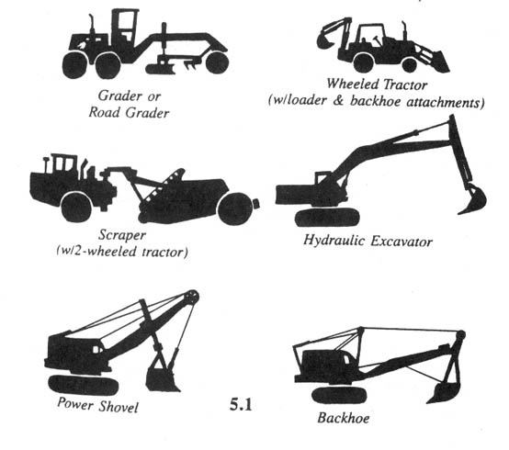

4.6 EQUIPMENTS USED IN CULVERT CONSTRUCTION
Excavator: It is used to dig and make trenches.
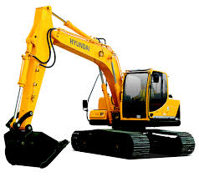 EXCAVATOR MACHINE
Concrete mixer machine: It is used for mixing wet concrete (wet concrete composes of aggregates, sand, cement and water).

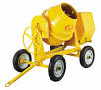
CONCRETE MIXER MACHINE

3.2.2 MATERIALS AND INSTRUMENT USED IN CULVERT CONSTRUCTION
- Cement
- Sharp sand
- Granite / gravel
- Reinforcement bar
- Hammer
- Shovel
- Wood plank
- Head pan / wheel barrow
- Range
Casting of blinding of box culvert
- Using 1:3:6 concrete mix design regarding the specification
- Bar bending schedule and casting erete mix design and the wall were doubly reinforcement (12mm iron)
3.3 SLUMP TEST AND CUBE TEST
Slump Test checks the fresh concrete's workability, while Cube Test checks the hardened concrete's strength. The Slump Test is done immediately after mixing, and the Cube Test is performed after curing (usually 7 or 28 days).
This is mainly used on-site to ensure the consistency of the concrete batch before pouring.
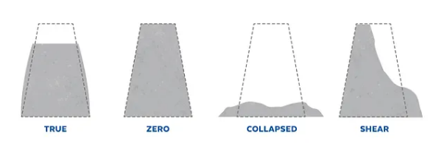

CHAPTER FOUR
4.0 EXPERIENCE GAIN
In summary, this program has exposed me to some practical aspect in relation to my course of study (Civil Engineering) and I benefitted greatly from the program. What I learnt at various site involves the following
- Civil Engineering construction
- Civil Engineering material management
- Civil Engineering building and highway set up

CHAPTER FIVE
5.0 CONCLUSION
The organisation to which I was attached gave me more impression about my course of study. The engineers are hardworking, they always in team which make the organisation. I am also impressed about the way they always plans their work which make thing easier and faster. Also the industrial based supervisor on student industrial work experience scheme programme always give special assistance to the SIWES student for them to archived their goals.
5.2 RECOMMENDATION TO THE INSTITUTION ON SIWES PROGRAMME
I will suggest that the institution should be make sure each student on SIWES programme is attached to an organisation which is relevant to their cause of study so as to achieved their goal after the programme. More so the institution should find a way of amending the period of SIWES programme so that it will not affect the school academic calendar. The institution should also give proper enlightenment to student for them to know that SIWES is all about and for them to behave and their industrial attachment. Also the institution supervisor should always visit student at their industrial attachment places for proper checking, balance and punctuality to the organisation.

