

TECHNICAL REPORT ON STUDENT INDUSTRIAL WORK EXPERIENCE SCHEME (SIWES)

SIWES REPORT
UNDERTAKEN AT

IKOSI-ISHERI LOCAL COUNCIL DEVELOPMENT AREA
NO 15, KOSOFE LAGOS STATE

By:
MUSA MUHAMMED ADEWALE
ND/23/PAD/PT/0496

SUBMITTED TO:
DEPARTMENT OF PUBLIC ADMINISTRATION,
INSTITUTE OF FINANCE AND MANAGEMENT STUDIES (IFMS),
KWARA STATE POLYTECHNIC, ILORIN

IN PARTIAL FULFILMENT OF THE REQUIREMENT FOR THE AWARD OF NATIONAL DIPLOMA (ND) IN PUBLIC ADMINISTRATION

AUGUST – NOVEMBER, 2024

CERTIFICATION
This is to certify that this SIWES was carried out by MUSA MUHAMMED ADEWALE with Matric Number ND/23/PAD/PT/0496 in the Department of Public Administration, Institute of Finance and Management Studies (IFMS), Kwara State Polytechnic, Ilorin.

DEDICATION
I dedicate this report to the Almighty God for his guidance, strength, and protection throughout and protection throughout my industrial training. I also dedicate it to my parents for their constant support and encouragement, as well as to my mentors and supervisors whose guidance helped me succeed during this period.

ACKNOWLEDGEMENTS
First and foremost, I appreciate Almighty Allah for giving me the privilege to partake in the Students Industrial Work Experience Scheme (SIWES).
I acknowledge my amiable and dynamic parents MR AND MRS MUSA, for their financial, moral and spiritual caring and support during the course of my SIWES program.
I also appreciate my Industrial based supervisor for their patient, endurance, courage and kind support during the course of my stayed in IKOSI-ISHERI LOCAL COUNCIL DEVELOPMENT AREA.
I wish to also acknowledge my school based supervisor, for their support, encouragement and kind during their visitation to IKOSI-ISHERI LOCAL COUNCIL DEVELOPMENT AREA.
Finally, I appreciate my colleagues in the same industrial based training; I pray Almighty Allah will grant us success in our entire endeavor (Amin).

TABLE OF CONTENT
Title page Dedication Acknowledgment Table of contents
Chapter One:
Introduction & History of SIWES Objectives of SIWES

Chapter Two:
Description of the Establishment Location
Brief History Objectives of the Establishment
Organizational Structure
Various Department And Their Functions
Chapter Three Works Carried out
Actual work done and Experience gained

Chapter Four:
Recommendations
Challenges Faced In the Industry

CHAPTER ONE

1.1 Introduction to SIWES
The Student Industrial Work Experience Scheme (SIWES) exposes students to industry based skills necessary for a smooth transition from the classroom to the world of work. It affords students of tertiary institutions the opportunity of being familiarized and exposed to the needed experience in handling machinery and equipment which are usually not available in the educational institutions and seeing firsthand the practical experience of some theoretical knowledge gained in the course of study.
Participation in SIWES has become a necessary pre-condition for the award of Diploma and Degree certificates in specific disciplines in most institutions of higher learning in the country, in accordance with the education policy of government.

1.2 Background to the SIWES
The Student Industrial Work Experience Scheme (SIWES) is an initiative which was established in 1973 by the Industrial Training Fund (ITF) to help bridge the gap between acquired classroom education and skills necessary for work in the industry.
Before the inception of the scheme in 1973, there was glaring evidence that inadequate practical exposure of students in tertiary institutions posed serious challenges to both the quality and standard of engineering and technological education in our nation. This resulted in half-baked engineering graduates who needed to undergo a form of training (Industrial Training) to be suitable for employment in industries and firms.
In order to forestall this threat that could bring about industrial regression, the Federal Government through the Industrial Training Fund (ITF) which was established by decree 47 of 1971 introduced the Student Industrial Work Experience Scheme (SIWES) in 1973.
SIWES exposes students to machines and equipment, professional work methods and ways of safe guarding the work areas and workers in industries and other organizations. It helps the student to know the link between what is learnt in the university and what is actually practiced on site. It further helps students to appreciate their field of study better, thereby also determining which area of specialization to go into to contribute to technological development of this nation.
The scheme involves the students, the universities and the industry (employers). It is funded by the Federal Government of Nigeria and jointly coordinated by the National Universities Commission (NUC) and the ITF.
SIWES orientation is usually done to intimate students with the rudiments of industrial training before they are being employed. At the end of the industrial training (IT), successful students whose log books were verified and approved by ITF officials are paid SIWES severance allowance.

1.3 Objectives of SIWES
- Provides the student with an opportunity to apply their theoretical knowledge in real work situation thereby bridging the gap between theory and Practical.
- Provides an avenue for students in tertiary institutions to acquire industrial skills and experience in their course of study.
- Expose students to work methods and techniques in handling equipment and machinery that may not be available in universities.
- Familiarizing the student for the working conditions they are likely to meet after graduation; and
- Make the transition from the university to the world of work easier and thus enhance student’s contacts for later job placement.

CHAPTER TWO

2.1 History of the Organization
Ikosi, the administrative headquarters of the seven villages that make up Kosofe, was founded in the 17th century, by Aina Ejo, the seventh son of Akanbiogun, an Ile-Ife prince and warrior who previously domiciled in Iwaye Quarters in Ota (Ogun State). He later left Ota to settle for a virgin land.
Indigenes of Ikosi are of the Awori stock of the Yoruba race and are remarkably hospitable and peaceful people. Traditional folklore has it that the name 'Ikosi' is a short form of the saying 'Kosi Kosi' which refers to the saying of the early settlers to visitors that they never hoard their things from visitors. They were traditionally farmers.
Aina Ejo founder of Ikosi kingdom begat Taiwo and Kehinde in 1795, Kehinde begat Bakare Onikosi, Rufai Oloyede and others Taiwo-Olowo begat Yesufu Oke Taiwo, Joseph Ogunlana Taiwo, Funmilayo Taiwo and the last born who became the first statutory King of modern Ikosi - Oba Adegboyega Taiwo (Akeja Oniyanru I) who was born in 1901 and ruled between 1996 and 2006. He was the statutory Chairman and Oba Bashua of Somolu was the vice-chairman of the Chieftaincy Committee of Somolu local Government till 1996. Upon the creation of Kosofe Local Government, he retained the chairmanship before the coronation and installation of Oba Bashiru Olountoyin Saliu, the Oba of Oworonshoki who deputised for him in 1998.
Ikosi is the site of TV Continental (formerly GOTEL UHF 65), a television station and Radio Continental 103.3FM (formerly LINK FM), a radio station. A campus of Lagos State Polytechnic was formerly located at Ikosi. The Centre for Management Development (CMD) is also located in Ikosi.
Prominent indigenes of Ikosi oer the years include Prince Olaolu Taiwo (Councilor in the Second Republic), Prince Atanda Jimoh (also a councilor then), Prince Alamu Taiwo who was instrumental to the placement of All Saints' Parish Anglican Church, Major Kayode Taiwo (Rtd)., Arc (Prince) Ademola Taiwo, a former permanent secretary (PPUD) in the Lagos State Government.
Hon Prince Owolabi Taiwo was also councilor and later rose to the position of Speaker of Ikosi Local Govt., Lagos State. Records show that the young Ikosi prince bluntly refused to compromise the development of Ikosi/Isheri for personal material gain while in office thus making him the most popular council leader and one of the most vibrant and upright councilors in Lagos. State

2.2 Vision and Mission Statement

Vision: “Our vision for Ikosi-Isheri LCDA is built on the belief that. Strong and resilient infrastructure is the foundation for progressive development.

Mission: To make life better for the hospitable people of Agboyi-Ketu LCDA.

2.3 ORGANOGRAM OF IKOSI-ISHERI LOCAL COUNCIL DEVELOPMENT AREA.
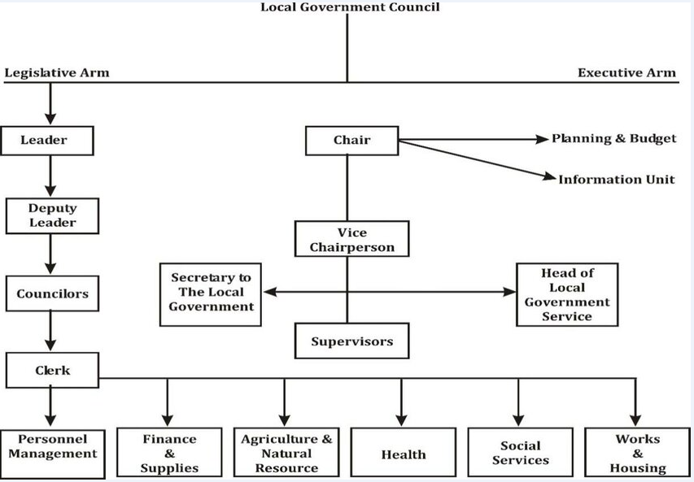

CHAPTER THREE
3.0 EXPERIENCE GAINED AND ACTUAL WORK DONE
During the period of my SIWES program, I was taught about roles and important of an Administrator in Local Council Development Area (LCDA) Sector. I realized that in a Local Council Development Area (LCDA), the administrator's primary role is to ensure the smooth and efficient operation of the LCDA's administrative functions. This involves managing resources, coordinating departmental activities, and serving as a liaison between the government, community, and other stakeholders.
Other experiences gained are:
Here's a more detailed look at the administrator's responsibilities:
- Record Keeping:
Maintaining accurate and organized records of all LCDA activities and property, including property records and ensuring prompt retrieval when necessary.
- Communication:
Communicating effectively with residents, colleagues, and other stakeholders, handling inquiries, and providing information.
- Meeting Management:
Organizing and servicing committee meetings, preparing agendas and minutes, and presenting information.
- Policy Implementation:
Supporting the formulation and implementation of council policies and procedures.
- Document Management:
Creating, organizing, and storing information in both paper and digital formats, managing confidential documents, and ensuring data security.
- Office Management:
Managing office supplies, equipment, and resources, ensuring proper operation of office equipment, and maintaining office supplies.

CHAPTER FOUR

CHALLENGES ENCOUNTERED AND RECOMMENDATION

4.1 Challenges Encountered
There is nothing on earth that is free on challenges; life itself is full with different kinds of challenges
Firstly, there are many insults been placed on it’s by some of the staff in the organization. In the first week of observing the finance unit where I was posted to, some of the staff in the microfinance bank do ask us if we can make use of excel or MS word and if not, they will see us as an incompetent in the field or an unserious element. And at that time, they belittle us by not teaching us anything.
Another challenge was that, there were many students from different school doing their SIWES programme also. And we needed to shift period for each other which they divided us into groups.

4.2 Recommendation
SIWES is an important program that needs to be encouraged because, it provides from for practical knowledge to students in their areas of discipline.
It is important to ensure that student takes the programme seriously and the government is to ensure strict supervision and monitoring of both the student and the school and the industry based supervision for better results.

