
REPORT ON STUDENT INDUSTRIAL WORK EXPERIENCE SCHEME (SIWES)
HELD AT
MIC MART ELSHADDIA MALL
CELE EGBE BUS STOP IKOTUN LAGOS
WRITTEN BY
ATHANASIUS NGOZI BLESSING
MATRIC NO: ND/23/BAM/PT/0507

SUBMITTED TO
DEPARTMENT OF BUSINESS ADMINISTRATION,
KWARA STATE POLYTECHNIC, ILORIN.
IN PARTIAL FULFILLMENT OF THE REQUIREMENT FOR THE AWARD OF NATIONAL DIPLOMA (ND):
AUGUST – DECEMBER 2024

TABLE OF CONTENT
1. Chapter One: Introduction
- Background of SIWES
- Objectives of SIWES
- Overview of Mic Mart Elshaddai Mall
- Relevance of SIWES to Business Administration Students
- Goals and Expectations
2. Chapter Two: Organizational Overview
- History and Background of the Supermarket
- Organizational Structure
- Departments and Their Functions
3. Chapter Three: Training Activities and Work Experience
- Duties and Responsibilities Assigned
- Departmental Experiences (Snacks, Cosmetics, Beverages)
- Tools, Equipment, and Technologies Used
- Challenges Encountered
4. Chapter Four: Skills and Knowledge Acquired
- Technical and Administrative Skills
- Interpersonal and Communication Skills
- Bridging Classroom Theory with Practical Experience
5. Chapter Five: Challenges, Recommendations, and Conclusion
- Challenges and Solutions
- Recommendations for the Organization
- Suggestions for Future SIWES Participants
- Summary and Conclusion
6. References
CHAPTER ONE
INTRODUCTION
1.1 Background of SIWES
The Student Industrial Work Experience Scheme (SIWES) is a skill development program designed and introduced by the Industrial Training Fund (ITF) in 1973. It was initiated to tackle the growing concern of inadequate practical knowledge among graduates of Nigerian tertiary institutions. SIWES provides students with firsthand experience in industrial operations relevant to their course of study. The scheme allows students to relate the theories learned in classrooms with actual work environments, thereby enhancing their competence and employability upon graduation. It is a mandatory part of most academic programs, especially in science, technology, and business-related disciplines.
1.2 Objectives of SIWES
The core objectives of the SIWES program include:
- To expose students to the practical aspects of their course of study.
- To provide students with an opportunity to gain real work experience in an industrial setting.
- To help students understand the operations, practices, and structures of organizations.
- To develop students’ communication, teamwork, and technical skills through direct engagement with professionals in the field.
- To bridge the gap between theoretical learning in classrooms and its practical application in the workplace.
- To assist students in making informed career decisions based on real industry experiences.
1.3 Overview of Mic Mart Elshaddai Mall
Mic Mart Elshaddai Mall is a modern, customer-focused retail supermarket situated at Cele Egbe Bus Stop, Ikotun, Lagos State. The mall offers a wide variety of goods ranging from groceries, snacks, beverages, personal care items, cosmetics, household items, and more. It serves a broad clientele drawn from the densely populated Ikotun-Egbe axis. The mall operates with a structured departmental layout and a coordinated workforce that ensures seamless day-to-day retail operations. With a commitment to quality customer service, inventory control, and effective team management, Mic Mart Elshaddai Mall is an ideal environment for SIWES participants to gain meaningful retail business experience.
1.4 Relevance of SIWES to Business Administration Students
For students in the Department of Business Administration, the SIWES program provides a unique opportunity to observe and participate in business operations in a real-world setting. It offers practical insights into key areas such as organizational behavior, customer relationship management, marketing strategies, inventory and supply chain management, sales operations, and human resources practices. Through such exposure, students develop critical thinking, decision-making, and leadership skills that are essential for their professional advancement. The experience also helps to solidify their understanding of core business principles learned in school by observing their application in a structured workplace.
1.5 Goals and Expectations
During my industrial attachment at Mic Mart Elshaddai Mall, my primary goal was to gain firsthand experience in the retail business sector and to observe how theoretical knowledge is applied in day-to-day business activities. I aimed to familiarize myself with the functioning of different departments, especially in sales, stock management, and customer service. I also hoped to improve my communication, time management, and problem-solving skills. I expected the training to deepen my understanding of retail management and provide me with the exposure and confidence needed to pursue a successful career in business administration.

CHAPTER TWO
ORGANIZATIONAL OVERVIEW
2.1 History and Background of the Supermarket
Mic Mart Elshaddai Mall is a growing retail outlet that caters to the needs of residents in and around Cele Egbe, Ikotun, Lagos State. Established to offer a convenient and affordable shopping experience, the supermarket is structured to provide a wide range of products in a well-organized environment. The management team ensures that customers receive quality service while maintaining proper stock of daily essentials. Over the years, the mall has expanded its inventory and services to meet the increasing demands of customers and has built a solid reputation for affordability, product availability, and professionalism.
2.2 Organizational Structure
The supermarket is structured in a hierarchical system that promotes accountability and division of labor. The typical structure includes:
- General Manager – Oversees all operations in the supermarket.
- Department Supervisors – Manage individual sections such as snacks, cosmetics, beverages, and groceries.
- Sales Representatives – Attend to customers, arrange goods, and restock shelves.
- Cashiers – Handle payments and ensure accurate transactions.
- Storekeepers – Monitor stock levels, inventory records, and store arrangements.
- Security Personnel – Ensure safety of goods and monitor customer and staff activities.
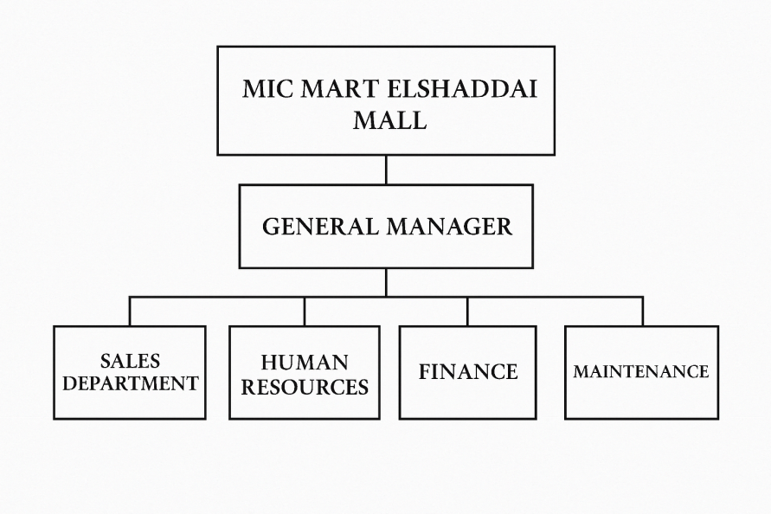
2.3 Departments and Their Functions
Mic Mart Elshaddai Mall is divided into several key departments, each performing unique functions:
- Snacks Department: This section handles all snack-related products such as biscuits, chips, sweets, and confectioneries. Responsibilities include shelf arrangement, stock replenishment, and assisting customers with their snack choices.
- Cosmetics Department: Focuses on personal care products including creams, lotions, soaps, makeup, and beauty items. Staff members help with product recommendations and organizing the shelves attractively.
- Beverages Department: Manages both alcoholic and non-alcoholic drinks like bottled water, soft drinks, juices, and energy drinks. Duties include stacking, labeling, and stock control.
- Cashier Unit: Responsible for processing purchases, providing receipts, and managing payment methods like cash, POS, and transfers.
- Storekeeping/Inventory Control: Keeps records of products in stock and ensures adequate supply through frequent checks and coordination with suppliers.
- Customer Service Desk: Handles inquiries, complaints, and product returns or exchanges to maintain customer satisfaction.
Each department plays a vital role in delivering excellent customer experience and smooth supermarket operations.
CHAPTER THREE
TRAINING ACTIVITIES AND WORK EXPERIENCE
3.1 Duties and Responsibilities Assigned
During my SIWES training at Mic Mart Elshaddai Mall, I was assigned to various departments on a rotational basis, which provided me with broad exposure to the retail business environment. My key responsibilities included:
- Welcoming and assisting customers with their shopping needs.
- Arranging products on shelves in a neat and appealing manner.
- Monitoring product availability and reporting low stock levels.
- Assisting in stock replenishment and product labeling.
- Keeping work areas clean and well-organized.
- Taking inventory and restocking items.
- Reporting customer complaints and forwarding feedback to supervisors.
3.2 Departmental Experiences
- Snacks Department (First 2 Weeks):
I was involved in arranging and categorizing snack items such as biscuits, chips, and sweets. I learned about the importance of product positioning and expiration date monitoring. I also provided assistance to customers in selecting snacks for events and casual purchases.
- Cosmetics Department (5 Weeks):
My experience in the cosmetics section was more detailed and engaging. I gained knowledge of different skincare and beauty products, helped with sales recommendations, and learned how to answer customer inquiries effectively. I also worked on organizing shelves, price tagging, and ensuring all products were clean and well-presented.
- Beverages Department (Final Weeks):
Here, I handled heavy lifting, sorting of bottled drinks, and assisted with deliveries. I arranged soft drinks, juices, and water on shelves and cold storage units. I also learned how to record outgoing and incoming stock and helped load products for customer pickups.
3.3 Tools, Equipment, and Technologies Used
- Point of Sale (POS) System: For transaction recording and payment processing.
- Barcode Scanner: Used to scan items for checkout.
- Inventory Register/Forms: For tracking product availability and restocking needs.
- Stockroom Tools: Trolleys, shelves, crates, and labeling equipment.
- Microsoft Excel (Occasionally): Used by supervisors for stock reports and sales tracking (I observed this process).
3.4 Challenges Encountered
- Difficulty adjusting to standing for long hours, especially during peak periods.
- Occasional communication gaps between departments, leading to stock delays.
- Managing impatient or difficult customers.
- Handling product spillages or breakages under pressure.
- Learning how to properly use some digital tools within a short time frame.
Despite these challenges, I remained focused and adapted quickly with the guidance of experienced staff.

CHAPTER FOUR
SKILLS AND KNOWLEDGE ACQUIRED
4.1 Technical and Administrative Skills
During my industrial training at Mic Mart Elshaddai Mall, I acquired a wide range of practical skills that are essential in the retail and customer service sectors. These skills have enhanced my technical understanding and administrative abilities. Key skills include:
- Inventory Management: I learned how to manage stock effectively, track inventory levels, monitor expiration dates of consumable items, and support the restocking process. I also assisted in identifying fast-moving and slow-moving goods, which helped improve stock turnover.
- Sales and Marketing Techniques: I was exposed to various methods of promoting products through visual merchandising, seasonal displays, and strategic product placement to attract customer interest and boost sales.
- POS (Point of Sale) Operation: While I was not directly in charge of operating the POS system, I observed its functions closely. I learned how it facilitates quick and secure transactions, prints receipts, and records customer purchases for inventory accuracy.
- Product Categorization and Labeling: I became proficient in organizing goods based on brand, product type, and shelf life. I also assisted in labeling items with barcodes, prices, and promotional tags, which improved product visibility and accessibility.
- Basic Documentation and Reporting: I occasionally helped in documenting daily sales summaries and noting inventory updates, giving me insight into administrative record-keeping within a retail setting.
4.2 Interpersonal and Communication Skills
Throughout my time at Mic Mart Elshaddai Mall, I interacted with both customers and colleagues, which significantly developed my interpersonal competencies.
- I improved my verbal communication through regular customer interactions, explaining product features, guiding shoppers, and responding to inquiries courteously and professionally.
- I practiced active listening, especially when resolving complaints or attending to specific customer needs, which helped in building rapport and trust with clients.
- Teamwork and cooperation were vital during peak shopping hours or when organizing stock. I learned how to work collaboratively, share responsibilities, and support other staff members to ensure efficient service delivery.
- I also developed confidence and emotional intelligence by learning how to remain calm and composed when dealing with difficult customers or under pressure.
4.3 Bridging Classroom Theory with Practical Experience
The industrial training provided me with the opportunity to apply theoretical knowledge gained from my academic courses in a real-world context.
- Customer Relationship Management (CRM): I experienced how good customer service practices foster loyalty and increase customer retention, reinforcing the principles learned in class.
- Marketing and Consumer Behavior: Concepts such as branding, pricing strategy, and consumer preference were clearly evident in the snacks and cosmetics departments, where product arrangement and promotional offers directly influenced buying decisions.
- Stock Control and Inventory Management: I applied business theories of stock monitoring and control in the beverages section, where accurate tracking of goods was essential for maintaining stock balance and preventing losses.
- Business Ethics and Professional Conduct: Observing workplace discipline, dress code, punctuality, and respect for customers and supervisors reflected real-life examples of business ethics taught in school.
In summary, my experience at Mic Mart Elshaddai Mall bridged the gap between classroom learning and industrial practice. It deepened my understanding of retail operations and customer engagement, and prepared me for future professional endeavors in the field of business administration.

CHAPTER FIVE
CHALLENGES, RECOMMENDATIONS, AND CONCLUSION
5.1 Challenges and Solutions
During my industrial training at Mic Mart Elshaddai Mall, I encountered several challenges that tested my adaptability and resilience:
- Standing for Long Hours: As a sales representative, I had to remain on my feet for extended periods. To cope, I ensured I wore comfortable footwear and took short breaks when possible.
- Managing Difficult Customers: Some customers were impatient or demanding. I overcame this by remaining calm, listening carefully to their concerns, and responding with respect and professionalism.
- Learning Multiple Departments: Transitioning from the snacks department to cosmetics, and then to beverages required adaptability. I addressed this by taking notes, asking questions, and observing experienced staff members.
- Limited Access to Administrative Systems: Due to company policy, trainees were restricted from using some systems. I maximized the opportunity by observing the processes and assisting indirectly to understand their operations.
5.2 Recommendations for the Organization
- The management should consider creating a short orientation program for SIWES students to help them settle in quickly.
- Introducing a feedback session at the end of each week would help improve communication and productivity among staff and trainees.
- More seating options or short rest breaks for sales staff would improve comfort and performance, especially during peak hours.
5.3 Suggestions for Future SIWES Participants
- Future trainees should be mentally prepared to work in a fast-paced and customer-focused environment.
- It’s important to stay organized, take notes, and be open to learning from both supervisors and peers.
- Developing good communication skills and patience is key when dealing with diverse customers.
5.4 Summary and Conclusion
The Student Industrial Work Experience Scheme (SIWES) at Mic Mart Elshaddai Mall was a fulfilling experience. It exposed me to real-life business operations and allowed me to develop both technical and interpersonal skills. Despite the challenges, I learned valuable lessons in time management, teamwork, and customer service.
This training has strengthened my understanding of the retail industry and prepared me for future roles in business administration. I believe the skills and experiences I gained will be beneficial in my academic journey and future career.

REFERENCES
- Adebayo, K. (2018). Retail Management and Customer Experience in Supermarkets. Lagos: Emerald Publishers.
- Eze, J. U. (2015). Skill Acquisition and Practical Training for Nigerian Students. Enugu: University Press.
- Olayemi, T. O. (2019). Understanding Sales and Inventory Management in Retail Stores. Ibadan: Spectrum Books Limited.
- National Board for Technical Education (NBTE) (2022). SIWES Handbook and Guidelines. Retrieved from www.nbte.gov.ng
- Federal Government of Nigeria (2020). Industrial Training Guidelines and Standards. Retrieved from www.nuc.edu.ng
- Mic Mart Elshaddai Mall (2024). Internal Operational Manual for Retail Departments. Lagos State.
- National Open University of Nigeria (2021). SIWES Orientation Manual for Polytechnic Students. Abuja: NOUN Press.
- Okonkwo, B. A. (2020). Principles of Business Administration and Sales Techniques. Lagos: University of Lagos Press.
- Adekunle, S. (2022). Supermarket Layouts and Departmental Functions. Ilorin: Kwarex Publishing.
- Retail Nigeria Digest (2023). Growth Trends in the Nigerian Retail Industry. Retrieved from www.retailnigeria.com

