
REPORT ON STUDENT INDUSTRIAL WORK EXPERIENCE SCHEME (SIWES)
HELD AT
ASEJERE ILELORUN
NO 9 OLOROGBO AGBEDE, ASOLO, IKORODU LAGOS STATE
WRITTEN BY
ADEOYE OLUWAPELUMI OLAMIDE
MATRIC NO: ND/23/BAM/PT/0048
SUBMITTED TO
DEPARTMENT OF BUSINESS ADMINISTRATION,
KWARA STATE POLYTECHNIC, ILORIN.
IN PARTIAL FULFILLMENT OF THE REQUIREMENT FOR THE AWARD OF NATIONAL DIPLOMA (ND):
SEPTEMBER – NOVEMBER 2024

TABLE OF CONTENT
- Chapter One: Introduction
  - 1.1 Background of SIWES
  - 1.2 Objectives of SIWES
  - 1.3 Overview of Asejere Ilelorun
  - 1.4 Relevance of SIWES to Business Administration Students
  - 1.5 Goals and Expectations
- Chapter Two: Organizational Overview
  - 2.1 History and Background of Asejere Ilelorun
  - 2.2 Organizational Structure
  - 2.3 Departments and Their Functions
- Chapter Three: Training Activities and Work Experience
  - 3.1 Duties and Responsibilities Assigned
  - 3.2 Departmental Experiences
  - 3.3 Tools, Equipment, and Technologies Used
  - 3.4 Challenges Encountered
- Chapter Four: Skills and Knowledge Acquired
  - 4.1 Technical and Administrative Skills
  - 4.2 Interpersonal and Communication Skills
  - 4.3 Bridging Classroom Theory with Practical Experience
- Chapter Five: Challenges, Recommendations, and Conclusion
  - 5.1 Challenges and Solutions
  - 5.2 Recommendations for the Organization
  - 5.3 Suggestions for Future SIWES Participants
  - 5.4 Summary and Conclusion
- References

CHAPTER ONE
INTRODUCTION
1.1 Background of SIWES
The Student Industrial Work Experience Scheme (SIWES) is a vital program initiated by the Federal Government of Nigeria and supervised by the National Board for Technical Education (NBTE) for polytechnic students. Its primary purpose is to prepare students for the professional world by offering practical experiences that complement their classroom-based theoretical knowledge. SIWES bridges the gap between academic knowledge and real-world practices, equipping students with relevant hands-on skills in their chosen fields of study.
1.2 Objectives of SIWES
The major objectives of the SIWES program include:
- To expose students to real-life working environments and professional procedures.
- To enable students to apply the theoretical knowledge gained in the classroom to actual job roles.
- To develop students’ technical, administrative, and interpersonal skills.
- To help students understand workplace ethics, business processes, and industrial operations.
- To improve students’ chances of employment after graduation by making them more skilled and experienced.
1.3 Overview of ASEJERE ILELORUN
ASEJERE ILELORUN is a financial and cooperative organization located at No. 9 Olorogbo Agbede, Asolo, Ikorodu, Lagos State. The organization is involved in financial operations such as cooperative savings, micro-lending, and loan management services. It supports local individuals and businesses by offering financial assistance through flexible loan packages, savings opportunities, and financial advisory services. ASEJERE ILELORUN is committed to transparent service delivery, customer satisfaction, and community development.
1.4 Relevance of SIWES to Business Administration Students
For Business Administration students, the SIWES program is essential for acquiring practical exposure to various business functions, including customer service, financial management, record keeping, and organizational communication. The experience enhances students' understanding of how administrative and financial operations are coordinated, and it strengthens their problem-solving and decision-making abilities in a real business environment.
1.5 Goals and Expectations
My goal during the SIWES program was to gain hands-on experience in business and financial operations. I expected to learn how loan and savings systems work in a cooperative setting, understand client engagement, and improve my knowledge of customer service practices. Additionally, I hoped to become familiar with financial documentation and gain confidence in handling administrative tasks within a corporate setup.

CHAPTER TWO
ORGANIZATIONAL OVERVIEW
2.1 History and Background of ASEJERE ILELORUN
ASEJERE ILELORUN was established to provide cooperative financial services to individuals, small businesses, and traders in the Ikorodu area of Lagos State. It started with the mission of empowering the local community through access to micro-loans, savings programs, and other financial support services. The organization was founded on principles of trust, accountability, and mutual growth. Over the years, ASEJERE ILELORUN has expanded its membership base and service capacity, becoming a trusted financial partner to many.
Its core functions include providing soft loans to members, managing group contributions (ajo/esusu), offering financial counseling, and encouraging a savings culture among individuals. The organization also operates in accordance with relevant financial regulations and ensures transparency in all its operations.
2.2 Organizational Structure
The organizational structure of ASEJERE ILELORUN is relatively simple but effective, allowing for efficient communication and smooth operation. The structure includes the following key roles:
- General Manager: Oversees all the operations and policy implementation.
- Loan Officer: Responsible for processing loan applications and monitoring repayment.
- Customer Service Representative: Handles inquiries, attends to clients, and manages member relations.
- Accountant: Manages financial records, savings, loan disbursement, and repayment tracking.
- Administrative Staff: Supports record keeping, filing, and clerical duties.
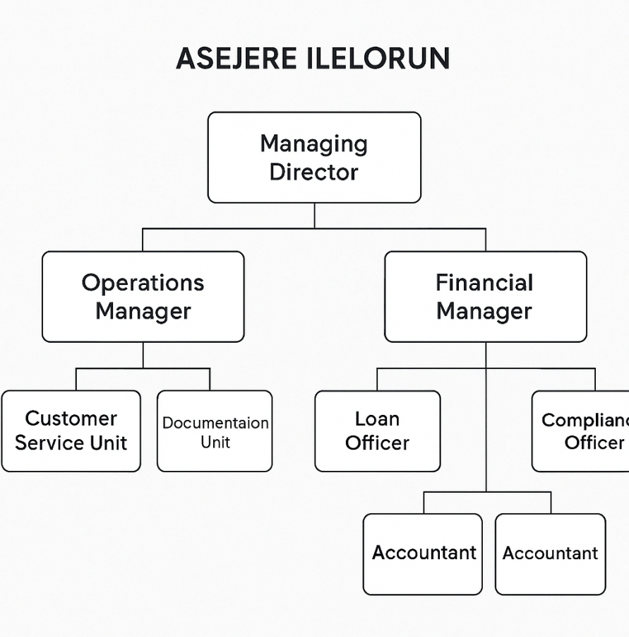
2.3 Departments and Their Functions
- Loan Department:
This department is in charge of assessing, approving, and disbursing loans. It also monitors repayments and ensures compliance with lending policies.
- Customer Service Unit:
This unit focuses on attending to clients, answering questions, resolving issues, and maintaining good relationships between the organization and its members.
- Accounts and Finance Department:
This section is responsible for tracking all financial activities, managing member contributions, preparing financial reports, and ensuring transparency.
- Administrative Unit:
The administrative department handles filing, correspondence, staff records, and general support for the day-to-day operations.

CHAPTER THREE
TRAINING ACTIVITIES AND WORK EXPERIENCE
3.1 Duties and Responsibilities Assigned
During my Industrial Training at ASEJERE ILELORUN, I was assigned to assist in various aspects of financial operations and customer service. My responsibilities included the following:
- Receiving and verifying loan applications from clients.
- Checking and recording customers' financial history and creditworthiness.
- Assisting in the documentation and processing of approved loans.
- Following up on loan repayments and updating loan status.
- Attending to customers’ inquiries and complaints.
- Filing and organizing customer records and financial documents.
- Supporting the account officer in updating transaction logs.
These duties exposed me to real-life business practices and improved my understanding of how financial institutions operate, particularly in a community setting.
3.2 Departmental Experiences
I rotated across the main departments, gaining a broad experience in:
- Loan Department: I learned how loan applications are processed, including the screening of applicants and risk assessment. I observed how the loan officers verify customers' financial backgrounds and ensure all documents are accurate before approval.
- Customer Service Unit: I developed skills in handling customers professionally, resolving issues politely, and keeping client records updated.
- Accounts Department: Here, I participated in recording loan disbursement, repayment entries, and helped in reconciling savings and loan accounts.
3.3 Tools, Equipment, and Technologies Used
The organization used a mix of manual and digital tools to manage its operations. The tools and equipment I used included:
- Microsoft Excel and Word: For data entry, documentation, and report generation.
- Manual Ledger Books: For recording savings and loan transactions.
- Computers and Printers: For accessing digital records, printing forms, and reports.
- Loan Processing Forms: For capturing clients' details and financial records.
- Mobile Phones: Used for follow-up calls to clients regarding payments.
3.4 Challenges Encountered
Although the training experience was enriching, I faced some challenges, including:
- Limited Access to Digital Tools: Some records were still maintained manually, which sometimes caused delays and required extra effort in filing and tracking.
- High Customer Turnout: On busy days, it was challenging to manage a large number of customers without affecting service quality.
- Strict Loan Policies: Some clients became agitated when their loan applications were delayed or denied due to incomplete documentation or poor financial records.
Despite these challenges, the supportive environment at ASEJERE ILELORUN helped me to adapt quickly and learn how to work effectively under pressure.

CHAPTER FOUR
SKILLS AND KNOWLEDGE ACQUIRED
4.1 Technical and Administrative Skills
During the course of my industrial training at ASEJERE ILELORUN, I gained valuable technical and administrative skills that have greatly contributed to my understanding of business operations. Some of the key skills I acquired include:
- Loan Application Processing: I learned how to evaluate loan applications, check for completeness, and verify supporting documents.
- Record Keeping and Data Entry: I became proficient in organizing financial records, entering customer information into the system, and updating ledgers accurately.
- Use of Microsoft Office Tools: I improved my use of Microsoft Excel and Word for preparing reports, documenting transactions, and keeping digital records.
- Client Assessment: I acquired basic knowledge in assessing the creditworthiness of clients based on their financial history and repayment capability.
4.2 Interpersonal and Communication Skills
The SIWES program enhanced my interpersonal relationships and ability to communicate effectively in a business environment. Key interpersonal skills I developed include:
- Customer Interaction: I learned how to interact respectfully and professionally with clients, listen attentively, and respond to their inquiries with patience and clarity.
- Team Collaboration: I worked as part of a team, assisting my colleagues in meeting daily targets and supporting each other in performing departmental tasks.
- Conflict Resolution: I experienced instances where I had to calmly address dissatisfied customers, helping to resolve misunderstandings politely and constructively.
4.3 Bridging Classroom Theory with Practical Experience
One of the most significant benefits of the SIWES program was the opportunity to apply theoretical knowledge gained in class to real-life work situations. For instance:
- Business Administration Concepts: I applied business principles such as customer relationship management, loan documentation procedures, and organizational behavior in a practical setting.
- Financial Management: Classroom topics like loan structuring, interest calculation, and financial accountability became clearer and more meaningful through hands-on experience.
- Professional Ethics: I understood the importance of integrity, confidentiality, and attention to detail in financial institutions.
Overall, the skills and knowledge I acquired during my SIWES have prepared me for future roles in administrative and financial sectors, and have given me a clearer perspective on my career path.

CHAPTER FIVE
CHALLENGES, RECOMMENDATIONS, AND CONCLUSION
5.1 Challenges and Solutions
During my industrial attachment at ASEJERE ILELORUN, I encountered a few challenges that helped me grow both professionally and personally. These challenges include:
- Limited Use of Technology: Some tasks were done manually, which slowed down operations. However, I adapted by improving my speed and accuracy in handling physical documents.
- Communication Barriers: Initially, I found it difficult to understand some technical financial terms. I addressed this by asking questions and taking notes for further study.
- Handling Customer Complaints: Dealing with unsatisfied clients was sometimes challenging, but I learned to remain calm, listen attentively, and follow due procedures to resolve issues.
5.2 Recommendations for the Organization
To enhance efficiency and improve the experience of future interns, I recommend the following to ASEJERE ILELORUN:
- Digitalization of Processes: The adoption of updated financial software and databases would improve workflow and reduce time spent on manual processing.
- Intern Orientation: Introducing a short orientation or training program for new interns will help them settle in faster and become productive earlier.
- Customer Feedback System: Implementing a structured system for customer feedback could help improve client satisfaction and service quality.
5.3 Suggestions for Future SIWES Participants
For students preparing for their SIWES programs, I offer the following suggestions based on my experience:
- Be Eager to Learn: Approach every task as an opportunity to learn. Ask questions and seek clarification when in doubt.
- Be Professional: Always dress neatly, arrive on time, and respect organizational rules and colleagues.
- Take Notes: Keeping records of daily activities helps in compiling the final report and reinforces learning.
- Network: Build positive relationships with staff and clients; they could become useful connections in your future career.
5.4 Summary and Conclusion
My time at ASEJERE ILELORUN was a highly rewarding experience. I had the opportunity to observe and participate in real-life business operations, particularly in the areas of financial management and customer service. The program helped me develop key administrative and communication skills while applying theoretical knowledge to practical tasks.
This industrial training has not only prepared me for the workforce but has also given me a deeper appreciation of the role of Business Administration in organizational success. I am confident that the experience gained during this period will significantly impact my future career path.

REFERENCES
- Adebayo, K. (2018). Principles of Financial Management in Microfinance Institutions. Lagos: Emerald Publishing.
- Eze, J. U. (2017). Industrial Training and Skills Development in Nigeria. Enugu: University Press.
- Olayemi, T. O. (2020). Customer Service Strategies in Financial Institutions. Ibadan: Spectrum Books Ltd.
- National Board for Technical Education (NBTE) (2022). SIWES Operational Guidelines and Expectations. Retrieved from www.nbte.gov.ng
- Federal Government of Nigeria (2021). Guidelines on the Student Industrial Work Experience Scheme (SIWES). Retrieved from www.nuc.edu.ng
- Asejere Ilelorun (2024). Operational and Training Manual. Ikorodu, Lagos State.
- National Open University of Nigeria (2021). SIWES Handbook for Polytechnic and University Students.
- Small Business Chronicle (2023). Loan Management and Customer Relations in SMEs. Retrieved from www.smallbusiness.chron.com
- Okonkwo, B. A. (2020). Entrepreneurship and Financial Services in Nigeria. Lagos: University of Lagos Press.
- Adekunle, S. (2022). Microcredit Systems and Economic Growth in Nigeria. Ilorin: Kwarex Publishing.
- Financial Literacy Nigeria (2023). Best Practices in Loan Application Verification. Retrieved from www.financialliteracyng.org
- Microsoft Corporation (2023). Microsoft Excel and Data Management Tools Guide. Available at www.microsoft.com

