
REPORT ON STUDENT INDUSTRIAL WORK EXPERIENCE SCHEME (SIWES)
HELD AT
FORTUNATE BAKERY
NO 9, TIJANI ADEJUMO STREET,BEHIND LOWER NIGER RIVER BASIN, ILORIN, KWARA STATE.
WRITTEN BY
AFOLAYAN FATIA PELUMI
MATRIC NO: ND/23/BAM/PT/0381

SUBMITTED TO
DEPARTMENT OF BUSINESS ADMINISTRATION,
KWARA STATE POLYTECHNIC, ILORIN.
IN PARTIAL FULFILLMENT OF THE REQUIREMENT FOR THE AWARD OF NATIONAL DIPLOMA (ND):
AUGUST – NOVEMBER 2024

TABLE OF CONTENT
- Chapter One: Introduction
  - Background of SIWES
  - Objectives of SIWES
  - Overview of Fortunate Bakery
  - Relevance of SIWES to Business Administration Students
  - Goals and Expectations
- Chapter Two: Organizational Overview
  - History and Background of the Bakery
  - Organizational Structure
  - Departments and Their Functions
- Chapter Three: Training Activities and Work Experience
  - Duties and Responsibilities Assigned
  - Departmental Experiences
  - Tools, Equipment, and Technologies Used
  - Challenges Encountered
- Chapter Four: Skills and Knowledge Acquired
  - Technical and Administrative Skills
  - Interpersonal and Communication Skills
  - Bridging Classroom Theory with Practical Experience
- Chapter Five: Challenges, Recommendations, and Conclusion
  - Challenges and Solutions
  - Recommendations for the Organization
  - Suggestions for Future SIWES Participants
  - Summary and Conclusion
- References

CHAPTER ONE

INTRODUCTION

1.1 Background of SIWES
The Student Industrial Work Experience Scheme (SIWES) is a mandatory training program organized by the National Universities Commission (NUC) and the National Board for Technical Education (NBTE) for students in various disciplines. It is designed to provide practical experience and expose students to the work environment before graduation. SIWES serves as a bridge between theoretical knowledge acquired in the classroom and its practical application in the real world, enhancing students' employability and understanding of professional work ethics.

1.2 Objectives of SIWES
The main objectives of SIWES include:
- To provide students with an opportunity to apply their classroom knowledge in real-life situations.
- To expose students to operational procedures, organizational structures, and workplace cultures.
- To help students gain relevant skills and competencies required in their field of study.
- To promote the development of good work habits and professional responsibility.
- To enhance students’ understanding of the role of their discipline in the industrial and economic development of the nation.

1.3 Overview of Fortunate Bakery
Fortunate Bakery is a growing confectionery and baked goods company located in Ilorin, Kwara State. The organization is involved in the production and sales of various types of bread, pastries, and cakes. The bakery prides itself on its commitment to hygiene, consistent product quality, and customer satisfaction. With a dedicated team of bakers, sales personnel, and administrative staff, Fortunate Bakery serves both individual and commercial clients within the Ilorin metropolis and beyond.

1.4 Relevance of SIWES to Business Administration Students
The SIWES program is particularly relevant to students of Business Administration as it enables them to understand how businesses operate in real-world contexts. Students can observe and participate in key business activities such as production planning, customer relations, inventory control, and administrative management. These experiences help them bridge the gap between theory and practice and improve their critical thinking, organizational, and leadership skills.

1.5 Goals and Expectations
My goal during the SIWES program at Fortunate Bakery was to acquire practical knowledge in business operations, customer service, and administrative processes. I expected to learn how small to medium-scale enterprises function, how daily business activities are coordinated, and how to handle challenges that arise in the workplace. Ultimately, I hoped to become better prepared for future roles in the business sector.

CHAPTER TWO

ORGANIZATIONAL OVERVIEW

2.1 Overview of Fortunate Bakery
Fortunate Bakery is a medium-scale bakery business located at No. 9, Tijani Adejumo Street, behind Lower Niger River Basin, Ilorin, Kwara State. The bakery specializes in the production of a wide variety of baked goods, including bread (loaves and rolls), cakes, meat pies, doughnuts, chin-chin, and other pastries. The company serves a wide range of customers including individuals, retail outlets, supermarkets, and wholesalers within Ilorin and surrounding communities.
The bakery is known for its consistency in product quality, hygienic production environment, and excellent customer service. With a strong emphasis on timely delivery and affordability, Fortunate Bakery has built a loyal customer base and continues to expand its market reach.

2.2 Organizational Structure
Fortunate Bakery operates under a hierarchical structure with clear lines of authority and responsibility. The organization is led by a General Manager who oversees all departments and ensures efficient operations. Below is the typical structure:
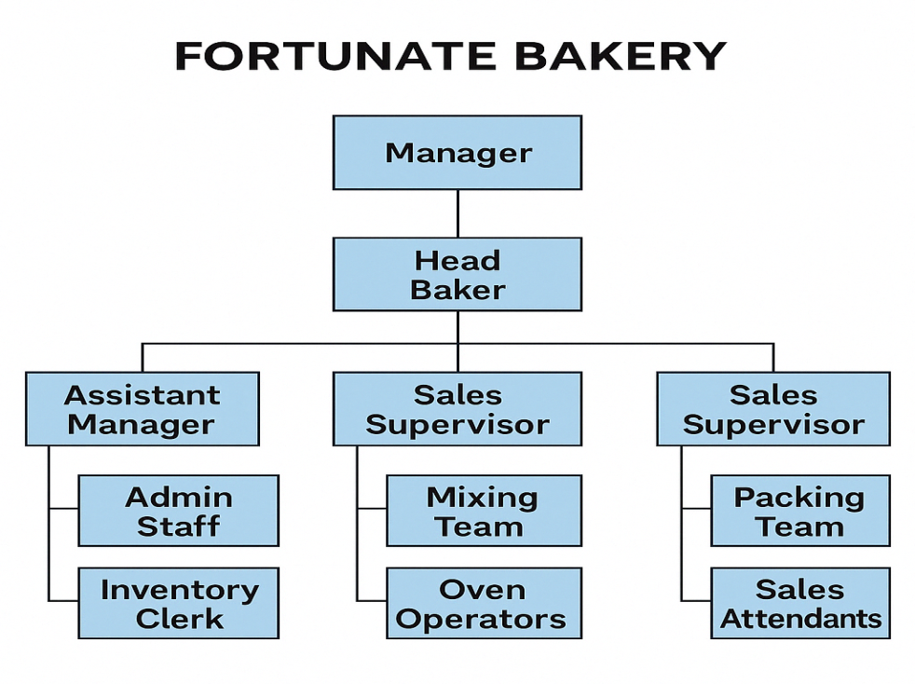
Each department works collaboratively to ensure smooth daily operations, from ingredient procurement to product delivery and customer service.

2.3 Departments and Their Functions
- Production Department:
Responsible for the preparation, baking, and packaging of all bakery products. This department ensures quality control, hygiene, and timeliness in production.
- Sales and Marketing Department:
Handles customer orders, pricing, product distribution, and promotional activities. They play a major role in increasing the bakery’s customer base and managing client relations.
- Store and Inventory Unit:
Oversees the receipt, storage, and issuance of baking materials and packaging supplies. This unit keeps inventory records and ensures timely stock replenishment.
- Administrative and Accounts Department:
Manages financial records, employee documentation, payroll, and internal communication. This unit ensures that all operational costs are tracked and that the business remains profitable and organized.

CHAPTER THREE

TRAINING ACTIVITIES AND WORK EXPERIENCE

3.1 Duties and Responsibilities Assigned
During my industrial training at Fortunate Bakery, I was assigned a variety of tasks across different units of the organization. My main responsibilities included:
- Assisting in the weighing, mixing, and preparation of ingredients for baking.
- Helping to package and label finished bakery products for distribution.
- Supporting the sales team in attending to customer orders and issuing receipts.
- Participating in the cleaning and sanitizing of baking equipment and work areas.
- Monitoring inventory levels and assisting in stock-taking exercises.
- Learning basic bookkeeping such as recording daily sales and expenses.

3.2 Departmental Experiences
I had the opportunity to work in different departments during my training period:
- Production Department:
I supported the bakers in preparing ingredients, mixing dough, and learning the operation of industrial baking ovens. I was also taught how to shape and cut dough uniformly and ensure consistency in product sizes and textures.
- Sales and Customer Service:
In this department, I interacted directly with customers, responded to inquiries, and processed transactions. This experience improved my communication and interpersonal skills.
- Store and Inventory Unit:
I assisted in checking and recording the quantity of raw materials such as flour, sugar, yeast, and flavorings received and used. I also participated in organizing the storage area to ensure easy accessibility and proper rotation of stock.
- Administrative and Accounts:
Here, I was introduced to basic record-keeping, data entry, and expense monitoring. I observed how income and expenses were tracked daily and monthly.

3.3 Tools, Equipment, and Technologies Used
While at Fortunate Bakery, I was exposed to various baking tools and office-related technologies:
- Baking Tools and Equipment:
  - Industrial ovens
  - Dough mixers
  - Scales for weighing ingredients
  - Baking pans and trays
  - Measuring cups and spoons
  - Cooling racks
  - Rolling pins and cutters
- Office Tools and Software:
  - Cash register
  - Point-of-sale (POS) machine
  - Microsoft Excel and Word for recording inventory and financial data
  - Manual record books for tracking daily sales

3.4 Challenges Encountered
Some of the challenges I experienced during the training period included:
- Adapting to the early work hours and fast-paced nature of bakery operations.
- Standing for long periods during baking and packaging processes.
- Learning to operate some of the baking machines and handling hot trays safely.
- Managing customer complaints during busy periods.
Despite these challenges, I gradually adapted and became more efficient with guidance from my supervisors and fellow trainees.

CHAPTER FOUR

SKILLS AND KNOWLEDGE ACQUIRED

4.1 Technical and Administrative Skills
My time at Fortunate Bakery provided me with valuable hands-on experience and improved my understanding of both the technical and administrative aspects of running a small business. Some of the skills I acquired include:
- Baking and Pastry Preparation: I learned how to measure ingredients accurately, mix doughs, shape pastries, and operate industrial ovens under supervision.
- Product Packaging: I became skilled in proper packaging techniques that ensured hygiene, freshness, and attractiveness of bakery products.
- Basic Inventory Management: I was able to keep simple records of items received and used, and I supported stock replenishment planning.
- Administrative Record-Keeping: I helped maintain daily production logs, sales records, and order forms using both manual and digital formats.
- Sales and Cash Handling: I gained experience in handling cash, issuing receipts, and balancing end-of-day sales.

4.2 Interpersonal and Communication Skills
Working with a team and interacting with customers helped me enhance my soft skills significantly. Some of these include:
- Customer Interaction: I learned how to greet customers, listen to their orders, answer inquiries politely, and provide timely service.
- Teamwork: I collaborated effectively with bakers, storekeepers, and sales staff to meet daily targets and ensure smooth operations.
- Time Management: I learned how to prioritize tasks during peak baking hours and how to work under pressure without compromising on quality.
- Adaptability: Being exposed to new tasks daily helped me become more flexible and willing to learn.

4.3 Bridging Classroom Theory with Practical Experience
This industrial training helped me apply several concepts and theories I had learned in class:
- Operations Management: I observed how production was planned, monitored, and controlled from raw material sourcing to final product distribution.
- Customer Service: I implemented practical customer service principles by handling orders, resolving minor complaints, and ensuring customer satisfaction.
- Small Business Finance: I witnessed how income and expenses were tracked, helping me understand basic financial documentation in a business context.
- Entrepreneurship: I gained insight into the daily challenges and responsibilities of running a small enterprise, which strengthened my entrepreneurial mindset.
This real-world experience made the knowledge from my Business Administration courses more relatable, meaningful, and easier to retain.

CHAPTER FIVE

CHALLENGES, RECOMMENDATIONS, AND CONCLUSION

5.1 Challenges and Solutions
During my industrial training at Fortunate Bakery, I encountered several challenges that tested my adaptability and problem-solving skills. These included:
- Early Working Hours:
The bakery operations started as early as 6:00 AM, and adjusting to the new routine was difficult initially. With time, I developed better time management and prepared myself the night before to avoid lateness.
- Physical Fatigue:
Standing for long hours during baking and packaging processes caused fatigue and discomfort. I overcame this by taking short breaks when possible and staying hydrated throughout the day.
- Limited Technical Knowledge at the Beginning:
At the beginning of the training, I had no prior knowledge of how to operate baking machines. However, through close supervision and consistent practice, I became more confident and efficient.
- Managing Customer Demands:
Dealing with multiple customer requests during peak hours was sometimes overwhelming. With practice and guidance, I improved my customer handling and multitasking skills.

5.2 Recommendations for the Organization
- Formal Training Sessions:
Organizing a short onboarding session for new trainees would help them understand safety guidelines, equipment operation, and job expectations earlier in the training.
- Provision of Protective Gear:
Provision of aprons, gloves, and hairnets on the first day of resumption would help ensure hygiene and reduce safety risks.
- Improved Record Systems:
Transitioning from manual to fully digital inventory and sales records would improve efficiency and reduce human error.

5.3 Suggestions for Future SIWES Participants
- Be Willing to Learn:
Future participants should be open to learning and ready to perform any task assigned, even if it seems difficult at first.
- Ask Questions:
Don't hesitate to ask for clarification or assistance when you're unsure. It is better to learn correctly than to assume and make errors.
- Be Punctual and Disciplined:
Developing discipline and punctuality will earn you the trust of your supervisors and colleagues.
- Take Notes and Document Experience:
Keeping a daily log of your activities will help when writing your SIWES report and in reflecting on your growth.

5.4 Summary and Conclusion
The Student Industrial Work Experience Scheme (SIWES) at Fortunate Bakery was a valuable and enlightening experience. It helped bridge the gap between theoretical knowledge and practical application in a real business environment. Through my active involvement in the bakery’s operations, I acquired new skills, enhanced my understanding of business management, and learned the importance of teamwork, time management, and customer service.
This training has equipped me with relevant experience that will be useful in my academic journey and future career in business administration. I am grateful for the opportunity and the support received during the program.

REFERENCES
- Adebayo, K. (2018). Business Operations and Customer Relations in Small Enterprises. Abuja: Emerald Publishing.
- Eze, J. U. (2015). Industrial Training and Skill Acquisition: A Guide for Nigerian Students. Lagos: University Press.
- Olayemi, T. O. (2019). Workplace Dynamics and Industrial Training in Nigeria. Ibadan: Spectrum Books Limited.
- National Board for Technical Education (NBTE) (2022). Industrial Training and the Role of SIWES in Skill Development. Retrieved from www.nbte.gov.ng
- Federal Government of Nigeria (2020). Guidelines on the Student Industrial Work Experience Scheme (SIWES). Retrieved from www.nuc.edu.ng
- Small Business Chronicle (2023). Challenges and Growth in Nigeria’s Bakery Industry. Retrieved from www.smallbusiness.chron.com
- Fortunate Bakery (2024). Internal Training Manual for Bakery Staff and Assistants. Ilorin, Kwara State.
- National Open University of Nigeria (NOUN) (2021). SIWES Handbook for Polytechnic and University Students.
- Okonkwo, B. A. (2020). Entrepreneurship and Small Business Management in Nigeria. Lagos: University of Lagos Press.
- Adekunle, S. (2022). Food Production and Processing Techniques in Nigeria. Ilorin: Kwarex Publishing.
- Health and Hygiene Nigeria (2023). Bakery Safety and Sanitation Guidelines. Retrieved from www.healthhygiene.org
- Microsoft Corporation (2023). Microsoft Office User Guide – Word and Excel Tools. Available at www.microsoft.com

