

TECHNICAL REPORT

ON
STUDENTS INDUSTRIAL WORK EXPERIENCE SCHEME (SIWES)

HELD AT:
BALOGUN GAMBARI MICROFINANCE BANK
OJAGBORO, ILORIN, KWARA STATE

By
AKINOLA BLESSING OYINDAMOLA
ND/23/PAD/PT/0497

SUBMITTED TO:
THE DEPARTMENT OF PUBLIC ADMIN, INSTITUTE OF FINANCE AND MANAGEMENT STUDIES (IFMS), KWARA STATE POLYTECHNIC, ILORIN.

IN PARTIAL FULFILLMENT FOR THE AWARD OF NATIONAL DIPLOMA IN PUBLIC ADMINISTRATION.

AUGUST-DECEMBER, 2024

DEDICATION
I dedicate this technical report to the Almighty God, the giver of knowledge, wisdom and who is rich in mercy.

ACKNOWLEDGEMENT
I would like to begin by expressing my heartfelt gratitude to the Creator of heaven and earth, the One who knows the beginning and the end, the Alpha and the Omega, the Almighty God for His guidance and blessings throughout this journey.
I am deeply grateful to my beloved parents, Mr. and Mrs. Blessing, whose unwavering support and prayers have been my foundation. To my brothers and dear friends, your encouragement and companionship have meant the world to me.
My special thanks go to my SIWES supervisor for his guidance, mentorship, and invaluable insights during this program. I also extend my profound appreciation to everyone who supported me during my SIWES experience. May the Almighty God bless, protect, sustain, and guide you through all of life’s journeys.
Lastly, I wish to express my sincere regards to the school’s Board of Trustees and the entire staff of the Public administration department for their dedication and support. Once again, a big thank you to everyone who contributed to making this experience a memorable and successful one.

TABLE OF CONTENT
Title Pages
Dedication
Acknowledgement
Table of content
CHAPTER ONE
1.0 Introduction
1.1 About SIWES
1.2 Brief history of SIWES
1.3 Aim and objectives of SIWES
1.4 Role of student during SIWES
1.5 Objectives of the report
1.6 The logbook
CHAPTER TWO
2.0 Organization Chart
2.1 Brief history of the establishment
CHAPTER THREE
3.0 Experiences Gained
CHAPTER FOUR
4.0 Knowledge gained during the SIWES exercise
4.1 Conclusion
4.2 Recommendation

CHAPTER ONE

INTRODUCTION

Industrial Training Fund (ITF) and SIWES

SIWES was founded by ITF in 1973 to address the issue of Nigerian tertiary school graduates lacking sufficient practical skills to prepare them for employment in industries. The program exposes students to industry-based skills that are essential for a seamless transition from the classroom to the workplace. It gives tertiary institution students the chance to become acquainted with and exposed to the necessary experience in operating machinery and equipment, which is typically not available in educational institutions.
Participation in industrial training is a well-known educational strategy. Classroom studies are integrated with learning through hands-on work experiences in a field related to the students’ academic major and career goals. Successful internships foster an experiential learning process that not only promotes career preparation, but provides opportunities for learning to develop skills necessary to become leaders in their chosen professions.
One of the primary goals of the SIWES is to help students integrate leadership development into the experiential learning process. Students are expected to learn and develop basic non-profit leadership skills through a mentoring relationship with innovative non-profit leaders. By integrating leadership development activities into the industrial training experience, we hope to encourage students to actively engage in non-profit managements as professional career objectives. However, the effectiveness of the SIWES experience will have varying outcomes based upon the individual student, the work assignment, and the supervisor/mentor requirements. It is vital that each internship position description includes specific, written learning objectivities to ensure leadership skill development is incorporated.
Participation in SIWES has become a necessary pre-condition for the award of diplona and degrees certificates in specific practical-oriented disciplines in most institutions of higher learning in the country, in accordance with the education
policy of government operators-the ITF, the coordinating agencies (NUC, NCCE and NBTE), employers of labor and the institutions.

Objectives of the Students Industrial Work Experience Scheme (SIWES)

- To provide students the opportunity to test their interest in a particular career before permanent commitments are made.
- To provide an avenue for students in institutions of higher learning, acquire industrial skills and experience in their course of study.
- To provide and prepare students for the industrial work situation they are to meet after school.

- To aid students in adjusting from college to full-time employments

- To provide students the opportunity to develop attitudes conducive to effective interpersonal relationships.
- To increase students’ sense of responsibility.

- To make students acquire good work habits.

- To provide students with an opportunity to apply their knowledge in real work situation thereby bridging the gap between theory and practice.

CHAPTER TWO

INTRODUCTION

Organizational Background
The microfinance market is expected to experience continued growth over the coming years. Despite new entrants in this market, BALOGUN GAMBARI MICROFINANCE BANK LIMITED expects to take advantage of this growth by rapidly expanding its operations within new geographical areas and product lines. According to a 2012 report produced by Enhancing Financial Innovation & Access (EFINA), about 39.7% of the Nigerian adult population does not have access to any type of formal financial services. This is a huge untapped market which the Bank intends to penetrate aggressively. The Bank’s aim is to put all necessary strategies in place to capture a substantial part of this burgeoning market.
The microfinance market is expected to experience continued growth over the coming years. Despite new entrants in this market, BALOGUN GAMBARI MICROFINANCE BANK LIMITED expects to take advantage of this growth by rapidly expanding its operations within new geographical areas and product lines. According to a 2012 report produced by Enhancing Financial Innovation & Access (EFINA), about 39.7% of the Nigerian adult population does not have access to any type of formal financial services. This is a huge untapped market which the Bank intends to penetrate aggressively. The Bank’s aim is to put all necessary strategies in place to capture a substantial part of this burgeoning market.
BALOGUN GAMBARI MFB’s Competitive Positioning
BALOGUN GAMBARI MICROFINANCE BANK LIMITED has the potential to grow rapidly to become one of the leading microfinance banks in Nigeria. The Bank has a competent management team in terms of qualification and industry experience and strong growth potential. BALOGUN GAMBARI MICROFINANCE BANK LIMITED is currently recognized as a model microfinance institution in the industry.
Good Treasury Management
The bank is very careful in the choice of banks to place our statutory reserve and surplus funds. This is done to enable us maximize our returns on unused funds beyond the rate of return on investment in Treasury Bills. The Bank operate with the following Deposit Money Banks in Nigeria for the management of its surplus funds and for the purpose of correspondent banking.
BALOGUN GAMBARI MICROFINANCE BANK LIMITED deliberately focusing its risk asset creation on the ratio of 80:20 to microcredit/agriculture financing and SME respectively. The returns and safety of its funds are more generally secured under the micro credit scheme where the focus is on the rural women at the bottom of economic pyramid. The methodology is that women are allowed to self-select themselves into a group of maximum of 10 and are jointly bound by a cross guarantee to the extent that the responsibility for a default by one member is assumed and fully and finally settled by the other nine (9) members at the centre meeting where repayment is collected weekly by our loan officers. This methodology has resulted to almost zero Portfolio at Risk.

On agriculture financing, after exercising due diligence on the lending requirements and dynamics, it take further comfort on the Agricultural Credit Guaranteed Scheme Fund (ACGSF) to protect our funds (75% of any credit extended to support is guaranteed by the CBN); Nigerian Agricultural Insurance Corporation (NAIC) to protect our assets in the event of any insured mishap in the farms of our customers and Interest Drawback Programme (IDP) to incentivize our customers towards prompt repayment of all credit accommodation extended to them (40% of interest charged on our agric loans are paid back to the customers by the CBN for every facility that was paid on time).
SME financing is one area where we tread more carefully. The bank is disposed to financing businesses that are turnover driven with clear contribution of equity from the customers. We do not, as a rule, finance start-up businesses because one of the key conditions that drive our credit decision is the availability of pedigree of customer’s understanding of business requiring our support.
BALOGUN GAMBARI MICROFINANCE BANK LIMITED deliberately finance LPOs from blue chip companies with clear payment history for contracts and LPOs awarded by them. It also carefully finance contracts and LPOs from selected Nigerian public institutions that meet obligations to their clients reasonably as at when due. This approach is to ensure that we do not endanger the return of our principal and earnable income from granting credit facilities to our customers.
BALOGUN GAMBARI MICROFINANCE BANK LIMITED had participated in the past for SURR-P payment and many of such programme where the bank acted as intermediary in ASA, MORO, ILORIN EAST, ILORIN WEST and PATIGI Local Government Area of the state to mention but few.
2.3 Organogram of the Organization
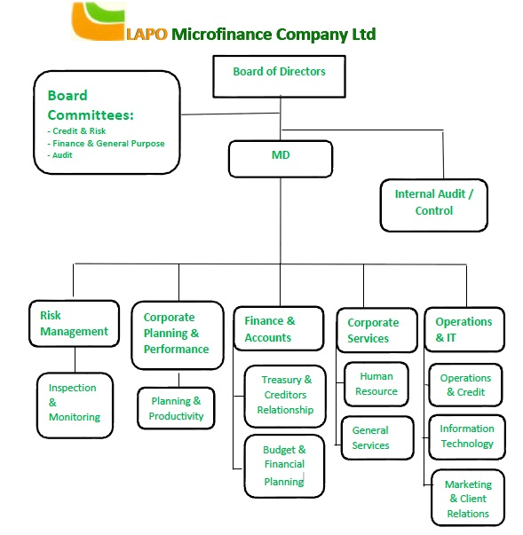

CHAPTER THREE
KEY PROJECTS AND ASSIGNMENTS

3.1 Key Projects / Assignments and Achievements

During the Student Industrial Work Experience Scheme (SIWES) at Balogun Gambari microfinance bank multiple projects, assignments, and responsibilities were undertaken, significantly contributing to the Application forms and Many forms in the banking hall.
During my siwes programme I was posted to customer service section,
Where;
- I receive loan application, searching for loan files and attaching it to the files available for Loans
- Learnt about stamping and recording all application form
- Stamping and receiving all OFSA forms and LGs (Loan Guaranty Savings) forms
- Account Opening
- Filling of files
- Searching for loan files of customer that submit loan application
- Filing of pink copies of accounting voucher into their various files according to their date of posting
- Inventory and Stock Management Optimization: Inventory control is a critical aspect of supply chain management, ensuring seamless operations in the fashion store. Key achievements include:

Application of Microsoft Excel in Inventory Management:
    - Developed proficiency in using Excel spreadsheets for stock monitoring by applying fundamental formulas such as SUM, COUNTIF, and IFERROR, which are crucial in data validation and error handling.
    - Assisted in maintaining real-time stock records, ensuring an efficient tracking system that prevents understocking and overstocking.

Physical Stock Auditing and Verification:
    - Conducted manual stock reconciliation by cross-checking system records with physical inventory, ensuring accuracy in documentation.
    - Participated in weekly stock-taking exercise, ensuring that discrepancies were promptly identified and corrected, a practice essential for maintaining optimal inventory levels.

- Customer Relations and Front Desk Operations: Customer service excellence is fundamental in retail businesses, particularly in the fashion industry, where client satisfaction drives revenue growth. Major contributions include:

Order Processing and Invoice Documentation:
    - Managed front desk operations, handling customer inquiries, order placements, and invoice generation using a structured order-tracking system.
    - Processed electronic and cash transactions using Point-of-Sale (POS) terminals, ensuring proper financial documentation and reconciliation.

Customer Relationship Management (CRM):
    - Engaged in customer interaction training, enhancing skills in handling complaints, addressing inquiries, and providing after-sales support.
    - Implemented strategies in customer persuasion and retention, ensuring client satisfaction and repeat patronage.

Payroll and Administrative Responsibilities
Financial management, particularly payroll administration, plays a vital role in employee satisfaction and business stability. Key tasks included:

Introduction to Payroll Systems:
    - Observed and assisted in payroll preparation, learning salary computation techniques, including deductions, bonuses, and statutory contributions (e.g., pensions and taxes).
    - Gained insight into how payroll systems integrate with financial reporting, ensuring compliance with accounting principles.

CHAPTER FOUR

4.1 KEY KNOWLEDGE GAINED FROM THE SIWES TRAINING PROGRAMME
During my Student Industrial Work Experience Scheme (SIWES) at Balogun Gambari Microfinance Bank, I gained practical knowledge and hands-on experience in various aspects of Office Equipment, business administration, inventory management, customer service, and fashion retail operations. Key experience gained included:

Identification Of Office Equipment and Their Functions
I get to know more about Various office equipment utilized to enhance administrative efficiency, record-keeping, customer service, and sales processing. These devices play crucial roles in streamlining business operations, ensuring smooth communication, and improving overall workflow. Below are list of Office Equipment and Their Functions:

Computer: Used for processing business data, managing inventory using Microsoft Excel, writing invoices, scanning and storing documents, and handling payroll records.

Printer: Used to produce hard copies of invoices, receipts, payroll documents, and other business records required for customer and administrative use.

Photocopier Machine: Duplicates essential business documents such as receipts, invoices, staff records, and sales reports for record-keeping.
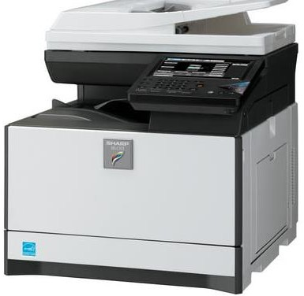
Point-of-Sale (POS): Machine Processes customer transactions, allowing for secure and efficient payment via credit/debit cards, reducing reliance on cash payments.

Scanner: Converts physical documents into digital files for secure storage, record-keeping, and easy retrieval.
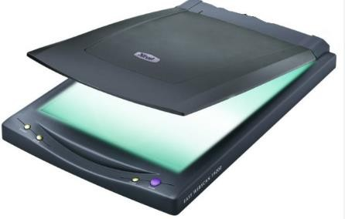


Telephone (Landline and Mobile): Facilitates communication with customers, suppliers, and employees, ensuring seamless business operations.

Binding Machine: Used to assemble and organize hard copies of business reports, invoices, and other important documents for easy reference.

Laminating Machine: Protects important documents (e.g., business licenses, certifications, and ID cards) by sealing them in a plastic covering to prevent damage.

Cash Register: Records sales transactions, providing printed receipts and keeping track of daily revenue.

Inventory and Stock Management

Inventory management involves tracking, ordering, storing, and controlling business materials, goods, and supplies to ensure there is enough stock to meet customer demand without excessive overstocking. I acquired valuable hands-on experience in tracking and managing inventory, ensuring stock records were up to date and accurately recorded. I also learned how to use Microsoft Excel for stock control and reporting, an essential tool for inventory management. Proper inventory management prevents stock shortages, reduces waste, and optimizes financial resources. By keeping an accurate record of stock levels, businesses can forecast demand, reduce unnecessary costs, and ensure customer satisfaction.

Financial Documentation and Payroll Processing

Financial documentation involves recording, storing, and managing financial transactions such as invoices, sales records, payroll, and expenses. Payroll processing refers to calculating and distributing employee salaries, including deductions and benefits. I gained in-depth knowledge of preparing invoices, handling payroll records, and maintaining financial accuracy. Observing payroll management processes gave me insights into salary calculations, tax deductions, and employee benefits. Accurate financial documentation ensures compliance with financial regulations, minimizes errors, and enhances transparency in business operations. Payroll processing is essential for employee satisfaction and legal compliance regarding wages and tax obligations.

Customer Relations and Front Desk Operations

Customer relations refers to the strategies and processes a business uses to interact with and satisfy its customers. Front desk operations involve handling inquiries, issuing invoices, processing transactions, and addressing customer concerns. Interacting with customers taught me effective communication, problem-solving, and the importance of professionalism. I learned how to process transactions, issue invoices, and address customer concerns politely and efficiently. Good customer relations increase customer retention, enhance brand loyalty, and drive business growth. Front desk operations ensure efficient service delivery, professional communication, and streamlined business transactions.

Digital Record-Keeping and Administrative Efficiency

Digital record-keeping involves scanning, storing, and managing business records electronically for quick access and long-term storage. It replaces manual filing systems with computerized data management tools. I was trained in scanning, organizing, and securing digital business records, reducing reliance on manual filing systems. I also learned how to retrieve and manage customer and financial records digitally. Digital documentation improves accuracy, enhances security, and allows easy retrieval of important business records. It reduces paperwork, saves time, and ensures compliance with data protection regulations.

In one word, My SIWES experience at Jolayemi Chartered Accountant provided me with comprehensive exposure to business administration functions. I developed practical skills in inventory management, financial documentation, customer relations, digital operations, and supply chain management. These competencies are essential for ensuring business efficiency, optimizing resources, and driving sustainable growth.

This training has equipped me with the ability to analyze business challenges, propose effective solutions, and implement best practices for operational success. The hands-on experience has bridged the gap between theoretical knowledge and real-world business applications, making me better prepared for a future career in business administration.

CHAPTER FIVE
CHALLENGES, RECOMMENDATIONS, AND CONCLUSION

Challenges

During my Student Industrial Work Experience Scheme (SIWES) at Balogun Gambari Microfinance Bank, I encountered several challenges that tested my ability to adapt, learn, and apply my knowledge of business administration in a real-world setting. These challenges, while demanding, significantly contributed to my professional growth.
Limited Initial Experience in Public Administrative Processes: At the start of my internship, I faced difficulties understanding core business administration tasks such as inventory management, payroll processing, and financial documentation..
Lack of Financial Incentives for SIWES Students: While SIWES provided invaluable practical knowledge, the lack of financial compensation posed a challenge, especially for students who had to cover transportation and other expenses. A small stipend for interns could serve as motivation and enhance productivity.
Technical Challenges with Office Equipment: The photocopier, scanner, POS machine, and other office equipment occasionally developed technical faults, causing delays in administrative processes. Learning basic troubleshooting and maintenance techniques became necessary to ensure smooth workflow and prevent operational inefficiencies.

Conclusion

The Student Industrial Work Experience Scheme (SIWES) at Balogun Gambari Microfinance Bank provided me with invaluable hands-on experience in business administration, enhancing my understanding of key administrative functions such as inventory management, financial documentation, payroll processing, and customer relations. Through practical engagement in these tasks, I developed essential workplace skills, including effective communication, problem-solving, multitasking, and digital proficiency in business tools like Microsoft Excel.

Despite the challenges encountered, such as handling customer complaints, managing high workloads, and adapting to technical and inventory-related issues, these obstacles ultimately contributed to my professional growth, resilience, and adaptability in a real-world business environment. Additionally, my exposure to various administrative duties deepened my knowledge of business operations, stock control, and financial record-keeping, which are vital components of any successful organization.
Overall, this experience has been a significant stepping stone in my academic and career journey, preparing me for future roles in business administration and corporate management. The lessons learned will remain invaluable as I continue to develop my expertise and contribute meaningfully to any organization I become a part of.

Recommendations

Based on my industrial work experience, I propose the following recommendations to improve the SIWES program and enhance its benefits for future students:
    - Comprehensive Departmental Exposure: All students undergoing SIWES, especially in business-related organizations, should be given the opportunity to work across various departments, such as inventory management, financial records, sales, and customer service. This will ensure a holistic learning experience and allow students to discover areas where they excel.
    - Provision of Financial Support for SIWES Students: Given that students actively contribute to business operations, organizations should consider offering stipends or transportation allowances. This will motivate students, enhance commitment, and reduce financial strain, particularly for those who live far from their place of primary assignment (PPA).
    - Incorporation of Digital Skills Training: Business organizations should provide training on digital tools such as Microsoft Excel, accounting software, and customer management systems. These digital skills are essential in modern business administration and will significantly benefit students beyond their internship period.

