

A TECHNICAL REPORT ON
STUDENT INDUSTRIAL WORK EXPERIENCE SCHEME (SIWES)

HELD AT
RAMON FASSASI CONSTRUCTION AND FABRICATION COMPANY
ZONE 1, KM 24, MEBAMU MARKET BUS-STOP, OKOKO-MIAKO OJO, LAGOS STATE

PRESENTED BY:
RAJI HAKEEM SHINA
ND/23/MET/FT/0051

SUBMITTED TO
DEPARTMENT OF METALLURGICAL ENGINEERING, INSTITUTE OF TECHNOLOGY, KWARA STATE POLYTECHNIC, ILORIN, KWARA STATE

IN PARTIAL FULFILLMENT OF THE REQUIREMENT FOR THE AWARD OF NATIONAL DIPLOMA CERTIFICATE IN METALLURGICAL ENGINEERING TECHNOLOGY.
AUGUST – NOVEMBER, 2024

DEDICATION
I dedicate this work to my dearest parents Mr. and Mrs. Raji whom through their advices, love, care and financial assistance have made me to be where I am today. I pray the good God will continue to keep and guide them for me. Amen.

ACKNOWLEDGEMENTS
I cannot but express my unquenchable and eternal gratitude to HIM “The Alpha and Omega who has proved his tremendous works in my life and has not cut short my expectations throughout the course of this programme.
My heartfelt appreciation goes to my loving parents; Mr. and Mrs. Raji, for their financial, spiritual and moral contributions through my academic course.
I am deeply indebted to our SIWES coordinator for his excellent advice, efficient supervisions, to my able Supervisor Engr. Ramoni Fassasi and the official name to all the entire staff of Metallurgical Engineering Department, Kwara State Polytechnic, Ilorin. My eagle could not have flown wings to my loyal allies for their words of encouragement and for believing in my dreams.
And to all the entire Metallurgical Engineering ND II Students, if there is anything my soul love best it is you. My profound gratitude also goes to the management of Ramon Fassasi Construction. To those whom I omit to mention, pardon my inadvertence, the pressure of the season has impressed upon my fallible mind. Thank you.

Preface
This report is a summary of the experience I acquired during my Four Months Student’s Industrial Work Experience Scheme (SIWES) at Ramon Fassasi Construction and Fabrication Company, Zone 1, KM 24, Mebamu-Market, Bus stop, Okokomiako Lagos State. With highlight majorly on construction and fabrication, giving a full enlightenment on equipment used during the course of the work as well the various component and processes, giving a clear idea of the student involvement in an operational activities carried out in the firm.

Table of Contents
Title Page i
Dedication ii
Acknowledgements iii
Preface iv
Table of Contents v
CHAPTER ONE 1
1.0 Introduction 1
1.1 Definition of SIWES 2
1.2 Aim and Objectives of SIWES 2
1.3 Ramon Fassasi Construction and Fabrication Company 3
1.3.1 Brief History of Ramon Fassasi Construction and Fabrication Company 3
1.3.2 Vision 3
1.4 Major Activities of the Organization/Company 3
1.5 Organization Chart Of Ramon Fassasi Construction and Fabrication Company 4
CHAPTER TWO 5
2.0 Section of the Organization and Specific Function 5
2.1 The Workshop Section 5
2.2 Functions of the Section/Unit 5
CHAPTER THREE 6

3.0 Procedures for Repair Welding and Surfacing…………………………………...6

3.1 Preparation for Welding…………………………………………………….6

3.2 Protection of Adjacent Machinery………………………………………….
3.3 Layout for Repair Work
3.4 Cutting and Gouging 7
3.5 Grinding and cleaning

3.6 Post-Weld Operations

3.7 Rebuilding and Overlaying

3.8 Diagrammatical Representation of Tools Listed Above
CHAPTER FOUR 10
4.1 Production of Aluminium Pot (Size E4) 10
4.2 Finishing 13
CHAPTER FIVE 14
5.1 My Personal Impression About the Organization 14
5.2 Experience Gained 14
5.3 Recommendation to the Organization and to the Polytechnic Concerning the SIWES Program 14
5.4 Interpersonal Relationship 15
5.5 Conclusion 15

CHAPTER ONE

1.0 Introduction
The Students Industrial Work Experience Scheme (SIWES) is a skill Training Programme designed to expose and prepare students of Universities, Polytechnics/Colleges of Technology/Colleges of Agriculture and Colleges of Education for the Industrial Work situation they are likely to meet after graduation. The scheme also affords students the opportunity of familiarizing and exposing themselves to the needed experience in handling equipment and machinery that are usually not available in their Institutions.
Before the establishment of the scheme, there was a growing concern among our Industrialists that graduates of our Institutions of Higher learning lacked adequate practical background studies preparatory for employment in Industries. Thus, the employers were of the opinion that the theoretical education going on in higher institutions was not responsive to the needs of the employers of labour.
The organization responsible for student industrial work experience scheme (SIWES) is Industrial Training Fund (ITF) and was established on October 1971. The student industrial work experience scheme (SIWES) is the accepted skills training programme which form part of the approved minimum academic standards in the various programme.
The practical knowledge and skilled acquired in Nigeria Tertiary Institution are no longer sufficient to provide adequate required skills in construction technology it is regarded as a part of the course requirement (curriculum) for engineering and some other professional courses offered in higher institution of learning, it was established in 1973 by the Industrial Training Fund in collaboration with the National Board for Technical Education which has it headquarter at Kaduna to solve the problem or adequate practice skill required for employment in industries by Nigeria Graduates of Tertiary Institution.
The main operators in the SIWES programme are the ITF and the Government agencies are NBTE. It is funded by the Federal Government of Nigeria and beneficiaries of the programme include Undergraduate student of Agriculture Engineering, Environment Science Education, Medical Science and Pure and Applied Science.

1.1 Definition of SIWES
Student Industrial Work Experience (SIWES) is a programme established by government and introduced to every higher institution in order for student to have practical experience of the work done.

1.2 Aim and Objectives of SIWES
Specifically, the objectives of the Students Industrial Work Experience Scheme (SIWES) are to:
- Provide an avenue for students in institutions of higher learning to acquire industrial skills and experience in their course of study, which are restricted to Engineering and Technology including Environmental studies and other courses that may be approved. Courses of NCE (Technical), NCE Agriculture, NCE (Business), NCE (Fine and Applied Arts) and NCE (Home Economics) in Colleges of Education are also included.
- Prepare students for the industrial work situation they are to meet after graduation;
- Expose students to work methods and techniques in handling equipment and machinery that may not be available in their institutions.
- Make the transition from school to the world of work easier, and enhance students contacts for later job placement;
- Provide students with an opportunity to apply their knowledge in real work situation thereby bridging the gap between theory and practice; and
- Enlist and strengthen employers, involvement in the entire educational process and prepare students for employment in Industry and Commerce.

1.3 Ramon Fassasi Construction and Fabrication Company

1.3.1 Brief History of Ramon Fassasi Construction and Fabrication Company
Ramon Fassasi, Construction and Fabrication Company was established in the year 2007, which is situated at Zone 1, Km 24, Mebamu Market, Bus stop, Okokomiako, Lagos State. The Industry is made up of five of Departments and chaired by the General manager/Chief Executive Officer, who is responsible for the day to day running of the organization. It was charged with the broad function of generating and catalyzing industrialization by carrying out the correction of defective castings, etc.

1.3.2 Vision
To make Nigeria one of the acknowledged leaders of the scientifically and technologically developed nations of the world.

1.4 Major Activities of the Organization/Company
Ramon Fassasi Construction and Fabrication Company was majorly established to construct and fabricate iron into different forms and shapes.

1.5 Organization Chart of Ramon Fassasi Construction and Fabrication Company

CHAPTER TWO

2.0 Section of the Organization and Specific Function
The organization has a little amount of workers, whom are divided into units. The sectional unit can also be sub-divided into different section there are

2.1 The Workshop Section
i. Constructing and fabricating Section
ii. Finishing Section

2.2 Functions of the Section/Unit
1. Constructing and Fabricating Section: This is the structural components of a workshop building. Which are typically made by combining pre-fabricated metal sections (like steel beams and columns) with on-site concrete or masonry construction of propeller reboring of rims and constructing of chaxis. Allowing for customized spaces to accommodate specific machinery and work processes within the workshop.
2. Finishing Section: This is the final section of the workshop where all inspection and correction are made on the material produced. Also, this section are also set aside for the correction of defect and materials used by this section are hand file, ring, grinding machine, hand file etc. and a pomade substances used for correction such as hardener and filler.
Enlarging of Hole
Enlarging of hole on a spring with a drilling machine from 20hole to 24hole
Repairing of Bore Joint
Repairing of bore joint by cotting its head with a cutting machine and replacing its spring and welding it back.
Constructing of Propeller
Welding of proper with a welding machine and straightening the hand part
Constructing of Proper of 9¹/₂ inches to its stock and fixing it to the car.
I tried making use of drilling machine although it wasn’t perfect. Cutting of plate with a cutting machine
Constructing of Rakes
By using a pipe of 3 feet and a quarter rod to make the rake
Repairing of Tyroid
By charging of its spring, putting of grease in it and welding its cover.
My supervisor and I weld a propeller by replacing it head with a new one.
My supervisor and I also made use of drilling machine and a 22bit to enlarge hole. I also made use of a welding machine to tack a washer to a propeller. Enlarging of hole with a drilling machine on a work piece. Cutting of cast iron and applying of cutting flood while cutting (Compressed oil). Filling of broken shaft, constructing of stamp holder.
CHAPTER THREE

3.0 Procedures for Repair Welding and Surfacing
Repair welding involves three key operations: preparation for welding, repair welding, and post-weld operations. This article introduces the necessary actions and procedures for effective repair welding and surfacing.

3.1 Preparation for Welding
Before starting the welding process, several factors must be considered:
Safety
The welding area must be surveyed to address all safety considerations. This includes posting safety signs, removing combustible materials, and draining fuel tanks from equipment such as aircraft, boats, and trucks. Additionally, toxic materials like lead paint and plastic coverings should be eliminated.
Cleaning
The work area must be free from contaminants, including dirt, grease, oil, rust, and paint. The cleaning method depends on the material to be removed and the workpiece location. Recommended methods include steam cleaning, solvent cleaning, abrasive blast cleaning, and power tool cleaning. Investing time in cleaning will yield long-term benefits.
Disassembly
For most repair jobs, disassembly may be necessary. This may involve removing lubrication lines, instrument tubing, and wiring, and, in some cases, major components from machinery frames.
3.2 Protection of Adjacent Machinery
Parts that are not removed should be protected from weld spatter and sparks using sheet metal guards or baffles. Asbestos cloth can safeguard machined surfaces, and protective materials should be secured with wire, clamps, or temporary bracing. Protect all machined surfaces within five feet of the welding operation.
Bracing and Clamping
Complex repairs may require bracing or clamping due to the weight of parts or external loads. Temporary braces may be welded to the structure being repaired.
3.3 Layout for Repair Work
A layout is necessary to indicate the metal to be removed for a full-penetration weld. Minimize the amount of metal removed while ensuring that welding can be performed comfortably.
Preheating
Preheating is essential when flame cutting or gouging, similar to welding. It helps prevent thermal shock on the metal.
3.4 Cutting and Gouging
Oxygen-fuel gas cutting torches are commonly used for cutting and gouging. Special gouging tips should be selected based on joint preparation geometry. Flame gouging can help identify and follow cracks during the process. For some metals, mechanical chipping or grinding may be more suitable.
3.5 Grinding and cleaning
The resulting surfaces may require grinding to achieve clean, bright metal. For critical work, magnetic particle inspection is advisable to ensure all cracks and defects are removed.
These steps are crucial for proper weld preparation; while some may be omitted, all should be considered.

2. Repair Welding
Successful repair welding requires a logical sequence of operations:
Welding Procedure
A detailed welding procedure must be available, outlining the welding process, filler metals, preheat requirements, and joint technique.
Welding Equipment
Ensure sufficient welding equipment is on hand to avoid delays, including electrode holders, grinders, wire feeders, and cables.
Materials
Adequate materials must be available, including properly stored filler metals, insert pieces, and reinforcing components. This also includes fuel for preheating and shielding gases if required.
Alignment Markers
Prior to welding, alignment markers (e.g., center punch marks) should be made across the joint.
Welding Sequences
The welding procedure should detail the sequence to be followed, which may include block welding, back-step welding, or peeling.
Safety
Maintain safety measures throughout the welding operation, including adequate ventilation when using fuel gases for preheating.

3.6 Post-Weld Operations
After completing the weld, allow it to cool slowly, avoiding exposure to wind or drafts. Machinery loads should not be applied until the temperature returns to normal.
Inspection
Inspect the finished weld for quality and smoothness, employing nondestructive testing methods such as magnetic particle, ultrasonic, or X-ray testing.
Clean-Up Operation
Remove all strong backs, bracing, and protective covers. Ensure all weld stubs, spatter, slag, and dust are cleaned thoroughly to prevent future issues.
Repainting
After cleaning, repaint the welded area and re-grease other components in preparation for machinery operation.
Reassembly
Return and reassemble any machinery components that were disassembled during the repair process.

3.7 Rebuilding and Overlaying
Rebuilding and overlaying with weld or spray metal are considered surfacing operations. Surfacing deposits filler metal on a base metal to achieve desired dimensions or properties, while overlaying involves applying a deposit with specific properties that may differ from the original surface.
Rebuilding restores parts to their original dimensions and properties, while overlay surfacing enhances wear resistance and corrosion protection.
Surfacing can be achieved using various welding processes or thermal spraying, with the process selection based on specific project requirements. Thermal spray methods are advantageous when minimal heat input is essential, especially for materials that cannot be deposited through traditional welding.

Selection of the Welding Process
Choosing the appropriate welding process and technique is as crucial as selecting the deposit alloy. Common methods for hardfacing include:
- Shielded Metal Arc Welding (SMAW): Widely used for hardfacing, applicable in various positions and suitable for both small and large parts.
- Submerged Arc Welding (SAW): Primarily used in plant operations for flat-position welding and routine applications.
- Flux-Cored Arc Welding (FCAW): A popular semiautomatic process that can be used in the field or shop and is not limited to the flat position.
- Gas Tungsten Arc Welding (GTAW): Suitable for smaller applications and typically used in the shop for precision work.
- Plasma Arc Welding (PAW): Effective for certain applications requiring higher temperatures, often limited to smaller jobs.
- Electroslag Welding: Used for specialized applications, including rebuilding components like crusher hammers.
- Oxyacetylene Welding: Applied for specialized alloys on thin edges.
The selection process should consider normal factors alongside specific comments mentioned above. Once the process is chosen, select the deposited metal to ensure it provides the necessary properties for the application.

3.3 Diagrammatical Representation of Tools Listed Above
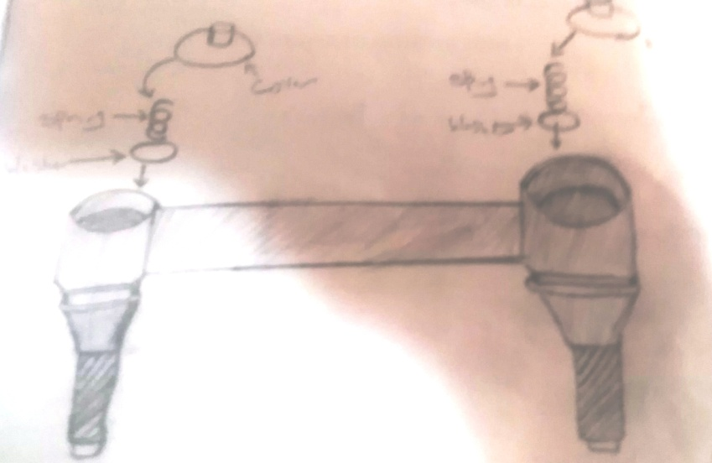
TYROID

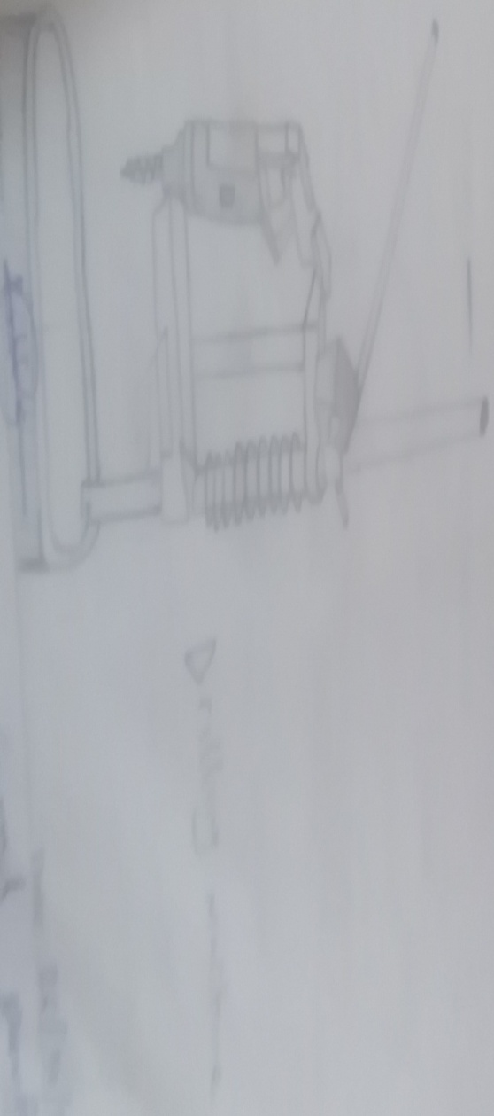
DRILLING MACHINE

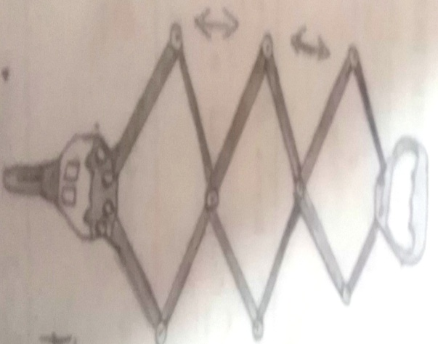

RIVERTING MACHINE

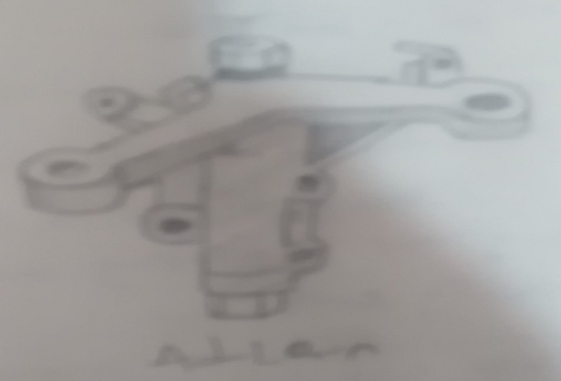
ADLARN

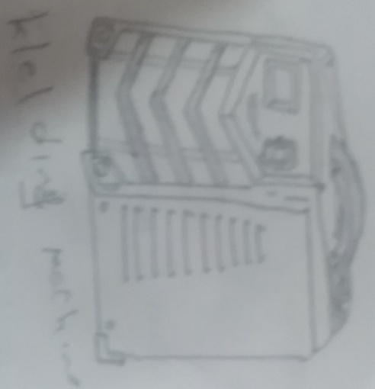

WELDING MACHINE

3.4 Safety Precautions and Their Reasons
- Do not run in the workshop, because running in the workshop can
- Do not wear shoe from outside to the workshop, because the shoe might have other constituents aside sand that can lead to defect
- Always wear workshop boot when working or walking in the workshop, because walking in the workshop barefooted in the workshop can lead to injury as a result of stepping on molten metal
- Use tools correctly; follow proper procedures for each tools and ensure they and good working condition
- Know where safety equipment is located and how to respond in case of an emergency
- Follow safety instruction always adhere to established workshop safety guidance
- Maintain a tidy workspace: Keep your work area clean and organized to prevent accidents from tripping hazards or clutter

CHAPTER FOUR

4.1 Production of Aluminium Pot (Size E4)
The production of this pot (Aluminium pot) commonly known as E4 follow a sequential process i.e having a heap of sand and a hoe, then The sand will be filled into the pot until it is full, then it will be rammed with the use of rammer and the surface will be smoothened with a strike off bar as in the figure below;
Then a bed will be prepared with the use of strike off bar and sand as shown below
A core is the opening at the middle of the mould where molten metal is being poured. After the production of the core, the mould will be raised carefully up-ward so as to remove the pattern. And after the removal of the pattern the mould will be dressed properly and then it will be carefully placed back with the correspondence of the line of co-ordination.
After all these processes are being carried out successfully then molten metal will be poured and the mould will be opened after 10-15 seconds. The molten metal will be transferred from the furnace to the workshop through the use of a crucible ladle and mind you, the molten metal will be poured through the core.

4.2 Finishing
Substances used in the finishing section are:
- Filler
- Hardner and
- Petrol
In foundry, finishing is the final stage in the workshop where all completion of casting is carried out. In this process correction of minor defect is being done by patching through the process of hammering a metallic scrap towards the point of defect as shown in the diagram below;
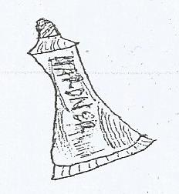
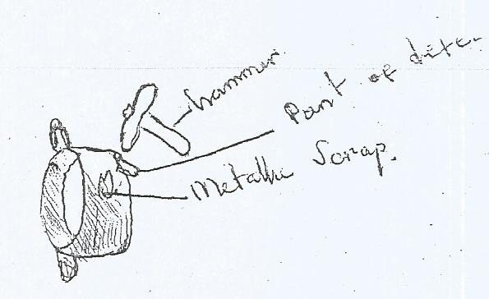

Also defect sometimes are correct with the use of pomade like substance called body filler and a white gelatinous substance called hardener mixed thoroughly together and rubbed on the point of defect.

CHAPTER FIVE

5.1 My Personal Impression about the Organization
Ramon Fassasi Construction and Fabrication Company, a very friendly organization which addresses issues in a polite manner and equally encourages both the SIWES students and apprentices to be self-dependent and motivated. I can say that the organization as a bright/promising future if he will not change the way he operates.

5.2 Experience Gained
Working as a student Trainee at Ramon Fassasi Construction and Fabrication Company Workshop has given me the opportunity of getting a firsthand appreciation of Foundry, learning its fundamentals, learning to work with the various equipment used. I was able to apply some of the theoretical knowledge gained during my study at the Polytechnic to real work situations thereby bridging the gap between school work and actual practice.
My general experiences concerning Metallurgical Engineers are as follow:
- I was able to understand what Foundry generally was all about.
- I was made to understand how to use some foundry equipment and their general maintenances
- I learnt how to make use and handle of the welding machine
- I learnt how to use different work shop equipment
Finally, I learnt how difficult tasks are handled to ensure smooth progress of a project work in conjunction to the time frame for a given project.

5.3 Recommendation to the Organization and to the Polytechnic Concerning the SIWES Program
In view of the relevance of the SIWES program, it is important that it is sustained by the government through the industrial training fund (ITF) as it exposes the student to work tools, facilities and equipment that may not be available in their respective institutions in relation to their course of study.
- To this end, I recommend that the following under-listed points should be implemented.
- Students’ Industrial work Experience Scheme (SIWES) needs to be strengthened by all concerned stakeholders in order for its objective to be full realized.
- Regular monthly allowances for students on attachment should be paid promptly.
- Organizations should always accept students for SIWES and subsequently assign them to relevant jobs.
- It will be of great benefit if the institution can create a platform whereby student can obtain Pre-SIWES knowledge or excursion programs, before the student embark for general 4-Months Industrial Training Programme.

5.4 Interpersonal Relationship
My four (4) month SIWES programme at Ramon Fassasi Construction and Fabrication Company was much educational because their staff was always ready to entertain every question and to provide reasonable answers to them. In other words, the workers there were hard working, reasonable and also good at clearing doubt.

5.5 Conclusion
This report has been able to X-ray an account of the entire work-experience garnered by me during my SIWES program at Ramon Fassasi Construction and Fabrication Company which is a core scheme in ITF and which is saddled with the responsibility of strengthening the effective teaching and learning skill-based course such as Metallurgical Engineering. I therefore concluded that SIWES is of great benefit to students in tertiary institutions. It therefore implies that the proper and effective administration of SIWES will go a long way in boosting and enhancing the competencies of the workforce of the country. I also learnt that SIWES is confronted with series of challenges and this may have hindered the realization of the goals and objectives of the scheme and it therefore needs to be given attention by all concerned stakeholders.

