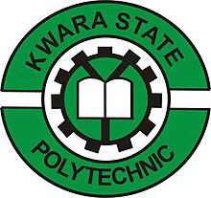

A
TECHNICAL REPORT ON INDUSTRIAL ATTACHMENT FOR STUDENT INDUSTIRAL WORK EXPERIENCE SCHEME (SIWES)
HELD AT

KWARA STATE BROADCASTING CORPORATION ILORIN KWARA STATE

BY

ABDULSOMOD OLAWALE HASSAN
ND/23/MAC/PT/0925

DEPARTMENT OF MASS COMMUNICATION
INSTITUTION OF INFORMATION AND COMMUNICATION TECHNOLOGY
KWARA STATE POLYTECHNIC, ILORIN.

IN PARTIAL FULFILLMENT OF THE REQUIREMENT FOR THE AWARD IN NATIONAL DIPLOMA CERTIFICATE IN MASS COMMUNICATION.

DECEMBER 2024

PREFACE

This is a report of four months of industrial training which was done as part of the requirement needed for the award of National Diploma Certificate which was embarked upon by the technical student after their first year of stay in school.
It is also done to enable the student’s to be exposed to the practical aspect of their course of study and write down what he/she has gained during the training.
The program is aimed at correcting the incompetence in the school, leaving the scientific and technical in the country.

DEDICATION
This report is dedicated to the Almighty God, the Beneficent, the merciful, the cherisher of the universe, the uncreated creator of all creatures and the most knowledgeable who seek knowledge just from himself for giving me the opportunity, privilege an understanding to participate in the student industrial work experience scheme (SIWES).
I also dedicate this report to my amiable parents Mr. and Mrs. Abdulsomod for their financial support during the course of the program. May God continue to bless them (AMIN)
TABLE OF CONTENT
Title
Preface
Dedication
Acknowledgement
Table content
CHAPTER ONE
  - Introduction
  - Background
  - Objective of SIWES
CHAPTER TWO
2.0 Brief History of the Establishment
2.1 Organizational structure
2.2 The various Department/Units in the Establishment
CHAPTER THREE
3.0 Experience gained during the SIWES program
3.1 Interactive relationship within the organization
CHAPTER FOUR
4.0 Summary
4.1 Recommendations
4.1 Conclusion

CHAPTER ONE
INTRODUCTION OF SIWES
The Students Industrial Work Experience Scheme (SIWES) for the 2023 /2024 academic session kicked off the month of in August 2023 and was concluded (4) months in the month of December, 2024. The industrial attachment program is solely aimed at improving in working skills of students in tertiary institutions as well as effecting, learning, participation and observation into proactive invariable fields with respect to grasp very useful practical knowledge which not only makes them employable but also aids in the perfect understanding of theories and operation in their different profession. It is a corporative industrial internship program that involves industries, the Federal Government of Nigeria, Industrial Training Fund (ITF), and Nigeria Universities Commission (NUC). The program is of very high importance considering the lack of adequate practical equipment for learning in most Nigeria tertiary institutions and itself proven as it has been part and parcel of the countries system of education for over 28 years

AIMS OF SIWES

The Industrial Training Funds Policy document Number 1 of 1973, which established SIWES outline the objective of the scheme. The objectives are to:-
- To provide an avenue for Students in Nigerian Tertiary Institutions to acquire Industrial Skills and Experience during their course of Study.
- To prepare Students for the work they are likely to meet after graduation.
- To expose students to work methods and techniques of handling equipment and machinery that may not be available in their Institutions.
- To allow the transition phase from school to the world of working environment easier and facilitate students contact for later job placement.
- To provide students with an opportunity to apply theoretical knowledge in real work situation there by bridging the gap between theory and practice.
HISTORICAL BACKGROUND OF SIWES
SIWES was set up by the federal government of Nigeria to close the gap between theoretical la was taught in the classroom and actual practices for students in tertiary institution. It was first kicked off and funded by the Industrial Training Fund ITF) in 1973 the scheme has gone through series of reforms. Its management has changed hands from the ITF in 1978 to various regulatory agencies such as National Universities (NUC) and National Board for Technical Education (NBTE) and board to the ITF again in 1985. These are the major stake holders in SIWES. Consequently, SIWES program was introduced into the curriculum of tertiary institution in the country as far back as 1974 with 948 students from two institution of higher earning and the scheme has over the year contributed immensely to the personal development and motivation of their academic programs and what knowledge and skill will be expected of them on professional practice after graduation.

CHAPTER TWO
DEPARTMENTS IN RADIO KWARA ILORIN AND THEIR FUNCTIONS
Station Manager
At the top of the pyramid is the station manager, who's responsible for day-to-day operations. She enforces the owner's standards while making sure the needs of all employees are being met. The station manager maintains the budget, hires and fires, trains personnel and reviews employee performance. She also ensures that operations comply with Federal Communications Commission regulations.
Operations Manager
The operations manager holds down the No. 2 spot within a radio station and usually focuses on coordinating, scheduling and promoting on-air programming. He works closely with disc jockeys, anchors and hosts to make sure they represent the station's branding correctly. When new programming options must be found the operations manager is usually in charge of doing the detective work. He answers to the station manager.
Program Director
Program directors create and plan the daily broadcast schedule. This means locating and providing the news, music, or entertainment that should be covered while monitoring on-air activity to ensure content is disseminated properly. There is usually a program director for each individual broadcast. Program directors generally work with the same staff every day and report to the operations manager.
Sales Manager
Having a sales manager working with a team which constantly generates revenue by selling air time to advertisers is vital. Some of her charges research potential accounts, do some cold-calling and generally generate sales leads. Others actually sell air time to meet a quota while negotiating price and payment schedules. The sales manager must often designate employees to perform collections on past-due accounts. The sales manager usually reports to the station manager.

Office Manager
The office manager works with a team of administrative and finance employees to handle logistics, payroll, taxes, bills, audits and legal matters. Administrative employees also field phone calls and take messages for the station manager and operations director. They also book any outside business travel for station employees as well as lodging for guests. The office manager reports to the operations manager or station manager.
BRIEF HISTORY OF RADIO KWARA ILORIN
Ilorin was the first location in Kwara State where broadcasting services were provided by the Kwara State Broadcasting Corporation (also known as “Radio Kwara”). These services began in 1956 as a relay station. In those days, people referred to it as the provincial broadcasting house. The one quarter kilowatt (kW) medium wave transmitter that was employed at the time could only reach an area within an eight kilometer radius of Ilorin. However, the Kwara State Broadcasting Corporation as it is now was not one of the beneficial byproducts of the first state to be created in Nigeria. It did not come into existence until the adoption of the Kwara Edict No. 3 of 1979, but it took effect back on April 10th, 1978.
Due to the state of Kwara’s topography, it was decided that it should be covered with both medium and shirt wave transmitters when it was created in 1967. This was part of a larger master plan that was developed and approved for the entire nation at the same time. This plan was based on the number and capacity of transmitters as well as the mode of transmission that were to be sited in each new state. These facilities wave put into use is from 19th December, 1976; however, as a result of a directive from the federal government, the short wave transmitter was shut down in 1976. Instruction work began in 1974 in the modern studio/broadcasting house at the 10kw short wave and 20kw medium wave transmitting station sites. On April 1st, 1978, a decree was issued in camphene with the federal government that transfers all radio Nigeria stations on the state to their respective host states. On September 5, 1978, Mr. Horation Agedoti of radio corporation in Lagos reframed the formal handing over of the station by the NBA to the Kwara state government. At that time, all of the existing staff members were given the option of either continuing to work for corporation or moving on to work for Federal Radio Corporation. Those employees who made the decision to remain on staff were kept. At the time of the takeover by the state government, the state already possessed a broadcasting house and a transmitting station that were located at their current locations. The two inherited ten kW transmitters were both very old; in fact, by the time the station was taken over in 1978, only one of the transmitters was functioning adequately. The decree that transferred the federal radio station in Ilorin to the government of the state of Kwara in 1978 allowed the federal government to boost the transmitting capacity of Radio Kwara, which was a service of the Kwara state government. After then, the station emitted two medium-wave signals of 50 kilowatts each at Budo Eko. As a result of this turn of events, the state government gave its stamp of approval to a suggestion made by the corporation to build four imported 10 kW medium wave transmitters in the periphery area of what was then the state of Kwara in order to ensure adequate coverage. The Egba title was bestowed to two of them. One of them was located at Okike, close to Okene (both of which are now in Kogi State), and the other was located at Koro, in New Bussa (which is now in Nigeria Skew). Each of the three stations that had been reserved was eventually built and put into operation.
Despite the enormous progress, the transmitting stations at Bin Do Eko suffered a major setback in 1991 when the 840-foot tower mast was damaged by a lightning strike. This occurred despite the fact that the stations had made enormous achievements. When you take into consideration that the transmitting station had by that point become an essential component of radio kwara and a reliable ally in the fulfillment of its statutory obligation, this situation became a significant obstacle that needed to be addressed immediately. Between the years 2000 and 2002, efforts were made to resurrect the station. As a result of these efforts, a new tower mast and a 50 kW thom cast transmitter were installed so that normal broadcast could resume. In spite of the efforts.
STRUCTURE OF RADIO KWARA ILORIN
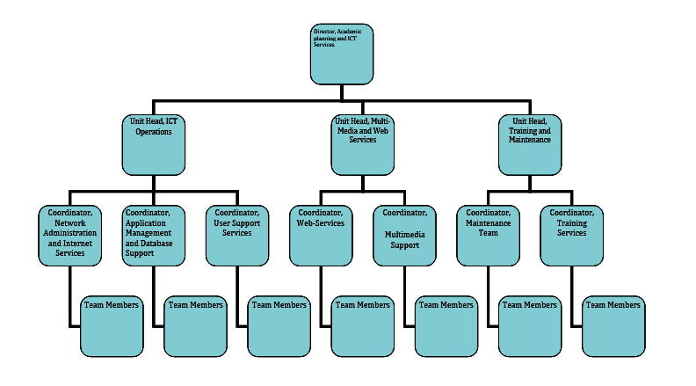
.

CHAPTER THREE
  - SIWES EXPERIENCE AT RADIO KWARA ILORIN
  - My Siwes at RADIO KWARA ILORIN Is actually a great one and I have the opportunity of gaining more insight than what we are taught in class, especially in practical aspects. I am under the supervision of Mrs salamat shehu who gave me the opportunity to learn more in the Programme department in which Herq and his other colleagues tried enough to show us how reporters gathered news from several event and social issues in which it will be broadcast by the news presenter at a certain time for the audience.
  - My Experience at RADIO KWARA ILORIN is a great one and am opportuned to put all what I experience into action even though there is not much time.
  - One of my major experiences in RADIO KWARA ILORIN is that I am able to witness how reporters gathered news from several event and social issues in which it will be broadcast by the news presenter at a certain time for the audience. I observed and gained experience about writing news, the more you write the more the level of writing improved, that is continuous exercise in writing news, stories, articles, features etc. enhance better knowledge. With this kind of observation, am able to have the experience of sourcing news on different sites both online and physical newspapers.
  - I am able to have the experience on how news is written in a Line up order and not only to write news make a newsworthy but editing of news is major work to make a newsworthy. I have the experience of editing news with the aid of editing tools such as laptop, software applications and so on.
  - One of my major is that am able to witness how reporters gathered news from several event and social issues in which it will be broadcast by the news presenter at a certain time for the audience. I observed and gained experience about writing of news, the more you write the more the level of writing improved, that is continuous exercise in writing of news, stories, articles, features etc. enhance better knowledge.
  - While on this internship, I gained some experience on how a console works and how it is being operated in the MCR (Master Control Room).
  - I also have the experience on how others equipment in the master control room work such transmitter and others. Surprisingly, the so called transmitter as one of the major instrument in a radio station which is a device that produces radio waves radiating from an antenna, Am able to witness it physically.
  - Most importantly, through this internship I acquired encompassing knowledge on different strategies involved in broadcasting, and how essential it is for a good professional broadcaster to understand his/her topics under discuss so as to give it effective delivery/judgment.
  - In overall, it was a great learning experience; and an indication that I am on the right course of learning [i.e Mass Communication).
I have experience in the program department on how different kinds of program are been presented live on the studio room. The live program is being controlled from the Master control room (MCR) By a certain specialist and trained personnel who is saddled with the responsibility of Controlling all the studio activities on system and calling action of when the live program ought to start and end. I took my time to visit the Studio where I gained little experience on programme preparation and anchoring. Also, I spent time in the language section where I had the opportunity to participate innumerous translations of news stories, editorials and news commentaries of programs into Yoruba language. Another experience is witnessing major equipment in the newsroom and how it is used such as Teleprompter, Microphones, Headphones, Cameras, Tripod etc.

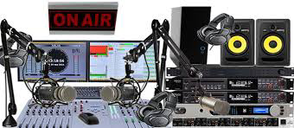
FM BROADCAST

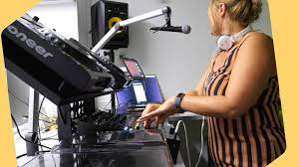

BROADCAST EQUIPMENT

WORK ACTUALLY CARRIED OUT
- I observed and gained experience about writing of news, the more you write the more the level of writing improves, that is continuous exercise in writing of news, stories, articles, features etc. enhance better knowledge. With this kind of observation, I am able to have the experience of sourcing news on different sites both online and physical newspapers.
- I am able to have the experience on how news is written in a Line up order and not only to write news make a newsworthy but editing of news is major work to make a newsworthy. I have the experience of editing news with the aid of editing tools such as laptop, software applications and so on.
- I have experience in the program department on how different kinds of programs are presented live on the studio room. The live program is being controlled from the Master control room (MCR) By a certain specialist and trained personnel whom is saddled with the responsibility of Controlling all the studio activities on system and calling action of when the live program ought to start and end. I took my time to visit the Studio where I gained little experience on programme preparation and anchoring. Also, I spent time in the language section where I had the opportunity to participate innumerous translations of news stories, editorials and news commentaries of programs into Yoruba language. Another experience is witnessing major equipment in the newsroom and how it is used such as Teleprompter, Microphones, Headphones, Cameras, Tripod etc.

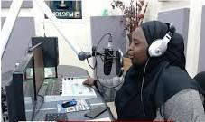
News Room
A newsroom is the central hub where news organizations, such as newspapers, television stations, radio stations, or online media platforms, coordinate and manage their news-gathering and production activities. It serves as both a physical space and a metaphorical center for collaboration among journalists, editors, and producers.
Skills Acquired
The SIWES experience significantly improved my knowledge and skills in advertisement and mass communication. Some of the key skills I acquired include:
- Creative Content Development: I learned to write compelling advertising copy and design eye-catching visuals to attract and retain audience attention.
- Strategic Thinking: I developed the ability to analyze market trends and audience behavior, which are critical for planning successful advertising campaigns.
- Media Literacy: I gained insight into how different media channels operate and how to select the most appropriate medium for a campaign.
- Teamwork and Collaboration: Working with a team of professionals taught me the importance of collaboration and effective communication in achieving organizational goals.
- Technical Skills: I acquired proficiency in tools such as Canva, Adobe Photoshop, and social media analytics tools, which are essential for designing and monitoring advertisements.

CHAPTER FOUR
SUMMARY, RECOMMENDATION AND CONCLUSION
My experience at RADIO KWARA ILORIN is a wonderful experience and I have come to say that studying Mass Communication without practical, could be regarded as a waste of time, resources and energy because the training has helped me a lot.
I was taught how to write News basically, how to cast a news, how to handle different equipment in Radio Station, writing of News story, how to edit news and identify a news worthy event. I was also exposed to different equipment that are used in the radio station.

RECOMMENDATION
- I would recommend that the Kwara State polytechnic should improve the school by assisting the SIWES student with computer and modern technology and it would lead to create development of the school
- I would recommend that the department of Mass Communication in Kwara State Polytechnic should expose student to practical skill and allow them to practice until they understand it perfectly well.
CONCLUSION
Student Industrial Work Experience Scheme is very Essential for all student to be able to understand what their cause of study will present to them after graduation and also learn beyond what you they will be able to learn in school. SIWES really helps students a lot by also allowing students to connect with people that are already practicing in the field. All thanks to the Government, RADIO KWARA ILORIN , Kwara State Polytechnic and my Department.

