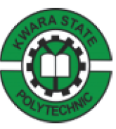

TECHNICAL REPORT ON STUDENT INDUSTRIAL WORK EXPERIENCE SCHEME (SIWES)

HELD AT

JIRIKA CONSULT

PRESENTED BY

AYOMIDE PAMILERIN

ND/23/COM/FT/0079

SUBMITTED TO

DEPARTMENT OF COMPUTER SCIENCE, INSTITUTE OF INFORMATION AND COMMUNICATION TECHNOLOGY KWARA STATE POLYTECHNIC, ILORIN

IN PARTIAL FULFILLMENT OF THE AWARD OF NATIONAL DIPLOMA (ND) IN COMPUTER SCIENCE

AUGUST-DECEMBER 2024

DEDICATION
This work is dedicated to the Almighty God, for their love, mercies, guidance a protection during and even after this work.
This work is also dedicated to my lovely and caring parents and wonderful brothers a sisters for their love, support and encouragement.

ACKNOWLEDGEMENT
I wish to acknowledge and thank everyone who contributed one way or the other towards the success of my industrial training.
My special thanks goes to the management of JIRIKA CONSULT and my supervisor for their numerous contribution and effort to make this research a success.
Also my beloved parent Mr. and Mrs. Iyanda and my colleagues for giving me the great opportunity.
I want to say a big thanks to my siblings and my friends for their support and love also my friends for their encouragement and advice.

ABSTRACT
The Student Industrial Work Experience Scheme (SIWES) Relevance to the Department of Computer Science was researched upon. The instruments used was practicalized and this practical were used to answer the research questions. The results were collected and analyzed in the chapters that make up this study report and project works.
Based on the analysis, Major findings emerged revealing that students did receive practical work on the job training. The SIWES scheme further exposes students to proper methods of using and handling information technology (IT) equipment and development.
However, the study concluded that if students are adequately exposed to research materials and facilities, if students are provided with thorough and proper supervision by supervisors, if orientation towards equipment and machinery handling was well fashioned out, there will necessarily be an upsurge in performance rates Therefore, the researcher recommends the following
That employers ought to accept students supervisors need to be attached to individual’s students. Students should be allowed to express and get themselves exposed to information technology (IT) practices in order to acquire a deeper orientation before the commencement of the programme if adequate performance is to be guaranteed.

CHAPTER ONE
Student Industrial Work Experience Scheme
The Students Industrial Work Experience Scheme (SIWES), is a skills Development programme initiated by the Industrial Training Fund (ITF), in 1973 to bridge the gap between theory and practice among students of Engineering and technology in Institution of Higher Learning in Nigeria. It provides for on-the-job practical experience for students as they are exposed to work methods and techniques in handling equipment and machinery that may not be available in their Institutions.
SIWES was established by ITF in 1973 to solve the problem of lack of adequate practical skills preparatory for employment in industries by Nigerian graduates of tertiary institutions.
The Scheme exposes students to industry based skills necessary for a smooth transition from the classroom to the world of work. It affords students of tertiary institutions the opportunity of being familiarized and exposed to the needed experience in handling machinery and equipment which are usually not available in the educational institutions.
Participation in SIWES has become a necessary pre-condition for the award of Diploma and Degree certificates in specific disciplines in most institutions of higher learning in the country, in accordance with the education policy of government.
Duration – Four months for the Polytechnics.
Aim of the Study
The aim of the study was to evaluate the impact of SIWES on Technical Skills Development in the Nigerian economy. This is to enable Institutions of Higher Learning and other Stakeholders assess the performance of their roles in the Scheme.
THE ROLE OF THE INDUSTRIAL TRAINING FUND
The Industrial Training Fund (ITF) was established by the decree 47 of 1971 constitution and charged with the responsibility of promoting and encouraging the acquisition of industrial skills, with the view of generating a collection of indigenous trained manpower, sufficient enough to enhance and meet the needs of the economy so as to promote development. Supervision of students, organizing orientation programs, and disbursing allowances to students are some of the roles played by the industrial training fund in the implementation of SIWES.

THE SCOPE AND IMPORTANCE OF SIWES
The scheme covers all science and technological based students in monotechnics, polytechnics and universities in Nigeria, resulting in a high population of students which is easily managed because of the public and private industries that partake in the scheme. SIWES enables students acquire industrial know-how in their field of study particularly in technological based courses. It also enables students experience the application of theoretical knowledge in solving real life problems.
THE ROLE OF THE STUDENT AND THE INSTITUTION
The role of the student is to partake in the program in such a way that he/she will achieve maximum benefit from the program. The student is advised to ask questions, be submissive, and adhere to all the rules and regulations of the organization where he is attached. Identification of placement opportunities, funding of SIWES supervisors and assessment of the student are some of the roles played by the institutions to ensure smooth running of the program.

CHAPTER TWO
About The Organization
Our Information and Communications Technology (ICT) organization, often referred to as an IT organization, is a crucial component of modern businesses and institutions. Our primary purpose is to manage and leverage technology to support the organization’s goals, operations, and strategic objectives. Here’s a general overview of the key aspects of our ICT organization:
- Infrastructure Management: ICT organizations are responsible for maintaining and expanding the technology infrastructure, which includes networks, servers, data centers, and cloud services. They ensure that these components operate efficiently, securely, and reliably.
- Software Development and Application Management: Developing and maintaining software applications and systems is a core function. This includes custom software development, integrating third-party applications, and ensuring that software aligns with the organization’s needs.
- Information Security: Protecting sensitive data and systems is paramount. ICT organizations implement security measures to safeguard against cyber threats, including firewalls, antivirus software, encryption, and employee training.
- User Support and Helpdesk: Providing technical support to end-users is essential. This includes addressing issues, troubleshooting, and offering guidance to ensure that employees can work effectively with technology.
- Data Management and Analytics: Managing and analyzing data is vital for Informed decision-making. ICT organizations oversee data storage, retrieval, and analysis, often utilizing tools and technologies for business intelligence and data analytics.
- Project Management: Managing IT projects efficiently is crucial. ICT organizations use project management methodologies to ensure that technology initiatives are completed on time and within budget.
- Vendor Management: Engaging with technology vendors and suppliers is a common task. ICT organizations negotiate contracts, maintain vendor relationships, and assess the value of third-party services and products.
- . Compliance and Regulatory Adherence: Staying compliant with industry regulations and standards, such as GDPR or HIPAA, is vital, especially in sectors like healthcare or finance.
- Innovation and Strategy: ICT organizations need to stay abreast of technological advancements and assess how emerging technologies can benefit the organization. They also develop IT strategies that align with the broader organizational goals.
- Cost Management: Budgeting and cost control are critical to ensure that technology investments are financially sustainable and provide value to the organization.
- Disaster Recovery and Business Continuity: Planning for and mitigating the impact of disasters, including data breaches or system failures, is a significant aspect of ICT. This involves creating backup and recovery strategies.
- Training and Skill Development: Keeping IT staff up-to-date with the latest technologies and certifications is essential for maintaining a skilled and capable workforce.
In summary, our ICT organization plays a central role in enabling businesses and institutions to leverage technology effectively. Its responsibilities encompass infrastructure management, software development, cybersecurity, support, data management, and strategic planning, all aimed at achieving the organization's objectives in an increasingly digital world.

CHAPTER THREE
Activities during the programs as follows:
Software Package:
MICROSOFT WORD (APPLICATION PACKAGE)
This software is specifically designed for editing text, formatting text, inserting pictures, typing documents like memos, thesis, letter, seminar, etc Application packages is the collection of software programs that have been licensed for the purpose of typesetting of documents which support images with it features.
Microsoft word has the following features:
The Menu bar
Office button
The title bar
Formatting tool bar
The task pane
Minimize button
Drawing bar
Scroll bar
Maximize bar
Close button

Microsoft word has some basic function which it performs:
Editing of document
Save and save as
Previewing of document before printing
Spellchecking of spelt words
Page setting
Typing of professional texts
Inserting of word Art, page Number
Inserting of tables, Smart Art
Inserting of header and footer, shapes, chart,
Creating of link to a web page
Inserting water marks, page borders
Creating of newspaper columns
Inserting of symbols

31 MICROSOFT EXCEL (APPLICATION PACKAGE)
Microsoft Excel is a spreadsheet program that was created by Microsoft and can be used on computers, tablets and cell phones. It allows people to conveniently share their work with others and organize data. In the modern era, many businesses and firms collect data from multiple sources, which include in-store transactions, online sales and social media. This means that they need a quick and efficient way to gather the data together and analyze it. Excel is most often used for financial information and the data that is relevant to financial information; however, it can also be used for other processes, such as human resources list data.
Excel allows users to build a variety of great charts including pie charts, clustered column charts and graphs. This helps users visualize their data. Excel also allows conditional formatting, which means that users can use different colors as well as bolding, shades and italics to help differentiate between their data. Trend lines are able to extend beyond each graph’s lines and help to offer predictions and forecasts. Data can be imported and exported from a variety of files.
This is an electronic spreadsheet package designed specifically for the purpose of processing data in a tabular form. It is specially designed for analyst, accountants, administrators, statisticians etc
Schools make use of excel for computation of students semester results and grade point determination using the school grading system.
Microsoft publisher is a graphic design application that is similar to Microsoft word but different in the fact that its emphasis lays more on page layout and design and less on word composition and formatting
Publisher tools:
Word Art
Text box
Auto shape
Object
Picture frame
Rectangle
Oval
Designs of publisher
3.2 GRAPHIC DESIGN
Graphic design is the process of visual communication and problem solving through the use of typography, photography and illustration. Graphic designer create and combine symbols. Image and text to form a visual representation of ideas and messages. They use typography, visual arts and page layout techniques to create composition
USE OF GRAPHIC
Corporate design
Editorial design
Environmental design
Advertising design
Communication design
3.3 CORELDRAW FEAUTURES
Title bar: this is the first horizontal bar at the top of the window environment of the CorelDraw
Menu bar: this is located at the bottom of the title bar
Standard tool bar: this is located below the menu bar
Property toolbar: this is located below the standard bar
Ruler bar: it is usually vertical and horizontal use for measurements
Text bar: this bar enable you to enter text
Color palettes: this consist of many color which enable user to color object or text
TOOLS FOUND IN CORELDRAW
Shape tool
Ellipse tool
Rectangle tool
Spiral tool
Graph paper tool
Text tool
Dimension tool
Interactive blend tool
Interactive media tool
Artistic media tool
How to design a background using interactive blend tool
Click at text tool
Go to color and give it any color
Highlight and drag it down
To apply transparency tool:
Type the text
Click on transparency tool
Click and drag to the area of working
How to design Nigerian flag
Click and drag rectangle tool
Click on “arrange” from the menu bar and screw down
Convert shape to curve
Then click on shape tool
Move the cursor and double click on each dot-end of the rectangle
Convert each space between selected to curve
Drag up and down to get the flag
Pick another rectangle
Drag it at the centre of the first object
Go to color palette, right click and double click on white color then click on the “effect”
Move down to power clip and click on clip into container
Introduction and Icebreaker:
- Icebreaker games or activities to help participants get to know each other and create a comfortable learning environment.
Software Exploration:
- Hands-on exploration of the software package with guided exercises.
- Scenario-based tasks to familiarize participants with the software’s interface and basic functions.
Interactive Demos:
- Live demonstrations by the instructor, highlighting key features and best practices.
- Encourage participants to ask questions and interact during the demos.
Group Discussions:
- Facilitate discussions on the practical applications of the software in participants’ work or industry.
- Encourage participants to share their experiences and insights.
Problem-Solving Exercises:
- Present participants with software-related challenges and problem-solving scenarios.
- Allow them to work in groups or individually to find solutions.
Q&A Sessions:
- Dedicated question and answer sessions to address participants’ specific queries and concerns.
- Use these sessions to clarify concepts and troubleshoot issues.
Hands-On Workshops:
- Workshops where participants can practice using the software to complete tasks.
- Provide guidance and support as they work through exercises.
Collaborative Projects:
- Assign group projects that require participants to apply their knowledge and use the software to solve real problems.
- Encourage collaboration and teamwork.
Resource Sharing:
- Share additional resources such as user guides, tutorials, and online forums where participants can continue learning.
Wrap-Up and Reflection:
- Reflect on key takeaways from the program.
- Discuss how participants can continue to build their skills and apply what they’ve learned.
WEBSITE DESIGN
Introduction and Icebreaker:
- Start with an icebreaker to build rapport among participants and introduce the program’s goals and agenda.
Design Principles Workshop:
- Conduct a workshop on fundamental design principles such as layout, color theory, typography, and user experience (UX) design.
Wireframing and Prototyping:
- Have participants create wireframes and prototypes of website designs using software
- Encourage them to focus on user flow and functionality.
Visual Design Challenges:
- Pose visual design challenges, like designing a logo or custom graphics, to encourage creativity and originality.
Portfolio Development:
- Instruct participants on how to create an online portfolio to showcase their web design projects.
- Provide tips on presentation and storytelling.
Group Projects:
- Assign group website design projects with specific objectives and target audiences.
- Encourage collaboration and teamwork.
Critique Sessions:
- Organize design critique sessions where participants provide constructive feedback on each other’s work.
- Emphasize the importance of constructive criticism.
Final Project Showcase:
- Allow participants to present their final website design projects to the group.
- Encourage them to discuss their design choices and challenges faced.
HTML & CSS: HTML (HyperText Markup Language) and CSS (Cascading Style Sheets) were essential in creating the structure and styling of web pages. HTML was used to define content layout, while CSS allowed me to customize colors, fonts, and other design elements to create visually appealing and responsive web pages.
Under html I was also able to look into sub division like the linking, link bookmarking, heading, creation of ID tags, iframe tags, styling and so on. I was also able to run codes written on the vs code with an extension called live server.
JavaScript: JavaScript enabled interactive elements on web pages, such as animations, form validations, and dropdown menus. I also used JavaScript frameworks, particularly React.js, to manage complex user interfaces. Where i focused on java script basics, the use of data types, variables and operations Proceeds to learn about the control structures in javascript like the conditional statement and so on.

JAVASCRIPT CONTROL STRUCTURE

CONDITION

IF/ELSE SWITCH

LOOPS
FOR WHILE/DO WHILE

FUNCTIONS REUSEABLE CODE

React.js: React.js is a popular JavaScript library used for building dynamic and interactive user interfaces, particularly for single-page applications.”
WORDPRESS: I learnt a little about wordpress which only includes the basic of wordpress including (installation, configuration and dashboard navigations). Moved on to worpress themes and plugins as well as understanding heading post, pages categories, tags and so on.
- Setting Up the Development Environment
Installed VS Code and configured extensions like Live Server, Prettier, and Emmet.
Organized project files into folders for efficient project management.
- Website Design and Development
Created static web pages using HTML and styled them with CSS,
Implemented responsive designs using media queries.
Added interactivity to web pages using JavaScript.
- Using VS Code Features
Intelligence: VS Code’s intelligent code suggestions enhanced my productivity.
Integrated Terminal: Used to run commands like npm install and git commit. Debugging: Utilized VS Code’s debugging tools to identify and fix errors in JavaScript.
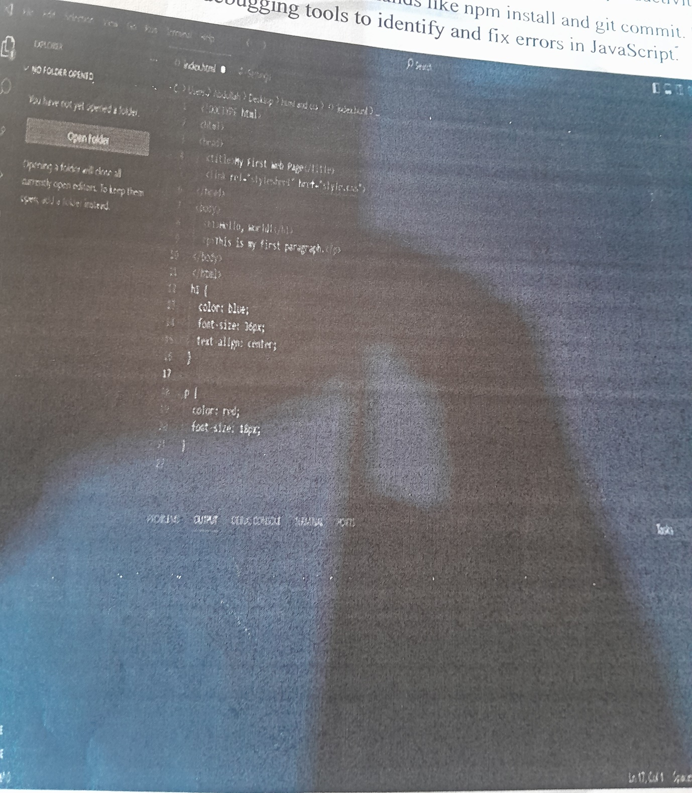
Explanation:
HTML:
<!DOCTYPE html>: Declares the document type as HTML5.
<html>: Root element of an HTML page.
<head>: Contains meta-information about the page, like the title.
<title>: Sets the title of the page, displayed in the browser’s tab.
<link>: Links an external stylesheet (style.css) to the HTML document.
<body>: Contains the visible content of the page.
<h1>: Defines a heading level 1.
<p>: Defines a paragraph.
CSS: hl {...}: Styles the <h1> element.
Color: blue;: Sets the text color to blue.
Font-size: 36px;:
Sets the font size to 36 pixels. Text-align: center;: Aligns the text to the center. P { ... }: Styles the <p> element.
Color: red;: Sets the text color to red.
Font-size: 18px;:
Sets the font size to 18 pixels.
When you open this HTML file in a web browser, you’ll see a simple page with the text “Hello, World!” in blue and a paragraph in red, styled according to the CSS rules.
- Version Control
Learned to use Git for version control directly within VS Code. Pushed changes to GitHub for collaborative projects.
- Testing and Deployment
Tested websites locally using Live Server.
D projects to hosting platformsily and Github Pages like

CHAPTER FOUR
CHALLENGES OF ICT FOR SIWES
The ICT environment has created new modus operandi for the profession by virtue ofnew tools for information exchange. When they note that the library profession in India, like their colleagues everywhere, particularly those serving high-tech institutions, are already subject to challenges resulting from ICT. They assert that thenew technology may call for organizational change in the traditional library and that librarians may function more like consulting information engineers than as the traditional, passive custodians of information and dispersers of documents.
This poses a challenge to educators, practitioners, and students, as discussed below:
Digital Environment
ICT created a new digital environment that led to the development of digitization, the conversion of print and other formats to digital form, as an enhanced storage and ‘preservation technique. Digital libraries are one result of these new information acquisition and distribution techniques all information resources are available in computer processable form and the functions of acquisition, storage, preservation, retrieval, access, and display are carried out through the use of digital technology.
The ICT environment calls for librarian to be managers and organizers of digital content. It requires new management skills and other roles such as content creators, web page planners and designers, and Internet navigators.
New career specializations
The digital environment facilitated by ICT created new platforms for professional activities, where librarians can be more proactive than in the analog era. Librarians operating in this information environment may be called Internet librarians, digital librarians, “cybrarians,” or “webarians,” all coined from ICT jargon. These changesare positioning librarians for the global information arena.

CHAPTER FIVE
CONCLUSION
During the course of the four months period of SIWES (Student Industrial Work Experience Scheme) at Grade Technology. I have acquired technical skills in the field of Website Design, Microsoft Office, Graphics Design and technical skills such as networking and managerial skills, and have had the opportunity to experience the application of theoretical knowledge acquired in the classroom to solve real problems. Thus, SIWES has been a success, because I have gained knowledge that ordinarily would not be obtained in the lecture hall.
RECOMMENDATION
As a result of difficulties experienced during the four months SIWES program, I would like to recommend the following changes: The duration of SIWES should be extended so as to enable students be more experienced. The ITF should make monthly allowance available for students, so as to put an end to financial difficulties that may arise as a result of transport problems. The Institutions and ITF should help students to get a place of attachment so that the program may commence as planned.
The following recommendations were based on the findings of the study and as asolution to the identified problems.
PROPER COORDINATION AND SUPERVISION OF THE EXERCISE: The various bodies involved in the management of the SIWES exercise i.e. Industrial Training Fund (ITF), NUC, NBTE and NCCE should come together and fashion out a modality that will ensure smooth operation of the SIWES exercise. Efforts should be made to ensure that students attached to the organization are properly supervised to ensure that what they are doing is in line with the objectives of the SIWES exercise.
The various bodies involved in the management of the SIWES programme should liaise with the various industries ahead of time so as to minimize or reduce to the barest minimum the high level of refusal to accept students for their industrial training participation.
ISSUING OF LOG BOOKS/IT LETTERS ON TIME: The log books used by the Student during the industrial training period and the IT letters should be issued to the students at the end of the first semester exam as against the end of second semester examination as this will afford the students enough time to search for place that are relevant to their field of study.
EMPLOYMENT OF EXPERTS: The various institutions should endeavor to employ
Experts in the areas of career development to manage the student’s industrial placement centers.

