

TECHNICAL REPORT ON THE STUDENT INDUSTRIAL

WORKS EXPERIENCE SCHEMES (SIWES)

HELD AT

LAGOS STATE MINISTRY OF ENERGY

NO. 144 MAROKO BUS-STOP,AJAGBADI, OJO, LAGOS STATE

PRESENTED BY

GBENLE JAMES OLASUNKANMI

ND/23/MPE/FT/0025

SUBMITTED TO

DEPARTMENT OF MINERAL AND PETROLEUM RESOURCES ENGINEERING,

INSTITUTION OF TECHNOLOGY (I.O.T) KWARA STATE

POLYTECHNIC, P.M.B 1375 ILORIN KWARA STATE

IN PARTIAL FULFILLMENT OF THE REQUIREMENT FOR AWARD OF NATIONAL DIPLOMA (ND) CERTIFICATE IN MINERAL AND PETROLEUM RESOURCES ENGINEERING

FROM

AUGUST - NOVEMBER 2024

CERTIFICATION
This is to certify that this report was compiled by GBENLE JAMES OLASUNKANMI with Matric Number ND/23/MPE/FT/0025 a student of Mineral and Petroleum Resources Engineering Technology Department, Institute of Technology (I.O.T) Kwara State Polytechnic Ilorin, Kwara state on the completion of the Student Industrial Work Experience scheme (SIWES).

___________________ ___________________
SIWES CORDINATOR DATE
DR. OLATUNJI J.A

___________________ ___________________
HEAD OF DEPARTMENT DATE
DR. OLATUNJI J.A

___________________ ___________________
GBENLE JAMES OLASUNKANMI DATE
STUDENT

PREFACE
This booklet contains the details of activities and experience undergone during my four (4) months Student Industrial Work Experience Scheme, also known as SIWES which was held at LAGOS STATE MINISTRY OF ENERGY located at No. 144 Maroko Bus Stop, Ajagbadi, Ojo, Lagos State.
The experience and knowledge acquired during the programme was written in this report which is basically on fabrication work, which is also essential for the fulfillment of National Certificate.
It has exposed me to the use of various tools whose operation techniques work only but theoretically explained in the lecture room. I thank the National Board of Technical Education for the introduction of the Student Industrial Work Experience Scheme (SIWES) programmed to the school of learning.

DEDICATION
This report is dedicated to Almighty God, the Alpha & Omega, the Merciful father for the privilege and opportunity to complete my (SIWES) programme in good health. Also to my parent Mr. and Mrs. GBENLE for their moral and financial support towards the successful completion of this programme. May the Good Lord bless your Endeavors, I pray that may Almighty God keeps you all alive to fulfill Destiny (Amen).

ACKNOWLEDGEMENT
All thanks, praise and adoration due to Almighty God, the maker and sustainer of mankind, the Gracious Father and Merciful God for his love, preservation and Good Health granted to me before, during and after the training.
I direct my thanks to all the workers of LAGOS STATE MINISTRY OF ENERGY special thanks to my boss, I want to use this medium thank all my friends & family for their continuous support morally, financially and their prayers. Thank you for always watching my back.
I use this medium to acknowledge people who in one way or the other contributed to my success throughout my academic programme.

TABLE OC CONTENT
Certification ii
Preface iii
Dedication iv
Acknowledgement vi
CHAPTER ONE 1
1.0 Introduction to SIWES 1
1.1 Definition of SIWES 2
1.2 Aim And Objectives of SIWES 2
1.4 Major Activities Of The Organization/Company 3
1.5 Organization Chart Of Qeuetech Steel and Metal Works 4
CHAPTER TWO 5
2.0 Section/ Units Of The Organization And Their Specific Functions 5
2.1 The Workshop Section/Factor Section 5
2.4 The Fabrication / Welding Section 6
CHAPTER THREE 7
3.0 Experience Gained During My SIWES 7
3.1 Fabrication 9
3.1.1 Construction Of Burglary Proof 10
3.2 Welding 13
3.2.1 Arc Welding 13
3.2.2 Factors To Know About Arc Welding 14
3.2.3 Step Involved In Welding 14
CHAPTER FOUR 15
4.0 Relevance Of Experience Gained 15
4.1.1 Performing Operation With Arc Welding Machine 15
4.1.2 Performing Operation in the Site with the Use of Pinches, Binding Wire, and Iron Rod of Different Sizes. 15
4.2 Grinding Machine 16
4.3 General Bench Work 16
CHAPTER FIVE 17
5.0 My Personal Impression About The Organization 17
5.1 Suggestion/Recommendation to the Organization and the Polytechnic Concerning the SIWES Programme 17
5.2 My Suggestion To The Polytechnic Are:- 17
5.3 Conclusion 18

CHAPTER ONE
- Introduction
Student Industrial Work Experience Scheme (SIWES) was established by the Industrial Training Fund (ITF) in 1973 to solve the problem of Lack of adequate practical skills preparation for employment in industries by Nigeria Graduates Tertiary Institution. The student expose themselves to Industrial base skills, necessary for smooth transition from the classroom to the world of work, it afford student of tertiary institution the opportunity to being familiarized and exposed to the needed experience in handling machinery and equipment which are usually not available in the education institution.
Participation in (SIWES) has become a necessary pre-condition for the award of National Diploma (ND) Degree certificate in specific discipline in most institution of higher learning in the country in accordance with the educational policy of government.
Operator: The Industrial Training Fund (ITF), the co-coordinating agencies of National Board of Technical Education (NBTET) employers of labor and the institution.
Beneficiary: Undergraduate student of the following fields of study: Agriculture, Engineering technology, environment science, education, medical science and pure and applied science.
Duration: Four month (16weeks) for polytechnic and college of education and six (24weeks) months for universities
Highlights of Numbers of Participating Institutions:
Universities 34% of 100
Polytechnic 65% of 100
College of Education 59% 100

  - Definition of SIWES
The student Industrial work scheme can be defined as skill training program which are from the approved minimum academic standard in various Degree/HND/Diploma/NCE program for all Nigeria Tertiary Institution, it seeks to bridge the gap existing between Hierarchy practice of Engineering technology science and other professional programs in the tertiary institution of Nigeria.
  - Purpose of SIWES Program
The purpose of SIWES is to expose the student to the area of their professional work method, and way if safeguarding the scheme involved The tertiary institution, industry (employers of labour and the Industrial Training Fund (ITF).
  - Objective of Student Industrial Work Experience Scheme (SIWES)
The Objective of (SIWES) includesthe following:
- Capacity building for Industries and commerce in the Nigeria economy through manpower training.
- Prepare student for the work in any situation that they may find themselves.
- To acquire industrial skills and experience in their field of studies.
- To provide student and opportunity to apply theoretical knowledge on real practice and ensure that they are good.
- Expose student to working methods and techniques in handling equipment instrument and machines that may not be available in student professional course.
  - VISION STATEMENT OF ITF
To be the foremost skill training and development organization in the Nigeria and one of the best in the world.
  - COMPANY PROFILE (HISTORY)
2way steel work Nigerian Limited is a steel manufacturing and fabricating company with Registration Number RC794769 under the Federal Republic of Nigeria Decree 1990.
2Way Steel Limited is an offshore of C.U Ochiabuson a spare mechanical parts supplier and Repair Company. C.U Ochiabuson deals in tumels for heavy duty vehicles tyres and rims and other heavy duty mechanical parts.
2Way steel was conceptualized in February, 2009 due to the need to meet customer enquiries and demand for water and petroleum storage tanks and tankers. In time the company give to the production of such mobile units as produce carriers, trailer flat bodies, drop-side bodies, construction of tipping trailer, dumpers and sundry works five years on, 2way has given in leaps and bounds expanding its frontier into the field of structural and mechanical engineering proper.
A new addition to the company is the block and interlocking paving sieve Industry in addition to the foray into Civil Engineering as the company has of late handled many roads and building projects for government and private individuals. The corps of engineers parading Industry credentials also adds value to the growth of 2Way Steel Ltd.

CHAPTER TWO
- Company Goal and Rule
Definition: according to the New Oxford Dictionary Seventh Edition, a company is defined as a business organization that makes money by producing or selling goods and services.
Company Goals
The goal of the company is to serve its customers with the best quality services and to be the best at what they do (Life is all about 2way).
  - Rules to Achieve their Goals
- Not be selfish but fair and reasonable
- Be serious in one job and raise to efficiency
- Dedicate yourself to your work and put in your best towards achieving the best towards their jobs.
- Marginalizing wastage of material.
- Self respect.
2.2 Mission and vision Statement of the Company
The pursuit of excellence in quality steel fabrication and manufacturing services to be recognized as the premier provider of cost effective services in our area of specialization, though dedication of program of investment in personal control technology and procedure while pursuing growth.

Vision of the Company
Our vision is to become role model in steel fabrication manufacturing and supply business.
CHAPTER THREE
- Lathe Machine
A Lathe machine is a very important machine in the mechanical workshop factory, it is a machine that rotates wood or metal at high-speed. The wood or metal is shaped by a stationary tool cutting into the rotating metal or word; it is a machine capable of doing more than one operation.
Lathe machine can come in variety of shape and sizes the smaller bench top versions are usually affordable, while the heavy-duty full-size models that is designed for professional are much more expensive, all lathe machines have a motor that spins the work-piece though the headstock, the tool rest and an adjustable tailstock. Lathes differ in the length of material they can hold, what material they can cut, how powerful, the motor, is the diameter of the material that will fit and type of mechanism that spins the work.
A Lathe machine consists of these principal parts.
- Headstock
- Tailstock
- Carriage
- Bed
- Feed and thread cutting mechanism
- Tool past
- Live centre
- Dead centre.
And on the Lathe machine these operation can be carried out, which are: facing, knurling, taper turning, straight tuning, internal threading, external threading, parting, boring, drilling, step tuning, grooving, etc.
The major operations I carried during my SIWES program are:
Drilling, step tuning, facing, internal and external threading, turning boring e.t.c and I worked on four and three jaws lathe machines.
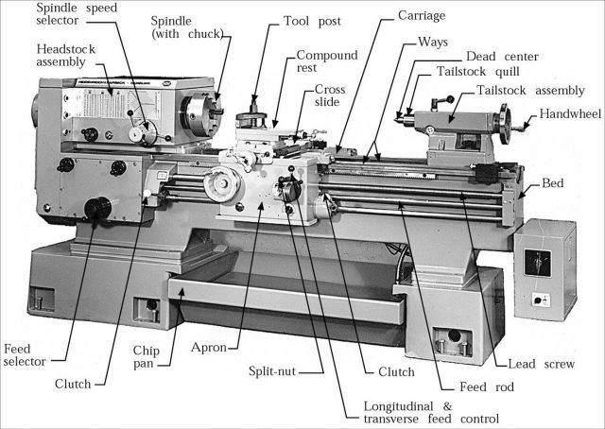

3.1 Drilling Machine
A drilling machine is a tool used for drilling holes in various types of wood, plastic and metal. The bench drill is bolted down for safe drilling of such material, the pillar or radial is a longer version of bench drill and has a long column enabling it to stand on the floor, it function the same as the bench drill but can drill longer pieces of materials.
Drilling machine also known as drill pressure are used for drilling different sized holes in a variety of material at many different depths. It is a necessary tool in many types of industrial jobs and can perform several other functions aside from drilling.
Tapping is one of the other functions of drilling machine performing referring to drilling holes in pipeline that are under pressure spot facing refer to refining the edge of a hole to fit a bolt head or washer. Reaming makes holes more dimensional and improves the finished surface. Counter sinking creates a space at the top of the hole to hold a bolt screw head in place. Counter boring makes an existing hole longer to upright sensitive drilling machine, radial drilling, magnetic drilling machine and special purpose drilling machine, and the major parts of the drilling machine are: spindle, table, drill head, base arm, etc.
During my period of SIWES I carried out three operation drilling, punching, counter sinking and counter boring operations and I also worked on radial and pillar and magnetic drilling machines.
Sketch of a Drilling Machine
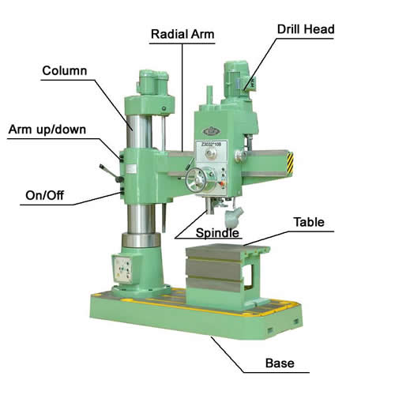
Production of Axle Base Support
The entire production of the axle base support was carried out in the radial drilling, it was first punched using centre punch, then drill with 8 or 10mm and for first drill and later 32mm and was used as the final drill.
Production of Landing Gear.
The Landing gear was entirely drilled on the radial drilling machine offer the welding (joining) it was first centre punched and then first drilled with 8 or 10mm and final drilled with the 25mm and 32mm.

CHAPTER FOUR
4.1 Roofing Structure Operation or System
A roof of a building envelope, both with covering on the uppermost parts of a building or shelter which provides protection from animal, weather, notable rain, but also heat, wind and sunlight and the framing or structure which supports the covering. The characteristics of a roof are dependent upon the purpose of building that it covers, the available roofing material and the local traditions of construction and the wider concept of architectural design and practice, may also be governed by the local or national legislation more roof also provide additional living space.
These metals roofing can be used for residential and commercial building. The same material used for the metal roofing can also be used for siding as well. Metal roofing can also be applied over an existing roof.
Design element:
The Element in the Design of a Roof are:
The material
The construction
The Durability
The material of a roof many raised from banana-leaves wheaten strew or sea grass to laminated glass, copper, aluminum sheeting and precast concrete, but in the aspect of study the material used are beams (H channels), purlins, girder, rafter or truss rafter foundation bolts or (anchor bolts) base plate. Zig rod, bolts and nuts and Aluminum sheet.
- Beam (H Channels):they are long piece of timber or Iron, long in proportion to its thickness and prepared for use. They can offer the ideal solution for supporting a wide variety of roofing system due to their excellent strength to weight ratio they also allow designers and engineers a greater flexibility when working to optimize internal space.
- Purlins (Z-Purlins): There is a horizontal beams or bar used for structural support in building, most commonly in a roof purlins are supported either by rafter or the walls of the building. They are most commonly used in metal building, though they sometimes replace closely spaced rafters in rod frame structure. The purlins of a roof support in the weight of the roof desk. Several kinds of purlins exist, they are divided into categories based on the material from which they are made and their shapes. Different purlins are used for different purpose including; structural support of walls or floors though solid beams of woods are sometimes used as purlins. The purlins most commonly used in roofing are the steel purlin; which is usually made of cold formed steed that is thin enough to put screws though.
There are three types of steel purlins:
- Rectangular hollow section (RHS)
- Cee or purlins
- zed or z purlins
- Girder or Lattice: it refers to the structure of a flat panel constructed with widely-spaced crossed thin strips of wood or other material commonly used as tight beams. They are also called Lattice Girder.
- Rafter: Rafter is a type of internal vertical beam that holds up a building roof load or weight form above and constitutes a roof’s framework combined with rigid exterior material rafters are typical combined with small horizontal beams called joist to create a triangular unit known as truss or truss rafter. These structural units are usually composed of one or more triangular section whose ends are connected at each ends by odes or joints. Many variation of truss rafter are available, depending on the type and style of roofing for instance, a scissor truss, or truss, M. truss gable truss.
- Foundation Bolt or Anchor Bolt:-An anchor bolt are used to attached object or structure to concrete, there are many types of anchor bolts, consisting of design that a mostly prepared by the manufacturing companies. All consist of a threaded end to which nuts and washer can be attached for the external load. Anchor bolt are extensively used on all types of projects from standard building to drains and nuclear power plants. They can also be used to firmly affix embedded plates to a concrete foundation when used with a structural steel element.
- Base Plate: A sold piece of material that has enough strength and sturdiness to serve as the surface to which other things are attached to be supported, which are drilled for the anchor bolt to pass through.
- Anti sig rod: They are steel rod used at attachment to purlins on roof to put or keep the purlins in space and add more rigid and firm strength to it on the roof.
- Bolt and Nuts: they are mechanical mechanism which are attached to the high tensile steel to tight the purlins.
Construction
The construction of the roof is the major engineering task, which involved man power, machinery and engineering reasoning ability.
In the construction of a roof, the first operation is the marking out, which is the marking out of the points where the anchor bolts will be laid to a specific dept buried in the ground. After the anchor bolt is put in place next is the assembling of the stanchions which is the attachment to the base plate, but when assembling the base plate to the beam. Some condition are put into consideration which the thickness of the base plate for the strength of the material it will carry; but before that, it should be sure that beam are drilled to the accurate measurement and stated drill is used, there the next operation will be the erection of the tight beam which is the girder or lattice girder using the required bolt and nut to hold them in place, in marking the girder a 20-30mm clearance should to taken.
Further more after the girder is positioned, but before the erection of the girder, the stanchions will be balanced using spirit level and some piece of packing or attachments to balance it. Then the erection of the rafter or truss rafter using bolt and nut to secure them, carrying out these operation is completely dons using cranes and some manpower at the top security the girder and rafter. Then after the rafter is secured purlins are then introduced to holding the rafter, together with bold and nut of specific diameter to given the roof support and shapes.
In some cases, lattice girder are introduced or erected in between the truss rafters which also serve as support, should it be that the roof is to be under tension of vibration, then the anti sig rodwith bolt and nuts and washer are attached to both end and fasten to the purlins to secure it and add more strength to it.
Finally, after the whole operations are carried out successfully, the next and final task is to fix the Aluminum sheet for the completion of the roofing operation.

Durability
The durability of a roof is a matter of concern because the roof is often the least accessible part of a building for purpose of repair and renewal, while its damage or destruction can have serious effects. one of the great advantage of metal roof, very durable special in cold weather and it has high percentage of recycling.
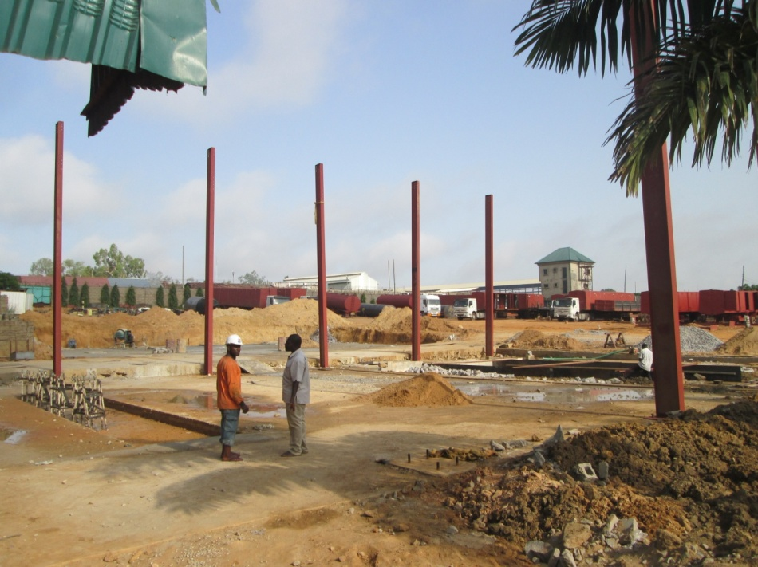

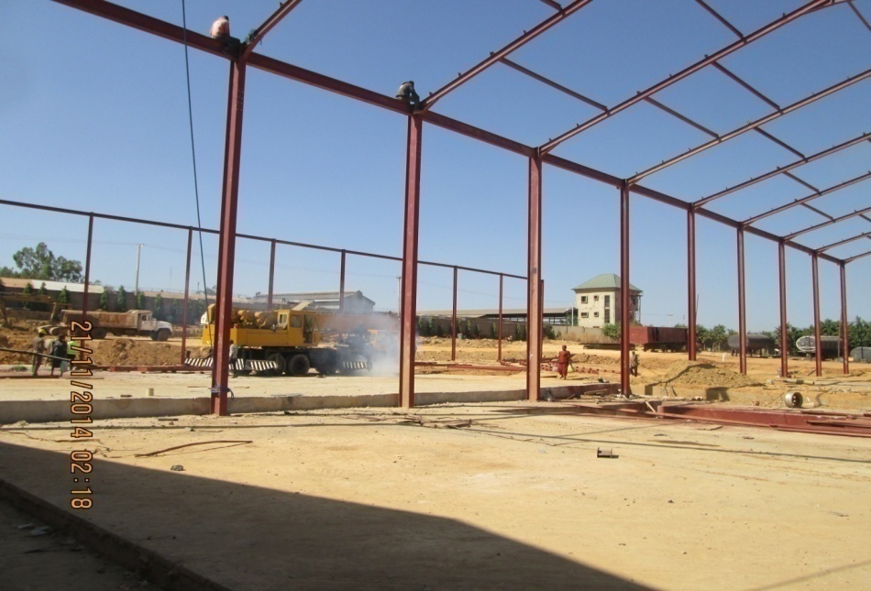

4.2 TANKER TRUCK FABRICATION AND CONSTRUCTION
What is Tanker Truck?
A tank is a large receptacle container or structure designed to carry liquefied loads such as fuels water, etc either on the road or stationary. Many variants exist due to the wide variety of liquids they may be insulated or non-insulated, pressurized or non-pressurized and designed for single or multiple loads (often by means of internal division in the tanks).
Tank trucks are describe by the size or volume capacity large trucks typically have capacities ranging from 5,500 to 11,600 liters, 20,800-43,900 liters, 45,000-50,000 liters, 60,000-90,000 liters.
A tank truck is distinguished by its shape usually a cylindrical tank upon the vehicle lying horizontally.
Some less visible distinction among tank trucks have to do with their intended use. The tanks themselves will always contain multiple compartment or baffles to prevent load movement destabilizing the vehicle.
Large tank trucks are used for example to transport gasoline to filling stations; they also transport a wide variety of liquid goods such as concrete, milk, water, gasoline, diesel and industrial chemicals.
Design element or Construction element
The design element or fact to consider before constructions which are:-
- Purpose
- Capacity
- Material
- Market value
- Construction
Purpose: This is the most valuable factors to consider before tank production could be undertaken, which simply means what is the tank going to fabricate for, either for transporting fuel or concrete transportation, diesel transportation or is it going to be a stationary underground or surface tank or for industrial chemical transport.
Capacity: When the purpose of fabricating a tank is considered then, the capacity will also be put to consideration; the capacity of tanks varies, from 20,000ltrs – 35,000ltrs, 40,000ltrs – 60,000lt, 60,000ltrs-90,000ltrs depending on the purpose. The capacity will be considered.
Material: When purpose and capacity have been considered, the material used in fabrication is also considered and their availability. tanks are constructed of various materials depending on what product they are hailing. Their materials include; aluminum, carbon steel, stainless steel and Fiberglass Reinforced Plastic (FRP).
Market Value:In producing a tank, the market value goes along with the purpose; tanker truck user consider the market value before they go for construction of tank and also consider the capacity, for what purpose of market it will be constructed.
Construction:After these elements are considered, then the proper fabrication of tanker truck begins.
But in the case of the report, I will be describing the construction of 40,000liters tank. In construction or fabrication of this tank, each capacity has a specific length of flat plate which will be rolled to form tank rings which 36,000ltrs tank need 6850mm length of flat plate which are7 rings rolled.
40,000liter tanks = 7250mm which is 8 rings
50,000 liters tanks = 7570mm which is 9 rings
60,000liters tanks = 7600mm which is 9 rings
4mm flat plate is mostly used for 40,000 tanker truck. For the total length of be acquire a formula is used for the calculation which is 2Lh.
After the flat plate have been rolled as rings the next is joining, the rings, they are first joined by tacking each to the other and it was made sure that the rings lap and none of the rings is higher than the other, then to full welding is carried out which is mostly running down welding and other using gauge 10 electrode(6013). After the rings are joined, the next is thecompartment fabrication of the tank, into the necessary compartment which is mostly three compartment for 40,000ltrs tank, thencovers are installed at both end forming a cylindrical tank, then is the assembling of the chassis, which is a 5 min flat plate, the chassis, which is the component of tank that carries the weight, which is the reason why a more thicker material is used, after the chassis are joined on the ground which is then lifted upon the tankwith a space of about 500mm-600mm, then welded to the tank, then the next thing is that the welding of the axle base support plate and king-pin plate, but before these opens are made on each compartment connecting a 3 inch discharge pipe to the discharging value or channel for discharging of the contained substances in the tank, then the tank is turn to the proper position to continue fabricating, at the top holes are made for man hole where the substance will be put in on each of the compartment, after the tank is turn to the proper position, then the layering of the “walk-away” is next, as the name implies, it is the component on top of the tank which the tank operator walk on; after all these operation are successfully carried out, the next is the finishing touch which is the assembling of axle, fixing of mould guard, fabricating of reservoir tank and spare tyre point and bomber and mounting of the 3 inch discharge pipe to the discharging value (phase II or ball value) then the proper fixing of manhole at the top of the tank and fixing of ladder to the tank.
Note: when fabrication of tanks is done, there are additional liters added known as over boarding as a result of some factor put into consideration such as evaporation silage, etc.
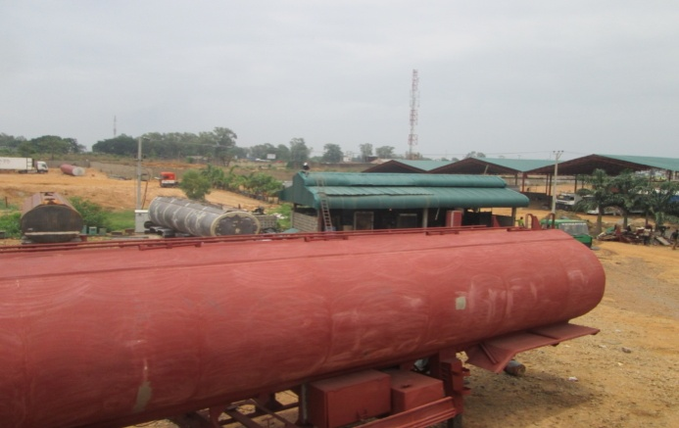
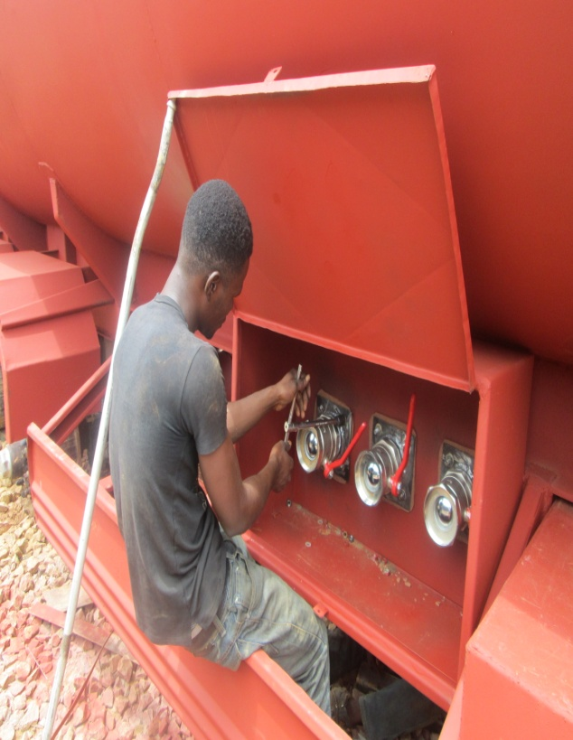

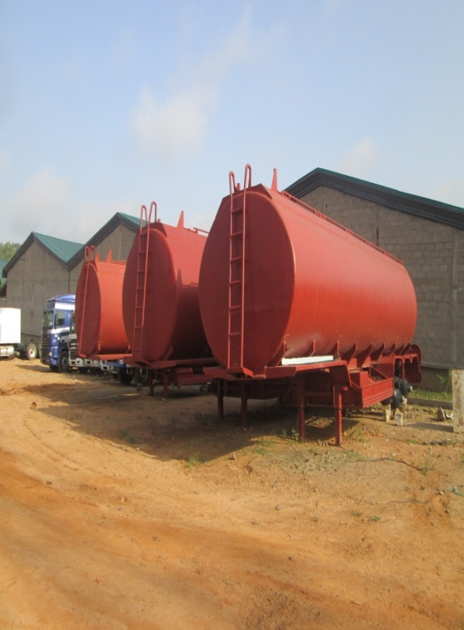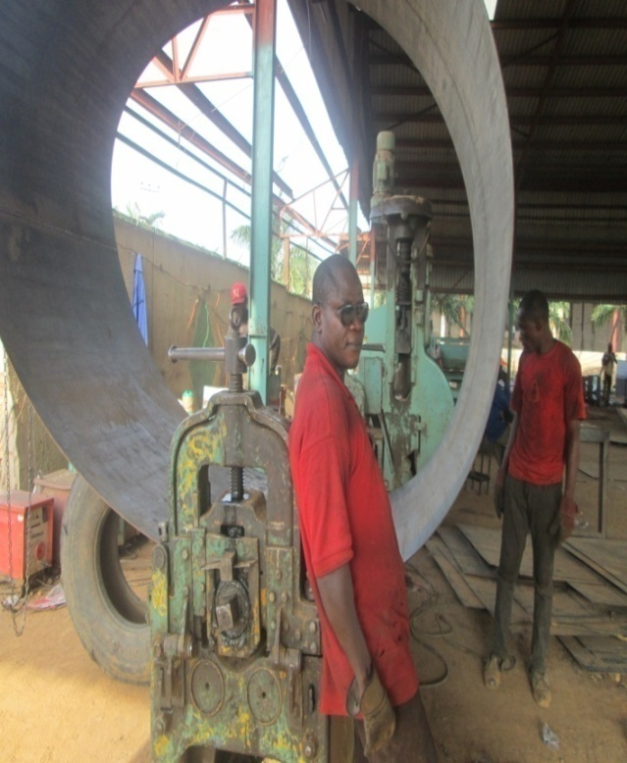
4.3 Trailer Truck Fabrication or Construction
What is a Trailer Truck?
Any of the various forms of vehicle for carrying goods and material, usually consisting of a single self-propelled unit but also often composed of a trailer vehicle hauled by a tractor unit, also a motor vehicle design to transport cargos.
Trucks or Trailer truckvary greatly in size power and configuration, with the smallest being mechanically similar to an automobile. Commercial trucks can be very large and powerful, and may be configured to mount specialized equipment such as in the case of trucks and concrete mixer and suction excavator.
Modern trailer trucks are largely powered by diesel engines exclusively, although small to medium size trucks are powered with gasoline engines. Almost all trucks share common construction. They are made of a chassis, a cab, an area for placing cargo or (i.e. body) axles, suspension, road wheels, an engine or drive train. Pneumatic hydraulic, water and electrical system may also be present, many also tow one or more trailers or semi trailers.
Design element or Construction Element
There are elements or factors to consider before fabrication which are:
- Purpose
- Capacity
- Material
- Construction of trailers truck
Purpose: The purpose of building a truck compensate the design purpose is a factor to consider, which is what and why it is the truck constructed, it use for transporting drinks, gains furniture, etc. If a truck is designed for drinks transportation, it is being used for transportation of gains then the truck has lost it purpose and therefore altering the design which the trucks will not last long; and it could be for container cargo or for some other purpose.
Capacity: It means the quantity of goods a specific truck can carry and what type of goods it will carry. If a truck is designed fora capacity of 22 pallets it shouldn’t exceed that quantity it was design forand if a truck is capacitated for cargo container and drinks. It should be used for its capacity or between its capacities.
Materials: When purpose and capacity of what a trailer truck is to be build for, their material consideration is put forth, the type of material that will be used for classis, floor, side door and so on, this are considered to go with the purpose as well as capacity.
Construction of Trailer Truck
After all those factors are considered then, the proper fabrication of the trailer truck is carrying out on this steps, but for the case of these report, the fabrication of 20 pallet drop side truck and a cargo container carrier.
First task is the construction and assembling of the chassis before it’s rigid and resistive strength, beam are used for chassis,it is cut from the beginning to a point of 3600m and forming a triangle like angle and will be welded to the other remaining half of the bam. These point is a sensitive part of the construction because it is the point where the King-pin will be assembled on the king pin base plate and also allow the truck to rotate at an angle of 180º when it is connected to cap after the task is carryout on both beam, then it is joined between a distance from both beam about 800mm out to out and 709mm in to in from the web with brasses to add support to the joints and also beam are used as the join of the beams, after the proper joining is complete, the next is the assembling of the axle base support which is already produced from the drilling machine, when it is fabricated on the chassis it will still be drilled at the point it was drilled on the chassis for space for axle bolt and nut to pass through the chassis, also the king-pin base plate is also welded to the top beginning of the chassis, one importance note is that all these assembling of the axlebase plate and king-pin base plate are fabricated on the chassis upside down (it will be turned upright), after the chassis is turned upright; further more it is the assembling and welding of the side rail/floor and arms.
The arms are pre-produced on the bending machine to the specification given as well as the side rail, In assembling of the arm the first arm is tacked to the chassis and the last arm to serve as a guide to the assembling of rest arms and square is used to get the accurate point and before tacking, the same process is carried out, on other side of the chassis. it could be flat, horizontal or vertically welded during this operating, next is the assembling of the side rail which is a cover to the arms and is also welded to the arm, after the arm and side rail are completely welded, the mounting of the floor, but before that container locks are welded underneath, 8 containers lock for locking long and short container as the case may be, then on the floor, a room is made where the lock will pass through then the floor is laid and welded from under the floor, the arms, is a 5mm thick plate and the side rail as well as the floor
After all the tasks have been successfully achieved, the next is the fabrication of the drop side door, front panel and back panel and pole and pole base. All these components are pre-produced in the bending and cutting machine, the poles and pole base are cut and bend to the given specification; the poles are 6mm thick which is bent then welded to a 4mm think to form the door and the poles and pole base.
After the door pole and pole base are completely pre-produced, then it is assembled it to the truck on production process. The pole is installed to the pole base before the doors will be assembled; the doors and the pole are removable. The door is attached with hinges which are pre-produced from The lathe machine, the hinges are pre welded to short plate as the base before welding it fully to the side rail and there are 3 hinges on the each door, after all the doors and pole are fully welded. The next is the assembling of the front and back panel which are also doors but do not need pole and pole base, they are just like covers which covers all the truck, they also under same process as the door, but little sight difference, the back panel is attached to the bomber with the hinges and also the front panel is attached to the V Shape side rail and the doors is also attached with hinges as well. After all these are completed and fully welded, the next is the finish stage which is the assembling of landing gear, reserve tank, spare tyre part, side protector and axle, when completed the trailer truck drop side is completed and ready for panting.
CHAPTER FIVE
5.0 Summary
In this technical report on “production” it covers the machinery of metals, fabrication of tanker truck, drop side and drilling of various types of material in specific shapes dimensions and requirement (reforming) of engine, plates and industrial machine parts.
5.1 Conclusion
The SIWES was a paramount important to me as a technologist. The practical experience I gained cannot be over emphasized.
The SIWES period was indeed a very good way of developing the communication skills of a student and their working career.
5.2 Recommendation
I recommend that some product should be given to the student in their place of SIWES to work on, Secondly measurement and dimensions are to be taken accurately and proper, measuring instrument should be used and also safety gadget should always to provide.

