

TECHNICAL REPORT ON THE STUDENT INDUSTRIAL
WORKS EXPERIENCE SCHEMES (SIWES)

HELD AT
MAN HARDI NIGERIA LIMITED
KWARA STATE

PRESENTED BY
OYUN PETER ADEWALE
ND/23/MPE/FT/0051

SUBMITTED TO
DEPARTMENT OF MINERAL AND PETROLEUM RESOURCES ENGINEERING,
INSTITUTION OF TECHNOLOGY (I.O.T) KWARA STATE
POLYTECHNIC, P.M.B 1375 ILORIN KWARA STATE

IN PARTIAL FULFILLMENT OF THE REQUIREMENT FOR AWARD OF NATIONAL DIPLOMA (ND) CERTIFICATE IN MINERAL AND PETROLEUM RESOURCES ENGINEERING

FROM

AUGUST - NOVEMBER, 2024

CERTIFICATION
This is to certify that this report was compiled by OYUN PETER ADEWALE with Matric Number ND/23/MPE/FT/0051 a student of Mineral and Petroleum resources Engineering Technology Department, Institute of Technology (I.O.T) Kwara State Polytechnic Ilorin, Kwara state on the completion of the Student Industrial Work Experience scheme (SIWES).

_______________________ ___________________
SIWES COORDINATOR DATE

DR. OLATUNJI J.A

_________________________ ___________________
HEAD OF DEPARTMENT DATE
DR. OLATUNJI J.A

_________________________ ___________________
OYUN PETER ADEWALE DATE
STUDENT

DEDICATION
This report is dedicated to Almighty God, the Alpha & Omega, the Merciful father for the privilege and opportunity to complete my (SIWES) programme in good health. Also to my parents; Mr. & Mrs. Oyun for their moral and financial support towards the successful completion of this programme.

ACKNOWLEDGEMENT
All thanks, praise and adoration due to Almighty Allah, the maker and sustainer of mankind, the Gracious God and Merciful God for his love, preservation and Good Health granted to me before, during and after the training.
My sincere gratitude goes to my parents; Mr. & Mrs. Oyun for their moral, spiritual and financial support.
I also direct my thanks to all the workers of Man Hardi Nigeria Limited special thanks to my boss. I want to use this medium thank all my friends & family for their continuous support morally, financially and their prayers.
I use this medium to acknowledge people who in one way or the other contributed to my success throughout my academic programme.

TABLE OF CONTENT
CERTIFICATION ii
DEDICATION ii
ACKNOWLEDGEMENT ii
TABLE OF CONTENT ii
CHAPTER ONE 2
1.0 INTRODUCTION TO SIWES 2
1.1 AMIS AND OBJECTIVES OF SIWES 2
1.2 VARIOUS DEPARTMENTS IN THE ORGANIZATION 2
1.3 BASIS OF INDIVIDUAL SECTION OF THE DEPARTMENT 2
1.4 ORGANIZATION CHART 2
CHAPTER TWO 2
2.0 OPERATIONS CARRIED OUT IN AUTOMOBILE SECTION 2
2.1 WORKING SYSTEM OF AN ENGINE 2
2.2 COOLING SYSTEM OF AN ENGINE 2
2.3 IMPORTANCE OF COOLING SYSTEM IN ENGINE 2
2.4 BASIC PART OF COOLING SYSTEM 2
CHAPTER THREE 2
3.0 VULCANIZATION SECTION 2
3.1 STEPS TO TAKE IN CARRYING OUT COLD PATCHING 2
3.2 STEPS TO TAKE IN CARRYING OUT HOT PATCHING 2
CHAPTER FOUR 2
4.1 SAFETY PRECAUTION NEED TO BE TAKE IN THE WORKSHOP 2
4.2 THE SYSTEM THAT CONSTITUTE HEAVY DUTY MACHINES 2
CHAPTER FIVE 2
5.1 CONCLUSION 2
5.2 RECOMMENDATION 2

CHAPTER ONE

1.0 INTRODUCTION TO SIWES
HISTORY
The student industrial work experience scheme (SIWES) was established by [ITF] in 1973 to solve the problem of lack of adequate practical skills preparatory for employment in industries by Nigerian graduates of tertiary institutions.
The scheme exposes students of tertiary the word of work. It affords students of tertiary institution the opportunity of being familiarized and exposed to the need experience in handing machinery and equipment which are usually not available in the educational institutions.
The participation in the scheme is a necessary pre-condition for the award of Diploma and Degree certificate in specific disciplines in most higher institutions in the country in accordance with the education policy of the government.
The programme is under the operation of the IT, the coordinating agencies (NUC, NCCE, NBTE), Employers of labour and the institutions whereby, the federal Government of Nigeria is in charge of funding the programme, the beneficiaries, includes undergraduate student of the following Department: Agriculture, Engineering, Environmental, Technology Education, Medical Science and pure and Applied Sciences. It is between the period of four months for polytechnics and colleges of Education, and six months for the Universities.

1.1 AMIS AND OBJECTIVES OF SIWES
- It gives student the opportunity of translating and relating their theoretical knowledge to the real world of work
- It helps in preparing student for the work situation they are likely to meet after graduation
- It exposes students to different machines, equipments and devices which are not present in their own school.
- It gives student opportunity of acquiring the knowledge of handing some tools and devices when on working field.

1.2 VARIOUS DEPARTMENTS IN THE ORGANIZATION
The organization is been divided into various department such as Mechanical engineering, Agriculture engineering department, electrical department, Agriculture science department chemistry laboratory department etc.
Specifically, the department which my Siwes programme is being carried out was mechanical engineering department workshop. The department comprise of Three (3) Sections which are
- Automobile section which is also divided in two ( Heavy duty & Light duty)
- Fabrication section
- Vulcanization section

1.3 BASIS OF INDIVIDUAL SECTION OF THE DEPARTMENT
- Automobile section: this section is divided into two units
- Heavy duty: This unit particular base on repairing and maintenance of heavy duty machines such as pay loader, budozer, excavator, general purpose tractors etc.
ii Light duty: this unit base on repairing of wear part and maintenance of light vehicles and official cars of the organization
- Fabrication section: this section base on fabrication of spare parts and welding of wear parts of machines
- Vulcanization section: this section deals with pumping of deflate tires and repairing of wear tube of both light and heavy duty vehicles

1.4 ORGANIZATION CHART
MAIN OFFICE
DIRECTOR
SECRETARY
WORKSHOP SUPERVISOR
MANAGER
TECHNICIAN
WORKSHOP

CHAPTER TWO

2.0 QUARRYING
This is a branch of surface mining that deals with the excavation, exploration, extraction and processing of blasted rock for certain purpose either industrial or domestic purpose.
It’s cycle of operation involves stripping of overburden and its ratio to minerals, excavation, drilling, blasting, loading milling which are all practically undergone at MAN HARDI NIGERIA LIMITED which specialized on excavation, drilling, blasting processing and marketing of dolomite marble.
As mine based company, marble aggregate make it more advantageous for commercial industries and ideal place for industrial training students.

2.1 QUARRYING OPERATION
These are the work carried out at site where solid minerals/rock are being dug out and broken into lumps and pebbles. The following are the operations that normally take place in quarry for its perfection
2.1.1 LAND CLEARING (SITE PREPARATION)
This is the clearing of land or a quarry site in order to ease the quarry operation if necessary.
It can be done or carried out manually with the use of simple tools like, diggers, shovel, head pan, hoe etc or mechanically which require the use of complex machine like bulldozer, dragline etc.

2.1.2 OVERBURDEN REMOVAL
This is the process whereby the top soil is removed to establish the surface of deposited rock for drilling, it is a compulsory operation and usually done manually with the use of simple tools like digger, hoe and head pan etc
SHOVEL:- This is a tools used in lifting and moving of bulk materials such as soil, gravel, ore etc Shovel is extensively used commonly in agriculture, construction.

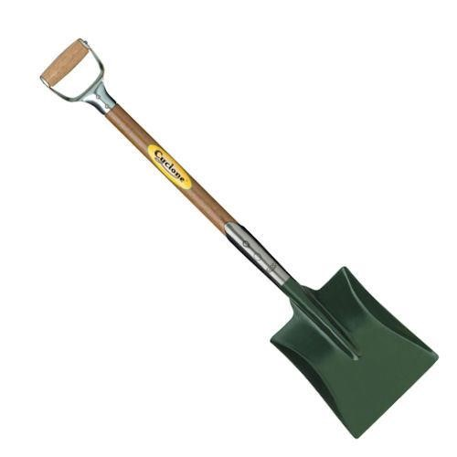

Fig. 1: Shovel

HOE:- A hoe is an ancient and versatile tools with a flat blade attached approximately at right angle to a long handle used to move small amount of soil.
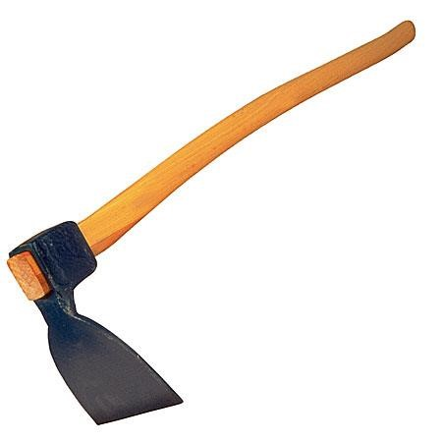
Fig. 2: Hoe

2.3 MINES EQUIPMENT’S AND MACHINES
Utilized equipment and machine in mines play an important role in the exploitation and excavation of rocks materials. They are referred to as the heartbeat of production because they facilitate a sustainable production development though some of these equipment’s and machines perform dual or multiple purpose yet the individually formation cannot be underestimated, hence, the possession of their varieties.
In solid mineral index, rock material are processed with the aid of crude implements and hired some when required in order to facilitate their daily production activities. These machine are:
- Air compressor
- Jack hammer
- Dumper
- Trailer
Air Compressor:- This is an air generating plant, it is design to convert atmospheric air to pressurized air, it consist of power system either diesel supplies engine or electrical motor engine. It is either mobile or stationary and has different types of models.
USES: It is basically used to power the jackhammer, also to blow out dust produced while drilling pre-blasting activities which is termed as flushing.
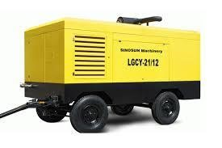
Fig. 3: Compressor

DUMPER: This is refer to as four wheel drive. It is made of heavy weight metals that consist of diesel engine. It is an automatic transmission and hydraulic system for and implementation of different operations. It has a loading bucket at the rear end which is used to load lumps from the quarry to the milling plant (Hammer mill).
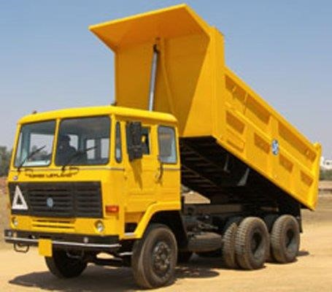

JACK HAMMER:- Is a pneumatic or electrochemical tool that combines a hammer directly with a chisel. Hand-held jack hammers are typically powered by compressed air, they are usually used to break up rock pavement, and concrete.
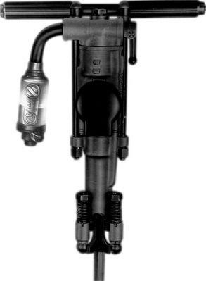
Fig. 5: Jack Hammer

TRAILER:- This an unpowered wheeled vehicle, not a caravan or camper, that is powered behind, another, and used to carry equipment, materials and finished product from place to place.
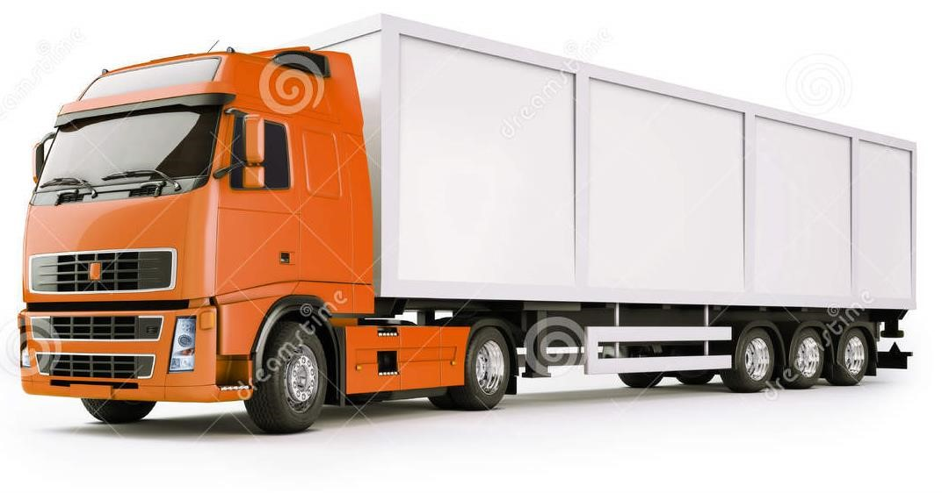

Fig. 6: Trailer

2.4 DRILLING
Drilling is the process of boring of holes with the use of drilling equipment called Jack Hammer and Compressor. It is the first unit of operation in the exploitation of mineral. Jack Hammer is a machine which creates holes in the ground with the use of a milling bit that is attached to the drilling rod which is in turn attached to the Jack Hammer.
TYPES OF DRILLING METHOD

1. ROTARY DRILLING
In rotary drilling, the drilling tools rotate along the same angle to which the impacted energy supplied the bit.

2. PERCUSSIVE DRILLING
This method of drilling strikes directly on the rock at the designated point along its face by percussive method and breaks the rocks.

3. ROTARY – PERCUSSIVE
The predominant method on this part is the rotary. It should be noted that drilling of this types takes 75% rotary and 25% percussive.

4. PERCUSSIVE – ROTARY
The drilling of this type takes 75% percussive while the remaining 25% is for the rotary.

2.5 DRILLING EQUIPMENT
- Air Compressor
- Drilling Rod
- Drilling Bit
- Jack Hammer
- Drilling Rig
- Man Power
DRILLING ROD: Is a tool steel round stock with a tight tolerance diameter. It is
usually 30mm – 40mm which is used in drilling operation. Fig. 7: Drilling Rod
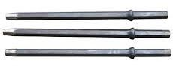

DRILLING BIT: Drilling bit are cutting tools used to create cylindrical holes, almost always of circular cross-section. Drill bits come in many sizes and have many uses. Bits are held in a tool called a drill, which rotates and them and provides torque and axial force to create the hole.

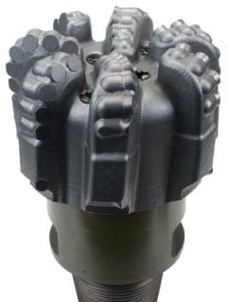
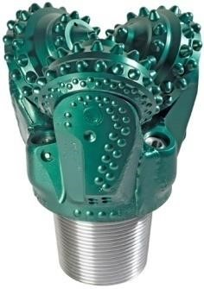
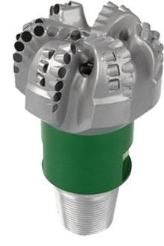
Fig. 8: Drilling Bit

2.6 SAFETY PRECAUTION TO BE TAKING IN DRILLING
- Consider the different in depth of the hole
- Ensure equal holes spacing
- Employ the same drilling bit through
- Avoid misalignment of holes
- Avoid hole blocking
- Avoid using blunt bit

2.7 NECESSARY PROCESS IN BLASTING
- Drawing of blasting plan
- Selection of blasting material
- Preparation of an to (Ammonium nitrate + diesel acid)
- Arrangement of blasting materials
- Priming
- Charging
- Stemming
- Connection
- Testing of the cabin current (in electrical mode)
- Extension of blasting wire and exploration which must place against the face direction.

2.8 CHARGING A DRILL HOLE
Charging of the drilled hole is the process by which detonating cord, explosive (ammonium) and mud or chipping are both drop one after the other into the drilled hole for the handful of ammonium nitrate mixed with fuel oil known as AMFO will be use in charge 2.5ft of drilled hole.
The detonating cord must be first lowered into the hole and you must sure that it touch the bottom of the hole then the explosive and ammonium nitrate are then drop on top of the detonating cord then stemming stick is use to press or stem it down to make sure that it is very tight and firm so that when draw it will not draw out of the hole, so cover with sand or chipping gradually and use stemming stick, to press or stem it down, it understood that during stemming, stemming stick is used, a care must take during stemming to avoid cutting of detonating cord, if cut it may cause misfiring.

2.9 CHARGING A HOLE THAT IS LODGED WITH WATER
Charge with explosive and not only AMFO, the amount of explosive to be use depends on the number of feet of the bole.
e.g
1ft = 2¼ explosive
2ft or 3ft = ½ explosive
4ft and above = 1 explosive
Blasting Accessories
Detonating cord
Ammonium nitrate
Diesel
Safety fuse
Detonator (plane cap)
Explosive
Detonating Cord
Another name for this is (cortex): this is a flexible cord containing a central cord of high explosive use to detonate other explosive. It is capable of burning and it is made in such a way that it cannot be soak by water, it is water resistance.
The detonating cord has to reach the bottom and must be shortly long outside for the connection.

2.10 EXPLOSIVE
Explosive are chemical compound or mechanical mixtures of solid or liquid minerals that are capable of rapid and violent decomposition under the effect of external impulse such as heat, fire, etc and thereby producing a great release of energy.

TYPES
Explosive can be grouped into two types which are mentioned below:
- High explosive: e.g glycerine, dynamite, gelatin, rock booster etc
- Low explosive: e.g ammonium nitrate (AN) in addition to full oil (Fo)
Blasting agent (ANFO) at an aggregate proportion in ratio 96:4 i.e 25kg of ammonium nitrate require 1.8 litre of diesel oil.

USED
Explosive are used for the following operation:
- For blasting and demolition
- Also as propellant
Therefore, generally explosive are used in the following areas:
- In open pit mines
- Exploration for oil and gas deposit
- Used for war purpose
- For construction of electric dams and irrigation dams

EFFECT
During blasting the energy released by the detonation of explosive produces fire basic effects:
i. Rock fragmentation ii. Rock displacement iii. Ground vibration iv. Air blast
v. Dust/fumes/nauseous gas

Safety Fused
This is a flexible cord containing internal burning medium by which fire or flame is convey at continuous and relatively uniform rate to the point of ignition to the point of use.

Detonator
The detonator is the one capable of detonating cord as soon as the safety fuse has been fired, it moves to the detonator, which detonates the detonating cord and the explosive rapidly.

Stemming
This is the process by which the holes are filled with mud or chipping and stem with the aid of stemming stick after the detonating cord and explosive has been inserted to ensure firm and tight. The stemming is done so that the pressure will move from high to low pressure.

2.11 CONNECTION AND BLASTING
After charging of holes each hole will be connected tightly with a long detonating cord to transfer fire to all the holes. The detonator and safety fuse that has been dip to the plain cap and dip together will be couple with wire to the detonating cord at a suitable area.
Types of Connection
- Parallel connection
- Series connection
- Parallel in series connection
- Series in parallel connection
Precaution
Precaution to be taking for life safety during connection and the blasting operation are:
- Confirm the rate of time at which the safety fuse burns compare with the distance before firing.
- Proper connection to avoid misfired
- Do away with any hot materials during connection
- The burden and spacing must be properly positioned to the strength of the explosive which must be proportional to resistance power of rock.
- Primary blasting must carried out before proceeding to secondary blasting.
- Proper announcement is compulsory before blasting.
- Follow the blasting distance to avoid been reach by the fly blasted rock i.e 100m – 150m away from the pit or area were blasting operation is going on.
- After blasting, allow the dust (poisonous gases) to diffuse or dissipate before moving close to the area.
- Low explosive is required for secondary blasting.

Forms of Blasting
- Primary Blasting: this is the type of blasting that firstly takes place on the parent marble rock or any other parent rocks.
- Secondary Blasting: this is type of blasting that is performs on huge boulders that are too big for haulage.
Types of blasting
i. Electric Blasting ii. Fire blasting

2.12 FACTORS AFFECTING MINING SITE IN ORO
- Location of the site: all these sites are located very far in the sub.
- Transportation: because of the location the haulage roads are also poor therefore there is no easy transportation.
- Financial Problems: the sites in the area are fairly financed, machine work are always done manually.
- Machine: there is no enough machine, for instance one air compressor is used by two or three company.
- Government Interference: there is no government interface which cause unqualified miners to blast without acquiring blasting license and blasting officer which may be harmful to the environment they may use expire blasting accessories.
- Mining Method: the mining method use is not encouraging because of the financial problem, machine work are done by man.
- Too much overburden: the thickness of overburden is too much, the crops are only tap the minerals with much distance between them which lead to waste of blasting minerals e.g cortex.

CHAPTER THREE

3.0 MILLING OPERATION
Milling is the process of reducing the size of solid bodies by breaking them with the aid of external forces as a result of which internal adhesional forces joining the separate particles of the solid body are overcome and new particles are exposed.
Also mining can be categorized into the same stage as crushing since is the mechanical stage in the process of comminution.
It is generally a dry operation and is usually performed in two stages of primary and secondary milling stages. The pebbles of run off time ore can be as large as 1.5mm across these are reduce in primary milling stage.
While the secondary milling is done as a result of production of chips which are of different aggregate. Examples are of production of dust, trowel, sharp, smooth, fine smooth.

Pre-milling Operation
Immediately the boulders/hand ores are blasted, they are ready to undergo communition, but they have to pass through loading and haulage.
Loading/haulaging are done at quarry site after a successive primary and secondary blasting, the available labourers (packer) load the pebbles into the awaiting dumper (tipper). The dumper are used as substitute to load all the pebbles into the milling plant (hammer mill) for adequate processing operation.

3.1 STAGES INVOLVE IN PROCESSING OF A ROCK – DOLOMITE MARBLE AS A CASE STUDY
- SHAKING: is the process done to separate the undersize from the oversize, with the aid of a screen shaker, with the feed at one end and the undersize product passing through the aperture of the sieve, and the oversize coming out at the other end.
- MILLING: Is the process of size reduction of solid bodies, with the aid of external force, either by compression or by impact against hard rigid surface, which is done by a secondary crusher e.g hammer mill consisting of hammers for creating impact on the rock pebbles, producing to the size from the aperture.
- SCALING: It is done with the aid of a measuring scale, with the sole aim of grading the sizes of the finished product into kilograms, into sizes of 30kg and 50kg respectively.
- SEWING: This is the threading or closing up of the loose end of the sack bag, to avoid wastage of the finished product.
- BAGGING: Is the grading of discharge from the shaker according to their sizes into sack-bags with sizes ranging from, 0.1mm – 0.5mm, 0.5mm – 1mm, 1mm
– 10mm, and 10mm – 20mm.
6. PALLETING:- This is the orderly arrangement of the finished product on a pallet, either accordingly to the size of the bagged product in kilograms or according the grade of the product itself, before transportation for further use.

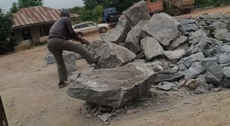
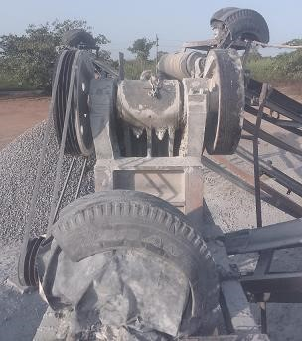

CHAPTER FOUR

4.0 DOLOMITE MARBLE
Dolomite marbles are usually predominantly white or greenish white, sometimes with yellowish or brownish Mgca (CO₃)₂.
Calcium carbonates are usually the finish production of dolomite. It is one of minerals that form rock. It is a widely distributed industrial mineral on earth. Large deposit of marble occurred at Jakura in Kogi State, Igbeti in Oyo State, Okpella, North of Auchi, Edo State and North part of Sokoto. Nigeria marble is locally used for structural decoration, main producer being Jakura marble industry. Limestone and marble especially the magnesium varieties.
It can also be used as fertilizers for magnesia-deficient soils such marble occur at Igbeti, Elebu, Itobu and Burun. Dolomite itself is used mainly for refractory linings, an important process for iron and steel industry.
Dolomite are economic importance to man by virtue of its physical versatility, its mineralogical and chemical properties recommend it for numerous usages.
Marble can be produced in blocks of various sizes these block are subjected to polishing. This will definitely assist in their exploitation disability.

4.1 Uses of Dolomite Marble
- It is used as building stone
- It is used as refractory and fluxes in metallurgy and in the chemical, plants, cosmetics and other industries.
- It is used in extraction of iron ore.
- It is used for the production of dining table, centre table, bed-side stool.
- It is used for production of marble tiles.

CHAPTER FIVE

RECOMMENDATION AND CONCLUSION

5.0 RECOMMENDATIONS
Since Nigeria is blessed with numerous mineral, over some have not been discovers till this moment, so government should ensure that mining course are accredited in all the polytechnic (both the HND and ND) and university in the country, to make mining course easily available for the student that have interest. Also government should try and cooperate with private miner section by provide to them some equipment which lead to the improvement in there production.
There should be a good commencement of on the importance mineral
available, these will motivate people to apply for mining course, since this will be job opportunity for them.
There should also be provision of good and accessible roads for the haulage of mineral recovered for forward transmission to the point of processing.
The student industrial work experience scheme (SIWES) is a must for all science and technology student to undergo and it must be taken with full seriousness, since it is done once at the national diploma programme.

5.2 CONCLUSION
The Student Industrial Work Experience Scheme (SIWES) is an importance programme that brings about importance programme that brings about improvement to student in the field of work (SIWES), also made student to be self-confidence and to withstand industrial work.

REFERENCES
Mr. Kajobola: Lecture note on introduction to basic mining, Mineral Resources
Engineering Department Kwara State Polytechnic, Ilorin 2023/24 Section.
Mr. Olatunji: Lecture note on safety and environmental control, Mineral Resources
Engineering Department Kwara State Polytechnic, Ilorin 2023/24 Session
Engr. Durojaiye: Lecture note on mineral processing, Mineral Resources Engineering Department Kwara State Polytechnic, Ilorin 2023/24 Session
Engr. M.B. Saka: Lecture note on Mining Method, Mineral Resources Engineering
Department Kwara State Polytechnic, Ilorin 2023/24 Session.

`.

