
TECHNICAL REPORT ON THE STUDENT
INDUSTRIAL WORK EXPERIENCE SCHEME
(SIWES)

HELD AT
KWARA STATE MINISTRY OF WORK AND TRANSPORT

PRESENTED BY:

YUSUF AABIDAH ADEOYE
ND/23/CEC/PT/0178

SUBMITTED TO
DEPARTMENT OF CIVIL ENGINEERING
INSTITUTE OF TECHNOLOGY (I.O.T) KWARA STATE POLYTECHNIC ILORIN, KWARA STATE.
P.M.B. 1375, ILORIN, KWARA STATE.

IN PARTIAL FULFILMENT OF THE REQUIREMENT FOR AWARD OF NATIONAL DIPLOMA (ND) CERTIFICATION IN CIVIL ENGINEERING

AUGUST - NOVEMBER, 2025

PREFACE

This report contains all experience gained during the time of my student industrial work experience scheme (SIWES). Thus it vividly gives a comprehensive summary report of the engaged and experience gained at the company.

DEDICATION

This report is dedicated to the Almighty Allah for his mercy and protection on me throughout the program. Almighty Allah the giver of knowledge, He who gave knowledge to those He want. He whoever he gave knowledge to, he has gave him abundant blessing, and the most knowledge person among human kind Prophet Muhammad (SAW) and my parent Mr. Yusuf Harun Adeoye and his wife Mrs. Yusuf Ganiyah Adeoye.

ACKNOWLEDGEMENT

My endless thanks goes to Almighty Allah (SWT) the creator, mentor and commander of the world, for his love, guidance and protection over me throughout the beginning of my living till academic level and for his protection and acquire of knowledge during period of my academic career with courage and effort to complete this (SIWES) with success in-spite of all difficulties. In facts, it is marvelous and great to me, oh! Allah I will forever worship you till death (Alhamdulillah).

Special thanks also go to my humble families (THE SPECIAL ADEOYE’S) for their moral support, words of advice both morally and financially given to me towards the successful completion before and during my (SIWES) program, I shall forever be grateful. May you live long enough to reap the fruit of your labour (Amin) Jazakumullahu Khairan.

TABLES OF CONTENTS

Title Page i
Dedication ii
Acknowledgements iii
Table of Contents iv-v

CHAPTER ONE

1.1. Historical background of student industrial work experience scheme 1
1.2 Aim and objectives 1
1.3 Scope of report 2

CHAPTER TWO

2.1 Description of Kwara State Ministry of Works. 3
2.2 Location and brief history of Kwara State Ministry of work and Transport 3
2.3 Departments and their functions 3
2.4 Department and duties given 4

CHAPTER THREE

Work done 5
3.1 Construction terms and techniques experienced on site 5
3.1.1 Cleaning and removal of top-soil 5
3.1.2 Construction of reinforced concrete drainage 6
3.2 Road works 9
3.2.1 Sub-base course construction 10
3.2.2 Base course construction 10
3.4 Priming and tack coat 11
3.5 Experienced gained 12

CHAPTER FOUR

4.0 Machines and equipments 13
4.1 Bulldozer 13
4.2 Concrete mixer 14
4.3 Excavator 14
4.4 Wheel barrow 15
4.5 Shovel 15

CHAPTER FIVE

5.1 Conclusion 16 5.2 Recommendation 16
5.3 References 18

CHAPTER ONE

  - HISTORIAL BACKGROUND OF STUDENT INDUSTRIAL WORK EXPERIENCE SCHEME

Students' Industrial Work-experience Scheme (SIWES) is one of the Industrial Training Fund (ITF) programmes which were introduced in 1974 due to the inability of engineering and technology students in Nigeria universities and polytechnics to meet the practical aspects of their training. That is, the needs to enable students match their theoretical school knowledge with the practical aspect of their training in industry. The Training lasts for six months. According to Ekpenyong (2011), one of the principles underlying any industrial work experience scheme for students in institutions of learning is the desire to marry the practical with the theoretical learning which characterizes conventional classroom situations with a view to striking a balance between theory and practice. The author stressed further that it was in realization of this that the ITF when it was established, set out to study the extent to which the theoretical knowledge that students in engineering technology and other allied fields in Nigerian institutions offering technology-based courses related to the kind of work experience expected of them by employers.

The result of the ITF survey showed a great disparity between students' knowledge and their ability to apply it in relevant jobs. In order to bridge the gap between the two, the ITF in 1974 established a co-operative internship programme, which enabled students of technology to spend some part of their courses for relevant on the-job practical experiences in appropriate areas of the Nigerian industry (Ekpenyong, 2011). The author further stressed that the internship programme, SIWES, can therefore be seen as that which is intended to give Nigerian students studying occupationally related courses experience that would supplement their theoretical learning as a well of equipping the students with the needed skills to function in the world of work.

This need to combine theoretical knowledge with practical skills in order to produce results in the form of goods and services or to be productive is the essence and rationale for industrial training, and a basic requirement for the award of B.Eng.

  - AIM AND OBJECTIVES
The Industrial Training Fund's policy Document No. 1 of 1973 which established SIWES outlined the objectives of the scheme. The objectives are to:
- It provides an avenue for students in institutions of higher learning to acquire industrial skills and experience during their course of study.
- It exposes Students to work methods and techniques in handling equipment and machinery that may not be available in their institutions.
- It makes the transition from school to the world of work easier and enhance students' contact for later job placements and a chance to evaluate companies for which they might wish to work.
- It provides students with the opportunities to apply their educational knowledge in real work and industrial situations, there by bridging the gap between theory and practice.
- The programme teaches the students on how to interact effectively with other workers and supervisors under various conditions in the organization.

  - SCOPE OF REPORT

This report was prepared based on personal skills and experience gained during the program and relates some basic principles reviewed from existing literature from various sources. Conclusions were drawn from observations made during the training and necessary recommendations were given.

CHAPTER TWO

2.1 DESCRIPTION OF KWARA STATE MINISTRY OF WORKS

Kwara state ministry of is establish to oversee and supervise road projects, Structure and quality control for the Government. It has training Section which provides adequate technical knowledge for Students of Tertiary institutions. It also comes out for direct labour such as rehabilitation of road i.e. Road maintenance, Construction of Culverts pavement etc.

2.2 LOCATION AND BRIEF HISTORY OF KWARA STATE MINISTRY OF WORKS AND TRANSPORT

Kwara State ministry of works & transport is situated along Ahmadu Bello Way, Ilorin. It is a state Governmental organization, which was set up to control specific road and infrastructural activities for the development of both the Rural and Urban region of the state. The organization as First known as Public works cooperation since creation of Kwara State in 1967, Until some years back when it was changes to Ministry of works and Transport with the headquarter at Ilorin the state Capital. Kwara State Ministry of Works & Transport was meant for carrying out works on road such as Maintenance, developments of new route and construction of roads network.

2.3 DEPARTMENTS AND THEIR FUNCTIONS

- Material Testing Unit: Is a laboratory where quality control and testing for construction has to be carried out in other to know the weight/strength of Materials used in construction, Such as Soil, reinforcement, and Cubes, etc.

- Design Office Unit: The Unit is in charge of designing the projects work that Government want to execute.

- Survey Office Unit: It is a section where Professional Quantity and Land Surveyors are delegated the duties to evaluate, value qualities and locate points for Constructional Purposes.

- Construction/Maintenance Unit: It is a unit consisting of skilled persons to maintain existing works, such as Roads, Bridges etc. They are also the one that supervise the works of construction that is going on in the State i.e. the projects of Government, and it is also their duties to construct some infrastructure if it necessary.

2.4 DEPARTMENT AND DUTIES GIVEN

In Kwara state ministry of works and transport, I worked in the Construction/Maintenance unit as a student trainee. I worked alongside other engineers and foremen on site work. Moreover, the department is responsible for supervising all onsite and offsite constructions to monitor compliance with road general specification and safety regulations, and also coordinate and direct construction workers and subcontractors. The sector ensures quality construction standards and the use of proper construction techniques for every given project work.

CHAPTER THREE

WORKDONE

During the period of sixteen weeks of Industrial Training, I was involved in construction unit of civil engineering.
I was posted to the ongoing road construction at Gaa-Saka area, Ilorin Kwara State, where I was involved in Earthwork, construction of drainage and Asphalt road pavement.

3.1 CONSTRUCTION TERMS AND TECHNIQUES EXPERIENCED ON SITE

The Construction techniques and terms described in this report involves the various methods of construction carried out in the course of road construction. While onsite, certain terms were used during the construction. As a Civil Engineer, adequate knowledge of these terms must be paid attention to in order to communicate effectively with the workers. Below are the work-done on site and the terms used in describing them

3.1.1 CLEARING AND REMOVAL OF TOP SOIL

The roadway was being constructed drain to drain and the clearing width of the proposed road covered the main road and the drains on both sides. Top soils and unsuitable materials were also removed. All of these were done using a Bulldozer.

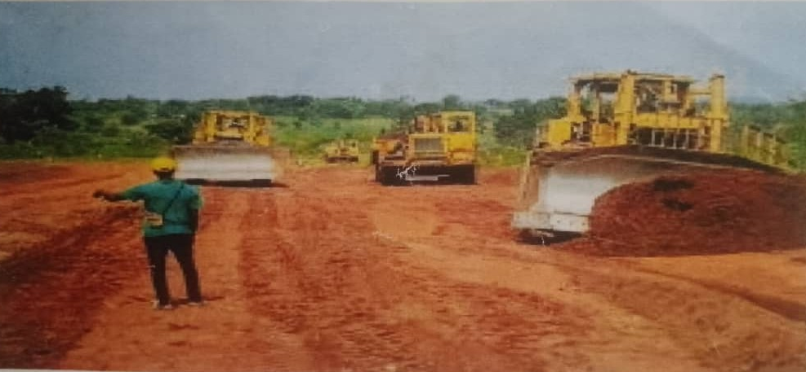

Figure 3.1: Clearing and removal of top soil

3.1.2 CONSTRUCTION OF REINFORCED CONCRETE DRAINAGE

This involves the construction of 0.6m×0.6m reinforced concrete drainage. It's used to manage and direct the flow of water, such as storm water or waste water, in construction project to prevent flooding and erosion. Construction of R.C.C drainage involves;

- Excavation of drainage trench: Excavating of the drain system trench to the proper slope for water flow.
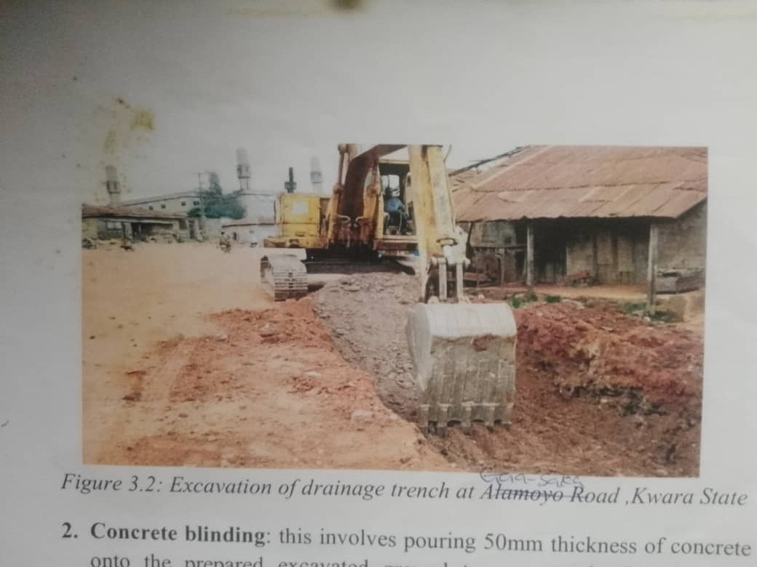

Figure 3.2: Excavation of drainage trench at Gaa-Saka Road, Kwara State

- Concrete blinding: this involves pouring 50mm thickness of concrete onto the prepared excavated ground to create a level and stable foundation for the drain. This was prepared at a specification of concrete mixing ratio of 1:316
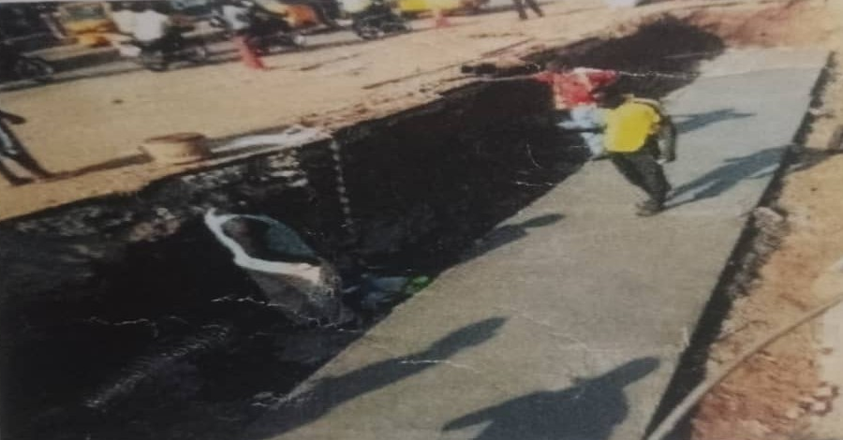

Figure 3.3: Concrete blinding at Gaa-Saka Road, Kwara state

- Casting of the drain base: involves pouring and shaping concrete to create the base for a drainage system. The specifications for the concrete mix ratio used were 1:2:4.
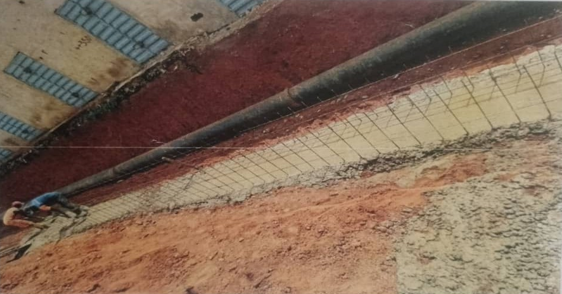

Figure 3.5: Casting of the drain base at Gaa-Saka Road, Kwara State
- Formworks construction: This involves propping and bracing of temporary structure known as formwork or shuttering, which holds the concrete in place while it is set-up for the construction of drain walls so as to maintain it intended shape, size and position.
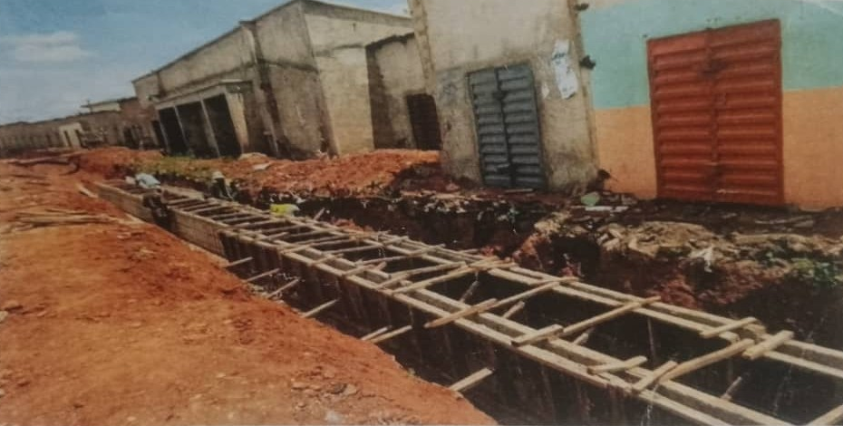

Figure 3.6: Propping of formworks by the carpenters at Gaa-Saka Road, Kwara State.

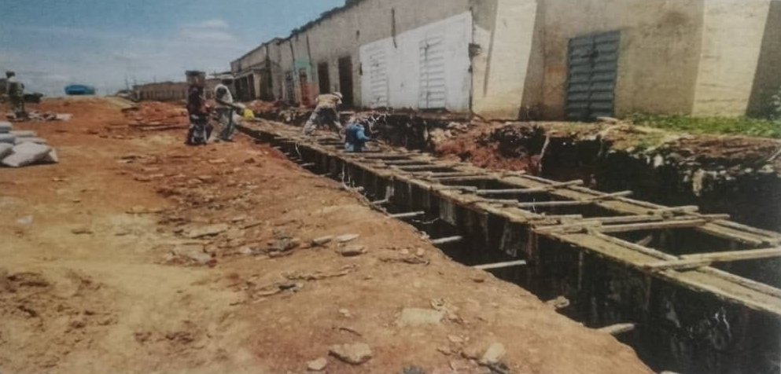
- Casting of the drainage side walls: involves the process of pouring and shaping concrete to create the vertical side walls of a drainage structure. The specification of concrete mixing ratio used was 1:2:4.

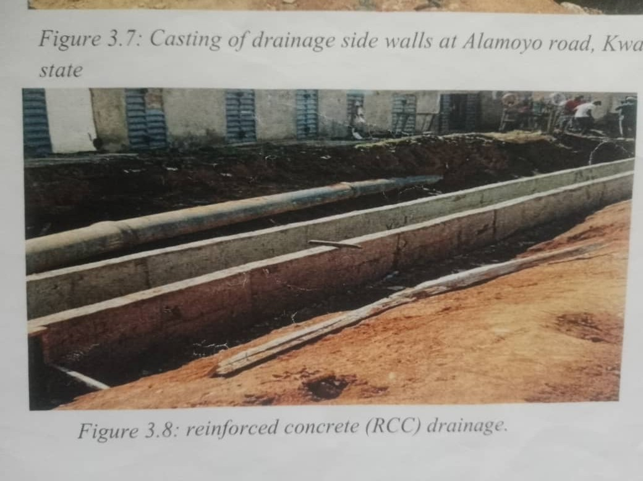
Figure 3.7: Casting of drainage side walls at Gaa-Saka road, Kwara state
Picture

Figure 3.8: reinforced concrete (RCC) drainage.
3.2 ROAD WORKS

The constructing of roads can be described by three processes;
- Setting out
- Earthworks
- Priming and tack coat.

SETTING OUT: This is carried out following the dimensions specified in the layout drawings. It mainly consists of the surveying process.

EARTHWORKS: This one of the major work involved in road construction. It involves removal of top soil, along with any vegetation, before scraping and grading the area to finished "formation level". It is usually done using tractor shovel, excavator, grader or buldozer. Most earthworks are formed by cut and fill and the type of fill material used must be considered, not only in terms of its physical properties, but on the conditions with which it is to be used, and the method of compaction.

3.3 SUB-BASE COURSE CONSTRUCTION

A Sub-base course is a layer designed of carefully selected materials that is located between the sub grade and the base course of the pavement. Its thickness is normally in the range of 100mm-400mm and it is made to withstand the required structural capacity of the pavement section.
In this project, laterite material was used for the sub-base course after it had passed various tests like California bearing ratio (CBR), Atterberg limit etc. The laterite was brought from approved borrow pits and laid to a compacted thickness of 150mm. A grader was used to lay the laterite material and a roller was used for compaction.

3.3.1 BASE COURSE CONSTRUCTION

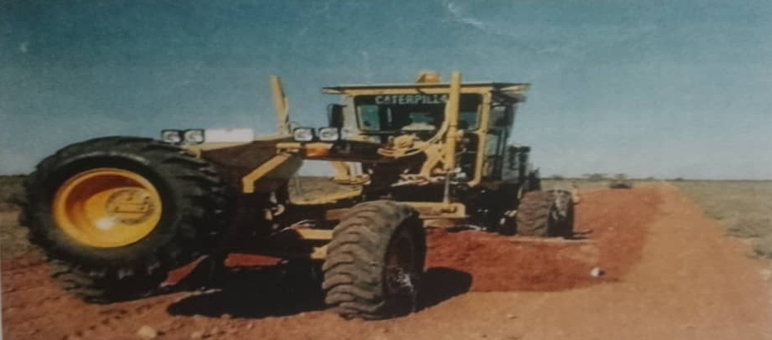
The base course is the region of the pavement section that is located directly under surface course or wearing course. If there is a sub-base course, the base course is constructed directly above it. Else it is built rightly on top of the sub grade. Typically, base course thickness ranges 100mm-150mm and is governed by underlying layer properties. Base course absorbs majority of heavy loads imposed on pavement surface.

Figure 3.7: Grading of the Gaa-Saka Road. Kwara state
3.4 PRIMING

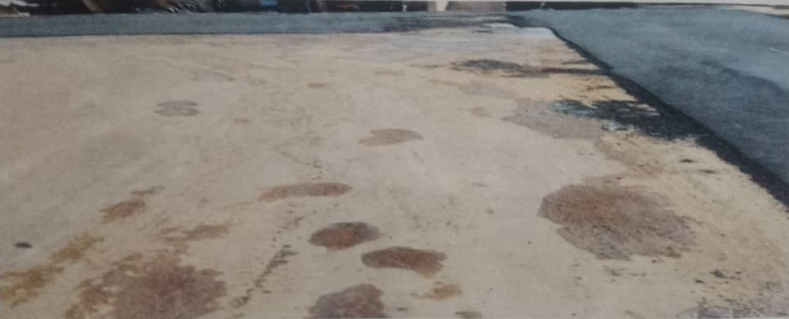
The surface of the road was primed using a bituminous substance called MCI after the final grading. The bituminous surface was later blinding with sharp sand.

Figure 3.8. Priming
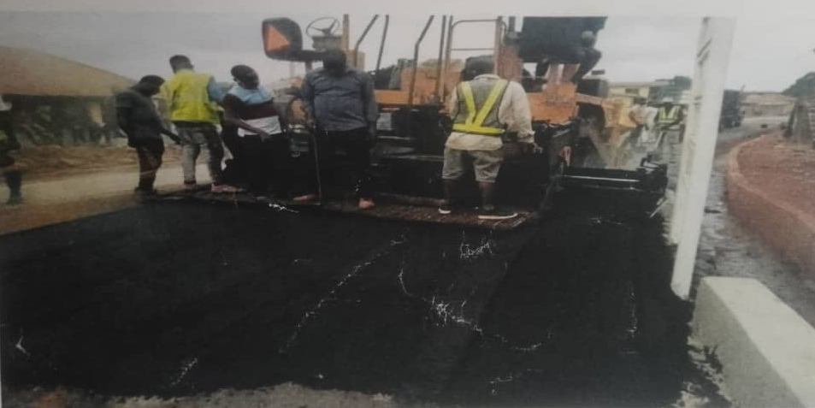

Figure 3.9: Laying of Asphalt

3.5 EXPERIENCED GAINED

- I was able to gain a firsthand practical experience in civil engineering. I leant that good team work is important for fast and good quality job delivery. I also gained knowledge on how to manage personnel on a site.
- I understood that proper field survey and inventory are pertinent to good quality desk study/work. I also learnt that good supervision produces good quality outcome of work.
- I learnt that proper project supervision is essential to produce good quality job. I also learnt that good technical, communication and project management skills are important to ensure completion of a project within budget and stipulated time period.
- I learnt that proper planning and execution are paramount to the success of a project. Also good environmental consideration should be taken.
- I gained full experience and attract full knowledge of achievement relating to the drainage construction, earthwork and construction of flexible road pavement.

CHAPTER FOUR

4.0 MACHINES AND EQUIPMENTS

4.1 BULLDOZER

A bulldozer is a crawler (continuous tracked tractor) equipped with a substantial metal plate (known as a blade) used to push large quantities of soil, sand, rubble, or other such material during construction or conversion work and typically equipped at the rear with a claw-like device (known as a ripper) to loosen densely compacted materials.
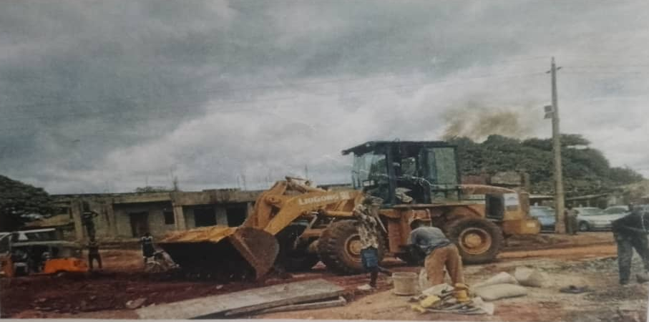

Figure 4.1: A bulldozer
4.2 CONCRETE MIXER

A concrete mixer (often mistakenly called a cement mixer) is a device that homogeneously combines cement, aggregate such as sand or gravel, and water to form drum that efficiently combines these materials to produce a consistent and uniform mixture, which is essential for various construction projects such as building foundations, roads, and structures.

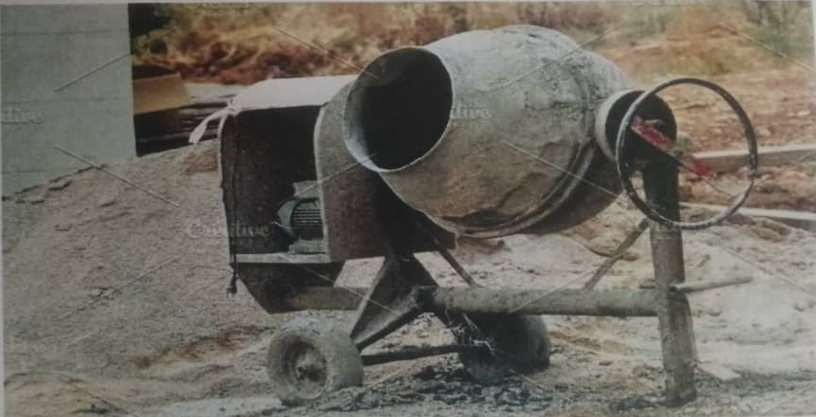

Figure 4.2: Concrete Mixer.

4.3 EXCAVATOR
Excavators are popular earthmoving vehicles that feature a bucket, arm, rotating cab, and movable tracks. These components provide superior digging power and mobility, allowing this heavy equipment to perform a variety of functions from digging trenches and breaking holes to lifting away waste trenches and breaking holes to lifting away waste and excavating mines
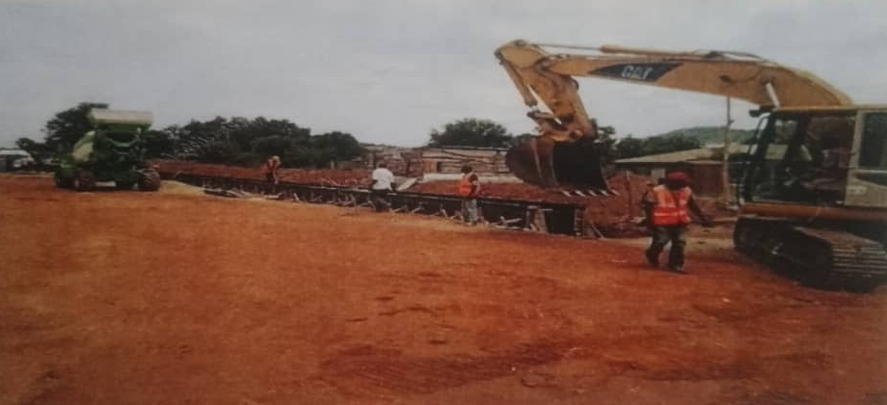

Figure 4.3 An Excavator
4.4 WHEELBARROW
Wheelbarrow is an indispensable hand-propelled vehicle used for carrying small loads, particularly in construction, gardening, agriculture and various manual labor tasks. Wheelbarrows are frequently used to transport materials across job sites, making it easy for workers to move heavy or bulky items efficiently.
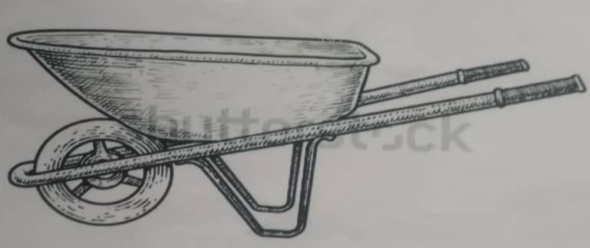

Figure 4.4: Wheelbarrow.

4.5 SHOVEL
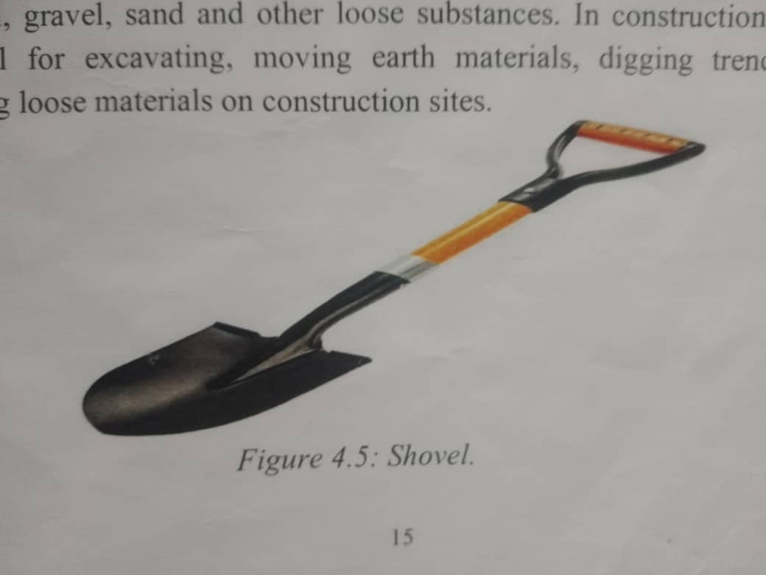
Shovel is a hand tool used for digging, lifting, and moving materials like soil, gravel, sand and other loose substances. In construction, they are essential for excavating, moving earth materials, digging trenches, and handling loose materials on construction sites.

Figure 4.5: Shovel
CHAPTER FIVE

5.1 CONCLUSSION

In road construction, the preliminary stage must involve a reconnaissance survey, the desk study, oral interview for the people around the proposed road.
A detailed survey of the proposed road site must be carried out for good vertical and horizontal alignments.
The geotechnical and physio-technical investigations of the proposed road site must be given full consideration in the road design and in the preparation of the Bill of Engineering Measurement and Evaluation (BEME). The Bill of Engineering Measurement and Evaluation must contain all necessary items of work in the right quantities.
Civil Engineering, thought very wide, is an interesting field of Engineering Civil Engineering practices are easy in as much the technical know-how is acquired. Every task in life possesses some challenges. So, one must be ever ready to face and solve the problems encountered in any tasks for the benefits of mankind and oneself.
Since this programme is of great imponance to student under no circumstance. Should the programme be eradicated because it is indeed a great programme enhance student not only academically but also intellectually.

5.2 RECOMMENDATION

In view of the relevance of the SIWES program, it is important that it is sustained by the government through the Industrial Training Fund (ITF) as it exposes the student to work tools, facilities, and equipment that may not be available in their respective institutions in relation to their course of study.
To this end, I recommend that the following under-listed points should be implemented:

- Students' Industrial Works Experience Scheme (SIWES) needs to be strengthened by all concerned stakeholder in order for its objectives to be fully realized.
- Regular monthly allowances for students on attachment should be paid promptly.
- Organizations should always accept students for SIWES and subsequently assign them to relevant jobs.
- Experience staff should always be made to train the students on attachment.
- There should be more funding of the scheme by the government in order for it to be more effective.
- The companies should put in place all the necessary facilities needed to enhance the knowledge of the student in industrial attachment.
- It will be of great benefit if the institution can create a platform whereby student can obtain pre-SIWES knowledge or excursion programs, before student embark for general 6 months industrial training programme.

5.3 PROBLEMS AFFECTING THE SCHEME

Recently problems are identified the management of the SIWES scheme which has depressingly affected the growth and development of the scheme, some of the problems include;

- Inadequate funding of the scheme.
- Negligence arising from the institution coordinators of the scheme.
- Lack of cooperation from employees/trainees.
- Insufficient professionals in the scheme.

REFERENCES

- NZ Ministry of Transport, (2013) Safer journeys: action plan 2013-2015. New Zealand. Ministry of Transport, Wellington, New Zealand.
- PIARC (2012), Comparison of National Road Safety Policies and Plans, PIARC Technical Committee C.2 Safer Road Operations, Report 2012R31EN, The World Road Association, Paris.
- Polidori, C. Cocu, X, Volckaert, A. Teichner, T. Lemke, K & Saleh, P (2012) Safety prevention manual for secondary roads European Commission. Available at http://pilot4safety.fehrl.org/index.php?m=3&id_directory-7254.
- Queensland Department of Transport and Main Roads, (2013) Guidelines for Road Design on Brownfield Sites, State of Queensland (Department of Transport and Main Roads), Brisbane, Australia. Available from http://www.tmr.qld.gov.au/business-industry/Technical-standards- publications/Brownfields-guidelines.aspx, accessed 25 February. 2014.

