

A TECHNICAL REPORT ON
STUDENT INDUSTRIAL WORK EXPERIENCE SCHEME
(SIWES)

HELD AT
H &H STEEL WORK LIMITED
TASHA 2 BESIDE THE REDEEMED CHRISTIAN CHURCH, FCT, PROVINCE 5, ABUJA

WRITTEN BY
ALIU JAMIU ADEWALE
MATRIC NO: ND/23/WEC/PT/0004

SUBMITTED TO

DEPARTMENT OF WELDING AND FABRICATION, INSTITUTE OF TECHNOLOGY (I.O.T), KWARA STATE POLYTECHNIC,
ILORIN
IN PARTIAL FULFILMENT OF THE REQUIREMENTS FOR THE
AWARD OF NATIONAL DIPLOMA (ND) IN WELDING AND FABRICATION ENGINEERING.

MARCH - APRIL, 2025

CERTIFICATION
This is to certify that ALIU JAMIU ADEWALE of Department of WELDING AND FABRICATION with matriculation number ND/23/WEC/PT/0004 has completed his four months SIWES training program held between JULY TO NOVEMBER, 2024 at H & H STEEL WORK LTD, TASHA 2 BESIDE REDEEMER CHRISTIAN CHURCH , FCT PROVINCE 5, ABUJA.

SIWES SUPERVISOR SIGNATURE & DATE

SIWES COORDINATOR SIGNATURE & DATE

HEAD OF DEPARTMENT SIGNATURE & DATE

DEDICATION
This SIWES Work is dedicated to Almighty ALLAH who gave me the knowledge and wisdom to complete this course. I give Him all the glory, honour and adoration for His protection, provision and guidance throughout the period of my study.

ACKNOWLEDGEMENT
My special thanks go to my lovely parents ALHAJI. and HAJIA. ALIU, together with my guidance that have been there for me. May God Almighty grants them long lives and prosperities and for the fruit of their labour.
Furthermore, I equally acknowledge my brothers, sisters and younger ones. May Almighty God bless them all.
I am particularly indebted to all staffs of

REPORT OVERVIEW
SIWES (Students' Industrial Work Experience Scheme) is a four months skill training program designed to expose and prepare students of Tertiary Institutions such as Kwara State Polytechnic for the Industrial Work experience they are likely to meet after graduation.
Design Integrated Services Fabrication is a H & H STEEL WORK LTD, TASHA 2 BESIDE REDEEMER CHRISTIAN CHURCH , FCT PROVINCE 5, ABUJA, Nigeria. It is a dedicated construction company driven with a core value to bring client's design taste and dream to a thorough actualization with great emphasis on getting work done.
Work actually carried out during the four months SIWES training are welding and fabrication of LOBBY BURGLARY, welding and fabrication of SLIDING ORNAMENT GATE and welding and fabrication of METALLIC DOOR.
Experiences gained are I know how to use electric arc welding machine, I know how to weld different weld joints such as butt joint, corner joint, tee joint, lap joint and edge joint. I also know how to carry out marking out and cutting operations using try-square, meter rule and hack saw.
Conclusion and Recommendation. My four months SIWES program has made me to have technical knowledge about what I have learnt theoretically in the classroom. I will recommend that the organization should provide some stipend for SIWES students and transport facility so as to ease their mobility.

ALIU JAMIU ADEWALE
ND/23/WEC/PT/0004
SIWES 2024

LIST OF FIGURES
FIG.1: ORGANOGRAM OF DESIGN INTEGRATED SERVICES FABRICATION 4
FIG.2: LOBBY BULGLARY 6
FIG.3: HAND RAIL 8
FIG.4: CAR PARK 10
FIG.5: ARC WELDING 11
FIG.6: PRINCIPLE OF ARC WELDING 12
FIG.7: WELD JOINTS
FIG.8: HACK SAW
FIG.9: TRY SQUARE

Title Page
Certification Page
Dedication
Acknowledgement
Report Overview
List of Figures
List of Tables
Table of Contents

TABLE OF CONTENTS

CHAPTER 1: INTRODUCTION
1.1: Background of SIWES
1.2: Objectives of SIWES

CHAPTER 2: DESCRIPTION OF THE ESTABLISHMENT OF ATTACHMENT
2.1: Location and Brief History of Establishment
2.2: Objectives of Establishment
2.3: Organization Structure (Including Organogram)

CHAPTER 3: WORK ACTUALLY CARRIED OUT
3.1: Description of Work done on Lobby Burglary
3.2: Description of Work done on Hand Rail
3.3: Description of Work done on Car Park
2.4: The Various Departments/Unit in the Establishment and Their Functions 5

CHAPTER 4: EXPERIENCES GAINED
4.1: Experience on Arc Welding
4.2: Experience on Weld Joints
4.3: Experience on Marking Out and Cutting Operation

CHAPTER 5: SUMMARY, CONCLUSION AND RECOMMENDATION
5.1: Summary of Attachment Activities
5.2: Problems Encountered During the Program
5.3: Suggestions for the Improvement of the Scheme

REFERENCE
INTRODUCTION
1.1: BACKGROUND OF SIWES
The Student Industrial Work Experience Scheme (SIWES) is a skill training program designed to prepare and expose students of Tertiary Institutions like POLYTECHNICS to the industrial work situation they are likely to meet after graduation. The scheme afford students the opportunity to familiarizing and exposing themselves to handling equipment machinery that are usually not available in institutions.
Before the establishment of the scheme, there was a growing concern among industrialists that graduates of Tertiary Institutions lacked adequate practical background (studies) preparatory for employment in industries. Thus, the employers were of the opinion that the theoretical education going on in institutions of higher learning was not responsive to their needs.
It is against this background that the Industrial Training Fund (ITF) initiated, designed and introduced SIWES scheme in 1973 to acquaint students with the skills of handling industrial equipment and machinery.
The ITF solely funded the scheme during its formative years. But as the financial involvement became unbearable to the fund, it withdrew from the scheme in 1978. The Federal Government handed over the scheme in 1979 to both the National Universities Commission (NUC) and the National Board for Technical Education (NBTE).
Later, the Federal Government in November 1984 reverted the management and implementation of the SIWES program to ITF and it was effectively taken over by the Industrial Training Fund in July 1985 with the funding being solely borne by the Federal Government.
SIWES İs a tripartite program involving the STUDENTS, the POLYTECHNIC and the INDUSTRIES (employer of labor). The program is funded by the Federal Government of Nigeria and jointly coordinated by Industrial Training Fund (ITF) and National Board for Technical Education (NBTE).

1.2: OBJECTIVES OF SIWES
Specifically, the objectives of the Students Industrial Work Experience Scheme (SIWES) are to:
- Provide an avenue for students in institutions of higher learning to acquire industrial skills and experience in their course of studies.
- Prepare students for the industrial work experience they are to undergo after graduation.
- Expose students to work methods and techniques in handling equipment and machinery that may not be available in their institutions.
- Make the transition from school to the real world.
- Enhance students' contacts for later job placement.
- Provide students with an opportunity to apply their knowledge in real work situation.
- Bridge the gap between theory and practical.
- Enlist and strengthen employer's involvement in the entire educational process.
- Prepare students for employment in Industry and Commerce.
- Satisfy accreditation requirements set by NBTE.

CHAPTER 2
DESCRIPTION OF THE ESTABLISHMENT OF ATTACHMENT
2.1: LOCATION AND BRIEF HISTORY OF ESTABLISHMENT
H & H STEEL WORK LIMITED is a H &H Steel Work Limited Tasha 2 Beside The Redeemed Christian Church, Fct, Province 5, Abuja Nigeria. Phone Number: +2348062774685
It is a dedicated construction company driven with a core value to bring client's design taste and dream to a thorough actualization with great emphasis on getting work done.
Design Integrated Services Fabrication encompasses Design Engineering, Fabrication Engineering, Steel Construction and Welding.
2.2: OBJECTIVES OF ESTABLISHMENT
The objectives of H & H Steel Work Limited are as follow:
- Foremost in Metal Fabrication, Metal Engineering, Steel Construction and Agricultural Machineries.
- Design and drawing of welding and bending of pipe works for fabrication process.
- Leading Metal Fabrication Company in Abuja and Nigeria at large.
- Automotive Body Shop and Metal Fabricator.
- One stop shop for metal/steel construction, building engineering, project management, doors, auto dealership and general contract.

2.3: ORGANIZATION STRUCTURE (INCLUDIND ORGANOGRAM)
Organization Structure of H & H Steel Work Limited
1. Manager
2. Assistance Manager
3. Engineer
4. Technician
5. Apprentice

 |  |  | MANAGER
 |  | ASSISTANCE MANAGER
 |  | ENGINEER
TECHNICIAN |  |  |  |  | APPREHENTICE

FIG. 1: ORGANOGRAM OF H & H STEEL WORK LIMITED

2.4: VARIOUS UNITS IN THE ESTABLISHMENT AND THEIR FUNCTIONS
S/N | UNIT | FUNCTION
1 | WELDING AND FABRICATION UNIT | RESPONSIBLE FOR WELDING AND FABRICATION WNORK
2 | BUILDING UNIT | CONSTRUCTION AND MAINTENANCE OF BUILDING
3 | MECHANICAL UNIT | KEEPING AND MAINTENING OF VEHICLES
4 | ELECTRICAL UNIT | RESPONSIBLE FOR ELECTRICAL WORK
5 | ACCOUNTING UNIT | PREPARE BUDGET AND EXERCISE BUDGETTING CONTROL

CHAPTER 3
WORK ACTUALLY CARRIED OUT
3.1: WELDING AND FABRICATION OF LOBBY BURGLARY
The following operations were carried out during the welding and fabrication processes of lobby burglaries, namely:
(i) DESIGN OF LOBBY BURGLARY: This involves detail calculation and drawing of the lobby burglary to be fabricated,

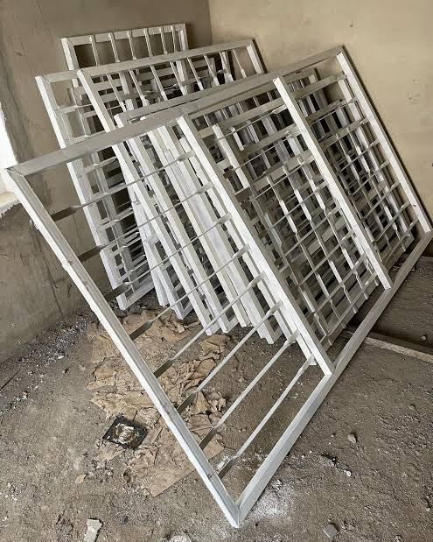

FIG.2: LOBBY BURGLARY

(ii) MEASURING OF MILD STEEL: This involves the measurement of 16mm mild steels iron to prescribed lengths as shown in the detailed diagram. It was done with the aid of a measuring tape.
(iii) CUTTING OF MILD STEEL: Mild steal were cut in accordance with the prescribed measurement and designed values using hack saw.
(iv) WELDING: Using arc welding process where coalescence is produced by heating the work piece with: an electric arc set-up between a flux coated electrode and the work piece.

3.2. WELDING AND FABRICATION OF HAND RAIL
To fabricate a Hand Rail, some basic operations are carried out using the vice, hack saw, hand grinding machine.
The following were the steps followed during the welding and fabrication of the Hand rail :
(i) MARKING OUT: Before any fabrication and construction is carried out, marking out is first operation to be carried out so as to construct the exact size. The marking out was done on a 3x3 angle iron using a meter rule and the scriber.
(ii) CUTTING OPERATION: After the marking out, the next step is the cutting operation and it was carried by the use of the hand grinding machine.
(iii) WELDING OPERATION: Before welding was carried out, tackling was done for temporary fastening so as to have a correct figure, And then full welding was carried out on the four angles iron members using an electric arc welding to form a rectangular shape.
(iv) GRINDING OPERATION: This grinding operation was carried out using the hand grinding machine to smoothen the welded part in other to look fine and have a smooth surface.

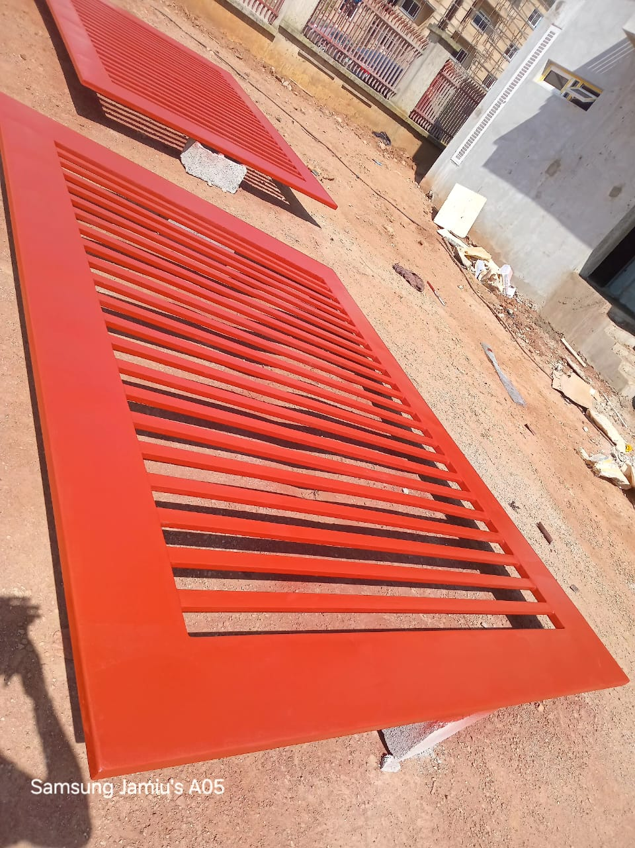

FIG.3: HAND RAIL

33: WELDING AND FABRICATION OF CAR PARK
(A) WELDING PREPRATION
(i) Properly setting up the frame before welding is critical to ensure the finished frame is squared.
(ii) Lay the head and the two jambs down on a level work surface with the material.
(iii) Assemble the frame and bend tabs on the jamb to lock the jambs to the head. Follow the manufacturer's instructions to determine which direction to bend the tabs. This is critical to ensure the proper door opening width.
(iv) Clamp the frame to the table for stability. Confirm the frame is squared and adjust as needed.
(v) Tack welding a shipping bar into the material of the frame to guarantee the opening width of the welded frame. For example, if the door opening is 3 feet, then the spreader bar should be exactly 3 feet.
(vi) Now the frame is ready for welding. Using the minimum amount of weld necessary, apply the face weld or full profile weld as specified.

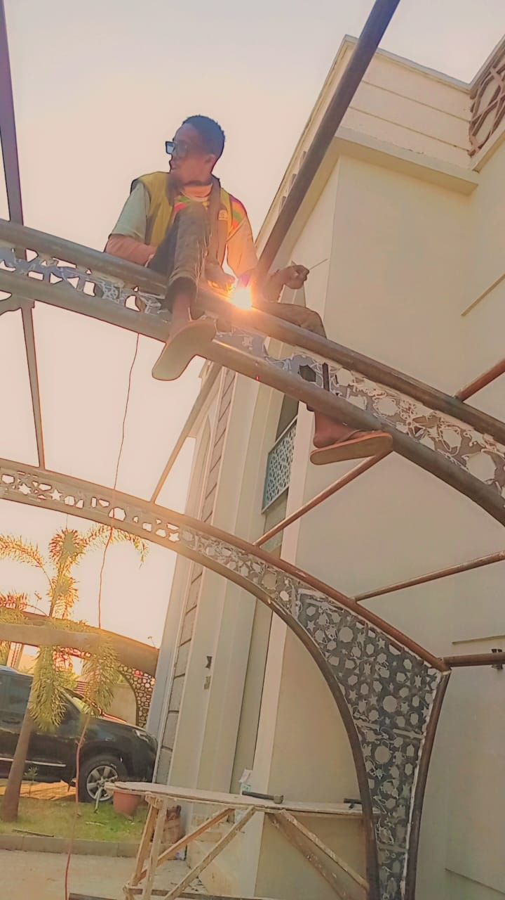
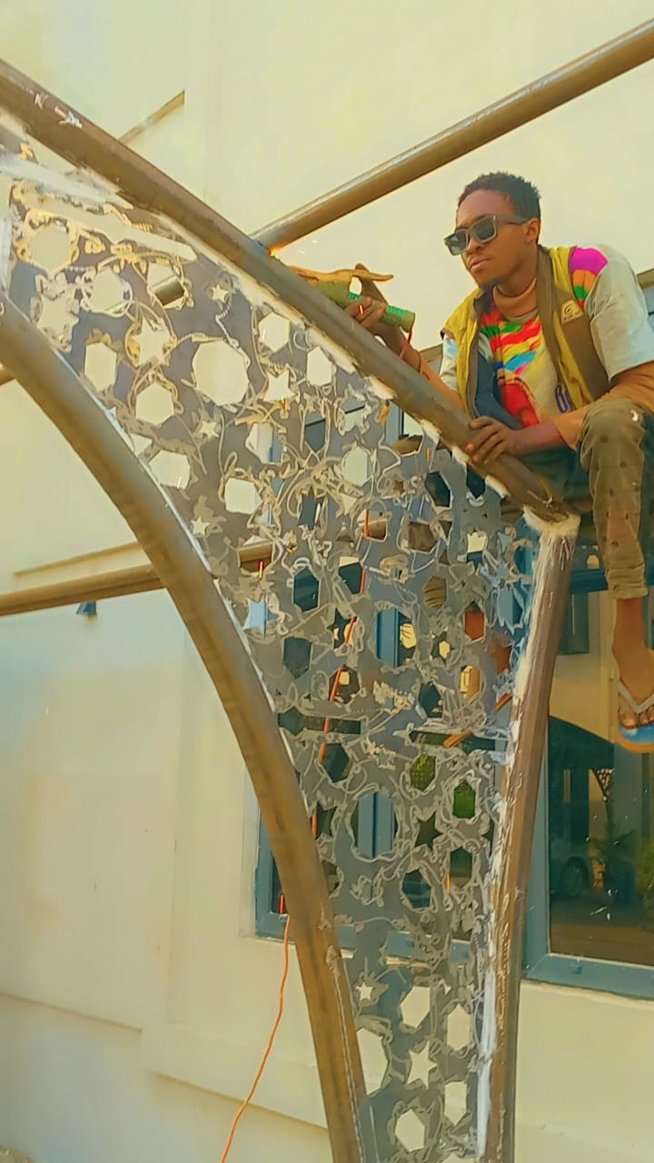

FIG.4: CAR PARK

(B) WELDING FINISHING
(i) Grind until the weld is level with the face of the frame.
(ii) File the edges smooth.
(iii) Finish with a DC sander.
(iv) The finishing process is completed and the frame is ready to be painted. After it was painted, a proper weld will give the frame a seamless appearance.

CHAPTER 4
EXPERIENCES GAINED
4.1 : EXPERIENCE ON ARC WELDING
In Arc Welding, awelding power isused to create and maintain an electric arc between an electrode and the base metal to melt at the welding point. In such welding process the power supply could be AC or DC, the electrode couldbe consumable or non-consumableand a filler material may or may not be added. The most common type of arc welding is Shielded Metal Arc Welding (SMAW).
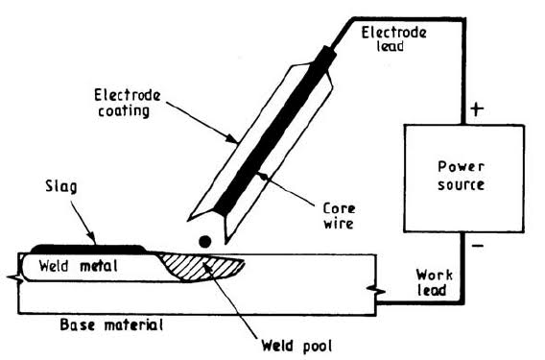

FIG.5: ARC WELDING

Shielded Metal Arc Welding (SMAW): A process that uses a coated consumable electrode to lay the weld. As the electrode melts, the (flux) coating disintegrates, giving off: shielding gases that protect the weld area from atmospheric gases and provides molten slag which covers the filler metal as it travels from the electrode to the weld pool. Once part of the weld pool, the slag floats to the surface and protects the weld from contamination as it solidifies. Once hardened, the slag must be chipped away to reveal the finished weld.

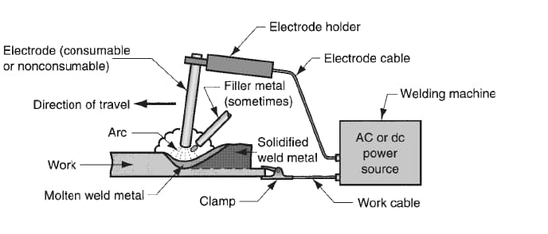

FIG. 6: PRINCIPLE OF ARC WELDING

4.2: EXPERIENCE ON WELD JOINTS
The weld joint is wheretwo or more metal parts are joined by welding. The five basic types o of weld joints are the butt, corner, tee, lap and edge.
BUTT JOINT: It is used to join two members aligned in the: same plane. This jointis frequently used l in plate work, sheet metal work and pipe work.
CORNER RAND TEE JOINTS: These joints are used to join two members located atright angles to each n other. In cross section, the corner joint forms an L-shapeand the tee joint has the shape of letter T.
LAP JOINT: This joint is made by lapping one piece of metal over another.

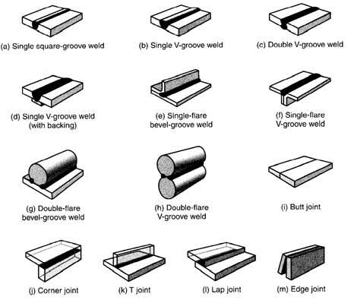

FIG.7: TYPES OF WELD JOINTS

4.3: EXPERIENCE ON MARKING OUT AND CUTTING OPERATION
MARKING OUT: Before any welding and fabrication operation is carried out,marking out is the first operation to carried out so as to fabricate the exact size.Try square and meter rule are usually used when marking out together withscriber.
CUTTING OPERATION: After the marking out, the next operation is cuttingoperation. Manually it is carried out using Hack Saw.
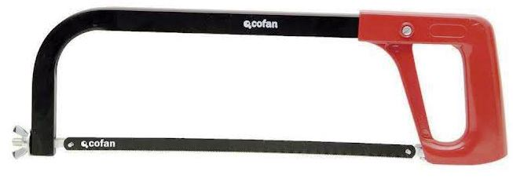

FIG.8: HACK SAN
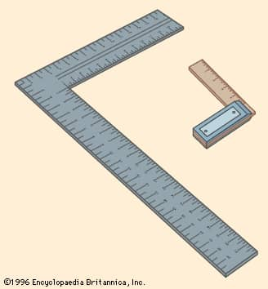

FIG.9: TRY SQUARE

CHAPTER 5
SUMMARY, CONCLUSION AND RECOMMENDATION
5.1: SUMMARY OF. ATTACHMENT ACTIVITIES
The four months SIWES program is an efficient and an effective programwhich has bring much improvement to me in my field of study. I have gained alot of f experiences from the various works done on field such as fabrication of Hand Rail, welding of Car Park as well as welding and fabrication of different set of Car Park.
It isa program that bridges the gap between theories and practical.therefore it has made me to have technical knowledge about what I have learnttheoretically in the classroom.
5.2: PROBLEMS ENCOUNTERED DURING THE PROGRAM
Despite the knowledge, experiences and exposures acquired during myfour months SIWES program, the following are some of the problems andchallenges I encountered:
(i) Difficulty in finding a place for industrial training is a big problem for students for SIWES program.
(ii) Another challenge is transport fare issues. After eventually getting acompany for the SIWES program, to finance my transport fare to my place ofwork is a very difficult experience.
(iii) The combination of the industrial training together with the course workwas so challenging and stressful.
5.3: SUGGESTIONS FOR THE IMPROVEMENT OF THE SCHEME
(i) I would suggest and strongly recommend that the establishment should begiving stipend to SIWES students.
(ii) I would also suggest and recommend that the establishment should providetransport facilities for SIWES students so as to ease their mobility.

REFERENCE
(i) Students Industrial Work Experience Scheme SIWES (2023).Students Manual la Practical Approach, Kwara State Polytechnic, Ilorin. Pp 2-5, Pp 17 and 26-27.
(ii) Students s Industrial Work Experience Scheme SIWES (2024).Training Logbook.
(iii) https://www.kwarastatepolytechnic.edu.ng/siwes (accessed onSaturday 4th of November, 2024 at 11:00 am)

