
A
TECHNICAL REPORT ON

STUDENT INDUSTRIAL WORK EXPERIENCE SCHEME (SIWES).

HELD AT
FABHULOUS INFORMATION TECHNOLOGY
Address: Line Wlk 3, Westend Market Kwarapoly, Ilorin Kwara State.
BY
SOLIU RIDWAN OLAMILEKAN
ND/23/PAD/PT/0674

DEPARTMENT OF PUBLIC ADMINISTRATION,
INSTITUTE OF FINANCE AND MANAGEMENT STUDIES,
KWARA STATE POLYTECHNIC, ILORIN.

IN PARTIAL FULFILLMENT OF
THE REQUIREMENT FOR THE AWARD OF
NATIONAL DIPLOMA CERTIFICATE.

AUGUST – NOVEMBER, 2024.
CERTIFICATION
This is to certify that this SIWES report was written by SOLIU RIDWAN OLAMILEKAN with matriculation number ND/23/PAD/PT/0674 undergoes her industrial training SIWES at FAHULOUS INFORMATION TECHNOLOGY. In partial fulfillment of the award of national diploma (ND) in Public , Kwara Polytechnic ,Ilorin undersigned by the following people:

DEDICATION
I dedicate this SIWE report dedicated to Almighty God, Mr. & Mrs. SOLIU for their spiritual and financial support during my SIWES program.
ACKNOWLEDGEMENT
My appreciation first goes to God almighty, the creator of Heaven and Earth for granting me the grace and privilege to be able to complete this SIWES program successfully and on schedule.
I also acknowledge the effort of my parent MR & MRS SOLIU and my siblings for their moral and financial support towards my success thanks very much for your unceasing prayer and advice.
Thanks and GOD bless you all.
TABLE OF CONTENT
TITLE
Pages------------------------------------------------------------------------------------- i
Certification.---------------------------------------------------------------------------- ii
Dedication.----------------------------------------------------------------------------- iii
Acknowledgement---------------------------------------------------------------------- iv
Table of content-------------------------------------------------------------------------- v
CHAPTER ONE
1.0 Introduction to Siwes-------------------------------------------------------------- 1
1.1 Aims and Objective--------------------------------------------------------------- 1
1.2 Importance of Siwes---------------------------------------------------------------- 2
1.4 Role of Student During Siwes--------------------------------------------------- 2
1.5 Objectives of the Report------------------------------------------------------- 2
1.6 The Logbook ----------------------------------------------------------------------- 2
CHAPTER TWO
2.0 Organization Chart------------------------------------------------------------------ 3
2.1 Brief History of The Establishment--------------------------------------------- 4
CHAPTER THREE
3.0 Introduction to Computer--------------------------------------------------------- 4
3.1 Introduction to MS-Word---------------------------------------------------------- 5
3.2 Introduction to Corel Draw-------------------------------------------------------- 7
3.3 Introduction to Photoshop ------------------------------------------------------ 11
CHAPTER FOUR
4.0 Knowledge Gained During the SIWES Exercise ------------------------- 16
CHAPTER FIVE
5.0 Conclusion ------------------------------------------------------------------------ 17
5.1 Recommendation.---------------------------------------------------------------- 17
References ------------------------------------------------------------------------- 18

CHAPTER ONE
1.0 INTRODUCTION TO SIWES
The student industrial work experience scheme (SIWES) Is a skilled training programme, designed to expose Nigerian students in tertiary institution to the realities of the work environment in Nigeria in their chosen profession so as to achieve the much needed technological advancement for the nation.
It exposes students to work method and techniques in handling equipment and machinery in the industrial sector, it provides an opportunity for the student to put in practice for the theoretical knowledge acquired.
The scheme is an effective instrument, which gives student studying occupational related courses, the experience that will supplement their theoretical learning industrial training is very important in life of every students because it has major role to play in their chosen profession
1.1 AIMS AND OBJECTIVES OF SIWES
- Provide an avenue for students in institutions of higher learning to acquire industrial skills and experience in their approved course of study and also by interacting with people more experience in the field under consideration.
- Prepare students for the industrial work situation which they are likely to meet after graduation.
- Expose students to work methods and techniques in handling equipment and machinery that are mostly not available in their various institutions.
- Provide students with an opportunity to apply their knowledge in real world situation thereby reducing the gap between theoretical knowledge and practical work.
- Enlist and strengthen employers’ involvement in the entire educational process and prepare students for employment in Industry and Commerce.

1.2 IMPORTANCE OF SIWES
The of the student industrial work experience scheme in any institution cannot be over emphasized. It's a means and platform through which what have been leant theoretically can also be learnt practically l, thereby preparing the student for their future employment. It gets the student exposed and interact with people they do not know
1.3 ROLES OF STUDENT
Attend SIWES orientation programme before going on attachment.
Comply with the establishment’s rule and regulation.
Arrange living accommodation during the period of attachment.
Record all training activity done and other assignment in the log book.
Complete SPEI from ITF, FORM 8 and get it endorsed by the employer for submission to the ITF.
1. 4 OBJECTIVES OF THE REPORT
The objectives of the SIWES report are;
- To make through explanation of the work done during my four month industrial training.
- To fulfill the requirement for national diploma in computer science.
- To contribute to the body of knowledge and to enhance the understanding of the writer about a similar or same job.
1.5 THE LOGBOOK
The logbook issued to student on attachment by the institution was used to record all daily activities that took place during the period of attachment, and it was checked and endorse by the industry based/institution based supervisors and ITF during supervision.

CHAPTER TWO
2.0 ORGANIZATION CHART OF GOODNESS GRAPHIC AND PRINTING
MANAGING DIRECTOR

ACCOUNTANT
ADMINISTRATIVE MANAGER
SECRETARY
ENGINEERS

INSTRUCTOR
SYSTEM ANALYSIST

IT/SIWES

2.1 BRIEF HISTORY OF FABHULOUS INFORMATION TECHNOLOGY
Fabhulous Information Technology is a private organization, established in the year 2016. It is owned and controlled by Mr. TiamiyuSaheed Adebayo.
It is a non-governmental organization in Kwara State. They operate graphic and printing at, westend market kwarapoly Ilorin, Kwara State.
Science academic training and skill acquisitions in nearly aspect of IT of some which include Engineering sector, Computer graphic and printing.
This company is head by the director and administrative manager next to him.

CHAPTER THREE
3.0 INTRODUCTION TO COMPUTER
A computer system be it micro, a mainframe or super computer consist of both hardware and software. It is an electronic machine capable of accepting data, process the data into a meaningful information as output. A computer is a machine or tool, which is capable of:
1. Taking input data
2. Storing the input data.
3. Processing the input data.
4. Producing the output report on paper or computer store for human being to use
The term computer is obtain from the word compute. A computer is an electronics device that inputs (take in) facts (known as data) and then processes (does something to or with it). Afterward
INTRODUCTION TECHNOLOGY
In simple language, information technology (I.T) is the overall technical where withal required for an efficient gathering, storage, processing utilizing computers, the internet and other electronic tools like camcorders, mobile or cell phone etc.
INPUT AND OUTPUT DEVICES
Some of the Input Devices include:
1. Keyboard
2. Joystick
3. Mouse
4. Electronic pen
5. Track ball etc.
Output Devices Include:
1. Printer
2. Monitor (VDU)
Plotters
PART OF A COMPUTER
There are two main parts of computers, hardware and software.
HARDWARE: are all part of computer he computer you can see and touch or visible part of a computer which means is the physical device one can see and touch the range from the smallest of chips to the total unit called computer system.
SOFTWARE: are list of instructions needed by a computer to perform specific tasks. Software is often called a programmer, most times they are compilation of codes written in specific language i.e. jargons and conventions developed by man to achieve certain ends. There are types of software such as utility software, application software etc.
CONNECTING COMPUTER TO POWER
This is very crucial and never learn it by trial. Let a competent technician demonstrate it to you.
Truth however is that it is as simple as connecting a video player and television set to themselves and then to power. Once the technician has demonstrated this at least twice-then you are good to go. The use of inverter and stabilizer for any computer is recommended, because of power fluctuation.
3.1 INTRODUCTION TO MICROSOFT WORD.
Microsoft word is the typing, editing, storing, and printing of texts through an electrochemical device called computer. It can also be define as the act of manipulation characters to create a professional looking document through the computer.
Some important keywords in the definition
- Typing: This is done by using the keyboard .The keyboard as it is known as input device. It has about 108 keys on it. There are five part of the keyboards namely: function keys e.g. f1-f12, computer keys e.g. Esc, ctrl, shift, e.t.c Typing keys A-Z, Dedicated keys e.g. page up, page down, Arrow keys and Numeric keypad.
- Editing. This is the act of correcting error (s) in a document. It is also involves rearranging the document so as to give a perfect, desire, and professional.
- Storing: This is the same thing as saving a document into the permanent memory so as to able to re-call it any other time. It is needed .this should always be done frequently so as to guide against frequently power failurewhich can shutdown the computer and erase any file that has not been saved.
- Printing: This is the act of getting the hard copy or the soft copy of the
document through a device called a printer using paper.
Loading (Starting Microsoft Word)
- Put on the computer and allow it to boot up and display the windows environment or desktop.
- After booting, click on the start button.
- Move the mouse to all programs
- Select Microsoft Word
- Wait for the loading.

Command keys used in Microsoft word
- Ctrl A - Select all
- Ctrl B - Bold
- Ctrl C - Copy
- Ctrl D - Font
- Ctrl E - Center alignment
- Ctrl F - Find
- Ctrl G - Go to
- Ctrl J - Justify
- Ctrl L - Left Alignment
- Ctrl N - Open new document
- Ctrl O - Open existing document
- Ctrl P - Print document
- Ctrl R - Right Alignment
- Ctrl S - Save document
- Ctrl U - Underline
- Ctrl V - Paste
- Ctrl W -Close document
- Ctrl X – Cut
- Ctrl Y – Redo
- Ctrl Z- Undo
3.2 INTRODUCTION TO COREL DRAW
Corel drawer is a vector graphic, edited, developed and marketed by Corel. Corel draw is one of the most popular graphics programs and gives designers a most rewarding and enjoyable work experience. It is built and design to meet the day to day demands working designing work.
Opening Corel draw
- Switch on the computer and take the following step
- Go to start and select program from the list
- Find the Corel section and select Corel Draw.
- Choose Open Graphic for the old design. New Graphic creates a new, one page document. Template allows access to professionally created templates from the library.

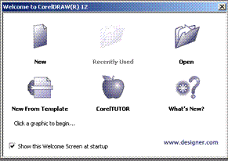

Component of Corel Draw
- Title Bar
- Menu Bar
- Property Bar
- Tools Box
- Ruler
- Drawing Page
- Drawing Window
- ColourPallete
- Docker
- Statue Bar
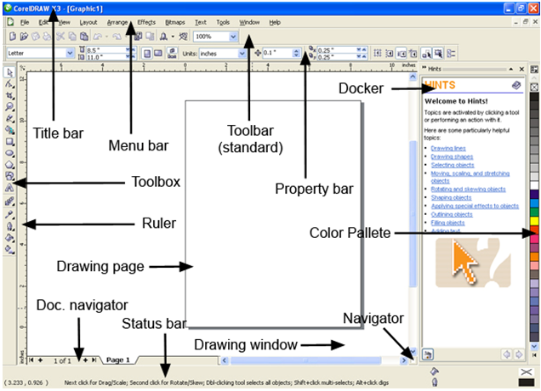

Tools Overview
The tools box is located in the left portion the window and contain all drawing and editing tools necessary to create object for an illustration. Tools containing a small triangle in the corner produce a fly out. These are describe as

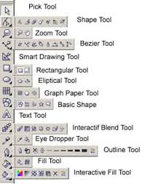

- Pick Tools :Pick tools select objects. Once selected. You can use the Pick Tools to move, stretch, scale, rotate, and screw object
- Shape Tools: it is used for reshaping object by moving the nods, lines and control point
- Zoom Tools: Zoom Tools changes the current view of the drawing
- Free Hand Tools: it is used for drawing lines and curves. You can also use this tools to trace bitmap.
- Smart Drawing: it is used to convert the freehand strokes you draw to basic shapes and smoothed curves.
- Rectangle Tools: To draw rectangle and square. Square are created by using the control key while drawing.
- Ellipse Tools: To draw ellipses and circles. Circle are created by holding down the control key as you draw.
- Graph Paper: it is used to draw a collection of boxes that stimulate a sheet of graph paper
- Perfect shape Tools: Is a collection of objects, which you can add to your drawing
3.3 INTRODUCTION TO ADOBE PHOTOSHOP
Adobe Photoshop is a popular image editing software that provide a work environment consistent with adobe illustrator, Adobe in design Adobe Photo shop and other products in the adobe Creative Suite.
Getting Started
- Begin by opening adobe Photoshop
On a PC, click start>Programe>Adobe>Photoshop
Setting Up a Document
Setting up your document correctly from the start will make easier as you work through your project. This will require some advanced planning. For example, if your final output will be a brochure, you may need to set up your document to be horizontal and double sided.
To create a new document, click File>New. This will open the new document setup dialog box
Here you will able to name your file, set up the correct page size and orientation or your document options include, but are not limited to:
- Page Size and Orientation
Change the page size by typing in new value in new values for width and height page size represents the final size you want after bleeds or trimming other marks outside the page. In the present dropdown menu you can find such common size as Letter, Legal, Tabloid etc. typing in exact value for height and width gives you more control over the size and orientation of your page
- Resolution
Resolution is the number of pixels on a printed area of an image. The higher the resolution, the more pixels there are on the page, the page, the better the quality of the image, However high resolution increase the size of the file. The standard recommended resolution for printed image is 150-300. For web image is 72
- Colour Mode
Choose a colour mode that will best fit your project. For example , when making a graphic for a web site, choose RGB, when making an image for print choose CMYK
- Background Contents
Choose the background: white colour or transparent. When you have entered all of your document settings, click Ok
Photoshop Interface
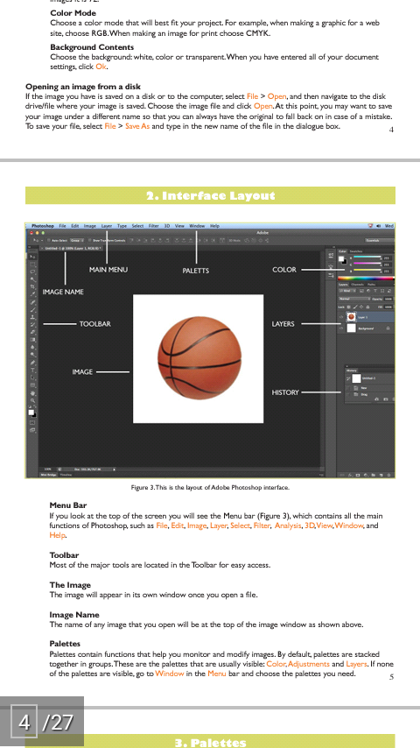

Menu Bar: If you look at the top of the screen you will see the Menu bar which contain all the main functions of Photoshop, such as File, Edit, Image, Layer, Select, Filter etc.
Tools Bar: The most major are located in the Toolbar for easy access.
Image Name: the name of any image that you open will be at the top of the image window as shown above.
PALATTERS
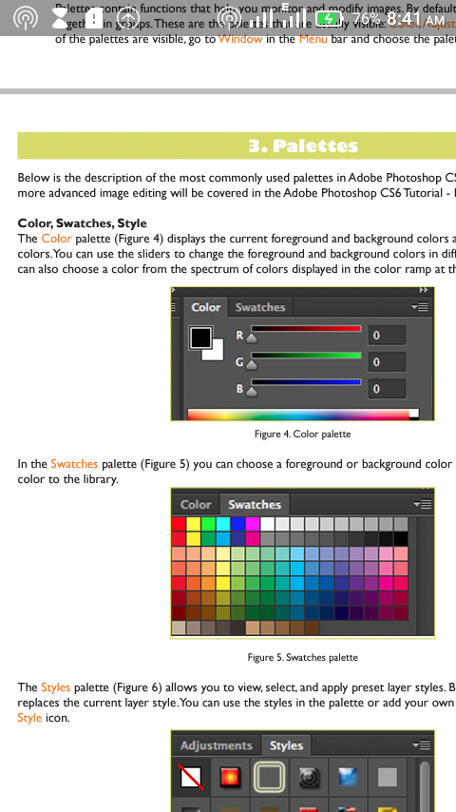
Colour Swatches Style

Swatches

Style

SAVING
Remember to save your work often, saving frequently lesson the risk of losing the work you have been doing
To save your Photoshop document, do the following
- Click File>Save As.
- Navigate to the place you would like your document to be saved by using the drop down menu and the navigation window.
- Enter the name of your document in the save as text field.
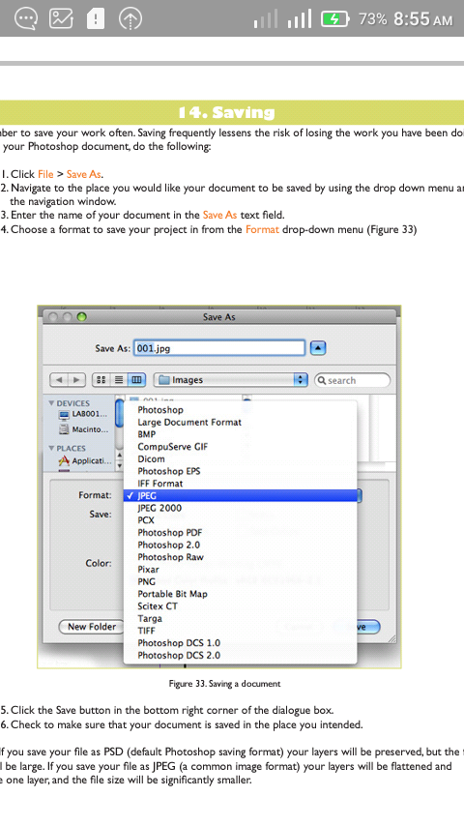
- Choose a format to save your project in from the format drop down menu.

- Click the save button in the bottom right corner of the dialogue box.
- Check to make sure that your document is saved in the place you intended.
CHAPTER FOUR
4.0 KNOWLEDGE GAINED DURING THE SIWES
The student industrial work experience scheme (SIWES) exercise has contributed greatly in my academic carrier, because I have gain some experience which is very useful to my field of study. The first advantage acquire during my industrial training programme was that i was taught computer component i.e. hardware and software, how to launch computer packages such as; Ms Word, Corel Draw, and Photoshop
Finally, my perception about office profession has been greatly widely broaden. It gives me the opportunity to gain first experience of the profession even though it was not easy.

CHAPTER FIVE
5.0 CONCLUSION
The SIWES program expected to be undergone by all students in the school of applied science in all tertiary institution in Nigeria.
I therefore deeply appreciate the industrial training of my school (Kwara State Polytechnic, Ilorin). For involving themselves in such a worldwide program. The importance of this training cannot be over emphasized industrial training by some operations carried out during the program.
5.1 RECOMMENDATION
I like to use this medium to explore the federal Government at all stage to take this SIWES program more seriously seen by the students of applied science as a virtual improvement in future of technology in our nature.
Government should also ensure a proper supervision of SIWES student so that the purpose of the programme will be achieved.
The federal Government should make adequate provision in the annual budget for proper funding of SIWES in view of the potential of the scheme to contribute to enhancing the quality of the pool to technical skill available to the economy.
A comprehensive and detail directory of employer who accept students for SIWES is urgently required to facilitate placement of student in industry.
In order to guarantee quality assurance of institution and the ITF. The ITF should ensure that the backlog in payment of students allowance is cleared urgently to remove the negative image being created for SIWES.

$

