

A TECHNICAL REPORT ON
STUDENT INDUSTRIAL WORK EXPERIENCE SCHEME (SIWES)

HELD AT
MINISTRY OF WORKS AND TRANSPORT
ILORIN, KWARA STATE

PRESENTED BY:

AYENI KEHINDE OLUWASHOGO
ND/23/CEC/PT/0158

DEPARTMENT OF CIVIL ENGINEERING, KWARA STATE POLYTECHNIC, ILORIN, INSTITUTE OF TECHNOLOGY

IN PARTIAL FULFILMENT OF THE REQUIREMENT OF THE AWARD OF NATIONAL DIPLOMA IN CIVIL ENGINEERING

AUGUST-NOVEMBER 2024
PREFACE
The SIWES programmed was introduced into the nation’s tertiary education system particularly science course student because of the belief that the general education would help student to acquire on their understanding of society and the place of the individual intervals.
It is in the light that the general studies programmes for polytechnic engineering student in Nigeria in the NBTE syllabus are aims to produce.
- To produce the students to proud of its antecedent.
- To make a citizenry conscious of its role in a wider would
- To make the student prepare for effective leadership role in the diversified field in the society.
And also this thereby is to ensure the positive contribution to the national intervention and greatness, and also the expectations if will serve as a means of inculcating of the idea of national loyalty and understanding that based on the awareness of the nation’s roof and cultural antecedents and it will enable the student to come to grips with our morals, national aspirations, values and problems.

DEDICATION
I dedicate this report to Almighty God for given me the wisdom, privilege, knowledge and understanding to participate in the student industrial work experience scheme (SIWES) programme.
I also dedicate it to my lovely parent MR & MRS. AYENI for their moral and financial support during the courses of the programme, May Almighty God continues to bless you Amen.

ACKNOWLEDGEMENT
I acknowledgement grateful with sincerity the most high God he has been in all ways faithful caring, providing sustaining, guarding and just so good to me. Glory honour and adoration be onto Almighty God.
My unalloyed thanks and appreciation to my parent, MR and MR AYENI for their financial and spiritual support, and also the entire family of AYENI for their care and support that has been driving me throughout the duration of my training.

TABLE OF CONTENT
Title Page i
Preface ii
Dedication iii
Acknowledgement iv
Table Contents v
CHAPTER ONE
1.1 Background of the SIWES 6
1.2 Objectives of SIWES 6
1.3 Organization 7
CHAPTER TWO
2.0 Hazard in construction sites 8
2.1 Basic hand tools and equipment 8
CHAPTER THREE
3.0 Student involvement at various unit 16
3.1 Experience Gained During the SIWES Programe 16
CHAPTER FOUR
4.1 Identification of Plants and their Uses 13
4.2 Some Terminologies in Road Construction 17
CHAPTER FIVE
5.1 Personal Impression about the Ministry 19
5.2 Recommendation 19
5.3 Conclusion

CHAPTER ONE
1.0 INTRODUCTION
1.1 Background
The student industrial work experience scheme (S.I.W.E.S.) is a skill development programme initiated by industrial training fund (I.T.F.) in the year 1973 to solve the problem of lack of adequate practical skills preparative for employment in industries by Nigerian graduates of tertiary institutions.
The student industrial work experience scheme (S.I.W.E.S.) was also founded in order to expose students to industry based skills necessary for an easy transition from the classroom to the world of work, which enables students to be exposed to work methods and techniques in handling equipment and machinery that may not be available in their institutions
The scheme started with 784 students from 11 institutions with 104 suitable courses at inception in 1974.The number of students that participated in SIWES from universities, polytechnics and college of education at the end of the year 2007 was 194,890. In the year 2008, the number of the students that participated in the scheme increased to 210,390 students with over 112 suitable courses from 219 institutions.
1.2 Objectives of S.I.W.E.S.
- To provide an avenue for students in the Nigerian universities to acquire experience and industrial skills during their course of study.
- To prepare students for the work situations they are likely to meet after graduation.
- To expose the students to work methods and techniques in handling equipment and machinery that may be available in their institutions.
- To provide students with an opportunity to apply their theoretical knowledge in real work situation thereby bridging the gap between theory and practice.
- To allow the transition phase from school to the world of working environment easier and facilitate students contact for later job placements.

2.3 Organizational structure

CHAPTER TWO
2.0 HAZARDS IN CONSTRUCTION SITES
The first to be taken into consideration in a construction site is personal safety and accidents on sites interest and attention, tiredness, carelessness, slip shod method and congestion of sites e.t.c
It is therefore advisable for construction workers should be guard against these attitude by the following way;
i. Arranging of materials safety in a working area.
ii. Using tools safety.
iii. Using ladders safety.
iv. Lofting of object safety.
v. Avoid careless drop page of materials.
vi. First aid treatments.
2.1 Basic Hand Tools and Equipment
Tools consist of both hand or manually operated and few related power driven equipment, which are specifically designed to meet the nature of work involved in different operation on the building sites.
The quality of work done to some extents depends on the condition and quality of the tools used.
Some various Hand Tools and Equipment are:
- Saw
- Hammer
- Hacksaw
- Tongs
- Electrodes
- Head pan
- Wheel Barrows
- Shovels
- Bar Bender
- Springs
- Bar
- Pinches & Pincers
- Tape Rule
- Steel Tape
- Digger
- Hand Trowel
- Range
- Plumb or Spirit Levels
2.2 Cement
Cement is one of the important bonding agent (binder) used in building industry. The most popular and common types of cement in Nigeria and around the world is the PORTLAND CEMENT. Portland lime stone quarried on the site of Portland. It was first produced in England in 1824 by a bricklayer called Joseph Aspinding. Portland cement usually sets when its hydrated.
Cement is produced from two major materials namely:-
- Clay or shale (refers as silicious materials)
- Limestone or chalk (refers as calcerous materials)
TYPES OF CEMENT
- Water proof & water repellent Portland cement
- White coloured Portland cement
- Ordinary Portland cement
- Low heat Portland cement
- Hydrophobic Portland cement
- Sulphate resisting Portland cement
- Rapid hardening Portland cement
- Utra-high early strength Portland cement
- Super sulphate cement
- High alumina cement
- Air-entraining Portland cement
- Pozzolanic cement – resistance to chemical attack
- Portland blast furnace
2.3 Preliminary Site Works
Choice of the Site
This is the duty of the client in most cases. In selecting a building location the client should keep in mind the following question is it for commercial or residential purpose? Is it a public or private building?
Planning the Sites
After the site had been identified, the builder or the contractor must outline the basic things he must put in place before the commencement of the actual projects.
Site Clearing
Before construction works begins, the site must be cleared off plants, shrub, bushes, trees and other objective materials present on sites. If it is an old site the structure must be demolished and the materials must be completely from site or reduce to debris use as hard cores.
Hoarding
It is always advisable to secure the building site by erecting temporary high fencing around the site to prevent unauthorized entering of the sites.

Bearing Capacity of the Soil
This are soil tests which are to be carried out on site before choosing the suitable foundation in which the soil capacity can withstand before designing and construction could take place
2.4 Setting Out
This is the process of marking out the physical features that appears on engineering plans with pegs, lines and tapes. In setting out, the exact position of the foundation trenches which will carry the entire walls of the building are properly located on the ground, true dimension and squareness as specified in the building plan.
Setting Out Equipment
- Measuring Tape: This is used for measurement. For accuracy the tape must be properly checked before use.
- Profiles: When setting out a building, it is adviceable to secure the lines so that they are well clear of the building liens which consist of pegs driven into the ground and boards nailed across them. The lines can then be stretched above the ground.
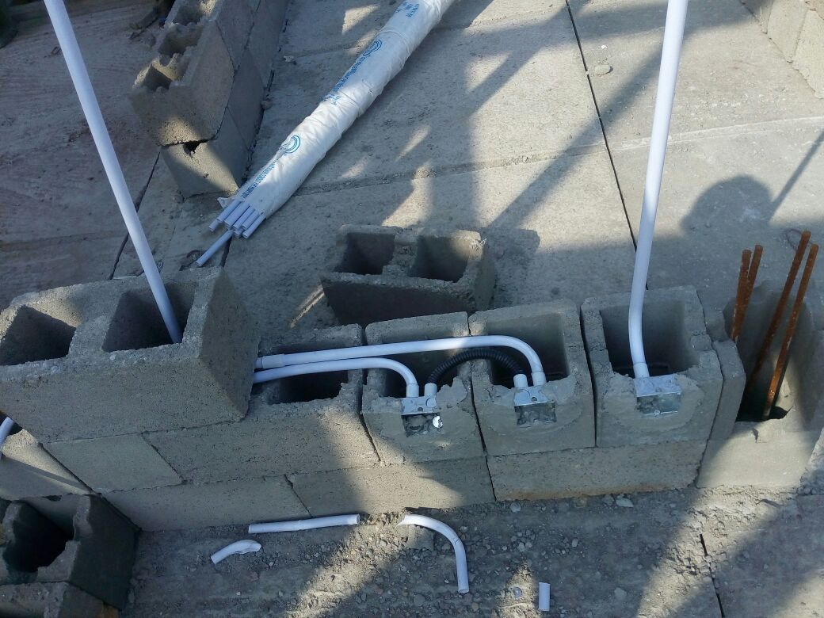
- Datum Level: After checking the accuracy of the line the next is to determine a basic level in which all the measurement for the building to be erected on the site can be taken.

Excavation
This can be carried out in 2 ways:
- Manually for a small residential building with shallow foundation trenches
- Mechanically for deeper trenches for industrial building or series of building which cannot be effectively done by hand.
Tools Required for Manually Excavation Includes
- Digger
- Shovel or spade
- Hammer or chisel
Machines Required for Mechanical Excavation
- Excavator
- Grab
- Face or Back Shovels
- Trenching Machine
- Anger
- Truck Dumper
- Compressor/Jack Hammer
2.5 Foundation
Foundation: This are the lowest parts of a building, they can be in form of stone, concrete, or steel, although the most common materials in modern construction is the concrete.
The purpose of foundation is to support the building, transmitting the weight of the building, both live and dead weights to the sub-soil without failing as the building lasts.
The building regulation (British 1978) states that foundation must;
- Safety transfers all loads (dead imposed and wind) to the ground without any applicable settlement which could cause damage to the structure.
- Be taken down – soil movement level.
- Be resistant to attacks by sulphate or other deleterious matters found in the soil.
Types of Foundation
- Strip Foundation
- Raft Foundation
- Pile Foundation
- Pad Foundation
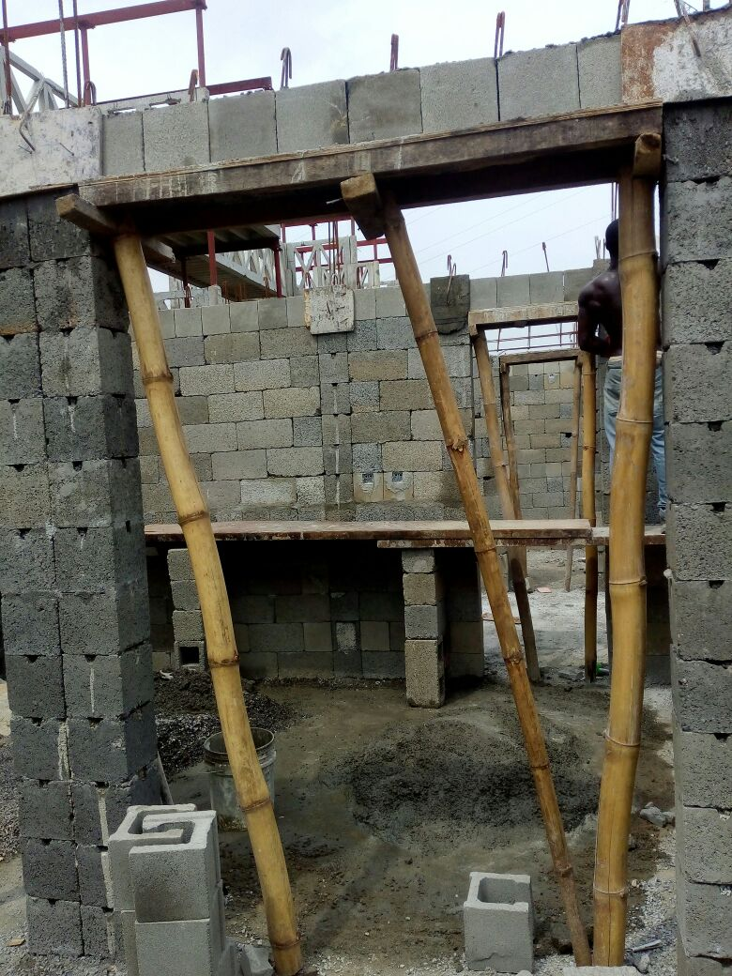

2.6 Structure
Structure was defined by DrayCott and Bitumen A as an organized combination of connected parts designed to carry loads and provide adequate rigidity.
Types of Structure
- Rigid Frame: This is a type of structure in which the members are joined together by rigid joints
- Truss (Pin connected joints): This is a type of structure which is formed by members in triangular form, the resulting figure is called a joints. In truss, joints are pin connected and loads are applied at joints. There is no shear force and bending moment is producing only axial compression and axial tension is to be determined while analyzing a truss.
2.7 Structural Members
Beam: This is a flexure member of the structure. It is subjected to transverse loading such as vertical loads and gravity loads.
Classification of Beams Based on Support
- Simply Supported: This is a beam supported at the ends which are free to relates and no moment resistance.
- Fixed: A beam supported at both ends and is restrained from rotation.
- Over Handing: A simple beam extending beyond its support on one end.
- Double Over Handing: A simple beam with both ends extending beyond its supports on both ends.
- Continuous: A beam extending over more than two support.
- Cantilever: A projecting beam fixed only at one end.
- Trussed: A beam strengthened by adding a cable or rod to form a truss.
Types of Beam
- Surface Beam: This are the visible beams
- Inner Beam
General Shapes of Beams
Most beams in reinforced concrete building have rectangular cross sections, but a more efficient cross section for a beam is I or H section which is mostly seen in steel construction.
Column
A column is an upright pillar or post which is subjected to horizontal loads. Columns may be used to support roofs, beam and they can be purely decorative.
Column Structure
A column has three:
- The Base: Most column rest or square base.
- The Shaft: This is the main parts of a column and it may be smooth, fluted (grooved) or carved with designs.
- The Cartal: This is top of the column and may be simple elaborately decorated.
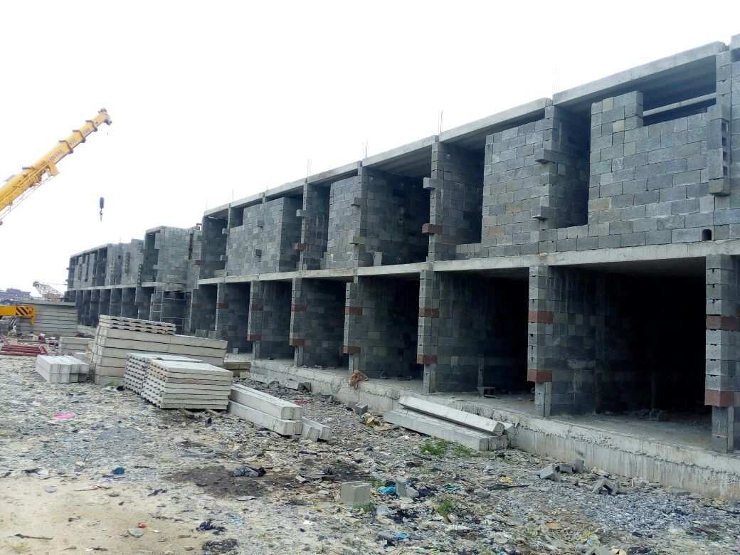
Slab
This is a large, flat, usually made with concrete, wood or other solid materials. It is either in rectangular or square shape.
Spanning Determination of Slab
The spanning of slab has one way, two ways or cantilever which depends on the following conditions.
- If Ly/Lx > 2.0, Slab is considered as one-way
- If Ly/Lx < 2.0, Slab is considered as two – way
- If slab is unsupported along edges it is referred to as cantilevered slab
- And spanned towards the fixed end when spanning and the slab is one-way spanning to the shortest distance.

CHAPTER THREE
3.0 STUDENT INVOLVEMENT AT VARIOUS UNITS
During my Two months SIWES programme at Ministry of Works And Transport, Ilorin Kwara State. I was made to understand the following aspect of construction:
- Provision/ supply of street light and all their installation
- Excavation of unsuitable material (laterite) from the surface of the road.
- Road construction such as, drainage as well as priming.
- How to determined or measure the center line of a road.
Also during my SIWES programme I was made to understand the various type of machine such as roller, grader, bulldozer, excavator etc. and I also made to understand some of terminologist used in road construction when they working on site.
3.1 EXPERIENCE GAINED DURING THE SIWES PROGRAMME
At first stage, I was involved in civil engineering construction unit and I was made to understand civil engineering terms and works such as construction of road, culvert, field drain and excavating unsuitable topsoil from the surface of the road.
ROAD CONSTRUCTION
This aspect give brief method of road construction, the road has different theories due to different number of vehicle that moves over it e.g. highway cannot compare to estate road.
COMPONENT OF ROAD
- Carriage way: This is designed mainly to allow vehicle to pass through different direction and also allow vehicle to move to and fro. The standard thickness of carriage way is 3.5meters.
- Shoulder: This is place along a particular road that is designed mainly for car-park and the thickness is 3.0meters.
- Lay-bye: This place beside a particular road that is designed mainly for resting and is normally located at both side of a road.
- Drainage: This is usually designed and located at both of a road in order to ensure the easy flow of water and also carries waste water from the surface of the road and the thickness is 2.0meters.
- Culvert: This is usually located at a place where the runoff is usually occur in a road and is used to cross the passage of running water.
- Kerbs: This is a line that is mainly to divide a road into two equal parts.
INSTRUMENT USED IN ROAD CONSTRUCTION
- Bulldozer: This is used mainly for the clearing of site.
- Asphalt paver: This is used mainly for laying of asphalt on the surface of the road
- Roller: This is use mainly for compaction of a road
- Excavator: This is use mainly to dig out the earth work for drainage purpose
- Pail loader: This is use for loading material like granite in to construction site
- Linear tape: This is use mainly for measurement of linear distance along the surface of the road
- Water tanker: This is use mainly for carrying water and use it to wet the surface of the road
- Dumper: This is use mainly for carry unwanted material away from the construction site
- Grader: This is use mainly for spreading of suitable material on the surface of the road
- Bitumen sprayer: This is use mainly for spreading of bitumen on the surface of the road.
STAGES IN ROAD CONSTRUCTION
Bush clearance and felling of trees: the first sequence in road construction project is site clearance which involves bush clearing, felling of trees and removal of stumps. The approach of clearing the site involves the use of earth moving machine like the bulldozer which is use to clear the site of trees and stump by pushing the tree, while the rooter or ripper is use to fell down trees and scraper is use to pull out stump.
Sub-grade
This is a process of clearing of site and removal of top soil; this can be done by using of earth moving machine like grader and bulldozer. This is also known as formation level i.e. removal of top soil
Sub-base
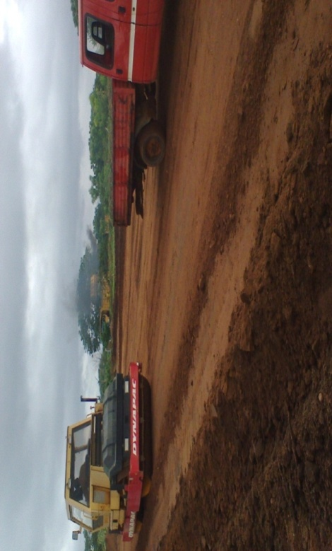
This is the layer laid directly after the formation level (subgrade) and is normally laid when the bearing capacity of the sub grade is not likely to withstand the load.

Base course
This is the process of transferring suitable material like laterite from the Borrow pit to the construction site and levelling using grader and compaction using roller, wetting of the soil is necessary before compaction to avoid void, base course may be laterite or stone base (macadam)

Borrow pit
This is a place or an area which is usually located within the construction site where suitable material (laterite) is being pack by the pail loader and transfer to the construction site for construction purpose
Priming
This is the first single coat or primary coat of the liquid bitumen of low viscosity given upon the untreated surface of laterite or gravel as a requirement before placing of bituminous pavement on the surface of the road.
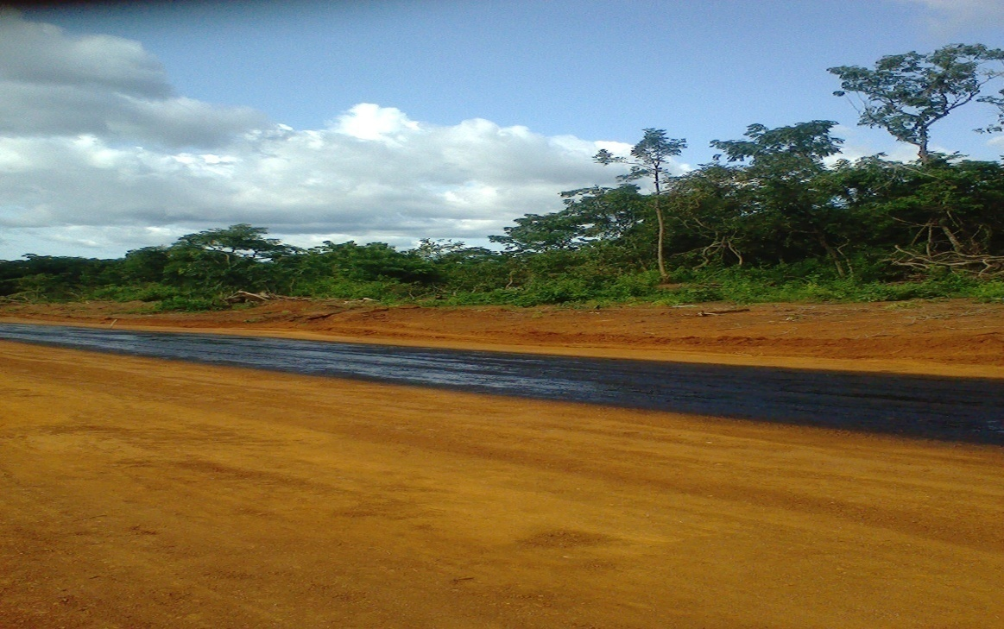
Purpose of priming
- Hardening and toughening the surface
- To halt upward movement of water
- To coat and bind dust the road surface
- To improve the adhesion between the and the surface course

PROCESS IN ROAD CONSTRUCTION
FIELD COMPACTION
This is usually done after the surveyor have levelled the road by using levelling instrument like levelling staff, ranging pole, measuring tape, total station etc. The surveyor will now tell the engineer whether the road is to level or not, but if the road is to levelled engineers will make use of grading machine to spread the suitable material to the surface of the road i.e. to level the road with a laterite and after that engineer will also make use of water tanker to wet the surface of the road with water and the road will now be compact with a rolling machine and rolling should begin at the edges not at centre of the surface of the road for the road to be well compacted.
SCARIFICATION
This is a process whereby a suitable material (laterite) is use to level the surface of the road when it not well levelled by using grader and roller for compaction in order to make the road camber.
Camber: This normally constructed on the surface of a road by raising the centre line of carriage way with respect to the edges forming the highest point at the centre and it is also refers to slope of line joining the crown and edges of the road surface together. This constructed mainly for quick draining of rain water from the surface of the road.

CHAPTER FOUR
RELEVANCE OF EXPERIENCE GAINED TO FIELD OF STUDY
The experience I gained which is related to Civil Engineering are as follows:
- Identification of plants/equipment and their uses.
- Some terminologies in road construction.
4.1 IDENTIFICATION OF PLANTS AND THEIR USES
- Excavator: It is a heavy construction equipment consisting of a boom, stick, bucket, and cab on a rotating platform known as the house. It is used for: digging of trenches, material handling, demolition, river dredging, etc.
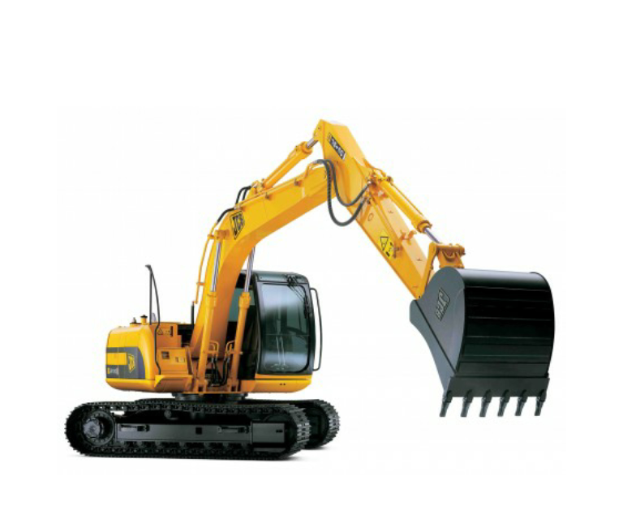

- Crane: It is a type of machine that is generally equipped with a hoist, wire ropes or chains, and sheaves, that can be used to both lift and lower materials. It is mainly used to lift heavy things, and transport them to other places.
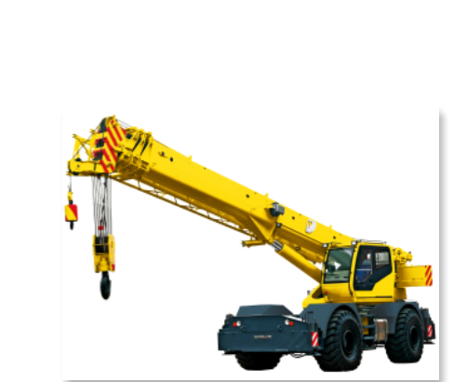

- Pay Loader: it is a heavy machine used in construction to move aside or load materials such as demolition debris, gravel, sand, dirt, etc.
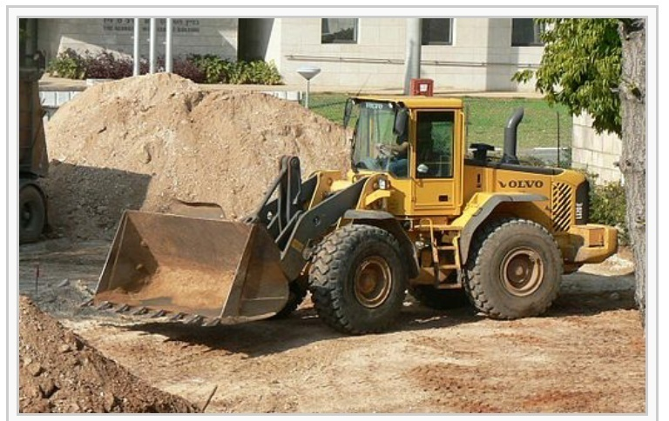
- Truck: It is use for various hauling operation.
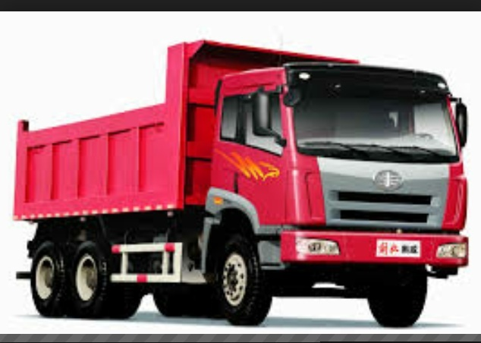
- Grader: It is use for cutting the slope of an embankment for smoothing grade level, and for spreading loose materials.
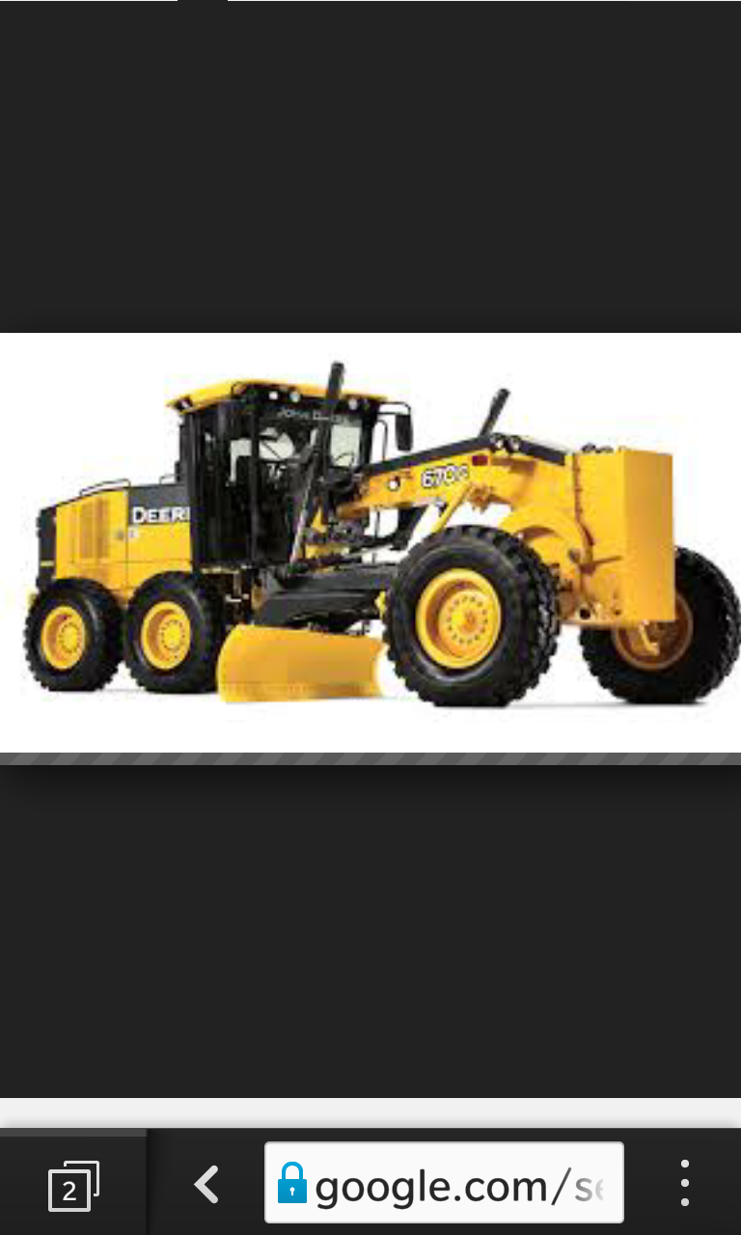
- Bulldozer: It is use for the demolishing of existing structures and also use for clearing a virgin land in preparing for construction.
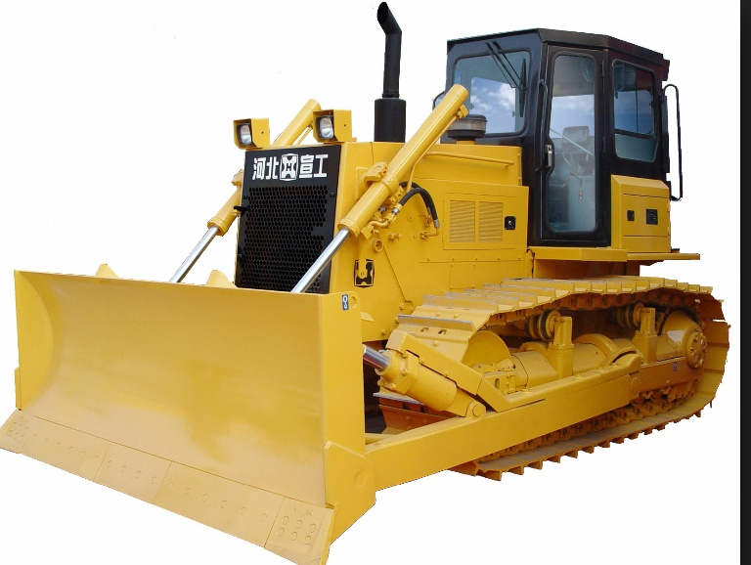
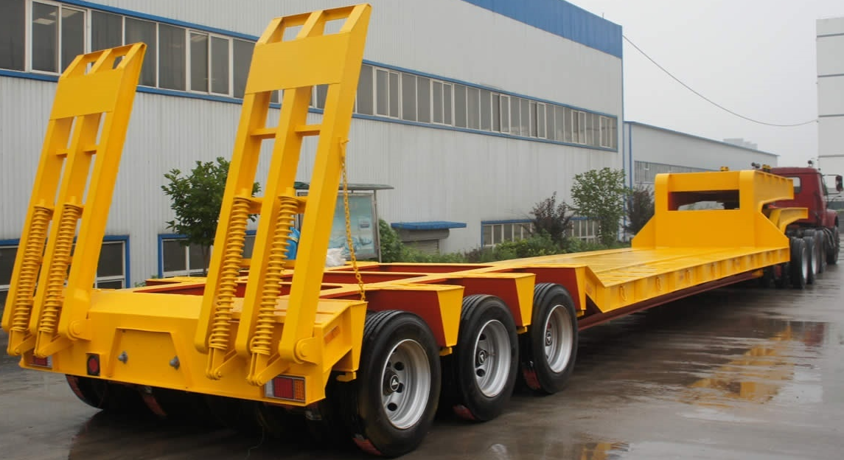
- Low Bed: It is use to transport machines from one place to another.

- Hand Concrete Mixer: It is used for mixing concrete at a stationary position.
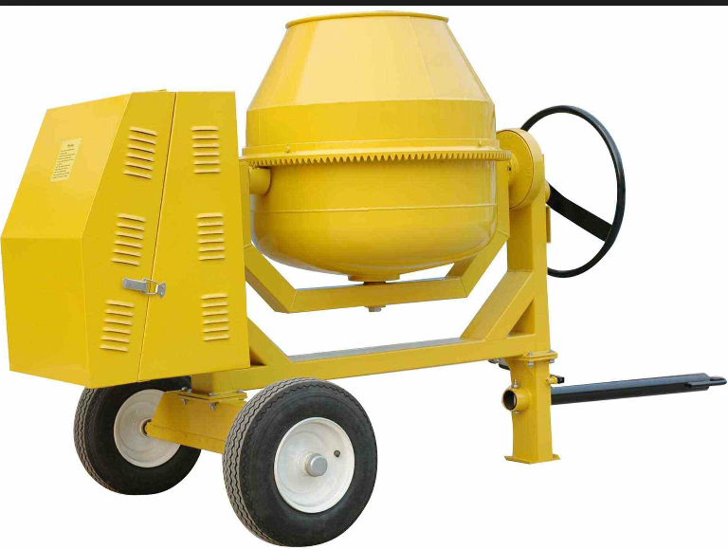
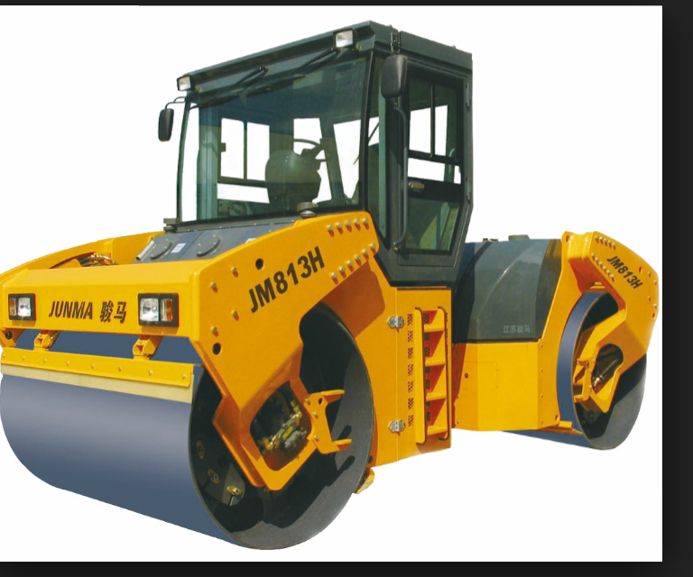
- Vibrating Roller: It is use to compact soil and also roll on asphalt during lying

- Tar Boiler: This is used for heating/ boiling tar for road construction.
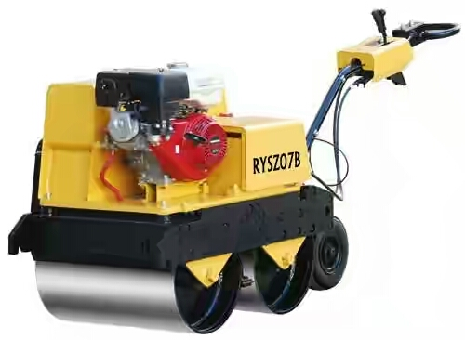
- Hand Roller: This is used for compacting soil and rolling on asphalt.

  - SOME TERMINOLOGIES IN ROAD CONSTRUCTION
Aggregate base course
This is the layer of material immediately underneath the pavement, it may be composed of crushed stone and gravel or the combination of this material to provide the service intended, it maybe uniform to provide the service.
Alignment
This is the horizontal and vertical location of the road.
Alternate route
To provide another way for easy movement.
Bitumen
Natural asphalt or substances found in a natural state of residual bi-product from petroleum refinery. Most bitumen contains sulphur, several heavy metals such as nickel, lead, chromium, mercury and other tonic element.
Traffic
Is the congestion of vehicle on the road
Average daily traffic
This involves the measurement of the number of vehicles which uses a highway over a period of a year.
Abutment
An abutment is made of concrete on piling and support the end of the road.
Embankment
This serves as support to the road, embankment is therefore when the grade line of a highway is required to be raised above the existing ground level.
Aggregate
These are stone and gravel of various sizes which compose the major portion of the surfacing material, the sand or pebbles added to cement in making concrete are also aggregate.
CHAPTER FIVE
5.1 PERSONAL IMPRESSION ABOUT THE ORGANIZATION
The said Ministry gave me the chance to know what S.I.W.E.S entails; also I had the opportunity to know what civil engineering discipline constitutes. During my industrial training work, I had the chance of experiencing how Road is being constructed from the sub-grade level to base-course level and levelling operation in survey.
5.2 RECOMMENDATION
The experience I gained during my SIWES program cannot be over emphasized. I was practically oriented, I humbly recommend that the SIWES programme should be made compulsory for student of engineering fields in order to gain more experience in their course of study.
5.3 CONCLUSION
Student Industrial Training scheme is a very essential exercise that must be compulsory on all student, because it enables student to gain more practical experience and more knowledge about what he/she has learnt in school.
I will also advise the organization to give room for young engineers who had received their experience scheme with and had tested and justified to be given employment opportunity offer his/her course of study and the school to try as much as possible to improve the educational system in order to make education more interesting to young ones.

