

TECHNICAL REPORT
ON
STUDENTS INDUSTRIAL WORKS EXPERIENCE SCHEMES
(SIWES)
HELD AT
KWARA STATE GEOGRAPHIC INFORMATION SERVICE, COMMISSIONER LODGE UNIT WAY, GRA ILORIN, KWARA STATE
BY:
ALATISE AYOMIDE OLATUNBOSUN
ND/23/PAD/PT/0362

SUBMITTED TO:
DEPARTMENT OF PUBLIC ADMINISTRATION,
INSTITUTE OF FINANCE AND MANAGEMENT STUDIES (IFMS), KWARA STATE POLYTECHNIC, KWARA STATE.

IN PARTIAL FULFILMENT OF THE REQUIREMENTS FOR THE AWARD OF NATIONAL DIPLOMA (ND) IN PUBLIC ADMINISTRATION, KWARA STATE POLYTECHNIC ILORIN, NIGERIA.

AUGUST — DECEMBER, 2024.

DEDICATION
I dedicate this project to God Almighty my creator, my strong pillar, my source of inspiration, wisdom, knowledge and understanding. God has been the source of my strength throughout this program and on His wings only have I soared. I also dedicate this work to my parents who has encouraged me all the way and whose encouragement has made sure that I give it all it takes to finish that which I have started.

ACKNOWLEDGEMENT
This SIWES work has been a great journey for me and has helped me to understand an area of work that is vast and wonderful. It has been completed with months of hard work and dedication and would not have been possible if not for the blessing and guidance I have received from a number of people. For this I am particularly indebted to all staffs of Public Administration Department of Kwara Poly who had earlier thought me all the basics involved with workshop practice. Also, I appreciate the rigorous training and teaching from the staff of Kwara State Geographic Information Service.

TABLE OF CONTENTS
TITLE PAGE I
DEDICATION II
ACKNOWLEDGMENT III
TABLE OF CONTENTS IV
CHAPTER ONE
1.0 INTRODUCION 1
1.1 AIMS AND OBJECTIVES OF SIWES 1
1.2 FUNCTION OF SIWES UNIT 2
1.3 HISTORY OF SIWES 2
CHAPTER TWO
2.0 HISTORICAL BACKGROUND OF THE ORGANIZATION ATTACHMENT OF
KW-GIS 4
2.1 FUNCTIONS OF THE ORGANIZATION 4
2.2 BENEFITS OF KW-GIS 4
2.3 ORGANIZATION STRUCTURE AND CHART 5
2.3.1 ORGANIZATION CHART 6
2.4 MAJOR FUNCTIONS OF THE VARIOUS DEPARTMENT AT KW-GIS 7
CHAPTER THREE
3.0 TECHNICAL TRAINING EXPERIENCE 8

CHAPTER FOUR
4.0 WORK CARRIED OUT DURING SIWES 13
CHAPTER FIVE
5.0 CONCLUSION AND RECOMMENDATIONS 14
5.1 CHALLENGES 14
5.2 RECCOMENDATIONS 14
5.3 CONCLUSION 15

CHAPTER ONE
1.0 INTRODUCTION
The Students’ Industrial Work Experience Scheme (SIWES) is a program that is coordinated by the Industrial Training Fund (ITF), in conjunction with the National University Commission (NUC).
The SIWES program is designed to engage students in various degree programs in order to provide the student with practical experience in various fields of study and to expose them to actual working conditions.
This program involves the ITF, students and industries. It is meant to bridge the gap between theory and practical work, sharpen students’ skills and understanding of actual work processes and also provide an avenue to acquire more knowledge.
The Student Industrial Work Experience Scheme [SIWES] is the accepted skill training program which forms part of approved medium academic standards in the various degrees program of the Nigeria tertiary institutions.
This scheme helps student in their various field to know or have knowledge and picture of what they have been studying in school which enable the student to practicalize the theoretical aspect of his profession. This scheme contributes largely to prepare the student for any future engagement exposing him to atmosphere of veracity and adaptation.

AIMS AND OBJECTIVES OF SIWES
    - Student industrial work experience scheme SIWES provide avenue for student to acquire industrial skill and experience in their approved course of study
    - Expose students to work methods and techniques in handling equipment and machinery that may not be available in their institutions;
    - Enlist and strengthen employers’ involvement in the entire educational process through SIWES.
    - To provide opportunity for students to apply their knowledge in real work situations thereby bridging the gap between theory and practice.
    - To earnest placement and strengths employee’s involvement in the education process of preparing student for employment in industries.
    - To ease the transition from school to the world of work and enhance students contact for later job.
  - FUNCTION OF SIWES UNIT
By the directive of National Universities Commission (NUC) and Industrial Training Fund (ITF), the Unit is mandated to carry out the following functions.
- Supervision of the students placed in the industries located within our ITFzone.
- Processing of students’ logbooks, ITF forms and industrial attachment reports upon which is based on the Federal Government funding of supervision and students’ allowances.
- Fostering of close links between the university and industries participating in SIWES programme.
- Provision of advisory guidance to participating students on careeremployment opportunities.
- Monitoring of compliance with the requirements of SIWES on the part ofstudents in eligible disciplines as a condition for graduation.

HISTORY OF SIWES
The early phase of science and technology in Nigeria was characterized by the theoretical lectures in polytechnics and universities which have proven to be an ill method of teaching students in Universities and Polytechnics graduate with little or no technical experience in their course of study.
In the same vein, students’ inability to contribute to the society in hampering the growth and development of our country it was in this view SIWES was introduced to the industrial and Education sector.
SIWES is the acronym for Student’s Industrial Work Experience Scheme. SIWES was established in the year 1973 in order to improve the standard of Education in Nigeria.
SIWES was funded by ITF (Industrial Training Funds) during it early stage not until it was difficult to continue for economic stress: then the responsibility was shared between Industrial Training Funds (ITF) and the Federal Government.
SIWES is a scheme for the duration of sixteen weeks (4 months). SIWES is done after the first year in polytechnics (ND1) and done after second year or third year in University depending on the institution.

CHAPTER TWO
2.0 HISTORICAL BACKGROUND OF THE ORGANIZATION ATTACHMENT OF KW-GIS
The KW-GIS is a parastatal agency that was established in 2021 to provide land administration services in Kwara State. The agency uses technology and digital platforms to improve land administration. The KW-GIS was created after the Kwara State House of Assembly passed a law in 2020 that abolished the Kwara State Bureau of Lands, Office of Surveyor-General, and other agencies. Abdulmutalib A. Shittu has been the Executive Chairman of the Kwara State Geographic Information Service (KW-GIS) since June 2021. The Kwara State Geographic Information Service (KW-GIS) manages land and property in Kwara State, Nigeria. The KW-GIS uses technology and digital platforms to improve land administration.
2.1 FUNCTIONS OF THE KW-GIS
- KW-GIS manages land and building matters, including title, registration, and searches
- KW-GIS processes and issues development permits
- KW-GIS receives, verifies, and conducts due diligence on applications for land rights
- KW-GIS develops and maintains a database of all land in the state
- KW-GIS introduces, implements, and sustains best practices for land ownership and title certification
- KW-GIS allows the public to search for land titles for a fee
- KW-GIS manages land matters and related data
- KW-GIS develops and maintains a geospatial information system for land management, research, and overall development
2.2 BENEFITS OF THE KW-GIS
- KW-GIS improves land and property files
- KW-GIS reduces data loss
- KW-GIS enables easy data retrieval
- KW-GIS improves long-term planning
- KW-GIS minimizes bottlenecks
- KW-GIS enhances efficiency
- KW-GIS curtails land grabbing activities
- KW-GIS digitizes and serializes title documents

2.3 ORGANIZATION STRUCTURE AND CHART
The KW-GIS governing board includes:
- A chairman who is also the Chief Executive Officer
- The Administrative Secretary
- The Legal Officer
- A Special Adviser to the Executive Governor
- Three members from the state's three Senatorial Districts
- One representative from each of certain Ministries and Agencies

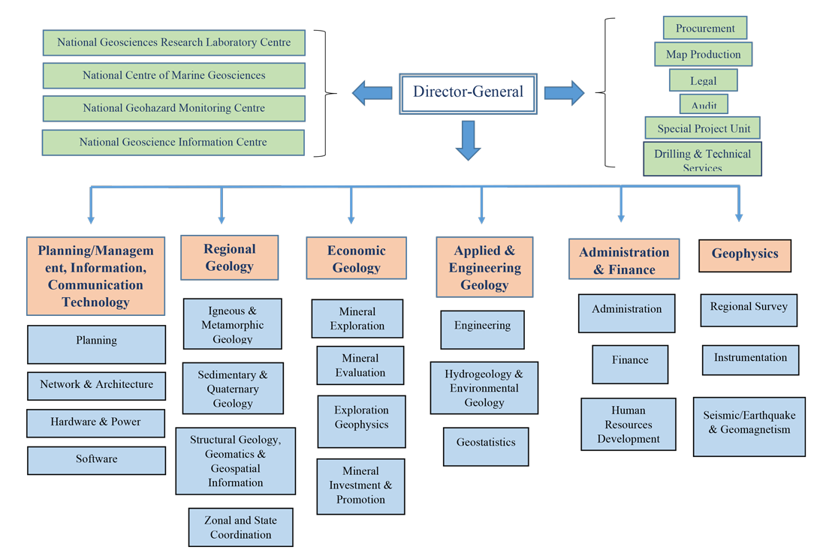
2.3.1 ORGANIZATION CHART

2.4 MAJOR FUNCTIONS OF THE VARIOUS DEPARTMENTS AT KWARA STATE GEOGRAPHIC INFORMATION SERVICES
- Process and issue development permits
- Verify applications for land rights
- Maintain a database of land in the state
- Implement best practices for land ownership and title certification
- Ensure developmental activities are in line with the state master plan
- Promote growth and rapid development
- Improve land and property files
- Reduce data loss
- Enable easy data retrieval
- Receive reports and statistics

CHAPTER THREE
3.0 TECHNICAL TRAINING EXPERIENCE
This include all my experience gained at Kwara State Geographic Information Service

WEEK ONE
INTRODUCTION
- There are four (4) types of leave in an organization in Nigeria.
- Annual leave: This leave must be given once in a year
- Sick leave: This is the leave given to someone that is not feeling fine
- Study leave: This is the leave given to someone that want to further more for his/her education
- Maternity leave: This leave is just for women
- There are four (4) directorate office in GIS
- Directorate of lands
- Directorate of physical planning of development
- Urban and regional planning
- Office of the surveyor
- We taught different kind of files
- Incoming files
- Outgoing files
- Secret files
- When I was about to record a staff file, I will need to putdown the File No, Date, File name
- I thought how to approve a file either sick leave, study leave etc the file will be submitted to the Admin officer and from the Admin officer to S.O
WEEK TWO
- Difference between head of service and civil service commission: Head of service focuses on policy implementation, while civil service commission focuses on personnel management oversight
- Assisted in data collection and analysis for a research project on public service delivery in the local government area.
- Maintained records files
- Provide customer service and responding to inquiries
- Assisted in the preparation of proposal for a grant to fund community development project
WEEK THREE
- Updated the organization’s social media platforms with relevant contact or resources
- Short note about retirement files:
- Contain employee’s personal and service details
- Typically maintained by (HR) or personal department
- Confidential and sensitive information
- I was taught a lot about secret files
- Contain confidential and sensitive information
- Stored security to prevent unauthorized access or breaches
- Access restricted to authorized personnel only
- I prepared a report on the findings recommendation from the field visit
- I conduct a field visit to a local community to access the effectiveness of a poverty reduction program
WEEK FOUR
- I was taught some common applications of (GIS)
- Mapping and navigation
- Urban planning and development
- Environmental management and conservation
- Natural resource management
- GIS technology has many benefits, including:
- Improved decision making through data driven
- Enhanced visualization
- Communication of complex data
- GIS technology integrates common database operations, such as query and statistical analysis capabilities offered by maps
- Short note about data collection: Assisting in collecting and updating geographic data such as boundaries, roads and landmarks
- Assisting in the development and implementation of GIS project such as mapping project, spatial modeling
WEEK FIVE
- GIS software support: Providing technical support and training on GIS software to other staff members
- Creating visualizations and report to communicate geographic data insights to stakeholders
- Mapping creating and updating map by using GIS software such as ARC GIS or QGIS
- Providing customer service
- Handling correspondence and communication
WEEK SIX
- I went to post the officers names that was posted internal from the office of executive chairman to the director of survey
- Assess the effectiveness of programs and services, identifying areas for improvement
- Manage and coordinate public programs, services and resources
- Communication specialist
- Recording some staff files in the director office
WEEK SEVEN
- Assist with organizational development, including strategic planning, change management and capacity building
- Program development
- Facilitate community engagement, participation and collaboration to achieve organization goals
- Research and write grants to secure funding for organization needs and opportunities
- Providing customer service
WEEK EIGHT
- The major work been carried out in secret office is where all staff files are kept
- We have two (2) files which are personal and subject files
- The structure, the chairman, the vice chairman, the supervisor, and the education work financing agricultural tax

CHAPTER FOUR

4.0. WORK CARRIED OUT DURING S.I.W.E.S
During my SIWES program, I have more experience on how to record file staff and how to approve a file of leave. I have more know about how to maintain records file which I put into practice during the period of my assignment.
I was assigned to prepare a report on the findings recommendations from the field visit. I also learnt how to conduct a field visit to a local community of a poverty reduction program.
I was thought by my industrial based supervisor (MRS. MUSTAPHA SIDIKAT) that I should learn something on GIS technology.

CHAPTER FIVE

5.0 CONCLUSION AND RECOMMENDATION
  - CHALLENGES ENCOUNTER
The Kwara State Geographic Information Service (KW-GIS) has encountered challenges such as encroachment on public land and barricades on business districts.
- The KW-GIS has removed corner shops that were built on land allocated for a car park.
- The KW-GIS has taken action against encroachment into public land and setbacks.
- The Kwara State Government erected barricades in the Challenge and Post Office business districts of Ilorin.
- The barricades were part of a government project to prevent road encroachments and reclaim setbacks.
- The barricades blocked major roads and affected the livelihoods of traders and shop owners.
- The traders protested against the barricades, saying that they couldn't get customers to buy from them.
5.2 RECOMMENDATIONS
- Use technology to improve land and property files, reduce data loss, and make it easier to retrieve data
- Use digital platforms to streamline land administration and reduce bottlenecks
- Introduce and implement best practices for land ownership and title certification
- Develop and maintain up-to-date geospatial information systems for the state
- Provide technical support to other government agencies and individuals who want to use geospatial information systems
- Charge appropriate fees for the services provided by the KW-GIS
- Use open-source platforms and tools to build the KW-GIS
- Make the digital archive accessible over a network and allow for different roles and permissions
- Generate statistical reports on the number of certificates of occupancy (CofOs) by gender, ownership type, and issuance and registration dates
5.3 CONCLUSION
There is every need to appreciate and recognize the advent of SIWES program and agree it has brought about dynamism into learning system. The SIWES program brings new learning services and practical interactivity on the side of the students.
My report revealed the history of my SIWES placement and the aims and important of SIWES. However, my report is detailed with my experience and what I learned during the period.

