CHAPTER ONE INTRODUCTION
  - BACKGROUND
The Students Industrial Work Experience Scheme (SIWES) is a work-based learning program designed to prepare students for the transition from academic life to professional careers. It is an integral part of the Nigerian educational system, aimed at equipping students with practical skills and knowledge to complement their theoretical studies. SIWES was established in 1973 by the Industrial Training Fund (ITF) in response to the growing concerns of employers about the lack of practical skills among graduates from tertiary institutions (Ezeabikwa, 1991). The scheme is a collaborative initiative involving students, tertiary institutions, employers of labor, and the ITF.
The program was introduced to address the gap between classroom learning and the real- world demands of industries. It recognizes that while theoretical knowledge is essential, it is often insufficient for solving practical problems in professional environments. SIWES provides students with opportunities to gain hands-on experience, develop technical competencies, and understand workplace ethics and culture (Agbai, 1992).
The scheme is a mandatory part of the curriculum for students studying courses such as engineering, technology, medical sciences, agriculture, education, and other applied sciences. It typically lasts for six months for university undergraduates and four months for students in polytechnics or colleges of education (ITF, 2024). Through this initiative, students are exposed to industrial practices and technologies that are not available within their academic institutions. This exposure enhances their employability and prepares them for the challenges of the modern workforce (Adebayo & Adesanya, 2013).

SIWES also serves as a platform for fostering partnerships between educational institutions and industries. These partnerships enable industries to contribute to curriculum development by providing feedback on the skills and knowledge required in the workplace. This collaboration ensures that graduates are better equipped to meet industry standards and expectations (Akinyemi & Abiodun, 2018).
In summary, SIWES is a vital component of Nigeria's educational system that bridges the gap between theory and practice. It plays a crucial role in preparing students for professional careers by equipping them with practical skills, knowledge, and experiences that are essential for success in their chosen fields.

BRIEF HISTORICAL DEVELOPMENT OF SIWES
The history of SIWES dates back to the early 1970s when Nigeria experienced rapid industrial growth following its independence. This growth created a demand for skilled manpower to operate and manage industrial facilities. However, employers soon realized that graduates from tertiary institutions lacked the practical skills needed to perform effectively in the workplace (Ezeabikwa, 1991).
In response to this challenge, the Industrial Training Fund (ITF) was established in 1971 by Decree No. 47 with a mandate to promote skill acquisition and manpower development in Nigeria. Two years later, in 1973, SIWES was introduced as one of ITF's flagship programs aimed at addressing the skill gap among graduates (ITF, 2024). Initially, SIWES was fully funded and managed by ITF. The program targeted students in engineering and technology- related fields who required practical training as part of their academic curriculum (Adebayo & Adesanya, 2013).
By 1978, financial constraints forced ITF to withdraw from direct management of SIWES. The Federal Government subsequently transferred oversight responsibilities to the National Universities Commission (NUC) for universities and the National Board for Technical

Education (NBTE) for polytechnics and colleges of education (Legit.ng, 2022). However, this arrangement proved ineffective due to inadequate funding and poor coordination among stakeholders. In 1984, management responsibilities were returned to ITF under a new funding arrangement supported by the Federal Government (SmartBukites, 2023).
Over time, SIWES has undergone significant changes aimed at improving its effectiveness and expanding its scope. Initially limited to engineering and technology disciplines, it now includes other fields such as medical sciences, agriculture, business administration, and education. These changes reflect an ongoing commitment to align SIWES with evolving industry needs and national development goals (Akinyemi & Abiodun, 2018).
Today, SIWES is recognized as one of Nigeria's most successful initiatives for bridging the gap between academic learning and industrial practice. It has become an essential component of tertiary education in Nigeria, contributing significantly to skill development and employability among graduates.

OBJECTIVES OF SIWES
The primary objectives of SIWES are multifaceted and aim to enhance both student learning and industry engagement:
    - To provide students with industrial skills and experience relevant to their field of study.
    - To expose students to work methods and techniques that may not be available in their academic institutions.
    - To facilitate a smoother transition from academic life to professional employment by enhancing students' networks with potential employers.
    - To allow students to apply theoretical knowledge in practical settings, thereby bridging the gap between theory and practice.

    - To strengthen employer participation in the educational process by fostering collaboration between educational institutions and industries (Ezeabikwa, 1991; ITF, 2024).

CHAPTER TWO

DESCRIPTION OF THE ESTABLISHMENT OF ATTACHMENT

  - LOCATION AND BRIEF HISTORY OF ESTABLISHMENT
The Nigerian Television Authority (NTA) Ilorin is strategically located along Shoprite Road, Fate, Ilorin, Kwara State. This location provides easy access to the city's central business district and facilitates effective coverage of local events. NTA, as the largest television network in Africa, was formally established in May 1977 through Decree 24 of 1977. However, its origins date back to October 1959 with the establishment of the Western Nigerian Government Broadcasting Corporation (WNTV), which was Africa's first television station. Over time, regional stations such as RKTV (Kaduna) and NBC (Nigerian Broadcasting Corporation) merged under NTA’s umbrella, creating a comprehensive national broadcasting network.
NTA transitioned from black-and-white to color broadcasting in 1976 and expanded systematically to operate about 100 stations across Nigeria today. This expansion has enabled NTA to reach a wide audience, providing diverse programming that caters to various cultural, social, and educational needs. The network's growth has been marked by significant technological advancements, including the adoption of digital broadcasting technologies to enhance signal quality and coverage.

OBJECTIVES OF ESTABLISHMENT
The Nigerian Television Authority was established with several key objectives:

    - Independent and Impartial Broadcasting: To provide independent and impartial television broadcasting for general reception across Nigeria, ensuring that all content is free from bias and reflects the diverse perspectives of the nation.
    - Promotion of Societal Values: To influence, promote, and sustain positive societal values through cultural, social, economic, political, and technological programming. This includes promoting unity, peace, and stability across different regions.
    - Cultural Preservation: To preserve Nigerian culture while projecting African perspectives globally. This involves showcasing traditional arts, music, and festivals to both local and international audiences.
    - Educational and Informative Programs: To serve as a platform for educational, informative, and entertaining programs that cater to different age groups and interests. This includes documentaries, educational series, and children's programs.
    - Reliable News Coverage: To ensure reliable coverage and analysis of national and international events through news programming. This involves providing timely updates on current affairs and in-depth analysis of significant events.
    - Promotion of Civic Responsibility: To promote civic responsibility and indigenous technology while maintaining high broadcasting standards. This includes encouraging viewers to participate in democratic processes and supporting local innovations.
    - National Integration: To foster national integration and enrich productivity through impactful programming. This involves promoting unity among diverse ethnic groups and highlighting successful projects that contribute to national development.

ORGANIZATIONAL STRUCTURE
The organizational structure of NTA is hierarchical and well-defined, ensuring efficient management and operation of its numerous stations across the country. The structure includes:
    - Board of Directors: This is the highest governing body of NTA, responsible for setting overall policies and strategic directions for the organization. The Board comprises experienced professionals from various fields, including media, finance, and law.
    - Director-General: The Director-General is the chief executive officer of NTA, responsible for overseeing all operations and reporting directly to the Board. This position involves managing the day-to-day activities of the organization and implementing policies set by the Board.
    - Deputy Director-General: Assists the Director-General in managing operations, focusing on specific areas such as programming, engineering, or finance. This role ensures continuity and support in leadership.
    - Executive Management Team: Comprises heads of key departments such as News & Current Affairs, Programming, Engineering, Finance, Marketing & Business Development, Human Resources, and Audience Research & Monitoring. This team is responsible for strategic planning and decision-making across different operational areas.
    - Zonal Directors: Supervise operations within ten zones across Nigeria, ensuring that each zone meets its broadcasting objectives and adheres to national standards. Zonal directors also play a crucial role in regional content development and community engagement.

DEPARTMENTS IN THE ESTABLISHMENT AND THEIR FUNCTIONS
NTA Ilorin comprises several departments, each with distinct functions that contribute to the overall success of the station:
- News Department: Responsible for gathering, editing, and broadcasting news content.

This includes local, national, and international news, as well as current affairs programs. The department works closely with correspondents and news agencies to ensure timely and accurate reporting.
- Programmes Department: Oversees the creation and scheduling of entertainment, educational, and cultural programs. This involves commissioning new content, managing program schedules, and ensuring that all programs meet NTA's quality standards.
- Engineering Department: Handles technical operations like signal transmission, equipment maintenance, and ensuring uninterrupted broadcasts. The department is also responsible for adopting new technologies to improve broadcast quality and expand coverage.
- Finance Department: Manages financial planning, budgeting, and expenditures. This includes securing funding for new projects, managing operational costs, and ensuring financial compliance with regulatory requirements.
- Marketing Department: Secures sponsorships and advertisements while coordinating airtime sales. The department also promotes NTA's brand and programs through various marketing strategies to attract new audiences and retain existing ones.
- Administration & Training Department: Focuses on human resource management and staff development. This includes recruitment, training programs, and ensuring that all staff members have the necessary skills to perform their duties effectively.

- Special Duties Department: Handles unique assignments that require specialized attention. This can include managing special events coverage, coordinating with external partners for co-productions, or overseeing projects that require innovative approaches.
- Audience Research & Monitoring Department: Conducts research to understand audience preferences and monitor viewer feedback. This helps in tailoring programs to meet audience needs and improving overall service quality.
- Legal Department: Provides legal advice and ensures compliance with broadcasting regulations and laws. This includes handling copyright issues, contract negotiations, and representing NTA in legal matters.
- Public Relations Department: Manages NTA's public image and handles media relations. This involves issuing press releases, managing social media presence, and coordinating community outreach programs.
Each department works collaboratively to ensure efficient operation of the station while fulfilling NTA's mission of providing world-class television services that project African perspectives globally. This collaborative approach enables NTA to maintain its position as a leading broadcaster in Nigeria and Africa.

CHAPTER THREE INDUSTRIAL EXPERIENCE
3.1 EQUIPMENT THAT WAS FOUND IN THE STUDIO AND THEIR FUNCTION
- Micro phone: it is use in changing physical/natural voice to electronic voice.
- Console mixer: basic units of all equipment to control the each programme.
- Computer system: to keep a file, songs and typing news.
- Aquatic wall: to present sound and hear.
- Que light: it enable the people to known whether there is a live programme going on or not.
- Disk: it is use to record some programme.
- UPS: it enable the programme to be continue when the light is off.
- Phone: the serve as a means of which audience get through to the presenter.
- Air condition: it make all the equipment in the studio to be cool.
- Dictionary: it help the newscaster to be able to pronounce words correctly.
- Speaker: this change electronic voice to physical voice for the people to hear clearly.
3.2 ITEMS THAT CAN BE FIND IN A TELEVISION STUDIO
The studio floor is the actual stage on which the actions that will be recording take place. A studio floor has the following characteristics and installations:
- SETS CONTRUCTION: I s the process by which a set designer works in collaboration with the director of a production to create the set of a theatrical film, or television production. The set designer produces a scale model, scale drawing, paint elevation and research props, textures, and so on. Model and paint elevation are frequently hand produced through in recent years, many designers and most commercial theatres have begun production scale drawing with the aid of computer drafting programs such as AUTO CARD or VECTOR works.
PRODUTION LIGHT
Studio lightening it enables the camera to see and take clear picture and to provide the viewer with important virtual information about an event such as space area, time of the day and even mood of an event.

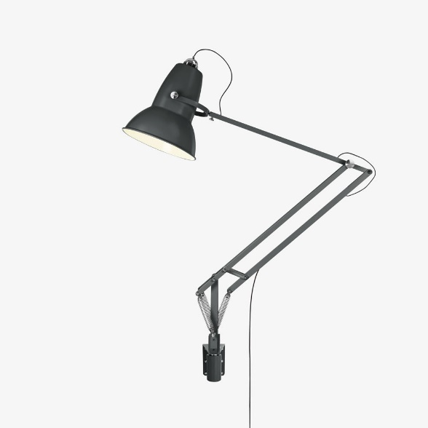

TYPES OF PRODUCTION LIGHT
- Base lightening: this is general studio lightening which is soft and not hard, it is directed to any particular place and therefore does not create much shadow. However the lightening is enough for a television camera to transmit acceptable picture.
- Modern lightening: this lightening usually directed toward a specific sense or performance. It contain three base light namely; key light, fill light, back light.
  - The key lights are directional, very strong and illuminate the subject, but one disadvantage is that it creates shadow.
  - Fill light reduce the hardness of the shadow.
  - The backs light on the other hand outline the subject and separate him/her from the background.
- Red harded lightening: this is usually use to change the color of a particular background with the help of using gel of any color and the color will infect in the object, for a particular purpose.
HEADPHONES
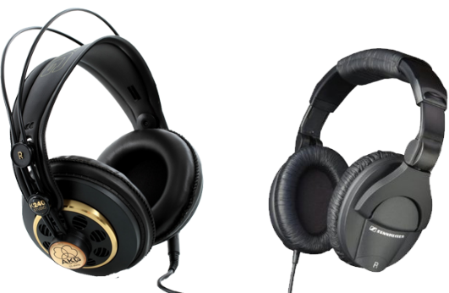
Studio Monitor Speakers are automatically muted whenever a microphone is turned on. As a result, anyone in a studio needs headphones to hear what is going to air. Headphone selection is often a very personal decision based on your preferences in comfort and frequency response.
MICROPHONE
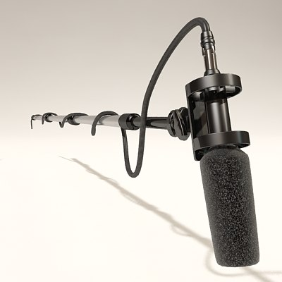
The microphone is also important equipment needed by broadcaster in the discharge of their daily duties. Microphones are several type but they perform one function that of magnifying the voice of the artist as fear as program production is concerned. Microphone converts sound energy into electrical energy.

A Boom Mic
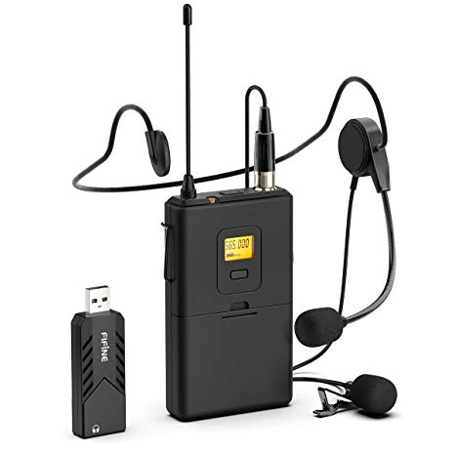

Lapel mic
TYPES OF MICROPHONE
- Uni-directional microphone: this type of microphone can be used in one direction. It can only handle about two person ant not more than that and the person must position in one direction.
- Omni-directional microphone: this type of microphone usually has a long cable and be extended over a considerable space within a given area. It can be easily use for outside broadcasting.
- Bi-directional microphone: this kind of microphone can be directed at the voice from different direction at the same time. This type is most suitable for interview and group discussion program.
- Nick microphone: this is a small electronic cup-on the microphone which is extensively use for speech pick up, it can be use to libel, shirt or tie and may be hidden beneath the clothing.
- Hanging microphone: this type of microphone, it is suspended over the action area and is effective for area sound pick such as choir or orchestra.
THE VIDEO CAMERA
A video camera (often called a television camera even through the use has spread beyond television) is a high-end device for creating electronic moving images that record the originally developed for use in television station, they are now commonly use for corporate and education videos, music videos and direct-to-video movies. There are two types of professional video camera:
- Television studio camera: which link the recording capability of a camcorder, and are often fixed on studio pedestal, or tripod to get a good caption for the viewers.
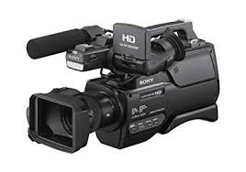
- High end portable recording camera (essentially, high end tapeless camcorders) use for electronic news gathering (ENG) and electronic field production (EFP) portable professional camera are generally much large then the consumers and are designed to be carried on the shoulder.

COPY EDITING
Copy editing, is the process of examining writing or visual work for any error, it is a work that an editor does to improve the quality of writing or visual material. No matter what you are publishing, no matter the medium, the copy editor must ensure that the copy is accurate, clear, concise, correct, clean, complete, and consistent.
Copy editing involves not only great attention to detail for issues of punctuation, grammar, style, and spelling, but also the ability to transform writer based content into reader or virtual based document that resonate with the audience.
Playout & Automation Software
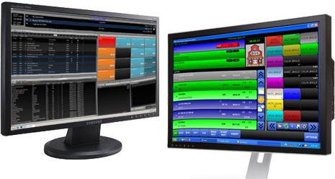
The computer system that plays back music, spots (ads, promos, etc.) and sweepers (the little voice-overs played between songs) is called a Playout System or Automation Software. These are specially designed computer programs that allow for continuous playback of audio, with a lot of granular control for Announcers and Programme Directors.
At the heart of any Automation System is the “log”. This is a sequential list of all audio files and commands that need to be played at certain times. All music played on a commercial radio station will be pre-programmed by the Music Director and loaded into the log. A separate person will often load all advertisements into the same log.
  - WORK DONE
During my 16-week SIWES program at the Nigerian Television Authority (NTA) Ilorin, I was actively involved in various tasks that enhanced my understanding of broadcasting operations. My work experience was divided into several key areas:
    - News Department: I assisted in news gathering, editing, and broadcasting. This involved accompanying reporters on field assignments, helping with scriptwriting, and participating in the editing process to ensure that news segments were concise and informative.
    - Programmes Department: I contributed to the creation and scheduling of entertainment, educational, and cultural programs. This included brainstorming ideas for new shows, coordinating with producers, and ensuring that all programs adhered to NTA's quality standards.
    - Engineering Department: I gained hands-on experience with technical operations such as signal transmission and equipment maintenance. This involved learning about the latest broadcasting technologies and assisting engineers in troubleshooting technical issues.
    - Marketing Department: I helped secure sponsorships and advertisements by coordinating with potential clients and managing airtime sales. This experience taught me the importance of marketing in sustaining a broadcasting organization.
    - Administration & Training Department: I assisted in human resource management and staff development initiatives. This included helping with recruitment processes and organizing training sessions for new staff members.
Throughout my SIWES program, I learned several valuable lessons that will benefit me in my future career:
      - Teamwork and Collaboration: The importance of working as part of a team to achieve common goals. In broadcasting, collaboration between departments is crucial for successful program execution.
      - Adaptability and Flexibility: Being adaptable in a fast-paced environment where priorities can change quickly. This skill is essential in responding to breaking news or unexpected technical issues.
      - Time Management: Effective time management is critical in meeting deadlines, especially in news and programming departments where timely delivery is paramount.
      - Professionalism and Ethics: Maintaining high professional standards and ethical conduct in all aspects of broadcasting, including accuracy in reporting and respect for diverse perspectives.
      - Continuous Learning: The need for continuous learning and professional development to stay updated with the latest technologies and trends in broadcasting.

TOOLS AND EQUIPMENT USED
During my SIWES program, I had the opportunity to work with a variety of tools and equipment essential for broadcasting operations:
    - Broadcasting Software: I used software like Adobe Premiere Pro for video editing and DaVinci Resolve for color grading.
    - Camera Equipment: I worked with high-definition cameras such as Sony and Panasonic models for field recordings.
    - Audio Equipment: I used professional microphones and audio mixers to ensure high- quality sound in both studio and field recordings.
    - Transmission Equipment: I gained experience with satellite transmission systems and terrestrial broadcasting infrastructure.
    - Studio Lighting: I learned about setting up studio lighting for optimal visual effects during live broadcasts.

SAFETY PRECAUTIONS
Safety is a top priority in any broadcasting environment. During my SIWES program, I adhered to several safety precautions:
    - Electrical Safety: Ensuring that all electrical equipment was properly grounded and maintained to prevent electrical shocks.
    - Studio Safety: Following guidelines for safe studio operations, including proper use of lighting and sound equipment.
    - Field Safety: Taking necessary precautions during field assignments, such as wearing personal protective equipment (PPE) and being aware of surroundings.
    - Data Security: Protecting sensitive information by using secure networks and following data protection protocols.

CHALLENGES FACED DURING MY SIWES PROGRAMME
Despite the rewarding experiences, I encountered several challenges during my SIWES program:
    - Technical Challenges: Dealing with occasional technical issues such as equipment malfunctions or signal disruptions, which required quick problem-solving skills.
    - Time Constraints: Managing tight deadlines, especially in news production where timely delivery is critical.
    - Adapting to New Roles: Initially, it was challenging to adjust to new responsibilities and tasks, but with time and guidance, I became more comfortable.
    - Balancing Tasks: Juggling multiple tasks simultaneously, such as assisting in different departments, required effective time management and prioritization.
    - Learning New Technologies: Familiarizing myself with new broadcasting technologies and software was a challenge, but it provided valuable learning opportunities.

CHAPTER FOUR

SUMMARY, CONCLUSION, AND RECOMMENDATION

  - SUMMARY
This project report summarizes my experiences and learning outcomes from the 16-week SIWES program at the Nigerian Television Authority (NTA) Ilorin. The program provided a comprehensive insight into the operations of a major broadcasting organization, covering various departments such as News, Programmes, Engineering, Marketing, and Administration.
During my attachment, I was actively involved in news gathering and editing, program creation and scheduling, technical operations, marketing strategies, and human resource management. These experiences not only deepened my understanding of broadcasting processes but also taught me valuable skills in teamwork, adaptability, time management, and professionalism.
Key lessons learned include the importance of collaboration, continuous learning, and maintaining high ethical standards in broadcasting. I also gained hands-on experience with various broadcasting tools and equipment, ensuring safety precautions were always observed. However, I faced challenges such as technical issues, tight deadlines, and adapting to new roles. Overcoming these challenges enhanced my problem-solving skills and ability to work under pressure.

CONCLUSION
In conclusion, my SIWES program at NTA Ilorin was a transformative experience that bridged the gap between theoretical knowledge and practical application in the field of broadcasting. The program exposed me to the complexities and dynamics of a real-world broadcasting environment, equipping me with the skills and confidence necessary for a successful career in mass communication.

The experience highlighted the importance of teamwork, adaptability, and continuous learning in a fast-paced industry like broadcasting. It also underscored the need for maintaining high professional standards and ethical conduct in all aspects of broadcasting.
Overall, the SIWES program was invaluable in preparing me for the challenges and opportunities in the broadcasting industry, and I am grateful for the opportunity to have been part of NTA Ilorin.

RECOMMENDATION
Based on my experiences and observations during the SIWES program, I recommend the following:
    - Continuous Training and Development: NTA should continue to invest in training programs for staff to keep them updated with the latest broadcasting technologies and trends. This will enhance operational efficiency and competitiveness in the industry.
    - Infrastructure Upgrade: Regular maintenance and upgrade of broadcasting equipment are crucial to prevent technical issues and ensure uninterrupted service. This includes investing in digital technologies to improve signal quality and expand coverage.
    - Internship Opportunities: NTA should continue to offer internship opportunities to students, as these programs provide valuable practical experience and can serve as a pipeline for future talent acquisition.
    - Collaboration with Educational Institutions: Strengthening partnerships with educational institutions can facilitate knowledge sharing and ensure that students are well-prepared for the demands of the broadcasting industry upon graduation.
    - Digital Expansion: NTA should explore expanding its digital presence by developing online platforms and social media strategies to engage with younger audiences and stay competitive in the digital age.



A
TECHNICAL REPORT
ON

STUDENT INDUSTRIAL WORK EXPERIENCED SCHEME
(SIWES)

HELD AT

NIGERIA TELEVISION AUTHORITY ILORIN(NTA)
Beside Shoprite, Fate Road, Ilorin, Kwara State.

PRESENTED BY
ADEOYE IBRAHIM AWEDA
ND/23/MAC/PT/0416

SUBMITED TO:

THE DEPARTMENT OF MASS COMMUNICATION
INSTITUTE OF INFORMATION AND COMMUNICATION TECHNOLOGY
KWARA STATE POLYTECHNIC, ILORIN
IN PARTIAL FULFILMEN OF AWARD ON NATIONAL DIPLOMA.
2023/2024 SESSION

DEDICATION

I dedicate my Industrial Training report to Almighty God, who has given me the grace to participate in the SIWES program, to my Parents and as many that have contributed greatly to the success of my Industrial Training.

ACKNOWLEDGEMENT
I thank God who has seen me throughout my SIWES program and also thank my Industrial based supervisor who guided me through My Industrial training. I also send out my appreciation to my lecturers, friends and Coworkers for their moral support. My special thanks to my wonderful and lovely parents Mr. and Mrs. Olagunju who were there for me in terms of care, prayers, financial support and others.

TABLE OF CONTENTS

Title Page Dedication Acknowledgment Table of content

CHAPTER ONE: INTRODUCTION
  - Background

  - Brief historical development of SIWES

  - Objectives of SIWES

CHAPTER TWO: DESCRIPTION OF THE ESTABLISHMENT OF ATTACHMENT
  - Location and Brief history of establishment

  - Objectives of establishment

  - Organization Structure

  - Departments in the establishment and their functions

CHAPTER THREE: INDUSTRIAL EXPERIENCE
  - Work Done

  - Tools and Equipment Used

  - Safety precautions

  - Challenges faced during my SIWES Programme

CHAPTER FOUR: SUMMARY, CONCLUSION AND RECOMMENDATION
  - Summary

  - Conclusion

  - Recommendation References

