

STUDENTS INDUSTRIAL WORK EXPERIENCE SCHEME
(SIWES)
HELD AT
NIX SOFT ICT
TANKE ILORIN, KWARA STATE

PRESENTED BY
OYEYEMI SAHEED
ND/23/COM/PT/0246

DEPARTMENT OF PUBLIC ADMINISTRATION
KWARA STATE POLYTECHNIC ILORIN, KWARA STATE
IN PARTIAL FUILFILMENT FOR THE REQUIREMENT FOR
AWARD NATIONAL DIPLOMA IN PUBLIC ADMINISTRATION

MARCH 2025

DEDICATION
I dedicate this students industrial work experience scheme (SIWES) report to God Almighty for his grace and mercy towards the completion of the siwes programme.

ACKNOWLEDGMENT
My acknowledgment goes to Almighty God, my parents , kwara state polytechnic Ilorin, my supervisor and also to my friends may we all excel in life and may Almighty God continue to be with everyone Amin.

REPORT OVERVIEW
This is an industrial attachment report for the Students' Industrial Work Experience (SIWES) programme carried out within the period of three months. The report comprises the background of SIWES, the description of the organization, its aims and objectives, the experiences gained as an industrial training student and the summary, conclusions and recommendations. It has a total of 5 chapters with sub-chapters. It also has the preliminary pages, such as the title page, report overview and table of contents and recommendations on the improvement of scheme.

TABLE OF CONTENT
Tittle page
Dedication
Acknowledgement
Report over view
Table of content
CHAPTER ONE: INTRODUCTION
- Background of the study
  - Advent Of Siwes
  - Organization And Operation Of Siwes
  - Objectives Of Siwes
  - Aims Of Siwes
CHAPTER TWO: DESCRIPTION OF ESTABLISHMENT ATTACHMENT
2.1 History of the firm.
2.2 Organisational chart.
2.3 Various departments and functions
CHAPTER THREE: JOB DESCRIPTION AND RESPONSIBILITIES
3.1 Job Description And Responsibilities
3.2 challenges and lesson learned
CHAPTER FOUR: ACTUAL WORK DONE WITH EXPERIENCE GAINED
4.1 Conclusion
4.2 Recommendation

SECTION ONE
1.1 INTRODUCTION
The Industrial Training is a training Scheme by which a student can undergo practical training within an approved Industrial undertaking having specific amount of fixed assets or turnover of paid up share capital. The scheme is a participatory program involving Universities, Polytechnics and Technical Colleges and students of carious Institutions of Nigeria.
The Student Industrial Work Experience Scheme (SIWES) is funded jointly by Industrial Training Fund (ITF). The Scheme completes part of the academics requirement standards in pursing the award of the National Diploma in Office Technology Management. The training lasts for six months. The theory and the practical aspect are being joined together in the programme in order to find out how things are being done. In theory, we are to read electronic guidance, books, novels which concern deeply with sense of belonging especially in course of concern them in practical we have to know how to do things by ourselves to enhance spirits of commitment in all we do. That is why, for efficient moving of this programme in conjunction with ministry of education has set a step that students should be going for these programme. Office Technology Management Departments has seen it as a step forward of progress by sending their student to embark on it.
  - DEFINITION OF SIWES
Student industrial working experience scheme (Siwes) is a program organized by industrial training fund (ITF) for National Diploma science student after their first year (ITF) for National Diploma science student after their first year on campus , to help them known more about the practical aspect of what they have been thought in the school, thou will do practical in the school but we still have some area where we have to know, that it will help us in future to be able to call ourself a computer operator , programmer a system analyst.
  - AIMS AND OBJECTIVE OF SIWES
- It promotes interaction between student in training and the company staffs.
- It helps us to gain moiré to what to customer.
- It help us to know how to relate to customer
- It help us to be perfect in our course of study
- It help us to know how the computer system is been operate
- It help us to know more about practical aspect of what we have being taught in the school

SECTION TWO
2.1 Location and Brief History of Nixsoft ICT
Nixsoft ICT, established in 2015, is a forward-thinking technology company founded by Mr. Azeez Muideen Gbolagade. With a mission to deliver innovative solutions in the digital realm, Nixsoft ICT has positioned itself as a key player in the web development and design industry.
Nixsoft ICT is a technology company based in Ilorin, Nigeria, specializing in website design, digital modern language labs, SEO, online registration, and serving as an NYSC center in Ilorin.
Under the visionary leadership of Mr. Azeez Muideen Gbolagade, the company has steadily grown, embracing advancements in technology while maintaining a strong commitment to client satisfaction. Nixsoft ICT continues to shape the digital landscape, empowering businesses with impactful online solutions.

CURRENT STAFF STRENGTH = 5

2.2 Objective of Establishment
Mission Statement:
Our mission is to provide innovative, high-quality, and affordable mobile phones and gadgets that enhance connectivity, productivity, and entertainment for our customers. We are committed to delivering exceptional customer service, staying ahead of technology trends, and making the latest tech accessible to everyone.
Vision Statement:
Our vision is to become a leading global retailer of smartphones and gadgets, recognized for our innovation, reliability, and customer satisfaction. We aim to bridge the digital divide by offering cutting-edge technology solutions that empower individuals and businesses in an increasingly connected world.

STRUCTUREOFTHEORGANISATION

Nixsoft ICT operates with a well-defined organizational structure designed to promote efficiency, collaboration, and innovation. The company is structured as follows:

Chief Executive Officer (CEO): Mr. Azeez Muideen Gbolagade

    - Web Development Department: The Web Development Team at Nixsoft ICT is responsible for creating functional and visually appealing websites by combining branding, design, and technical expertise. They collaborate with clients to understand their brand identity, ensuring consistent aesthetics through font selection, color schemes, and layouts. Using tools like Figma, they design wireframes and create sitemaps with platforms like Relume.io to structure website navigation and user experience. The team manages frontend design, ensuring adherence to modern UI/UX principles, and utilizes local servers (WAMP/XAMPP) for development and testing. They also handle web hosting, domain management, and implement content management systems like WordPress to deliver fully functional websites tailored to client needs.
    - Web Design Department: The Web Design Team at Nixsoft ICT focuses on crafting visually appealing and user-centric website designs that align with clients' branding and objectives. They begin by understanding the brand identity, using tools like Adobe Color, Coolors.co, and Color Space to develop harmonious color schemes based on the 60-30-10 rule. The team creates low, medium, and high-fidelity wireframes using Figma to map out website layouts and designs, ensuring an intuitive and engaging user experience. They also utilize tools like Relume.io to design sitemaps that guide navigation flow. By integrating creativity with technical tools, the team delivers aesthetically pleasing designs that enhance usability and align with the client's vision
Client Relations and Marketing Department: The Client Relations and Marketing Department at Nixsoft ICT ensures effective communication with clients by understanding their needs, gathering project requirements, and maintaining strong relationshipsthroughregularupdatesandsupport.Theyalsodevelopmarketingstrategies to promote the organization’s services, leveraging digital channels and branding initiatives. By aligning client expectations with deliverables and enhancing the company’s visibility, this department plays a vital role in customer satisfaction and business growth.
- Administrative and Support Team: The Administrative and Support Team at Nixsoft ICT ensures the smooth operation of daily activities by managing organizational processes, maintaining records, and overseeing logistics. They provide essential support to all departments, ensuring resources, tools, and systems are available for efficient workflow.Thisteamplaysacriticalrolein fosteringawell-organizedworkenvironment, enabling the organization to meet its goals effectively.

TEAM/DEPARTMENT

WebDevelopmentandWebdesignDepartment
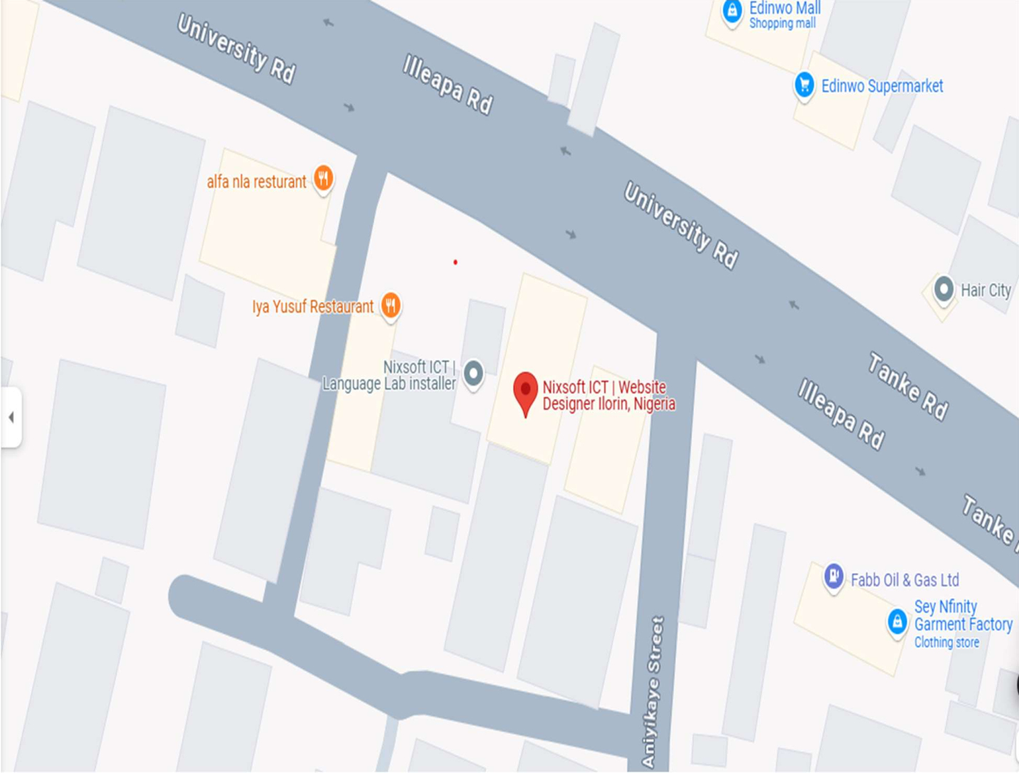

CONTACTINFORMATION

Figure1:Companymap

Emailaddress;mailto:NixsoftIct1@gmail.com

PhoneNumber:09159471685,08089817907.

OfficeAddress:BesidesIyaYusufrestaurant,AlongUnilorin,Road,TankeRd,opposite Edinwo Supermarket, Ilorin 240222, Kwara.

SECTION THREE
3.1 INTRODUTION TO COMPUTER NETWORKING
In the world of computer, computer networking, is the practice of linking two or more computer devices together for the purpose of sharing data. Network are built with a mix of computer hardware and computer software. In networking, the communication languages used by computer devices is called protocol. Another way of classify computer network is by set of protocol, they support. The popular protocol included, TCP ( Transmission Control Protocol) and IP (Internet Protocol), they are the most common protocol fond on the internet and in how network.
3.2 ADVANTAGES OF COMPUTER NETWORKS
- It allow user to have direct access to there file from different computer within the networks
- It allow sharing of resources within the network place by computer, the resources are: printer, scanner etc.
- There is security provide by the network to secure the program such as password.
3.3 DISADVANTAGES OF COMPUTER NETWORKS
- It expensive to install, the cost of installation is high because software, cable and other item is expensive to by
- The server may get fault or tail and there will be lost of some program and file.
3.4 TYPES OF COMPUTER NETWORKS
There are three main types of computer networks
- LOCAL AREA NETWORK: This is a type of network that serves user within a geographical area. This kind of network is been used by few users in a small area such as school, office building etc.
- METROPOLITAN AREA NETWORK (MAN) : This is a network which cover a large geographical area such as cities. This types of network combined two or more LANS together but limited to a specific geographical area.
- WIDE AREA NETWORK ( WAN): This is a types of network that used to connect and distribute network to two or more geographical area which make used of a local telephone line or other wireless devices. The purpose of WAN is to provide reliable, task and safe communication between two more places.
3.5 NETWORK TOPOLOGY
A network topology describe arrangement of system on a computer networks, it describe how the computer, or node, within the net works are arranged and connected to each other some common networks topologies are defined below.
i. STAR TOPOLOG: A star topology is designed with each node connected directly to the hub a concentrator. The hub or concentrator serve as backbow to allthe device connect to it. The advantages is that it is easy to add and remove a computer system without disturb the networks.
- RING TOPOLOGY: Ring topology refers to atopology that allow data pass in one direction and teach node are connected with each other forming a ring or circle. The message shows around the ring in one direction.
- BUS TOPOLOGY: Bus topology deal with connecting each node to a central bus that run along the entire networks. It required a least amount of cable to connect the computer. It is simple and reliable and easy to understand. The disadvantages is that is that it difficult to troubleshoot.
- TREE TOPOLOGY: A tree topology is the combination of the characteristic of star topology and bus topology. The star configured workstation is connected to the bus topology backbone cable. Tree topology supported by several hardware and software, but if the backbone cable break, the network will goes down.
SECTION FOUR
INTRODUCTION TO INTERNET
  - DEFINITION
Internet can be defined as the global information system that provides users or maker accessible to the general public. ;the interconnected computer work s by transmitting data through special types of packet switching which is known as the internet protocol (IP) . The network enable the internet to be used for various important function which include the several means of communication like file transfer, the online chat and even sharing of document.
  - BENEFIT OF INTERNET
  - It distributes information to the public about a particular organization product and services.
  - It provide facility to read book of different nature online, many books are published on the web, including social science books, computer science books etc.
  - Internet allow to chatting between two people by sending and received message instantly
  - Through internet connection people can also watch live television broadcast and listing to radio.
  - Through internet people can also get software by downloading it on your own computer to used.

SECTION FIVE
CONCLUSION AND RECOMMENDATIONS
  - CONCLUSION
My three month student industrial work experience scheme with Black tech Info tech has been one of the most interesting, productive and instructive experience in my life. Through this training. I have gained new insight and more comprehensive understanding about the real industrial working condition and practice; it has also improved my soft and functional skills. All these valuable experiences and knowledge’s that I have gained were not only acquired through the direct involvement in taskbut also through other aspects of the training such as:work observation, interaction with colleagues , superior and other people related to the field.

RECOMMENDATION:
In view of my experience during my industrial training, the following recommendations are made to the students, industrial training fund (I.T.F) and the companies:
    - Students should personally ensure that they get a good placement for the program in time to commence and gain the best from the six-months.
    - Students should make sure that the entire period for the attachment is completed before bowing out of the program.
    - Also, student should have a focused mind and interest as it will help them get the maximum knowledge attainable from the companyattached to.
    - Not all students have the opportunity of getting good industrial training placement, so the Polytechnic should ensure they establish good relationships with companies, firms and organizations capable of assisting in the SIWES program on a yearly basis thereby helping the less privileged students.
    - On the part of I.T.F, Student supervision should also be intensified to make the program

