

TECHNICAL REPORT ON STUDENT INDUSTRIAL WORK EXPERIENCE SCHEME (SIWES)

SIWES REPORT
UNDERTAKEN AT
PETALS 102.3 FM

By:
OLAITAN FARUK BAYONLE
ND/23/MAC/FT/0088

SUBMITTED TO:
DEPARTMENT OF MASS COMMUNICATION, INSTITUTE OF INFORMATION AND COMMUNICATION TECHNOLOGY (IICT) KWARA STATE POLYTECHNIC, ILORIN
IN PARTIAL FULFILMENT OF THE REQUIREMENT FOR THE AWARD OF NATIONAL DIPLOMA (ND) IN MASS COMMUNICATION

AUGUST – NOVEMBER, 2024

CERTIFICATION
This is to certify that this SIWES was carried out by OLAITAN, Faruk Bayonle with Matric Number: ND/23/MAC/FT/0088 in the Department of Mass Communication, Institute of Information and Communication Technology (IICT), Kwara State Polytechnic, Ilorin.

DEDICATION
This SIWES is dedicated to Almighty Allah, the Author and Finisher of my faith.

ACKNOWLEDGEMENTS
First and foremost, I appreciate Almighty Allah for giving me the privilege to partake in the Students Industrial Work Experience Scheme (SIWES).
I acknowledge my amiable and dynamic parents Mr. and Mrs. OLAITAN, for their financial, moral and spiritual caring and support during the course of my SIWES programme.
I also appreciate my Industrial based supervisor (Mr. Olamilekan Ridwan Omoola and Olaoye Hepzibah) for their patient, endurance, courage and kind support during the course of my stayed in the PETALS.
I wish to also acknowledge my school based supervisor, for their support, encouragement and kind during their visitation to PETALS.
Finally, I appreciate my colleagues in the same industrial based training, I pray Almighty Allah will grant us success in all our endeavor (Amen).

TABLE OF CONTENTS
TITLE PAGE i
CERTIFICATION ii
DEDICATION iii
ACKNOWLEDGEMENTS iv
TABLE OF CONTENTS v
CHAPTER ONE 1
1.1 Introduction to SIWES 1
1.2 Background to the SIWES 1
1.3 Objectives of SIWES 2
CHAPTER TWO 3
2.1 History of the Organization 3
2.2 Vision And Mission Statement 3
2.2.1 Vision 3
2.2.2 Mission Statement 4
2.2.3 Organisation Structure And Department 4
2.2.4 Departments In PETALS Radio Station 4
2.3 Station Running Activities 6
CHAPTER THREE 7
INVOLVEMENT IN THE ORGANIZATION 7
3.1 Experienced Acquired 7
3.2 Work Done 7
3.3 Importance of Paper in News 8
3.4 Instrument Used in the News Room 8
3.5 What is Editing? 10
3.6 Who is a Reporter? 10
3.6.1 Types of Reporter 10
3.7 Sources of News 10
3.8 What is Line-Up? 10
3.9 Rule of Engagement in News Department 10
3.10 What is a Newscasters? 10
3.11 Duties of a Newscaster 10
3.12 What is Jingle? 10
3.13 What is Promo 11
3.14 What is Programme Demo? 11
CHAPTER FOUR 11
EXPERIENCED GAINED IN THE ORGANIZATION 11
4.1 What is Microphone 11
4.2 Types of Microphone 11
4.2.1 What Is A Condenser Microphone? 11
4.2.2 What Is A Dynamic Microphone? 12
4.2.3 What Is A Ribbon Microphone? 13
CHAPTER FIVE 14
CHALLENGES ENCOUNTERED, CONCLUSION AND RECOMMENDATION 14
5.1 Challenges Encountered 14
5.2 Conclusion 14
5.2 Recommendation 15

CHAPTER ONE

1.1 Introduction to SIWES
The Student Industrial Work Experience Scheme (SIWES) exposes students to industry based skills necessary for a smooth transition from the classroom to the world of work. It affords students of tertiary institutions the opportunity of being familiarized and exposed to the needed experience in handling machinery and equipment which are usually not available in the educational institutions and seeing firsthand the practical experience of some theoretical knowledge gained in the course of study.
Participation in SIWES has become a necessary pre-condition for the award of Diploma and Degree certificates in specific disciplines in most institutions of higher learning in the country, in accordance with the education policy of government.

1.2 Background to the SIWES
The Student Industrial Work Experience Scheme (SIWES) is an initiative which was established in 1973 by the Industrial Training Fund (ITF) to help bridge the gap between acquired classroom education and skills necessary for work in the industry.
Before the inception of the scheme in 1973, there was glaring evidence that inadequate practical exposure of students in tertiary institutions posed serious challenges to both the quality and standard of engineering and technological education in our nation. This resulted in half-baked engineering graduates who needed to undergo a form of training (Industrial Training) to be suitable for employment in industries and firms.
In order to forestall this threat that could bring about industrial regression, the Federal Government through the Industrial Training Fund (ITF) which was established by decree 47 of 1971 introduced the Student Industrial Work Experience Scheme (SIWES) in 1973.
SIWES exposes students to machines and equipment, professional work methods and ways of safe guarding the work areas and workers in industries and other organizations. It helps the student to know the link between what is learnt in the university and what is actually practiced on site. It further helps students to appreciate their field of study better, thereby also determining which area of specialization to go into to contribute to technological development of this nation.
The scheme involves the students, the universities and the industry (employers). It is funded by the Federal Government of Nigeria and jointly coordinated by the National Universities Commission (NUC) and the ITF.
SIWES orientation is usually done to intimate students with the rudiments of industrial training before they are being employed. At the end of the industrial training (IT), successful students whose log books were verified and approved by ITF officials are paid SIWES severance allowance.

1.3 Objectives of SIWES
- Provides the student with an opportunity to apply their theoretical knowledge in real work situation thereby bridging the gap between theory and Practical.
- Provides an avenue for students in tertiary institutions to acquire industrial skills and experience in their course of study.
- Expose students to work methods and techniques in handling equipment and machinery that may not be available in universities.
- Familiarizing the student for the working conditions they are likely to meet after graduation; and
- Make the transition from the university to the world of work easier and thus enhance student’s contacts for later job placement.

CHAPTER TWO

2.1 History of the Organization
Petals FM 102.3 is a private radio station located in Ibadan, the capital city of Oyo State. It is one of the popular and fast-growing media stations in the South-West region of the country. The station is owned under a private establishment and guided by a board of trustees who help make key decisions.

PETALS 96.9 FM is a commercial license radio station, located at 11A Obe Street, Bodija, Ibadan Oyo state.

PETALS FM was officially launched on October 23, 2015, and since then, it has remained committed to promoting truth, fairness, and unity through broadcasting. The radio station was founded by the late Yinka Odumakin, a well-known human rights activist, journalist, and former spokesman of the Afenifere group. His aim was to create a media platform that would speak for the people and uphold integrity and justice across Nigeria.
Petals FM broadcasts in both English and Yoruba languages, making its programs easily accessible to a wide audience. It offers a mix of news, talk shows, educational content, music, and entertainment and traditions.
Its radio signal covers most parts of Oyo State and can be heard in some areas of Ogun, Osun, and Ondo states. Petals FM also runs an online radio platform, allowing listeners to stream programs from anywhere in Nigeria and across the world.
The station is composed of professionals staff under the leadership of General Manager.

2.2 Vision And Mission Statement

2.2.1 Vision
To be a leading media platform in Ibadan and Nigeria as a whole, delivering quality radio content that inspires, informs, and connects people from all walks of life, while promoting truth, culture, and community development.

2.2.2 Mission Statement
Petals FM is committed to promoting excellence, fairness, and integrity in all its broadcasts. The station aims to give a voice to the people, support cultural heritage, and contribute to the educational and social development of Oyo State and Nigeria at large. Through responsible journalism and creative programming, Petals FM seeks to build a more informed, united, and empowered society.

2.2.3 Organisation Structure And Department
PETALS Fm is well structure radio station which all running and management is been fully control under the following step structure.
- Board of Trustees
- General Manager
- Station Manager
- Programmes Manager
- Administration Manager
- Marketing/ Finance Manager
- Studio Operators and Engineers

2.2.4 Departments In PETALS Radio Station
- Administrative Department
- Programme Department
- Marketing Department
- Engineering Department
- Finance Department
- News and Current affairs
- Audit Department
Administrative Department: This department is in charge of all staffs matters, ranging from the code of conduct for all staffs, moral behavior, rules and regulation and scheme of services for all staffs. The department caters for personal matters training, training of staffs, and employment of new staffs, discipline and promotion. The department handles record keeping, takes care of matters relating to insurance of man and materials, survey of corporations land matters, dealing with contracts, provides clerical and secretariat duties for all department.
News and Programme Department: This department handles the entire programs as well as news section. Various Artists, freelancers as well as in house presenter are manage by this department. The Programme manager is responsible for the initiation of programs, and this idea must serve the purpose of informing, educating, persuading and entertaining.
Marketing Department: This is the department where the financial aspect of the organization is discussed and settled, not only that, the department deals with any jingle or advert rate and payment before going on air once verified by the programme department.
Engineering Department: This department is indebted with the task of supervising the equipment procurement, installation and maintenance of such equipment. He (producer/engineer) must be conversant with the broadcasting technology state.
Finance Department: The finance department is a service department that deals with the inflow and the outflow of the organization finances. It is in charge of budget preparation and budget control. It offers advice on financial matters to the chief director at all times. This department discharge duties ranging from billings, debt collection and payment of all fees for all channel, account reconciliation.
Editing Department: This is the department where we have experienced computer operator, their ingenuities is being task with the burning of disk, editing of recorded Audios, Jingles and Advert , and also keep the records.
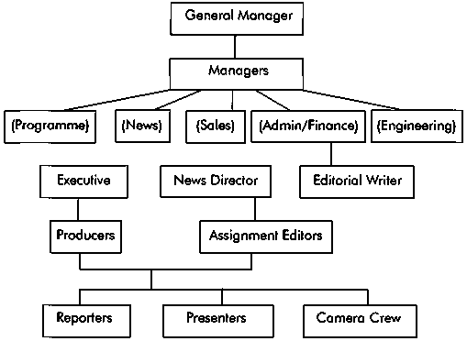

2.3 Station Running Activities
PETALS FM run Uninterrupted hours of transmission for 19hours of quality and quantitative broadcast to our audience between 5:00am to 12:00am on daily basis making it one of our strength.
Our Programming Strength: We have distinctive programs with flexible but firm schedule.
News and current affairs: Our news hours is unique with accurate, balance and objective contents that attract high listeners.
Qualified and seasoned on air personalities that are young, vibrant and adding values to the broadcast industry.
PETALS FM also transmit and stream on social media platforms which includes Facebook and Tiktok as well as Radio Garden as recognized worldwide radio streamers

CHAPTER THREE

INVOLVEMENT IN THE ORGANIZATION

3.1 Experienced Acquired
I started my SIWES program at Petals FM on he 8th of August 2024 in the Production department, under the supervision Mrs. Toni Adeoye.
The news department is where news is being processed, produced and given to a caster to road to members of the public.
During my stays at PETALS, news department, I had the opportunity to observe how news stories were edited and arranged for presentation. Although I did not follow reporters outside to gather news, I learned that news items come from various sources such as newspapers, press releases, and online platforms. The news gathered is usually edited to remove errors and checked for accuracy before been broadcasted.
Later, I was transferred to programme department, under the supervision of Olamilekan Riwan Omoola and Olaoye Hepzibah. Programmed and produced is where a radio programme are packaged and produced for airing. The department comprises varies units such as record room, marketing room and so on.
I gained more practical knowledge in this department where a know diferent between jingle and promo. I know how program is being produced and also given an explanations on how to control the console, music ethics to play on a schedule programs and so on.
I was opportune to produce a program called “Karina” program in the studio and more programs.

3.2 Work Done
I was persuaded to do so many tasks at PETALS radio station, even though I was unable to work as a new editor but I was able Observed how news is sourced, edited, and broadcasted in the newsroom.

I also learned how the console is operated and how sound is managed inside the studio, and had opportunity to produce program.
I was able to go Live on Facebook and other social media platform, using camera and streaming tools to broadcast programs online.
There are numerous of my work done in which experienced a lot at PETALS radio station.

3.3 Importance of Paper in News
The following are the importance of paper in news.
- Available of news
- It will help the producer for the particular day to know which news will go for their time.
- It help the producer alignment of a news story

3.4 Instrument Used in the News Room
The following are the instrument used in the news room.
- Table and chair
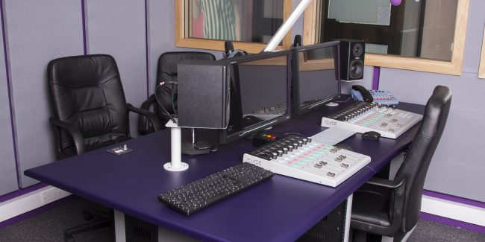

- Consoler

- Camera
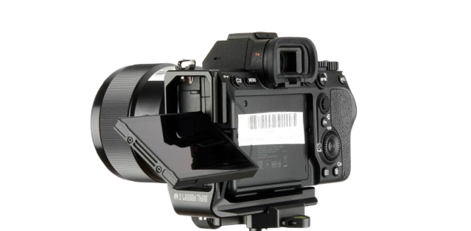
- Transmitter
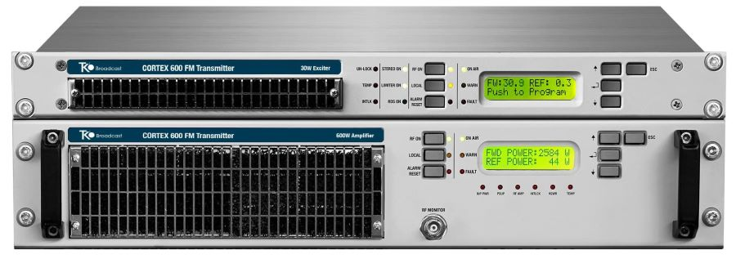
- Computer
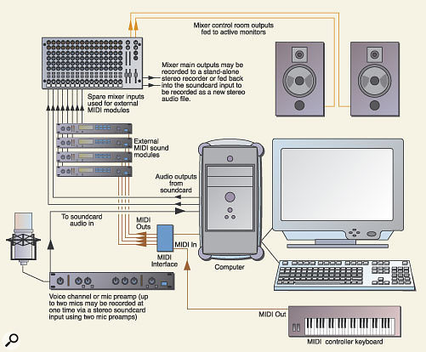

- Microphone

3.5 What is Editing?
Editing means doing all graphics. As a communicator you must know how to handle the system very well.

3.6 Who is a Reporter?
A reporter is a person who gathers news from events, interviews, or investigations and submits it for broadcast or publication. He is also known as a journalist.

3.6.1 Types of Reporter
There are three types of reporter know to me.
i. Political reporter ii. Education reporter iii. Sports Reporter

3.7 Sources of News
There are different ways of sourcing for news.
i. Rooting ii. Searching iii. Schedule assignment

3.8 What is Line-Up?
A line-up refers to a list of sequence individual on topic that will be featured on discussed in a news program or publication.

3.9 Rule of Engagement in News Department
The following are the rules of engagement in the news department.
i. Responsibilities of reporter ii. Alignment to responsibility
iii. Always meet news deadlines iv. You must have a good news for news

3.10 What is a Newscasters?
A newscaster is the person who reads and presents the news live on radio or television. They must be fluent, clear, and confident while reading news to the public.

3.11 Duties of a Newscaster
A newscaster is both a journalist and a broadcast specialist who communicates the news to a viewing or listening public. He/she must ensure correct pronunciation and timing.

3.12 What is a Jingle?
A jingle is a production of a minute that showcase a commercial advertiment. Its is a short catchy piece of music or audio use to promote a product or service.

3.13 What is a Promo?
A promo is a pre-launching of a advert of a radio or television program. Its a short advertisement for a specific program or events.

3.14 What is a Program Demo?
Program demo is summary or preview of a program. Its use to show what the program will look like or sound like.

CHAPTER FOUR

EXPERIENCED GAINED IN THE ORGANIZATION

4.1 What is Microphone
A microphone is a device that changes sound (voice) into electrical signals so it can be recorded or broadcasted. It is one of the most important tools in radio.

4.2 Types of Microphone
There are three primary types of microphones. Those include cardioid, dynamic, and ribbon microphones.
Ideally, they all work the same but are designed to capture different elements. For example, if you're a singer, you may want your microphone to capture your voice while reducing the instruments in the background.

4.2.1 What Is A Condenser Microphone?
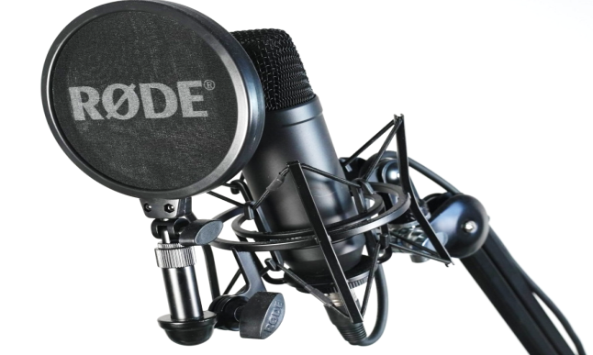
A condenser microphone is a type of microphone that uses a capacitor to convert sound to an electrical signal. It is sensitive and used mostly in studios for voice recording because of its high sound quality.

4.2.2 What Is A Dynamic Microphone?
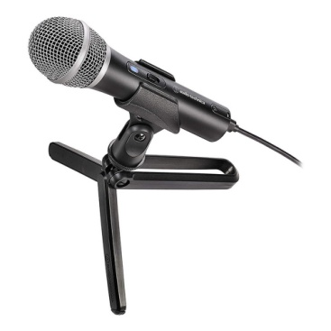
Dynamic microphones is another type of microphones that are strong and can handle loud sounds. They are more rugged and can handle high volumes, making them ideal for live performances.
Some popular dynamic microphones are the Shure SM58, Shure SM7B, the Sennheiser e935, and the Audix i5.
Dynamic microphones are less sensitive than condenser microphones, meaning they can handle more sound without distorting the audio. This also makes them better for capturing louder sounds.

4.2.3 What Is A Ribbon Microphone?
Ribbon microphones is an older and less common type. It uses a thin ribbon of metal to pick up sound. It produces a soft, natural sound and is used for special studio recordings.
There are a few different types of ribbon microphones available on the market.
Ribbon microphones are not as common as condenser or dynamic mics. However, they often produce a mellower sound than other microphone types, making them well-suited for certain genres of music. They can also be used for studio recordings for capturing the sound of vocals and acoustic guitars or capturing the sound of a choir or band.

CHAPTER FIVE

CHALLENGES ENCOUNTERED, CONCLUSION AND RECOMMENDATION

5.1 Challenges Encountered
During my industrial training at Petals FM, I experienced some challenges which I tried my best to overcome. At first, when I was posted to the News Department, I noticed that some staff were not always willing to carry students along, especially at the beginning. This made it hard for me to fully understand what was going on in the department.
Another challenge I faced was related to limited access to equipment. Sometimes I only observed without having the chance to operate or practice directly with the tools. Also, there were times when power issues interrupted the normal flow of activities in the studio, especially during live programming or music sessions.
Lastly, as a new intern, it took me some time to adjust to the station's rules, timing, and structure, especially when moving from one department to another. But over time, I was able to adapt and learn through observation and asking questions.

5.2 Conclusion
Honestly speaking, I will say that during my four (4) months in the SIWES programme at PETALS,I have the opportunity to experience the practical side of radio broadcasting. I learned how radio content is created, edited, and transmitted. I now have a better understanding of what happens behind the scenes in a real radio station.
I gained new knowledge about how to gather news, write news stories, work with studio equipment, play music on-air, and participate in drama recordings. This training helped me to apply some of the things I have learned in class and opened my eyes to what the world of mass communication looks like in real life.

5.2 Recommendation
I recommend that radio station like PETALS FM continue to give SIWES student more chances to pratices with the equipment and engage more actively in real tasks. Also, there should be better orientation for student at the beginning of their training, so they know what to expect and how to behave professionally.
For students, I recommend they take their training seriously, be ready to learn, and always ask questions where necessary. SIWES is a great opportunity to build experience, and it should not be taken for granted.

REFERENCES
www.google.com
www.wikipedia.com
My training log book

