
TECHNICAL REPORT
ON
STUDENTS INDUSTRIAL WORKS EXPERIENCE SCHEMES
(SIWES)
HELD AT
AKOREDE RADIO STATION (98.9 FM) IWO, OSUN STATE
BY:
ISIAKA RIDWANULLAHI OLALEKAN
ND/23/MAC/FT/0057
SUBMITTED TO:
DEPARTMENT OF MASS COMMUNICATION,
INSTITUTE OF INFORMATION AND COMMUNICATION TECHNOLOGY (IICT), KWARA STATE POLYTECHNIC, KWARA STATE.
IN PARTIAL FULFILMENT OF THE REQUIREMENTS FOR THE AWARD OF NATIONAL DIPLOMA (ND) IN MASS COMMUNICATION, KWARA STATE POLYTECHNIC ILORIN, NIGERIA.

AUGUST-DECEMBER 2024

DEDICATION
DEDICATION
I dedicate this project to God Almighty my creator, my strong pillar, my source of inspiration,
wisdom, knowledge and understanding. He has been the source of my strength throughout this
program and on His wings only have I soared.
I also dedicate this to my parents and my loving sister who encouraged me all the way and whose
encouragement have made sure that I give it all it takes to finish that which I have started. May
the blessing of God be with them now and always “AmenDEDICATION
I dedicate this project to God Almighty my creator, my strong pillar, my source of inspiration, wisdom, knowledge and understanding. God has been the source of my strength throughout this program and on His wings only have I soared. I also dedicate this work to my parents who has encouraged me all the way and whose encouragement has made sure that I give it all it takes to finish that which I have started.

ACKNOWLEDGEMENT
This SIWES work has been a great journey for me and has helped me to understand an area of work that is vast and wonderful. It has been completed with months of hard work and dedication and would not have been possible if not for the blessing and guidance I have received from a number of people. For this I am particularly indebted to all staffs of Mass Communication Department of Kwara Poly who had earlier thought me all the basics involved with workshop practice. Also, I appreciate the rigorous training and teaching from the staff of Akorede Radio Station.

TABLE OF CONTENTS
CHAPTER ONE
1.0 INTRODUCTION
1.1 BACKGROUND
1.2 OBJECTIVES OF SIWES
CHAPTER TWO
2.0 DESCRIBTION OF THE ESTABLISHMENT OF ATTACHMENT
2.1 LOCATION
2.2 BRIEF HISTORY OF THE ESTABLISHMENT
2.3 MISSION AND OBJECTIVES OF ESTABLISHMENT
CHAPTER THREE
3.0 WORK EXPERIENCE
3.1 INTRODUCTION
3.1.1 CHAINS IN THE PRODUCTION
3.2 EQUIPMENT’S USED IN THE PRODUCTION
CHAPTER FOUR
4.1. RECOMMENDATION
4.2 CONCLUSION

CHAPTER ONE
1.0 INTRODUCTION
1.1 Background
The Industrial Training fund established by decree 43 was introduced in 1971, vis-à-vis the birth of the Students Industrial Work Experience Scheme (SIWES) the same year by the Federal Government of Nigeria (FGN). It is against this background that the industrial training fund (ITF) initiated, designed and introduced SIWES Scheme in 1973 to acquaint students with the skills of handling employers’ equipment and machinery.
The Industrial Training Fund (ITF) solely funded the scheme during its formative years. However, due to financial constraints, the fund withdrew from the scheme in 1978. The Federal Government, noting the significance of the skills training, handed the management of the scheme to both the National Universities Commission (NUC), and the National Board for Technical Education (NBTE) in 1979. The management and implementation of the scheme was however, reverted to the ITF by the Federal Government in November, 1984 and the administration was effectively taken over by the industrial training fund in July 1985, with the funding solely boned by the Federal Government. It is an integral part of the requirements for the award of Certificates, Diplomas and Degrees in institutions of higher learning, e.g. Colleges of Education, Polytechnics, Universities, etc.
Student Industrial Work Experience Scheme (SIWES) exposes students to industry based skills necessary for a smooth transition from the classroom to work environments. It accords students of tertiary institutions the opportunity of being familiarized, exposed, and prepare students of universities, polytechnics, college of technology, college of agricultures and college of education for the industrial work situation they are likely to meet after graduation and to the needed experience in handling machinery and equipment which are not found in such an educational institution.
1.2 Objectives of SIWES
- To provide students with relevant practical experience.
- To satisfy accreditation requirements set by the Nigerian Universities Commission (NUC).
- To familiarize students with typical environments in which they are likely to function professionally after graduation.
- To provide student an opportunity to see the real world of their discipline and consequently bridge the gap between the University work and actual practice.
- To change the orientation of students towards labour market when seeking for job.
- To help students access area of interest and suitability for their chosen profession.
- To enhance students, contact for future employment
- To provide access to equipment and other facilities that would not normally be available in the University workshop
- To enlist and enhance industry involvement in university education.
- Summarily the objective of the Student Industrial Work Experience Scheme.
- To solve, the problem of inadequate practical skills, preparatory for employment in industries by Nigerian graduates of tertiary institution.
- To promote and encourage the acquisition of skills in industry and commerce, with a view of generating a pool of indigenous trained manpower sufficient to meet the needs of the economy.

CHAPTER TWO
2.0 DESCRIPTION OF THE ESTABLISHMENT OF ATTACHMENT
2.1 Location
Akorede Radio 98.9 FM is located in Iwo, Osun State, Nigeria. It is a commercial radio station that broadcasts a mix of music, talk shows, and other engaging content. The station's Facebook page, Akorede Radio 98.9 FM, confirms its location in Iwo.
2.2 Brief History of the Establishment
Akorede Radio 98.9 FM is a relatively new radio station located in Iwo, Osun State, Nigeria, that began test transmissions in May 2024. It describes itself as a commercial radio station focused on entertainment, news, and more, aiming to be the go-to station for residents of Iwo and surrounding areas. The station is also recognized as the Best Indigenous Radio Station in Iwo.
2.3 Mission and Objectives of Establishment
- To encourage content and technology innovation
- To advance the interest of our members in local, state, national, International, industry and public affairs.
- To serve as an advisory body to the Federal and State Governments on broadcasting matters.
- To encourage and sustain greater co-operation and collaboration among the broadcasting organizations, and other industry players.
- To improve the quality and profitability of broadcasting
- To seek and utilize available resources for manpower development, research and set training standards.
- To set, regulate and monitor professional standards and ethics of its members.
- To encourage members to serve their communities.

CHAPTER THREE
3.0 WORK EXPERIENCE
I carried out my Industrial Training in Control Room
3.1 Introduction
This to initiates, coordinates, supervise, and control matters such as funding, hiring key personnel, contracting and arranging for distributors. This also is involved throughout all phases of the process from the development to completion of the production. The also include how to set-up live shows on the studio.
3.1.1 Chains in the production
1. Director: This person is responsible for overseeing the creative aspects in controlling the content and flow of the film's plot, and directing their performance.
2. Screen Writer: Are responsible for researching the story, developing the narrative, writing the screenplay, and delivering it, in the required format, to the Producers.
3. Executive producer This person is usually an investor in the project or someone who has facilitated the funding of the project. There may be multiple of these people on a project, depending on the financing arrangements.
4. Line producer Typically, this person manages the budget of the film production. Alternatively, or in addition, they may manage the day to day physical aspects of the film production.
5. Production Manager This person supervises the physical aspects of the production including personnel, technology, budget, and scheduling.
6.Production Coordinator This person is the information nexus of the production, responsible for organizing all the logistics from hiring crew, renting equipment, and booking talent. This person is an integral part of film production.
7. Production Secretary This person provides administration assistance in the production office to the production coordinator and production manager.
8. Production Accountant These people are responsible for managing finances and maintaining financial records during film production.
9. Post-Production Supervisor These people are responsible for the post production process, during which they maintain clarity of information and good channels of communication between the Producer, Editor, Supervising Sound Editor, the Facilities Companies (such as film labs, CGI studios and negative cutters) and the Production Accountant.
10. Camera Operator This person operates the camera under the direction of photography, or the film director, to capture the scenes on film.
11. Scripts Supervisor Also known as "continuity", keeps track of what parts of the script have been filmed and makes notes of any deviations between what was actually filmed and what appeared in the script.
12. Story Producer: This person has overall responsibility for the story across episodes. In reality TV, this person is responsible for creating a story line via editing/producing the show's source footage.
13. Scripts Editor Provides a critical overview of the screenwriting process, using their analytical skills to help the screenwriter identify problems and thereby help to strengthen and develop the screenplay.
14. Production Sound Mixer This person is head of the sound department on set, responsible for recording all sound during filming.
15. Video Split/Assist Operator This is used by directors to watch a monitor during each take.
16. Digital Imaging Technician (DIT) On digital productions this person is responsible for the coordination of the internal workings of the digital camera.
17. Motion Control Technician/Operator This technician operates a motion control rig, which essentially is a 'camera robot' able to consistently repeat camera moves for special effects use.
18. Boom Operator (Boom Swinger) This person is responsible for microphone placement and movement during filming.
3.2 Equipment’s used in the production
- Studio System: The studio system in filmmaking refers to a method where a small number of large studios dominate production and distribution. It's particularly associated with the early years of Hollywood, from the introduction of sound in 1927 to around 1948, where studios controlled all aspects of film making. This included production on their own lots, employing personnel under long-term contracts, and controlling exhibition through vertical integration, ensuring films were shown in their own theaters.
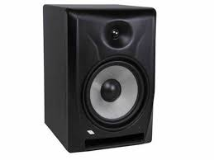

- Speakers: Speaker refers to a loudspeaker, a device that converts electrical signals into sound waves, allowing the broadcast audio to be heard. These speakers are essential for reproducing the station's audio content for listeners.
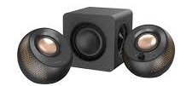

- Studio Microphone: A studio microphone in a radio station is a specific type of microphone designed for capturing high-quality audio in a controlled environment, such as a radio studio. It's typically used by announcers, interviewers, or other individuals recording audio for broadcast purposes.
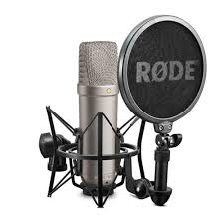

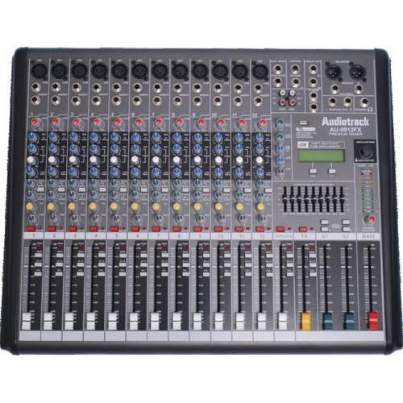
- Audio mixer: A mixer is an electronic device which is often used for changing the quality and the levels of audio signals. It is also known as a mixing console, an audio mixer, or a soundboard. Using a mixer is the most convenient way to route or combine various audio signals and even change the timbre and dynamics of the sound.

- Studio System Stream: It refers to the flow of audio and other signals from the studio to the transmitter for broadcast. This is often accomplished using a Studio Transmitter Link (STL) system, which can involve analog or digital technology. The stream carries the audio content, control signals, and sometimes even video or data to the transmitter, allowing the station to reach its audience.
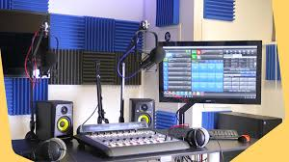

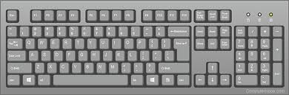
- Keyboard: It refers to the computer keyboard used by staff for tasks like typing, editing, or operating software. It's the standard input device for text entry and interacting with digital systems within the station. For musical purposes, a keyboard can also refer to a musical instrument with keys used for creating sound effects or live music during the broadcast.

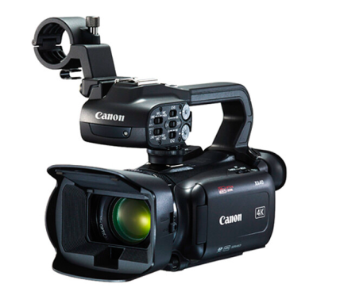
- Live stream camera: This is a type of camera that transmits video footage in real-time over a network or platform to a live audience. This allows viewers to see the visuals of a radio show or event happening concurrently with the audio broadcast.

- Studio Telephone: This is a specialized telephone system designed for broadcasting purposes, often used for on-air interviews and calls. It differs from a standard telephone in its integration with the station's audio equipment, allowing for seamless audio transmission to the airwaves.
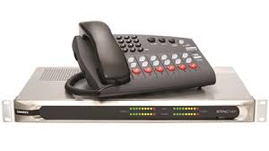

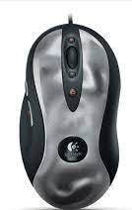
- Mouse: refers to a computer mouse, a hand-held pointing device used for interacting with the station's computer systems. It's not directly related to the radio broadcast itself but rather the operational technology.

- Computer: The computer in a radio station is a central hub that manages and controls the flow of audio and information throughout the broadcast process.
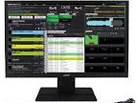

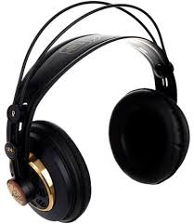
- Headphone: Headphones are audio monitoring devices worn by hosts, producers, and technicians. They allow users to hear the audio being broadcast, including their own voice, other participants, and any background music or sound effects. This helps ensure the audio quality is optimal and that everything sounds as intended

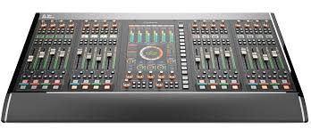
- Equalizer: An equalizer adjusts the frequency content of an audio signal to enhance its sound quality, while a transmitter converts that audio signal into a radio wave for broadcast. The equalizer acts as a filter, boosting or attenuating specific frequency bands, like bass or treble, while the transmitter prepares the signal for transmission over the airwaves.

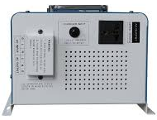
- Inverter: An inverter is an electronic device that converts direct current (DC) power, typically from batteries or a power supply, into alternating current (AC) power. This allows the station to operate AC-powered equipment like transmitters, audio processors, and studio equipment.

- Portable transmitter: A portable transmitter used in a radio station is a compact, mobile device that emits radio waves to broadcast audio or data. It's typically a self-contained unit, meaning it can be powered and operated independently, and it's designed to be easily moved and deployed in various locations. These transmitters are often used for temporary or mobile broadcast operations, such as covering events or providing radio service in areas where a permanent station isn't available.
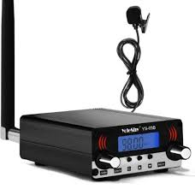

- RDS: RDS stands for Radio Data System. It's a standard for sending small amounts of digital information, including station names, song details, and traffic information, alongside the standard FM radio broadcast signal. This allows radio receivers to display this data, enhancing the listener's experience.
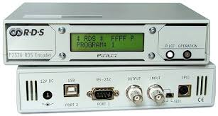

- Air conditioner: An air conditioner is a system or unit that regulates temperature, humidity, and sometimes air purity, primarily for the purpose of cooling the studios and ensuring the comfort of the staff and proper functioning of the equipment
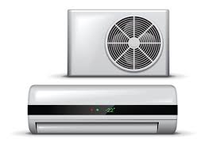

- Television: It refers to the process of broadcasting both audio and visual content, typically through radio waves, to a wide audience. It's a broadcasting service that involves transmitting visual images, often with accompanying sound, to television receivers. This contrasts with traditional radio, which focuses solely on audio transmission.


- Solar panel: a solar panel is a device that converts sunlight into usable electricity to power the station's equipment, including transmitters, amplifiers, and other electronics. Solar panels use photovoltaic (PV) technology, where sunlight directly generates electricity.
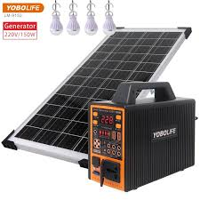

- Streaming audio control: It refers to the process and tools used to manage and manipulate the audio stream being transmitted over the internet to listeners. This includes features like adjusting audio levels, selecting different sources, adding effects, and controlling the flow of the broadcast.
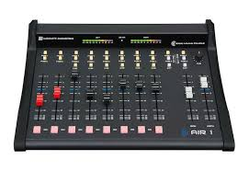

- Studio table: a studio table or mixing table refers to an audio mixer console. This device is the central control point for all audio inputs and outputs in the studio, allowing the DJ or operator to adjust and mix sounds for broadcast. It's also known as a mixing desk, broadcasting desk, or sound panel.
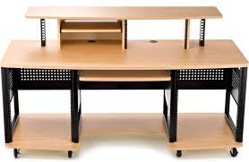

CHAPTER FOUR
RECOMMENDATION AND CONCLUSION
4.1 Recommendation
The recommendations arising from the foregoing appraisal of the effectiveness of SIWES in the formation of competent and productive technical manpower for the economy are summarized as follows;
- The establishment of a National Commission for Student Industrial Training or a National Board for Cooperative Education was proposed to oversee the implementation of SIWES at the national level.
- Funds earmarked for SIWES should be appropriated directly by the National Assembly in the same way for the National Youth Service Corps Scheme in order to remove the bottlenecks associated with release of fund for the operation of the scheme.
- The Federal Government should make adequate provisions in the annual budget for proper funding for SIWES in view of the potentials of the scheme to contribute to enhancing the quality of pool of technical skills available to the economy.
- The stipulation that employers should accept students for SIWES should be strengthened with stiffer penalties put in place for defaulters.
- A review of the policies that guide and regulate SIWES is necessary to ensure that the scheme complies fully with the tenants of cooperative education or work-integrated learning.
4.2 Conclusion
The Student Industrial Work Experience Scheme (SIWES) plays a significant role in human resource development, it helps students develop new skills and enlightens them of what the present society holds for them after graduation and helps them adapt accordingly. As a result of the programme, I am now more confident to build my future My four (4) months industrial has been one of the most interesting, productive and instructive experience in my life. Through this training, I have gained new insight and more comprehensive understanding about the real industrial working condition and practice; it has also improved my soft and functional skills. All these valuable experience and knowledge that I have gained were not only acquired through the direct involvement in task but also through other aspect of training such as work observation, interaction with colleges, superior and other people related to the field.

