A TECHNICAL REPORT

ON

STUDENT’S INDUSTRIAL TRAINING

UNDERTAKEN
AT FRESH FM ABEOKUTA OGUN STATE

BY

OLUYINKA NODIRAT IRORUNOLA
ND/23/MAC/PT/0523

SUBMITTED TO
THE DEPARTMENT OF MASS COMMUNICATION
INSTITUTE OF INFORMATION AND COMMUNICATION TECHNOLOGY
KWARA STATE POLYTHECNIC, ILORIN

IN PARTIAL FULFILMENT OF YHE REQUIREMENT FOR THE AWARD OF NATIONAL DIPLOMA (ND) IN MASS COMMUNICATION

AUGUST-NOVEMBER 2024.

TABLE OF CONTENTS
Title pagei
Certification ii
Declaration iii
Dedication iv
Acknowledgement v
Preface vi
Abstract vii

CHAPTER ONE
  - Introduction
  - About Industrial Training Fund (ITF)
  - About Siwes
  - Objectives and scope of Siwes
  - Benefit of industrial training to students
  - Benefit of industrial training employers
1.7Background of Fresh FM 107.9
1.8Department at Fresh
1.9Objectives of the Report

CHAPTER TWO
2.1 Duties Performed

CHAPTER THREE: Work Experience/Training Received
3.1 From the Projects and Tasks Carried Out
3.2 From Supervisory Works

CHAPTER FOUR: Summary, Conclusion, and Recommendations
4.1 Summary
4.1 Conclusion on the Industrial Training Undergone
4.2 Views and Recommendation

Reference
Pictures

DEDICATION

This report is dedicated to Almighty ALLAH for giving me the strength and opportunity to gain more knowledge from my field of study, through the Students Industrial Work Experience Scheme (SIWES) and FRESH FM ABEOKUTA (107.9 FM) OGUN STATE. I also dedicate it to my Family and friends for being there for me.

ACKNOWLEDGEMENT

I wish to register my profound gratitude to Almighty ALLAH for the guidance, protection and grace throughout my life and throughout my months of attachment with FRESH FM ABEOKUTA (107.9 FM)
I am deeply grateful to the MANAGEMENTofFRESH FM ABEOKUTA (107.9 FM), for granting me a placement for my industrial training at their organization and for making my industrial training very educative, interactive and worthwhile.
I will like to thank the Industrial Training Fund (I.T.F) for their foresight in putting SIWES together. I appreciate all my amazing lecturers in the department, my ever efficient for all the teachings, lectures and guidance on campus.

My special appreciation to my Family, siblings, friends and all other relatives for being there for me. Also I thank my Parents (Mr&Mrs Oluyinka for the support both financially and mentally, Also an unending appreciation to Adewumi and Khadija , my biggest support.

I also want to thank my Institution, kwara state polytechnic for giving me this opportunity to study. Lastly, to the whole staff of FRESH FM ABEOKUTA, for giving me an opportunity to complete my industrial training.

My sincere gratitude and appreciation goes to my industrial training supervisors.

PREFACE
The students industrial work experience scheme (SIWES) is a skills training programme designed to expose and prepare students of Universities, Polytechnics, Colleges of Technology, Colleges of Agriculture and Colleges of Education for the industrial work situation they are likely to meet after graduation.
This shows a comprehensive report of my SIWES at FRESH FM ABEOKUTA (107.9 FM)OGUN STATE.

ABSTRACT
The Student Industrial Work Experience Scheme established by the Federal Government of Nigeria was aimed at exposing students of higher institutions to acquire skill and practice in their approved courses of study and to also prepare the students for the industrial work situation which they are likely to meet after graduation. This technical report is based on the experiences gained during my three months (JULY-OCTOBER 2024) of industrial training at FRESH FM 107.9 ABEOKUTA. This report is divided into (4) chapters, chapter one contains the importance of students industrial training in Fresh FM 107.9, Background of Fresh FM 107.9, Chapter two contains the Duties Performed, chapter three contains Work experience/ Training Received, project and tasks carried out, site inspection/surveys and the problem encountered and/ or solved. Chapter four contains Summary, conclusion, and Recommendations. This report simply entails my experiences during my three month practical experience at Fresh FM 107.9 in Abeokuta.It’s also include a detailed examination of the station’s organization structure and programming. This work further explained a brief summary of the things I learnt, the skills I gained, also the challenges I encountered and my recommendations.

CHAPTER ONE

1.1 INTRODUCTION
In recruiting new employees, the job market is ever emphasizing on working experience inaddition to the paper qualification; thus the requirement makes working experience or industrialtraining become fundamental in the higher learning institutions (Saat and Ahmad, 2009). Higherlearning institutions are now providing students with the opportunity to translate the knowledgegained into practice through industrial training, also known as practical training or internship.
The training period which lasts to about six months or three months aims to develop the skills required by theindustry and this seems to become an important role to provide quality and professionalworkforce in the future (Omar, et al., 2008)

1.2 ABOUT THE INDUSTRIAL TRAINING FUND (I.T.F)
Established in 1971, the Industrial Training Fund (I.T.F) has operated consistently and painstakingly within the context of its enabling laws Decree 47 of 1971 as amended in the 2011 I.T.F act. The objective for which the Fund was established has been pursued vigorously and efficaciously. In the four decades of its existence, the I.T.F has not only raised training consciousness in the economy, but has also helped in generating a handful of skilled indigenous manpower which has been manning and managing various sectors of the national economy.
Over the years, pursuant to its statutory responsibility, the I.T.F has expanded its structures, developed training programs, reviewed its strategies, operations and services in order to meet the expanding, and changing demands for skilled manpower in the economy. Beginning as a Parastatal “B” in 1971, headed by a Director, the I.T.F became a Parastatal “A” in 1981, with a Director-General as the Chief Executive under the aegis of the Ministry of Industry. The Fund has a 13-member governing council and operates with 10 departments and 4 units at the Headquarters, 33 area offices, 3 skills training centers, and a center for Industrial Training Excellence.
A governing council of thirteen members drawn from the public and private sectors will be appointed by the Federal Government to manage the Fund. This is to reflect the co-operative spirit of the enterprise, the need for private employers, organized labor, and the providers and users of training to co-operate in identifying training needs and devising training policy and system.
As part of its responsibilities, the ITF provides direct training, vocational and apprentice training, research and consultancy service, reimbursement of up to 50% levy paid by employers of labor registered with it, and administers the Students Industrial Work Experience Scheme (SIWES). It also provides human resource development information and training technology service to industry and commerce to enhance their manpower capacity and in-house training delivery effort.
The main thrust of I.T.F programs and services is to stimulate human performance, improve productivity, and induce value-added production in industry and commerce. Through its SIWES and Vocational and Apprentice Training Programs, the Fund also builds capacity for graduates and youth self-employment, in the context of Small Scale Industrialization, in the economy.
The Industrial Training Fund is a grade ‘A’ Parastatal operating under the aegis of the Federal Ministry of Industry, Trade and Investment. It has been operating for 42 years as a specialist agency that promotes and encourages the acquisition of industrial and commercial skills required for national economic development.
Vision
To be the foremost Skills Training Development Organization in Nigeria and one of the best in the world.
Mission
To set and regulate standards and offer direct training intervention in industrial and commercial skills training and development, using a corps of highly competent professional staff, modern techniques and technology.

1.3 ABOUT SIWES
The Student Industrial Work Experience Scheme (SIWES), also known as Industrial Training is a compulsory skills training program designed to expose and prepare students of Nigerian Universities, Polytechnics, Colleges of Education, Colleges of Technology and Colleges of Agriculture, for the industrial work situation they’re likely to meet after graduation.
According to the National Universities Commission (NUC), SIWES is the most accepted skills training program which forms part of approved minimum Academic Standards in the various degree programs for all Nigerian universities. The main objective of the SIWES program is to bridge theory with practice by making it possible for students to get themselves exposed to ‘real jobs’ situations and environments. The scheme also affords students the opportunity of familiarizing and exposing themselves to the needed experience in handling equipment and machinery that are usually not available in their institution.
Before the establishment of the scheme, there was a growing concern among industrialists, that graduates of institutions of higher learning lacked adequate practical background studies preparatory for employment in industries. Thus, employers were of the opinion that the theoretical education in higher institutions wasn’t responsive to the needs of the employers of labor.
SIWES introduction, initiation and design was done by the Industrial Training Fund (I.T.F) in 1993 to acquaint students with the skills of handling employer’s equipment and machinery.
The Industrial Training Fund (I.T.F) solely funded the scheme during its formative years. However, due to financial constraints, the fund withdrew from the scheme in 1978.
The Federal Government, noting the significance of the skills training handed the management of the scheme to both the National Universities Commission (N.U.C) and the National Board for Technical Education (N.B.T.E) in 1979.
The management and implementation of the scheme was however reverted to the I.T.F by the Federal Government in November, 1984 and the administration was effectively taken over by the Industrial Training Fund in July 1985, with the funding solely borne by the Federal Government.

1.4 OBJECTIVES AND SCOPE OF SIWES
(a) To enlist and strengthen employer’s involvement in the entire education process and prepares students for employment in the industry.
(b) To provide students with an opportunity to apply their theoretical knowledge in real work situation,thereby bridging the gap between university work and actual practice.
(c) To expose students to work methods and techniques in handling equipment and machinery that may not be available in the University.
(d) To make transition from university to the world of work easier and thus enhance contests for later job placement.

1.5 BENEFITS OF INDUSTRIAL TRAINING TO STUDENTS
(a) The scheme provides the opportunity to apply the theoretical principles taught in school in real job situations. This leads to a deeper understanding of the subject.
(b) It gives room for the opportunity to interact with a larger spectrum of people in an industrial setup, which is far different from campus life. Hence, industrial training helps with personality and maturity development.
(c) It enables the students prepare themselves for the work ahead of them. It serves as an opportunity to peep into the future and help them determine how much they are ready for it.
(d) The scheme helps students in developing intellectual skills as they are often left on their own to take technical decisions and often analyze complex interdisciplinary problems and proffer appropriate solutions applicable to real situations.

1.6 BENEFITS OF INDUSTRIAL TRAINING EMPLOYERS
(a) By taking students on industrial training, employers have the opportunity of screening potential employees. During the period of industrial training, an employer would be able to assess the potential of such students and determine their employability after graduation.
(b) Students on industrial training are usually young, full of fresh ideas, concept and theoretical knowledge. By doing so, their way of approach to certain problems would is fresh and could be used to an advantage by employers in tackling problems that have previously been treated as trivial and familiar.
(c) When a potential employee is identified during industrial training, such students after graduation and if eventually employed, need very little or no orientation in the organization. They can be employed and put straight on the expected responsibilities.
(d) Usually, when students on industrial training are properly utilized, they could serve as relief hands.

  - Background of Fresh FM
Fresh FM is a contemporary radio station that operates on 80% Yoruba and 20% English withcoverage spreading across news, music, sport and societal related issue. The station wasestablished in 2019, it hit the airwaves with test transmission while hardcore programming andnews began in the same 2019.
Fresh FM is located at 10, Bolude Oyebolu street presidential hilltop white houseibara Gra localAbeokuta.

1.8 Departments in Fresh FM
They are seven departments in Family FM, namely;

Managerial Department: In the management department of a Fresh fm 107.9 fm, they oversee theoverall operations, make strategic decisions, and ensure that the station runs smoothly. They areresponsible for setting goals, managing staff, and implementing policies to achieve thestation's objectives.

News and current affairs Department: The responsibility bestowed on this department is thegathering of news, reporting, relating news events to the society among others. It consists ofEnglish and Yoruba desk, this department has reporters and correspondents, headed by the news editors and head of news.

Accounting department: In the accounting department also known as the bedrock of any organization, theyhandle financialtasks such as budgeting, payroll, invoicing, and financial reporting. They ensure that financialtransactions are accurately recorded, budgets are managed effectively, and compliance withfinancial regulations is maintained.

Commercial department: This department is in charge of entering customers data base and giving different prices on advert in applications to the rate card when customers approach the department.

Marketing department: Conducting research to understand target audiences, their needs, preferences, and behaviors. Developing and implementing marketing strategies to achieve business objectives, and managing the organization's brand identity, reputation, and messaging.

Production Department: In a radio station's production department, they are responsible forcreating and producing radio content such as jingles, commercials, promos, and other audiomaterials. The production team works on recording, editing, and mixing audio elements to createengaging and high-quality content for broadcast. They play a crucial role in ensuring that thestation's programming is well-produced and meets audience expectations.

Engineering department:This department is in charge of maintaining and installing alltransmitting equipment in the radio station. It has three units in Fresh FM; they include thetransmitter, this department ensures that the station signal is clear and uninterrupted. Headed bythe head of engineering.

1.9. OBJECTIVES OF THE REPORT
- To inform the school management of my experience during my industrial training.
- To explain my understanding of the work environment.
- To reflect on my learning and achievements.
- To reveal how my training expose me to the practical aspect of news writing and reporting.
- To explain the relevance of my training to the field of study.
- To introduce the organization I acquired my training.
- To comprehensively explain the nature of organization business, mission, vision as well as thestructure.

CHAPTER TWO
INDUSTRIAL EXPERIENCE
OVERVIEW OF WORK DONE

My Industrial Training took place at Fresh 107.9fm (Abeokuta)
My first week at fresh 107.9fm was a week of orientation and training for the week done. I was introduced to my department which is the traffic department where placement of advert is been carried out before getting to the production studio. I was taught how to examine adverts with regards to NBC (National Broadcasting Commission)Codes which is very important
Second and Third week,I was posted to commercial department where I was taugh how to enter customer data base, the rate card and also exposed to discount applicable to the prices and advert that attract discount and the importance of effective communication.
Fourth and fifth week, I was posted to Accounting department where I was taught how to issue receipt, enter expenses and write payment vouchers. I was able to prepare financial agency reports and also realized the importance to attention to detail.
Sixth week, I was posted to the marketing department, where I was taught the importance of target audience and market strategy, I also participated in creating social media content for the station
Seventh week, I was transferred back to the traffic department where I was taught how to prepare a commercial log and also prepare one myself
During my Eight week,I was transferred to the Newsroom, I observed the newsproduction, put the tips into practice, and edited some news bulletins.
In my Ninth week, edited news stories, observed more of the work done in the newsroomand edited few stories myself
My tenth week was all about editing national newspaper bulletins, and technicalities invoicing reports and went cohosted a program called what’s trending.
My eleventh week, I was enlightened on the station’s numerous Identifications, how to usephones to get feedback from the listening’s and the usefulness of consoles in a live studio and also , learnt more about studio rules
In my twelfth weeklearnt more about the usage of the console keys, and arrangement ofthe playlist used for live shows and learnt how to import
commercial log on the BSI soft ware

CHAPTER THREE

Experience received
The experience I gained at Fresh FM cannot be over emphasized. It was really educative andimpactful.The traffic department taught me the importance of examining various advert with regard to NBC Codes. The commercial epartment taught me the importance of effective communication. The marketing department made me understand the importance of target audience and marketing strategy. The Accounting department being the bedrock of an organization made me understand the importance of attention to detail. The production department was an eye opener for me as I was made to know that theyare the engine of a radio station, they project what Is being heard outside. The experience and how i function well in the organization exposed me to the fact that I am in the right field of study. The
newsroom helped build my confidence and improve my writing skills greatly. The frequentpresentation of my work to the news editor helped with my voicing skills, and instill some couragein me. The constant corrections also contributed to my experience. Working with other journalistsand professionals.It was a well needed experience unlike the classroom where lecturers may nothave the luxury of time to attend to every students, I was properly attended to, corrected, andimproved upon by the news editors. These experiences has shaped me greatly in my field of studyand I have no doubt that I will function well in my future organization.

3.1 Tasks carried out
I carried out numerous tasks during my industrial training at Fresh FM, which include;
-Listening to jingles to know if it regard with NBC Codes
- Entering of customer database
- preparing commercial log
- writing payment vouchers
-preparing financial agency report
- creating social media content
- Rewriting of news stories in line with the station’s house style.
- Judging of news stories base on relevance and current situations
- Arrangements and alignment of news
- Sourcing of news stories, from transcription, internet, national newspaper and press
releases.
- Monitoring and transcription of news from various Tv station like Channels
- Proofread the station’s bulletin.
I edited press releases and ews in line with the house style of the station.
Some of these are:

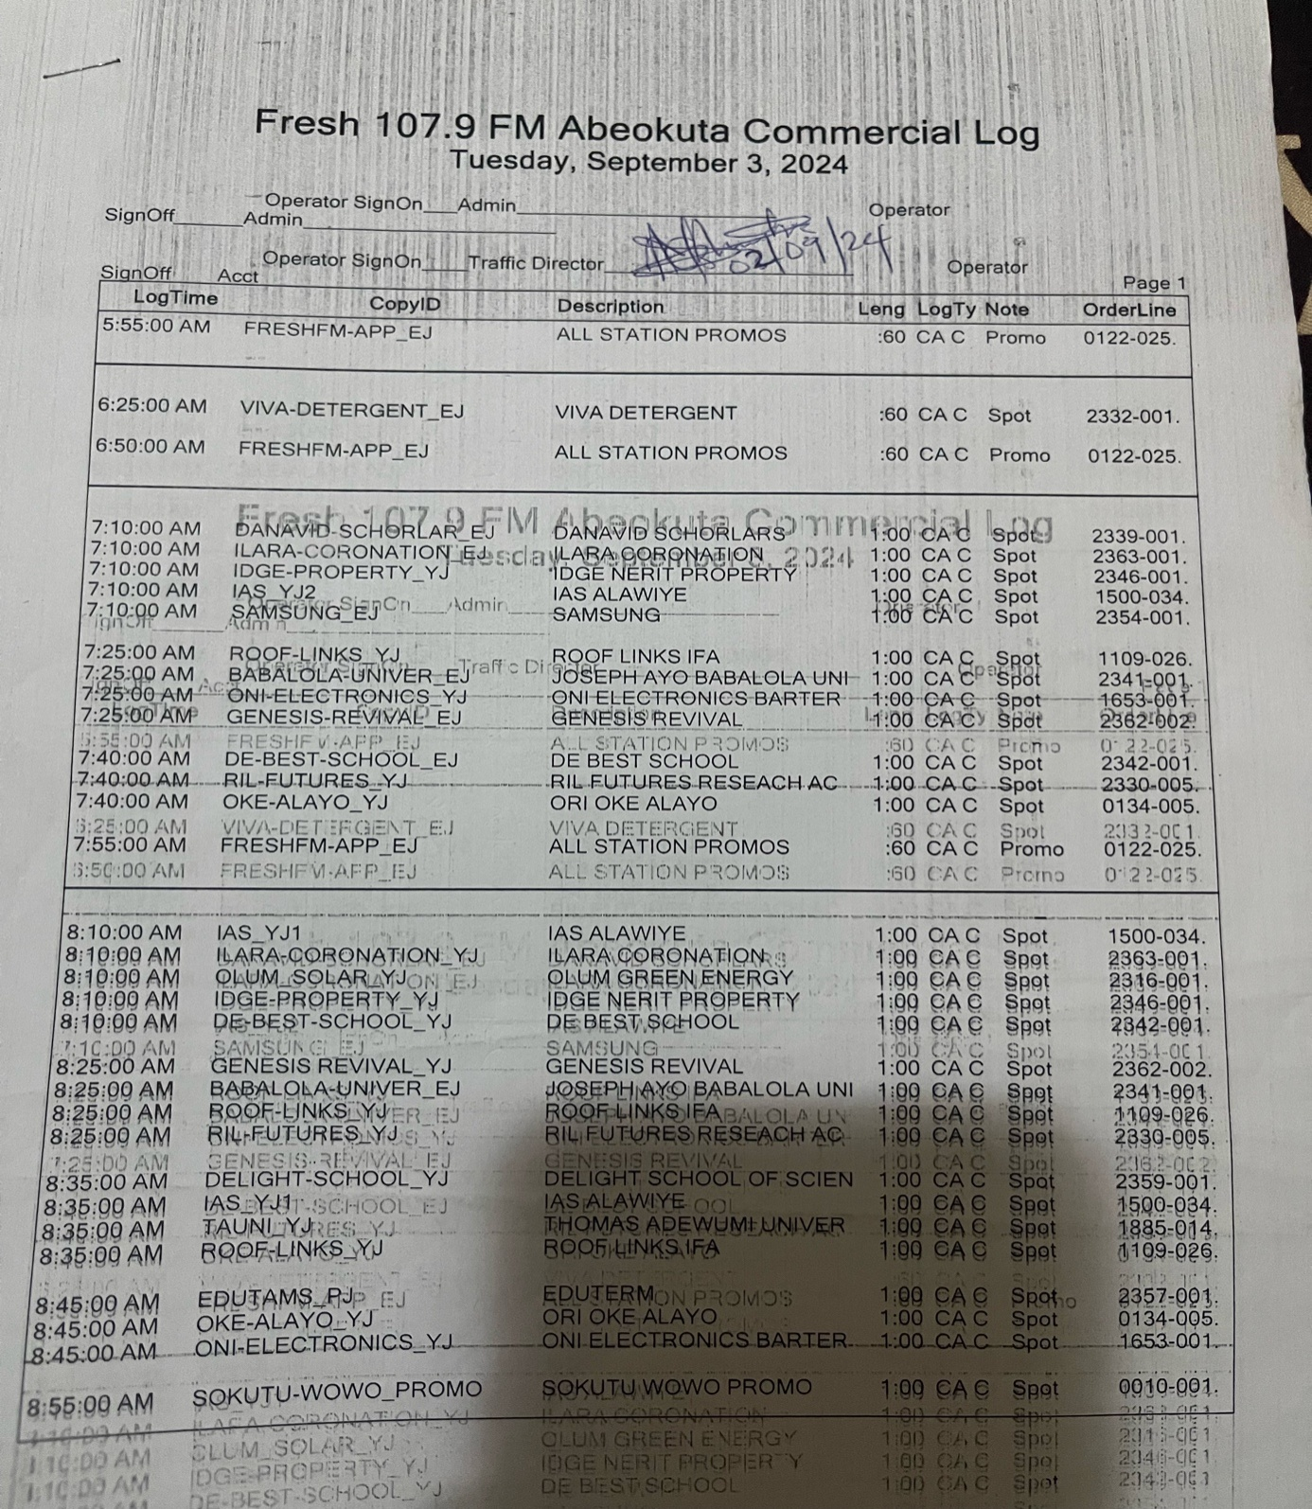
I also prepared some commercial log

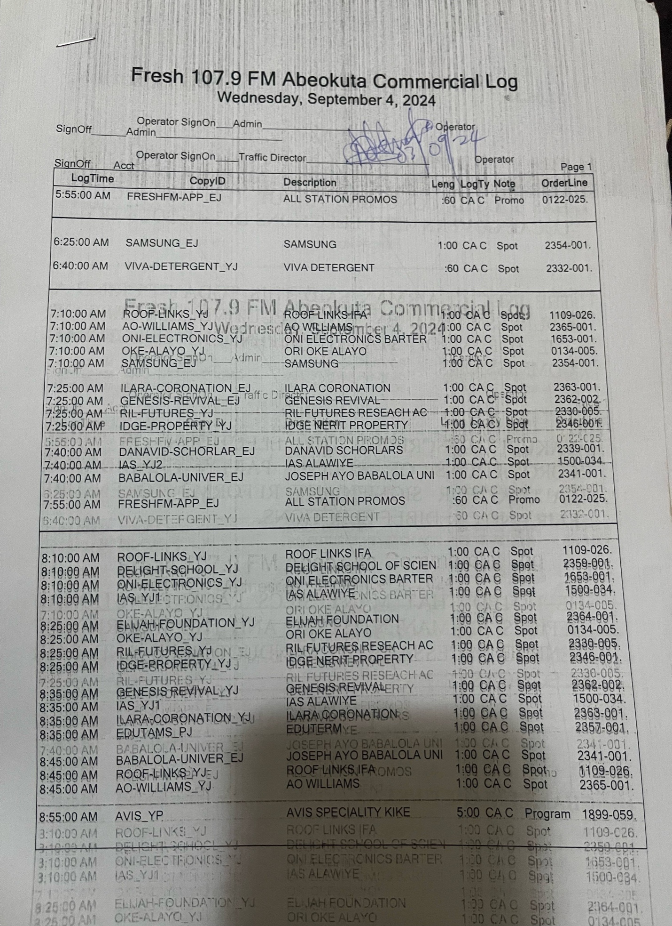
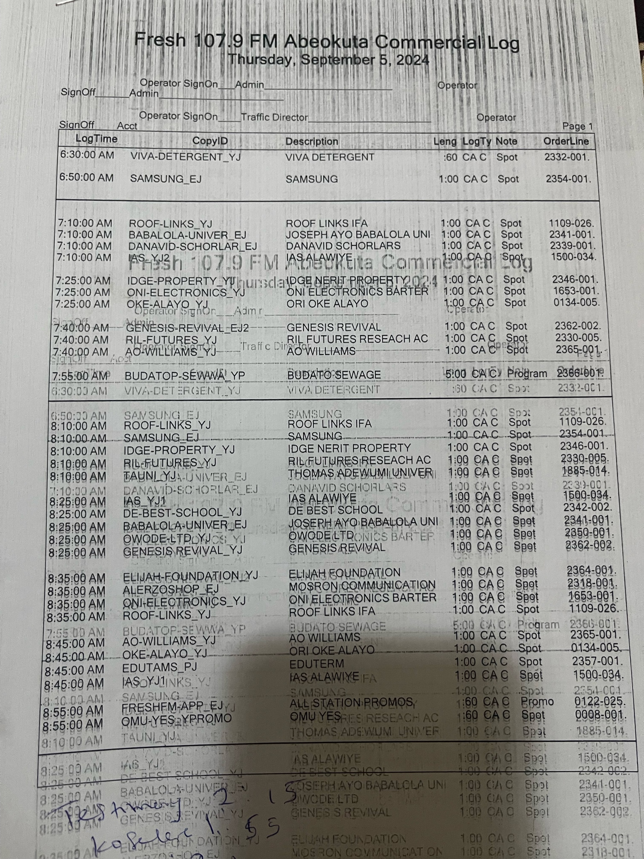

CHAPTER FOUR

Summary of experience acquired
Fresh FM was a learning curve for me and I was impacted and lectured by the news editors. I wasmainly in the newsroom and live studio during my industrial training; I was saddled with theresponsibility of sourcing for news from the internet, national newspaper and Tv stations.Some of the essential skills I developed include;

Production of some shows, Research and information gathering: This is how to use various sourcesto obtain relevant information, I conducted research on various news stories and also gatheredinformation from monitoring of other station’s news
Interviewing: I learnt how to draft out interview questions that will bringmeaningful response andalso how to conduct interviews.

Time management: Working with deadlines and also prioritizing task, I knew how to properlymanage my time.

Writing skills: I learnt how to effectively write for a radio station.
Presentations: Asides writing, I also presented my work for the editor for evaluations.

PRODUCTION
In a radio station's production department, they are responsible for creating and producing radiocontent such as jingles, commercials, promos, and other audio materials. The production teamworks on recording, editing, and mixing audio elements to create engaging and high-qualitycontent for broadcast. They play a crucial role in ensuring that the station's programming is well-produced and meets audience expectations.

MONITORING AND TRANSCRIBING
This is the process of listening and recording the news broadcast of a station for the purpose ofanalysis and to improve one’s listening abilities. This is also to gain insights into the content andstyle of the station’s news programming and to identify their pattern of news. This is a form ofsourcing for news at family FM because it improve the station news output and ensures accurateinformation.
I monitored news headlines and details from various radio station and I also transcribed it. I willread the news and present it to the news editor to test my presentation skills.

NEWS JUDGEMENT
This is the ability and skill to make a decision about what news stories are more important baseon the relevance and current situations. Its requires weighing factors like timelessness, humaninterest, significance, conflict among others factors to decide which stories shouldbe featured. Italso includes the consideration of the ethical and legal implications of a story.I would source for news stories online, read them and judge them base on theabove factors. This
is a subjective process and this is a criteria that makes a story news worthy.

NEWS ALIGNMENT
This is the process in which a station aligns its news with the mission, vision, values and targetaudience; this is simply ensuring that the station’s news output is in line with its overall brand.This is a determinant on which news to cover and how to frame them as well as the choice oflanguage, tone and style.

NEWS EDITING
This is the process of selecting, reviewing, and shaping news stories for broadcast. This is theresponsibility of the news editor, its requires making the news accurate, interesting and appealingto the station’s audience.Editors make changes to the stories to improve flow, clarity and to cut the parts that are irrelevantand add additional information to make it more engaging. This is a critical process of news
production as its ensures that the station news output is true to its values.

NEWS ARRANGEMENT
This is the process of organizing news for broadcast, this is what decides whichstories will beselected and the order in which the stories would be aired. Factors to consider in news judgmentinclude; relevance, timelessness, human interest among others, in order to create an engaging newsprogram that will keep the listeners informed.In Fresh FM, news is arranged in the order of; Federal governmentnews, State government news,crime news, entertainment news followed by foreign news and then sport news.

4.2 Conclusion
The student practicum experience scheme plays a very vital role in human resource development.It’s an avenue for students to develop new skills and expose them to what the real world entailsafter graduation.My work experience at Fresh FM has been effective in my personal and professionaldevelopment. The program helped me develop practicable skills, and gain a better understandingof the work place environment.I have discovered new strengths and creative abilities. In addition, Ihave gained the confidenceto pursue a career in the field of mass communicationand I am certain that this experience will setme up for success in my future endeavors.

4.3 Recommendations
➢ Place of attachment should provide compensation and reward for students as they’re alsoworkers in other to ease student’s expenses.
➢ I also recommend that students on industrial training should take the training veryimportant and be hardworking in their respective place of attachment

REFERENCES
Omar, M.Z., Rahman, M.N.A., Kofli, N.T., K., M.Darus, Z., Osman, S. A.,et al. (2008). Assessment ofengineering student’s perception after Industrial Training Placement. Paper presented at the 4thWSEAS/IASSME International Conference on EDUCATIONAL TECHNOLOGIES (EDUTE’08)

