
N

A TECHNICAL REPORT ON
STUDENTS INDUSTRIAL WORKING EXPERIENCE SCHEME
(SIWES)
Held at
MM TECH GLOBAL MULTI SERVICES ENTERPRISE
Prepared by:
NURAIN HAWAU OMOWUMI
ND/23/COM/PT/0184

SUBMITTED TO
DEPARTMENT OF COMPUTER SCIENCE
Institute of Information and Communication Technology
KWARA STATE POLYTECHNIC, ILORIN
IN PARTIAL FULFILLMENT OF PART OF THE REQUIREMENT FOR THE AWARD OF NATIONAL DIPLOMA IN COMPUTER SCIENCE.

Sept., – Dec., 2024

DEDICATION
I dedicate this technical report to the Almighty God, the giver of knowledge, wisdom and who is rich in mercy.

ACKNOWLEDGEMENT
I take this opportunity to express my profound gratitude and deep regards to the creator of heaven and earth, the one who knows the beginning and the end, the alpha and the omega, the Almighty Allah and also to my guides (MR & MRS ZUBAIR ), and to all those who has helped me during my SIWES programme.
I also extend my sincere gratitude to my colleagues and fellow interns for their cooperation and the friendly working environment they provided. The team spirit and collaboration made the work experience more enjoyable and productive. I appreciate the encouragement, teamwork, and shared learning experiences that contributed significantly to my professional development. The interactions with my peers helped me understand the importance of networking and teamwork in a professional setting.
Additionally, I wish to acknowledge my family and friends for their unwavering support, encouragement, and prayers during this period. Their moral and financial support gave me the strength to persevere and excel during my industrial attachment. Their constant motivation and belief in my abilities inspired me to give my best effort throughout the training. This training has been an invaluable learning opportunity, and I look forward to applying the knowledge and skills gained in my future career. I am confident that the lessons learned during this period will significantly contribute to my personal and professional growth.

PREFACE
The student industrial work experience scheme (SIWES) helps in exposing students to the practical application of their course and to get used to equipment and machines used in the factory. The SIWES was established to promote student skill in industrial practice and pre – expose them to working experience in industrial setting.
The SIWES program covered a period of four months from September to December 2024 and it is a partial fulfillment of a two year academic program to obtain an OND certification. The report explains the description of the work done.

TABLE OF CONTENT
Title page i
Dedication ii
Acknowledgements iii
Preface iv
Table of Contents v
CHAPTER ONE
1.0 Students Industrial Work Experience Scheme 1
1.1 History of Siwes 2 - 3
1.2 Bodies Involved in the Management of Siwes
Programme and their Roles 3 - 4
1.3 Aim and Objectives of Siwes 4
1.4 Roles of Student 4 - 5
1.5 The Need for Industrial Training 5
1.6 Benefit of Industrial Training 5
1.7 The Logbook 5
CHAPTER TWO
2.0 Introduction to Computer 6
2.1 Careers Opportunities Under Computer 6 - 7
2.2 Graphic Design and its Components 7 - 8
2.2.1 Components of Graphic Design 8 - 11
2.3 Corel Draw Components and Tools 12
2.3.1 Components of Corel Draw 12 - 13
2.3.2 Tools Used in Corel Draw 14 - 15
2.4 Adobe Photoshop Components and Tools 15 - 16
2.4 Components of Adobe Photoshop 16 - 17
CHAPTER THREE
3.0 Power Point 18
3.1.1 Launching Power Point 18 - 19
3.1.2 Benefits of Power Point 19
3.2 Microsoft Word 19
3.2.1 What is Microsoft Word 19
3.2.2 Step in Launching Microsoft Word 19 - 20
3.2.3 The Menu Bar 20
3.3 Formatting Toolbar 21
3.4 Formatting Text 21- 22
3.5 Saving Document 22 - 23
3.6 Printing of File 23
CHAPTER FOUR
4.0 System Maintenance 24 - 26
4.1 Computer Network 26 - 27
4.1.1 Hub, Switch and Router 27 - 28
4.2 Internet Protocols 28
4.3 Media Access Control 28
CHAPTER FIVE
5.0 Conclusion 29
5.1 Personal Impression About the Organization 29
5.2 Suggestion and Recommendation to Kwara State Polytechnic 30
CHAPTER ONE
INTRODUCTION
1.0 STUDENTS INDUSTRIAL WORK EXPERIENCE SCHEME
The student work experience scheme (SIWES) is a worldwide program practiced in countries like Japan, Australia, USA, Europe, and in African countries too. It is popularly known as co-operative education and referred to as sandwich in Europe. It is a four (4) months students industrial work experience scheme (SIWES) taken in the two year of the diploma program, where the students go to various establishments related to their course of study.
The program was initially introduced in Nigeria by the Industrial Training Fund (I.T.F.) which was established under Decree 47 of 1972 by the Supreme Military Council, headed by General Yakubu Gowon. The Decree was billed to take effect from 31st March, 1974 and had as its core objective, the gradual reduction of the percentage of foreign participation in most of Nigeria’s economic activities, accompanied by a systematic cooperation of locally oriented skilled manpower into the vast economic sector.
One of the key functions of the ITF is to work as cooperative body with industry and commerce where students in institutions of higher learning can undertake mid-career work experience attachment in industries which are compatible with student’s area of study. The students Industrial Work Experience Scheme (SIWES) is a skill Training program designed to expose and prepare students for the Industrial work situation which they are likely to meet after graduation. Participation in SIWES has become a necessary pre-condition for the award of diploma and degree certificate in specific disciplines in most institutions of higher learning in the country in accordance with the education policy of government.

1.1 HISTORY OF SIWES
SIWES was founded in 1973 by ITF (Industrial Training Funds) to address the problem of tertiary institution graduates' lack of appropriate skills for employment in Nigerian industries. The Students' Industrial Work Experience Scheme (SIWES) was founded to be a skill training programme to help expose and prepare students of universities, Polytechnics and colleges of education for the industrial work situation to be met after graduation.
This system facilitates the transfer from the classroom to the workplace and aids in the
application of knowledge. The program allows students to become acquainted with
and exposed to the experience required in handling and operating equipment and
machinery that are typically not available at their schools.
Prior to the establishment of this scheme, there was a rising concern and trend among
industrialists that graduates from higher education institutions lacked appropriate
practical experience for employment. Students who entered Nigerian universities to
study science and technology were not previously trained in the practical aspects of
their chosen fields. As a result of their lack of work experience, they had difficulty
finding work.
As a result, employers believed that theoretical education in higher education was
unresponsive to the needs of labor employers. Thousands of Nigerians faced this
difficulty till 1973. The fund's main motivation for establishing and designing the
scheme in 1973/74 was launched against this context.
The ITF (Industrial Training Fund) organization decided to aid all interested Nigerian
students and created the SIWES program. The federal government officially approved
and presented it in 1974. During its early years, the scheme was entirely supported by
the ITF, but as the financial commitment became too much for the fund, it withdrew
in 1978. The National Universities Commission (NUC) and the National Board for
Technical Education (NBTE) were given control of the scheme by the federal
government in 1979. The federal government handed over supervision and
implementation of the scheme to ITF in November 1984. It was taken over by the
Industrial Training Fund (ITF) in July 1985, with the federal government bearing
entire responsibility for funding.
This system facilitates the transfer from the classroom to the workplace and aids in the application of knowledge. The program allows students to become acquainted with and exposed to the experience required in handling and operating equipment and machinery that are typically not available at their schools.
Prior to the establishment of this scheme, there was a rising concern and trend among industrialists that graduates from higher education institutions lacked appropriate practical experience for employment. Students who entered Nigerian universities to study science and technology were not previously trained in the practical aspects of their chosen fields. As a result of their lack of work experience, they had difficulty finding work.
As a result, employers believed that theoretical education in higher education was unresponsive to the needs of labor employers. Thousands of Nigerians faced this difficulty till 1973. The fund's main motivation for establishing and designing the scheme in 1973/74 was launched against this context.
The ITF (Industrial Training Fund) organization decided to aid all interested Nigerian students and created the SIWES program. The federal government officially approved and presented it in 1974. During its early years, the scheme was entirely supported by the ITF, but as the financial commitment became too much for the fund, it withdrew in 1978. The National Universities Commission (NUC) and the National Board for Technical Education (NBTE) were given control of the scheme by the federal government in 1979. The federal government handed over supervision and implementation of the scheme to ITF in November 1984. It was taken over by the Industrial Training Fund (ITF) in July 1985, with the federal government bearing entire responsibility for funding.
The Student Industrial Work Experience Scheme (SIWES), is a skill training program, it was initiated in the year 1973 by industrial training fund (ITF). It is a tripartite program involving the students, the universities and industrial. It is found by the Federal Government of Nigeria and jointly coordinated by the ITF and the National Universities Commission (NUC). It is a skill training program designed to expose and prepare students of tertiary institution for the industrial work situation they are likely torment after graduation. The scheme also afford the students the opportunity of familiarizing and exposing themselves to the needed experience in handing equipment and machinery.
1.2 BODIES INVOLVED IN THE MANAGEMENT OF SIWES PROGRAMME
AND THEIR ROLES
The bodies involved are:
- The Federal Government
- Industrial Training Fund (ITF)
Other supervising agents are:
- National University Commission (NUC)
- National Board for Technical Education (NBTE)
- National Council for Colleges of Education (NCE)

The Functions of these Agencies above include:
- Establish SIWES and accredit SIWES unit in the approved institutions
- Formulate policies and guideline for participating bodies and instructions as well as appointing SIWES coordinators and supporting staff.
- Supervise students at their places of attachment and sign their log-books and IT Forms.
- Ensure payment of allowances for the students and supervisors
- Ensure adequate funding of the scheme
1.3 AIM AND OBJECTIVES OF SIWES
Specifically the objectives of the students industrial work experience scheme (SIWES) are to
- Prepare students for the industrial work situation they are to meet after graduation
- Enlighten and strengthen employer involvement in the entire educational process and prepared students for employment in industry and commerce.
- Make the transition from school to the world of work easier and enhance student contacts for late job placement.
Provide an avenue for student in the higher learning to acquire industrial skill and experience in their course of study, which are restricted to engineering and technology.
1.4 ROLES OF STUDENT
- Attend SIWES orientation programme before going on attachment.
- Comply with the establishment’s rule and regulation.
- Arrange living accommodation during the period of attachment.
- Record all training activity done and other assignment in the log book.
- Complete SPEI from ITF, FORM 8 and get it endorsed by the employer for submission to the ITF
1.5 THE NEED FOR INDUSTRIAL TRAINING
1. The purpose for training is to guide, enlighten and empower students to participate effectively.
2. It helps to derive the maximum benefit from doing so.
3. The need to combine theoretical knowledge with practical skills in order to produce results in form of goods and services or be production.
1.6 BENEFIT OF INDUSTRIAL TRAINING
1. It exposes students to the environment in which they will eventually work, thereby enabling them to see how future profession and organized in practice.
2. It provides an enabling environment where students can develop and enhance their personal attribute such as critical thinking creativity.
1.7 THE LOGBOOK
The logbook issued to student on attachment by the institution was used to record all daily activities that took place during the period of attachment, and it was checked and endorse by the industry based/institution based supervisors and ITF during supervision.

CHAPTER TWO
2.0 INTRODUCTION TO COMPUTER
A computer is an electronic device that can store, process, and retrieve data. It consists of hardware components like the Central Processing Unit (CPU), memory devices (such as RAM and storage drives), input devices (keyboard, mouse, scanner), output devices (monitor, speakers, printer), and communication interfaces (network card, USB ports). Computers use software, which includes operating systems and application programs, to manipulate data and interact with users. They are used across industries and sectors for tasks ranging from basic data entry to advanced scientific computation.
Historically, computers have evolved from early mechanical calculators to modern digital devices capable of handling vast amounts of information. Today's computers fall into categories such as desktop PCs, laptops, tablets, smart phones, servers, supercomputers, and embedded systems. The concept of a computer encompasses both the physical device and the abstract notion of computation, where data is transformed according to a predefined set of rules.
2.1 CAREERS OPPORTUNITIES UNDER COMPUTER
Career opportunities in the field of computers are vast and diverse, offering a wide range of options for individuals with different interests and skills. Some common career paths under computer-related fields include:
1. Web Developer: Responsible for designing and creating websites.
2. Computer Systems Analyst: Analyzes an organization's computer systems and procedures to help organizations operate more efficiently.
3. Computer Systems Manager: Oversees the implementation of computer systems within an organization.
4. IT Project Manager: Manages the planning, execution, and closing of projects related to information technology.
5. Information Security Analyst: Protects an organization's computer systems and networks from cyber threats.
6. Database Administrator: Manages and maintains databases to ensure they operate efficiently.
7. Software Developer: Designs, develops, and tests software applications.
8. Network Administrator: Manages an organization's computer networks
9. Computer Science Researcher: Conducts research in various areas of computer
science to advance knowledge and technology.
10. Artificial Intelligence Specialist: Develops programs that simulate human
intelligence.
2.2 GRAPHIC DESIGN AND ITS COMPONENTS
Graphic design is the practice of creating and using visual or textual content to communicate ideas to an audience or elicit a specific effect.
That’s why graphic design is commonly categorized as a form of communication design.
Visuals in this context can take on many forms. From a company logo, event flyer, newspaper layout, business website, mobile app, or video game, graphic design encompasses many different media and sub-categories.
Graphic designs are often created with a specific goal in mind, usually relating to a company or business plan.
The design choices should align with this goal to produce a visually pleasing yet practical creation: graphic design is like art but guided by business objectives. For instance, someone may design a music festival flyer to advertise the bands that will perform and give viewers a sense of what type of vibe they can expect to experience if attending.
An upbeat, electronic music festival flyer will likely have very different text, color, image, and design choices than a folk music festival flyer.
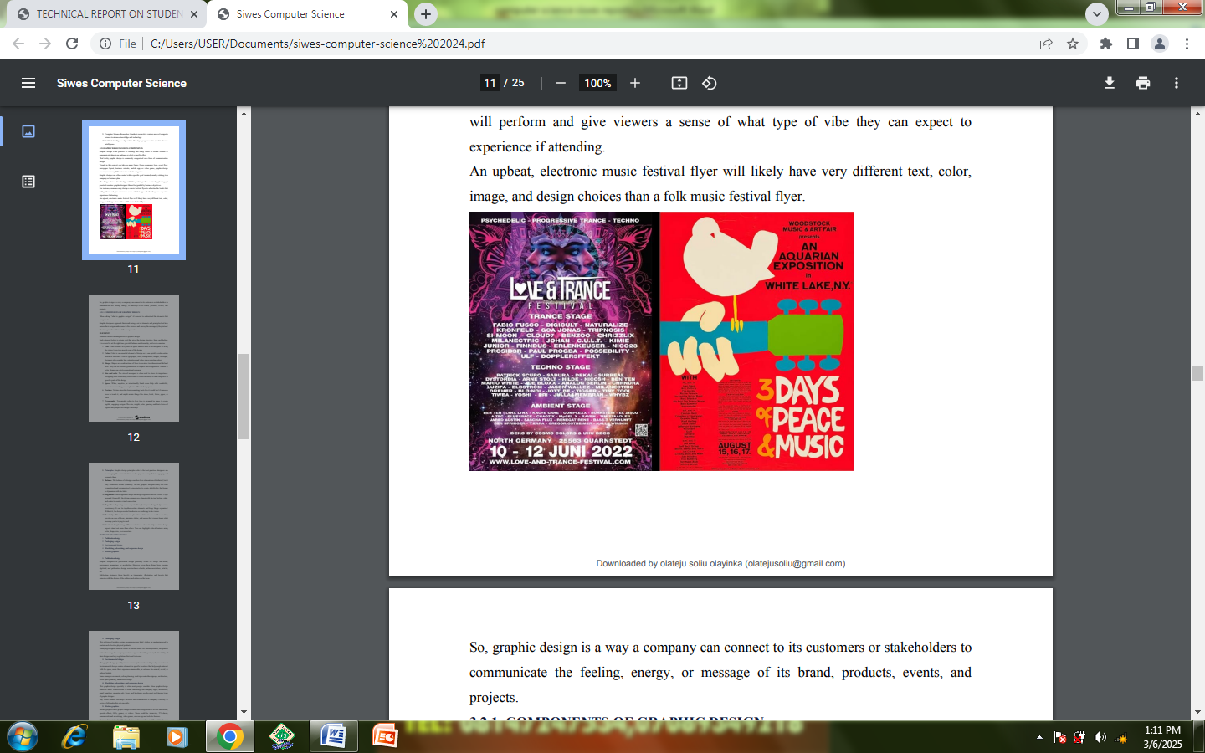
So, graphic design is a way a company can connect to its customers or stakeholders to communicate the feeling, energy, or message of its brand, products, events, and projects.
2.2.1 COMPONENTS OF GRAPHIC DESIGN
When asking “what is graphic design?” it’s crucial to understand the elements that comprise it. Graphic designers approach their work using a set of elements and principles that help ensure their designs make sense to the viewers and convey the message(s) they intend.
Here’s a quick breakdown of the components.

ELEMENTS
Elements are the building blocks of graphic design. Each category below is a basic unit that gives the design structure, form, and feeling. It is crucial to set the right tone, provide balance and hierarchy, and evoke emotion.
1. Line: Lines connect two points in space and are used to divide space or bring the viewer’s eye to a specific part of the design.
2. Color: Color is an essential element of design as it can quickly evoke certain moods or emotions. Used in typography, lines, backgrounds, images, or shapes, designers also consider hue, saturation, and value when selecting colors.
3. Shape: Shapes are combinations of lines to create a two-dimensional defined area. They can be abstract, geometrical, or organic and recognizable. Similar to color, shapes can elicit an emotional response.
4. Size and Scale: The size of an aspect is often used to stress its importance: Designing with contrasting sizes creates a visual hierarchy or adds emphasis to specific parts of the design.
5. Space: White, negative, or intentionally blank areas help with readability, prevent overcrowding, and emphasize different design parts.
6. Texture: Texture describes how something looks like it would feel if someone were to touch it, and might mimic things like stone, brick, fabric, paper, or sand.
7. Typography: Typography refers to how type is arranged in space to create legible, engaging designs. The size, weight, color, spacing, and font choice all significantly impact the design’s message.
8. Principles: Graphic design principles refer to the best practices designers use in arranging the elements above on the page in a way that is engaging and connects them.
9. Balance: The balance of a design considers how elements are distributed, but it only sometimes means symmetry. In fact, graphic designers may use both symmetrical and asymmetrical design tactics to create stability for the former or dynamism with the latter.
10. Alignment: Good alignment keeps the design organized and the viewer’s eyes engaged. Generally, the design elements are aligned with the top, bottom, sides, and center to create a visual connection.
11. Repetition: Repeating some aspects throughout your design helps ensure consistency. It can tie together certain elements and keep things organized. Without it, the design can feel incohesive or confusing to the viewer.
12. Proximity: Where elements are placed in relation to one another can help provide an area of focus, minimize clutter, and ensure that viewers know what message you’re trying to send.
13. Contrast: Emphasizing differences between elements helps certain design aspects stand out more than others. You can highlight critical features using color, shape, size, or even texture.
TYPES OF GRAPHIC DESIGN
1. Publication design
2. Packaging design
3. Environmental Design
4. Marketing, Advertising, and Corporate Design
5. Motion Graphics
1. Publication Design
Graphic designers in publication design generally create for things like books, newspapers, magazines, or newsletters. However, even these things have become digitized, and publication design now includes e-books, online newsletters, articles, etc. Publication designers focus heavily on typography, illustration, and layouts that coincide with the desires of the authors and editors on the team.
2. Packaging Design
This subtype of graphic design encompasses any label, sticker, or packaging used to contain and advertise physical products. Packaging designers must be aware of current trends for similar products, the general feel and message the company wants to express about the product, the feasibility of their designs, and any regulations that need to be met.
3. Environmental Design
This graphic design specialty is less commonly known but is frequently encountered. Environmental design curates elements in specific locations that help people interact with the space, make their experience memorable, or enhance the natural, social, or cultural habitat. Some examples are murals, urban planning, road signs and other signage, architecture, event space planning, and interior design.
4. Marketing, Advertising, and Corporate Design
This graphic design specialty is what most people consider when graphic design comes to mind. Products used in brand marketing, like company logos, newsletters, email templates, magazine ads, flyers, and brochures, are the most well-known types of graphic designs. Any visual element that helps advertise and communicate a company’s identity or services falls under this sub-specialty.
5. Motion Graphics
Motion graphics takes graphic design elements and brings them to life via animations, special effects, GIFs, games, or videos. These could be in movies, TV shows, commercials and advertising, video games, or even app and website features. Compared to print and publication design, motion graphics is still a relatively new subset of design. However, this field is expected to grow with more things becoming entertainment-based and digitized.

2.3 COREL DRAW; COMPONENTS AND TOOLS
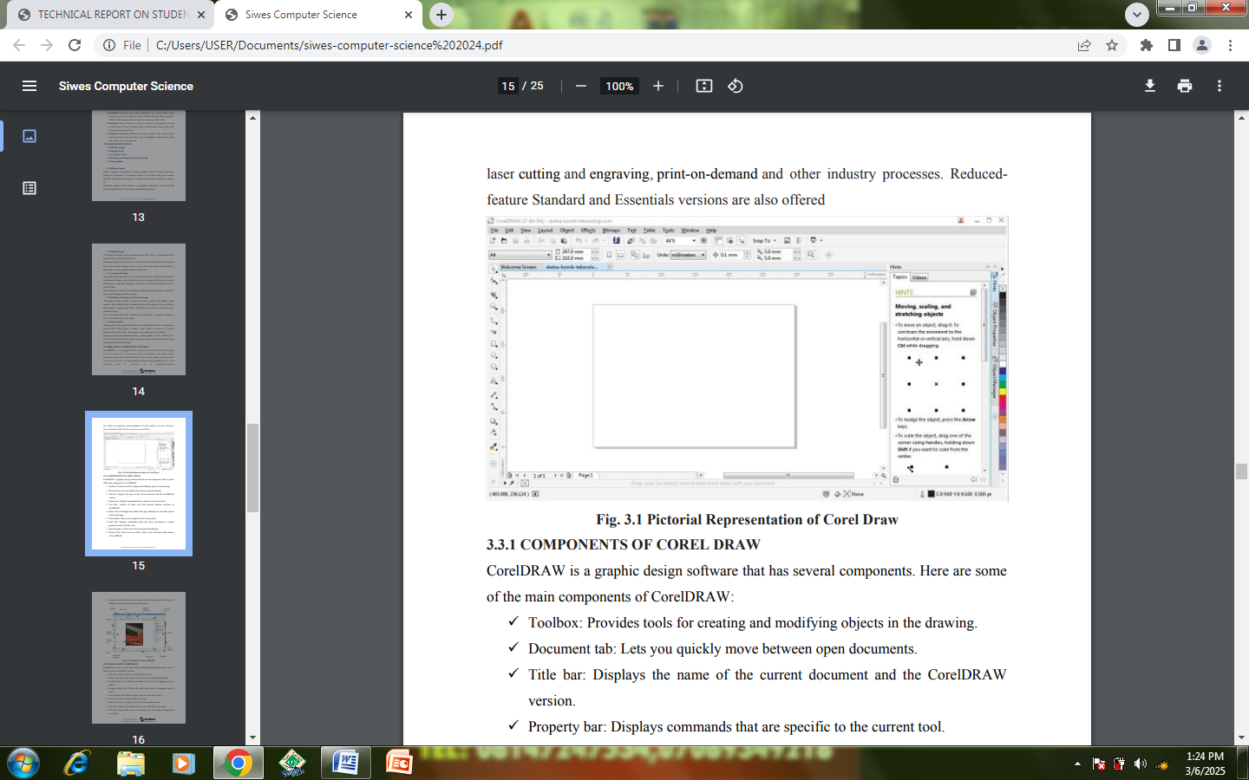
Corel DRAW is a vector graphics editor developed and marketed by Alludo (formerly Corel Corporation). It is also the name of the Corel graphics suite, which includes the bitmap-image editor Corel Photo-Paint as well as other graphics-related programs (see below). It can serve as a digital painting platform, desktop publishing suite, and is commonly used for production art in sign making, vinyl and laser cutting and engraving, print-on-demand and other industry processes. Reduced-feature Standard and Essentials versions are also offered.

2.3.1 COMPONENTS OF COREL DRAW
CorelDRAW is a graphic design software that has several components. Here are some of the main components of CorelDRAW:
- Toolbox: Provides tools for creating and modifying objects in the drawing.
- Document tab: Lets you quickly move between open documents.
- Title bar: Displays the name of the current document and the CorelDRAW version.
- Property bar: Displays commands that are specific to the current tool.
- Tool Box: Consists of many tools that provide different functions in CorelDRAW.
- Rulers: Show the height and width of the page and help to create other objects on the Corel page.
- Color Palette: Allows you to apply the color of any object.
- Status Bar: Displays information about the cursor movements or symbol properties such as the fill or size.
- Page Navigator: Used to move between pages and add pages.
- Dockers Tabs: Allow access to effects, styles, colors, and many other features of CorelDRAW.
- Layouts: Contain additional tools and are activated by pressing the left key and holding down on any tool button with the mouse.
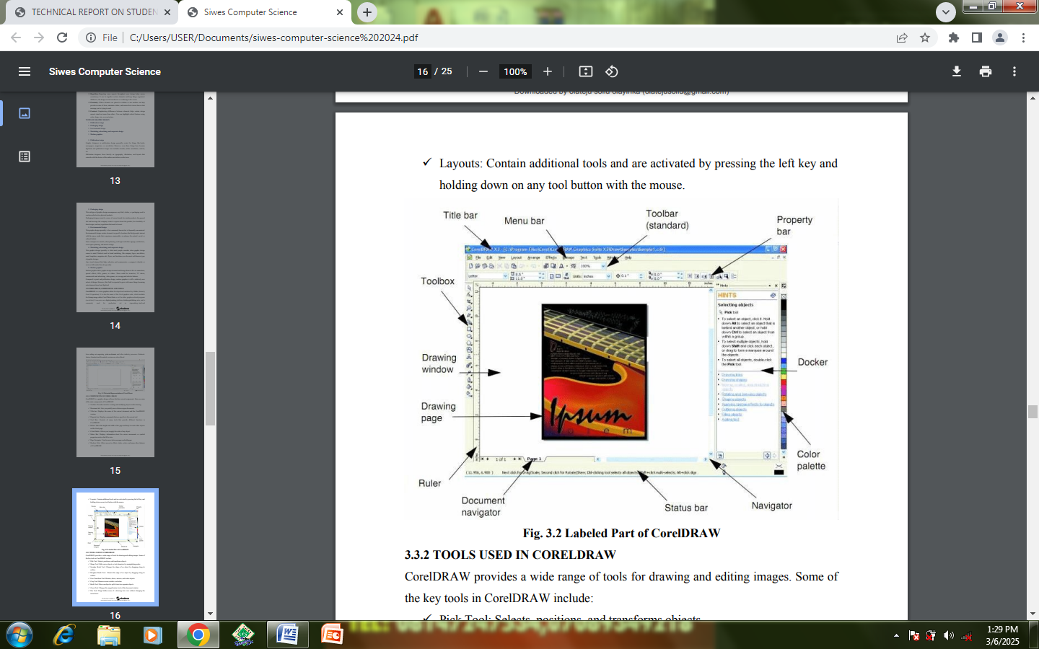

2.3.2 TOOLS USED IN CORELDRAW
Corel DRAW provides a wide range of tools for drawing and editing images. Some of
the key tools in Corel DRAW include:
- Pick Tool: Selects, positions, and transforms objects.
- Shape Tool: Edits curve objects or text characters by manipulating nodes.
- Smudge Brush Tool: Changes the shape of an object by dragging along its outline.
- Roughen Brush Tool: Distorts the edge of an object by dragging along its outline.
- Free Transform Tool: Rotates, skews, mirrors, and scales objects.
- Crop Tool: Removes areas outside a selection.
- Knife Tool: Slices an object to split it into two separate objects.
- Zoom Tool: Changes the magnification level of the document window.
- Pan Tool: Drags hidden areas of a drawing into view without changing the zoom level.
- Freehand Tool: Draws curves and straight line segments.
- 2-Point Line Tool: Draws a straight line from the starting point to the end⎫ point.
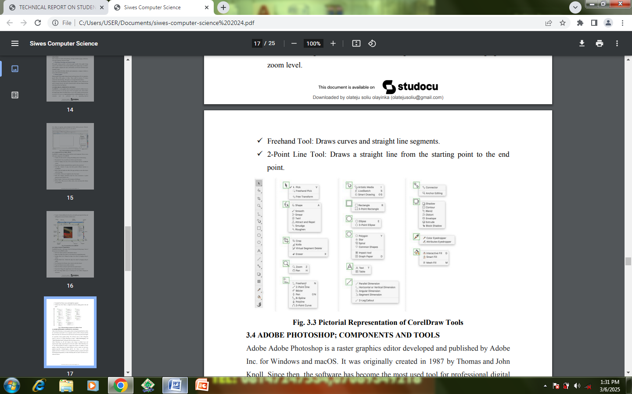
2.4 ADOBE PHOTOSHOP; COMPONENTS AND TOOLS.
Adobe Adobe Photoshop is a raster graphics editor developed and published by Adobe Inc. for Windows and macOS. It was originally created in 1987 by Thomas and John Knoll. Since then, the software has become the most used tool for professional digital art, especially in raster graphics editing. The software's name is often colloquially used as a verb (e.g. "to Adobe Photoshop an image", "Adobe Photo- shopping", and "Adobe Photoshop contest") although Adobe discourages such use. Adobe Photoshop can edit and compose raster images in multiple layers and supports masks, alpha compositing and several color models. Adobe Photoshop uses its own PSD and PSB file formats to support these features. In addition to raster graphics, Adobe Photoshop has limited abilities to edit or render text and vector graphics (especially through clipping path for the latter), as well as 3D graphics and video. Its feature set can be expanded by plug-ins; programs developed and distributed independently of Adobe Photoshop that run inside it and offer new or enhanced features.

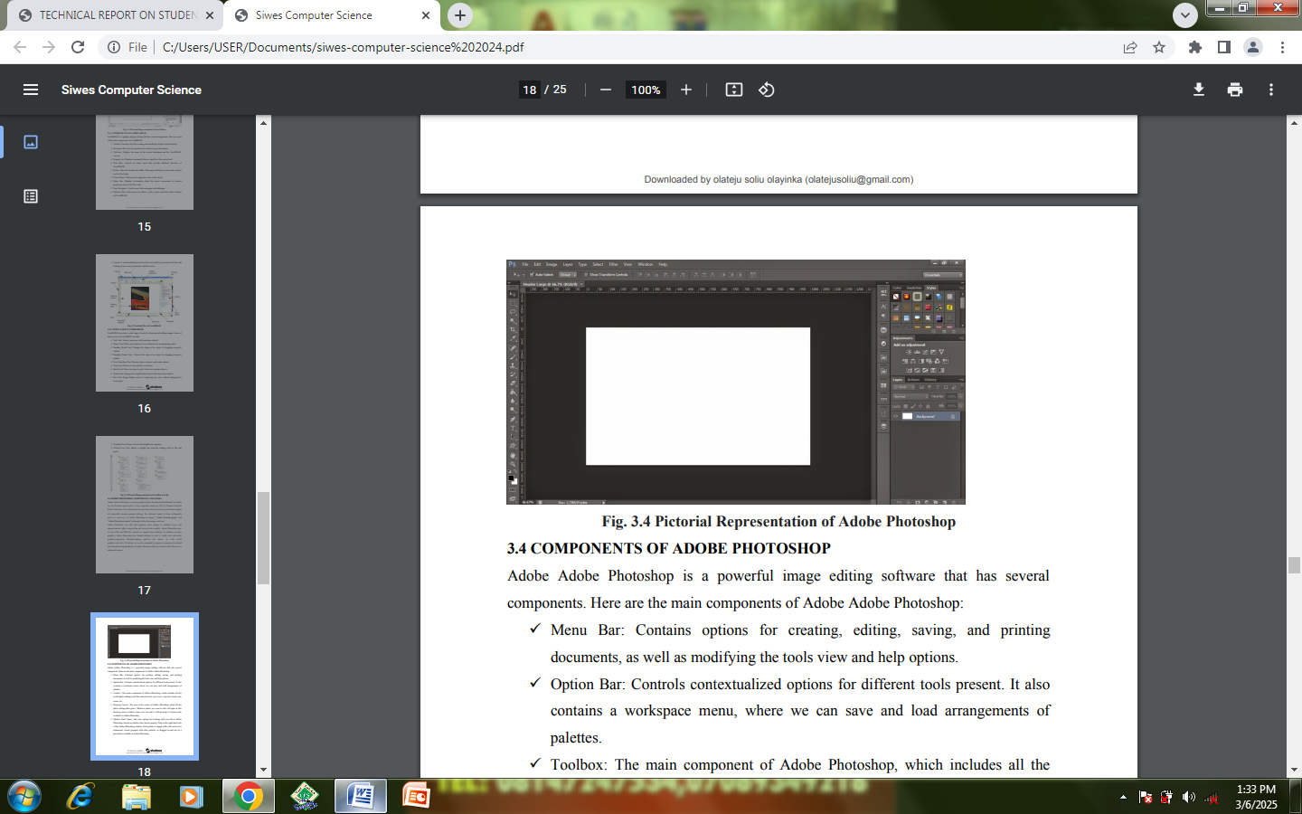

2.4 COMPONENTS OF ADOBE PHOTOSHOP
Adobe Adobe Photoshop is a powerful image editing software that has several components. Here are the main components of Adobe Adobe Photoshop:
- Menu Bar: Contains options for creating, editing, saving, and printing⎫ documents, as well as modifying the tools view and help options.
- Option Bar: Controls contextualized options for different tools present. It also⎫ contains a workspace menu, where we can save and load arrangements of palettes.
- Toolbox: The main component of Adobe Photoshop, which includes all the⎫ useful photo editing tools like selection tool, move tool, crop tool, brush, pen, eraser, etc.
- Drawing Canvas: The area in the center of Adobe Photoshop where all the⎫ photo editing takes place. Whatever photo you want to edit will open in this drawing canvas window where you can edit it with the help of various tools available in Adobe Photoshop.
- Palettes: Each “panes” that carry options for working with your file in Adobe⎫ Photoshop, known as palettes (also known panels), float on the right-hand side of the Adobe Photoshop window. Each palette is tagged with a tab and can be minimized, closed, grouped with other palettes, or dragged in and out of a panel dock available in Adobe Photoshop.
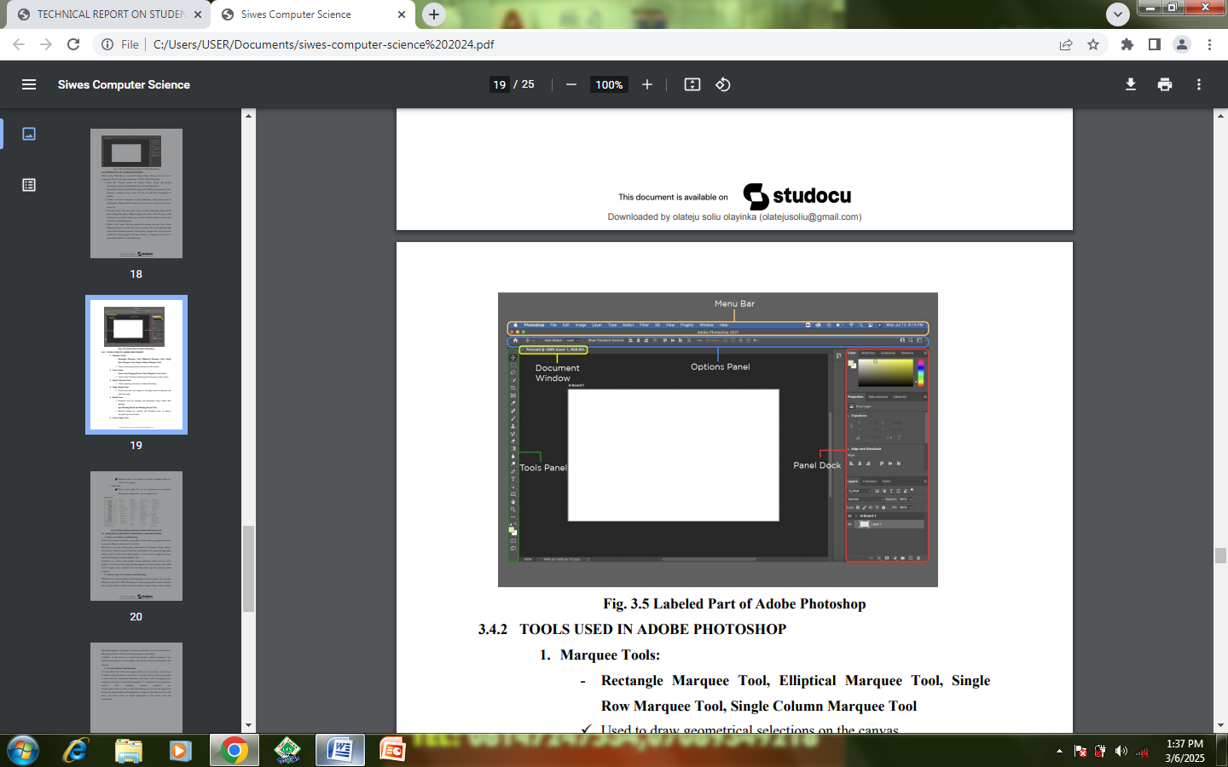

CHAPTER THREE
3.0 POWER POINT
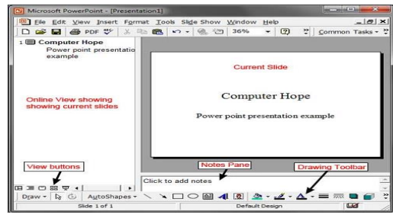
Sometimes abbreviated as PP or PPT, PowerPoint is a presentation program developed by Microsoft that creates a slide show of important information, charts, and images for a presentation. It is most often used for business and school presentations.

PowerPoint slides may contain only text, or they can include pictures, videos, or animated text and images. Text may be formatted in the same ways as in Microsoft Word, with custom color, size, and font type.
3.1.1 LAUNCHING POWER POINT
Use the following steps to launch PowerPoint manually from a windows system:
1. Open My Computer.
2. Click or select the C: drive. If Microsoft Office is installed on a drive other than the C: drive, select that drive instead.
3. Navigate to the Program Files (x86) folder, then the Microsoft Office folder.
4. In the Microsoft Office folder, if there is a root folder, open that folder. Then open the Office XX folder, where XX is the version of Office (e.g.,
Office16 for Microsoft Office 2016). If there is no root folder, look for and open a folder with "Office" in the name.
5. Look for a file named POWERPNT.EXE and double-click that file to start Microsoft PowerPoint.
3.1.2 BENEFITS OF POWER POINT
- PowerPoint provides multiple benefits to users, including:
- It is widely used, and considered the "standard" for presentation software. If you create a PowerPoint presentation, it's more likely it will be easier for others to open and view.
- It includes many optional presentation features, including slide transitions,• animations, layouts, templates, and more.
- It offers the option to export its slides to alternative file formats, including• GIF and JPG images, MPEG-4 video, PDF, RTF (rich text format), WMV (Windows Media Video), and PowerPoint XML.
3.2 MICROSOFT WORD
3.2.1 WHAT IS MICROSOFT WORD
A word processor is a computer program used to create and print text documents that might otherwise be prepared on a typewriter. The key advantage of a word processor is its ability to make changes easily, such as correcting spelling, adding.
3.2.2 STEPS IN LAUNCHING MICROSOFT WORD
Before you get started with Microsoft Word (commonly referred to as MS Word), you will need to locate and open it from the computer. It may be on your desktop.
From the computer desktop:
- Double-click on the MS Word icon
Go to the Start menu if the MS Word icon is not on the desktop: 1. Click ►Start ►Programs ►Microsoft Word* *Occasionally, Microsoft Word will be in a folder called ―Microsoft Office‖ or similar – this will make one more step between ―Programs‖ and ―Microsoft Word‖ in the diagram above. MS Word will open a blank page called ―Document 1.‖.
3.2.3 THE MENU BAR
The Menu Bar is a common sight in almost all Microsoft Windows programs. It features text-based menus, on which are listed virtually every option. Each menu expands when clicked (with the left mouse button), offering many options categorized by specific tasks.
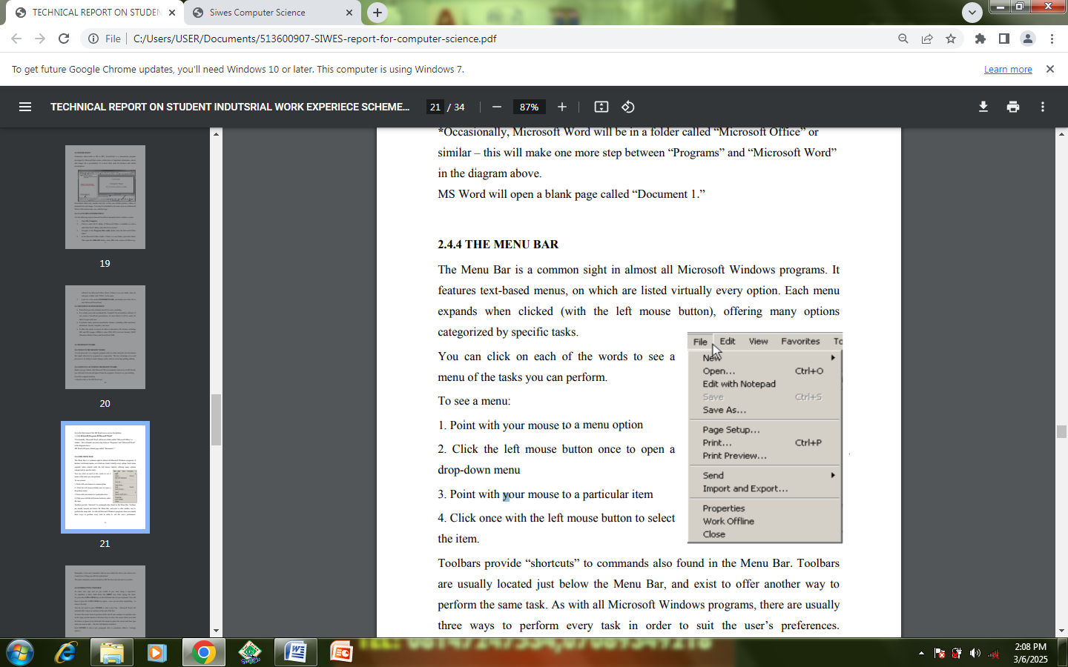
You can click on each of the words to see a menu of the tasks you can perform.
To see a menu:
1. Point with your mouse to a menu option
2. Click the left mouse button once to open a drop-down menu
3. Point with your mouse to a particular item
4. Click once with the left mouse button to select the item.

Toolbars provide ―shortcuts‖ to commands also found in the Menu Bar. Toolbars are usually located just below the Menu Bar, and exist to offer another way to perform the same task. As with all Microsoft Windows programs, there are usually three ways to perform every task in order to suit the user’s preferences.
Remember, if you can’t remember what an icon stands for, hover your mouse over it and a box will pop up with the explanation! The most commonly used commands in MS Word are also the most accessible.

3.3 FORMATTING TOOLBAR
To enter text, type just as you would if you were using a typewriter. To capitalize a letter, hold down the SHIFT key while typing the letter. Or, press the CAPS LOCK key on the left hand side of your keyboard. You will have to press the CAPS LOCK key again – once you are done capitalizing – to remove the lock.
You do not need to press ENTER to start a new line – Microsoft Word will automatically wrap your sentence at the end of the line. To move the cursor from its position at the end of your sentence to anywhere else on the page, use the mouse or the arrow keys to move the cursor where you want the letters or spaces to be (left-click the mouse to place the cursor) and then type what you want to add — the text will adjust to include it. Press ENTER to start a new paragraph (this is sometimes called a ―carriage return‖).
3.4 FORMATTING TEXT
Changing the look of what you’ve written is called ―formatting‖. This can include changing the text style, size, color, and more. You can also make bold, underline, or italicize when using MS Word. These features do not have to be used independently of each other either – in other words, you can make bold, underline, and italicize a single piece of text.
To make text really stand out, you can also combine this with alignment and size to produce a heading in bold, italics, underlined, sized and centered:
Sale at Bob’s Paint Supplies!
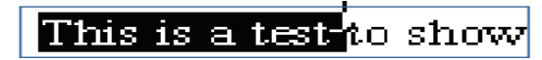
In order to apply certain stylistic or other changes to text, you must first HIGHLIGHT the text. This is a common procedure in Microsoft Windows applications, and like being able to successfully navigate the mouse around your screen, the ability to highlight well is one that you want to master.

To highlight text, you start by placing your cursor (by moving the mouse) directly to one side of the selection that you are working with. In the case above, the user wants to highlight the phrase ―This is a test‖ but NOT ―to show.‖ In this example, the user should place the cursor directly to the left of the word ―This‖ and hold down the left-click button on the mouse.
Then, drag the mouse across the sentence, and a black highlight will follow. The computer now understands that any and all formatting that you command will ONLY apply to the part of the sentence that you highlighted (and not ―to show,‖ since it is not highlighted).
Suppose we wanted to make the words ―This is a test‖ bold, and leave the rest of the sentence unformatted. The end result (once you click elsewhere on the screen to remove the highlight) would be this: Experimenting with formatting can be fun, and it is an essential tool to master in MS Word.
You can also change the font color by clicking on the appropriate buttons in the Formatting Toolbar. Experiment and remember – you can always start over with a fresh, new document, so don’t worry about making mistakes! If you do, however, there is always the incredible ―UNDO‖ tool.
3.5 SAVING DOCUMENT
When you finish typing and want to leave the computer, it is important to save your work (even if you are printing a hard copy—saving should be a reflex). To save your work in MS Word, it is essential to know WHAT you are trying to save as well as WHERE you are trying to save it. Click ►File ►Save from the Menu Bar to get started. You can change the filename that Word has chosen just by typing a new one in the File name box at the bottom of the window that appears. MS Word will automatically save your document with the suffix ―.doc‖ – this is simply a tag that lets Word know that your work is specific to this program. You do not have to type it – just highlight what is there (default is ―Documet1‖) and write a new file name.
There are many places in which you can save a file, some of which are portable and some of which are immobile. The My Documents folder on your computer’s hard drive is a good place to store your documents. A blank CD (compact disc) is a great portable storage device and can contain a LOT of data. It is important to note that every consequent command of SAVE will overwrite your original file, creating the most up-to-date version.
If you want to save the changed document without destroying the original one: In the Menu Bar, click ►File ►Save As from the menu bar and give your document a new filename (unique from the original). To bring a saved document back up on the screen from MS Word: Click ►File ►Open from the Menu Bar. Locate where the file is located (which folder, that is) and click on the filename of the document you want. Click ►Open.
3.6 PRINTING OF FILE
To print your MS Word document: Click ►File ►Print from the Menu Bar and a Print window will pop up on the screen. Click ►OK for your document to start printing. As with all commands in MS Word, you can make changes along the way. From the Print menu, you can alter how many copies will be made, in what order the pages will be and much more.
Another useful tool is the Print Preview function found alongside the Print command. This will allow you to look over an exact copy of what will come out of the printer before actually executing the print command. It is especially useful when experimenting with altered margins and page dimensions, and can help to conserve paper.

CHAPTER FOUR
NETWORK AND SYSTEM MAINTENANCE
4.0 SYSTEM MAINTENANCE
System maintenance is a catchall term used to describe various forms of computer or server maintenance required to keep a computer system running properly. It can describe network maintenance, which could mean that servers are being physically repaired, replaced, or moved. Network maintenance can also mean that the software for a server is being updated, changed, or repaired. This sort of maintenance is typically performed on a regular or semi-regular schedule, often during non-peak usage hours, and keeps servers running smoothly.
Below are some basic maintenance tips:
1. Keep the Keyboard, Mouse, and Openings Clean:
a. Start with the easy stuff: keeping your device’s accessories and openings clean.
b. A dirty keyboard will eventually stop working properly. Ditto for a dirty mouse. A replacement keyboard costs roughly N800 new, so replacing yours won’t ruin you, but that money could absolutely be spent on better things.
c. To clean your keyboard’s more accessible surfaces, use a damp, lint-free cloth. Don’t spray water directly onto the keyboard or allow water to pool anywhere on it – this will only make things worse. Use the same approach to clean your mouse’s accessible surfaces.
d. To clean harder-to-reach parts of your keyboard and mouse, such as the mouse’s optical opening and the spaces underneath the keys, use a compressed air canister. You can get one for N600 or N800 online or in your local hardware store.
e. Don’t neglect laptop and desktop ports and crevices either. Dusty or particle-clogged ports reduce airflow into and out of the device, increasing the risk of overheating. If you’re prone to forgetting small tasks like this, set a recurring calendar reminder every month.
2. Gently Clean Your Monitor:
Your monitor might seem solid enough, but it’s just as vulnerable to dust and debris as your keyboard and ports. Dust it periodically with a microfiber cloth. Remove tougher stains with LCD screen cleaner, which should cost you no more than N700 to N1000 per can.
3. Keep Food and Beverages Away From Desktops and Laptops
4. Organize Cords and Other e-Debris:
If you have an active home office setup, it probably features a mess of cords, power strips, and random accessories on the floors and working surfaces. This mess is unsightly and unwieldy at minimum. If you have small children or pets, it may well present an electrocution risk. Depending on how loaded-up your power strips and outlets are, you could have a fire hazard on your hands. And jumbled cords are more vulnerable to damage, meaning higher long-term ownership costs.
5. Don’t Overcharge Your Batteries:
Resist the temptation to keep your portable devices plugged in at all times. Not only is this a needless drain on your local power grid, which means preventable bloat for your utility bill, but it’s also actively bad for your devices’ batteries.
6. Don’t Block the Vents:
Like people, desktop and laptop computers need to breathe. The operative rule here is ―don’t block the vents.‖ Just like people, machines need to breathe – though, in their case, it’s to ensure their insides remain cool enough to function properly. This is especially important when you’re asking a lot of a highperformance machine, such as a gaming laptop. (Even if you’re not a gamer, gaming laptops have significant benefits – this article from Walmart Canada explains why you might want to use one for classroom assignments, for instance).
7. Have Desiccant on Hand:
You dropped your phone in the toilet. Oops! What’s your next move? With little hesitation, most people confidently answer: ―Put it in a jar of rice!‖ That’s not the worst thing you could do for your waterlogged phone, but it’s not the ideal fix either. Rice is merely the best desiccant, or drying agent, that most people have lying around the home. It’s not made for clearing water from sensitive devices – it’s made for eating. As it turns out, there are products made specifically to mop moisture out of electronics. They’re commonly known as desiccant bags, and they’re cheap . An even cheaper alternative: the little silica gel bags that come in many shipping boxes. Rather than throwing them out, collect them as they come in, taking care to store them somewhere child- and pet-proof. You’ll need several to dry out a dripping phone.
8. Keep Magnets Away:
Keep your home office – and your devices themselves – away from magnets, even the weak refrigerator kinds. Your hard drive is incredibly sensitive to magnetic fields of any strength.
If you need to remember websites or phone numbers, use Post-it notes or digital files instead. Keep magnets where they belong – in the kitchen.
9. Be Careful With Unfamiliar Wi-Fi Networks:
Be wary of unsecured Wi-Fi networks in coffee shops, airports, hotel lobbies, and other public places. Without basic network security, your computer is a sitting duck – out there in the open for any hacker or cyber-criminal who feels like sending a malware package your way. When in doubt, use a virtual private network (VPN) to encrypt your connection and repel attacks.
4.1 COMPUTER NETWORK
A computer network is a group of computers that use a set of common communication protocols over digital interconnections for the purpose of sharing resources located on or provided by the network nodes. The interconnections between nodes are formed from a broad spectrum of telecommunication network technologies, based on physically wired, optical, and wireless radio-frequency methods that may be arranged in a variety of network topologies.
4.1.1 HUB, SWITCH AND ROUTER
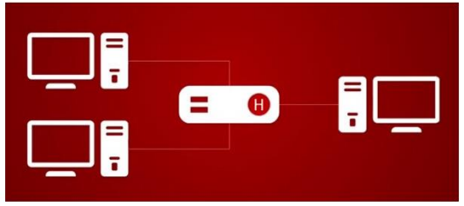
1. Hub: A hub is to send out a message from one port to other ports. For example, if there are three computers of A, B, C, the message sent by a hub for computer A will also come to the other computers. But only computer A will respond and the response will also go out to every other port on the hub. Therefore, all the computers can receive the message and computers themselves need to decide whether to accept the message.

- Switch:
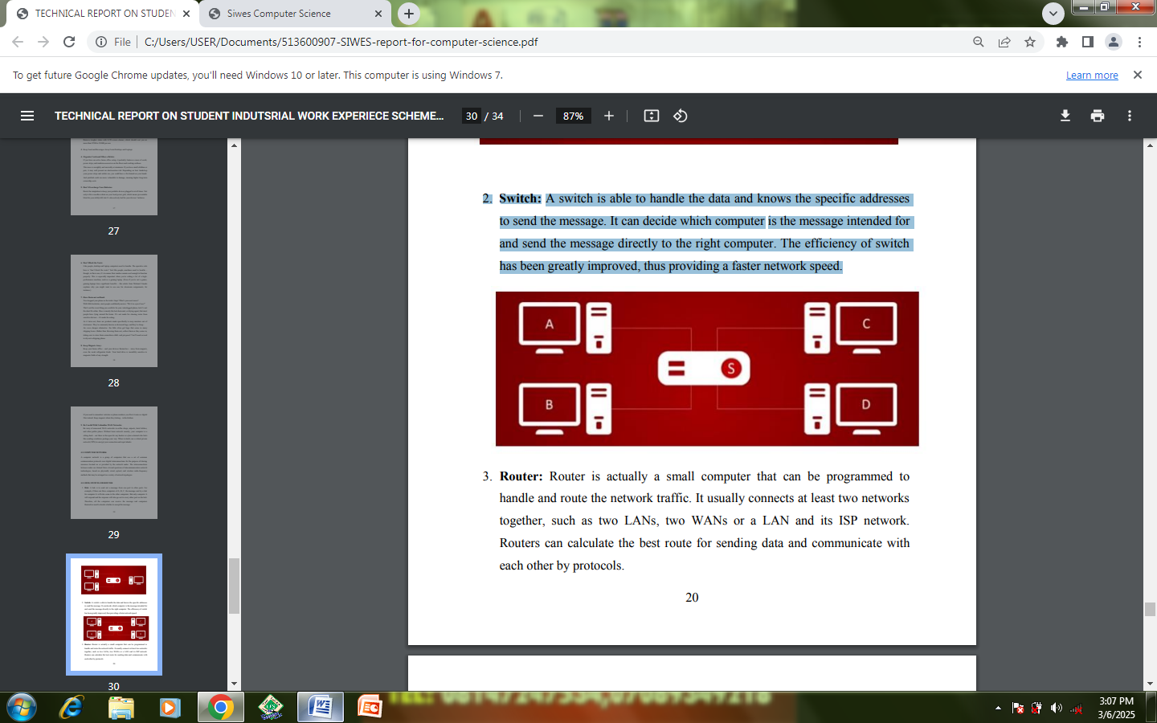
A switch is able to handle the data and knows the specific addresses to send the message. It can decide which computer is the message intended for and send the message directly to the right computer. The efficiency of switch has been greatly improved, thus providing a faster network speed.

- Router:
Router is actually a small computer that can be programmed to handle and route the network traffic. It usually connects at least two networks together, such as two LANs, two WANs or a LAN and its ISP network. Routers can calculate the best route for sending data and communicate with each other by protocols.
4.2 INTERNET PROTOCOLS
The Internet Protocol (IP) is the principal communications protocol in the Internet protocol suite for relaying datagrams across network boundaries. Its routing function enables internetworking, and essentially establishes the Internet. IP has the task of delivering packets from the source host to the destination host solely based on the IP addresses in the packet headers. For this purpose, IP defines packet structures that encapsulate the data to be delivered. It also defines addressing methods that are used to label the datagram with source and destination information
4.3 MEDIA ACCESS CONTROL
MAC Addresses: A Media Access Control (MAC) address is the unique hardware address of an Ethernet network interface card (NIC), typically ―burned in‖ at the factory. MAC addresses may be changed in software. Note: Burned-in MAC addresses should be unique. There are real-world exceptions to this, often due to mistakes by NIC manufacturers, but hardware MAC addresses are considered unique on the exam. Historically, MAC addresses were 48 bits long. They have two halves: the first 24 bits form the Organizationally Unique Identifier (OUI) and the last 24 bits form a serial number (formally called an extension identifier).

CHAPTER FIVE
5.0 CONCLUSION
The student Industrial Work Experience Scheme (SIWES) is a skill training program designed to expose and prepare student in institution of higher training for industrial work situation they are likely to meet after graduation.
I have gain a lot of experience from the various works done on the site such as building construction, design of parapet, culvert and also the use of equipment like theodolite for making alignment on various station and also opportune to know various way of building design and type of foundation and reinforcement.
The program which has given me more detail between theory and practical aspect.
I hereby compensate and duly thank the Federal Government and Industrial Training Fund (I.T.F) Lagos of enhance the standard of technology development of these nation. And also give thanks to my school Kwara State Polytechnic Ilorin which has given up the ability to want to know more about civil engineering and very thank to my lecturer e.g H.O.D, and other lecturer.
5.1 PERSONAL IMPRESSION ABOUT THE ORGANIZATION
I was highly impressed about the organization toward acceptance of my Student Industrial Work Experience Scheme (SIWES) letter in the organization, also what impressed me most about the organization is the experience and knowledge gained during my four months in the civil engineering department in the organization.

5.2 SUGGESTION AND RECOMMENDATION TO KWARA STATE POLYTECHNIC
I would suggest that the department of civil engineering in Kwara State Polytechnic should expose student to various practical skill in term of construction activities like road construction, student should be expose to various instrument use in road construction such as grading machine, roller machine, excavator etc.
I would recommend that Kwara State Polytechnic should improve on modern computer outrage for SIWES student in term of architectural design a bridge or road construction with computer and this will also improve the development of the school.
The training department of ITF should be providing adequate information about the biennial SIWES national conference and workshops on time.
All the institution involved should be organizing orientation courses in collaboration with the ITF for their students prior to their attachment with the attendance made mandatory for the students accepted for SIWES and ITF staff.
ITF should ensure the regular visitation of the ITF officers to supervising agencies, institutions, employers and students on attachment. Students are most time faced with the problem of placement. The log-book issued to students at attachment by institutions must be checked and signed by the institutions and ITF supervisors responsible during supervision. Ensure payment of allowances for the students and supervisors even if is for only transport of the SIWES student.

