

TECHNICAL REPORT
ON
STUDENTS’ INDUSTRIAL WORK EXPERIENCE SCHEME (SIWES)

HELD AT
EARTHTRICK TECHNOLOGY
AROLOWO WAY BALOGUN BUS/STOP IKEJA, LAGOS STATE.
BY
SAMUEL KEHINDE BOLUWATIFE
ND/23/SGI/PT/0008

SUBMITTED TO:

DEPARTMENT OF SURVEYING AND GEO-INFORMATICS, INSTITUTE OF EVIRONMENTAL STUDIES (IES)
KWARA STATE POLYTECNIC, ILORIN

2024/2025 Academic Session

Dedication
This SIWES report is dedicated to Almighty God for its successful completion

Acknowledgements
I would like to express my sincere gratitude to God Almighty for His guidance, protection, and strength throughout the duration of my Student Industrial Work Experience Scheme (SIWES). My sincere appreciation goes to Industrial Training and Management of kwara State Polytechnic for the opportunities given in having practical idea of what’s learnt in the four wall of a class room.
Lastly, I appreciate my family and friends for their constant support and encouragement throughout this experience.
Thanks to you all.

TABLE OF CONTENTS
Title Page i
Dedication ii
Acknowledgements iii
Table of Contents iv

CHAPTER ONE: INTRODUCTION
1.1 Background of the Study 6
1.2 Objectives of SIWES 7
1.3 History of Bright World Enterprise 7
1.4 Organizational Structure 8

CHAPTER TWO:

2.1 Description of Work Done 9
CHAPTER THREE
3.1 Challenges Encountered 11
3.2 Lessons Learned 12

CHAPTER FOUR
4.1 Conclusion 13
4.2 Recommendations 14

CHAPTER ONE
INTRODUCTION
1.1 Background of the Study
The Student Industrial Work Experience Scheme (SIWES) was introduced to expose students of science, engineering, and technology-related disciplines to real-life industrial environments where they can apply the knowledge gained from the classroom. As a student of Surveying and Geo-Informatics, I have always studied the theories behind measurements, mapping, data collection, and spatial analysis, but I had very limited hands-on experience with actual surveying instruments and software tools. The SIWES program gave me the chance to bridge this gap by allowing me to work directly in a professional surveying company EARTHTRICK TECHNOLOGY. It helped me understand how surveyors operate on field projects, interact with clients, and manage data from collection to final map production. I learned to handle instruments like the Total Station, leveling instrument, and GPS, and also practiced drawing using both manual tools and AutoCAD software. SIWES brought my academic knowledge to life and taught me the real meaning of accuracy, coordination, and teamwork. I began to understand the importance of procedures like angle reduction, control establishment, setting out, and plotting vectors. The fieldwork deepened my confidence and technical capacity. More importantly, the experience helped me appreciate how crucial surveyors are in land development, urban planning, and infrastructure design. This program was a major stepping stone in my career path, and it gave me a better sense of direction for my future as a professional in the field.

1.2 Objectives of SIWES
The primary objective of SIWES is to prepare students for the challenges they will face in the professional world. Specifically, it aims to:
- To expose students to practical tools and real-life applications in Surveying and Geo-Informatics.
- To help students understand technical procedures such as manual plotting and use of differential instruments.
- To introduce students to digital tools like AutoCAD and Total Station.
- To encourage teamwork and effective communication in a professional setting.
- To build competence in the handling of modern surveying equipment.
- To bridge the knowledge gap between academic learning and fieldwork.
1.3 HISTORY OF EARTHTRICK TECHNOLOGY
EARTHTRICK TECHNOLOGY is a surveying and geo-informatics firm based in Lagos State, Nigeria. The company was founded to provide specialized services in land surveying, mapping, GIS solutions, and consulting. Since its establishment, it has grown steadily by taking on projects in both the private and public sectors. The firm is known for combining traditional surveying methods with modern technologies like AutoCAD and Total Station. With a team of experienced professionals, EARTHTRICK TECHNOLOGY has become a trusted name in land documentation and spatial data analysis. Their commitment to quality work and mentorship has also made them a preferred training center for students like me. The company emphasizes accuracy, professionalism, and timely delivery of services. They also ensure that trainees are well-guided and actively involved in real-life projects. It was a privilege to undergo my SIWES training in such a forward-thinking and organized firm. The knowledge and support I received during my stay there were exceptional.

1.4 Organizational Structure
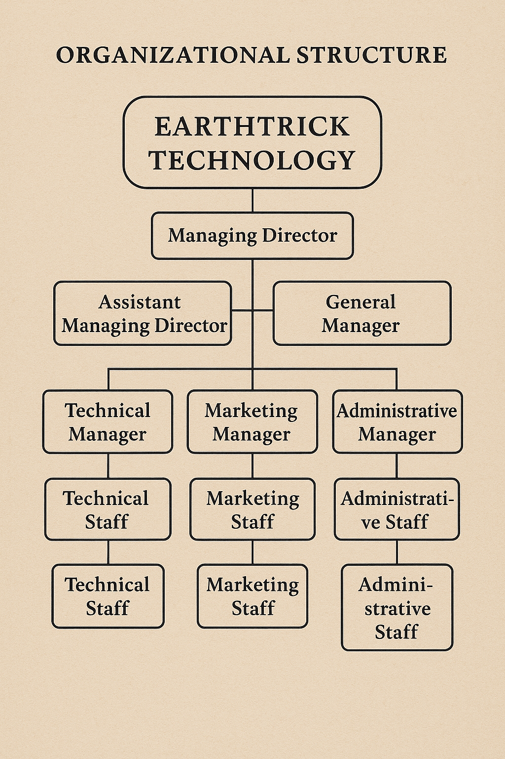
EARTHTRICK TECHNOLOGY has a simple but efficient organizational structure that ensures smooth workflow and coordination among departments. At the top of the hierarchy is the Managing Director, who oversees the company’s operations and major decisions. Below him are heads of departments, including technical, administrative, and field operations units. The technical unit handles fieldwork, data collection, plotting, and computation tasks. The administrative unit manages documentation, customer relations, and internal coordination. Interns like me are usually placed under supervisors in the technical unit but are also allowed to interact with other departments. This cross-exposure helps students learn how all parts of the organization function together. The supervisors were approachable and took their time to teach, correct, and evaluate our progress. The structure of the organization encouraged collaboration and constant communication. It made it easy to report issues, get feedback, and learn quickly. The teamwork spirit at EARTHTRICK really stood out and made learning more enjoyable.

CHAPTER TWO:
DESCRIPTION OF WORK DONE
2.1 Description of Work Done
Throughout my SIWES training, I was introduced to a wide range of tasks, starting with the basics such as lettering and quadrant identification. Lettering taught me the importance of clear labeling in maps and drawings, while quadrant bearings helped me understand how to record and interpret directions in surveying. I then learned how to reduce angles using both the left-left and right-right techniques. These calculations are essential in ensuring data collected from the field is accurate before it is processed or plotted. I was also trained on how to convert and record readings in feet, meters, and on sheets—an important task when working with different instruments or data from various regions. One of the more hands-on tasks was using computation sheets, where I manually solved survey problems and plotted data using a scale, pencil, ruler, and cardboard. It was challenging but very rewarding, especially when the plots came out accurate.
moved on to digital plotting using AutoCAD, where I learned to input bearings and distances to draw maps digitally. I also went on several field assignments, one of which was at Ajao Estate in Oshodi. There, we used the differential leveling instrument to collect elevation data for land profiling. Another site project was at Badagry, where we carried out setting-out activities and applied all necessary precautions before work began. These included inspecting the site, checking the instrument’s level and condition, and marking control points. I also got familiar with the leveling instrument and its accessories, learning how to set it up and use it effectively. In the office, I was taught various shortcuts in AutoCAD to speed up my plotting. On another day, we worked in the Agric area, using a tape, compass, and GPS to measure and map out land features. It showed me how multiple tools can complement each other during field surveys.
One of the highlights of my experience was getting to work with the Total Station. I was trained on how to set it up, carry out primary adjustments like leveling, centering, and focusing, and how to use it to collect precise data. I was also introduced to the concept of controls and the different types, including primary and secondary controls, which are vital in ensuring accuracy across projects. I came to understand the importance of the red copy—a finalized, signed, and sealed version of a survey drawing that serves as a legal document. Additionally, I was introduced to vector data and its significance in digital cartography. Plotting vectors helped me understand how direction and distance are used to define positions and movements in space. Each new task built upon the previous one, reinforcing my skills and expanding my understanding of surveying. The hands-on learning approach helped me develop confidence and technical know-how that I could never have gained from theory alone.

CHAPTER THREE:
CHALLENGES ENCOUNTERED AND LESSONS LEARNED
3.1 Challenges Encountered
During the course of my SIWES training, I encountered several challenges that tested my patience and adaptability. The first was understanding the professional terminology and work pace, which was much faster than what we were used to in school. Sometimes I struggled to keep up with instructions during fieldwork, especially when handling instruments for the first time. Weather also played a big role in disrupting some of our outdoor activities, particularly during the Badagry project, where we had to postpone work due to rainfall. Another challenge was using AutoCAD; although I had heard of it before, working with bearings and coordinates directly was entirely new to me. It took time to grasp how digital plotting worked and how to interpret the data correctly.
I also found manual plotting quite challenging. It required a high level of accuracy and neatness, as any mistake meant starting over. This was especially frustrating when working with cardboard and scale rulers under tight deadlines. At times, instrument malfunctions would occur, and I would have to wait or repeat measurements. Working with new people and adjusting to a formal work culture was also difficult at first, especially in terms of communication and understanding expectations. Juggling between office work and field assignments was stressful at times, but I learned to manage my time better as the weeks progressed. Overall, the experience came with its fair share of struggles, but it was through these difficulties that I grew the most.
3.2 Lessons Learned
Despite the challenges, my SIWES experience was rich with valuable lessons that I will carry with me throughout my career. I learned how to apply classroom knowledge in practical situations, which made my academic learning more meaningful. I developed patience and a greater appreciation for precision and detail, especially when using plotting tools or survey instruments. Working with AutoCAD helped me become digitally competent and efficient in producing technical drawings. The exposure to different software shortcuts and plotting methods has made me more comfortable with technology in surveying.
I learned the importance of teamwork and communication, especially during fieldwork, where one person’s mistake could affect the whole team’s result. The experience also taught me to ask questions and seek clarification rather than assume. In the field, I became more conscious of safety and the importance of checking instruments before and after use. I also learned to appreciate the role of documentation and the need for clear, complete, and accurate records. My confidence in handling tasks and taking responsibility has improved significantly. I now feel more prepared to take on advanced surveying roles and continue building on the foundation this experience has given me. From the safety perspective, I learned a lot about site precautions before setting out. For example, checking the environment for hazards, confirming benchmarks, securing instruments properly, and ensuring all team members understand their roles. These steps help prevent mistakes and protect the crew. Before SIWES, I underestimated how much planning goes into a successful field job. Now I understand that preparation is just as important as execution.
Lastly, I learned about the importance of keeping proper records—whether it’s field notes, computation sheets, or plotted data. At EARTHTRICK, we were trained to document everything clearly and in an organized manner. This habit is not just for personal reference; it helps others understand the work if they need to continue or review it. I also got familiar with the use of red copies and how they serve as a reference during checks and corrections. This reinforced the principle that surveying is as much about documentation as it is about measurement.

CHAPTER FOUR:
CONCLUSION AND RECOMMENDATIONS
4.1 Conclusion
My SIWES training at EARTHTRICK TECHNOLOGY was an unforgettable and impactful journey that opened my eyes to the real demands of the surveying profession. From manual plotting and computation sheets to AutoCAD drawings and Total Station fieldwork, every activity contributed to my growth. The combination of field experience and office tasks provided a well-rounded perspective of what it means to be a surveyor. I was able to apply theories learned in school in real-life settings and witness the /importance of accuracy, professionalism, and teamwork.
I came into the program with curiosity and left with clarity, confidence, and improved skills. I now understand the significance of preparation, attention to detail, and continuous learning in achieving success in surveying. My time at EARTHTRICK TECHNOLOGY confirmed my passion for this field and showed me the career possibilities that lie ahead. I’m truly grateful for the guidance I received from my supervisors and colleagues during the training.

4.2 Recommendations
For future students going for SIWES, I recommend taking every task seriously and being willing to learn—even from mistakes. Always carry a notebook to jot down processes and questions you may have. Don’t be afraid to ask for help or repeat a task until you get it right. Pay attention to safety rules during fieldwork and treat instruments with care. I also recommend practicing with AutoCAD before the training if possible, as it makes things easier when you’re introduced to digital plotting.
To institutions, I suggest organizing pre-SIWES workshops to prepare students better. For organizations like EARTHTRICK TECHNOLOGY, I recommend they continue their hands-on training style and even expand their mentorship approach. They could also include brief weekly assessments to help students track progress. Lastly, every student should make the most of this opportunity—it’s more than just a requirement; it’s a stepping stone to becoming a professional.

